TCSS 558: Applied Distributed Computing Institute of Technology
Fall 2017 University of Washington – Tacoma
http://faculty.washington.edu/wlloyd/courses/tcss558 Instructor: Wes Lloyd

Assignment 0
Version 0.14
Cloud Computing Infrastructure Tutorial

Due Date: Friday October 20th, 2017 @ 11:59 pm, tentative

Objective
The purpose of assignment 0 is to establish AWS accounts, and gain experience with technologies used to provide distributed computing infrastructure to support future TCSS 558 programming assignments.

We will leverage the AWS Educate program for education credits from Amazon Web Services (AWS) to provide cloud computing resources for TCSS 558 projects. We will create virtual machines, known as elastic compute cloud (EC2) instances to host individual nodes of our distributed systems. To support working with VMs to host our distributed applications, we will harness the Docker-Machine tool to automatically create and configure VMs. We will use Docker containers then to deploy code (our nodes) onto VMs.

Assignment 0 provides a tutorial on the use of Cloud Computing Infrastructure. Specifically assignment 0 walks through the use of EC2 instances, docker, docker-machine, and haproxy for load balancing.

Use of a Linux environment is recommended for assignment 0.

For Windows 10 users, there is now a Ubuntu “App” that can be installed onto Windows 10 directly. This provides a Ubuntu Linux environment without the use of Oracle Virtualbox. Alternatively, Windows users can install Oracle Virtual Box to enable creating virtual machines under Windows 10, and then install a Ubuntu 16.04 virtual machine.

Windows 10 Ubuntu “App” instructions:
https://msdn.microsoft.com/en-us/commandline/wsl/install_guide

Windows Oracle Virtual Box & Ubuntu VM instructions:
There are a number of blogs and Youtube videos that walk through installing Oracle VirtualBox on Windows 10, and how to then install Ubuntu 16.04 LTS on Virtual Box. Search using google.com or video.google.com to find blogs and/or videos to help.

Oracle VirtualBox can be downloaded from: https://www.virtualbox.org/wiki/Downloads

Task 0 – Getting an AWS account

If you do not presently have an AWS account, the best option with the largest free credits is to apply for the GitHub education pack. This program provides up to $150 in usage credits:

Apply using your UW email id:
https://education.github.com/pack

If you already have an AWS account created on your own, not using a UW email, then try applying for the GitHub education account as a new user under your UW email.

If you already have an AWS account created using your UW email, either uw.edu or u.washington.edu, then you may try to apply for a new account using the “other” domain name: u.washington.edu or uw.edu.

If this doesn’t work, contact the instructor. Provide your AWS account ID, and your UW email address your account was created with. The instructor will follow-up by providing AWS credit coupons as soon as possible. Please note it may take considerable time to receive a response from Amazon. Please contact the instructor ASAP if needing credits for an existing AWS account. If credits are not available, it is possible to complete assignment 0 using only free tier resources (e.g. t2.micro instances).
_____________________________________________________________________________________
Task 1 – AWS account setup

Once having access to AWS, proceed to create account credentials to work with Docker-Machine, if you have not already done so.

From the AWS services home page, locate the “IAM” Identity Access Management link, and select it:
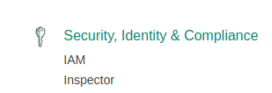

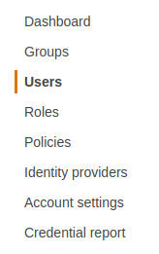
Once in the IAM dashboard, on the left hand-side select “Users”:

Provide a user account name. Here I am using “TCSS558” as an example:
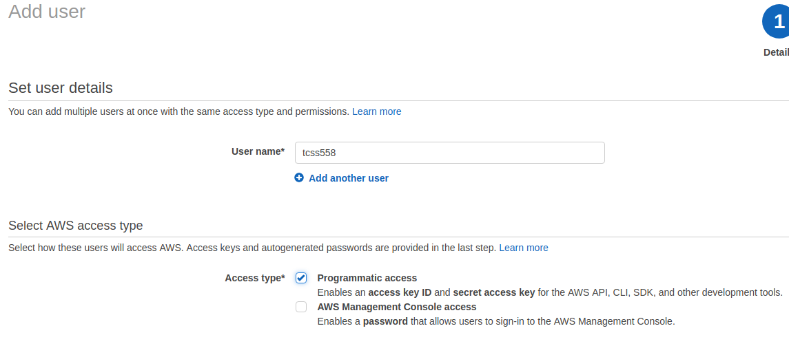

Be sure to select the “Programmatic access” checkbox.

Then click the “Next: Permissions” button…

For simplicity, you can simply select the button:

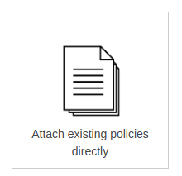

Using the search box, search, find, and select using the checkbox the following policy:

* AmazonEC2FullAccess

If you plan to use this user account for additional exploration of Amazon’s various services, then I recommend also adding:

* AdministratorAccess

This will allow you, via the CLI, to explore and do just about everything with this AWS account.

Now click the “Next: Review” button, and then select “Create user”.

You’ll now see a screen with an Access key ID (grayed out below), and a Secret access key. You can copy both the Access key, and the secret access key to a safe place, or alternatively, click the “Download .csv” button to download a file containing this information.

Once you’ve downloaded these keys, be sure to never publish these key values in a source code repository such as github where your account credentials could be exposed. Protect these keys as if they were your credit card or wallet!
_____________________________________________________________________________________
Task 2 – Working with Docker, creating Dockerfile for Apache Tomcat

Next, let’s launch a virtual machine on Amazon to support working with Docker/Docker-Machine. You will want to have access to a computer with the ssh/sftp tools. It is best to have access to a local computer with Ubuntu installed either natively or on Oracle Virtualbox. It is possible to download putty, an “SSH” client and also an “SFTP” client, for Windows, but not recommended.

First, let’s choose the “region” that you’ll work in. Recommended options are “UW East (N. Virginia)” known as “us-east-1” via the CLI, or “UW West (Oregon)” known as “us-west-2”.

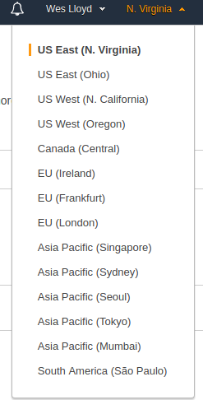
The region can be set using the dropdown in the upper-right hand corner. Selecting the region configures the entire AWS console to operate in that region as shown to the right –------------------------------------------------------------→

For assignment 0, we will use “t2.micro” instances. Every user is allowed up to 750-hours/month of instance time for FREE using the t2.micro type.

From the AWS menu, under Compute services, select “EC2”:

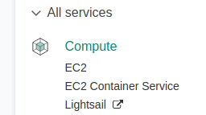

Next, click the Launch Instance button:

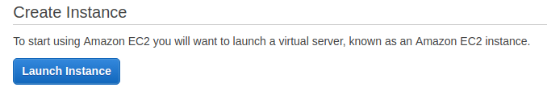

Select Ubuntu:

Specify t2.micro as the instance type, and click the “Next: Configure Instance Details” button,

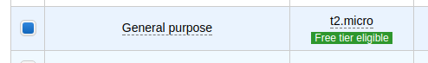

Next, specify the following instance details:

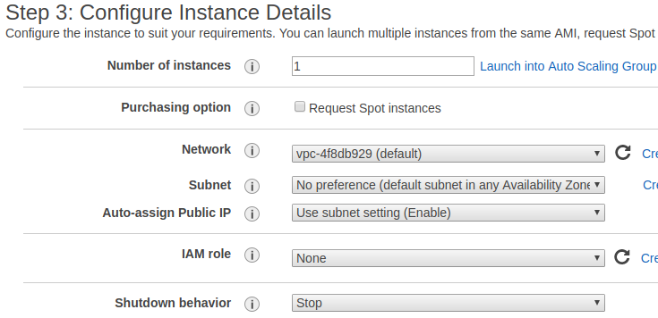

Network: choose “(default)” for the Virtual Private Cloud (VPC).
Subnet: choose an availability zone such as us-east-1e
Auto-assign Public IP: choose “Use subnet setting (Enable)”. This will provide a public IP address to enable connecting to your instance.
Shutdown behavior: Choose “Stop”

Next, click “Next: Add Storage”.
Then, keep defaults and click “Next: Add Tags”.
Then, keep defaults and click “Next: Configure Security Group”.

Choose the option:
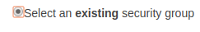

And then mark the option for “default VPC security group”.

As we go along, apply all security changes to the default security group for your default VPC. This way the rule changes will persist as you come back to AWS for future work sessions.
Then click “Review and Launch”.

Review the details and if everything looks ok, click “Launch”.

The very first time you’ll be prompted to create a new RSA private/public keypair to enable logging into your instance.

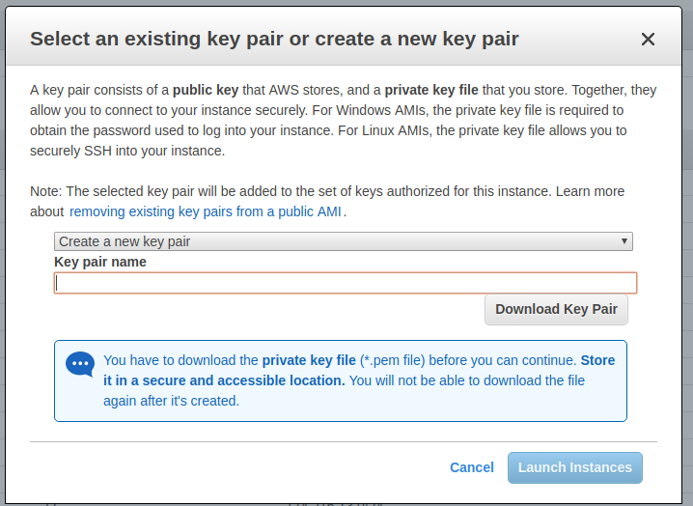

The instance should launch and be visible by clicking “Instances” on the left-hand side of the EC2 Dashboard. Locate the IPv4 Public IP.

Throughout the tutorial, Linux commands are prefaced with the “$”.

Comments are prefaced with a “#”.

First, from the Linux CLI change permissions on your keyfile:

$chmod 0600 <key_file_name>.pem

Before you can SSH into the instance, the default security group used by your instance must be modified to allow SSH (port 22) access from your computer.

In the Amazon management console., under instances, look at the detailed instance information and click on “default” next to “Security groups”:

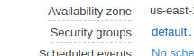
Click the “Inbound” tab, and then the “Edit” button.
Scroll down and click the “Add Rule” button at the bottom of the dialog box:

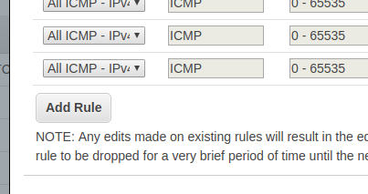

Add a “SSH” Rule with the following settings:
Protocol = TCP
Port Range = will automatically be set to 22
Source = My IP

Then “Save” the security change.

Then connect using ssh:

$ssh -i <key_file_name>.pem ubuntu@<IPv4 Public IP>

Say yes, when the following message is displayed:

The authenticity of host '107.21.193.159 (107.21.193.159)' can't be established.
ECDSA key fingerprint is SHA256:0cy2eP8Q15zmBThAqTq9z1TwO0+MS0ldKi1SmPZhkE0.
Are you sure you want to continue connecting (yes/no)? Yes

Linux tracks every machine you ever ssh to. The very first time it hashes the public key and places it into a file at /home/<user_user_id>/.ssh/known_hosts

The idea is when you reconnect to the VM again, there is a possibility that someone masquerades as the VM. To prevent someone from masquerading, ssh tracks the identity of each host and alerts the user every time there is a change. Sometimes the changes are expected, such as when you launch a new VM to replace an old one. The idea is to help notify the user if the VM’s identity changes unexpectedly.

Stopping, and backing up your VM on Amazon:

By default, the t2.micro is an “EBS-backed” instance. The t2.micro instances make use of remotely hosted elastic blockstore virtual hard disks for their “/root” volume. “EBS-backed” instances can be paused at any time. This allows you to stop your work, and come back later. Billing is paused, but storage charges for your EBS disk are ongoing 24/7. Every user is allowed 30GB of EBS disk space for free. Beyond this the price for each GB per month is 10 cents for standard “GP2-General Purpose 2” EBS storage. A second 30GB will cost $36/year in credits. In the console, any volumes listed under “Elastic Block Store | Volumes” will count towards this 30GB quota. Snapshots, under “Elastic Block Store” represent copies of EBS volumes that are stored onto Amazon Simple Storage Service (S3) aka blob storage. Standard pricing for S3 storage is 2.3 cents per month per GB.

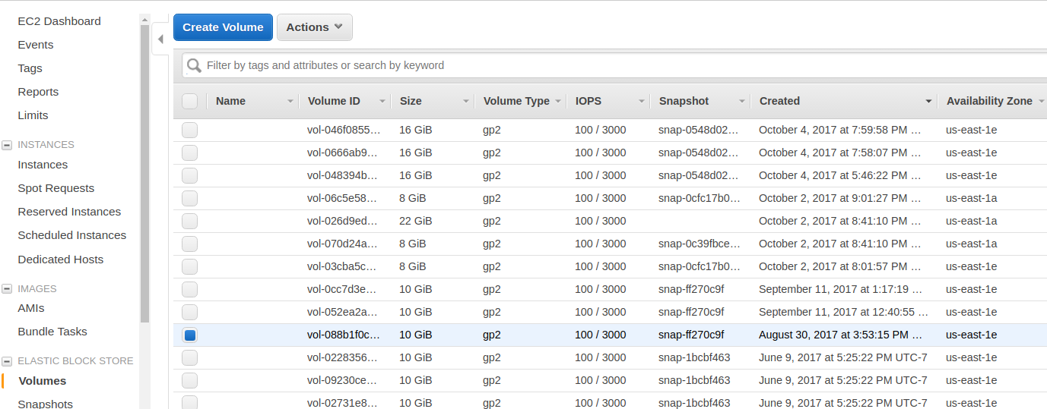

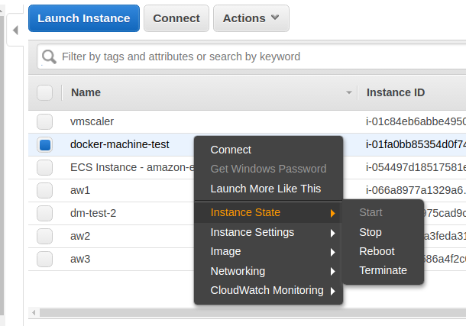

To “stop” your instance right-click on the row in the “Instances” view, select “Instance state”, and then “stop”. You may later resume the instance by selecting “start”. When restarting your instance, your public IPv4 address may be reassigned.

An image can be created by right-clicking on the instance row, and selecting “Image” and “Create Image”. This will temporarily shutdown your instance to create the image. Once the image has been created the instance is restored to its online state. New images will be listed under “Images | AMIs” on the left-handside of the EC2 console. Sorting by Creation Date makes it easy to locate newly created images.

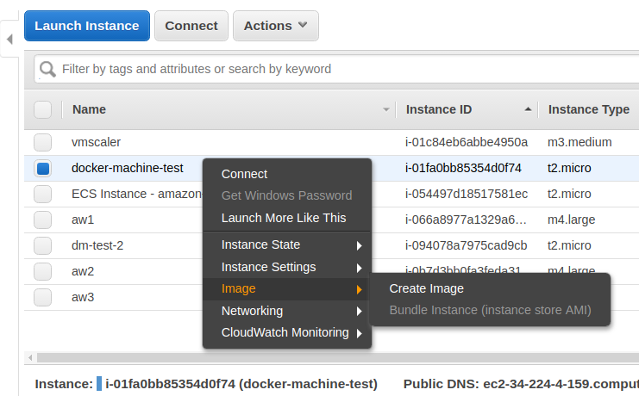

As you work throughout the course projects in TCSS 558, you will likely want to reusing your virtual machine from assignment 0 will help jump start deployment and testing of future projects.

Next, let’s install Docker on this VM.

highlight the following text, then copy-and-paste to the VM:
curl -fsSL https://download.docker.com/linux/ubuntu/gpg | sudo apt-key add -
sudo add-apt-repository "deb [arch=amd64] https://download.docker.com/linux/ubuntu $(lsb_release -cs) stable"

# refresh sources
sudo apt-get update

# install packages
apt-cache policy docker-ce

sudo apt-get install -y docker-ce

#verify that docker is running
sudo systemctl status docker

The “Docker Application Container Engine” should show as running.

When working with Docker directly on your local VM, we will preface docker commands with “sudo”, so the commands run as the superuser.

Create a docker image for Apache Tomcat

The “Docker Hub” is a public repository of docker images. Many public images are provided which include installations of many different software packages.
The “sudo docker search” command enables searching the repository to look for images.

Let’s start by downloading the “ubuntu” docker container image:
Note that docker commands are prefaced as “sudo”.
They must be run as superuser.
sudo docker pull ubuntu

Verify that the image was downloaded by viewing local images:

sudo docker images -a

Next, make a local directory to store files which describe a new docker image.

mkdir docker_tomcat
cd docker_tomcat

Now, download the Java application which we will deploy into the Docker container:

wget http://faculty.washington.edu/wlloyd/courses/tcss558/assignments/a0/fibo.war

Using a text editor such as vi, vim, pico, or nano, edit the file “Dockerfile” to describe a new Docker image based on ubuntu that will install the Apache tomcat webserver:

nano Dockerfile

# Apache Tomcat Dockerfile contents:
FROM ubuntu
RUN apt-get update
RUN apt-get install -y tomcat8
COPY fibo.war /usr/share/tomcat8/webapps/
COPY entrypoint_tomcat.sh /
RUN mkdir /usr/share/tomcat8/logs
RUN mkdir /usr/share/tomcat8/temp
RUN ln -s /var/lib/tomcat8/conf /usr/share/tomcat8
ENTRYPOINT ["/entrypoint_tomcat.sh"]

Next, create a script called “entrypoint_tomcat.sh” under your docker_tomcat directory as follows:

#!/bin/bash
# tomcat daemon - runs container continually until tomcat exits
/usr/share/tomcat8/bin/startup.sh
echo "tomcat daemon up..."
sleep 3
while :
do
tomcatstatus=`ps aux | grep tomcat8 | grep java`
if [ -z "$tomcatstatus" ]
then
#exit
echo "tomcat down"
fi
sleep 1
done

You’ll need to change permissions on this file.
Give the owner execute permission:
chmod u+x entrypoint_tomcat.sh

Next, build the docker container:
sudo docker build -t tomcat1 .

Check that the docker image was build locally:
sudo docker images

Next launch the container as follows:
sudo docker run -p 8080:8080 -d --rm tomcat1

Check that the container is up
sudo docker ps -a

Now, you’ll need to open port 8080 in the default security group in the Amazon management console.

Under instances, look at the detailed instance information and click on “default” next to “Security groups”:

Click the “Inbound” tab, and then the “Edit” button.
Scroll down and click the “Add Rule” button at the bottom of the dialog box:

Add a “Custom TCP Rule” with the following settings:
Protocol = TCP
Port Range = 8080
Source = My IP

Then “Save” the security change.

Now, using your browser, point at the http GET endpoint for the web application:

http://<IPv4 Public IP of instance>:8080/fibo/fibonacci
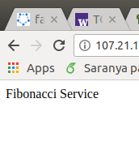
You should see a web page as follows:

Now, test the fibonacci web service deployed onto this container on your EC2 instance using the testFibPar.sh script.

Download the script here:
http://faculty.washington.edu/wlloyd/courses/tcss558/assignments/a0/testFibPar.sh
This script uses a Linux utility known as GNU parallel to coordinate separate threads to support parallel client sessions with Apache Tomcat.

If not already installed, you’ll need to install GNU parallel in your Ubuntu (Linux) environment:

sudo apt-get install parallel

Near the top of the script, you’ll see parameters for host and port:
host=34.232.53.152
port=8080

Update the host to match the public IPv4 Public IP for your EC2instance.

Now try exercising your web service using this script.
The first parameter is the total number of service requests to perform.
The second parameter is the number of concurrent threads to use.
Since we just have one docker container hosting the service, try just one thread:

./testFibPar.sh 10 1

Run this script 3 times.

The first and second runs may feature slower times reflecting “warm-up” of the infrastructure: VM, container, JVM…

Setting up test: runsperthread=10 threads=1 totalruns=10
run_id,thread_id,json,elapsed_time,sleep_time_ms
1,1,{"number":50000},258,.74200000000000000000
2,1,{"number":50000},300,.70000000000000000000
3,1,{"number":50000},306,.69400000000000000000
4,1,{"number":50000},390,.61000000000000000000
5,1,{"number":50000},274,.72600000000000000000
6,1,{"number":50000},288,.71200000000000000000
7,1,{"number":50000},279,.72100000000000000000
8,1,{"number":50000},356,.64400000000000000000
9,1,{"number":50000},317,.68300000000000000000
10,1,{"number":50000},328,.67200000000000000000

By the 3rd run, performance should be fairly consistent and stable.
_____________________________________________________________________________________
Task 3 – Creating a Dockerfile for haproxy

Haproxy is a TCP load balancer that is capable of distributing client requests to a very large number of server hosts. We will next create a Docker image for our haproxy load balancer deployment.

mkdir docker_haproxy
cd docker_haproxy

First, download the sample haproxy config file:

wget http://faculty.washington.edu/wlloyd/courses/tcss558/assignments/a0/haproxy.cfg

Using a text editor such as vi, pico, or nano, edit the file “Dockerfile” to describe a new Docker image based on ubuntu that will install the Apache tomcat webserver:
$nano Dockerfile

# haproxy Dockerfile contents:
FROM ubuntu
RUN apt-get update
RUN apt-get install -y haproxy
COPY entrypoint_haproxy.sh /
COPY haproxy.cfg /etc/haproxy/
ENTRYPOINT ["/entrypoint_haproxy.sh"]

Next, create a script called “entrypoint_haproxy.sh” under your docker_haproxy directory as follows:

#!/bin/bash
# haproxy daemon - runs container continually until haproxy exits
service haproxy start
echo "haproxy daemon up..."
sleep 3
while :
do
haproxystatus=`ps aux | grep haproxy-systemd | grep cfg`
if [ -z "$haproxystatus" ]
then
#exit
echo "haproxy down"
fi
sleep 10
done

You’ll need to change permissions on this file.
Give the owner execute permission:
chmod u+x entrypoint_haproxy.sh

Now, let’s update the haproxy configuration file (haproxy.cfg) using your favorite text editor. As provided the haproxy configuration file will perform round-robin load balancing against 3 nodes:

server web1 54.210.51.9:8080
server web2 54.210.51.9:8081
server web3 54.210.51.9:8082

So far, we have just one Apache Tomcat server in one container, let’s comment out the bottom two entries by using the “#” character:

server web1 54.210.51.9:8080
#server web2 54.210.51.9:8081
#server web3 54.210.51.9:8082

Now, update the IP address (here 54.210.51.9) to match your public IPv4 address of your ec2instance. Also, instead of using port 8080, change this port to 8081.
We will need to destroy your existing tomcat container which is presently using port 8080 and change this to port 8081. First destroy the old container:

sudo docker ps -a

Locate the “tomcat1” docker instance. The CONTAINER ID will be the left most column. Using this ID, stop the container:

sudo docker stop <CONTAINER ID>

Now, relaunch the Apache Tomcat container mapping container port 8080 to the host port 8081:

sudo docker run -p 8081:8080 -d --rm tomcat1

Now, we’re ready to build the docker container:
$sudo docker build -t haproxy1 .

Check that the haproxy docker image was built:
sudo docker images

Now let’s launch the haproxy container. Haproxy will direct incoming traffic to port 8080 to port 8081 which will map to Apache Tomcat:

sudo docker run -p 8080:8080 -d --rm haproxy1

Now, using the testParFib.sh script, retest that you’re still able to access your webservice, but this time through the haproxy load balancer server.

./testFibPar.sh 10 1

If this works, then all of the pieces are ready to be deployed across different Docker hosts and containers to complete assignment 0.
______________________________________________________________________________
Task 4 – Working with Docker-Machine

We will use docker-machine to support working with multiple docker hosts and EC2 instances. Docker-machine makes it very easy to create and destroy instances, and deploy code using Docker containers to multiple VMs on Amazon.

Before we begin, please stop all containers created for Task 2 and Task 3.
Search using “sudo docker ps -a”, and use the “sudo docker stop <CONTAINER ID> command to stop ALL running containers.

Sudo vs. non-sudo: When using docker-machine, docker commands run on remote hosts are not prefaced with “sudo”.

Let’s start by installing the Amazon Web Services Command Line Interface onto your VM (AWS CLI):

sudo apt update
sudo apt install awscli

Next configure the AWS CLI using your access credentials created earlier:

# configure aws cli
aws configure

Next install docker-machine onto your EC2 instance:

#to install Docker-Machine:

# Download the application
curl -L https://github.com/docker/machine/releases/download/v0.12.2/docker-machine-Linux-x86_64 >/tmp/docker-machine

# Make it executable
chmod a+x /tmp/docker-machine

# Copy it into an executable location in the system PATH
sudo cp /tmp/docker-machine /usr/local/bin/docker-machine

# verify the version
docker-machine version

You should see a version similar to:
docker-machine version 0.12.2, build 9371605

For further information on Docker Machine see documentation here:
https://docs.docker.com/machine/overview/

Now, let’s create a virtual machine to serve as a docker host.
A single command creates the EC2 instance of the specified type, installs the latest version of docker, and prepares the instance for hosting docker containers !!!

Below, I’ve specified “m4.large” an EC2 instance with 2 virtual CPUs. We will launch this instance as a “spot” instance with a maximum bid of 17 cents per hour:

docker-machine create --driver amazonec2 --amazonec2-region us-east-1 --amazonec2-instance-type "m4.large" --amazonec2-spot-price ".17" --amazonec2-request-spot-instance --amazonec2-zone "e" --amazonec2-open-port 8080 --amazonec2-open-port 8081 --amazonec2-open-port 8082 --amazonec2-open-port 8083 aw1

Note that I’ve specified availability zone “e”. Please set your availability zone accordingly. It will be best to consolidate your instances into the same availability zone for project work in TCSS 558.
The “aw1” refers to the name of the instance. This is the name that you’ll use to interact with the VM using the docker-machine CLI. You can use any name desired.

Also please note that docker-machine automatically opens ports using “--amazonec2-open-port <port number>”. This automatically adjusts the security-group to provide WORLD access to these ports. **This is not secure!**, but ok, assuming your instances will not stay up for long.

Alternatively, you could use “FREE tier t2.micro” instances for your docker host(s). These instances will spend on your 750-hours/month FREE credits for t2.micro instances. These instances are limited to an initial 30-minute burst of 100% CPU utilization. Once CPU credits are exhausted, the instance is down-throttled to 10% of one CPU core until credits are earned at a rate of 6-minutes @100% utilization per hour:

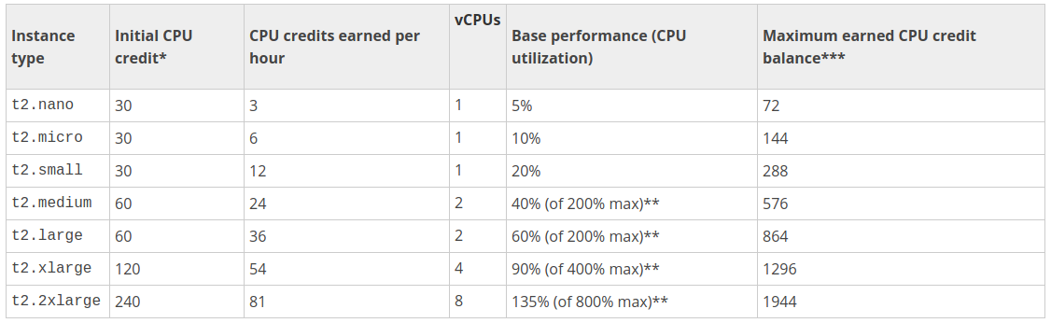
From: http://docs.aws.amazon.com/AWSEC2/latest/UserGuide/t2-instances.html

These t2 instances are not spot instances. They are considered full price where the first 750 hours is free. To create a t2.micro docker host:

docker-machine create --driver amazonec2 --amazonec2-region us-east-1 --amazonec2-instance-type "t2.micro" --amazonec2-zone "e" --amazonec2-open-port 8080 --amazonec2-open-port 8081 --amazonec2-open-port 8082 --amazonec2-open-port 8083 aw1

Try listing docker-machine hosts:

docker-machine ls

NAME ACTIVE DRIVER STATE URL SWARM DOCKER
aw1 - amazonec2 Running tcp://34.232.53.152:2376 v17.09.0-ce

You should see something similar to the listing above, 1 remote docker host.

Now change your docker CLI to work against the remote host.

eval $(docker-machine env aw1)

Check “docker-machine ls” again. The host should be marked “ACTIVE”.
The following command can also be used to show the active host:
docker-machine active

Next, we need provide the docker_tomcat and docker_haproxy containers locally on each host. While it is possible to use the “docker save” and “docker load” commands in conjunction with docker-machine to accomplish this, for simplicity we will simply rebuild the images on each host for assignment 0.

Try listing the container images known to this docker host:

docker images

There aren’t any!!! Now, go back into your docker_tomcat directory on your local instance:

cd docker_tomcat

Rebuild the tomcat container, but this time because we ran the “eval” command above, the build occurs on the remote server:

docker build -t tomcat1 .

Now check the list of images:

docker images

Next rebuild the haproxy image on this remote host.

cd docker_haproxy

Before rebuilding, update the haproxy.cfg file.
Please specify the IP address of the new docker-machine host that is listed using “docker-machine ls”. Specify port 8081.

After making these changes, build the haproxy image on the remote host:

docker build -t haproxy1 .
Now, create an apache tomcat docker container on the remote host.
We will map apache-tomcat’s port 8080 to 8081 on the Docker Host.

docker run -p 8081:8080 -d --rm tomcat1

Next, create the haproxy docker container on the remote host.
We will map haproxy’s port 8080 to 8080 on the Docker host.

docker run -p 8080:8080 -d --rm haproxy1

Now, by refering again to the IP address obtained from “docker-machine ls”.
Using the testFibPar.sh script, update the host IP and test the service:

./testFibPar.sh 10 1
If your service works, then this certifies you’ve been able to deploy the service onto a docker host using both an apache-tomcat and apache-haproxy container. You’re now ready to tackle assignment 0’s deliverable (task 5).
_____________________________________________________________________________________
Task 5 – Completing Assignment 0

The objective for assignment 0 is to compare performance of running the Fibonacci web service using three different configurations.

For each configuration, you will point to the testFibPar.sh script host and port to the haproxy instance which load balances the containers. Please run testFibPar.sh 3 times, and copy the CSV output of the last, third test run into an Excel, Open Office, or Google Sheets spreadsheet.

Run the test script to perform 3 concurrent threads with 10 requests per thread:
./testFibPar.sh 30 3

In the spreadsheet, label the raw data for each configuration clearly by name. Please indicate the instance type used (e.g. m4.large, t2.micro) for the docker host(s) for the tests. You must use the same instance type for all of your configurations. In the spreadsheet, add a formula to calculate the “average” Fibonacci web service performance for the 30 test results for each of the 3 configurations. It will be something like: “=AVERAGE(D6:D35)”. It is nice to compute percentage differences between the configurations but not required.

At the bottom of the spreadsheet include a summary report. Include a ranking with place, average performance in ms, and % equivalence as follows:

Performance Ranking:
1st place | Configuration 2 | 300ms | 100%
2nd place | Configuration 1 | 400ms | 133%
3rd place | Configuration 3 | 500ms | 166%
Test the following configurations:

Configuration #1:
Deploy three apache-tomcat containers on one Docker host Virtual Machine.
Map the tomcat containers to use successive port numbers, and update the haproxy configuration accordingly to use these ports:

# launch 3 containers
docker run -p 8081:8080 -d --rm tomcat1
docker run -p 8082:8080 -d --rm tomcat1
docker run -p 8083:8080 -d --rm tomcat1

Configuration #2:
Deploy three apache-tomcat containers on one Docker host Virtual Machine, with 66% CPU allocations for m4.large, or 33% CPU allocations for t2.micro

# launch 3 containers – m4.large weights
docker run -p 8081:8080 -d --rm --cpus .66 tomcat1
docker run -p 8082:8080 -d --rm --cpus .66 tomcat1
docker run -p 8083:8080 -d --rm --cpus .66 tomcat1

Configuration #3:
Deploy three apache-tomcat containers on three separate Docker host Virtual Machines. This will require launching an additional two docker hosts using docker-machine. Map haproxy accordingly on the first host to load balance against the apache-tomcat containers running on the other remote hosts.

Use “docker-machine ls” to find the IP address of each host.

You will need to build the tomcat container separately for each new host.

# On each host, launch one apache-tomcat container
docker run -p 8081:8080 -d --rm tomcat1

The expected behavior is that each of these three configurations will perform differently. If this is not the case, please check your configuration to be sure you’ve remember to reconfigure haproxy each time to use the appropriate hosts.

What to Submit
To complete the assignment, upload your .xslx spreadsheet file into Canvas under assignment 0.

Grading

This assignment will be scored out of 24 points. (24/24)=100%
Each cell in the summary spreadsheet is worth 2 points.

Teams (optional)
Optionally, this programming assignment can be completed with two person teams.

If choosing to work in pairs, only one person should submit the team’s xlsx spreadsheet with results to Canvas.

Additionally, EACH member of a team should submit an effort report on team participation. Effort reports are submitted INDEPENDENTLY and in confidence (i.e. not shared) by each team member.

Effort reports are not used to directly numerically weight assignment grades.

Effort reports should be submitted as a PDF file named: “effort_report.pdf”. Google Docs and recent versions of MS Word provide the ability to save or export a document in PDF format.
For assignment 0, the effort report should consist of a one-third to one-half page narrative description describing how the team members worked together to complete the assignment. The description should include the following:

- Describe the key contributions made by each team member.
- Describe how working together was beneficial for completing the assignment. This may include how the learning objectives of using EC2, Docker, Docker-machine, and haproxy were supported by the team effort.
- Comment on disadvantages and/or challenges for working together on the assignment. This could be anything from group dynamics, to commute challenges, to faulty technology.
- At the bottom of the write-up provide an effort ranking from 0 to 100 for each team member. Distribute a total of 100 points among both team members. Identify team members using first and last name. For example:

John Doe
Effort 43

Jane Smith
Effort 57

Team members may not share their effort reports, but should submit them independently in Canvas as a PDF file. Failure of one or both members to submit the effort report will result in both members receiving NO GRADE on the assignment…

Disclaimer regarding pair programming:
The purpose of TCSS 558 is for everyone to gain experience developing and working with distributed systems and requisite compute infrastructure. Pair programming is provided as an opportunity to harness teamwork to tackle programming challenges. But this does not mean that teams consist of one champion programmer, and a second observer simply watching the champion! The tasks and challenges should be shared as equally as possible.

Helpful Hints

To display all containers running on a given docker node:
docker ps -a

To stop a container:
docker stop <container-id>
For example:
docker stop cd5a89bb7a98

Multiple docker hosts
When creating multiple docker VM hosts on amazon, each host is referred to by name. To see your hosts use the command:
docker-machine ls

The active host will be shown with a ‘*’.

The hostname conveniently synced with the AWS keypair name, which is the SSH key used to interact with the virtual machine. If you should need to manually remove keys, this can be done via the EC2 console. On the left-hand side, see “Key Pairs” under “Network & Security”. Keys can be deleted if need be using the UI:

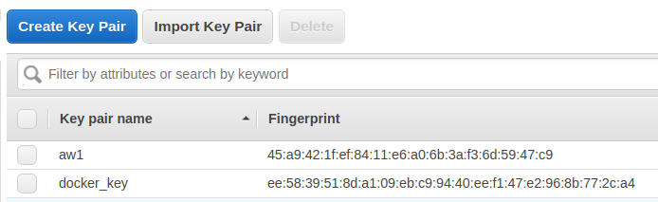

To use a specified remote docker host created by docker-machine:
eval $(docker-machine env <host-name>)

To unset the remote docker host, and work with your local docker:
# set docker back to the localhost
eval $(docker-machine env -u)

Remove a docker host
Once a host created by docker-machine is no longer needed it can be removed by name. This will destroy the VM and stop any associated charges.
$docker-machine rm aw2

Document History:
v.14 added description for installation of GNU parallel, renumbered tasks,
added description on opening the SSH port to initially connect to EC2
instance(s). Removed the “$” sign used to indicate a command. Use of the
bold courier font should be enough to indicate Linux commands. Cleaned up
the lines for installing the Docker repository.

