Standard Operating Procedure
Hydrogen Peroxide
CAS# 7722-84-1

Section 1 – Lab-Specific Information
Building/Room(s) covered by this SOP: Bag 005, 023
Unit or department: Chemistry
Principal Investigator Name: Sarah Keller
Principal Investigator Signature/Date: 24 Feb 2025
This SOP was created by (if not PI): Not applicable
Name/Title/Date/Signature

Section 2 – Hazards
Hydrogen peroxide is a strong oxidizer that has a potential to cause a fire or explosion in contact with incompatible materials such as combustibles (e.g., wood, paper, organic solvents). It is corrosive and light-sensitive. It is toxic if swallowed and corrosive to the eyes and skin. Prolonged exposure may cause dermatitis. 30% hydrogen peroxide requires special storage and handling procedures. It is a very strong oxidizing agent and severely corrosive to skin, eyes, and respiratory tract. Many common substances, including iron and other transition metals, will catalyze the decomposition to product copious amounts of oxygen gas and heat. The 30% solution is a dangerous fire and explosion risk—do not heat.
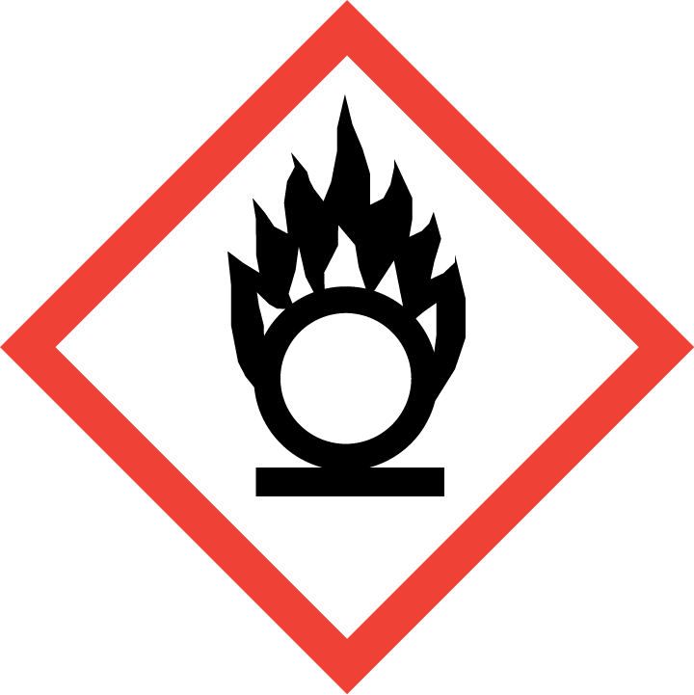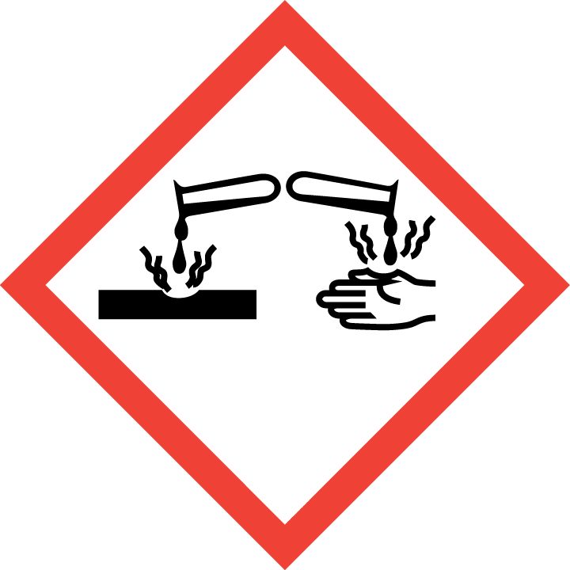

Section 3 – Engineering and Personal Protective Equipment (PPE)
Engineering Controls: Use of hydrogen peroxide should be conducted in a properly functioning chemical fume hood whenever possible. The chemical fume hood must be approved for use by EH&S.
Hygiene Measures: Avoid contact with skin, eyes, and clothing. Wash hands before breaks and immediately after handling the product.
Hand Protection: Chemical-resistant gloves must be worn, nitrile gloves are recommended for low volume applications. Wearing two pairs of nitrile gloves is recommended. For high volume applications, disposable gloves are not appropriate; a heavy-duty glove is required such as butyl rubber, Viton, or equivalent. NOTE: Consult with your preferred glove manufacturer to ensure that the gloves you plan on using are compatible with the specific chemical being used.
Eye Protection: ANSI approved properly fitting safety glasses or chemical splash goggles are required. A face shield may also be appropriate depending on the specific application.
Skin and Body Protection: Laboratory coats must be worn and be appropriately sized for the individual and buttoned to their full length. For high volume applications, additional PPE such as a chemical-resistant apron may be required. Personnel must also wear full length pants, or equivalent, and close-toed shoes. Full length pants and close-toed shoes must be worn at all times by all individuals that are occupying the laboratory area. The area of skin between the shoe and ankle must not be exposed.
Respiratory Protection: If hydrogen peroxide solution is being used outside of a chemical fume hood, respiratory protection may be required. If this activity is necessary, contact EH&S at 206.543.7388 so a respiratory protection analysis can be performed.
Vent

Section 4 – Special Handling and Storage Requirements
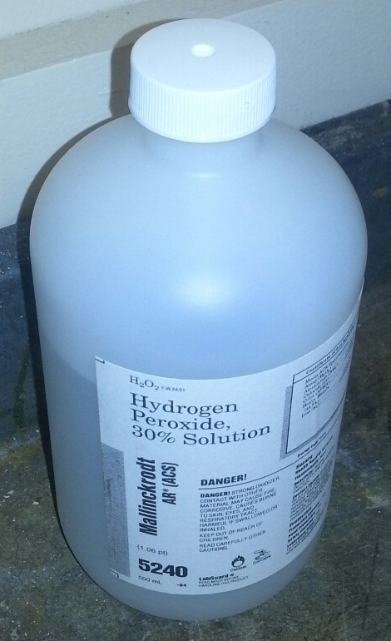
- Avoid contact with skin, eyes, and clothing. Avoid inhalation or ingestion.
- Hydrogen peroxide solutions greater than 10% should be kept in their original container with the manufacturer cap that allows the container to vent oxygen while in storage as shown in the picture to the right.
- Do not store hydrogen peroxide solutions greater than 10% in glass containers; only plastic containers should be used for storage.
- The 30% solution is a dangerous fire and explosion risk—do not heat.
- Keep container tightly closed in a dry and well-ventilated area. Opened containers must be carefully resealed and kept upright to prevent leakage.
- Recommended storage temperature is 2 – 8 ºC. A flammable-proof refrigerator is required for this.
- Do not over purchase; only purchase what can be safely stored in the laboratory.
- Keep container upright and tightly closed in a dry and well-ventilated place.
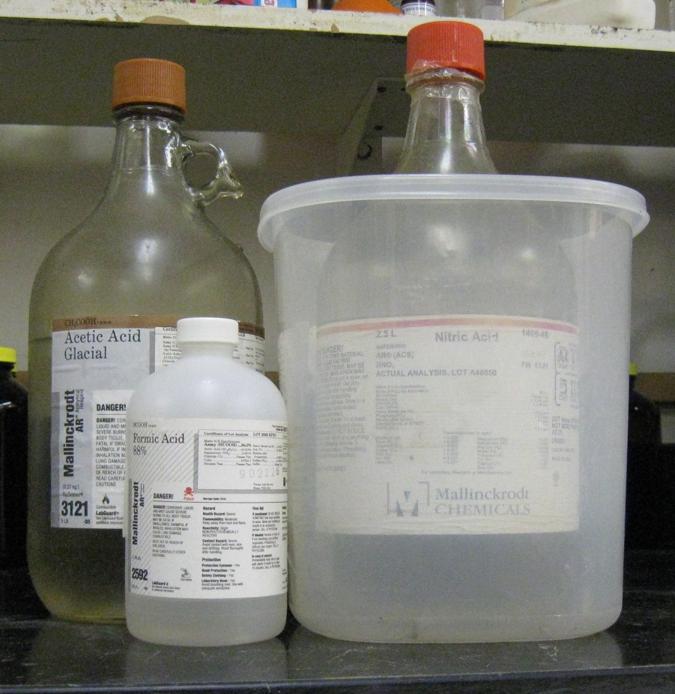
- Opened containers must be carefully resealed and kept upright to prevent leakage.
- Keep away from incompatible materials. Store away from combustible materials. Do not store on wooden shelves. Store away from all organic compounds, including organic solvents. Keep away from iron and other transition metals; hydrogen peroxide will catalyze their decomposition to produce copious amounts of oxygen gas and heat.
Organic acid
Oxidizing acid
- Use in the smallest practical quantities for the experiment being performed.
- Make a current copy of the SDS for the solution being used available to all personnel working in the laboratory at all times.
- Containers should remain closed when not in use.
- Label new containers appropriately. Label should indicate the name of the chemical(s) in the container. Avoid using chemical abbreviations (acceptable if a legend is present in the lab) and formulae.
- Containers should be in good condition and compatible with the material.
- Transport all corrosives in secondary containment, such as polyethylene or other non-reactive acid/solvent bottle carrier.

Section 5 – Spill and Accident Procedures
Immediately evacuate area and ensure others are aware of the spill. If there is an imminent threat of a fire, pull the nearest fire alarm station to evacuate the building and dial 911. If personnel have become exposed and need medical assistance, dial 911. If the spill is minor and does not pose a threat to personnel, contact EH&S at 206.543.0467 during normal business hours (Monday – Friday, 8 AM – 5 PM) for spill cleanup assistance (dial 911 if spill occurs after hours and assistance is needed).
Section 6 – Waste Disposal Procedures
Store hazardous waste in closed containers that are properly labeled, and in a designated area area (flammable cabinet is recommended). No oxidizers are permitted to be poured down the drain. Complete a Chemical Waste Collection Request Form to arrange for disposal by EH&S; detailed instructions are provided at the following link: http://www.ehs.washington.edu/epowaste/chemwaste.shtm.
Section 7 – Protocol
Protocols for handling acrylamide in the Keller Lab are the same as outlined in Sections 3 and 4 above.
Refer to Section 2 of the UW Laboratory Safety Manual on the EH&S website for additional guidance on chemical management and preparation for use for particularly hazardous substances (PHSs).
NOTE: Any deviation from this SOP requires approval from Principal Investigator.

Section 8 – Special Precautions for animal use (Not relevant)
This section is not applicable (“N/A”) because our lab does not use animals.

PARTICULARLY HAZARDOUS SUBSTANCE INVOLVED?
YES: Sections #9 to #11 are Mandatory.

Section 9 – Approvals required
All staff working with hydrogen peroxide must consult this SOP prior to starting work. They must also review the chemical’s SDS, which is available through the Keller Laboratory website and EH&S.

Section 10 – Decontamination
• If the eyes or body of any person may have been exposed, a safety shower/eye wash should be immediately used. Personnel who are working with acrylamide must be aware of location of nearest Safety Shower/Eye Wash and verify that a current certification of performance tag is present.
• Personnel shall rinse exposed areas of skin and/or eyes with copious amounts of water for at least 15 minutes.
• All equipment, materials and work surfaces that have/ potentially have become contaminated shall be cleaned in accordance with those identified for small spill in Section 5.

Section 11 – Designated area
- Acrylamide powder easily becomes airborne and may result in personal exposure and area contamination. Use care to avoid dispersing dust. Mixing or dispensing should be done within a fume hood.

Section 12 – Documentation relevant to ALL Particularly Hazardous Substances
- Lab members are expected to review the laboratory’s inventory of chemicals to identify any “Particularly Hazardous” substances. The inventory appears in MyChem with the letters “P” or “B” in the column labeled “Reg”.
- Before working with any of the “Particularly Hazardous” substances, lab members must review the laboratory’s SOP for that substance to learn how to protect themselves from the hazards and how to enact emergency procedures.
- Ready access to SOPs and to a Safety Data Sheets for all Particularly Hazardous materials used in the Keller Lab are available through the Keller Lab website.
- If lab any lab member determines that the SOP should be revised or if the substance is being used in a way that is not covered in the SOP, the lab member should bring it to the attention of the P .and propose changes to this SOP.
- Lab members must attest (in a separate document that applies to all Particularly Hazardous substances) that they will adhere to the policies in this SOP.

