Standardization_methods_26.doc

Methods for dealing with death and missing data, and for standardizing different health variables in longitudinal datasets: the Cardiovascular Health Study

Paula Diehr

Abstract

Longitudinal studies of older adults usually need to account for deaths and missing data. The databases often include multiple health-related variables, which are hard to compare because they were measured on different scales. Here we present the unified approach to these three problems that was developed and used in the Cardiovascular Health Study. Data were first transformed to a new scale that had integer/ratio properties, and on which “dead” takes the value zero. Missing data were then imputed on this new scale, using each person’s own data over time. Imputation could thus be informed by impending death. The new transformed and imputed variable has a value for every person at every potential time, accounts for death, and can also be considered as a measure of “standardized health” that permits comparison of variables that were originally measured on different scales. The new variable can also be transformed back to the original scale, which differs from the original data in that missing values have been imputed. Each observation is labeled as to whether it was observed, imputed (and how), or the person was dead at the time. The resulting “tidy” dataset can be considered complete, but is flexible enough to permit analysts to handle missing data and deaths in other ways. This approach may be useful for other longitudinal studies as well as for the Cardiovascular Health Study.
Methods for dealing with death and missing data, and for standardizing different health variables in longitudinal datasets: the Cardiovascular Health Study

Death, missingness, and multiple measures
In life, nothing is certain but death and taxes. Taxes are not much of a problem for longitudinal datasets, but there are frequently other major challenges: incompleteness due to death and missing data, and the use of multiple different variables, all measured on different scales. Our goal is to present a unified approach to these 3 problems: death, missingness, and comparison of multiple measures. As part of the first two goals we created a rectangular dataset, with K records per person, where K is the maximum number of periods in which the person could potentially have contributed data (although she may in fact have died or gone missing). Even at the times after the person has died, there is still a record for that person, with an indication that the person is dead. For each observation of each variable, we include an auxiliary variable called “status” which indicates whether this value was observed, the person was dead, or how it was imputed. The analyst may choose to use all the imputed values, or may easily eliminate or re-impute some of the values, since they are clearly labeled.
We illustrate this approach using data from the first 10 years (1990-1999) of the Cardiovascular Health Study (CHS), based on a sample of Medicare enrollees, who were followed annually from 1990 to 1999. (Baseline data were actually collected in 1989-1990, but we refer to baseline year as 1990 for simplicity). A second cohort, all African American, was followed from 1993 to 1999. The “tidy” dataset thus has 10 records for each person in cohort 1, and 7 for those in cohort 2. Fortunately, deaths were completely ascertained in CHS, and the amount of missing data and persons lost to follow-up was small.
The primary goal of this report is to provide documentation for users of the longitudinal CHS data. Although it is unusual to have such a long series of measures, we hope that some of these methods will also be useful for researchers using other datasets. Sections 1-3 deal with deaths and missing data. Section 4 deals with standardization of the various health measures so they may be compared.

Unified Approach
The unified approach to the 3 problems is described here. For each variable “X” that was potentially measured 10 times (cohort 1) or 7 times (cohort 2), we created a series of auxiliary variables, as explained in Table 1. We refer to the resulting dataset as a “tidy” dataset, which refers to the subscripts “tdie”.

 | Table 1
 | Definitions of Auxiliary Variables in Unified Approach
Variable | Definition
X | Longitudinal Health Variable, such as instrumental activities of daily living (IADL), which has values from 0 to 6 difficulties.
X_t | A transformation of X that is on an integer/ratio scale, and for which the value for death is logically 0.
X_td | X_t with the deaths set to zero.
X_tdi | X_td with missing data imputed using linear interpolation over time. (X_tdi is complete for persons who died)
X_tdie | X_tdi with any terminal missing data imputed from the last available observation of X and from self-rated health at that time.
X_back | X_tdie transformed back to the original scale
Status_X | A marker for whether X_tdie is observed, missing because dead, imputed using interpolation, or extrapolation, or a missing baseline measure imputed as the next observation carried back (NOCB)
Standardized X | X_tdie, relabeled as “standardized X”

0 Reference dataset
We will refer to a “reference dataset”, which is used to assist with the problems of death, missingness, and different scales. It could in theory be any large datset, not necessarily the same as the dataset that will be analyzed. Here, the reference dataset is all of the available longitudinal data collected in CHS, from 1990 to 1999, with no distinction as to the person’s age, sex, or which year it was collected. Everyone in cohort 1 contributed 10 records, and everyone in cohort 2 contributed 7 records. Much of this discussion will deal with self-rated health – is your health excellent, very good, good, fair, or poor? -- often abbreviated as EVGGFP. Unlike the other variables, EVGGFP was collected every semester (6 months) and is still being collected at this date, along with mortality.
- Transform X to a new, integer/ratio scale (X_t)
The first step is to transform the variable “X” from its original scale (which is often ordinal) to a different scale that is interpretable, has an integer/ratio property, and where death has a natural value (X_t). One approach we considered was to replace each observed value with the probability that a person with this value would be “healthy” in the following year. This probability was estimated from the reference dataset. That is, for t from 1 to 9 years, we dichotomized the data in year t to “healthy/sick”, and then used logistic regression to predict the probability that the person would be “healthy” in year t based on their observed value in year t-1. Here, we dichotomized self-rated health in year t as “excellent/very good/good” = 1, and “fair/poor” = 0. (Later we refer to these to these combined categories as EVGG and FP). Earlier research using several different reference datasets found that persons whose self-rated health was excellent in year 1 had about a 95% chance of being healthy in year 2, …., and that persons whose self-rated health was poor had about a 15% chance of being healthy. For that reason, we recommended recoding excellent/very good/ good/ fair/ poor to 95/90/80/30/15.^{[2]}
The large difference between the values for good (80) and fair (30) is due in large part to the fact that “healthy in year 2” was dichotomized between good and fair. If we had dichotomized at some other point, say between very good and good, a different large gap would have occurred (in this case between very good and good). Some empirical work suggested that, where possible, it was better to define “healthy” using some other variable than the one being transformed. For example, we transformed the SF-36 scales according to the probability of being in excellent/very good/ good health, and also on the probability of having a “healthy” SF-36 score. The former method had fewer large gaps between the values, because it was not based on dichotomizing the SF-36 score itself. In addition, we did not need to estimate the probability of being healthy in the following year, but could estimate the probability of being healthy in the same year, which simplified the interpretation. This variant was used for the CHS variables, with the exception of self-rated health (EVGGFP). Specifically, we used logistic regression to predict EVGG from the logarithm of “the variable on its original scale with 1 added” (e.g.,ln(1+ IADL))in the same year. The logarithms were used to minimize the effect of outliers. We added 1 before calculating the logarithm because 0 was a valid value for many of the variables. One variable, 3MSE, was negatively skewed and we instead used log(101-3MSE) in the standardization regression.
To illustrate these calculations we will use IADL, which refers to the number of instrumental activities of daily living (heavy or light housework, shopping, meal preparation, money management, or telephoning) which the person has some difficulty in performing. IADL takes on values from 0 (no difficulties) to 6. If we transform IADL as to the probability of a “healthy” IADL (having no IADL difficulties) in the following year, the codes are as follows: 0/1/2/3/4/5/6 / dead ➔ 82/35/15/9/7/8/6/0. Notice the big gap between 82 and 35, due to our definition of “healthy IADL” as having 0 IADL difficulties.
Here, however, are the probabilities of being EVGG in the same year for different IADL values: 0/1/2/3/4/5/6 / dead ➔ 84/64/47/39/35/31/27/0 (version not using the imputed IADL data). Thus, transformation using the probability of being EVGG gives a more uniform set of values with no large gaps. (When we repeated the transformation regression including the imputed IADL data the means were 85/61/41/34/31/26/20/0, which is the version used in some places in this documentation for convenience.) We will use this kind of transformation for every variable but EVGGFP itself, which was transformed to 95/90/80/30/15/0, as noted before. (We expect transformed EVGGFP (probability of being healthy next year) to be a little worse than for the other variables (probability of being healthy this year) because a person has some probability of being dead next year.)
We shall refer to a variable “X” that is recoded in this way as X_t, where the “t” stands for being transformed to the “probability of being healthy” scale. X_t has an interpretable value (the probability of being EVGG conditional on X). In addition, a (say) 5-point change in the scale has the same meaning (5 percentage points change in the probability of being healthy) everywhere in the scale, and there is a true 0 (0 probability of being healthy). This means that the new variable is on an integer/ratio scale. This property means that it is “proper” to calculate means and other summary statistics that might have been questionable on the original (often ordinal) scale.
Table 2 shows information for person A. The first column shows that he had 0 IADL difficulties in 1990, 1991, 1994, and 1995. He had one difficulty in 1992. Data were missing in 1993 and 1996. He was dead in 1997. The original values are shown in column 1. IADL_t, the probability of being EVGG for this number of IADL difficulties, is either 84 (no IADL difficulties) or 64 (1 IADL difficulty).

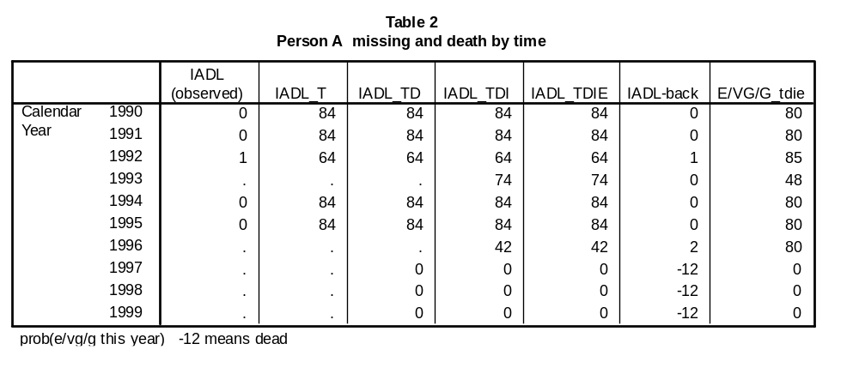
2 Add a value for Death (X_td)
When deaths occur, the analyst must think carefully about how to address them in the analysis, as different approaches can yield profoundly different results. For example, the subset of persons that had the most deaths could seem to have better outcomes than other subsets, because its sickest cases were removed by death. While there are many approaches for handling deaths at the time of analysis, our goal here is to provide a dataset with a reasonable value for death. Since the deaths are clearly identified in Status_X, they may be handled in different ways at the time of analysis, if desired.
The goal was to create a new variable that had a reasonable value for dead. We use the “joint model” referred to elsewhere. ^{[5]} Since a person who is dead is not healthy now, and has no probability of being healthy next year, the natural value to assign to X_t for dead is 0, which is what was done. The new variable is referred to as X_td, which stands for X, transformed and with deaths set to zero. Table 2 shows the transformations for person A. IADL_td is set to 0 for the three years when he was dead.
The assignment of 0 as the value for death will always be at least speciously accurate, since a dead person has no probability of doing or being anything. More seriously, the approach has the effect of conceptualizing the underlying construct as having dead as the worst value of the scale. We feel that this is reasonable for most measures of health, quality of life, and function; for example, the worst value of a measure of function is death. Some have felt that this might not be appropriate for measures of mental health (e.g., can we think of death as extreme depression, or alternatively does death cure depression?). The reasonableness of the approach to death is probably context-specific. For example, suppose we rated piano playing. If we conceptualize piano playing as a measure of physical dexterity, it may be reasonable to consider dead as an extremely low ability to play the piano. Alternatively, if piano playing is conceptualized as a measure of musicality, it is probably not appropriate to think of death as being extremely unmusical, and deaths will need to be handled in some other way. Because X_t usually becomes lower near to death, it may not matter whether it is very low after death, but this should be considered carefully for each analysis.

3 Missingness (X_tdi, X_tdie)
There are many approaches to handling missing data at the time of analysis ^{[5]} , which are not reviewed here. Our goal is to create a “complete” dataset that does something reasonable about missing data. One study of four CHS variables found that estimating a person’s missing data from that person’s available longitudinal data had the best performance of the methods considered. We suggest that, rather than imputing missing data from available X data on the original scale, that X_td should be the basis for imputation, because X_td is on an integer/ratio scale, making it “more appropriate” to calculate means and conduct regressions. X_td also has a value for dead, meaning that data missing just before death will be imputed using the information about impending death.
One possible approach to impute the missing data is to regress the person’s available X_td data on time, and to use the regression equation to predict values for times when the person’s data were missing. (For dead persons, we found it best to use only one or two of the 0’s after death in the regression calculation). We did not use the regression imputation approach for CHS, but have used it elsewhere.^{[8]}

3.1 Interpolation (X_tdi)
The imputation approach that was used for the CHS data was to impute the missing data using linear interpolation of the person’s own X_td over time. This simple approach is (probably) locally optimal under some assumptions. We refer to variables that are transformed, have death set to zero, and having missing data imputed within the range of the available data (that is, by interpolation) as X_tdi, where “i” may stand for imputed or for interpolated. Because dead has a value, missing data for every person who died can be completely filled in by interpolation. Any terminal missingness for persons who were still alive at the end of the study, however, still needs to be imputed, as is explained in section 3.2.
Table 2, in the column for IADL_tdi, shows that the two missing values for person A were imputed (IADL_tdi) as 74 (1993) and 42 (1996). The missing value in 1993 were imputed as the mean of the values in 1992 (64) and 1994 (84). For 1996, the imputed value was 42, the mean of 84 and 0. All missing data were imputed by interpolation because person A died during followup.
3.2 Extrapolation (X_tdie)
Often there is monotone missingness, in which all of the values after a certain time are missing. Last-observation-carried-forward (LOCF) is often used but may be risky, especially for older adults, where missingness is likely to be associated with worse health (i.e., informative). In one sensitivity analysis that considered different approaches for the terminal missingness, we found that 3 of the 4 approaches yielded the same analytic results, but that use of LOCF changed the study findings slightly. ^{[8]}
For the CHS longitudinal data, we used a variant of LOCF for monotone missingness when the person did not die. CHS was fortunate to have one variable (self-rated-health, EVGGFP) that was measured for a much longer time than the others (1990 to present), and measured more frequently than the others (every semester). For one study, we calculated X_td for all the variables to be analyzed, according to the probability of being in excellent/very good/good health. We then used the mean of the LOCF estimate of X_td (call it X_locf) and the value of self-rated health (EVGGFP_tdie) at the same time, as the estimate for X_td, for values missing at the end of the sequence for persons who were still alive. This was appropriate since both EVGGFP_tdie and X_td were on the same scale (probability of being EVGG). It also incorporated information about health and death that occurred after 1999, because EVGGFP was measured for a longer time. We chose to average in EVGGFP_tdie only if EVGGFP_tdie was lower than the X_locf, because our main concern was that using LOCF alone could cause the person to appear too healthy. In addition, the Engels study suggested that most imputed data were optimistic, on average.^{[7]} Different choices may be made at the time of analysis. We refer to the version of X in which X is transformed, death is added, data missing between two available time points were interpolated, and monotone missing data for survivors were extrapolated as X_tdie. An example is shown in Table 3 for person B, who lived throughout the study but had one missing observation at the end, in 1999.
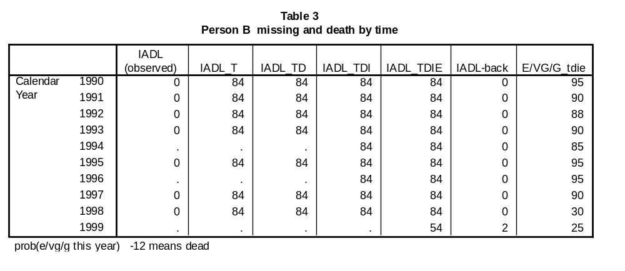

Table 3 is similar to Table 2, but is for a person whose final observation (1999) was missing, meaning that interpolation could not be used to impute that point. The last observed value was 84 in 1998, and the EVGG_tdie value in 1999 was 25. Because 25<84, we averaged the two. The mean of 84 and 25 is 54.5 (rounded to 54 in Table 3). Thus, IADL_tdie = (84+25)/2. (Why did EVGGFP have a 1999 value while IADL did not? In fact, EVGGFP was also missing in 1999, but it could be imputed by interpolation from known values in 1998.5 (80) and 1999.5 (30) because of the longer time series and more frequent measurements made for EVGGFP). Person B died in year 2002.5 (not shown).
3.3 X_back
Note that if desired, X_tdie may be transformed back to the original scale, to take advantage of the imputed missing data. (Dead would have to be treated as a separate category, indicated by a value of -12 here). We refer to this variable as X_back. Table 2 and Table 3 have a column for IADL_back. A logistic equation was used to transform X to X_t. If we instead solve that equation for X, given X_t, the result is a value on the original scale. For values which were originally observed, the back-transformed value was the observed value. Where the person was dead, the back-transformed values was set to -12. In other cases, the back-transformed value probably did not result in a valid value on the original scale (it was probably not an integer). When this occurred, we added a small amount of random noise and then rounded the result to the nearest valid living value. No missing value was ever back-transformed to dead; such low values of X_tdie were instead set to the worst possible living value.
Note also that for person B (Table 3), IADL_back = 2 in 1999, even though he had never reported any IADL difficulties prior to that year. This occurred because the very low value for EVGGFP_tdie was used (along with the last available value of IADL) to impute that value. The low value of EVGGFP is consistent with a person having IADL difficulties, but it is possible to have low EVGGFP without any IADL difficulties. Therefore, such an imputed value may not be useful in every case. For some analyses, such as those predicting the date of a person’s first IADL difficulty, the analyst may prefer not to use the person’s extrapolated data. This type of analytic option is always possible in a tidy dataset.
We also created a separate variable, Status_X, with a value for each person/year, describing whether the value was observed, the person was dead, the data were interpolated, or were extrapolated (here, Status_IADL). The analyst may choose, at times, to use only the observed data, to use interpolated but not extrapolated data, to impute the missing data in some other way, etc. Such options might also be considered to conduct sensitivity analyses. The distribution of Status_IADL is in Table 4. It shows that 79.1% of the potential observations were in fact observed, 12.3% were missing because of death, 5.4% were interpolated, and 3.1% extrapolated. In addition, 10 persons had missing baseline IADL data, which was imputed by substituting the first available IADL value (referred to as NOCB, for next observation carried back).

Table 4. Status of IADL Values in Reference Dataset

 |  | Frequency | Percent | Valid Percent | Cumulative Percent
Valid | 1 VALID | 44928 | 79.1 | 79.1 | 79.1
Valid | 2 DEAD | 7001 | 12.3 | 12.3 | 91.4
Valid | 3 INTERPOLATED | 3095 | 5.4 | 5.4 | 96.8
Valid | 4 EXTRAPOLATED USING LASTREAL AND VG DATA | 1785 | 3.1 | 3.1 | 100.0
Valid | 5 BASELINE MISSING, NOCB | 10 | .0 | .0 | 100.0
Valid | Total | 56819 | 100.0 | 100.0

- Standardized health variables
Longitudinal datasets of the health of older adults commonly include many different measures of health, quality of life, and function. In one analysis, our goal was to compare the 5-year decline across 13 different measures of health, to see which declined the fastest. (A more detailed version of the paper, with detailed examples of standardization, is available as a technical report. ) This was challenging because all the variables were measured on different scales. Instead of trying to compare changes over time for the various X’s, we looked at changes in the various X_tdie’s, estimated as shown above in sections 1 - 3. All variables were then on the same scale, because they were estimates of the probability of being in excellent, very good, or good health, conditional on X. In that study, we referred to X_tdie as “standardized X”, or X standardized by self-rated health, in the sense that all of the X_tdie’s were all estimates of the same thing, the probability of being in EVGG health.
The strict interpretation is that X_tdie is the probability that a person in the reference dataset is EVGG, estimated only from X. On average, X_tdie estimates will all be about the same for all X’s. But for an individual, or over time, the X’s may be quite different. For example, for a person with “good” ADL (no ADL difficulties) but “bad” (slow) gait speed, standardized ADL would be better than standardized gait. If a person’s ADL changed very little, but her gait speed slowed over time, then the change in standardized ADL would be smaller than the change in standardized gait.
We will illustrate the use of standardized health from that study, that compared 5-year change in 13 different health-related variables: hospitalization, bed days, cognition, extremity strength, feeling that life was worthwhile, grip strength, satisfaction with the purpose of life, depression, digit symbol substitution test, ADL, IADL, and gait speed.^{[10]} We found that the standardized (X_tdie) versions of HOSP, BED, and COG declined the least, while standardized ADL, IADL, and GAIT declined the most. Table TR2, from the technical report, is reproduced here. Each row represents a different variable, and the columns present the mean standardized value in each year. The 5-year decline is labeled “slope”. The top 3 variables (that declined the least) were HOSP, BED, and COG which declined 12 or 13 percentage points. The bottom 3 (the most decline) were ADL, IADL, and GAIT, which declined 16 or 17 points.
Technical Report Table TR2^{[10]} 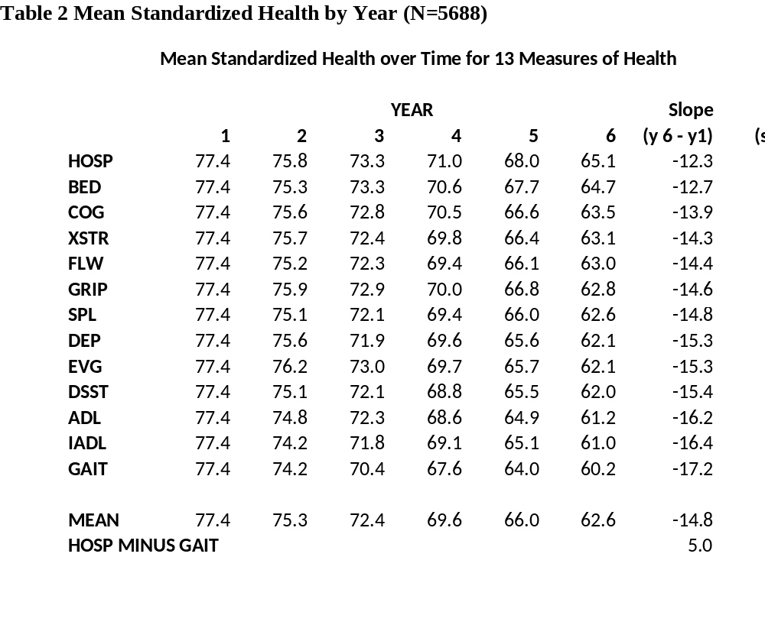
4.1 Consistency of ranks across different subsets of the data
Tables TR3 and TR4 in the technical report^{[10]} (not shown here) reported that the top 3 (least decline) and bottom 3 (most decline) variables were substantially the same whether the comparison was based on the entire sample or on subsets defined by age and sex. The top 3 and bottom 3 were also substantially the same if we looked at the 8-year change available in cohort 1 only (95% white), and if we looked only at the subset that survived throughout the study period. More detail about these assertions now follows.
Table 5 summarizes the results from tables TR2-TR4 in the technical report.^{[10]} It shows the ranks of the slopes for HOSP, BED, COG, ADL, IADL, and GAIT. For example, the ranks from Technical Report Table TR2 for those 5 variables are 1, 2, 3 and 11, 12, 13, as already noted. Table TR2 results are shown in the first line of ranks.
Technical Report Table TR3 showed the same information as Table TR2, but broken down by age and sex. For example column 1 of Table TR3 (which is not reproduced here) which contained the youngest females (F-young). Row 3 of Table 5 shows that for the youngest women, the ranks of those 6 variables were 1,3,2,11,12,13 (the ranks of BED and COG were interchanged). Table TR4 (not shown), which was restricted to persons who were alive at the end of the analysis, also showed similar but not identical results, as shown in Table 5. (For young females, the ranks of BED and COG were interchanged). In all of the rows of Table 5, HOSP, BED, and COG have low ranks, while ADL, IADL, and GAIT have high ranks. This indicates that results from the standardized data were relatively independent of age, sex, and mortality. The rank of COG was less consistent than the others, especially for the oldest persons.

Table 5
Ranks of slopes for 6 variables in different tables of tech report^{[10]}
 | HOSP | BED | COG | ADL | IADL | GAIT
Table TR2 | 1 | 2 | 3 | 11 | 12 | 13
Table TR3
F-young | 1 | 3 | 2 | 11 | 12 | 13
F-middle | 2 | 1 | 5 | 11 | 12 | 13
F-old | 1 | 2 | 4 | 12 | 11 | 13
M-young | 2 | 1 | 3 | 10 | 11 | 13
M-middle | 2 | 1 | 3 | 10 | 11 | 13
M-old | 1 | 2 | 3 | 11 | 12 | 13
Table TR4
F-young | 1 | 3 | 2 | 11 | 12 | 13
F-middle | 2 | 1 | 5.5 | 11 | 12 | 13
F-old | 1 | 2 | 8 | 11.5 | 11.5 | 13
M-young | 2 | 1 | 3 | 10 | 11 | 13
M-middle | 2 | 1 | 3.5 | 10 | 11 | 13
M-old | 1 | 2 | 8 | 10 | 11 | 13

4.2 Comparison with Different Standardization Methods
There was some concern that the results might be specific to the variable used for standardization (EVGGFP). We chose EVGGFP, because it was the strongest longitudinal variable in CHS. It was measured more often, and for a longer time period. (That was why we used EVGGFP to create X_tdie, as explained in sections 1 - 3). We could, however, have standardized by some other variable (a different Y) as long as it was monotonically related to all 13 of the study health variables. If the standard were completely uncorrelated with X, then the standardized X would take the identical value for every level of X, and be essentially a measure of mortality rather than of X. Therefore, it is desirable to have a significant correlation between Y and all the X’s.
We thought it likely that the same general study results would obtain under a different standardization. To see whether this was correct, we standardized the X’s in two additional ways, and performed the analysis of Technical Report Table TR2 ^{[10]} using the differently standardized variables. First, we standardized according to the probability of having no ADL difficulties (instead of by the probability of being EVGG). Second, we standard by age, substituting for each value of X the mean age of persons in the reference dataset who had that particular value of X.
Table 6 shows the transformed (standardized) value for the variable “Number of IADL difficulties”, under each of the standardization approaches. For example, column 2 shows the estimated probability of being in EVGG health. In the reference dataset, a person with 0 difficulities had an 84% chance of being EVGG, while only 27% of those with 6 difficulties were EVGG. (Dead was always coded as zero.) These are the values that were used in our study of decline ^{[9]}.
In column 3, Table 6 shows the values assigned to IADL if No ADL was used as the standard. These values indicate that, in the reference dataset, the probability of No ADL for a person with no IADL difficulties was 94% but for a person with 6 IADL difficulties the probability of no ADL was only 4.7%. The range of the scale (5 to 94) is larger than the range when EVGG was the standard (27 to 84).
Column 4 of Table 6 shows the results of age standardization, where each value of IADL was replaced by the mean age of persons in the reference dataset who had that IADL value. The mean age of persons with no IADL difficulties was 75.4, while the mean age of persons with 6 difficulties was 81.6. To further differentiate this standardization approach from the others, these means were estimated by linear (not logistic) regression of age on untransformed X (not log X), while the other two transformations/standardizations were based on logistic regression using the log of X. The value for “dead”, 82.6, was the mean age of all the records in the reference dataset where the person was set to “dead”. (Persons who died contributed a value to this mean for every year in the dataset when they were dead).

Table 6
Standardized values of IADL under three different standardizations
1 | 2 | 3 | 4
Standard: | EVGG | No ADL Difficulties | Age
# of IADL diffs
0 | 84 | 94.4 | 75.4
1 | 64 | 68.1 | 77.6
2 | 47 | 38.7 | 78.9
3 | 39 | 21.0 | 79.8
4 | 35 | 12.0 | 80.6
5 | 31 | 7.3 | 81.1
6 | 27 | 4.7 | 81.6
dead | 0 | 0 | 82.6

Figure 1 is a graph of the 3 sets of coefficients inTable 6. The X axis is the value of IADL (0-6 or dead). The lines for EVG and NoADL are fairly similar, especially for 0-2 IADL difficulties. In contrast, there is relatively little variation under the AGE standardization, primarily because age did not vary much with IADL. (Correlation of IADL with EVG was -.354, with NOADL was -.588, and with age was +.278).

Figure 1.
Graphs of Standardization Coefficients of IADLunder 3 different standardizations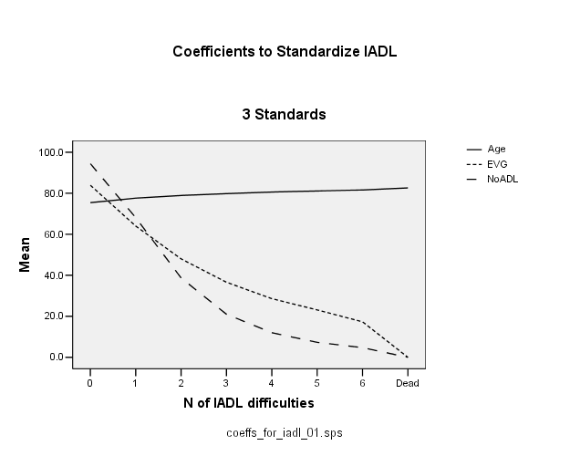
Table 6 and Figure 1 show that the standardized values of IADL are different if a different standard is used. This is not surprising, and is not a cause for concern. Our question here was whether the different standardization methods affected the results of the study.^{[10]} That is, were the relative rankings of the slopes over time for the different variables the same if a different standard was used? Table 7 shows the ranks of the top 3 and bottom 3 slopes from Technical Report Table TR2.^{[10]}
The rankings using EVGGFP as a standard (column 2) were identical to the rankings using ADL as a standard (column 3). (There were some differences in ordering among the middle ranks, not shown here).
When Age was used as the standard, the same 3 variables were in the top 3, but their ordering was changed slightly. For age, the bottom 3 had high ranks, but the very highest rank was for grip strength, which was not the highest under the other two standardizations. Therefore there was good consistency for the extreme rankings, but the rankings were not identical when different variables used for standardization. We show only the extreme rankings because the technical report ^{[10]} indicated that the less extreme variables were not significantly different from one another, and variation in their ranks would not be important here.

Table 7
Ranks of slopes for top 3 and bottom 3 variables, all cases, yr 1-6
(all persons, years 1-5)
1 | 2 | 3 | 4
Standard: | EVGG | No ADL Diffs | Age
HOSP | 1 | 1 | 2
BED | 2 | 2 | 3
COG | 3 | 3 | 1
ADL | 11 | n/a (the standard) | 12
IADL | 12 | 12 | 10
GAIT | 13 | 13 | 11
 |  |  | 13 was GRIP

Table 8 shows the same information as Table 7, but for cohort 1 only, for which there were 9 measurement times (year 1 plus 8 years of follow-up).^{[10]} The rankings are consistent with the main analysis for standardization by EVGGFP and ADL, but when age was the standard, DSST had rank 12.

Table 8
Ranks of slopes for top 3 and bottom 3 variables,
Cohort 1 only, years 1-9
1 | 2 | 3 | 4
Standard: | EVGG | No ADL Diffs | Age
HOSP | 1 | 1 | 2
BED | 2 | 2 | 3
COG | 3 | 3 | 1
ADL | 11 | n/a (the standard) | 10
IADL | 12 | 13 | 11
GAIT | 13 | 12 | 13
 |  |  | 12 = DSST

Figure 2 is a plot of the slopes under the 3 standardizations. The X axis indicates which variable the slopes are for (from HOSP at the left to GAIT at the right). (The slopes for X standardized by Age were multiplied by -10 to put them on approximately the same scale as the other two standard variables). The middle line is slopes of variables standardized by EVGG. The upper line is standardized by ADL, and the lowest standardized by AGE. There is strong agreement as to the variables with the highest and lowest slopes, but there were some discrepancies in the middle.
Therefore, we found that standardizing by self-rated health, ADL, or age had similar effects in identifying the variables with extreme slopes. Most of the differences among methods occurred for the intermediate slopes, which may not have been significantly different from one another. Standardization therefore allows conversion of disparately-scaled variables to the same scale, with generally consistent results regardless of the standard. In other words, the specific standard used may not be of great consequence. However, this needs to be verified in any analysis.

Figure 2
Estimated Slopes using 3 Standardizations 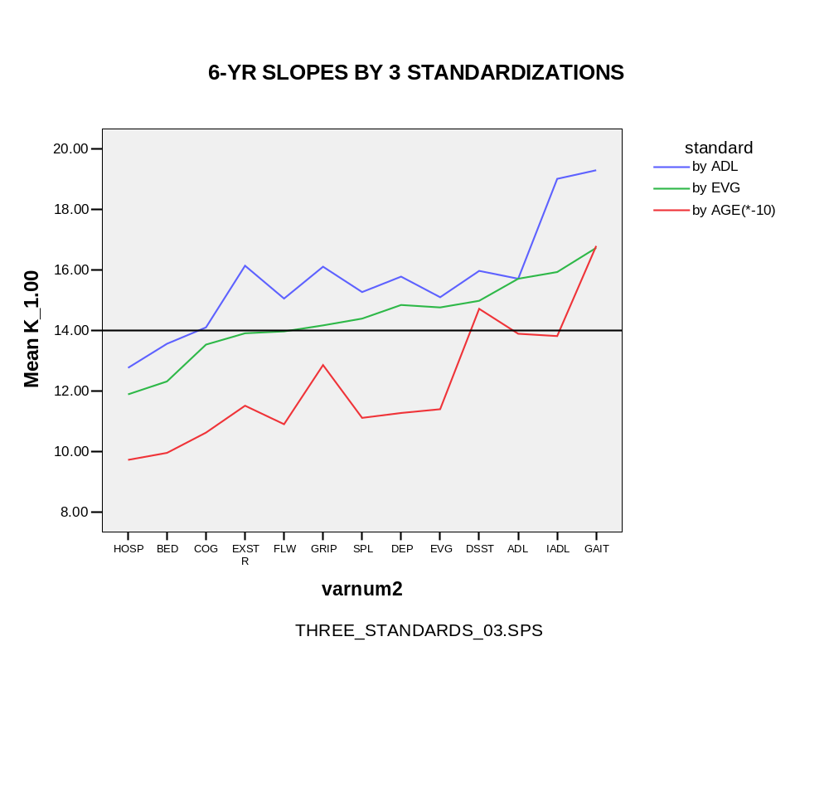
  - Features of standardized health
Standardized X is an estimated of the probability that a person in the reference dataset with a particular value of X is in EVGG health. It should be clear that standardized health based on (say) IADL is a value entirely based on a person’s IADL, and not on her EVGGFP at that time. In fact, standardized IADL is a poor estimate of an individual’s EVGGFP, which could be estimated much more accurately from her earlier or later values of EVGGFP. Standardized health refers to means in the reference dataset, not to an individual. Similarly, a person’s IADL standardized by age is not directly related to her actual age, but only to her IADL values.
Standardized variables tend to be more highly intercorrelated than the original variables, because of the inclusion of 0 for death which is the same for every variable. The deaths can be removed for this calculation by use of the status variable if this is a question of interest.
Standardization also creates a complicated type of dependence among the standardized variables. Consider a much simpler setting, in which the standardized values were calculated from a simple linear regression of Y on X (not logistic regression of Y on log X). A feature of linear regression is that the regression line passes through ( ). Therefore, the estimated value of Y at is . In standardization, we regress Y on all the X’s that are to be standardized. In each case, the standardized value of must be. Therefore, the standardized value of ₁ = standardized value of ₂, and so on. Standardization thus equates the mean of each variable on the original scale, setting the transformed mean of each original variable to .
Suppose we further assume that Y declines linearly over time (t). Then the value at will be . In our reference dataset, the average year is 1995.6. Therefore in 1995.6, y= , and (under monotonicity assumptions for all variables) the standardized values of all the variables will also by . That is, in a graph of mean standardized X over time (with deaths removed), that includes a separate straight line for each X, the lines should all intersect somewhere between 1995 and 1996.
This indicates that there is a constraint on the standardized X’s in that they all converge at . We should thus not be surprised to find that the means of the standardized variables are all approximately the same, any more than we would be surprised to find that z-scores of all the variables all had mean zero. Since 2 points determine a line, and the plots of all standardized variables over time must intersect at , the various lines can differ only in their slopes or, alternatively, in their intercepts. That is, there is only 1 degree of freedom in a comparison of slopes of different standardized variables.
This was a much simplified example. The actual graph of standardized X over time, shown in Figure 3, does not show a distinct intersection in 1995-1996. This is in part because we did not create the standardized variables using linear regression - we used logistic regression - and because Y and the X’s did not decline linearly with time. This simplified example was used only to motivate the existence of a constraint, and should not be taken literally.

Figure 3
Mean standardized health over time in reference dataset.
(deaths removed)
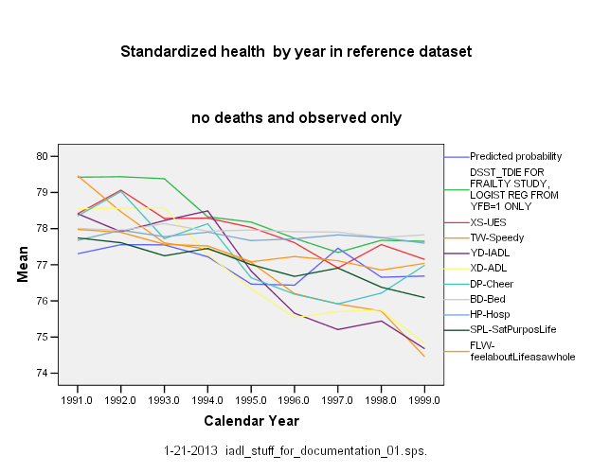

  - Discussion of Standardization
We proposed a method to standardize diverse health measures, recoding each value as the probability that a person with that value would be in EVGG health in the reference dataset. In the analytic example, we identified the three (standardized) variables that declined the most, and the 3 that declined the least. Subsetting the analytic sample by age and sex made little difference in the order of the rankings. Using the longer time range available for cohort 1 also made little difference in the findings. Standardizing by ADL or AGE instead of by EVGG gave strongly consistent results, but there were a few differences in the orderings of the slopes.
The standard should ideally have a significant monotonic relationship to all of the variables that need to be standardized. Age was less correlated with the health variables than were EVGG and ADL, which may make it less desirable as a standard. The standard can not itself be standardized, which suggests using a variable that is not crucial to the study goals as the standard. Given the importance of ADL in the aging literature, our choice of EVGGFP as the standard for the paper in the technical report^{[10]} seems reasonable.
Standardizing the health variables in this way worked well, in that the study findings were surprisingly robust. It may be wise, however, to consider more than one way of standardizing the variables as a type of sensitivity analysis, depending on the purposes of the study.
Standardization has some similarities to item response theory, which equates individual items based on the expected response of a person with a given underlying “latent health” status. We instead effectively equated variables according to expected self-rated health. For example, from Table TR1 in the technical report, having 2 bed days, having a 3MSE score of 60, feeling unhappy about life as a whole, being extremely unsatisfied with the purpose of life, or having a CESD score of 15 can be “equated” because they all correspond to a standardized score of about 50 (only about half the persons with those values were expected to be in excellent, very good, or good health). An item response analysis would not have accounted for death, and was not necessary for our purposes.
Variables are often standardized by turning them into z-scores. We did not do that here because the z-scores are still all estimates of different quantities, even though they have mean 0. In addition, the spaces between the different levels are the same on the original and transformed scales, while the method used here re-scales some of those differences to agree with differences in EVGGFP. Similarly, dichotomizing each variable to “healthy”/”not healthy” would still result in variables being estimates of different quantities.
  - Standardization of variables in a different dataset
Since the publication of the original paper ^{[9]} we attempted to use standardization on a different dataset, with less satisfying results. The dataset consisted of 6 depression scales, 3 general health variables, and 5 scales measuring quality of life. There was more variation in the results for different choices of the standard than in the study described here. We plan to continue to examine this dataset, to provide additional suggestions for use of the standardization method. Until then, the advice to conduct sensitivity analyses is strongly recommended.
5. Summary and Conclusions: the Tidy Dataset
Here we presented the approach used in the Cardiovascular Health study to create a “tidy” dataset, which has a separate record for every potential measurement. That record contains either the person’s observed value, a notation that they were dead at that time, or an imputed value in the data were missing at that point. Variables were first transformed to a new scale with integer/ratio properties, and on which “dead” takes the value zero. Missing data were then imputed on this new scale, using each person’s own data over time. Imputation was thus informed by impending death. The new transformed and imputed variable has a value for every person at every potential time, and accounts for death. It can also be considered as “standardized health,” permitting comparison of time trends for variables that were originally measured on different scales. The standardized variable can also be transformed back to the original scale, yielding missing values imputed from the person’s own longitudinal data and informed by impending death. Each observation is labeled as to whether it was observed, imputed (and how), or the person was dead at the time.
The resulting “tidy” dataset can be considered complete, but is flexible enough to permit analysts to handle missing data and deaths however they want. This approach may be useful for other longitudinal studies as well as for the Cardiovascular Health Study. Ideally, those datasets would have 3 or more measures per person, a low rate of missing data, and complete ascertainment of deaths.
References

Fried LP, Borhani NO, Enright PL, et al. The Cardiovascular Health Study: design and rationale. Annals of Epidemiology 1991. 1:263-276.
Diehr P, Patrick DL, Spertus J, Kiefe CI, McDonell M, Fihn SD. Transforming self-rated health and the SF-36 Scales to include death and improve interpretability. Medical care 39:670-680, 2001. (PMID: 11458132)
Diehr P, Johnson LL, Patrick DL, Psaty B. Methods for incorporating dath into health-related variables in longitudinal studies. J Clilnical Epidemiology 2005; 58:1115-1124.
Diehr P, Patrick DL, McDonell MB, Fihn SD. Accounting for deaths in longitudinal studies using the SF-36: the performance of the Physical Component Scale of the Short Form 36-Item Health Survey and the PCTD. Medical Care 2003; 41:1065-1073. (PMID: 12972846)
Kurland BF, Johnson LL, Diehr PH. Longitudinal data with follow-up truncated by death: match the analysis method to research aims. Statistical Science 2009; 24:211-222. (PMID: 20119502)
Kurland BF, Johnson LL, Diehr PH. Accommodation of missing data in supportive and palliative care trials. Curr Opin Support Palliat Care 2012;6.
Engels JM (Jean Mundahl), Diehr P. Imputation of Missing Longitudinal Data: a comparison of methods. Journal of Clinical Epidemiology 2003; 56:968-976. (PMID: 14568628)
Diehr PH, Lafferty W, Patrick DL, Downey L, Devlin S, Standish LJ. Quality of life at the end of life. Health and Quality of Life Outcomes. 2007; 5:51. (PMID: 17683554)
Diehr, PH, Thielke SM, Newman AB, Hirsch CH, Tracy R. Decline in health for older adults: 5-year change in 13 key measures of standardized health. J Gerontol A Biol Sci Med Sci. 2013 May 10. [epub ahead of print] doi:10.1093/gerona/glt038 5
Diehr, Paula H.; Thielke, Stephen M.; Newman, Anne B.; Hirsch, Calvin H.; and Tracy, Russell, "Decline in Health for Older Adults: 5-Year Change in 13 Key Measures of Standardized Health" (October 2012). UW Biostatistics Working Paper Series. Working Paper 385. http://biostats.bepress.com/uwbiostat/paper385.
McHorney CA. Equating health status measures with item response theory: illustrations with functional status items. Med Care. 2000;38(9 Suppl):II43-59.
Diehr PH, Derleth AM, McKenna SP, Martin ML, Bushnell DM, Simon G, Patrick DL, the LIDO group. Synchrony of change in depressive symptoms, health status, and quality of life in persons with clinical depression. Health Qual Life Outcomes 2006; 4:27.

