Solar PV for Coal

## **What is Solar Power?**

* Charged semiconducting material is sandwiched together with conductive wires
* Photons in sunlight hit the panels and negatively charged electrons are knocked loose in the semiconductor material starting a chain reaction

## **Types of Solar Power**

Major types of Photovoltaic (PV) panels

* Silicon
  + Monocrystalline Silicon
    - efficient but expensive
  + Polycrystalline silicon
    - less expensive and less efficient
  + Thin Film
    - Cadmium Telluride (CdTe) – Cheapest current option (First Solar) but not the most efficient
    - Copper indium gallium selenide (CIGS, can be CIS) (Solar Frontier) slightly more expensive than CIGS with good heat and shading properties

Concentrated Solar Power (CSP)

* Power Towers
  + Mirrors reflect sunlight at a boiler situated at the top of a tower
* Trough Technology
  + Parabolic troughs focus light on a liquid filled tube in the center of the trough
* CSP allows for the use of molten salt storage technology

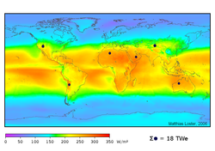

Global Solar Irradiation

* *Solar Panel manufacturing is increasing at an impressive pace driving installations*
* *Solar Panel prices have fallen significantly in the last 2 years*
* *High levels of uncertainty in adoption rates*

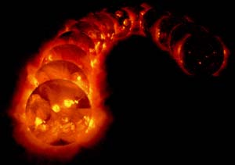

## **Quantification of Emissions Reduction**

* Installed Capacity is of minor importance
  + Production is key, driven by Net Capacity Factor (NCF) which is impacted by solar irradiation, heat, clouds and angle
  + Tracking mechanisms increase the NCF, but can also drive up costs
  + Installed Capacity (ac) x 8,760 hours x NCF = MWh (or kWh) production
* Sacolow and Pacala estimate need is 2,000 GW installed capacity or about 40 GW/yr
  + Estimate is about 25% to 30% NCF
  + This equates to 5.4MM GWh displaced by 2054 = 1 GtC
* Panels are produced DC, but need to be converted to AC to interconnect to electricity grids
  + Usually DC power is reduced to smooth power flow into the grid

Can we install enough solar energy to create a Socolow and Pacala wedge and save 1GtC by 2054?

## **Assessment of Wedge Feasibility**

*KEY FACTS*

* *US Energy Information Agency reports 41GW installed worldwide in 2010*
* *Solarbuzz lists about 20GW of manufacturing capacity in 2010 (85% utilization)*
* *10 Publicly traded solar panel manufacturers have 15GW capacity*

***EIA Estimates of Solar Installation (2005 – 2035) Extrapolated to 2055***



* EIA Estimates were used through 2035, with average growth (~8.8%) applied thereafter
* Only about 25% of a wedge is achieved
* *Solarbuzz reports 24GW pipeline in the US and 14 GW pipeline in China, significantly outpacing EIA estimates*

***The Market Approach:***

***Manufacturing Capacity Drives Growth***



* Baseline is 41GW worldwide installations in 2010
* Manufacturing capacity increases at 5% per year
* Utilization is 85%
* DC/AC ratio averages 1.2
* **Wedge is achieved!!!**

***Cost will drive the rate of adoption***



* Above graph represents 9 Publicly traded solar panel manufacturers
* Rev/watt = the price at which panels are being sold not MSRP
* Cost/watt = cost of goods sold listed by manufacturers
* Dramatic price declines in 2 years
* First Solar is the cost leader and estimates cost/watt of $0.56 by 2014
* *Continued cost reductions may be at risk as US solar manufacturers allege Chinese dumping, US may file with WTO*