Article VII. Density separations
We use two popular heavy liquids: the brand name LST (a lithium metatungstate) and diiodomethane (also known as methelyene iodide, MI or MEI, for short). LST is water-soluble, very expensive ($1,659/liter), and non-toxic. MI is soluble in acetone, insoluble in water, slightly less expensive ($1,193/liter), and highly carcinogenic/mutagenic/toxic. We only have one fume hood in our lab, it should only be used by one individual, doing one separation at a time. There are other hoods in the Petrography Laboratory on the 4th floor. We also have a system for letting everyone know what is in the hood: sticky-notes. Use them, love them. Never leave toxic chemicals open and ventilating in the hood without a sticky-note identifying them.
There is a hotplate in the hood for distillation. Leave this unplugged when not on, and a sticky-note to let others know if it is on. Never use acetone/ethanol/methanol in the hood when the hot plate it on, these are highly flammable liquids.
As both of these liquids are very costly, you will need to recover as much of the liquid as possible after your separation. If you have never worked with heavy liquids before, have someone with experience nearby when you first begin; and work slowly and deliberately. Don’t leave open flasks of pure LST/MI sitting in the hood, as they may be knocked over/contaminated/dry up. MI is photosensitive, and will turn dark if left in open light for extended periods of time. When not in use, store MI in a tinted bottle in or below the hood in the bottom of the “Corrosives” cabinet.
A lab coat and latex gloves are suitable for LST. You will need the long neoprene gloves to work with MI; goggles and sleeves are gauche, but also recommended. Use both liquids in the fume hood. Note that the MSDS sheets for all of these chemicals are readily available in the top drawer nearest the sink.

If you spill MI:
- tell everyone to leave the lab ASAP, and call UW’s Enviornmental Health and Safety (EH&S, number on pamphlet near door).
- open the spill kit beside the sink, don the respirator and with the long gloves on use acetone to clean up all traces of the fluid.
3. put all contaminated materials in the hood (including clothing, if you spill on the lab coat or on your pants/shoes),
4. close the hood and wait for EH&S.

If you spill LST:
- wearing gloves, soak up the liquid with a kimwipe and a little DI water, wait for the area to dry then wipe it down again with more DI water.
- throw the the kimwipes away in the large 2 liter beaker in the back of the hood. This is periodically washed to extract the LST for distillation.

LST
Check to see that the feldspar and quartz crystals are both floating in the LST. The quartz has a density of 2.65 g/cc; feldspar is a little less (2.55-2.63). Carefully pour a little LST (~60 mL) into a 100 mL graduated cylinder. Carefully place the hydrometer (also very expensive!) inside the graduated cylinder and slowly lower it until it is floating on its own, do not drop it into the cylinder as it will crack. Record the density of the LST by watching where the meniscus crosses the labeled scale inside the hydrometer (it should be > 2.7, never higher than 2.85). If the density is < 2.7; pour it into a ~500 mL beaker and place it on a “warm” hot plate, use LST Calc to calculate how much liquid you need to lose to achieve a density > 2.7; if the density is > 2.8, use LST Calc to calculate how much DI water to add to bring the density to 2.75. Only use the LST if the density is 2.7-2.8, the nearer 2.75, the better.
Periodically LST will react with carbonate/magnetite in samples and will cloud/turn funny colors. Add 1 mL per 100 mL LST of Hydrogen peroxide (30% strength, available in the Corrosives cabinet upstairs in the Petrology Lab, only use this chemical in a fume hood and wear long gloves and eye protection when handling it), and swirl until the color returns to a mild-straw color.

- Clean all working surfaces in the hood. Weigh the sample material you will be separating (no more than 200 g (100 g is best). Record the samples and their masses in the lab notebook.
- Set up a separatory funnel for each separation you want to do. Set aside two 500 ml vacuum flasks clearly labeled “waste” and “pure,” two ceramic Buchner funnels with rubber casings, and one small 250 mL beaker. Put a 1 liter beaker on the hot plate; leave the hotplate off. Fold 2 large qualitative filter papers over an upturned 250 mL beaker, and fold around the edges so that the folded papers fits snugly in the ceramic filters, label each paper with the sample number; then one with the LST density and an up-arrow; one with the same and a down arrow (this is for float and sink separations, respectively). Make sure all glassware is clean (i.e. rinsed with DI water, and wiped with a kimwipe/Acetone).
- Make sure the separatory funnel valve is in the “closed” position, with a vacuum flask/Buchner funnel/filter paper set up beneath it (see figure 1). Carefully pour LST into the separatory funnel, filling to the inflection point of the glass (there is sometimes a black line here to mark it). Try not to splash LST onto the upper sides of the glass.
- Slowly pour sample material into the separatory funnel, while rotating the funnel to evenly lay grains across the top of the liquid. Insert a metal stir rod into the mixture and stir until the sample clouds the liquid. Retract the stir rod slowly to minimize the amount of grains sticking to it, let it drip twice; rinse it off with DI water into the small 250 ml beaker, and set it aside.
- Wait 20-30 minutes, or until the sample has clearly separated into a “sink” fraction and a “float” fraction. The liquid will not be completely clear, but make sure there is, at a minimum, a clear sink fraction boundary. Use this time to rinse the hydrometer and graduated cylinder with DI water, pour off DI/LST into the “waste” beaker on the hotplate. Get in the habit of cleaning up after yourself (all kimwipes used to clean up go into the 2L beaker in the back of the hood). Enjoy some public radio.
- Once the grains have separated and there are reasonably clear “sink” and “float” fractions, reinsert the stir rod and stir the float fraction again, being careful not to agitate the sunk grains, make sure to get all the grains that may be stuck to the side of the glass. Stopcock the separatory funnel and wait until the grains have separated again (maybe another ~20-30 minutes).
- Once the grains have separated again, it is time to drain the sink fraction. You should leave the stopcock in to reduce the flow rate out the bottom of the separatory funnel, however be aware that if the slow stops you need to quickly close the valve and gently remove the stopcock to prevent a bubble from welling upwards and disturbing the grains. Make sure the “pure” flask/”> LST” filter combo is beneath the funnel, and attach the vaccuum hose to the vaccuum flask, turn on a mild vaccuum. Gentle open the funnel valve to allow the sink fraction to flow out the bottom of the funnel. The flow begins slowly but abruptly speeds up once the sink fraction is removed. So watch out! You need to close the valve quickly once the sink fraction has completely removed. Once you do this, wait a few minutes for any more dens grains to settle; and then also include them.
- The vaccuum should have filtered the LST through the grains and into the flask*, when the grains look dry, quickly replace the “> LST” filter/buchner funnel with the “< LST” filter/buchner funnel on top of the “pure” flask, so as to avoid any drips from the separatory funnel. The “> LST” filter/buchner funnel can rest for a minute on the “waste” vaccum flask. Remove the stopcock and repeat the draining procedure, using the valve to simply keep the flow of LST/ floating grains low so that the “< LST” filter does not flood. If the buchner funnel/filter paper won’t drain. This occurs if the LST is near 2.85 g/cm3 and the liquid begins to crystallize in the funnel, clogging it. Or if there is lots of very fine material still in the grains (silts, mainly) that were not properly removed during wet sieving, that coat the filter paper, making it impermeable to water. To treat the first issue: simply lift up the side of the filter paper, and add a little DI water to unclog the funnel (this means you will have to distill the “pure” LST afterwards). To treat the second issue, you need to make another filter paper and pour the LST/grains into it to allow the LST to drain. Then when washing the grains, you also wash the original filter paper.
- Let the separatory funnel drip for a few minutes, and wait until the grains remaining in filter looks dry. There will still be “float” grains in the separatory funnel… don’t worry about them right now. While you are waiting, hook the vaccum tube (still under a mild negative pressure) to the “waste” flask with the “> LST” filter/buchner funnel on top. Use DI water to gently rinse the grains a minimum of three times, or until you notice the water dripping from the buchner funnel into the flask to be clear. You are washing the LST off of the grains; as LST is water-soluable, you can accomplish this by simply dousing the grains in water repeatedly and sucking the water through the filter paper. When the grains are clean and dry, remove the filter paper and let it sit under the lamp to dry completely.
- Return to the now-done-dripping separatory funnel. Once the “float” grains in the filter are dry, replace the “pure” LST flask with the “waste” LST flask; and set the “pure” LST flask aside for the next separation. Keep the “< LST” filer/buchner funnel in place. With the valve closed, rinse the inside of the separatory funnel thoroughly, making sure to get all of the grains off the glass, settled in the bottom of the funnel. Open the valve and let the rest of the grains drain into the filter, keeping a mild vaccum on the underlying “waste” flask. Use DI to wash the rest of the inside of the funnel, and let it drip dry. Use DI to wash the remaining “float” grains in the filter paper, as you did with the “sink” grains. Once they are clean and dry, remove the filter paper and place it beside the “sink” fraction under the lamp to dry completely. Wash all surfaces that touched LST again with DI water, capturing all the DI in the large “waste” beaker on the hotplate, this should now be nearly full.
- Turn on the hotplate to ~100-150C to begin distillation of the LST; NEVER distill LST at temperatures above 200 C.

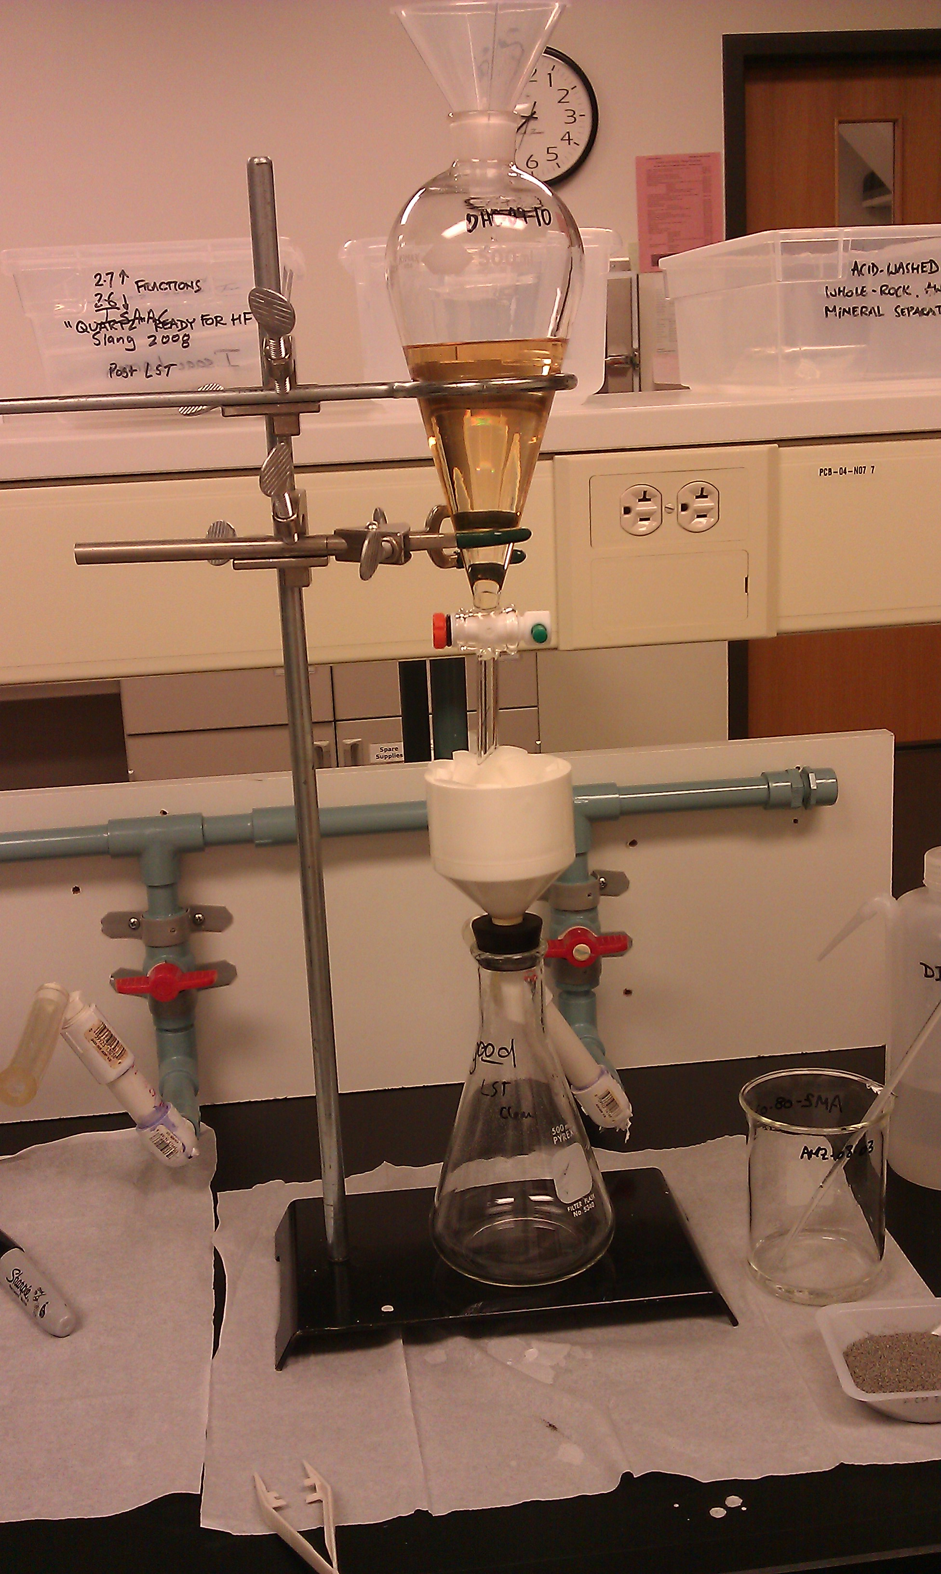
LST vacuum flask properly set up in John Stone’s lab.

Reclaiming LST

To restate: do not cook the LST at > 150-200°C; particularly if it will be cooking for long periods or overnight. It is possible to “burn” the LST. If you cook it down to a crystalline solid (which should be avoided at all costs!), and heat the solid above ~150°C, it turns white and insoluable, then black. It is possible (but difficult) to gradually dissolve this solid in DI water, but the resulting heavy liquid is usually darkened. To lighten the color of the liquid, add hydrogen peroxide as previously mentioned.

- When the “waste” liquid has distilled back to the straw color of the pure LST, test the density of the liquid with a hydrometer, and add it back to the “pure” liquid (if any is remaining) in the Pyrex glass with the blue top and quartz/feldspar crystals inside. This may require repeated measurements, and with time you will learn to judge when the LST is completely recovered. Do not manipulate the LST in any way while it is hot, let is cool completely before measuring density (as density is a f(T)).
- When the 2 L trash bin in the back of the hood is full; pull it out and pour enough DI water to completely soak and submerge the trash. Put on long gloves and manually squeeze the water through the papers, this is kind of fun. Be careful not to spill the waste-water or push too hard down on the 2 L glass; as it will break and cause a huge mess. Pour off the waste water into the “waste” beaker on the hotplate for distillation. Repeat this three times, and then squeeze down the wet papers and leave them in the 2 L beaker in the back of the hood. Distill new “waste” water as in previous, you will only get a little LST from this exercise.

MI (aka MEI, Metheleyne Iodide, Diiodomethane)

Double latex and thick gloves and sleeves over lab coat, eye protection. Be aware of location of spill kit.

- set up separatory tubes in rack over paper, label samples in each tube on paper clearly.
- test MI density in small graduated cylinder with small hydrometer: should be ~3.3 g/cc, record density.
- pour MI into each tube, about ~⅓-½ of the way full.
- pour in sample on top of inner tube, trying to keep grains from sticking on side of inner tube. mix well with thin metal stirrer. Do not add > 3 gm at a time!
- allow zircons to fall out of sample, mix again to make sure it is a complete separation.
- rinse stirrer w/ acetone over single 1 L waste flask w/ filter in small funnel.
- once grains have separated complete, one by one: plug the inner tube with a glass stir rod and pull out of outertube, the light minerals should stay in the MI in the innertube. remove stopper and allow pure MI and light grains to flow out the bottom of the tube into a funnel over the tinted glass “MI” bottle.
- Once the light grains have stopped dripping, wash grains thoroughly (thrice, with three different filter papers) with acetone over waste flask. Let light grains dry outside the hoof on a clean, labeled sheet of paper on a tray.
- repeat with new filters and with heavy grains remaining at the bottom of the outertube.
- repeat with the rest of your samples.
- rinse all tubes thoroughly (three times minimum) with acetone over the MI waste flask, and then again in sink with soapy water.
- You will have a full (or nearly so) large flask of acetone+MI. Let the acetone evaporate in the hood over ~1-3 days. Once is it mostly evaporated, pour the waste MI into the plastic “waste MI” bottle.

Store all contaminated MI waste (filter papers, kimwipes, gloves, etc.) in a gallon Ziploc plastic bag. When complete, put this plastic bag in the bucket in the “Flammables” cabinet. Request a hazardous chemical pick-up when this is full (ask Karl).

