O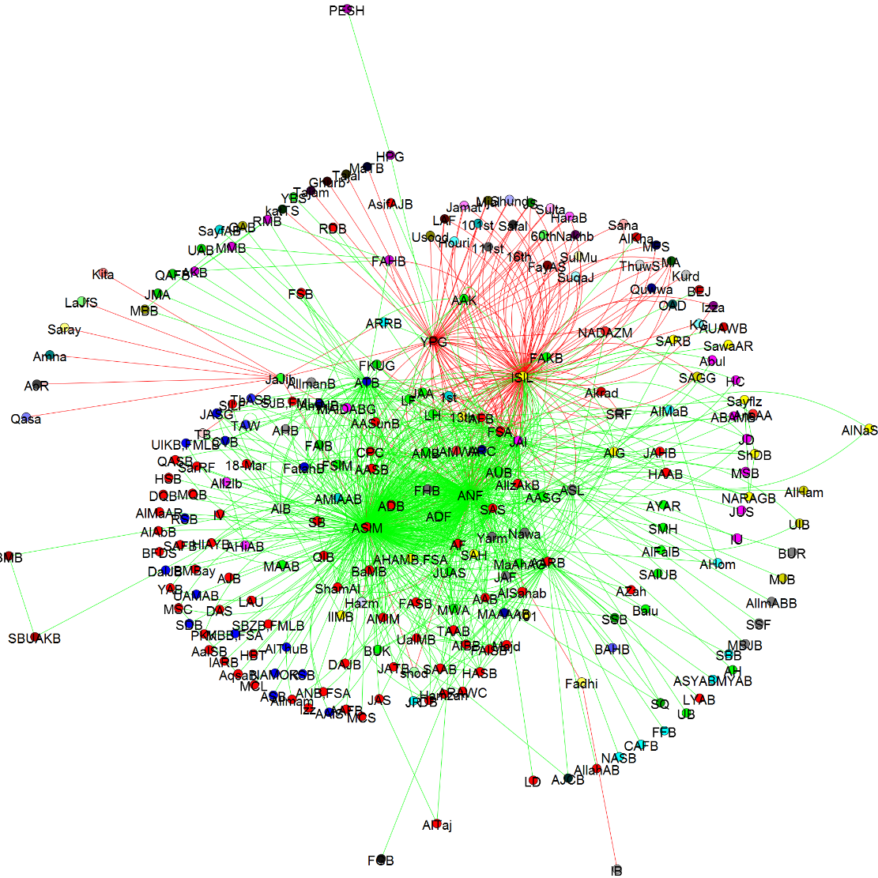

OK, this takes a bit to setup but it’s pretty nice. My son Chris put it together. The data are from a project Emily Gade is working on.
In computing, a ‘graph’ is relationship between data items. The data for a network graph are just three columns in a .csv file, the two nodes and the edge value (if no edge, no case).
Above is a ‘plot’ of graphs. In this case the dots or nodes are terrorist organizations. The lines or edges indicate a relationship. An edge can be based on anything – for example whether one website links to another or whether one organization posts something positive or negative about another organization. green is a positive relationship (the edge value is 1) and red is a negative one (the edge value is negative). The thickness of an edge can also indicate the frequency of a relationship.
The colors of the nodes indicates groups based on one of the grouping functions available in IGraph. The organizations closer to the center have more relationships – this ‘centrality’ is an important measure in network analysis. We see here are a large number of isolated groups and a smaller number of highly connected groups.
The Louvain version of IGraph available in Python. It is superior to the R version (faster with more options). To get up and running, we need to:
Go to your command line and
- pip install python-igraph
- pip install louvain (after downloading and executing the package from here: https://pypi.python.org/pypi/louvain/)
- Pip install tqdm
- Download the graphs folder at faculty.washington.edu/jwilker/559/graphs
- Locate folder wherever you normally access your python files
- Open spyder (or whatever)
- Open graphs/scripts/group_relationships/pickle_graphs.py
- Run it. If you get an error, run it again (should work the second time).
- If it doesn’t run, could be a ‘PythonPath’ problem. You need to set a PythonPath to the directory where the graphs folder is located
Pickle_graphs.py creates three different plots drawing from the three csv files located in graphs/lib/group_relationships. If you had your own csv graph files, just put them in there and update the file names in those two files.

