June 2000  Volume 64 | Number 6
Management of the Difficult Intubation in Closed Malpractice Claims
Carolyn G. Miller, M.D.

In order to assess and minimize adverse outcomes related to airway management, ASA developed the Task Force on Management of the Difficult Airway. This task force then produced the "Practice Guidelines for Management of the Difficult Airway." It is stated that the "purpose of these guidelines is to facilitate management of the difficult airway and to reduce the likelihood of adverse outcomes."¹ This was approved by the ASA House of Delegates on October 21, 1992, and became effective July 1, 1993. The difficult airway algorithm produced by this effort can now be found in essentially every anesthetizing location in use today. [Figure 1]
Difficult airway management can have a tremendous impact on patient outcome as well as the anesthesia care provider. In order to assess the management of tough airway scenarios, the ASA Closed Claims Project created a supplemental difficult airway data collection form that focused on the principles of the ASA difficult airway algorithm. At present, there are 98 closed claims from 1987-95 involving management of a difficult airway for which this data form was completed. As there is generally an average of five years between the actual event and the claim reaching the ASA Closed Claim Project database, nearly all of these 98 cases took place prior to the formal adoption of the ASA difficult airway guidelines. However, the presence of these guidelines did not change what was (and is) considered to be the standard of care in the management of the difficult airway. We therefore reviewed the management of these cases as described below.
Overview of Claims for Difficult Intubation
Airway management comprises a significant aspect of professional liability to the anesthesiologist. The ASA Closed Claims Project database demonstrates that difficult intubation is the second most frequent primary damaging event leading to anesthesia malpractice claims. It is responsible for 6.4 percent of 4,459 claims in the closed claims database [Figure 2]. Not only does difficult intubation lead to a significant proportion of claims, the severity of outcome can be devastating. Brain damage or death was the outcome in 57 percent of the 283 claims involving difficult intubation, compared to an incidence of 43 percent in all other claims (p <0.01) [Table 1]. Despite the severity of outcome, there is essentially no difference in the total payment amount resulting from claims involving difficult intubation as opposed to all other claims. The median payment for claims due to airway difficulties was $135,000, compared to a median amount of $100,000 for all other claims.
Figure 1: Most Common Damaging Events
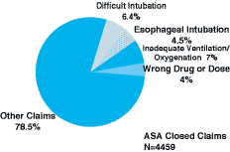
There are, however, some interesting demographic differences between claims involving difficult intubation compared to all other claims. While females tend to account for a similar majority in both airway and all others (62 percent and 60 percent, respectively), the patients in claims involving difficult intubation are significantly sicker and older (44.65 versus 40.67, p <0.01). Forty-one percent of difficult intubation claims were judged to be classified ASA III-IV as opposed to 29 percent of all other claims (p = 0.002). In addition, obesity was a factor in 31 percent of difficult intubation claims, compared to 14 percent of all other claims (p <0.01).
The quality of care was judged to be less than appropriate in a significantly higher proportion of difficult intubation claims as opposed to all other claims (49 percent versus 39 percent, respectively, p = 0.001). However, it has been demonstrated that the permanence or severity of outcome can affect the judgment of appropriateness of care.² Since claims involving difficult intubation are more likely to have a permanent adverse outcome (brain damage or death), these are therefore more likely to be judged to have less than appropriate care.
Claims with Supplemental Data on Airway Management
Figure 3: Airway Management Problems in
Claims Anticipated Versus Not Anticipated
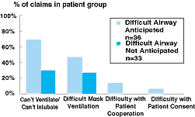
The ASA difficult airway algorithm begins with the assessment of the "likelihood and clinical impact of basic management problems." We found that a significant proportion of claims resulting in difficult airway management had virtually no preoperative assessment. A preoperative airway history was not conducted in 25 percent of these claims. This history includes but is not limited to:
1) prior airway difficulty,
2) congenital or acquired coexisting disease states and their progression/management and
3) prior surgical procedures and anesthetics. In addition, a physical examination was not conducted prior to initiation of anesthetic care in 22 percent of these claims involving a difficult airway. Difficulty surrounding any aspect of the airway management was anticipated in only 52 percent of the claims (e.g., suspicion of a difficult intubation, mask ventilation, patient cooperation, consent or an unspecified difficult airway management issue). Thus, there was no anticipation of any difficulty regarding the management of the airway in nearly half (48 percent) of these cases. Of those that did anticipate some difficulty (n = 36), inadequate patient cooperation or consent only contributed to 11 percent of the claims.
Inability to mask-ventilate occurred in 37 percent of the 98 difficult airway claims. Patient consent and/or cooperation was troublesome in 7 percent of cases [Figure 3]. Once the management of the airway was established as challenging, what types of strategies were employed? Repeated nonsurgical intubation attempts took place in most cases. None of these nonsurgical attempts included the laryngeal mask airway (LMA), as most closed claims predate the widespread use of this device in anesthesia practice. The techniques utilized and their corresponding frequencies are listed in Table 2. There is, however, no information available regarding whether regional anesthesia, local anesthesia or monitored anesthesia care (MAC) was a viable alternative or appropriate management in any more than 2 percent of cases.
In the situation in which the anesthesia care provider predicted a difficult airway, 28 percent of the claims (10 of 36) contained no explicit information about a preformulated strategy for management of the airway. Of the claims that reported a specific plan, various options for airway management were considered prior to the start of anesthesia. In two-thirds of cases, an awake nonsurgical intubation was planned, 25 percent planned an awake surgical airway (tracheostomy) and 25 percent planned an induction with the ablation of spontaneous ventilation followed by intubation. As these percentages suggest, the providers may have prepared for several alternatives of airway management.
The frequency of management strategies in claims with anticipation of a difficult airway is displayed in Table 3. The most common management strategy was persistent nonsurgical attempts. Of note, closed claims reviewers considered most of these repeated attempts to be inappropriately persistent. Again, it should be noted that the LMA was not a common option when these claims occurred.
An emergency situation (defined as "cannot intubate and cannot ventilate") was reported to occur in nearly half of all 98 claims in which difficult airway management data were available. In the 36 cases with an anticipated difficulty, 69 percent of cases (25 of 36) evolved into a "cannot intubate and cannot ventilate" situation [Figure 3]. A definitive airway was eventually secured in 79 percent of all 98 reported claims. In the claims involving an anticipated difficulty, 89 percent of cases succeeded in securing an airway. Help was either not called for or was unavailable in 7.5 percent of all claims. Of the claims with an anticipated difficulty, help was either not called for or was unavailable in just one claim.
In all of these closed claims involving a difficult airway, an extubation strategy was preformulated where appropriate for over half of the cases. Seventy-six percent of these reported cases had follow-up care or documentation by an anesthesia provider. These included, but were not limited to, a note in the patient chart documenting the presence of a difficult airway, a note documenting the management of the difficult airway, patient and/or family informed of difficulties encountered in airway management and surveillance conducted for airway complications.
Conclusion
All 98 cases took place prior to the adoption of the "Practice Guidelines for Management of the Difficult Airway" and the "ASA Difficult Airway Algorithm." The intent is to continue to analyze these data as they exist both before and after the acceptance of the guidelines. It is hoped that the advent of the difficult airway algorithm will serve to decrease the incidence of adverse outcomes and malpractice claims by improving the assessment and management of difficult airways when they arise.
Claims involving airway management comprise an important aspect of the ASA Closed Claims Project database. Difficult intubation is the second most common damaging event leading to malpractice claims. Despite no significant difference in payment amount, the outcome involving a difficult airway is significantly more likely to be judged severe and permanent (brain damage or death). It is somewhat disconcerting that the anesthesia care provider reported no anticipation of difficulty surrounding the airway management in nearly half of all claims reviewed here. This may reflect the fact that methods of predicting a difficult airway are not particularly sensitive.
Closed claims analysis cannot yet evaluate the effect of new airway management tools such as the LMA on anesthesia liability arising from airway management problems. Perhaps with the acceptance of the ASA algorithm and its emphasis on preoperative assessment and management techniques, fewer injuries arising from management of the difficult airway will occur.
References:
1. Practice guidelines for management of the difficult airway: A report by the American Society of Anesthesiologists task force on management of the difficult airway. Anesthesiology. 1993; 78:597-602.
2. Caplan, RA, Posner, KL, Cheney, FW. Effect of outcome on physician judgments of appropriateness of care. JAMA. 1991; 265:1957-1960. Fi

Figure2
1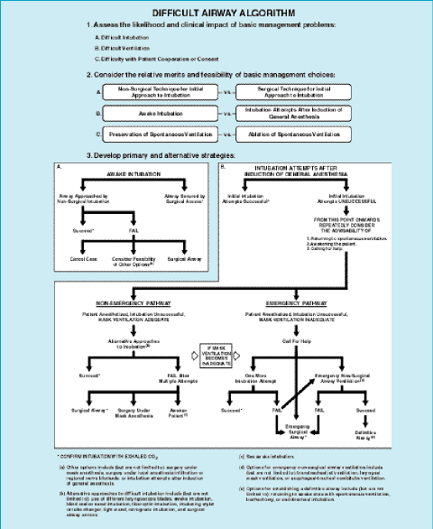
Table 1: Outcomes
 | Difficult Airway  Claims  (n=283) | Other  Claims  (n=4,176)
Death | 131 (46 percent) | * 1293 (31 percent)
Brain Damage | 31 (11 percent) | 504 (12 percent)
Airway Injury | 97 (34 percent) | * 169 (4 percent)
Aspiration | 19 (7 percent) | 139 (3 percent)
"p"0.01

Table 2. Techniques attempted in all difficult airway claims regardless of predicted difficulty
Management Strategy | Frequency
Persistent nonsurgical attempts | 77 percent
Surgical airway attempted | 29 percent
Case canceled | 13 percent
Return to spontaneous ventilation | 12 percent
Patient awakened | 11 percent
Proceed under mask GA | 6 percent
Change to regional, local or MAC | 2 percent

Table 3. Anticipated Difficult Airway: Management Strategies
Management Strategy | Frequency
Persistent nonsurgical attempts | 69 percent
Surgical airway attempted | 36 percent
Case canceled | 6 percent
Return to spontaneous ventilation | 6 percent
Patient awakened | 6 percent
Change to regional, local or MAC | 6 percentr

