REMOTE-SENSING ESTIMATION OF BATHYMETRY AND CURRENTS IN A TIDAL INLET

Rob Holman and Jim Thomson

Keywords
Bathymetry, wave celerity, remote sensing, Argus

0. Abstract
A method is proposed and tested for the simultaneous estimation of bathymetry and vector tidal currents based on optical remote sensing time series data of wave propagation and a rough estimate of the local tidal elevation from nearby tide predictions. Bathymetry is found using the linear dispersion relationship but with the inclusion of Doppler corrections due to the opposing or following components of tidal currents. The problem introduces sampling challenges but can be aided through the addition of a priori assumptions about the nature of time-varying tidal signals including a magnitude difference from predictions and the unknown phase between currents and tidal elevation. Initial tests based on a three-week field experiment at a complicated tidal inlet domain at New River Inlet, NC, show that the method yields some good results but will require further study before becoming operational.

- Introduction
The ability to make accurate predictions of nearshore dynamics requires not only a good model that captures the relevant physics but also knowledge of the bathymetry and wave and current forcing at the model boundaries. For most applications, the component that is most likely to limit prediction accuracy is the availability of bathymetry since traditional survey methods are tedious, dangerous and expensive and since dynamics, particularly wave dissipation that drives circulation, is quite sensitive to bathymetric details.
This data starvation problem has led to a long series of research efforts into remote sensing methods that would allow low-cost enduring measurements of changing bathymetry, for example by observing wave celerity and determining depth using the wave dispersion relationship. For example, a recent paper by Holman et al has proposed a three-step optical algorithm called cBathy that seems robust to optical clutter, rain, fog and other common complications and yields bias and rmse errors of 0.19 m and 0.51 m, respectively over a two year, sixteen survey test at Duck, NC. This approach ignores currents but is still applicable for sites where currents are small compared to wave celerity (i.e. most open ocean sites where the dominant wave periods are not short) or where currents and wave propagation have only a small co-linear component. The latter is true on most beaches where longshore currents are orthogonal to typical shoreward wave propagation but can be false in the immediate vicinity of rip currents.
In tidal inlet environments, wave propagation is often parallel to tidal currents and celerity can be significantly affected by ebb and flood flows, introducing errors in simple bathymetry estimates that must be corrected by allowing a Doppler term in the dispersion relationship. These adjustments are theoretically simple, but the adjustments to the cBathy algorithms involve a number of signal processing complications that must be tested. It is the goal of this paper to propose and test an adjusted cBathy algorithm that will allow simultaneous estimation of bathymetry and currents.
It should be noted that successful remote sensing solutions to the dispersion relationship, including the effect of currents, have been published before , based on 3D FFT analysis. This method works well in regions with fairly homogeneous depths but requires analysis tile sizes that are large, so incompatible with the spatial variability seen in nearshore bathymetry.

- Algorithm Modifications
The full linear dispersion relation that accounts for the Doppler shift associated with currents can be found in the standard literature and is given by
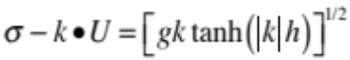 (1)
where σ and k are the radial frequency and vector wavenumber, U is the vector mean current, g is the acceleration due to gravity and h is the depth. Holman et al neglected the Doppler term 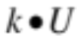 for the open beach test cases since currents and waves are typically orthogonal so the dot product equals zero.
The cBathy analysis algorithm is well described in the paper and includes three phases. The first phase involves the robust estimation of the vector wavenumbers for each of a sequence of candidate frequencies for each of a large number of candidate locations in a grid that will eventually become the depth locations of the resulting bathymetry map. Wavenumber estimation involves fitting a simple progressive wave model to the normalized cross-spectral matrix in a data tile that surrounds each analysis location. The second phase involves estimation of a single depth that best fit the resulting suite of f-k pairs while the third phase uses a Kalman filter to objectively smooth these estimates through time using time-dependent error estimates produced by the algorithm. The final phase three results were found to compare very well with ground truth surveys for both an extensive set of sixteen surveys at Duck, NC and for a single survey under the lower-sloping conditions on the Oregon Coast.
In the presence of co-aligned currents, the Doppler term will change the relationship between frequency, wavenumber and depth (equation 1). The magnitude of the change can be found by re-writing the equation to solve for depth, h:

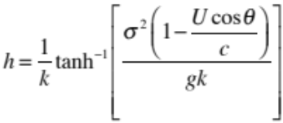 (2)

where we have simplified the dot product by defining an angle θ as the difference between the wave angle of propagation, α and the direction of the current, γ , i.e. θ = α+π-γ, where the π is required because the wave angle, α, is considered to be a “from” direction. In the absence of currents, the relationship simplifies to the standard dispersion relationship and depth is related to frequency-wavenumber pairs through the hyperbolic tangent relationship. When currents are present, this relationship is modified in proportion to the ratio of the propagation-directed current, 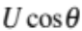, to the celerity c. Given that typical current magnitudes are 1 m/s, the effect will be negligible for open ocean waves in non-shallow water but will become significant in shallow water, especially for short period, slower waves motions.
The goal is to estimate not only bathymetry, but simultaneously the two vector components of the current (or equivalently, U and γ). The input data available for this estimation are estimates of wavenumber, k, and wave direction, α, for each of a suite of analysis frequencies, σ. Several issues quickly become evident. First, it is apparent that we can only learn about the component of the current in the direction of wave propagation. To estimate the vector current will therefore require the presence of a variety of wave directions. Second, the isolation of the effects of currents on observed celerity from the effects due to depth will require some independent information in the correction terms Ucosθ/c. This can be either the inclusion of frequency dependent celerities (i.e. they cannot all be non-dispersive shallow water waves), or the inclusion of a variety of wave angles. In cases where there is no variability in wave angles due configuration limits on approaching waves, separation of depth and current effects can rely only on the frequency-dependence of celerity and sampling likely must include high frequency (non shallow water) waves with short wavelengths that may be hard to adequately sample.
These issues make adequate sampling for any particular estimate challenging. Thus, achieving a stable estimate requires increasing the number of degrees of freedom in some way. For steady or slowly-changing currents, estimates can be merged using a Kalman filter or a similar smoothing method. Alternately, if the currents are tidal in nature, advantage can be taken of the relatively predictable nature of tidal oscillations.
Usually tidal elevation can be predicted with good accuracy and its contribution to water depth subtracted to yield bathymetry relative to a stable datum. However associated currents are less predictable, especially in a complex tidal inlet domain. For simplicity, we will assume that the magnitude of the tidal currents is proportional to the tidal sea level deviation from mean water and that the phase lies somewhere between in phase and quadrature, depending on the dynamics of the local tidal regime. Thus, if we assume that the tidal elevation is given locally by

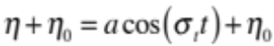 (3)
where η₀ is the offset between mean tide and the local bathymetry datum, then the current would look like

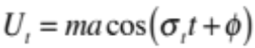 (4)

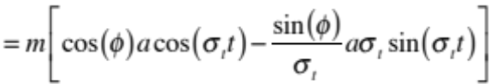 (5)

where σ_{t} is the tidal radial frequency, m is a magnitude adjustment of tidal amplitude compared to the reference location and φ is the phase difference between the tidal elevation and current. From this it is clear that we can simply model the vector tidal velocity as
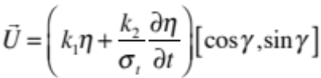 (6)
so that we need only need measurements or predictions of tidal elevation and its derivative to find a reasonable approximation tidal currents. Recall that the required tide for this calculation must have zero mean.
With these assumptions, we need to solve for k₁, k₂, γ and the bathymetry h. We base this on inputs of the tide, η, and tidal offset, η₀, and frequency-wavenumber estimations from cBathy. We assume that the tidal period is 12.4 hours and carry out the analysis based on a running window of data that is 24.8 hours long, averaging over two tidal cycles. Note that the phase angle of the current velocity compared to tidal elevation is given by

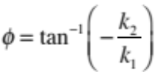 (7)

with an angle of 0 corresponding to a progressive (in phase) tidal wave motion.

- Field Tests
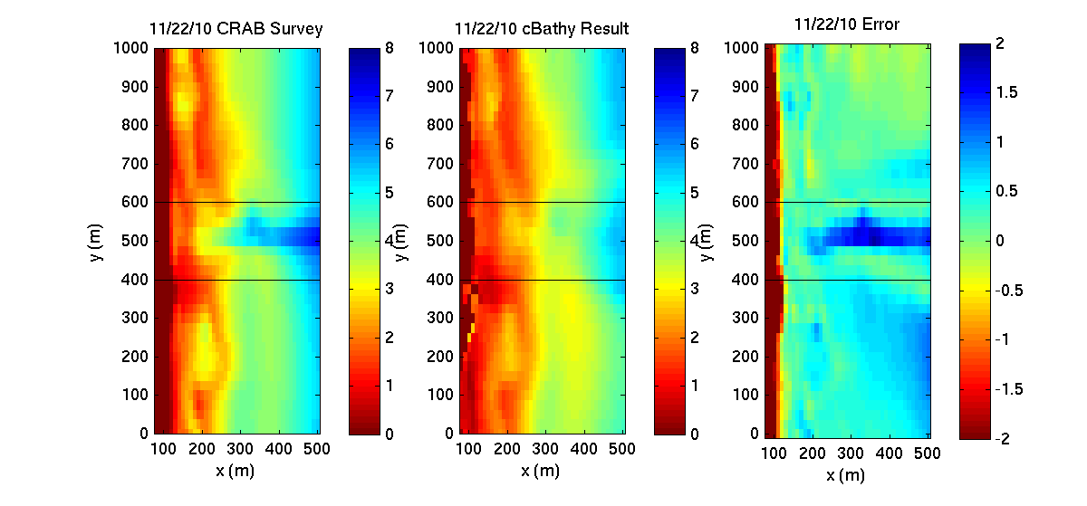
The cBathy algorithm without Doppler compensation was primarily developed and tested at Duck, NC, an intermediate beach with a one- or two-bar system that is often complicated by rip channels and alongshore variability . The main test was based on 16, roughly month, bathymetry surveys spaced over two years. Figure 1 shows one example result from November, 11, 2010 for the default test region of 1 km alongshore and 500 m offshore. Analysis was based on time series from 13,000 pixels from five cameras that spanned the view and were located at [x,y,z] = [32, 585, 43] m. The site features a long pier at y = 515 m that obstructs camera views, interrupts surveys and is usually anomalously deep due to piling scour, so the region from y = 400 to 600 m (black lines) has been omitted from statistical analysis. The details of the bathymetry and especially of the shallow sand bar are remarkably well estimated. The bias and rmse for the full 16-survey test were 0.19 and 0.51 m, respectively.
Figure 1. Example cBathy result for November 22, 2010, one of 16 test days. The left panel shows the ground truth survey results, with an estimated vertical accuracy of 0.05 m. The middle panel shows the cBathy estimate while the right panel shows the difference, or error, plot. A pier that transects the region at y = 515 m obscures the optical view and cannot be easily surveyed, so error statistics were omitted this pier region (between the black lines).

Modifications of the algorithm for the inclusion of the Doppler effects of currents were developed and tested based on field data collected during the three-week long RIVET field experiment at New River Inlet, North Carolina, USA, in May, 2012. The data collection domain (Figure 2) included an open beach component as well as a complex ebb tidal delta that is incised with channels including a main central channel. Tidal range was about 1 m and maximum tidal currents were about 1 m/s and showed strong spatial variation.
Initial tests were carried out at a single location in an ebb tidal sub-channel about 100 m from the cameras where a fixed current meter and pressure sensor recorded the time variations of depth and tidal currents as well as the spectrum of the overlying wave field. Optical data were collected using a six-camera Argus Station located atop a 30 m high, guyed tower near the shoreline (Figure 2). Data are available for the entire three-week sampling period and included large variations in wave and tidal conditions.
For a baseline comparison, cBathy was first run without Doppler compensation on an hour-by-hour basis to compare against the time-varying depths at the instrument due to the tide. Figure 3 shows depth time series for a ten-day period. The pressure gauge shows semi-diurnal fluctuations of approximately 1 m excursion and varying levels of high tide maxima. The cBathy results are from stage 2 of the algorithm, before predicted tide level corrections and before Kalman smoothing (it would make no sense to Kalman smooth depths that had not been tide corrected). Gaps in the cBathy time series correspond to night, when no data were collected, or bad conditions when stable solutions were not found. The basic cBathy results do a decent job tracking the changing tidal levels but tend to over-predict the maxima, especially in the latter half of the record. This is consistent with expectations due to current-induced effects since the high tides are associated with flood currents (the tide is mostly progressive) and flood currents will cause faster celerities, hence deeper estimates.

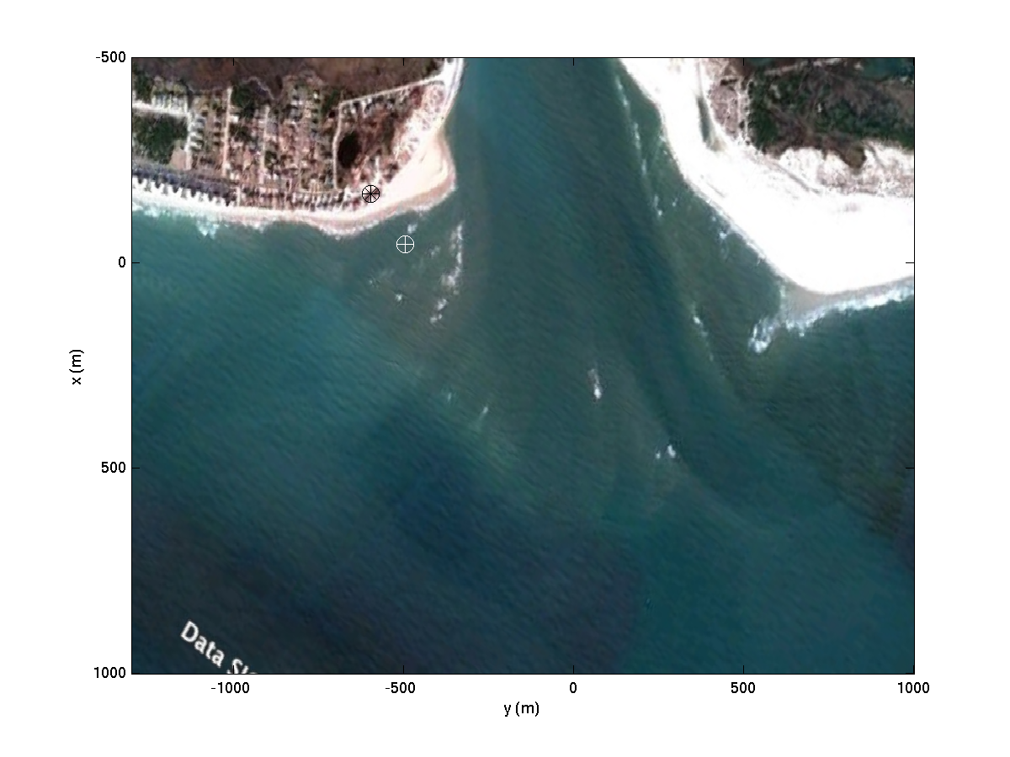
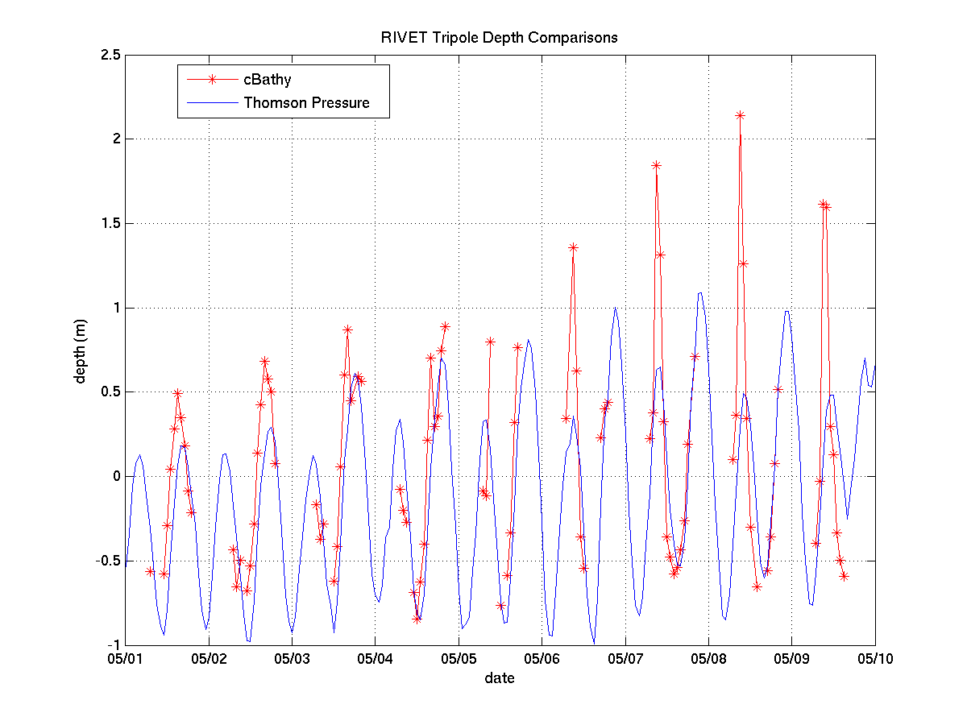
Figure 2. GoogleEarth view of New River Inlet, the location of the field experiment in May, 2012, rotated into the experiment coordinate system. Optical data were collected from the southwest side of the inlet (circled black asterisk) and included coverage of a sensor in the channel just to seaward (circled white plus sign). Tide predictions were based on a location on the west side of the channel at x = -675 m (off the map).
Figure 3. Time series of tidal depth variations measured by a pressure sensor (blue) compared to depth changes estimated by cBathy (red). Missing cBathy data corresponds to night conditions, bad visibility, or times when cBathy solutions failed to converge.

The magnitude of potential depth errors can be found by using actual measured currents and computing the best-fit depths using equation (2) with and without the current correction. Figure 4 shows these results for an example tidal cycle. The upper panel shows the depth variations at the instrument going from high, through low, and back to high tide while the middle panel shows the along-channel tidal current variations. Currents are of modest strength and are largely in phase with elevations, consistent with the known progressive nature of the tidal wave in this inlet.

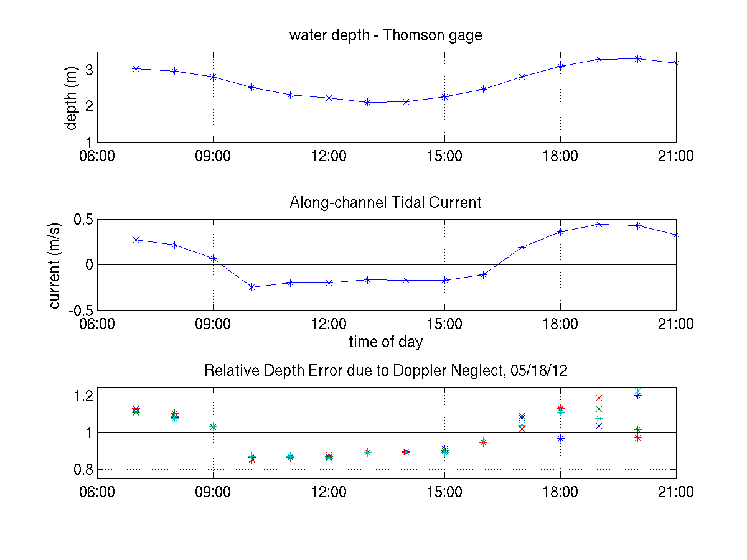
Figure 4. Forward model prediction of the bathymetry error due to the neglect of the Doppler term. The upper panel shows tidal depth variation from a pressure sensor at [x, y] = [-43, -505] while the middle panel shows the along-channel current. The lower panel shows that ratio of the depth that would be estimated neglecting Doppler to that found accounting for Doppler (so there is a 15% over-estimate of depth at the first high tide because the waves are propagating with the current, so are faster). The effect varies with frequency and wave angle, so different sampled waves are affected differently on the second high tide.

The lower panel shows the bathymetry error computed as the ratio of depth computed neglecting currents to that computed accounting for the measured current. The different symbols correspond to different frequencies and directions found by cBathy as the four most coherent bands detected by each analysis. Depth errors are typically +/-10% for these currents and frequencies, becoming variable during the second high tide due to the detection of different wave conditions.

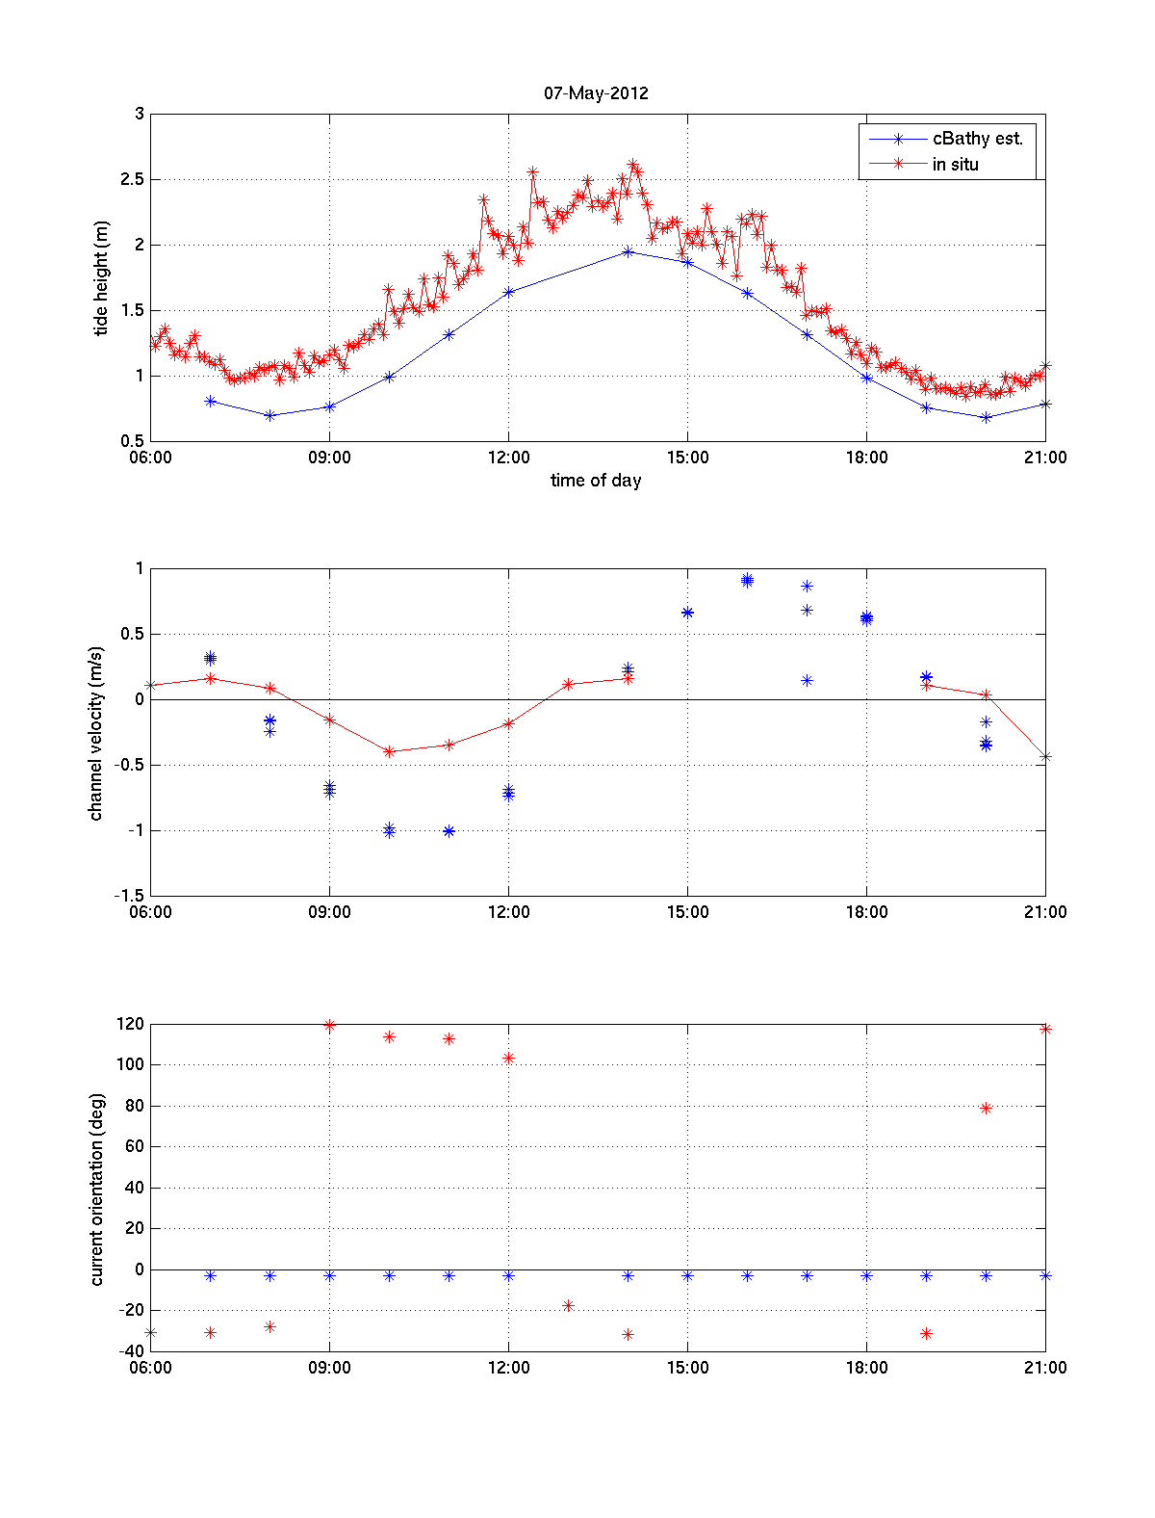
The analysis was next carried out using the full Doppler implementation of the dispersion relationship, partitioning the data into time segments that are twice the M2 tidal period (24.8 hours) to allow sampling over the full tidal excursion while still allowing for slow bathymetric variations. Tidal elevation inputs for the analysis (equations 3 and 6) were extracted from Xtide web resources from a reference site within New River Inlet, approximately 500 m landward of this site. Derivatives of tidal elevation were computed by center-differencing of hourly estimates.
Figure 5. Example section of time series showing important variables estimated by cBathy (blue) compared to local in-situ measurements (red). The upper panel shows the measured and estimated tidal elevation, the middle shows the along-channel tidal current and the bottom shows the orientation of the principle axis of tidal excursion relative to the x axis (offshore).
At the time of writing, there remain some uncertainties in the code. But results are promising. Figure 5 shows an example 24.8 hour window comparing estimated and measured variables at the in-situ test location. The upper panel shows the cBathy and measured tidal elevation variations over the sample period. The tidal signals are very similar with the cBathy result being of the right amplitude and correct phase. The middle panel shows the estimated and measured along-channel component of the current. Again, the phase of the signal is reasonabe but the magnitude of the current estimates is typically too large. Finally, the lower panel shows the estimated and measured orientation of the principle axis of tidal variation. There is only one value estimated for the cBathy analysis window, -5°, on the assumption that the direction will simply reverse with tidal direction. In contrast, the mean direction of measured flow is determined directly from the measured flow components and varies from about +115° during flood to -30° during ebb. This represents a variation of 145°, different from the expected 180° shift that we have assumed.

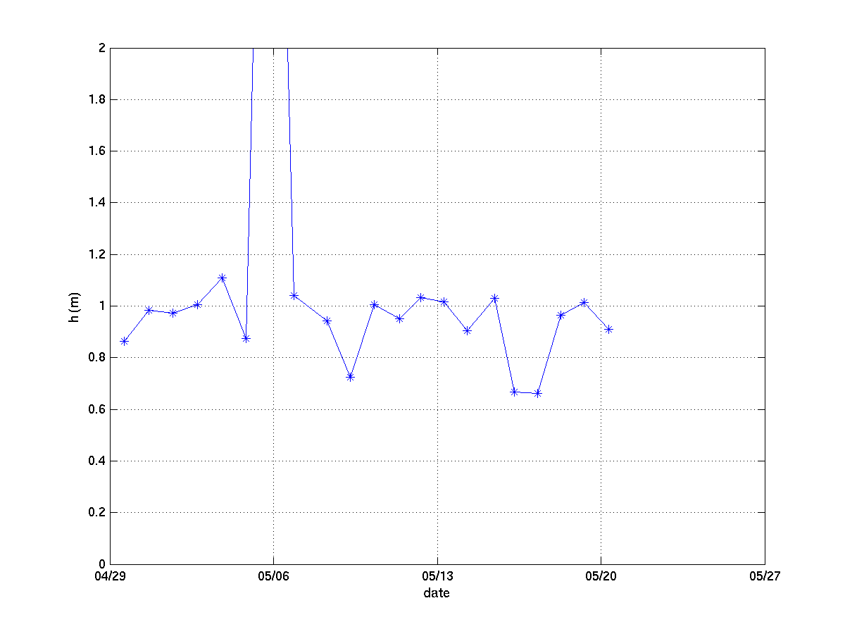
The primary result of interest for cBathy is the depth, h (to which the tide is added). Figure 6 shows the time variation of estimated depth, h, over the three week duration of the experiment. The results are quite stable, with mean and standard deviation values of 0.93 and 0.12 m, respectively (excluding a single bad value from late on May 5), a slight under-estimate of true depth.

Figure 6. Time variations of depth estimated by cBathy for the three weeks of data collection. Values correspond to the depth of water when tide level equals 0.0, usually corresponding to spring low water. With the exception of one bad value on lat May 5, the values are quite stable.

4.0 Discussion
The largest issue in adding current estimation to the cBathy algorithm is ensuring that information is available in the data to allow isolation of bathymetric effects on celerity from current effects. Under some circumstance, for example for waves from a single direction propagating on an opposing current in fairly shallow water, it will be impossible to distinguish whether the depth is shallow and there is no current or whether the depth is greater and there is an opposing current. Similarly, if there is no variability in the relative angles of waves and the current (i.e. a variety of incoming wave directions), there is no opportunity to learn about both the current strength and direction, just the magnitude of velocity in the direction of wave propagation.
Ambiguities can be resolved if waves approach from a variety of directions, similar to the need for probing over a variety of paths in acoustic or medical tomography. For example, odd refraction patterns at New River Inlet help provide a suite of incidence angles that help isolate the current magnitude and direction. Similarly, great advantage can be taken of the fact that tidal elevation and currents reverse in a fairly repeatable cycle over predictable time scales. Any a priori information or understanding that allows the analysis to increase the number of degrees of freedom by incorporating data over longer durations will help stabilize the solution.

The present formulation of the Doppler algorithm makes use of local predictions of time-varying tidal elevation but assumes that the local amplitude can be different and that the important tidal currents can be modeled in terms of an in-phase and quadrature component to the predicted tides. Coefficients are returned for those gains and can be used to estimate the phase of the current to the tidal level. It is possible that the entire estimation process could be done in the absense of any predicted tide, a possible topic for future work.

As with cBathy, it is required that results from cBathy include error estimates on returned variables. These allow operational analysis and the automatic distinction of results of varying quality using methods like Kalman filtering. This step has not yet been done for cBathy Doppler estimates.

It is important to note that the results presented in this paper are preliminary and still include some bugs that will be corrected with continuing work.

5.0 Conclusions
A method has been described for the simulataneous estimation of bathymetry and vector tidal currents through the addition of a Doppler term to the linear dispersion relationship. In order to obtain stable estimates, data from a full tidal cycle are used and assumptions made about the relationship between tidal currents and elevation. Solutions, in turn, can be used to improve the description of both the bathymetric depth and also the local tidal system.

The method was tested against time series from a test location in a large field experiment in May, 2012 at New River Inlet, NC. Example results are good, but the algorithm needs to mature and stabilize before becoming operational.

Acknowledgements
We would like to thank a host of colleagues involved with the RIVET experiment. John Stanley has long been the brain power behind Argus and ensures ongoing successful operations. Chris Chickadel and Andy Jessup of UW-APL were responsible for much of the excellent logistics of the remote sensing component of the experiment. We also appreciate the help of Adam Keen and Cassia Pianca for field support throughout the experiment and of the Jesse McNinch and the FRF crew for their support field measurements.

References
Dugan, J. P., C. C. Piotrowski, et al. (2001). "Water depth and surface current retrievals from airborne optical measurements of surface gravity wave dispersion." Journal of Geophysical Research 106(C8): 16,903-916,915.
Holman, R. A., N. G. Plant, et al. (in review). "cBathy: A robust algorithm for estimating nearshore bathymetry." Journal of Geophysical Research.
Lippmann, T. C. and R. A. Holman (1990). "The spatial and temporal variability of sand bar morphology." Journal of Geophysical Research 95(C7): 11,575-511,590.

CEOAS, Oregon State University, 104 Ocean Admin Bldg, Corvallis, OR USA, holman@coas.oregonstate.edu
University of Washington, Applied Physics Lab, 1013 NE 4oth St. Seattle WA, USA, jthomson@apl.washington.edu

