Worksheet: Why Hummingbirds Like Nectar
You will not have to turn in this worksheet, so take notes in whatever manner is most helpful to you.

Reference: Maude W. Baldwin et al. (2014), “Evolution of sweet taste perception in hummingbirds by transformation of the ancestral umami receptor,” Science 345: 929-33.

Goals
- Deepen our understanding of sensory receptors via in-depth exploration of an interesting example: the hummingbird T1R1-T1R3 receptor.
- Examine an example of the genetic changes necessary to achieve a major change in a protein’s function.
- Connect genetic changes to behavioral changes, thus seeing how genetic changes can confer an advantage in natural selection.
- Connect the data collected by the researchers to the conclusion of the article title.

Group roles to assign
- Discussion leader: introduces questions, allots time for solo work, gathers input
- Lifeline: looks things up, gets instructor’s attention
- Equity officer: ensures equal participation
- Digression manager: keeps discussion on track

General background

For background information, please see the study guide file posted to the Homework folder of Canvas’s Files page (2016_03_09_Baldwin_study_guide.docx).

Questions

1. The second paragraph of the paper (not counting the Abstract) includes some nice examples of how taste receptors differ in various animals. One additional example is that of whales and dolphins; a study published around the same time as Baldwin et al.’s noted, “Whales can’t taste anything but salt!” (http://www.sciencemag.org/news/2014/05/whales-cant-taste-anything-salt). What predictions can you make about whales’ T1R1, T1R2, and T1R3 genes?

2. Figure 1 shows a phylogenetic tree of T1R genes. Although not labeled as such, the extreme left of the tree represents an ancestral T1R gene that was then duplicated and adapted for different purposes. Based on this figure, why do alligators have a T1R2 gene while birds do not?

3. The third paragraph states, “Expression in oral tissue was verified by reverse transcription
polymerase chain reaction.”

a. What does the above sentence mean?

b. Why was expression studied, rather than just DNA sequences? (Hint: what are pseudogenes?)

4. The end of the third paragraph states, “These findings suggest that an alternative T1R2-independent mechanism for sugar detection arose in avian species that display high behavioral affinity for nectar or sweet fruit.” Please restate this in your own words. What findings are being referred to here?

5. Figure 2 measures the binding of various possible ligands to the receptors.

a. Summarize Figure 2A in one good sentence.

b. To what extent is Figure 2C redundant with Figure 2A, and to what extent does Figure 2C provide additional, distinct information?

c. What is the take-home message of Figure 2B?

6. Figure 3 covers chimeric (hybrid) T1R1 proteins created by the researchers. What was their goal in making chimeric proteins? Explain in your own words.

7. Figure 3D is a 3D model – funny, but true! – of the hummingbird T1R3. Based on this figure, do you think that sugar binds in essentially the same place as amino acids do (in other animals’ version of this receptor protein), or at their own distinct binding pocket? Briefly explain.

8. Figure 2A shows us that the typical umami receptor tightly binds amino acids like alanine, and that the hummingbird version tightly binds sugars like sucrose. Below are the chemical structures of alanine and sucrose (from Wikipedia and Wikimedia). Are these structures consistent with your answer to #7 above? In other words, are these two compounds likely to bind to the same binding site, or likely to require different binding sites?
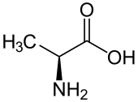  Alanine | 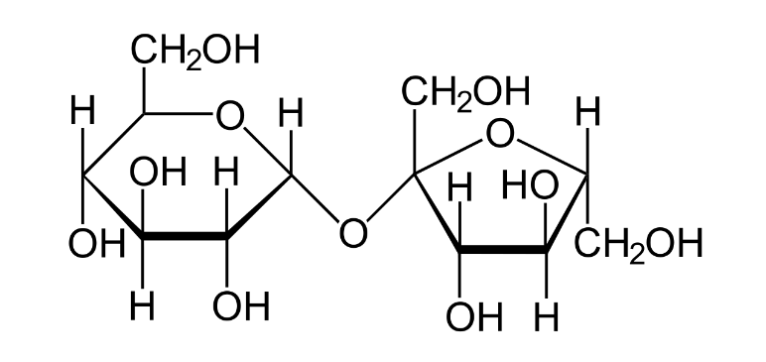  Sucrose

9. Figure 4 shows data from behavior assays of two species of hummingbirds.

a. Why did the researchers study both ruby-throated hummingbirds (Archilochus colubris) and Anna’s hummingbirds (Calypte anna)?

b. Why were these experiments even necessary? Don’t Figures 1, 2, and 3 tell a good, complete story?

c. Predict what the data would have looked like for a comparison of an alanine-rich solution versus a sucrose-rich solution. Should this experiment have been done? Defend your answer.

