Note to instructors: This worksheet represents a way that I have taught this material, which incorporates figures created by others. I have cited these figures’ sources, but I have not formally obtained permission to use the figures in this way. As far as I’m concerned, you’re welcome to modify this worksheet or use it as is; if you do so, please continue to cite the sources of these figures – and be aware that the figures’ inclusion here may or may not be permissible under “fair use” doctrine.
--Greg Crowther, Everett Community College (gcrowther@everettcc.edu)

Worksheet: Muscles

Goals
- Relate the main structural components of muscles to their functions.
- Analyze the molecular reasons for and functional consequences of muscles’ changing length.

A. What should muscle cells be filled with?

(Reference for this section: S.L. Lindstedt et al., “Task-specific design of skeletal muscle: balancing muscle structural composition,” Comparative Biochemistry and Physiology B 120: 35-40, 1998.)

Muscle cells are full of many components, but to understand their fundamental design, we can focus on three:
- Contractile proteins: myosin (a protein) pulls on actin (another protein), exerting force and causing the muscle cell to contract.
- Mitochondria: generate ATP for sustained muscular activity (as opposed to glycolysis, which occurs outside the mitochondria and provides much of the fuel for short bursts of muscle activity).
- Sarcoplasmic reticulum (SR): releases calcium ions to start muscle contraction, and removes calcium ions to stop muscle contraction.

A1. You have previously learned about mitochondria’s functions in “generic” cells. Are those functions similar to the mitochondrial function listed above?

A2. The sarcoplasmic reticulum (SR) is the muscle-specific term for the endoplasmic reticulum (ER) (“sarcos” means flesh). You have previously learned about the ER’s functions in “generic” cells. Are those functions similar to the SR functions listed above? If not, what are the main differences?

A3. Look at cartoons and/or labeled electron micrographs of a typical human or vertebrate skeletal muscle. Which one of the above three components takes up most of the space in the muscle cells?

A4. Your answer to A3 reflects a muscle cell composition that is adequate for typical human skeletal muscle tasks. Now think beyond everyday human experience! What kind of “extreme” tasks somewhere in the animal kingdom might require muscle cells to have many more mitochondria than human skeletal muscle cells typically have?

A5. Likewise, what kind of “extreme” tasks somewhere in the animal kingdom might require the muscle cells to have much more SR than human skeletal muscles typically have?

A6. At right is a diagram of mammalian cardiac muscle (not skeletal muscle). Note that the job of the heart is to beat continuously, without a break, for decades. Given this task, how would you expect heart muscle cells to differ from skeletal muscle cells in their  relative | 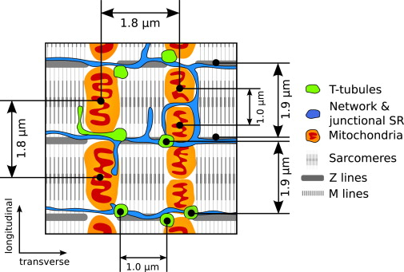  Figure: A. Illaste et al., Biophysical Journal 102: 739-748, 2012.
amounts of contractile proteins, mitochondria, and SR? Is that expectation consistent with this diagram?

A7. At right is a figure comparing “superfast” muscles (SFM), which turn on and off 90 to 250 times per second, with merely “fast” muscles from the same organisms. Which specific muscles in these animals are considered superfast? (Consult the source, if needed.)  A8. Based on a comparison of the fast and superfast muscles, which cellular component is consistently more prominent in superfast muscles? Is that trend consistent with your understanding of what this component does? | 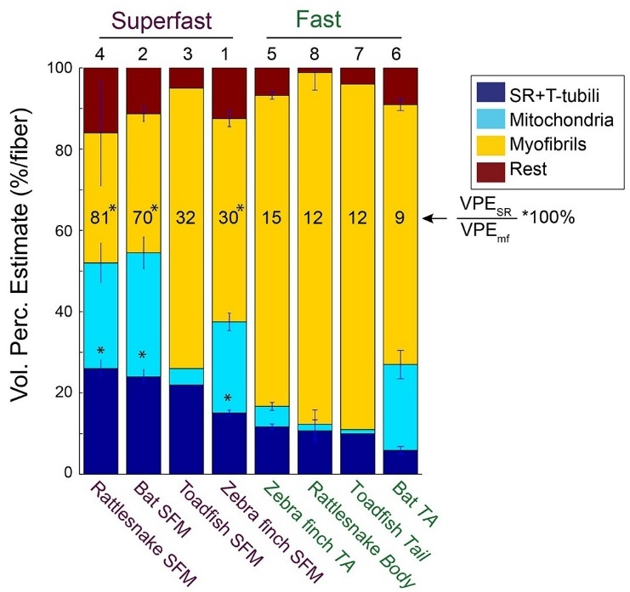  Figure: A.F. Mead et al., eLife 6: e29425, 2017

A9. Dramatic changes in muscle cell composition are possible only over evolutionary time. However, more modest changes are possible within an individual’s lifetime via chronic exercise training. Which of the three components becomes more abundant in muscle cells after prolonged periods of endurance training?

A10. Along with the change alluded to in A9, the capillary density also increases in these endurance-trained muscles. Why should an increase in capillary density accompany an increase in this other cellular component?

B. Zooming in on sarcomeres

At right are pictures showing a part of a skeletal muscle cell when it is relaxing and after it has contracted fully.  B1. Label the following components:  - Actin/thin filament  - Myosin/thick filament  - Sarcomere  B2. Skeletal muscle cells are said to be striated, striped. Alternating dark and light stripes can be seen under a light microscope; more detail is shown in the electron micrographs (EMs) at right. Compare the top EM, which shows one dark vertical stripe (taking up about the middle third of the picture) flanked by two white stripes (taking up the rest of the picture). What protein’s presence or absence appears to cause the dark and light stripes?  Now consider the changes from relaxation to contraction. | 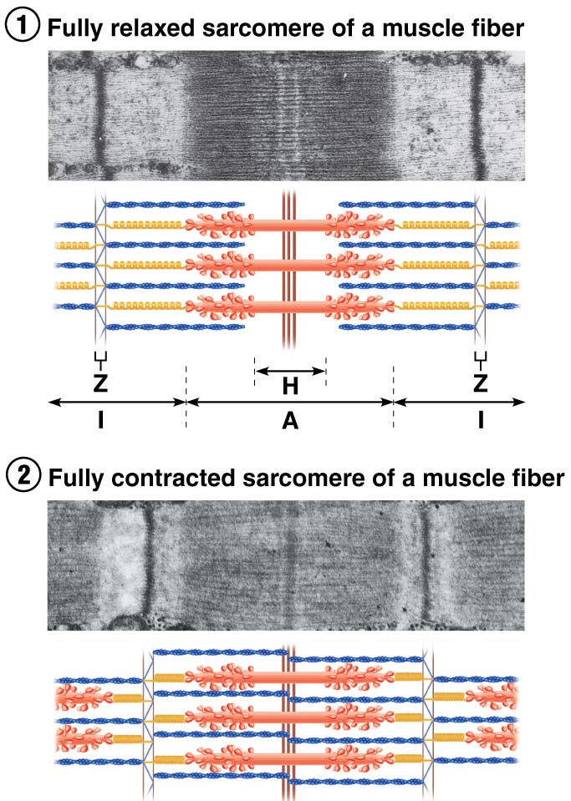  Figure: E. Marieb & K. Hoehn, Human Anatomy & Physiology (2016).

B3. Is the length of the thick filaments changing?

B4. Is the length of the thin filaments changing?

B5. Is the length of the sarcomeres, and thus the muscle cell as a whole, changing? How is this possible, given your answers to B3 and B4?

B6. What specifically causes the thin filaments to slide past the thick filaments?

C. The length-tension curve

In the top panel of the previous figure, note that not every myosin head can reach a thin filament above or below it. It turns out that the amount of force that a muscle can exert at any given time is proportional to the fraction of its myosin heads that are able to pull on actin. That fundamental idea is illustrated by the so-called length-tension curve, in which muscle force (or tension) is shown to vary as a function of muscle length.

C1. Try to draw the length-tension curve in the space below, noting the different arrangements of myosin and actin at different sarcomere lengths.

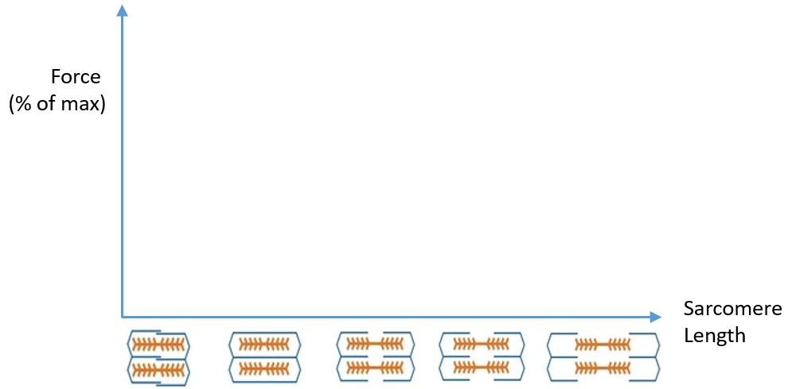

C2. Check your curve against a reference curve in your textbook or on the Internet. How did you do?

C3. At extremely short sarcomere lengths, force is submaximal because the proteins get smooshed together and cannot interact as well. Why is force also submaximal at extremely long sarcomere lengths?

C4. Use your biceps muscle to pull your hand upward against the resistance of a classmate (i.e., he/she pushes your hand down while you pull it up). Try this from both positions shown at right. In which position are you able to exert more force?  C5. Based on the amount of force that you can generate in these two positions, which parts of the length-tension curve correspond to these positions? | 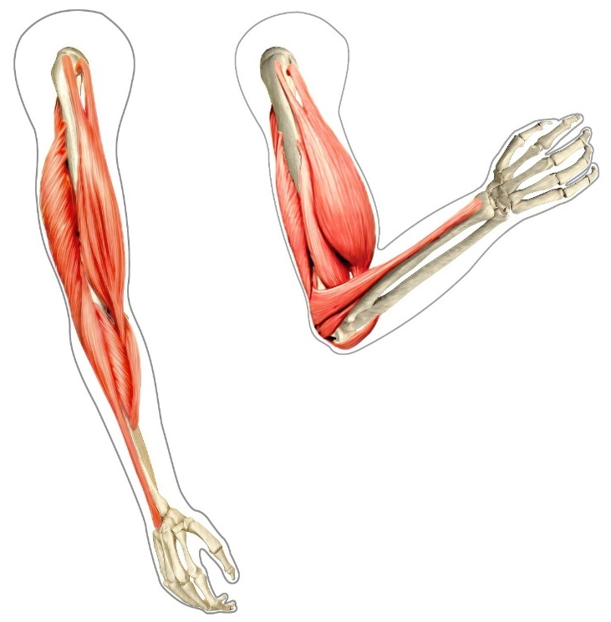  Figure: Johnthebodyman.com

C6. Let’s modify the length-tension curve to make it a curve of the rate of ATP use versus length. Draw your new graph below.
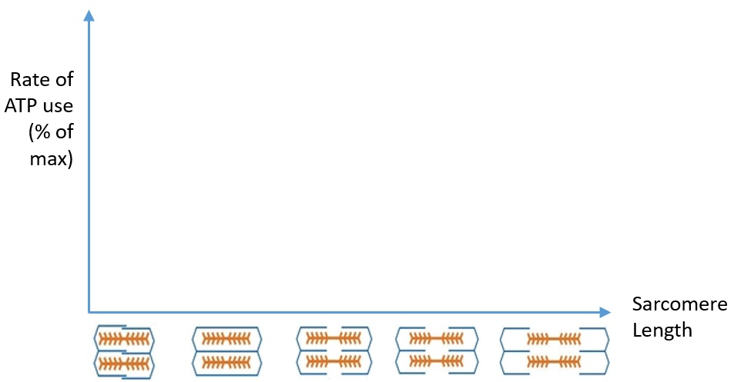

C7. How does the shape of this curve compare to the previous one (C1-C2)?

C8. Even at extreme sarcomere lengths, the absolute rate of ATP use should not be 0. Why not? (Hint: do muscle proteins/processes other than myosin also use ATP?)

