**Worksheet: Journey along the Nephron**

Goal:

* Reinforce our understanding of how various substances may be filtered, secreted, and/or reabsorbed by drawing graphs of substance levels at various sections along a nephron.

A. Background anatomy and terminology

|  |  |
| --- | --- |
| 1. Label the diagram at right (from catalog.niddk.nih.gov) with the following terms:  * Bowman’s capsule (glomerular capsule)  * collecting duct  * distal tubule  * glomerulus  * loop of Henle (nephron loop)  * proximal tubule  * renal corpuscle |  |

2. Three main processes govern the formation of urine. (A short song about them, “Pee Values,” is here: http://faculty.washington.edu/crowther/Misc/Songs/pee.shtml.) Briefly define each process below.

FILTRATION =

SECRETION =

REABSORPTION =

B. Nephron graphs

For any substance that is present in the blood, we can make a graph of the amount of it passing through any given section of a nephron as shown below.

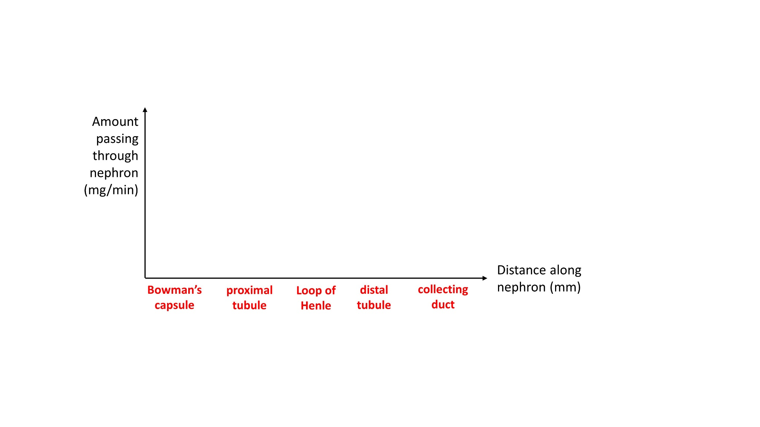

In this type of graph, we will focus on relative trends (as X increases, does Y go up, hold steady, or decrease?) rather than absolute quantities.

A simple case of this graph is for the molecule inulin (NOT insulin), which has the distinction of being filtered into Bowman’s capsule, but neither secreted nor reabsorbed. Thus, its graph would look about like this:

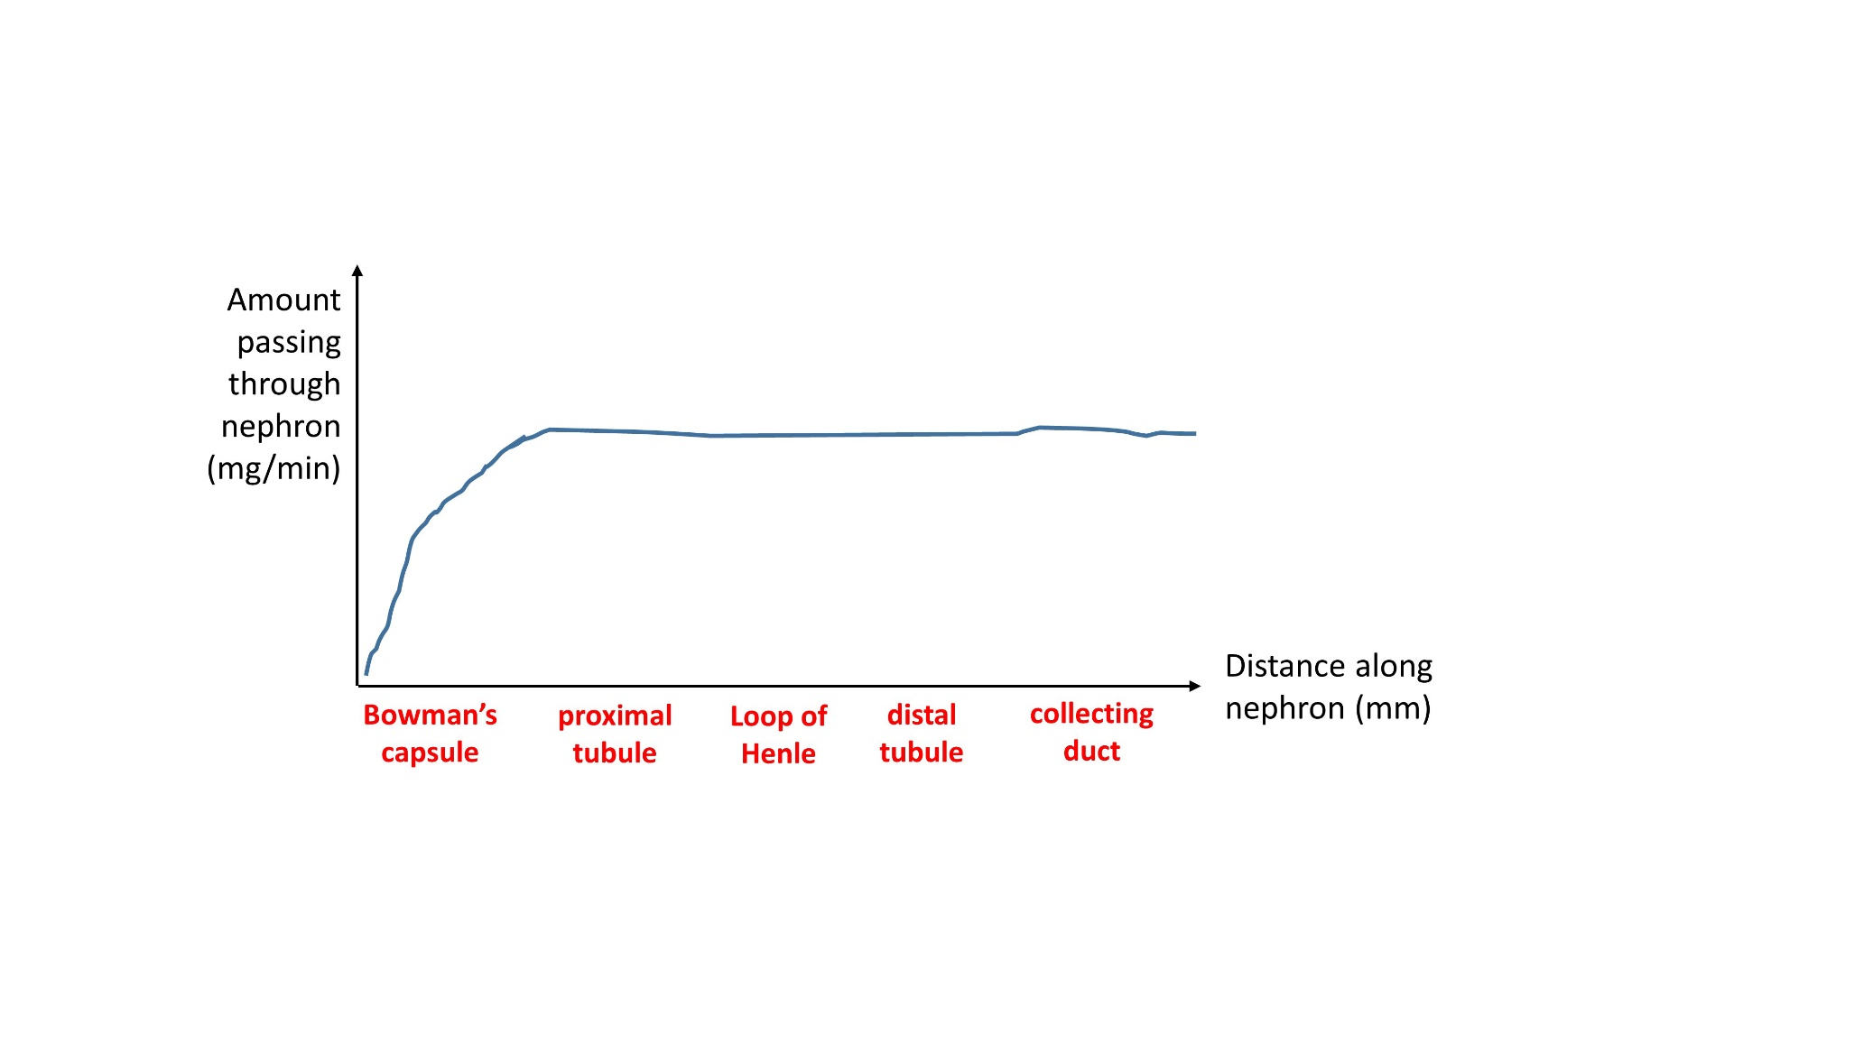

3. Would this graph look the same if the rates of secretion and reabsorption were not zero, but equal to each other at each part of the nephron?

|  |  |
| --- | --- |
| Now consider the drug morphine (image at right: sciencebase.com), which is actively secreted into the proximal and distal tubules.  4. Is morphine small enough to be filtered from the glomerulus into Bowman’s capsule? |  |

5. Based on the information you have, draw the graph for morphine.



Albumin is a plasma protein that is ~580 amino acids long and has a molecular weight of ~60,000. It is neither secreted nor reabsorbed along the nephron.

6. Draw the graph for albumen in a healthy person.



7. In some types of kidney disease, more albumen than usual is able to escape the glomeruli. Add a new curve, labeled “Disease,” to the graph above. Will this protein be present in the urine? If so, is protein in the urine a sign of disease?

Sodium (Na+) is reabsorbed along most of the nephron, including the ascending limb of the loop of Henle (but not the descending limb). Aldosterone enhances reabsorption in the distal tubule and collecting duct, but, either way, at least a bit of Na+ is lost in the urine.

8. Draw the graph for Na+ in the absence and in the presence of aldosterone. (Label your two lines “NO ALD” and “WITH ALD.”)



9. Despite the changes in Na+ amount graphed above, the Na+ concentration does not change that much between the Bowman’s capsule and the collecting duct. Why not?

Finally, let’s consider glucose in a normal person and in a case of diabetes.

10. Is glucose a small enough molecule to be filtered into Bowman’s capsule?

11. Would it be advantageous for the body to secrete glucose? Why or why not?

12. Glucose reabsorption occurs along the proximal tubule. Draw the curve for glucose during euglycemia (normal blood glucose levels) and hyperglycemia. Is glucose in the urine a sign of disease? Explain.



13. Based on the rest of this worksheet, briefly describe the contents of a healthy person’s urine in terms of its contents of morphine, albumen, sodium, and glucose.