Note to instructors: This worksheet represents a way that I have taught this material, which incorporates figures created by others. I have cited these figures’ sources, but I have not formally obtained permission to use the figures in this way. As far as I’m concerned, you’re welcome to modify this worksheet or use it as is; if you do so, please continue to cite the sources of these figures – and be aware that the figures’ inclusion here may or may not be permissible under “fair use” doctrine.
--Greg Crowther, Everett Community College (gcrowther@everettcc.edu)

Worksheet: BLOOD!

Goals
- Interpret variations of the oxygen-hemoglobin curve, and understand how various factors influence oxygen delivery.
- Use an understanding of antigens and antibodies to predict which blood types can safely donate blood to and accept blood from which.

A. Transport of oxygen by red blood cells

A1. Red blood cells (RBCs, or erythrocytes) are specialized for transporting oxygen (O₂). Where exactly does O₂ bind when it is transported by RBCs? Be as specific as possible.

A2. The plasma in blood contains very little O₂ because O₂ is not very water-soluble. Therefore O₂ transport depends almost completely on the RBCs. For this reason, hematocrit is an important clinical measurement. What is a normal hematocrit value (you may consult the Internet) and what does this number mean?

A3. How do hematocrit values change (i.e., do they go up or down?) in response to each of the following changes? (Again, Internet use is allowed.)

A. donate blood, then wait a couple of days for the body to adjust

B. receive injections of synthetic erythropoietin

C. live at high altitude for a month

One of the most famous and useful curves in all of physiology is the oxygen-hemoglobin curve shown at right (from Freeman et al., Biological Science 2014).  A4. The X axis is the partial pressure of oxygen. Partial pressures indicate the concentrations of gases. What does the Y axis mean? | 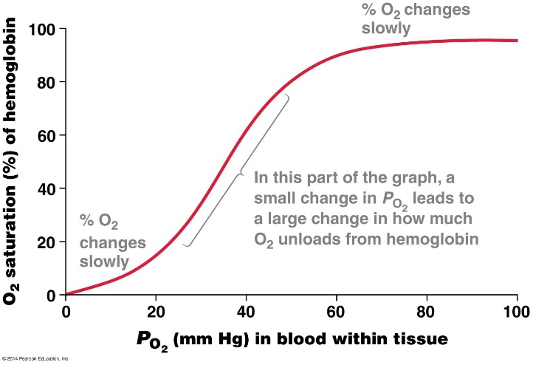

A5. If O₂ saturation in a sample of blood is 50%, how many O₂ binding sites per hemoglobin molecule are occupied with O₂, on average?

A6. P_{O2} in the pulmonary capillaries is generally >100 mm Hg. How saturated is the hemoglobin at this location?

A7. If the P_{O2} in the capillaries of the body’s non-lung tissues averages out to be 40 mm Hg, how saturated is the hemoglobin at these locations?

A8. Given your answers to #6 and #7, what percentage of the O₂ carried away from the pulmonary capillaries is dropped off in the other tissues?

A9. Under some conditions, severe exercise can drive P_{O2} in the tissues down to 20 mm Hg. How would this change your answer to #8 if P_{O2} in the pulmonary capillaries was still >100 mm Hg?

A10. At the summit of Mount Everest, oxygen levels are so low that P_{O2} in the pulmonary capillaries is about 30 mm Hg. How would this change your answer to #9?

A11. Based on this information, why is exercising at high altitude so difficult?

A12. The exact shape of the oxygen-hemoglobin curve can be altered by many factors. For example, fetuses express an alternative form of hemoglobin in which some amino acids are different than in the adult form. Is the fetal curve shifted to the left of the adult curve, or to the right? Sketch the shifted curve at right. How does this shift enable oxygen delivery from the maternal circulation to the fetal circulation? | 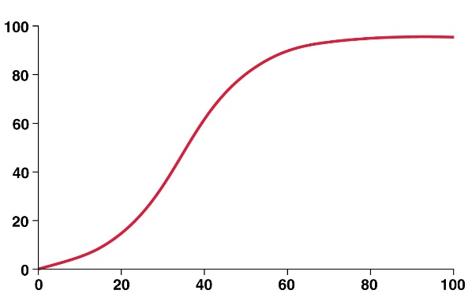

A13. Another alteration of the oxygen-hemoglobin curve is the so-called Bohr effect, in which low pH, high CO₂ levels, and high temperature all decrease hemoglobin’s affinity for oxygen. Sketch the shifted curve at right. The shifted curve should show enhanced oxygen delivery to exercising muscles relative to the unshifted curve. | 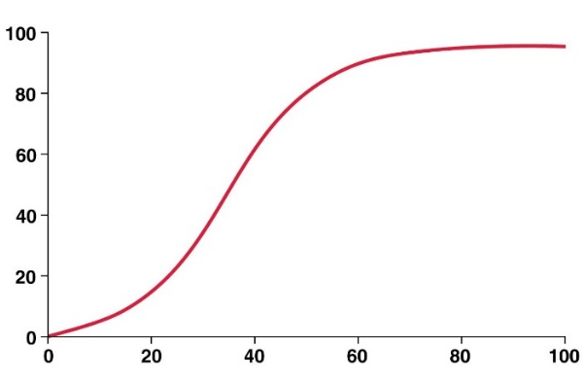

A14. Explain why exercise lowers the blood’s pH, increases its CO₂ levels, and raises its temperature, all of which contribute to the Bohr effect.

B. Surface antigens on red blood cells
[based on Patrick J.P. Brown’s Anatomy & Physiology: A Guided Inquiry, 2016]

Note the guide to the four blood types (A, B, and O) below. For each blood type, one row shows the surface antigens on RBCs of people with that blood type, and the other row shows the antibodies in people with that blood type. Early in development, the immune system is trained not to make antibodies against its own antigens; therefore, people with antigen A don’t make antibodies against that antigen, people with antigen B don’t make antibodies against that antigen, and people with antigens A and B don’t make antibodies against either antigen.

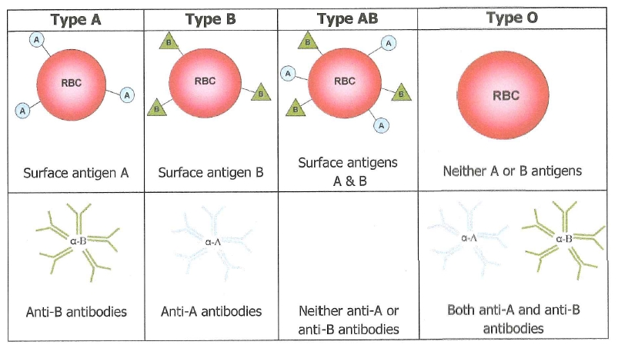

B1. If Dr. C has type A blood, what cell-surface proteins does he display on his RBCs?

B2. Which antibodies are likely present in Dr. C’s blood?
B3. If Dr. C’s wife, Dr. Z, has type O blood, what surface proteins are on her RBCs?

B4. Which antibodies are likely present in Dr. Z’s blood?

The picture at right shows what happens when incompatible blood types are mixed.  B5. What is the blood type of the donor?  B6. What is the blood type of the recipient?  B7. Would hemolysis have occurred if the recipient were given type O blood? Explain. | 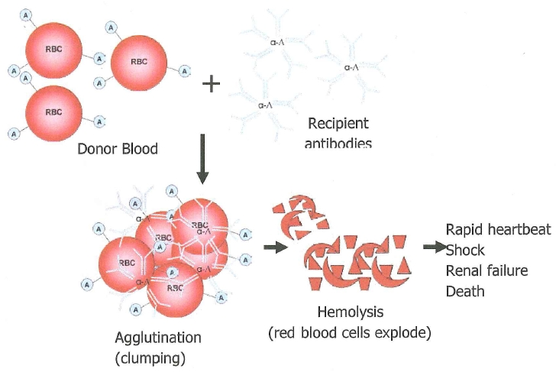

B8. Complete the following statements…

- Type-A donors can donate to these recipients:

- Type-B donors can donate to these recipients:

- Type-AB donors can donate to these recipients:

- Type-O donors can donate to these recipients:

B9. Based on B8, which blood type is the “universal donor”? Which is the “universal recipient”?

B10. Are blood types named according to the antigens present in the blood, or the antibodies?

