TCSS 422: Operating Systems School of Engineering and Technology
Winter 2026 University of Washington – Tacoma
http://faculty.washington.edu/wlloyd/courses/tcss422

Assignment 3: Introduction to Linux Kernel Modules (Tutorial) (v0.10)

Note: Use of Ubuntu 24.04 is required for this assignment.

The purpose of this assignment is to introduce Linux Kernel programming in the context of writing a Linux Kernel module. Kernel code executes in kernel (privileged mode) where program instructions can command the CPU to perform any operation allowed by the CPU’s architecture. This allows any instruction to be executed, any I/O operation to be initiated, and any area of memory accessed directly.

The host operating system is the base operating system of the computer which is started on boot time. The guest operating system is the operating system of any virtual machine that runs on the host. It is best to complete this tutorial on a virtual machine. In case of problems, it is easier to restart a virtual machine, than to restart the host system.

Assignment Submission
This assignment is accompanied by an online Canvas quiz which captures the answers for the questions in this assignment. After completing the activities described below, to complete the assignment and receive a grade, log into Canvas, and complete the Assignment #3 Quiz.

For this assignment, several packages for building kernel modules must be installed. The assumption is that the following packages have already been installed. To check if a package is installed use:
sudo dpkg --list | grep <search-term>

If the packages are not installed, they can be installed with:

sudo apt update
sudo apt install make binutils gcc build-essential linux-libc-dev pahole fakeroot flex binutils-dev
sudo apt install --reinstall gcc-13

After performing package installations, it may be necessary and helpful to reboot the VM.

- Download kernel module starter code.

To begin, download the tar.gz archive containing a basic Hello World Linux kernel module.

First, create a directory for this assignment, and then download the tar gz:

Kernel modules will FAIL TO COMPILE if source code is placed under paths with spaces.
In general spaces in filenames is a Windows/MAC convention and is uncommon on Linux.
Please do not use spaces in directory or filenames.

mkdir a3
cd a3
wget http://faculty.washington.edu/wlloyd/courses/tcss422/assignments/hello_module.tar.gz
tar xzf hello_module.tar.gz
cd hello_module
ls -l

The hello_module contains “helloModule.c”, which includes source code for the most basic Linux kernel module. Inspect the code. The module consists of an initialization method and a cleanup method. The initialization method is triggered automatically as an “event” when the module is loaded. The cleanup method is triggered when the kernel module is unloaded. Kernel modules are loaded dynamically into the operating system. They are not run as user programs on the command line. Consequently, they don’t have traditional I/O (e.g. stdin, stdout).

Note: Required #include files have already been included in hello_module.c for this assignment.

- Compile, install, and test a Linux Kernel Module

Before compiling the kernel module, to suppress the BTF compiler warning, run this command:

sudo ln -s /sys/kernel/btf/vmlinux /usr/lib/modules/$(uname -r)/build/

BTF is BPF Type Format, a metadata format that encodes debug information for eBPF programs and the Linux kernel, including kernel modules. When building the kernel module, Ubuntu 24.04 appears to be missing a path to /sys/kernel/btf/vmlinux which causes a warning message and BTF generation to be skipped.

Try compiling this module, and inspecting the resulting files:

make
You may receive the compiler warning as below:

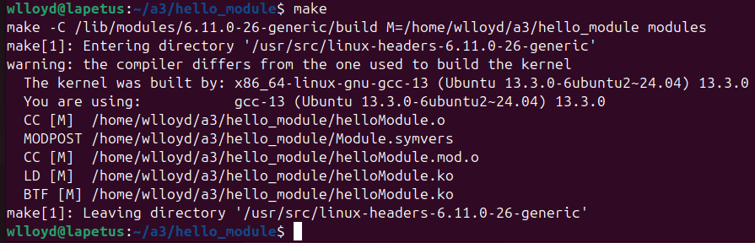

The compiler warning can be ignored as long as the kernel module compiles. Check if the module compiled:

ls -alt

If gcc-13 is NOT installed, the kernel module may fail to compile.
Check if gcc-13 is installed:

$ whereis gcc-13
gcc-13: /usr/bin/gcc-13 /usr/share/man/man1/gcc-13.1.gzs

If gcc-13 is not installed, install it as described on page 1.

The newly compiled kernel module should appear at the top of the directory output.
Compilation produces a kernel object (ko) file. Load this file:

sudo insmod helloModule.ko

The “insmod” command must be run as superuser. This “inserts” a module into the running kernel. When we load the module the init() method is automatically called. Any “printk” statements are sent to the kernel log file. To view what has been written to the kernel log file, check the last 10 lines of /var/log//syslog using:

tail -n 10 /var/log/syslog

The module can be unloaded using the “rmmod” command. It is not necessary to include the “ko” file extension:

sudo rmmod helloModule

Check the kernel log after unloading the module:

tail -n 10 /var/log/syslog

Separate log messages are written by the init() and cleanup() methods.

For this tutorial, we will iteratively make changes to the helloModule kernel module. For each iteration we will “rmmod” the previous version, “insmod” the new version”, and check printk output to /var/log/syslog using the tail command.
Messages regarding kernel module verification can be ignored as this is a user provided test module.

- Count the number of running Linux tasks

Only privileged kernel code can read kernel data structures.

Let’s access the task_struct data structure to inspect running processes and threads on the computer. Let’s add code to the init() method that is run when the module is loaded.

The task_struct data structure requires the <linux/sched/signal.h> include statement which defines an important helper function called for_each_process(). This include statement is already in the starter code.

#include<linux/sched/signal.h>

Now add source code for the function:
Under “Helper Routine Function Prototypes”, add the function prototype:

int proc_count(void);
Then under “Helper Routine implementation”, add the proc_count() function implementation:

int proc_count(void)
{
int i=0;
struct task_struct *thechild;
for_each_process(thechild)
i++;
return i;
}

Next, call this function by adding a printk() statement to init():

printk(KERN_INFO "There are %d running processes.\n", proc_count());

In this assignment, we leverage two Linux kernel data structures:

struct task_struct
defined in /usr/src/linux-headers-$(uname -r)/include/linux/sched.h
starting at line 758 (value for 6.11 Ubuntu 24.04 kernel, exact location may vary)
struct mm_struct
defined in /usr/src/linux-headers-$(uname -r)/include/linux/mm_types.h
starting at line 809 (value for 6.11 Ubuntu 24.04 kernel, exact location may vary)

Before recompiling, first check to ensure that these files are on your system with “ls”:

ls -l /usr/src/linux-headers-$(uname -r)/include/linux/sched.h
ls -l /usr/src/linux-headers-$(uname -r)/include/linux/mm_types.h

If you do not have these files, check if they are installed with:

sudo dpkg -l | grep linux-headers-$(uname -r)

If the result is blank, then try installing the required headers:

sudo apt install linux-headers-$(uname -r) linux-headers-$(uname -r)-generic

Then test if they are available:

sudo dpkg -l | grep linux-headers-$(uname -r)

If there are still problems obtaining the linux headers, please contact the instructor.

Recompile and reload the kernel module and check output to the syslog.

<Q1> - How many processes do you see?
- Inspecting Linux Task Codesize

Next, implement the function below to scan Linux processes and determine the code size for each of them.

Important Note about COPY-AND-PASTE:
If copying and pasting code from a PDF file, please note that some characters may not be copied correctly.
It may be necessary to correct quote marks, subtract operators, etc. The DOCX file is better for copy/paste.

Now add another helper function. Be sure to add the function prototype as before.

unsigned long code_memory(void)
{
unsigned long totalmem=0;
unsigned long thismem;
struct task_struct *thechild;
for_each_process(thechild)
{
printk(KERN_INFO "pid %d",thechild->pid);
thismem=thechild->mm->end_code - thechild->mm->start_code;
printk(KERN_INFO " has codesize %lu.\n",thismem);
totalmem=totalmem+thismem;
}
return totalmem;
}

Now, call this function by adding a printk() statement to init():

printk(KERN_INFO "Running processes have %lu bytes of code.\n", code_memory());

Recompile and reload the kernel module and check output to the syslog.

<Q2> – What happens when this kernel module is loaded?

Check the kernel log file.

tail -n 60 /var/log/syslog

Scroll up to view the full content of the log.
Look for an error message that says “BUG: unable to handle kernel”…
Examine the description of the error carefully to learn what has caused the issue.

>> Now, reboot and restore the Ubuntu virtual machine before continuing. <<

To proceed the bug needs to be corrected.

Not every process can be indexed with the code_memory() function.
Processes must be tested before running the code.
Line 9 of the function dereferences two pointers:

thismem=thechild->mm->end_code – thechild->mm->start_code;
When the first pointer is not valid, it is not possible to dereference the second pointer.
When the second pointer is not valid, it is not possible to read any members of the mm (memory map).

The variable “thechild” is a task_struct pointer.
Let’s inspect what member “mm” is by looking at sched.h in the task_struct type definition. See the table above on page 4 for the location of the sched.h include file. Skip to approximately line 898 in the file.

Line 898 assumes Ubuntu 24.04 with Linux kernel 6.11.0-26.

If using a different version of Ubuntu, this line number could vary.
You’ll be looking first for the location where struct task_struct is defined – and then the “mm” pointer within task_struct.
The definition of task_struct will look like:

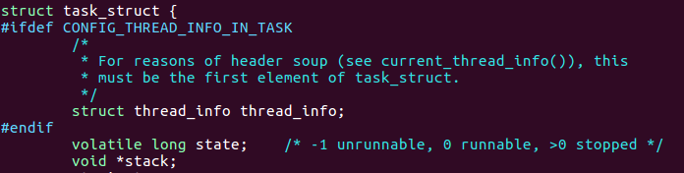

To correct the bug, we must first check that mm is valid before using it.

<Q3> – What test should be made before dereferencing a member that is pointed to in C ?

Correct the issue in Q3, and then continue.

The correction should allow the function to run where it will print the codesize of every process to the /var/log/syslog log file.

* * * If you experience trouble correcting the error, contact the instructor for a hint. * * *

Next, for simplicity combine the two printk() statements in the function.
Remove the first printk() statement, and replace the second printk() with the following:

printk(KERN_INFO "pid %d has codesize %lu.\n",thechild->pid,thismem);

Recompile and reload the kernel module.
Test the output by inspecting the tail of the log file:

tail -n 250 /var/log/syslog

It should be possible to see processes with and without code:
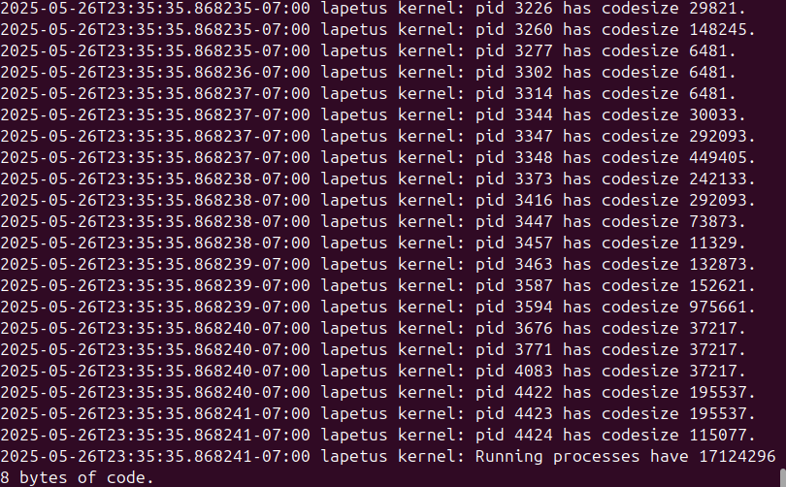
<Q4> – What is the codesize of process #1? This is the Linux kernel’s init process, the parent of all processes.
Write down the codesize of process #1.

Now, in the Linux include files, search for the “mm” member of this data structure.

In the task_struct definition, the mm member may be defined around line 898 of the file.

<Q5> – What is the data type for the mm member of task_struct data structure?
Provide name exactly as it appears in the header file. (case sensitive)

- Inspecting Linux Task Datasize and Heapsize

Next, look up the structure for task_struct’s “mm” member.
This data type (struct) is defined in the mm_types.h include file.
Check the table above on page 4 for the location of this file.

This struct, defined in mm_types, spans many lines of code.
Look for the two members (fields) in the struct that we’ve used in the code above:

field: start_code
field: end_code

Now copy the code_memory() function and create two new functions.
Name one function: “data_memory()” and the other “heap_memory()”.

Replace the use of start_code and end_code in these functions.

In data_memory, use:
field: start_data
field: end_data

In heap_memory, use:
field: start_brk
field: brk

In the init() function modify the printk call to call all three memory functions:

printk(KERN_INFO "Running processes have %lu bytes of code, %lu bytes of data, and %lu bytes of heap.\n", code_memory(),data_memory(),heap_memory());

Rebuild and reinstall the kernel module, and then check the output to /var/log/syslog.
There will be a lot of output lines. Try adjusting the number of lines returned by the tail command to capture data only from your latest version of the kernel module. There should be data for ‘heapsize’, ‘datasize’, and ‘codesize’ and then summary statistics. Adjust the number of lines returned so you do not see any output from the prior runs. This will be roughly ~ 3x the number of processes plus 10.
For example:
$tail -n 650 /var/log/syslog

<Q6> - For PID #1, which segment type utilizes the smallest amount of memory space?
A. Heap
B. Data
C. Code
D. Stack
E. None of the above

<Q7> - For all processes combined, which segment type utilizes the largest amount of memory space?
A. Heap
B. Data
C. Code
D. Stack
E. None of the above

<Q8> - For all processes combined, which segment type utilizes the smallest amount of memory space?
A. Heap
B. Data
C. Code
D. Stack
E. None of the above

<Q9> - Please copy and paste the complete output from your final Linux kernel module from /var/log/syslog into the box below for Question 9. Be sure that the output captures ‘heapsize’, ‘datasize’, and ‘codesize’ of every process, plus the summary statistics. Do not include output from prior testing of the kernel module.

<Q10> - (required) Upload the entire unmodified /var/log/syslog file to Canvas. A web browser such as Firefox can be used on your VM to interact directly with Canvas. Alternatively, try using a web browser to email yourself the syslog file as an attachment, and the submit it to Canvas.

To complete this assignment, to obtain credit, log in to Canvas, and complete the Assignment 3 Quiz.

Generative-AI policy:
Only Generative-AI output produced by Google Search is permitted for this assignment. Google Search combines several LLMs including Gemini to produce intelligent search results. It is not necessary to document the use of LLMs in this assignment. Since this assignment largely requires hands-on step-by-step effort to build kernel modules, it is unlikely that an LLM will be very helpful.

Version | Date | Change
0.1 | 3/5/2026 | Original Version
Please help improve this tutorial by reporting any errors or discrepancies found.

