BES 316 2010
SOIL LABORATORY ANALYSIS
Goals for Today
- To learn about selected approaches in the lab analysis of soils
- To understand equipment applications & limitations
- To explore properties of soils from contrasting field sites
- To understand ecological implications of various soil properties
- To learn about stream benthic macroinvertebrates and biotic indicies

SCHEDULE for MAY 13, 2010
Time Period | Activity
8:45 – 12:00 | Soil processing and analyses
12:05 – 1:05 | Lecture: Introduction to stream macroinvertebrates

TASKS FOR TODAY
As a team of 4 students, you will perform analyses on soils collected at St Edward State Park. You will use either the air-dried soils or oven-dried soils for these analyses. The table below summarizes the types of analyses you will perform. The data from these analyses will be combined from the field soils data for a complete analysis and report due on May 20.

Lab analyses on soil today
Soil pH
Soil organic matter concentration
Soil texture – by mechanical sieving
Soil texture – by hydrometer method

Detailed Procedures

1. Soil organic matter
You should complete your soil organic matter analyses on the samples in the muffle furnace in UW2-231. The following steps are necessary (reprinted from Tuesday’s lab handout):
- You will need to reweigh the crucibles following their combustion (done for you on Wednesday, May 12). With the cover, weigh each crucible with the soil sample on same analytical balance as before (to .0001 grams).
- Be sure the weight makes sense – check the numbers! The burned soil plus crucible weight should be less than the original soil plus crucible weight.
- Once you are done with all of the weights and they make sense (step above), discard the soil samples into receptacles provided, rinse out each crucible with tap water, and leave them upside down on a piece of paper towel to dry.

Calculating Soil Organic Matter Content
Oven-dry Weight – Furnace-dry Weight
% Organic Matter =
x 100
Oven-dry Weight

Oven Dry Wt = (Weight of Oven-dried soil and crucible+lid) - (Weight of empty crucible+lid)
Furnace Dry Wt = (Weight of Furnace-dried soil and crucible+lid) - (Weight of empty crucible+lid)
All weight should be expressed to .0001 grams.
2. Soil pH
We will use a simple pH electrode to assess the pH of our soil samples. Soil pH is influenced by the parent material, vegetation, and precipitation. It can have a strong influence on nutrient availability and the suspectibility of soil nutrients to leaching. The method of using a pH electrode on a soil:water paste is relatively simple and can easily be employed in the field (though we will do it in the lab). You will take 6 readings from each site (6 readings / site x 2 sites = 12 pH readings). You should calibrate your electrode prior to switching to reading soil samples from a different site.

1. Soil Preparation (procedure written for one site – repeat for both sites)
  - Take six samples of about 50 ml each from different parts of one of paper bags of air dried soil and mix them together
  - Sieve this soil through a 2 mm mesh sieve to produce at least 60 - 80 ml of sieved soil (< 2mm). Sieve additional soil from the bag if you do not get 60 - 80 ml of sieved soil.
  - Divide the soil into six 15 - 20-ml samples
For each sample:
  - Fill a plastic sample jar ½ of the way (about 15 ml)
  - Add deionized water up to the first ridge under the threads (for a 1:1 mixture)
  - Mix the soil and water gently into a slurry using a clean stir rod or the clean spoon
  - Let mixture stand for 10 minutes to dissolve the salts before measuring the pH
2. pH Electrode Conditioning
Most pH electrodes require conditioning of the electrode in a solution prior to measurement (this is also true of the many new ion-specific electrodes for measuring ionic constituents of solutions). Your pH electrode will have been immersed in tap water for at least one hour to condition it for use when you arrive in lab.
3. pH Electrode Calibration
Calibrate your pH electrode with the pH 7.0 buffer solution using the following steps:
    - Mixing the pH 7.0 buffer solution
  - Rinse the calibration jar with deioninzed water and make sure it is clean.
  - Fill the jar with deioninzed water to the first ridge under the threads
  - Add ONE tablet of pH 7.0 buffer
  - Replace the jar cap and shake vigorously until the tablet is broken up and mostly dissolved
B. Calibrate your pH Electrode
  - Remove the electrode cap and rinse the electrode gently with a stream of deionized water from a wash bottle.
  - Press the ON/OFF button to turn the power on.
  - Immerse the pH electrode at least 0.5 inches into the pH 7.0 buffer solution.
  - Stir the solution once or twice with the electrode
  - Press the CAL button. The abbreviation CAL should flash and the current reading should be displayed. Wait at least 30 seconds for the reading to stabilize.
  - When the reading is stable, press the HOLD/CON button to record the calibration. The abbreviation CO and the calibration value (7.0) should be displayed.
  - Rinse the electrode with deionized water and then return it to the beaker of tap water.
4. pH Readings
  - Remove electrode from the tap water. Rinse it thoroughly with deionized water.
  - Place electrode into the soil slurry.
  - Turn on the pH tester and wait for a stable reading.
  - Rinse the electrode thoroughly with tap water and make sure it is CLEAN (free of any debris). At this point you mayeither rinse the electrode thoroughly with deionized water and take another reading (on a different sample) or place it back into the tap water holding solution.

3. Soil texture by mechanical sieving
The determination of soil texture by mechanically separating particle size class with sieves and weighing those constituents is a relatively easy, rapid, and common approach to gathering information about texture. Unfortunately, it is not practical to separate clay (< .002 mm diameter) and silt (.002 to .05 mm diameter) constituents using this method. Thus, we will supplement this approach with the hydrometer method (part 4 below) which will allow the separation of those constituents.

You will be measuring FOUR replicate samples from each site (one from each of the 4 paper bags):
- 4 samples per site x 2 sites = 8 soil samples for mechanical sieving
Prepare soil:
- For each sample take 700 ml of air-dried soil from a paper bag and remove any large organic debris (the remainder of the soil in the bags will be used for part 4 below).
- Grind the soil in a mortar and pestel to eliminate soil aggregates.
Analysis:
- Place the 700-ml sample into a clean set of nested sieves (2 screens, a lid, & a bottom pan).
- Vigorously shake for 3 minutes.
- On a top-loading balance, separately weigh (to .01 grams) the soil components retained on each sieve and in the bottom collection pan.
The material trapped on top of your upper sieve is gravel.
The material trapped on top of your middle sieve is sand.
The material in your bottom pan is a combination of silt and clay.
The USDA size classes based upon particle diameters are: gravel is >2 mm in diameter; sand 2.0-.05 mm; silt .05-.002 mm; clay <.002 mm. Clay particles are too small to quantitatively separate from silt by mechanical sieving. The hydrometer method described below in part 4 can do that. Calculate the % soil weight in each of the three soil fractions listed above (equations below).
- Be sure to use a brush to carefully clean each sieve (or bottom pan) to get all the material for weighing. Also clean the sieve set thoroughly for the next sample. Dispose of used soil in containers provided. Use plastic weigh boats provided to keep the balances clean – but be sure to tare the balances correctly for the plastic weigh boats. If you don’t know how to do this – ASK FIRST!
- Record the weights and calculated values of texture classes (below)

% gravel = (weight of gravel / weight of total sample) x 100
% sand = (weight of sand / weight of total sample) x 100
% silt+clay = (weight of silt + clay / weight of total sample) x 100
weight of total sample = (weight of gravel) + (weight of sand) + (weight of silt+clay)

4. Soil texture by hydrometer
You will be measuring 4 replicate samples from each site:
- 4 samples per site x 2 sites = 8 soil samples for hydrometer measurements
- Use air-dried soil from the paper bags (one sample from each bag).
For each sample:

- Take about 200 ml of air dried soil from a paper bag and sieve it through a 2-mm mesh sieve.

- Weigh out ~50g of soil and record the exact mass to .01 grams on a top-loading balance.

- Transfer the soil to a metal mixing cup. Fill the cup to the second indentation with deionized water. Add 10mL of the dispersing agent, 10% sodium hexametaphosphate solution.

- Place the mixing cup on the mixer. Insert the lip of the cup in the upper container support on the stand of the mixer and rest the bottom of the cup on the lower container rest. Make sure the cup is secure. Turn on the mixer to the lower setting. Mix the soil suspension for 10 minutes. Monitor your sample while it is mixing. Roots can get tangled around the moving parts, causing liquid to spray out of the cup.

- Transfer the suspension to a 1-L glass graduated cylinder. Wash all of the soil from the mixing cup into the cylinder with a wash bottle of deionized water.

- Add deionized water to the cylinder to bring the volume of the suspension up to 1L.

- Hold the cylinder steady with one hand. Mix the soil suspension vigorously by moving the mixing tool up and down through the cylinder for 1 minute. As soon as you stop mixing, start timing.

- Immediately place the hydrometer GENTLY into the cylinder (we only have one!).

- Take a hydrometer reading 40 seconds after you remove the mixing tool. Record the reading. (The reading is the number visible at the surface of the water line.)

- Repeat steps 6-8 and record a second reading. Calculate the average of the two 40 second readings.

- Carefully insert the thermometer into the suspension. Read and record the temperature of the suspension. Temperature changes the viscosity of water, so if the temperature is >68°F, add 0.2 to the hydrometer reading for each degree above. If it is <68°F, subtract 0.2 for each degree below.

- Wait two hours and take a second set of readings reading (steps 7-9). DO NOT MIX AGAIN.

- Read and record the temperature of the suspension.

- Calculate the percentages of sand, silt, and clay using the equations given below.

Calculations:
40 sec reading (corrected for temperature) = grams (silt + clay) / liter
%Sand = {[(sample weight) – grams (silt + clay)]/(sample weight)} x 100
2 hr reading (corrected for temperature) = grams (clay) / liter
% Clay = {grams (clay) / (sample weight)} x 100
% Silt = 100 – (% Sand + % Clay)
You can use the hydrometer results to determine the soil texture class of your soils as expressed by the USDA soil texture class triangle (presented in lecture on May 4).

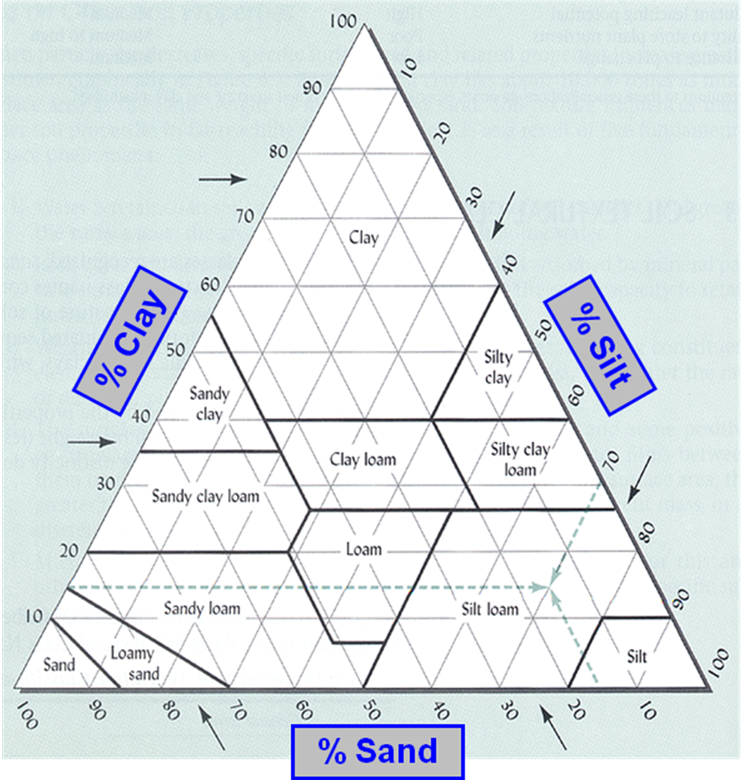
USDA Soil Texture Class Triangle

DATA ANALYSIS & COMPARISONS
You should focus on comparing the soil environment at the two sites. In the case of soil texture you will be able to analyze the differences and/or similarities in the conclusions developed through three different techniques (field texture analysis, mechanical sieving, and hydrometer). For your discussion you will need to draw upon information concerning the ecological implications of the variables being measured. I will have introduced these things briefly in the May 4 lecture and there is more detail in the electronic reserve reading for May 4. I can provide suggestions for further readings upon request.

PRODUCTS
1. Written Report
Each student should submit an INDIVIDUAL written report at the start of class on May 20. You should share the raw data collected among your group members, but do the calculations independently. This report will include (in an explicitly structured manner):
- A written summary of the results such as one would in a “Results” section of a scientific paper. Be sure to include ALL of the soil data that were collected – in the field and in the lab! Please make this double spaced. There are no page restrictions, but I would not expect much more than 4-6 pages of text (not including a number of illustrations).
- A section interpreting those results such as one might find in a “Discussion” section of a scientific paper. Cite references where appropriate (though I do not expect an extensive literature search – use the class readings and other easily available materials, such as background materials from your previous course in basic ecology).
- Unlike your previous papers, I expect you to interpret your results in light of the vegetation analysis results you obtained at these two forest sites. You need not present the vegetation analysis results in the Results section here – but you should present relevant vegetation analysis data that you discuss, where you discuss it in the “Discussion” section. You can think of presenting it as if you were bringing in data from another published paper for discussion.
- This paper should be of the highest quality, using feedback from your previous lab reports in this class.
- The illustrations (tables and figures) used for analysis
- Any other graphics you might generate to present ideas
- Literature cited list (if appropriate)

The emphasis in grading will be on your analysis, but presentation will also be a significant factor. You should treat all written products for this class as you would a professional paper with a target audience of well educated peers not taking this same class. It should be well written, with close attention paid to clarity of writing and brevity (but not at the expense of completeness).

