MODERN PHYSICS AND THE NEW COSMOLOGY

On Creation in Physics , Music and Elsewhere

January 14 2018 at 10 AM in the Great Hall, the Epiphany Parish, Seattle *Vladimir (Vladi) Chaloupka, University of Washington*

With both exuberance and humility, we will discuss how Physics is beginning to address issues previously thought to be in the exclusive domain of Philosophy and Theology. This will be illustrated on several specific topics such as the nature of the vacuum, the possibility of *Creatio Ex Nihilo*, or the life-giving role of extremely violent physical processes, and we will contemplate the awesome enormity of space and time.

Our examples will attempt to show that Physics can be a useful (perhaps even an indispensable) partner of Philosophy, Art and Theology in focusing our inner gaze on something higher, much higher than ourselves. And if there is time, we will not be able to resist mentioning the role of the “Amadeus phenomenon” of Johann Sebastian Bach[sic] in this worldview.

* ------------------

Vladi Chaloupka was born in what is now the Czech Republic, when it was under Nazi occupation. He grew up in the country subsequently dominated by the Soviet Union. In 1968 he experienced a “shock and awe” invasion, and escaped to Switzerland. There he obtained his PhD in Physics from the University of Geneva, and worked as a particle physicist at CERN. In 1975 he moved to the Stanford Linear Accelerator Center in California, and in 1981 he came to the University of Washington. After a career in experimental elementary particle physics, he is now working on merging his life experience with his three passions: science, music and human affairs, into one coherent whole

At the University of Washington, Dr. Chaloupka is Emeritus Professor of Physics, originally specializing in the Experimental Particle Physics, and lately in the Foundations of Quantum Mechanics. For many years, he has also taught *Physics of Music* for the UW School of Music, and *Science and Society* for the Henry M. Jackson School of International Studies. He lives in a cabin on a forest glade 25 miles east of Seattle, where he can play organ at night without disturbing any (human) neighbors.

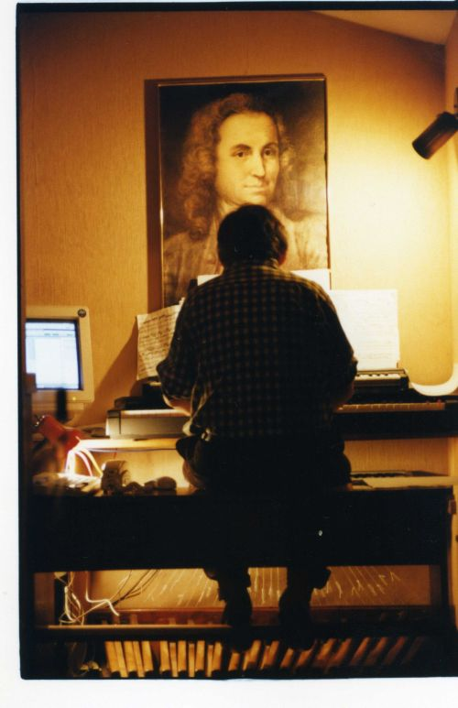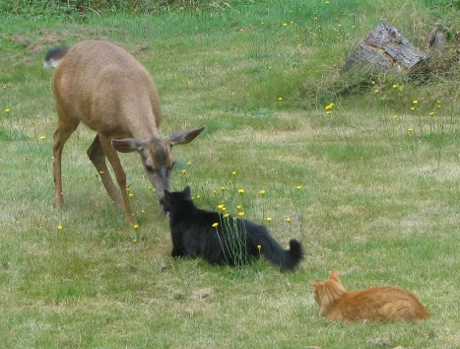

Presentation Outline

Note: At 10:55 we will take a brief break so that people going to the 11 AM service can leave. For the remaining audience (if any) we will have a question and comments period.

Note: I prepared more than I can present in 50 minutes. I hope that some participants will find it interesting to complete the presentation on their own, using resources on my website (faculty.washington.edu/vladi ). I will do my best to respond to all questions and/or comments sent to me at vladi@uw.edu

Ia Why is there Something rather than Nothing?

1b The Universe is practically empty

1b1 On atomic scale

1b2 On Solar system scale

1b3 On Cosmological scale

Ic But the vacuum is not really empty

Id The evolution of the Universe is breathtaking

1d1 The Big Bang

1d2 Inflation

1d3 the Grand Cosmic Recycling

1d4 extreme violence accompanying Creation (BigBang, inflation, supernova, ( neutron stars, black holes, collision of galaxies)

Ie the Fermi paradox

IIa Evolution of the Universe vs. evolution of Life

IIb a Grand mini-tour of the Universe

III Conclusions from Physics

IVa three views of Albert Einstein

IVb J.S.Bach, the Amadeus phenomenon, and Creation in Music

V Conclusion