Administration and Management Class Roster

Winter-Spring 2005

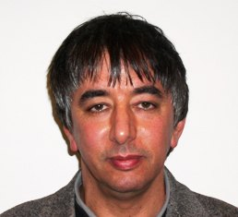 | Mohamed El Hadi Aggoune  Email:  mohsen@u.washington.edu  h.aggoune@henrycogswell.edu  Undergraduate Degree  National Polytechnic School, Algiers  Graduate Education  M.S and Ph.D in Electrical engineering, Univerisity of Washington  Work Experience  Vice President and Provost, Henry Cogswell College, Everett, WA
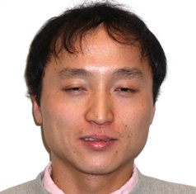 | Toshitaka Arai  toshia@u.washington.edu  Email:  toshia@u.washington.edu  tosharai@hotmail.com  Undergraduate Degree  Engineering (U of Tsukuba)  Work Experience  Life Insurance Company (IT division)  Consulting (IT & software)
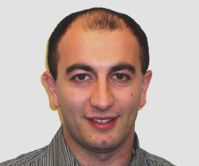 | Dimitri Arutiunov  Email:  dima1234@u.washington.edu  dimitri12@yahoo.com  Undergraduate Degree  Business and management training  Graduate Education  Work Experience  Restaurant Manager, Yankee Grill
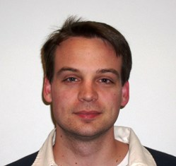 | Jeremy R Baker  Email:  jbaker99@u.washington.edu  JeremyBaker99@hotmail.com  Undergraduate Degree  Graduate Education  Work Experience  Manager, Northwest Hobbies.  14 years of retail experience
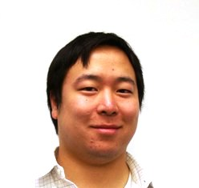 | Samuel Yoshiyuki Chayavichitsilp  Email:  sammyc@u.washington.edu  sammyc521@hotmail.com  Undergraduate Degree  BA in English and writing, Western Washington University  Graduate Education  Work Experience  Customer Service and accounts payable/receivable  Assistant Manager at a retail store
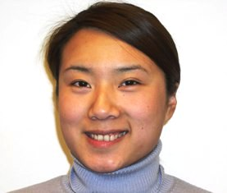 | “Jennifer” Hui-Hsin Cheng  Email:  huihsin@u.washington.edu  Undergraduate Degree  B.S. Chemistry and International Studies, University of Washington  Graduate Education  Work Experience  Guest Services, Watertown Hotel  Public Relations, Seattle Asian Museum
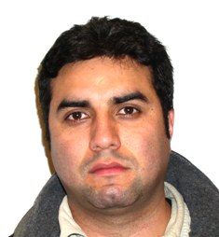 | Vitalo Renzo Delucchi  Email  vitalod@comcast.net  Undergraduate Degree:  International Studies, University of Washington  Graduate Education:  None  Work Experience:  Public Health Clinics, Customer Service
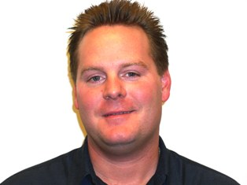 | Jeffrey D Falconer  Email:  falcoj@u.washington.edu  jefffalconer@comcast.net  Undergraduate Education:  Graduate Education:  Work Experience  Service Manager, Barrier Porsche Bellevue, WA
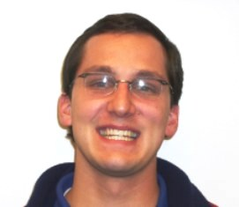 | Brian R George  Email:  brgeorge@u.washington.edu  brianrgeorge@mac.com  Undergraduate Degree  BA in International Studies, University of California at Irvine.  Graduate Education  Thinking of an MBA  Work Experience  Special project manager, James Hardie Company  Building sales
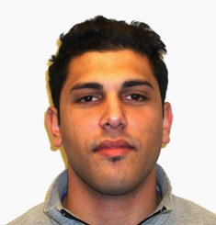 | Ameer Hashish  Email:  ameerh@u.washington.edu  Undergraduate Degree  BS in business economics, University of Washington  Graduate Education  Work Experience  Sales Team Lead, VMC Consulting  Product manager, Engagement Software
 | Caroline A Heckathorn  Email:  cah9@u.washington.edu  checkathorn@answorld.com  Undergraduate Degree  BS in Nutritional Science, UC Davis  Graduate Education  Work Experience  Manager, Custom Programming AMS Services, Inc
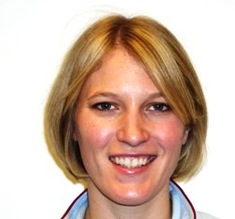 | Emily Frances Hill  Email:  efhill@u.washington.edu  emilyfhill@hotmail.com  Undergraduate Degree  BS psychology, University of Washington  Graduate Education  Work Experience  District Manager, Outside Sales, ADP
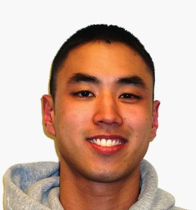 | John Y Ishii  jishii@u.washington.edu  Email:  jishii@u.washington.edu  john_ishii@hotmail.com  Undergraduate Degree  BS exercise & sports science, Western Washington  Graduate Education  Work Experience  Personal Trainer/Assessment Coordinator  Pro Sorts Club
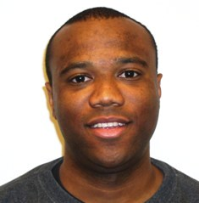 | Richard A Johnson  Email:  richjohn@u.washington.edu  Undergraduate Degree  B.S. Aerospace Engineering, U of Minnesota  Graduate Education  Working on MS in aerospace engineering  Work Experience  Engineer, Boeing  Pilot and flight instructor
 | Joshua Hunter Jozwik  Email:  jhawver@u.washington.edu  jjozwik@hotmail.com  Undergraduate Degree  BA in political science and economics, University of Washington  Graduate Education  Work Experience  Clerical recruiter/systems administrator, Amgen  Legal investigator (PI)
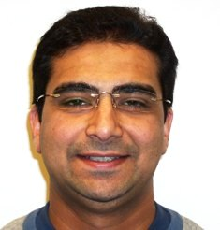 | Ashish Lakhani  Email:  Lakhaniashish@gmail.com  Undergraduate Degree  B.S. in business and marketing in India  Graduate Education  Work Experience  President, Reliable products Inc. and PureFarm Organics  IT Business Analyst
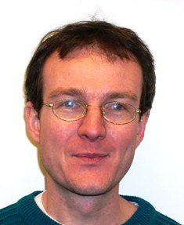 | Renaud Lecoeuche  Email:  renaudle@u.washington.edu  renaud.us@hotmail.com  Undergraduate Degree  Applied mathematics, INSA, France  Graduate Education  Work Experience  Software Engineer, Microsoft
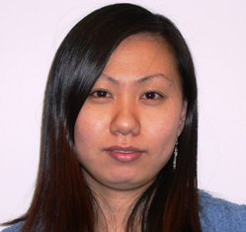 | Michelle Liu  liujing@u.washington.edu  Email:  liujing@u.washington.edu  Undergraduate  BSc – Computer Science  Nanjing University in China  Graduate  Master in computer science  Hong Kong University of Science & Technolgy  Grad student in Computer Science (UW)
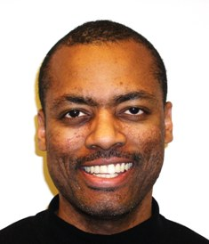 | LaMar Andre Lowe  Email:  lamar@u.washington.edu  lalowe@comcast.net  Undergraduate Degree  BA in Political Science, University of Washington  Graduate Education  Thinking of an MBA  Work Experience  Faculty Practice Manager, UW Dental School
 | Joshua J Malle  Email:  jmalle@u.washington.edu  joshmalle@hotmail.com  Undergraduate Degree  BA in Philosophy  Graduate Education  Work Experience  SPHR certified in human resources.  Managed a transcription service
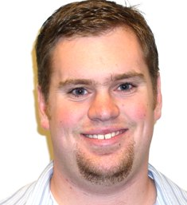 | Dru Garrett Metz  Email:  dmetz@u.washington.edu  dru.metz@gmail.com  Undergraduate Degree  Finishing a BA in Philosophy and History  Graduate Education  Work Experience  UW Astronomy Department
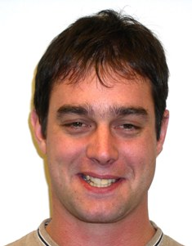 | Nicholas G Newhall  Email:  ngn@u.washington.edu  paddleyale@yahoo.com  Undergraduate Degree  BS, Aerospace Engineering  Graduate Education  Engineering Management course, Washington State  Work Experience  Stability Engineer, Boeing
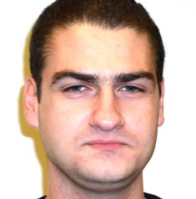 | Panayiotis Nicolaou  Email:  ngn@u.washington.edu  p_nicolaou@hotmail.com  Undergraduate Degree  Graduate Education  ME in Aerospace Engineering, UMIST in England  Work Experience  Design Engineer, Boeing Company
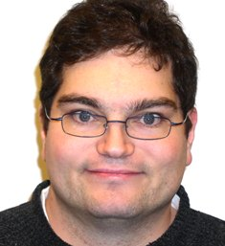 | Christopher J Norehad  Email:  cnorehard@oz.net  Undergraduate Degree  BA in business administration, Gonzaga University  Graduate Education  Work Experience  Network administrator, Lumedx
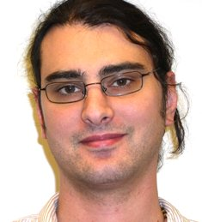 | Paul Coburn Norehad  Email:  pnorehad@u.washington.edu  pnorehad@hotmail.com  Undergraduate Degree  B.S. in psychology, Santa Clara University  Graduate Education  Work Experience  IT helpdesk, Cingular Wireless  Network Administrator
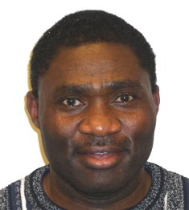 | Martin U Okoli  Email:  okolim@u.washington.edu  Undergraduate Education:  Agricultural engineering, Nigeria University  Graduate Education:  M.S. Resources Engineering, Germany  Work Experience  Grove Operations Manager, Cedar Grove Composting Inc. Maple Valley
 | Jerry Bautista Pineda  Email:  206-265-1368  Undergraduate Degree  Graduate Education  Work Experience  Project management Assistant.  Contruction
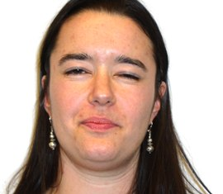 | Joelle E Rudenick  Email:  jerbil33@u.washington.edu  joeller33@comcast.net  Undergraduate Degree  BS Archaeology, University of Minnesota  Graduate Education  Work Experience  Director of Customer Accounts, MedRecs
 | Kelly M Rutherford  Email:  kelrut@u.washington.edu  krutherford@peacehealth.org  Undergraduate Degree  BS in physical therapy from Eastern Washington University  Graduate Education  Work Experience  Physical Therapist, St. Joseph’s Hospital
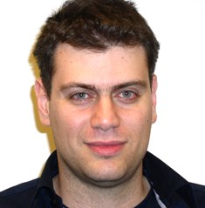 | Manolis Sergides  Email:  Manolis.sergides@boeing.com  Undergraduate Degree  Engineering Design. Warwick University  Graduate Education  Advanced Mechanical Engineering  Work Experience  Stress Analyst, Boeing
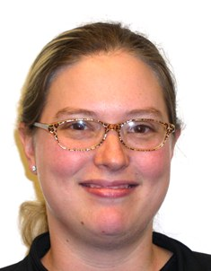 | Sarah E Shults  Email:  sshults@u.washington.edu  Undergraduate Degree  A.A. General Studies. Green River Ciollege  Graduate Education  Work Experience  Business Manager, Weinstein A/U Architects and Urban Designers  Patient Care Coordinator
 | Lisa Ann Tiedt  Email:  ltiedt@u.washington.edu  Undergraduate Degree  BA in advertising, Iowa State University  Graduate Education  Certificate in User-Centered Design  Work Experience  Product Manager, Microsoft  5 years marketing experience
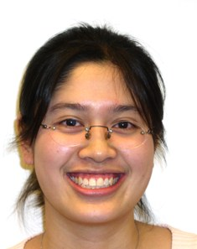 | Amy Y Tsang  Email:  tsangay@u.washington.edu  ammers23@hotmail.com  Undergraduate Degree  B.S.degree in Biology from Whitman College  Graduate Education  Clincial trials program.  Work Experience  Woman’s Clinic at Evergreen, Admin. Assistant  Northwest Headache clinic, Research Assistant
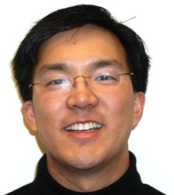 | Allan Kin Han Yeung  Email:  akyeung@u.washington.edu  akyeung@gmail.com  Undergraduate Degree  Bs Electrical Engineering, University of Washington  Graduate Education  MS Electrical Engineering, University of Washington  Work Experience  Analog Engineer, Intel Corporation

