Face | Name | Committees | Twitter | E-mail | Address | Phone
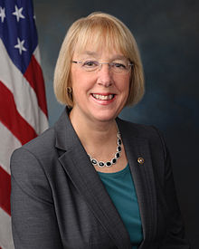 | US Senator Patty Murray (D) | Appropriations; Budget; Veteran’s Affairs; Health,  Education, Labor & Pensions | @PattyMurray | https://www.murray.senate.gov/public/index.cfm/contactme | DC: 154 Russell Senate Office Building (20510)  Seattle Office: 915 2nd Avenue, Suite 3206 (98174) | Seattle: (206) 220-6400  DC: (202) 224-3441
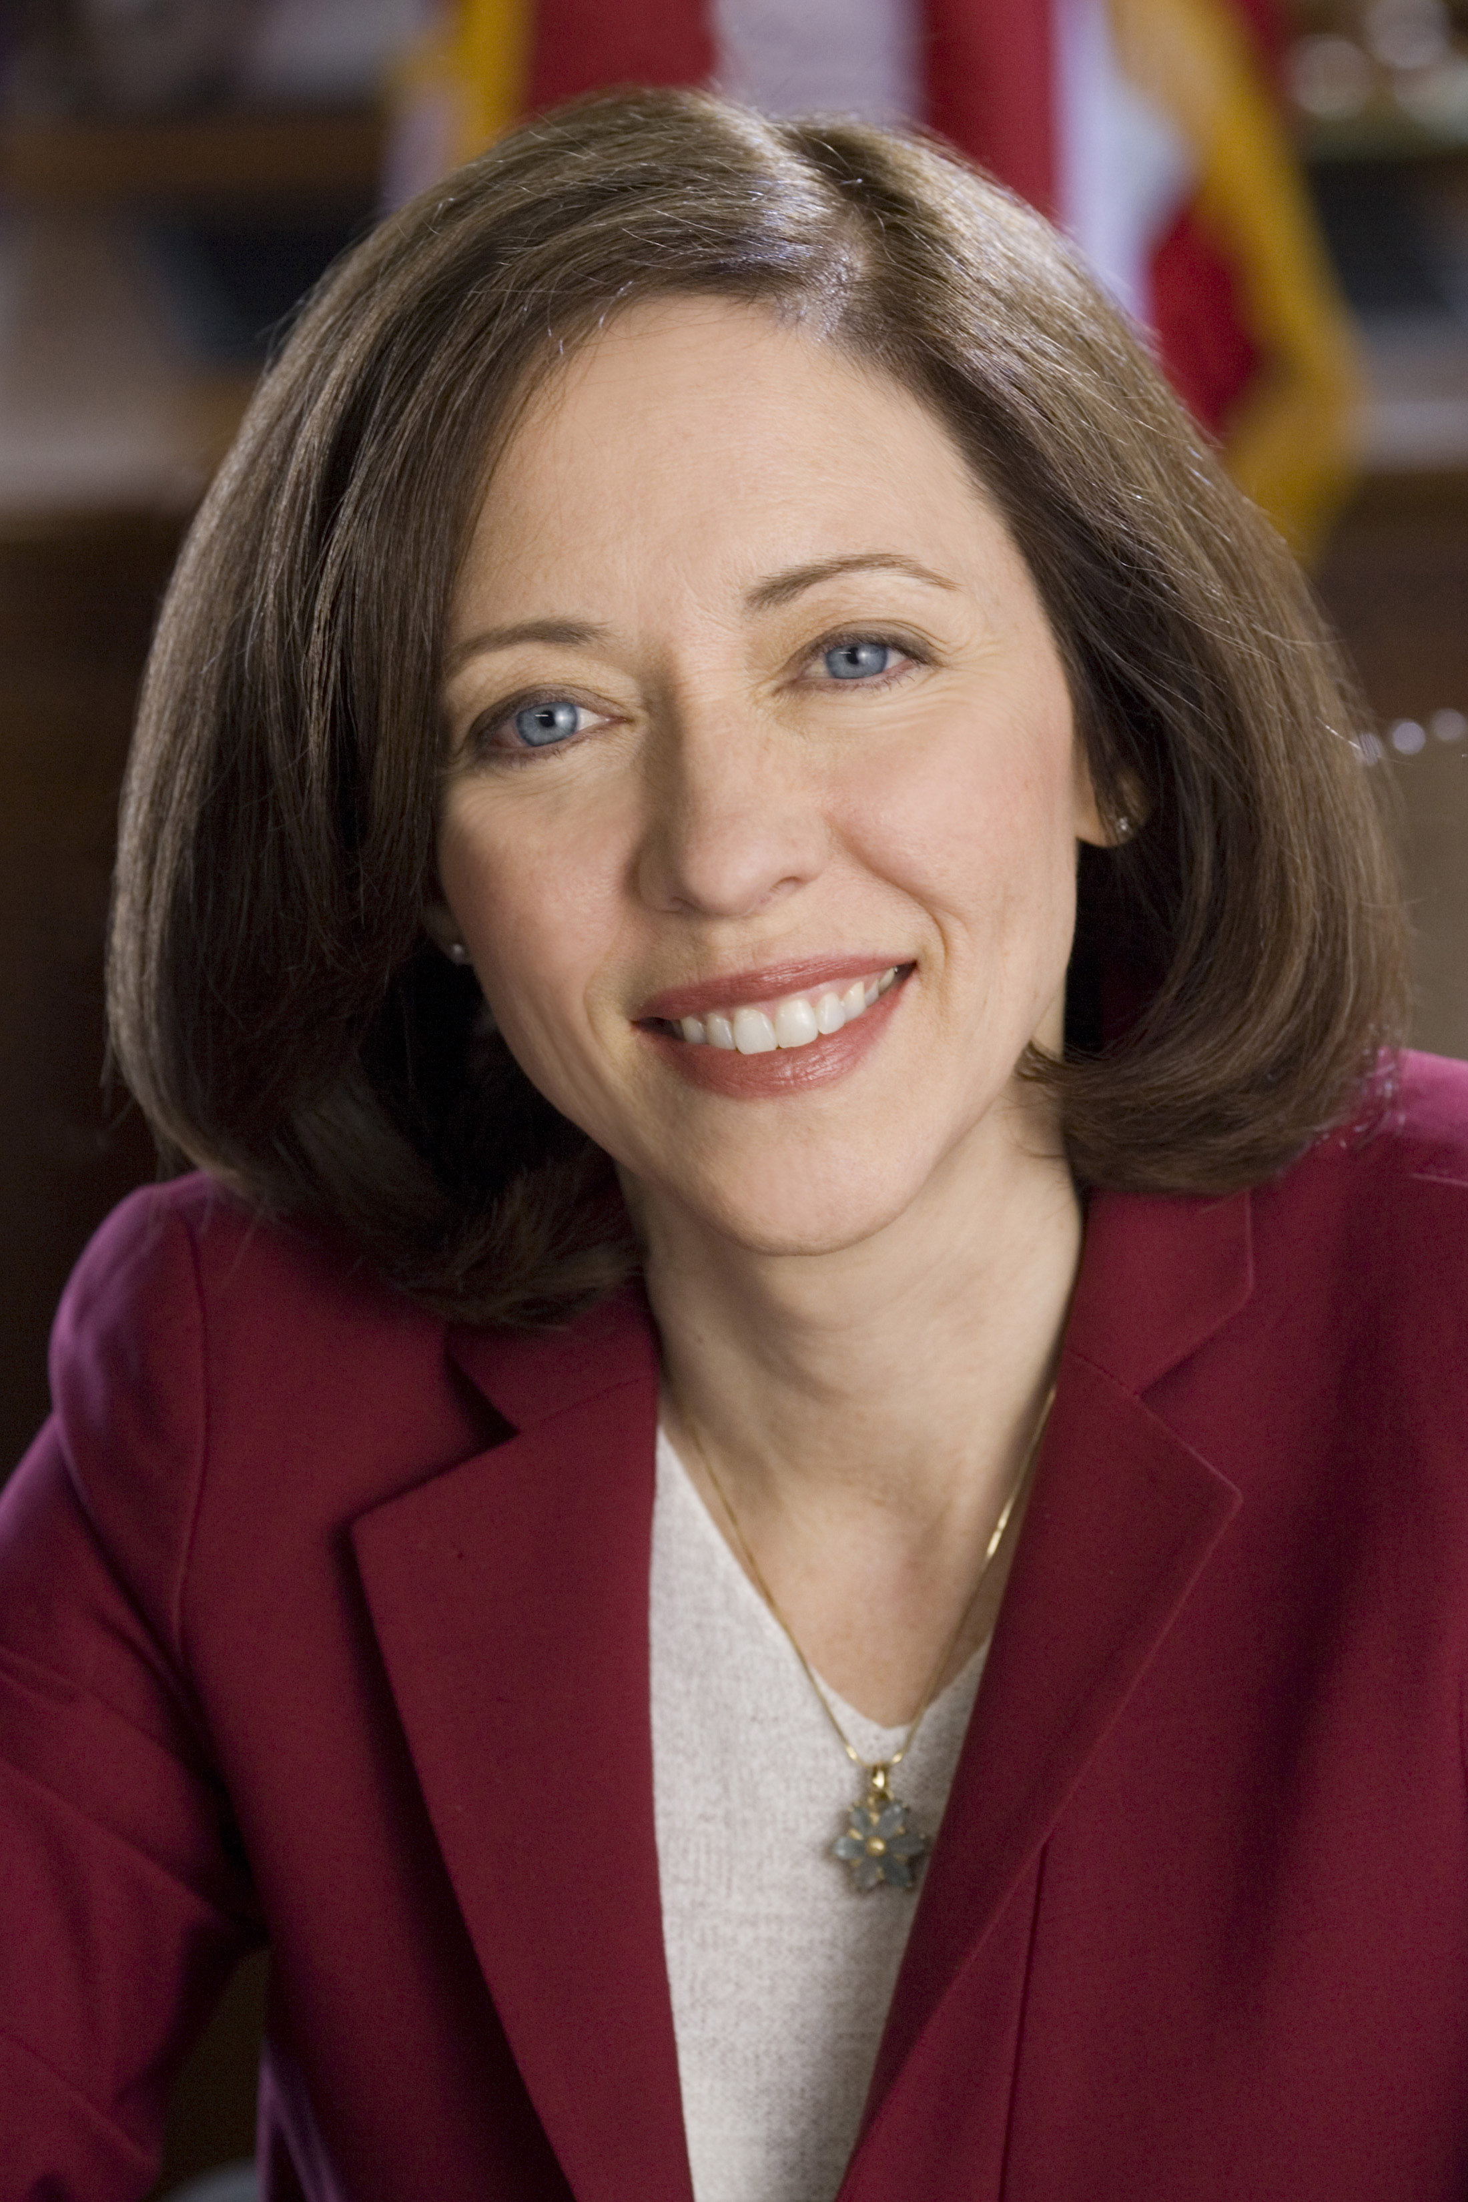 | US Senator Maria Cantwell (D) | Commerce, Science & Transportation, Energy & Natural Resources; Finance, Small Business & Entrepreneurship; Indian Affairs | @SenatorCantwell | https://www.cantwell.senate.gov/contact/email/form | DC: 311 Hart Senate Office Building (20510)  Seattle: 915 2nd Avenue, Suite 3206 (98174 | Seattle: (206) 220-6400  DC: (202) 224-3441
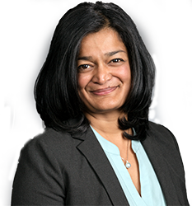 | US Rep Pramila Jayapal (D)  7th District | Budget, Judiciary, Immigration and Border Security, Regulatory Reform, Commercial and Antitrust Law | @pramilajayapal | https://jayapal.house.gov/contact | DC: 319 Cannon House Office Building  Washington, DC 20515  Seattle: 904 3rd Ave., Suite 510 Seattle, WA 98101 | DC: 202-225-3106  Seattle: 206-674-0040
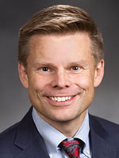 | State Senator Jamie Pedersen (D)  43rd legislative District | Committees  Law & Justice (Ranking Minority Member)  Ways & Means |  | https://app.leg.wa.gov/pbc/memberEmail/43/0 | Olympia: 235 John A. Cherberg Building  PO Box 40443  Olympia, WA 98504 | (360) 786 - 7628
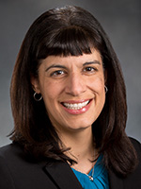 | State Rep Nicole Macri (D)  43rd legislative District | Community Development, Housing & Tribal Affairs (Vice Chair)  Health Care & Wellness (Vice Chair)  Capital Budget | @votenicolemacri | https://app.leg.wa.gov/pbc/memberEmail/43/1 | Olympia: 311 John L. O'Brien Building  PO Box 40600  Olympia, WA 98504 | (360) 786 - 7826
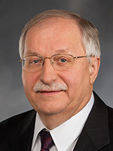 | State Rep Frank Chopp (D) Speaker  43rd legislative District | Rules (Chair) | @WAHouseDems | https://app.leg.wa.gov/pbc/memberEmail/43/2 | Olympia: 339C Legislative Building  PO Box 40600  Olympia, WA 98504 | (360) 786 - 7920
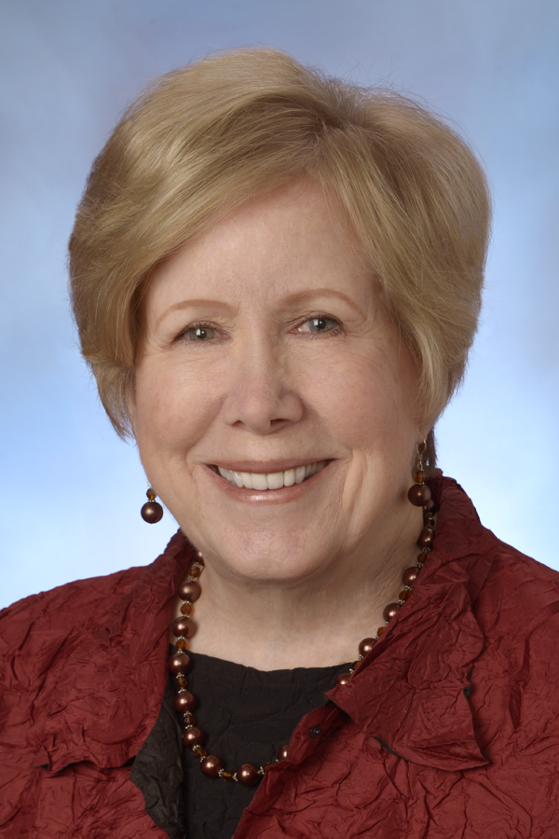 | King County Councilmember Jeanne Kohl-Welles (D)  4th District | Budget and Fiscal Management; Committee of the Whole; Law and Justice; Transportation, Economy and Environment | @JKohlWelles | jeanne.kohl-welles@kingcounty.gov | 516 Third Ave, Room 1200. Seattle, WA 98104 | 206-477-1004

