SCICHEM Version 3.0 (Beta 2)

USER’S GUIDE

B.Chowdhury, R. I. Sykes, D. S. Henn and S. F. Parker
Sage Management
15 Roszel Road, Suite 102
Princeton, NJ 08540

P. Karamchandani and B. Brashers
ENVIRON
773 San Marin Drive, Suite 2115
Novato, CA 94998

March 2014
(Version 0.3)

CONTRACT No. EPRI P41371/C18223
ACKNOWLEDGEMENTS

The authors of this report would like to acknowledge the contributions of Steven Schneider of Sage Management.
This Document is based on SCICHEM 1.0 USER’S GUIDE by L. Santos, R. I. Sykes, D. S. Henn and S. F. Parker.

FIGURES 4
TABLES 7
1 INTRODUCTION 9
1.1 Overview of the SCICHEM Model 11
1.1.1 Basic Input Data Requirements 11
1.1.2 Computer Hardware Requirements 12
1.1.3 Modeling Options 12
1.1.4 Starting SCICHEM 13
1.1.5 Keywords Parameter Approach 15
1.1.6 Namelists Approach 16
2 SCICHEM METEOROLOGICAL PREPROCESSOR (METSCI) 1
2.1 Job Pathway 1
2.2 Surface Pathway 1
2.3 Upper Air Pathway 2
3 INPUT FILE FORMATS 4
3.1 NAMELISTS Input Format 4
3.1.1 Main Input File 5
3.1.2 Release scenario file. 12
3.1.3 Meteorology Scenario File. 15
3.2 KEYWORDS Input Format 21
3.2.1 Overview 21
3.2.2 Description 21
3.2.3 Control Pathway Inputs and Options 23
3.2.4 Material Pathway Inputs And Options 30
3.2.5 Source Pathway Inputs and Options 33
3.2.6 Receptor Pathway Inputs And Options 43
3.2.7 Meteorology Pathway Inputs and Options 47
3.3 Multicomponent input File. 50
3.3.1 Multicomponent Control Section. 51
3.3.2 Aqueous-Aerosol Section. 52
3.3.3 Multicomponent Species Section. 53
3.3.4 Multicomponent Equation Section. 58
3.3.5 Multicomponent Table Section. 64
3.3.6 Ambient Concentration Input. 65
3.4 Sampler Location File. 70
3.5 Meteorology input. 79
3.5.1 Observation File Format. 79
3.5.2 MEDOC Format. 88
3.5.3 Extended MEDOC Header Format. 92
3.5.4 List input 96
3.5.5 Terrain File Format. 97
3.5.6 Landuse File Format. 100
4 RUNNING SCIPUFFgui 102
4.1 Creating a new project. 102
4.1.1 New Project Setup. 103
4.1.2 Project Coordinates. 103
4.1.3 Reference times. 104
4.1.4 Project Description. 104
4.1.5 New project editor 106
4.2 Material Editor 106
4.2.1 Gas Material. 108
4.2.2 Particle Material. 109
4.2.3 Liquid Material. 112
4.3 Release Editor 115
4.3.1 Continuous Release Type. 116
4.3.2 Instantaneous Release Type. 119
4.3.3 Moving Release Type. 121
4.3.4 Stack Release Type. 123
4.3.5 Release of Particle Materials. 125
4.4 Time Editor 126
4.4.1 Time Reference 127
4.4.2 Start Time 127
4.4.3 Stop Time 127
4.4.4 Time Intervals 127
4.4.5 Restart Time 128
4.5 Domain Editor 129
4.5.1 Domain Reference 129
4.5.2 Horizontal Domain 130
4.5.3 Vertical Domain 130
4.5.4 Local Origin 130
4.6 Weather Editor 131
4.6.1 Weather Data Types. 131
4.6.2 Large Scale Variability. 137
4.6.3 Additional Weather Input Parameters. 140
4.6.4 Meteorological Options 142
4.7 Audit Editor 146
4.8 Options Editor 147
4.8.1 Resolution 148
4.8.2 Stable Atmosphere 149
4.8.3 Parameters 149
4.8.4 Calm conditions 150
4.8.5 Substrate 150
4.8.6 Sampler Output 150
4.9 Starting a run. 150
5 OUTPUT FILES 153
5.1 Surface Output Files 153
5.2 Puff File 158
5.3 Sampler Time-History File. 161
5.4 Project Log Files 164
5.5 Project Err File 165
6 POST-PROCESSING PROGRAMS. 166
6.1 Generating Post Files 166
6.1.1 Usage 167
6.2 Class I Analysis Post-processor 168
6.2.1 Control File Structure 169
6.2.2 Usage 172
6.3 Reviewing using SCIPUFF Graphical User interface (SCIPUFFgui) 173
6.3.1 Project Viewer 175
6.3.2 Project Coordinates 176
6.3.3 Project Description 176
6.4 Plotting using SCIPUFF Graphical User Interface 177
6.4.1 Plot Control 178
6.4.2 Plot Options. 185
6.4.3 Axes 187
6.4.4 Options 190
6.4.5 Contours 192
6.4.6 Titles 196
6.5 Material Choice. 197
6.6 Plot Choice. 197
6.6.1 Plot type 198
6.6.2 Plot value 198
6.6.3 Time (hrs) 199
6.6.4 Additional parameters 199
6.6.5 Selecting vertical slices 200
7 INSTALLING AND RUNNING SCICHEM 202
7.1 Installation 202
7.2 Running the Model 203
7.3 Building from Source 204
8 REFERENCES. 205

FIGURES
Figure Page
Figure 3-1 Sample SCICHEM input file. 7
Figure 3-2 Sample SCICHEM release scenario file. 13
Figure 3-3 Sample SCICHEM meteorology scenario file. 19
Figure 3-4 Sample Control Section of the IMC file. 52
Figure 3-5. Sample Species sections of the IMC file. 56
Figure 3-6 Sample Equation Section of the IMC file. 64
Figure 3-7 Sample Table Section of the IMC file. 64
Figure 3-8 Fortran pseudo-code for reading a formatted ambient concentration file in MEDOC format. 67
Figure 3-9 General structure of the SCIPUFF format sensor location file. 69
Figure 3-10 Examples of header records in an SCIPUFF sensor location file 72
Figure 3-11 Two examples of output time lists in an SCIPUFF sensor location file. 73
Figure 3-12 SCIPUFF SENSOR location file showing several examples of sensor input. 77
Figure 3-16: General structure of the special native coordinate header section. 93
Table 3-11 Recognized vertical coordinates and associated input. 94
Figure 3-17. General structure of a meteorology “list” input file. The first line must consist of the string ‘SCIPUFF_LIST’. The square brackets indicate optional input, i.e., multiple files may be specified but only one is required. 95
Figure 3-18. General structure of a terrain file. 96
Figure 5-1 Fortran statements to write a surface output file timebreak. 153
Figure 5-3. Examples of multicomponent sampler output. 163
Figure 6-1. Sample AVS Export File 181

TABLES
Table Page
Table 3-1 SCICHEM ME Pathway Input File Types. 47
Table 3-2 SCICHEM Species Types. 54
Table 3-3 Required species names for the aerosol equilibrium module and aqueous-phase chemistry module 57
Table 3-4 Header record keywords and input for SCIPUFF sensor location format. 70
Table 3-5 Sensor type keywords. 74
Table 3-6 Required sensor input for various sensor types. 74
Table 3-7 Sensor classes 75
Table 3-8 Choices for various sensor classes 76
Table 3-9: Meteorological variables and their units recognized in SCICHEM. 85
Table 3-10 Recognized map projections and associated input. 91
Table 3-11 Recognized vertical coordinates and associated input. 94
Table 3-12: Valid file types for meteorology list input file. 96
Table 3-13: Valid indices and associated landuse types for terrain files with first header record ‘LAND_USE = CATEGORY’. 99
Table 4-1 Typical Bowen Ratios. 134
Table 4-2 Typical Albedo Values. 134
Table 4-3 Assumed Mixing heights for use with PGT or MOL. 135
Table 4-4 Suggested values for surface roughness (Saucier, 1987). 140
Table 4-5 Precipitation Categories. 141
Table 5-1. Sensor output variables. 162

INTRODUCTION
SCIPUFF is a Lagrangian transport and diffusion model for atmospheric dispersion applications. The acronym SCIPUFF stands for Second-order Closure Integrated PUFF and describes two basic aspects of the model. First, the numerical technique employed to solve the dispersion equations is the Gaussian puff method (Bass, 1980) in which a collection of three-dimensional puffs is used to represent an arbitrary time-dependent concentration field. Second, the turbulent diffusion parameterization used in SCIPUFF is based on the second-order turbulence closure theories of Donaldson (1973) and Lewellen (1977), providing a direct connection between measurable velocity statistics and the predicted dispersion rates. SCIPUFF has been expanded under EPRI sponsorship to include the treatment of gas and aqueous-phase reactions and aerosol thermodynamics. SCIPUFF with chemistry is referred to as SCICHEM.
The Lagrangian puff methodology affords a number of advantages for atmospheric dispersion applications from localized sources. The Lagrangian scheme avoids the artificial diffusion problems inherent in any Eulerian advection scheme, and allows an accurate treatment of the wide range of length scales as a plume or cloud grows from a small source size and spreads onto larger atmospheric scales. This range may extend from a few meters up to continental or global scales of thousands of kilometers. In addition, the puff method provides a very robust prediction under coarse resolution conditions, giving a flexible model for rapid assessment when detailed results are not required. The model is highly efficient for multiscale dispersion problems, since puffs can be merged as they grow and resolution is therefore adapted to each stage of the diffusion process.
SCICHEM implements efficient adaptive time stepping and output grids. Each puff uses a time step appropriate for resolving its local evolution rate, so that the multiscale range can be accurately described in the time domain without using a small step for the entire calculation. The output spatial fields are also computed on an adaptive grid, avoiding the need for the user to specify grid information and providing a complete description of the concentration field within the computational constraints under most conditions.
The generality of the turbulence closure relations provides a dispersion representation for arbitrary conditions. Empirical models based on specific dispersion data are limited in their range of application, but the fundamental relationship between the turbulent diffusion and the velocity fluctuation statistics is applicable for a much wider range. Our understanding of the daytime planetary boundary layer velocity fluctuations provides reliable input for the second-order closure description of dispersion for these conditions. For larger scales and upper atmosphere stable conditions, the turbulence description is based on climatological information, but the closure framework is in place to accept improvement as our understanding of these regimes improves. The closure model has been applied on local scales up to 50 km range (Sykes et al., 1988) and also on continental scales up to 3000 km range (Sykes et al., 1993).
The second-order closure model also provides the probabilistic feature of SCICHEM through the prediction of the concentration fluctuation variance. In addition to giving a mean value for the concentration field, SCICHEM provides a quantitative value for the random variation in the concentration value due to the stochastic nature of the turbulent diffusion process. This uncertainty estimate is used to provide a probabilistic description of the dispersion result, and gives a quantitative characterization of the reliability of the prediction. For many dispersion calculations, the prediction is inherently uncertain due to a lack of detailed knowledge of the wind field and a probabilistic description is the only meaningful approach.
SCICHEM treats the chemistry by using a passive tracer that carries a set of reactive chemical species, which is referred to as a “multicomponent” material. While the attached species are transported and diffused with the conserved tracer, they are also transformed through chemical reaction. The gas-phase chemical mechanism and rate constants are provided by the user. Dry deposition of the reactive species may also be treated. Details of the technical approach of the treatment of chemistry in SCICHEM can be found in the “SCICHEM 3.0 (Beta2) Technical Documentation”.
The core SCICHEM model executable is called runSCI. In addition, the distribution package includes 3 other executables that may optionally be used for pre-processing and post-processing, depending on the user application. The METSCI executable is a meteorological pre-processor that converts standard surface and upper air sounding observations to SCICHEM-ready inputs. A meteorological pre-processor, referred to as MMIF, is also available from the U.S. EPA SCRAM website. It is not included in this distribution. This pre-processor converts prognostic meteorological model (MM5 and WRF) outputs to SCICHEM-ready gridded meteorological files. Two post-processors are available to process the SCICHEM output files. One post-processor reads the SCICHEM sampler output file to create AERMOD-like POSTFILES. This processor is typically used for short-range SCICHEM applications to calculate 1-hour average SO₂, NO₂ or PM_{2.5} increments. The second post-processor is used to process the SCICHEM surface incremental concentration and deposition dosage output files to extract information relevant for regulatory use (e.g., a Class I area analysis). This processor is typically used for long-range SCICHEM applications to determine source impacts on air quality and AQRVs in a Class I area.
This User’s Guide will describe, in a step-by-step approach, how to use the four executable files in the SCICHEM distribution package and the format of the input and output files required for running the model. In addition to the four executable files, a beta version of the Graphical User Interface (GUI), SCIPUFFgui is available for the Windows operating system. SCIPUFFgui can be used to create and run most projects, except for some new source types such as area, volume and sources with building effects. However, the GUI can also be used to plot the concentration contour plots for surface, horizontal, or vertical slices for all source types.

.

Overview of the SCICHEM Model
This section provides an overview of SCICHEM, including a description of the basic options available for running the model, and an explanation of the basic input data and hardware requirements needed for running the model. The model can be used for both short-range and long-range applications with or without full chemistry options.

Basic Input Data Requirements
One of the basic inputs to SCICHEM is the keyword setup file, which must have the “.sci” extension. Alternatively, a set of namelist files with extension “.inp”, “.scn” and “.msc” can be provided. For multicomponent runs with the full chemistry option, or for 1-hour NO₂ applications with explicit treatment of near source plume chemistry, another file with extension “.imc” is required for providing the details of the chemical mechanism, etc. The keyword file or the namelist input files contain the selected modeling options, as well as source location and parameter data, receptor locations, meteorological data file specifications, and output options. Another type of basic input data needed to run the SCICHEM model is the meteorological data. SCICHEM can utilize AERMOD surface and profile data, meteorological output data from WRF (ARW) as well as gridded MEDOC (Multiscale Environmental Dispersion Over Complex terrain) meteorological data files. The SCICHEM meteorological preprocessor, METSCI, can also be used to read upper air files in FSL format and surface files in TD-3505 or ISD format and create surface and profile meteorological input files for SCICHEM.
SCICHEM meteorological files in MEDOC format can be created from WRF and MM5 outputs using the Mesoscale Model Interface Program (MMIF), developed for the U.S. EPA by ENVIRON. The MMIF Version 3.0 beta source code and user's guide are available at the time of the preparation of this User's Guide at EPA's SCRAM website (http://www.epa.gov/ttn/scram/dispersion_related.htm#mmif). However, SCICHEM 3.0 B2 is compatible with MMIF Version 3.1, which is expected to be available at the above website by early April 2014. Although MMIF 3.0 outputs will also work with SCICHEM 3.0 B2, the resulting MEDOC file will be inconsistent with the Lambert Conformal Conic Projection that is routinely used in MM5 and WRF. This inconsistency was discovered during the testing of SCICHEM 3.0 B2. Thus, SCICHEM 3.0 B2 users wishing to develop MEDOC files using MMIF are advised to use Version 3.1 or later of MMIF.

Computer Hardware Requirements
SCICHEM can be run on Windows computers using the prebuilt executable files provided in the distribution package. The SCICHEM source code is also provided and can be compiled on any computer with a standard FORTRAN90 compiler on operating systems such as Windows, Linux or Mac OS X. The compilers supported by the developers are the Intel compiler for Windows and Portland Group compiler on Linux systems. However, the code has not been compiled and tested using other compilers for Linux or Windows.

Modeling Options
SCICHEM includes a wide range of options for modeling air quality impacts of pollution sources. The following sections provide a brief overview of the available options.

Source Options
The model is capable of handling instantaneous and continuous sources, including point, volume, and area source types. Line sources may also be modeled as a string of volume sources or as elongated area sources. The model also includes established regulatory algorithms for modeling the effects of aerodynamic downwash due to nearby buildings on point source emissions. Note that the treatments of volume and area source types, and the treatment of building downwash for point sources, are new features in SCICHEM and are currently only available through the use of the keyword set up file (i.e., a file with the "sci" extension). The standard SCICHEM namelist files cannot be used for these new source types.
Source emission rates can be constant or variable throughout the modeling period. These emission rates may be specified for a single source or for a group of sources. The user may also specify a separate file of hourly emission rates for some or all of the sources included in a particular model run when using the keyword setup file (“sci” extension).

Receptor Options
SCICHEM has considerable flexibility in the specification of receptor locations. The user must specify the locations for elevated receptors to model flagpole receptors. However, for surface receptors, the user can use the dos2smp postprocessor to determine the surface concentration and important statistics for any arbitrary network of receptors. This can useful for applications where the user may need a coarse grid over the whole modeling domain, but a denser grid in the area of maximum expected impacts.

Meteorology Options
SCICHEM supports a wide variety of formats for meteorological inputs including surface and upper air observations or three-dimensional meteorological outputs from prognostic models. Planetary boundary layer turbulence is represented explicitly in terms of surface heat flux and shear stress using parameterized profile shapes.

Output Options
The basic outputs from SCICHEM are the sampler output file, the integrated concentration (dosage) output file, and the deposition file. The sampler output file provides the time average increments for the tracer and chemical species at desired receptor locations. The smp2post post processor described in Section 6.1 can be used to convert this output to the AERMOD POSTFILE format that can then be used directly in readily available third-party software developed for analyzing AERMOD outputs. The SciClass1Flag post-processor described in Section 6.2 can be used to conduct a Class I area analysis using the surface dosage and deposition files.

Starting SCICHEM
The SCICHEM model can be run using a command line executable named runSCI. On a Windows operating system, the Graphical User Interface (GUI), SCIPUFFgui, can also be used.
For the command line run mode, the input files can be run using any one of two types of input formats, namely, KEYWORDS input format or the NAMELISTS input format. Due to limitations in the NAMELISTS format, some of the new options such as, area sources, volume sources and sources with building effects can be run only with runSCI using the KEYWORDS input format.
SCICHEM can be also be run on WINDOWS in graphical mode using SCIPUFFgui.exe The GUI can be launched using the executable file SCIPUFFgui.exe from a DOS window or by double clicking the SCIPUFFgui icon. The project namelist files can be created and run using the GUI. SCIPUFFgui can also be used to review and plot all projects after the successful completion of the run. Currently, the GUI is limited to creating and running SCICHEM projects using namelist files and cannot create or run projects using the KEYWORDS input file (“sci” extension). However, the GUI can be used to view model results regardless of the project type. Details of setting up of input files for runSCI and SCIPUFFgui will be provided in Section 5. Table 1-1 provides a summary of the project input format and the supported source types or modes.

TABLE 1-1: Input format and supported sources or modes
 | Input Format
 | KEYWORDS  (“Project.sci”) |  | NAMELISTS  (“Project.inp, Project.scn, Project.msc”)
Executable | runSCI | SCIPUFFgui | runSCI | SCIPUFFgui
Sources/Run Mode
Point sources | Yes | No | Yes | Yes
Area Sources | Yes | No | No | No
Volume Sources | Yes | No | No | No
Create Project | No | No | No | Yes†
Run Project | Yes | No | Yes | Yes
Review Project | No | No | No | Yes‡
Plot Project | No | No | No | Yes
† Only namelist supported source types
‡ Details of new source types are not displayed
The input files for the SCICHEM model make use of a keyword parameter approach or a FORTRAN namelist approach for specifying the options and input data for running the model.
The descriptive keywords and parameters are described next.

Keywords Parameter Approach
The input files for SCICHEM for the keyword format consist of a single file, named as "Project".sci, where "Project" is the name of the project specified by the user. The user must specify the options and input data for running the model in this file. The keywords specify the type of option or input data being entered on each line of the input file, and the parameters following the keyword define the specific options selected or the actual input data. Some of the parameters are also input as descriptive secondary keywords. The keywords are grouped by pathway, and are in a logical order based on their function within the model. The syntax for each keyword is provided, and the keyword type is specified - either mandatory or optional and either repeatable or non-repeatable. Unless noted otherwise, there are no special requirements for the order of keywords within each pathway, although the order in which the keywords are presented here is recommended. Any keyword which has special requirements for its order within the pathway is so noted following the syntax and type description. The syntax descriptions in the following sections use certain conventions. Parameters that are in all capital letters and underlined in the syntax description are secondary keywords that are to be entered as indicated for that keyword. Other parameters are given descriptive names to convey the meaning of the parameter, and are listed with an initial capital letter. Parentheses around a parameter indicate that the parameter is optional for that keyword. The default that is taken, when an optional parameter is left blank, is explained in the discussion for that keyword.

Namelists Approach
For the namelist input format, parameters are specified through namelist groups and free formatted data located in the input ("project".inp), release scenario ("project".scn), meteorology scenario ("project".msc) and a multicomponent input file (referred to as the IMC file) with extension “imc”, where "project" is the name of the project specified by the user. The tutorials provided with the SCICHEM distribution include IMC files for two types of SCICHEM multicomponent (i.e., with chemistry) simulations. The first IMC file contains the specifications for the full chemistry version of SCICHEM for simulating ozone and secondary PM_{2.5} increments. The second file is specifically for near-source plume chemistry of NO_{x} sources that is applicable for calculating 1-hour NO₂ increments at short distances from the source. These are the only two types of IMC files currently supported in this version of SCICHEM. The name of the IMC file is specified in the "project".inp file.
All namelist parameters must be contained within the ‘&groupname’ and ‘/’ lines of the given input file. All lines contained outside of the namelist section are considered comments and are disregarded by SCICHEM, except in the multicomponent input file. Some input parameters have default values that are used if the parameter is not included in the namelist. If a parameter does not have a default value, the program will abort if the parameter is not included in the namelist.

SCICHEM METEOROLOGICAL PREPROCESSOR (METSCI)
This section describes a separate meteorological preprocessor, METSCI, that reads standard surface and upper air sounding observation files and creates files in the formats described in Section 3.5.1, suitable for running SCICHEM. It is similar to the AERMET preprocessor (EPA 2004) for AERMOD and is functionally equivalent to running only Stage 1 of AERMET. In fact, it should be noted that the AERMET source code is utilized in METSCI to read the observation files and to perform minimal processing and quality assurance. However, METSCI only extracts the basic observations and does not perform any boundary layer modeling as would be the case for full AERMET processing. The boundary layer calculations are conducted within SCICHEM as described in the SCICHEM Technical Document (Chowdhury et al., 2013).
The input for METSCI is similar to the Stage 1 AERMET format and employs a pathway and keyword format. These are read from a file specified on the command line with no particular file name or extension assumed. This file will contain three pathways: JOB, SURFACE and UPPERAIR. They may appear in any order. Input that follows a pathway is associated with that pathway until another recognized pathway is given. Lines beginning with an asterisk are ignored. Note that surface observations files are currently limited to those in ISHD (DS-3505) format and the upper air observations are limited to FSL Rawinsondes.
Progress messages, including certain error messages, are displayed to the standard output device, typically the video screen. In particular, default settings are displayed in this way. This display can be sent to a user-specified file by redirecting the output as follows:
METSCI inputFile > outputFile
where inputfile is the basic METSCI input file and outputFile is the file name for the output.

Job Pathway
This pathway gives file names for reports and messages. The two keywords are:

MESSAGES file name where errors, warnings and other messages are written by the AERMET-utilized subroutines. Mandatory
REPORTS file name where a simple summary is written by the AERMET subroutines. Optional.

Surface Pathway
This pathway indicates that the keywords defining the processing of surface observations will follow. The keywords and associated input are:

DATA surface file name and file format. The file name must include the path (if any) and is limited to 512 characters. The file type is a character string limited to 8 characters. Currently only type “ISHD” (DS-3050) is valid. Mandatory
EXTRACT file name of SCICHEM surface meteorological file. Mandatory.
XDATES start and end dates of the data to be processed. The format is YY/MM/DD TO YY/MM/DD. Leading zeros in the year, month or day integers may be omitted but blanks after the “/” characters will result in error. The word “TO” is optional. Mandatory.
LOCATION station identifier, latitude, longitude. The station identifier is limited to 16 characters. The latitude and longitude are given in decimal degrees appended with conventional direction abbreviations (“E”,”W’,”S”, or “N”). (“+” and “−“ symbols are not recognized.) Optional. If this pathway is not given, the station identifier and location are taken from the observation file.
QAOUT character strings “TRUE” or “FALSE” (synonyms “YES” or “NO”) that invoke a limited quality assurance check of the observations. The results are given in the report and message files specified in the JOB pathway. (Unlike AERMET, no corresponding output file is generated.) Optional.
LANDUSE character string describing the local surface conditions. Recognized strings are “CULTIVATED”, “URBAN”, “FOREST”, “DESERT”, ”WATER”, and ”GRASSLAND”. Optional. If not specified, “CULTIVATED” is assumed.

Upper Air Pathway
This pathway indicates that the keywords defining the processing of upper air observations will follow. The keywords and associated input are:

DATA upper air file name and file format. The file name must include the path (if any) and is limited to 512 characters. The file type is a character string limited to 8 characters. Currently only type “FSL” is valid. Mandatory
EXTRACT file name of SCICHEM profile meteorological file. Mandatory.
XDATES start and end dates of the data to be processed. The format is YY/MM/DD TO YY/MM/DD. Leading zeros in the year, month or day integers may be omitted but blanks after the “/” characters will result in error. The word “TO” is optional. Mandatory.
LOCATION station identifier, latitude, longitude. The station identifier is limited to 16 characters. The latitude and longitude are given in decimal degrees appended with conventional direction abbreviations (“E”,”W’,”S”, or “N”). (“+” and “−“ symbols are not recognized.) Optional. If this pathway is not given, the station identifier and location are taken from the observation file.
QAOUT character strings “TRUE” or “FALSE” (synonyms “YES” or “NO”) that invoke a limited quality assurance check of the observations. The results are given in the report and message files specified in the JOB pathway. (Unlike AERMET, no corresponding output file is generated.) Optional.

In addition to this meteorological pre-processor provided with the SCICHEM distribution package, a pre-processor is available from the U.S. EPA to convert prognostic model (MM5 and WRF) outputs to the SCICHEM gridded MEDOC format. This processor is referred to as the Mesoscale Model Interface Program (MMIF). The MMIF processor and the associated User's Guide can be downloaded from the EPA SCRAM website at http://www.epa.gov/ttn/scram/dispersion_related.htm#mmif.

INPUT FILE FORMATS

NAMELISTS Input Format
The NAMELISTS format is one of the two input formats for running SCICHEM. The second input format viz. KEYWORDS is described in section 3.2, and is a new feature of the model. Note that the namelist format currently only supports point sources. It does not support area sources, volume sources, or point sources with building effects. For these source types, the KEYWORDS format has to be used.
The namelists input format consists of four input files with Fortran NAMELIST statements. Three of the input files have specific name and extension requirements. The three input files are:
ProjectName.INP - the main input parameter file
ProjectName.SCN - the release scenario file
ProjectName.MSC - the meteorological scenario file
where ProjectName is the project identifying name for the runSCI or SCIPUFFgui calculation. The name for the fourth file, which is required only for a multicomponent run (i.e., for a run with chemistry calculations and multiple chemical species), is specified within the ProjectName.INP file above. This file is referred to as the "IMC" (for multicomponent inputs) file and conventionally has a file name extension of IMC.
The Graphical User Interface (SCIPUFFgui) can be used to construct the first three namelist input files for SCICHEM using the "Create new project" option (See Section 4.1). The INP, SCN and MSC files are maintained separately so that an arbitrary number of releases can be made, and multiple release material types can be defined. The last namelist file discussed above, the IMC file, is required only for multicomponent runs and is provided to the users by the model developers. Two types of IMC files are provided in the tutorial case studies that are part of the SCICHEM distribution package. The first IMC file, suitable for long-range transport applications and calculation of ozone and primary and secondary PM_{2.5} increments, contains the specifications for the full chemistry version of SCICHEM (the gas-phase, aerosol and aqueous chemistry modules are based on those in the USEPA model CMAQ, version 4.7.1). The second IMC file is provided for short-range applications to calculate near-source 1-hour NO₂ increments due to NO_{x} sources. Only gas-phase chemistry is performed when this IMC file is used, and the gas-phase chemistry mechanism is optimized to simulate near-source NO-NO₂-O₃ chemistry. Note that these are the only two IMC file configurations supported in this release of SCICHEM, and it is not recommended to edit or change the IMC files provided in the distribution with the exception of changing the name for the ambient file containing background concentrations of the chemical species and deselecting aerosol and aqueous chemistry options for long-range transport applications with gas-phase chemistry only (described in more detail later). For multicomponent runs, the provided IMC file must be available to SCICHEM and the IMC file name has to be attached to the material using the material editor or by changing the value of FILE_NAME in the matdef namelist of the INP file.
SCIPUFFgui and runSCI input parameters are specified through namelist groups and free formatted data located in the input, release scenario, meteorology scenario and multicomponent input files. All namelist parameters must be contained within the ‘&groupname’ and ‘/’ lines of the given input file. All lines contained outside of the namelist section are considered comments and are disregarded by SCIPUFFgui, except in the multicomponent input file. Some input parameters have default values; if a parameter does not have a default, the program will abort if the parameter is not included in the namelist.

Main Input File
A sample input file is shown in Figure 3-1. The following section describes the namelist parameters and their defaults, if available. Some of the important namelist parameters are shown in the example below.
&CTRL
RESTART = F,
FILE_RST = ' ',
PATH_RST = ' ',
TIME_RST = 0.0000000E+00
/
&TIME1
YEAR_START = 1999,
MONTH_START = 7,
DAY_START = 6,
TSTART = 0.0000000E+00,
TZONE = 18.00000 ,
LOCAL = T
/
&TIME2
YEAR_END = 1999,
MONTH_END = 7,
DAY_END = 7,
TEND = 0.0000000E+00,
TEND_HR = 24.00000 ,
DELT = 900.0000 ,
DT_SAVE = 1800.000
/
&CTRL
RESTART = F,
FILE_RST = ' ',
PATH_RST = ' ',
TIME_RST = 0.0000000E+00
/
&TIME1
YEAR_START = 1999,
MONTH_START = 7,
DAY_START = 6,
TSTART = 0.0000000E+00,
TZONE = 18.00000 ,
LOCAL = T
/
&TIME2
YEAR_END = 1999,
MONTH_END = 7,
DAY_END = 7,
TEND = 0.0000000E+00,
TEND_HR = 24.00000 ,
DELT = 900.0000 ,
DT_SAVE = 1800.000
/
&FLAGS
TITLE = Example
CREATE = T,
AUDIT_CLASS = ' ‘
AUDIT_ANALYST = ' Anonymous’
DYNAMIC = T,
DENSE_GAS = F,
STATIC = T,
RUN_MODE = 0
/
&DOMAIN
CMAP = 'CARTESIAN
XMIN = 782.0000 ,
XMAX = 922.0000 ,
YMIN = -418.0000 ,
YMAX = -278.0000 ,
ZMAX = 16562.24 ,
VRES = 9.9999996E+35,
HRES = 9.9999996E+35,
UTM_ZONE = 65535,
XREF = 0.0000000E+00,
YREF = 0.0000000E+00,
LON0 = -88.27100 ,
LAT0 = 35.88100
/
&OPTIONS
T_AVG = 0.0000000E+00,
CMIN = 0.0000000E+00,
LSPLITZ = F,
DELMIN = 9.9999996E+35,
WWTROP = 9.9999998E-03,
EPSTROP = 3.9999990E-04,
SLTROP = 10.00000 ,
UU_CALM = 0.2500000 ,
SL_CALM = 1000.000 ,
NZBL = 11,
MGRD = 2,
Z_DOSAGE = 0.0000000E+00,
SMPFILE = 'ae5.sam',
DT_SMP = 1800.000 ,
SUBSTRATE_TYPE = 0
/
&MATDEF
CLASS = 'GAS ',
MNAME = 'TRAC ',
UNITS = 'kg ',
FILE_NAME = 'ae5.imc’,
FILE_PATH = ' ‘,
GROUP_DEPOSITION = F,
GROUP_DOSE = F,
MULTI_COMP = F,
CONC_MIN = 0.0000000E+00,
DECAY_AMP = 0.0000000E+00,
DECAY_MIN = 0.0000000E+00,
DENSITY = 1.200000 ,
GAS_DEPOSITION = 0.0000000E+00
/
Figure 3-1 Sample SCICHEM input file.
The namelist group input parameters are defined as follows:
Namelist: CTRL - run control flag
restart - Flag for run status (LOGICAL). If ‘True’, the old project file is used to continue the run from the last time break. The default is ‘False’.
file_rst - name of project used to initialize current project. (CHARACTER*128). If not blank, the current project is run on from the state defined by the file_rst project, puff and surface files. The default is ‘ ‘ (blank).
path_rst - path for project file_rst. (CHARACTER*128). The default is ‘ ‘.
time_rst - time on the puff and surface files of project file_rst used to initialize the current project (REAL*4). The default is the last time.
Namelist: TIME1 - time domain information
year_start - Start year of the calculation (INTEGER*4). If the year is not specified, it is assumed to be that of the first year given in the meteorological input.
month_start - Start month of the calculation (INTEGER*4). If the month is not specified, it is assumed to be that of the first month given in the meteorological input.
day_start - Start day of the calculation (INTEGER*4). If the day is not specified, it is assumed to be that of the first day given in the meteorological input.
tstart - Start time (hours) of the calculation (REAL*4). If the time is not specified, it is assumed to be that of the first time given in the meteorological input.
tzone - Local time of midnight UTC (REAL*4). The default is zero.
local - Flag for calculation time convention (LOGICAL). If ‘True’, the time is taken as local instead of UTC. The default is ‘False’.
time_status - This variable is not required for this version of the code, however, it will appear if the project is created with the GUI. It is not used.
Namelist: TIME2 - supplementary time domain input used for restart
year_end - Stop year of the calculation (INTEGER*4). If the year is not specified, it is assumed to be the same as the start year.
month_end - Stop month of the calculation (INTEGER*4). If the month is not specified, it is assumed to be the same as the start month.
day_end - Stop day of the calculation (INTEGER*4). If the day is not specified, it is assumed to be the same as the start day.
tend - Stop time (hours) of the calculation (REAL*4). If the time is not specified, it is assumed to be 1 hour past the start time.
tend_hr - Duration (hours) of the calculation (REAL*4).
delt - Maximum timestep (seconds) of the calculation (REAL*4). The default is 900.
dt_save - Amount of time (hours) between output dumps (REAL*4). The output includes the instantaneous fields and the surface accumulation fields, as specified by the user. The default is 6.
Namelist: FLAGS - run control and audit information
title - Descriptive title of the project (CHARACTER*80). No default is available.
create - Flag for full SCIPUFFgui calculation (LOGICAL). If ‘True’, SCIPUFFgui only initializes the project, but does not start the calculation. The default is ‘False’. If a project is created with the GUI, this will be set to ‘True’. To run the DOS version, set create to ‘False’.
audit_class - Classification of the current project (CHARACTER*32). No default is available.
audit_analyst - Name of the project analyst (CHARACTER*32). The default is ‘anonymous’.
dynamic - Flag to including momentum and buoyancy dynamics (LOGICAL). If ‘False’ then puffs are treated as passive. Only gaseous puffs can carry dynamics; however all puffs will be influenced by the dynamics.
dense_gas - Flag to include dense gas effects (LOGICAL
static - Flag to perform quasi-steady calculation of continuous sources (LOGICAL). The default is ‘True’.
multicomp - Flag to perform multicomponent chemistry (LOGICAL). Must also have a multicomponent input file (ProjectName.IMC).
hazarea - Type of hazard area prediction (CHARACTER*4). Not required in the current version. Must be ‘OFF’.
run_mode - Run mode (INTEGER*4). If set to 0, the standard run mode is used. If set to 1, a fast mode is used. In the fast mode, the vertical and horizontal resolution are coarsened and the merge criteria for puffs is relaxed, leading to fewer puffs and faster computation speed.
Namelist: DOMAIN- defines the spatial domain
cmap - Type of spatial domain, ‘CARTESIAN’ or ‘LATLON’ (CHARACTER*40). The default is ‘LATLON’.
xmin - Minimum horizontal coordinate (REAL*4). For a LATLON run, this value represents the minimum longitude of the domain in degrees. For CARTESIAN runs, this value represents the western boundary in kilometers.
xmax - Maximum longitude (deg) or eastern (km) boundary (REAL*4).
ymin - Minimum latitude (deg) or southern (km) boundary (REAL*4).
ymax - Maximum latitude (deg) or northern (km) boundary (REAL*4).
zmax - Vertical extent (meters) of the calculation domain (REAL*4). The default is 2500.
vres - Spacing parameter (meters) that limits the vertical growth of a puff (REAL*4). The default is 250.
hres - Spacing parameter that limits the horizontal growth of a puff in the same units as xmin (REAL*4). For observational data, the default is 1/10 of the domain. For gridded data, the resolution is taken as that of the meteorology.
xref - Cartesian x-coordinate (km) of the reference point when CARTESIAN coordinates are specified (REAL*4). The default is zero.
yref - Cartesian y-coordinate (km) of the reference point when CARTESIAN coordinates are specified (REAL*4). The default is zero.
utm_zone -This variable is not required for this version of the code, however, it will appear if the project is created with the GUI. It is not used.
lon0 - Longitude of the reference point in degrees, when CARTESIAN coordinates are specified (REAL*4). The default is zero and east is positive.
lat0 - Latitude of the reference point in degrees, when CARTESIAN coordinates are specified (REAL*4). The default is zero and north is positive.
domain_status - This variable is not required for this version of the code, however, it will appear if the project is created with the GUI. It is not used.
Namelist: OPTIONS - optional parameters
t_avg - Conditional averaging time (seconds) for defining the diffusive component of turbulence (REAL*4). The default is no conditional averaging.
cmin - Minimum puff mass (REAL*4) in user-defined units (see units under MATDEF). The default is zero.
lsplitz - Flag for vertical puff splitting within the planetary boundary layer (LOGICAL). If ‘True’, puffs are not split in the vertical direction within the boundary layer. The default is ‘False’. This option has been disabled.
delmin - Minimum grid size (meters) for the adaptive surface grid (REAL*4). The default is zero.
wwtrop - Tropospheric vertical turbulent fluctuations (m2s–2) used as the minimum value (REAL*4). The default is 0.01.
sltrop - Tropospheric vertical length scale (meters) (REAL*4). The default is 10.
epstrop - Tropospheric energy dissipation rate (m2s–3) (REAL*4). The default is 4.0e10–4.
uu_calm - Minimum horizontal velocity fluctuation variance (m2s–2) (REAL*4). The default is 0.25.
sl_calm - Horizontal length scale associated with uu_calm (meters) (REAL*4). The default is 1000.
nzbl - Number of boundary layer vertical grid levels (INTEGER*4). The default is 11.
mgrd - Grid resolution parameter that limits the horizontal growth of a puff (INTEGER*4). The horizontal size of the puffs will be limited to 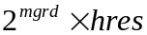, where hres is specified under the DOMAIN section. The default is 2.
grdmin - Minimum grid size (meters) for the puff grid resolution (REAL*4). The default is zero.
z_dosage - Elevation at which surface dosages are computed (REAL*4). Default is 0.0
smpfile - Name of a file with sampler locations for sampler output (CHARACTER*80). See Section 4.6.
dt_smp - Not available in this version of the code (REAL*4). If the project is created with the GUI, the default value of 1.E+36 will appear. It will not be used
Namelist: MATDEF - defines material properties (multiple copies of this namelist can be included in the input file to define multiple materials)
mname - Material name (CHARACTER*16). Any sixteen character string used to identify the material. No default.
class - Material class (CHARACTER*16). Must be ‘GAS’ (gaseous) or ‘PART’ (particle).
nsg - Number of particle size groups (INTEGER*4). Only used for particle type materials.
density - Gaseous or particle material density (kg/m3) (REAL*4).
gas_deposition - Gas deposition velocity (m/s) (REAL*4). Only used for gaseous materials.
psize - Array of particle mass mean diameters (microns) (REAL*4). Only used for particle type materials.
pbounds - Bin boundaries (microns) that determine the range of particle sizes within the subgroup (REAL*4). Only used for particle type materials.
group_deposition - Flag for group deposition (LOGICAL). If ‘True’, the deposition of each subgroup is included on the output surface deposition file. The default is ‘False’.
total_deposition - Flag for total deposition (LOGICAL). If ‘True’, the total deposition of all subgroups is included on the output surface deposition file. The default is ‘False’.
group_dose - Flag for group dose (LOGICAL). If ‘True’, the dose of each subgroup is included on the output surface dose file. The default is ‘False’.
total_dose - Flag for total dose (LOGICAL). If ‘True’, the total dose of all subgroups is included on the output surface dose file. The default is ‘False’.
units - Material mass units for labeling plots (CHARACTER*4).
conc_min - Minimum concentration of interest for this material (REAL*4).
decay_amp - Daytime decay rate (s–1) of the material (REAL*4). The default is zero.
decay_min - Nighttime decay rate (s–1) of the material (REAL*4). The default is zero.
multi_comp - Flag to attach multiple chemical species to the material (LOGICAL). Must also have a multicomponent input file (ProjectName.IMC).
nwpn_decay - Not used in this version of the code(REAL*4). If the file is created with the GUI, this variable will appear on the input file as a “not set” value of -1.E+36. It is not used.
file_name - IMC file name (CHARACTER*80) being used.
file_path - Path to the IMC file being used (CHARACTER*80). The default value is ‘ ’ (blank).

Release scenario file.
A sample release scenario file is shown in Figure 3-2. The following section describes the namelist parameters and their defaults, if available. Not all of the namelist parameters are shown in the example.

&SCN
TREL = 0.0000000E+00,
XREL = 831.7692 ,
YREL = -357.5436 ,
ZREL = 193.5480 ,
CMASS = 1.000000 ,
SUBGROUP = 1,
TDUR = 1.000000 ,
SIZE = 11.73480 ,
WMOM = 19.65960 ,
BUOY = 48.18000 ,
LOGNORM_MMD = -9.9999996E+35,
LOGNORM_SIGMA = -9.9999996E+35,
SLURRY_FRACTION = -9.9999996E+35,
RELTYP = 'CS ',
RELMAT = 'TRAC '
/
#START_MC
NO2 3.588982E+01
NO 3.230084E+02
FORM 1.560000E-03
PAR 2.981190E+00
CO 5.476050E+01
OLE 2.731100E-01
TOL 1.059300E+00
XYL 1.142850E+00
SO2 1.507805E+02
SULF 1.052363E+01
NH3 9.981000E-02
#END_MC

Figure 3-2 Sample SCICHEM release scenario file.
The namelist parameters are defined as follows:
trel - Release time (hours) (REAL*4). No default is available.
xrel - Absolute x-coordinate of the release, Cartesian (km) or Lat/Long (degrees) (REAL*4). No default is available.
yrel - Absolute y-coordinate of the release, Cartesian (km) or Lat/Long (degrees) (REAL*4). No default is available.
zrel - Release height (meters) above the surface (REAL*4). No default is available.
reltyp - Type of release, ‘C’ for continuous, ‘I’ for instantaneous, ‘CM’ for continuous moving, ‘CS’ for continuous stack, or ‘CSP’ for a continuous stack with a plume rise formula (CHARACTER*4). No default is available.
cmass - Total mass of material for an instantaneous release or mass flux for a continuous release (REAL*4). In user-defined units (see units under MATDEF in the INP file), units for instantaneous and units per second for continuous, moving or stack. No default.
size - Source radius or initial Gaussian spread or stack diameter (meters) (REAL*4). No default is available.
tdur - Duration (hours) of release for a continuous release (REAL*4). No default is available.
name_rel - For instantaneous releases only: the name of the file containing the puff data release (CHARACTER*80). No default is available.
relmat - Name identifying the material being released (CHARACTER*4). Must be identical to a name given in the materials list in the input file. No default is available.
sigx - x-direction source diameter (meters) (REAL*4). No default is available.
sigy - y-direction source diameter (meters) (REAL*4). No default is available.
sigz - z-direction source diameter (meters) (REAL*4). No default is available.
subgroup - Number of the individual material subgroup for a tracer particle release (INTEGER*4). No default is available. For tracer particle material releases if subgroup is equal nsg+1 where nsg is the number of size bins defined in the MATDEF namelist in ProjectName.INP, then the cmass is distributed among all material bins with a lognormal distribution.
horiz_uncertainty - The horizontal uncertainty (m) of the location of the source (REAL*4). The default is zero.
vert_uncertainty - The vertical uncertainty (m) of the location of the source (REAL*4). The default is zero.
urel - x-direction velocity (m/s) for a moving continuous source (REAL*4). No default is available.
vrel - y-direction velocity (m/s) for a moving continuous source (REAL*4). No default is available.
wrel - z-direction velocity (m/s) for a moving continuous source (REAL*4). No default is available.
wmom - Integrated vertical momentum for the release (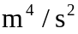) for continuous releases and () for instantaneous releases or stack exit velocity (m/s) (REAL*4).
buoy - Integrated buoyancy for the release (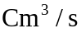) for continuous releases and (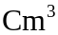) for instantaneous releases or stack exit temperature (C) (REAL*4).
lognorm_mmd - The mass-mean diameter of the lognormal distribution for lognormal releases (REAL*4).
lognorm_sigma - The sigma of the lognormal distribution for lognormal releases (REAL*4).
number_random - The number of copies of this release to be randomly released (INTEGER*4). Default is 1.
random_spread - The diameter over which the releases are randomly released (m) (REAL*4). Default is 0.0.
random_seed - Random generator seed value (INTEGER*4).
opid - This variable is not required for this version of the code, however, it will appear if the project is created with the GUI. It is not used.
opmod - This variable is not required for this version of the code, however, it will appear if the project is created with the GUI. It is not used.
Multicomponent emissions – This section should start immediately after the end of the SCN namelist using the keywords “#STARTMC”. The section end is marked using the keywords “#ENDMC”. The emission rates of the multicomponent chemical species (REAL*4) in emission_units specified on the ProjectName.IMC are listed in this section with each species on a single line. Only the species with non-zero emissions can be listed. The non-listed species are assumed to have zero emissions.

Meteorology Scenario File.
A sample meteorology scenario file is shown in Figure 3-3. The following section describes the namelist parameters and their defaults, if available. Not all of the namelist parameters are shown in the example.
The namelist parameters are defined as follows:
met_type - Type of meteorological input, ‘OBS’, ‘GRIDDED’, ‘MEDOC’ or ‘FIXED’, (CHARACTER*80). If MET_TYPE = ‘FIXED’, the last line of the MSC file must contain the wind speed and direction, otherwise, the last line must contain the file names of the meteorological input files, as shown in Figure 4-3. No default.
bl_type - Type of boundary layer input, ‘SBL’, ‘CALC’, ‘OBS’, ‘OPER’, ‘PROF’, ‘MEDOC’, or ‘NONE’ (CHARACTER*80). No default.
ensm_type - Type of large-scale meteorological input, ‘INPUT’, ‘MODEL’, ‘OBS’, ‘OPER’ or ‘NONE’ (CHARACTER*80). No default.
uu_ensm - Velocity variance (m2s–2) for calculating the large-scale component of the dispersion (REAL*4). Used only with ‘INPUT’ large-scale meteorology. The default is 0.25.
sl_ensm - Length scale (meters) for calculating the meandering component of the dispersion (REAL*4). Used only with ‘INPUT’ or ‘OBS’ large-scale meteorology. The default is 105.
sl_haz - Length scale (meters) for calculating dispersion due to wind uncertainty given as velocity variance on observational meteorology input files (REAL*4). Not required in the current version. The default is 105.
zimin - Minimum daily inversion height (meters) for calculating boundary layer parameters (REAL*4). Used only with ‘SBL’ boundary layers. No default is available.
zimax - Maximum daily inversion height (meters) for calculating boundary layer parameters (REAL*4). Used only with ‘SBL’ boundary layers. No default is available.
hconst - Minimum daily surface heat flux (Wm-2) for calculating boundary layer parameters (REAL*4). Used only with ‘SBL’ boundary layers. No default is available.
hdiur - Maximum daily surface heat flux (Wm-2) for calculating boundary layer parameters (REAL*4). Used only with ‘SBL’ boundary layers. No default is available.
h_cnp - Canopy height (meters) (REAL*4). A negative value indicates no vegetative canopy. No default is available.
zruf - Surface roughness (meters) (REAL*4). No default is available.
albedo - Fraction of incident light that is reflected by the surface (REAL*4). Used only with ‘CALC’ boundary layers. No default is available.
bowen - Ratio of surface sensible heat flux to latent heat flux (REAL*4). Used only with ‘calculated’ ‘CALC’ layers. No default is available.
cloud_cover - Fractional cloud cover where complete overcast is 1 and clear sky is 0 (REAL*4). Used only with ‘CALC’ boundary layers. No default is available. If the fractional cloud cover is provided on an observational or gridded file, this value will be ignored.
local_met - Flag specifying the reference time for the Met files (LOGICAL). If ‘True’ then it is assumed that the times in the Met files are local times. If ‘False’ the times are assumed to be UTC (GMT) times.
tbin_met - Observation time bin width in seconds (REAL*4). Observations within a bin are all given the same time. The default is no time binning.
pr_type - Global precipitation type, ‘LGTRAIN’, ‘MODRAIN’, ‘HVYRAIN’, ‘LGTSNOW’, ‘MODSNOW’, ‘HVYSNOW’ or ‘METFILE’ (CHARACTER). When not set to ‘METFILE’, it will override what has been specified on the meteorological input file for either ‘PRATE’ or ‘PRCP’.
nearest_sfc - Number of nearest surface observation stations used for meteorology interpolation (INTEGER*4). The default is all.
nearest_prf - Number of nearest upper air profile observation stations used for meteorology interpolation (INTEGER*4). The default is all.
lmc_ua - Flag to calculate a mass-consistent adjustment to the wind fields (LOGICAL). This is relevant only if met_type is ‘OBS’. The default is ‘False’.
lout_mc - Not used in the current version (LOGICAL). If the project is created with the GUI, it will appear in the MSC file. The default is ‘False’.
lout_met - Flag to output the met fields in a MEDOC-type file (LOGICAL). The default is ‘False’.
tout_met - Time in seconds to output met fields (REAL*4). The default is the “not set” value of -1.E+36.
lout_2D - Flag to output the 2-D fields in a MEDOC-type file (LOGICAL). The default is ‘False’.
lout_3D - Flag to output the 3-D fields in a MEDOC-type file (LOGICAL). The default is ‘False’.
lformat - Flag to output the adjusted wind fields in ASCII format (LOGICAL). If ‘False’, a binary file is created. This is relevant only if lout_2D and/or lout_3D are ‘True’. The default is ‘False’.
file_ter - Name of file containing terrain information (CHARACTER*80). This is required if lmc_ua is ‘True’. No default is available.
alpha_max - Maximum value of vertical adjustment parameter for mass-consistent wind field calculation (REAL*4). This is relevant only if lmc_ua is ‘True’ and MC-SCICHEM is invoked. The default is 1.
alpha_min - Minimum value of vertical adjustment parameter for mass-consistent wind field calculation (REAL*4). This is relevant only if lmc_ua is ‘True’ and MC-SCICHEM is invoked. The default is 0.
max_iter_ac - Maximum number of iterations allowed for MC-SCICHEM calculation using the point relaxation method (INTEGER*4). The default is 10000.
max_iter - Maximum number of iterations allowed for MC-SCICHEM calculation using the FFT method (INTEGER*4). The default is 30.
ac_eps - Convergence criterion for MC-SCICHEM calculation using the point relaxation method (REAL*4). The default is 1.0102.
p_eps - Convergence criterion for a MC-SCICHEM calculation using the FFT method (REAL*4). The default is 1.0105.
nzb - Number of vertical grid levels used for MC-SCICHEM calculation (INTEGER*4). No default is available.
zb - Vertical grid levels used for MC-SCICHEM calculation (REAL*4). There must be nzb levels specified. No default is available.
dt_swift - Update time interval (sec) for the SWIFT mass-consistent wind field calculation. (REAL*4). The default is no time binning. Not required in the current version.
lswift - Flag indicating availability of SWIFT mass-consistent wind field module (LOGICAL). Not required in the current version. Must be set to ‘False’.
ncld - Number of cloud droplet size sections on observational or MEDOC type files (INTEGER).The default is 0 and currently, the maximum is 1. This is not currently available for editing with the GUI and projects that are created with the GUI may only change this value from the default value by editing the MSC file.
size_cld - An array (REAL*4) of cloud droplet sizes (m) corresponding to the cloud droplet sections. Must provide ncld sizes. The default is 1.e-5. This is not currently available for editing with the GUI and projects that are created with the GUI may only change this value from the default value by editing the MSC file.

&MET
MET_TYPE = 'MEDOC ',
BL_TYPE = 'MEDOC ',
ENSM_TYPE = 'OPER3.1 ',
UU_ENSM = 0.0000000E+00,
SL_ENSM = 100000.0 ,
ZIMIN = 50.00000 ,
ZIMAX = 1000.000 ,
HCONST = 0.0000000E+00,
HDIUR = 50.00000 ,
H_CNP = -1.000000 ,
ALPHA_CNP = 0.0000000E+00,
ZRUF = 2.9999999E-02,
SL_HAZ = 100000.0 ,
ALBEDO = 0.1600000 ,
BOWEN = 0.6000000 ,
CLOUD_COVER = 0.0000000E+00,
LOCAL_MET = F,
NEAREST_SFC = 65535,
NEAREST_PRF = 65535,
LMC_UA = F,
ALPHA_MAX = 1.000000 ,
ALPHA_MIN = 1.0000000E-03,
MAX_ITER_AC = 200,
AC_EPS = 9.9999998E-03,
MAX_ITER = 100,
P_EPS = 9.9999997E-06,
NZB = 23,
ZB = 50.00000, 150.0000, 261.4300, 385.4140, 523.1650, 675.9950, 845.3170,
1032.650, 239.620, 1467.990, 1719.600, 1996.440, 2300.620, 2634.360,
3000.000, 3400.000, 3892.620, 4503.540, 5266.700, 6227.120, 7444.830,
9000.000, 11000.00, 177*0.0000000E+00,
FILE_TER = ‘’,
LOUT_MC = F,
LOUT_MET = F,
TOUT_MET = -9.9999996E+35,
LOUT_3D = F,
LOUT_2D = F,
PR_TYPE = 'METFILE ',
TBIN_MET = 3600.000 ,
I_WET = 2,
LANDUSE = 'NOT SET ',
MCTYPE = 17408,
LFORMAT = F
/
@012metfile.mcw

Figure 3-3 Sample SCICHEM meteorology scenario file.

Note: The last line in the figure provides the names of the meteorological input files and must appear as shown ( @NNNfilename) for MET_TYPE = ‘OBS’, ‘GRIDDED’, or ‘MEDOC’. Here NNN is a 3 digit number with leading zeros equal to the length of the filename. For MET_TYPE = ‘FIXED’, the last line should contain the space-separated wind direction and wind speed.

KEYWORDS Input Format
This section of the SCICHEM User's Guide provides a detailed reference for all of the KEYWORDS input options for running SCICHEM.

Overview
The information in this section is organized by function, i.e., the keywords are grouped by pathway, and are in a logical order based on their function within the model. The format is similar to that used in the USEPA’s AERMOD model. The syntax for each keyword is provided, and the keyword type is specified - either mandatory or optional and either repeatable or non-repeatable. Unless noted otherwise, there are no special requirements for the order of keywords within each pathway, although the order in which the keywords are presented here is recommended. Any keyword which has special requirements for its order within the pathway is so noted following the syntax and type description.
The syntax descriptions in the following sections use certain conventions. Parameters that are in all capital letters and underlined in the syntax description are secondary keywords that are to be entered as indicated for that keyword. Other parameters are given descriptive names to convey the meaning of the parameter, and are listed with an initial capital letter. Parentheses around a parameter indicate that the parameter is optional for that keyword. The default that is taken when an optional parameter is left blank is explained in the discussion for that keyword.

Description
The keywords specify the type of option or input data being entered on each line of the input file, and the parameters following the keyword define the specific options selected or the actual input data. Some of the parameters are also input as descriptive secondary keywords. Progress messages, including certain error messages, are displayed to the standard output device, typically the screen. In particular, SCICHEM uses default settings for some of the parameters which are not specified. These are displayed to the screen and can be sent to a user-specified file by redirecting the output as follows:
runSCI inputFile > outputFile
where inputfile is the basic runSCI input file and outputFile is the file name for the output.

The KEYWORDS file is divided into five functional "pathways” which are identified by a two-character ID placed at the beginning of each pathway.
The pathways and the order in which they are input to the model are as follows:

CO - for specifying overall job COntrol options;
MA - for specifying MAterial information;
SO - for specifying SOurce information;
RE - for specifying REceptor information;
ME - for specifying MEteorology information;
Each line of the input KEYWORDS file consists of a pathway ID, an 8-character keyword, and a parameter list.

Basic Rules for Structuring Input KEYWORDS Files
While the input KEYWORDS file has been designed to provide the user with considerable flexibility in structuring the input file, there are some basic syntax rules that need to be followed. These rules serve to maintain some consistency between input files generated by different users, to simplify the job of error handling performed by the model on the input data, and to provide information to the model in the appropriate order wherever order is critical to the interpretation of the inputs. These basic rules and the various elements of the input KEYWORDS file are as follows:
All inputs for a particular pathway must be contiguous, i.e., all inputs for the CO pathway must come first, followed by the inputs for the MA pathway, if present, and so on. The beginning of each pathway is identified with a "STARTING" keyword, and the ending of the pathway with the "FINISHED" keyword. Thus the first functional record of each input file must be "CO STARTING".
Each record in the input KEYWORDS file is referred to as a pathway "image." These records are initially read into the model as 132-character images. The information on each input image consists of a "pathway," a "keyword," and one or more "parameters." Each of these "fields" on the pathway image must be separated from other fields by at least one blank space. For most keywords, the order of parameters following the keyword is important -- the exact spacing of the parameters is not important, as long as they are separated from each other by at least one blank space and do not extend beyond the 132 character limit.
Alphabetical characters can be input as either lower case or upper case letters. The model converts all character input to upper case letters internally, with the exception of the title fields and file names.
For numeric input data, it should be noted that all data are assumed to be in metric units, i.e., length units of meters, speed units of meters per second, temperature units of degrees Kelvin, and emission units of grams per second.
Certain keywords are mandatory and must be present in every KEYWORDS Input file, such as the MODELOPT keyword which identifies the modeling options. Other keywords are optional and are only needed to exercise particular options, such as the option to allow for the input of flagpole receptor heights. Some of the keywords are repeatable, such as the keywords to specify source parameters, while other keywords may only appear once. With a few exceptions that are described below, the order of keywords within each pathway is not critical. For the SO pathway, the LOCATION keyword must be specified before other keywords for a particular source. The optional MULTCOMP keyword must come before the SRCPARAM keyword and is used for runs where chemistry calculations are required (e.g., for 1-hour NO₂ concentrations or Class I area analysis). The MULTCOMP chemical species list applies to all sources.
Some special provisions have been made to increase the flexibility in structuring the input files. One provision is to allow for blank records in the input file. This allows the user to separate the pathways from each other, or to separate a group of images, such as source locations, from the other images. Another provision is for the use of "comment lines," identified by a "**" in the pathway field. Any input image that has "**" for the pathway ID will be ignored by the model. Because of the descriptive nature of the keyword options and the flexibility of the inputs, it is generally much easier to make modifications to an existing input KEYWORDS file to obtain the desired result than to create a new KEYWORDS file and populate it.

Control Pathway Inputs and Options
The COntrol pathway contains the keywords that provide the overall control of the model run. These include the dispersion options, averaging time options, terrain height options, and others that are described below. The CO pathway must be the first pathway in the KEYWORDS input file.

Title Information
There are two keywords that allow the user to specify up to two lines of title information that will appear on each page of the main output file from the model. The first keyword, TITLEONE, is mandatory, while the second keyword, TITLETWO, is optional. The syntax and type for the keywords are summarized below:

SYNTAX: CO TITLEONE Title1
CO TITLETWO Title2
TYPE: TITLEONE - Mandatory, Non-repeatable
TITLETWO - Optional, Non-repeatable
The parameters Title1 and Title2 are character parameters of length 68, which are read as a single field from columns 13 to 80 of the input record. The title information is taken as it appears in the KEYWORDS file without any conversion of lower case to upper case letters. If the TITLETWO keyword is not included in the KEYWORDS file, then the second line of the title in the output file will appear blank.

Dispersion Options
The dispersion options are controlled by the MODELOPT keyword on the CO pathway. The syntax, type, and order of the MODELOPT keyword are summarized below:

SYNTAX: CO MODELOPT PASSIVE DENSEGAS NOSTATIC FASTMODE
TYPE: Optional, Non-repeatable

where the secondary keyword parameters are described below (the order and spacing of these parameters is not critical):

PASSIVE - Specifies that the non-default option of no momentum or buoyancy dynamics will be used;
DENSGAS - Specifies that the non-default option of dense gas effects will be used;
NOSTATIC - Specifies that the default option of quasi-steady state calculation of continuous sources will NOT be used;
FASTMODE - Specifies that the non-default option of a coarser resolution calculation is performed with the surface grid and vertical resolution restricted.
The default option in SCICHEM includes the use of momentum and buoyancy dynamics to calculate plume rise, no dense gas effect, quasi-steady state calculation of continuous sources, and standard (not fast) run mode. However, if the release type is 'CSP', i.e., continuous stack with a plume rise formula (see Section 3.1.2 and Figure 3-2), the momentum and buoyancy dynamics calculations are not performed.

Specifying the Pollutant Type
The POLLUTID keyword is used to identify the type of material being modeled for a particular run, and is included in SCICHEM for consistency with AERMOD. The POLLUTID keyword can be used in lieu of the MAterial pathway to specify a single material applied to all sources, and will be ignored if the MAterial pathway is present. The syntax, type, and order of the POLLUTID keyword are summarized below:

Syntax: CO POLLUTID Pollut
Type: Optional, Non-repeatable
where the Pollut parameter may be a name of up to eight characters. The pollutant ID has no effect on the calculations made in SCICHEM.

Flagpole Receptor Height Option
The FLAGPOLE keyword specifies that receptor heights above local ground level (i.e. flagpole receptors) are allowed on the REceptor pathway. The FLAGPOLE keyword may also be used to specify a default flagpole receptor height other than 0.0 meters. The syntax and type of the FLAGPOLE keyword are summarized below:

Syntax: CO FLAGPOLE (Flagdf)
Type: Optional, Non-repeatable
where Flagdf is an optional parameter to specify a default flagpole receptor height. If no parameter is provided, then a default flagpole receptor height of 0.0 meters is used. Any flagpole receptor heights that are entered on the Receptor pathway will override the default value, but are ignored if the FLAGPOLE keyword is not present on the Control pathway, and a non-fatal warning message is generated.

Specifying Projection
The PROJECTN keyword specifies the geographic projection for the run. The syntax and type of the PROJECTN keyword are summarized below:

Syntax: CO PROJECTN Prjctn Datum ...
Type: Optional, Non-repeatable

where the Prjctn parameter is the projection code identified by one of the secondary keywords – UTM, CARTESIAN, or LONLAT, and Datum is the 3 to 5 letter NIMA (National Imagery and Mapping Agency) datum.
The syntax for a UTM projection is summarized below:

Syntax: CO PROJECTN UTM Datum Zone Hem Units
where the Zone parameter is the UTM zone from 1 to 60, Hem is the Hemisphere (N or S), and Units is the horizontal distance units in METERS or KILOMETERS.
The syntax for a CARTESIAN projection is summarized below:

Syntax: CO PROJECTN CARTESIAN Datum Lonref Latref Xref Yref Units
where the Lonref and Latref parameters are the reference (origin) longitude and latitude, and Xref and Yref are the reference X and Y coordinates (false easting and northing), and Units is the horizontal distance units in METERS or KILOMETERS.
The syntax for a LONLAT projection is summarized below:

Syntax: CO PROJECTN LONLAT Datum (Units)

where the optional Units parameter is the horizontal distance units in DEGREES.
Examples of valid projections are given below:

CO PROJECTN UTM NAR-C 15 N METERS
CO PROJECTN CARTESIAN WGE -88.5426 44.0247 0 0 KILOMETERS
CO PROJECTN LONLAT WGC DEGREES

Specifying the Computational Domain
The DOMAIN keyword specifies the computational domain for the run. The syntax and type of the DOMAIN keyword are summarized below:

Syntax: CO DOMAIN Xmin Xmax Ymin Ymax Zmax
Type: Optional, Non-repeatable

Specifying a Data Period to Process
The STARTEND keyword controls which period within the meteorological data file is read by the model. The default for the model is to read the entire meteorological data file (up to a full year) and to process all days within that period.
The syntax and type for the STARTEND keyword are summarized below:

Syntax: CO STARTEND Strtyr Strtmn Strtdy (Strthr) (Strtmn) (Strtsc) Endyr Endmn Enddy (Endhr) (Endmn) (Endsc)
Type: Optional, Non-repeatable
where the Strtyr Strtmn Strtdy parameters specify the year, month and day of the first record to be read (e.g., 87 01 31 for January 31, 1987), and the parameters Endyr Endmn Enddy specify the year, month and day of the last record to be read. The Strthr Strtmn Strtsc and Endhr Endmn Endsc are optional parameters that may be used to specify the start and end times for the data period to be read. If either Strthr or Endhr is to be specified, then both must be specified. Any records in the data file that occur before the start date are ignored, as are any records in the data file that occur after the end date. If Strthr and Endhr are not specified, then processing begins with hour 0 of the start date, and ends with hour 23 of the end date. If Strtmn and Endmn are not specified, then processing begins with minute 0 of the start date, and ends with minute 59 of the end date. If Strtsc and Endsc are not specified, then processing begins with second 0 of the start date, and ends with second 59 of the end date. Note that the minute and second parameters may not be necessary when using AERMET derived meteorological data.

Specifying a Time Zone
The TIMEZONE keyword specifies the time zone of the SCICHEM scenario location. The syntax and type for the TIMEZONE keyword are summarized below:

Syntax: CO TIMEZONE Offset
Type: OPTIONAL, Non-repeatable

where the Offset parameter is the offset in hours from Coordinated Universal Time (UTC).
The following example sets the input scenario location time zone to Eastern Time (US & Canada):

CO TIMEZONE -5
Alternatively, the LT_00UTC keyword can be used to specify the local time of midnight UTC; SCICHEM then computes the time zone offset internally. The syntax and type for the LT_00UTC keyword are summarized below:

Syntax: CO LT_00UTC time
Type: OPTIONAL, Non-repeatable

where the time parameter is the local time in hours corresponding to midnight in UTC.

Specifying Maximum Time Step
The MAXTSTEP keyword specifies the maximum time step for the run. The syntax and type of the MAXTSTEP keyword are summarized below:

Syntax: CO MAXTSTEP Maxstp
Type: Optional, Non-repeatable

where Maxstp is the maximum time step in seconds. The default value is 900.

Specifying Output Interval
The OUTPTINT keyword specifies the output interval for the binary puff output file. The syntax and type of the OUTPTINT keyword are summarized below:

Syntax: CO OUTPTINT Outint
Type: Optional, Non-repeatable

where Outint is the output interval in seconds.

Specifying Maximum Puffs
The MAXPUFFS keyword specifies the maximum puffs for the run – the default is 20,000. The syntax and type of the MAXPUFFS keyword are summarized below:

Syntax: CO MAXPUFFS Maxpuf
Type: Optional, Non-repeatable

where Maxpuf is the maximum number of puffs.

Specifying Horizontal Resolution
The HORIZRES keyword specifies the horizontal resolution of the domain. The syntax and type of the HORIZRES keyword are summarized below:

Syntax: CO HORIZRES Hrzres
Type: Optional, Non-repeatable

where Hrzres is the horizontal resolution in the units of the domain (i.e., kilometers, meters, degrees).

Specifying Vertical Resolution
The VERTIRES keyword specifies the vertical resolution of the domain. The syntax and type of the VERTIRES keyword are summarized below:

Syntax: CO VERTIRES Vrtres
Type: Optional, Non-repeatable

where Vrtres is the vertical resolution in meters.

Material Pathway Inputs And Options
The optional MAterial pathway contains the keywords that define the material (pollutant) information for a particular model run, and must precede the SOurce pathway. Multiple materials can be defined for a single run and applied to different sources. The model currently handles two classes of materials, gases or particles. The input parameters vary depending on the material class.

Specifying Material Types
The MATCLASS keyword is used to identify the material class of each material to be modeled. The MATCLASS card must be the first card entered for each material since it identifies the material class, and dictates which parameters are needed and/or accepted. The syntax, type and order of the MATCLASS keyword are summarized below:

Syntax: MA MATCLASS Matid Matcls
Type: Optional, Repeatable
Order: Must be first card for each material input

where the Matid parameter is the alphanumeric material ID defined by the user (up to eight characters), and Matcls is the material class, which is identified by one of the secondary keywords - GAS, or PART. The GAS material keyword is used to specify a gaseous material. The PART material keyword is used to specify a particle material.
The material ID entered on the MATCLASS card identifies that material for the remainder of the MA pathway inputs. Since the model accepts alphanumeric strings of up to eight characters for the material ID, the material can be identified with descriptive names, such as SO2, XYLENE, CHLORINE, etc. For particle materials, the material ID should be either PM2.5 or PM10, depending on the primary particle species of interest. No other particle species names are allowed in this version of SCICHEM. Note that this only applies to the tracer material -- the full PM chemistry and species are addressed in multicomponent simulations.
The DESCRPTN keyword provides for a detailed description of the material. The syntax, type and order of the DESCRPTN keyword are summarized below:

Syntax: MA MATCLASS Matid Matdes
Type: Optional, Repeatable
Order: Must follow the MATCLASS card for each material input
where the Matid parameter is the alphanumeric material ID, and Matdes is the material description contained in quotes.

Specifying Material Parameters
The material parameters are input on various MAterial cards, dependent upon the class of material being modeled. Since the input parameters vary depending on the material type, the different material types handled by the SCICHEM model are discussed separately.

GAS Material Inputs
The DENSITY keyword is used to define the material density. The DENSITY keyword is optional for concentration, and mandatory for gas deposition. The syntax, type and order of the DENSITY keyword are summarized below:

Syntax: MA DENSITY Matid Matden
Type: Mandatory for gas deposition, Repeatable
Order: Must follow the MATCLASS card for each material input
where the Matid parameter is the alphanumeric material ID, and Matden is the material density in kg/m³.
The GASDEPOS keyword is used to define the material gas deposition velocity. The GASDEPOS keyword is optional for concentration and mandatory for gas deposition. Note that the specification of dry deposition velocity is applicable to the tracer material. For multicomponent species, dry deposition velocities are specified in the multicomponent input file. The syntax, type and order of the GASDEPOS keyword are summarized below:

Syntax: MA GASDEPOS Matid Matgdv
Type: Mandatory for gas deposition, Repeatable
Order: Must follow the MATCLASS card for each material input

where the Matid parameter is the alphanumeric material ID, and Matgdv is the material gas deposition velocity in m/s.
The DECAYAMP and DECAYMIN keywords are used to define the material daytime and nighttime decay rate respectively. The DECAYAMP and DECAYMIN keywords are optional for concentration and mandatory for gas deposition. The syntax, type and order of the DECAYAMP and DECAYMIN keyword are summarized below:

Syntax: MA DECAYAMP Matid Matdcy
Syntax: MA DECAYMIN Matid Matdcy
Type: Mandatory for gas deposition, Repeatable
Order: Must follow the MATCLASS card for each material input
where the Matid parameter is the alphanumeric material ID, and Matdcy is the material decay rate in s⁻¹.
An example of a valid gaseous material is given below:

MA MATCLASS MAT1 GAS
MA DESCRPTN MAT1 "1,3,5-Trimethylbenzene"
MA DENSITY MAT1 1.2
where the material ID is MAT1, the description is 1,3,5-Trimethylbenzene, and the density is 1.2 kg/m³.
As discussed previously, for multicomponent simulations (calculations with chemistry) the IMCFILE keyword is used to give the file name that contains information on the chemical species, their units, chemistry options, deposition velocities, and chemical reactions.

Source Pathway Inputs and Options
The SOurce pathway contains the keywords that define the source information for a particular model run. The model currently handles three source types, identified as point, volume or area sources. The input parameters vary depending on the source type. For point sources, the user can also identify building dimensions for nearby structures that cause aerodynamic downwash influences on the source. The user can also identify groups of sources for which the model will combine the results.
The LOCATION keyword, which identifies the source type and location, must be the first card entered for each source. The optional keyword MULTCOMP must come before SRCPARAM is specified. The only other requirement for the order of the keywords is that the SRCGROUP keyword must be the last keyword before the SO FINISHED card. The user may group all of the LOCATION cards together, then group the source parameter cards together, or they may want to group all input cards for a particular source together. All sources are given a source ID by the user, which is used to link the source parameter inputs to the correct source or sources. The source ID can be any alphanumeric string of up to eight characters.

Identifying Source Types and Locations
The LOCATION keyword is used to identify the source type and the location of each source to be modeled. The LOCATION card must be the first card entered for each source since it identifies the source type, and dictates which parameters are needed and/or accepted. The syntax, type and order of the LOCATION keyword are summarized below:

Syntax: SO LOCATION Srcid Srctyp Xs Ys
Type: Mandatory, Repeatable
Order: Must be first card for each source input

where the Srcid parameter is the alphanumeric source ID defined by the user (up to eight characters), Srctyp is the source type, which is identified by one of the secondary keywords ¬POINT, VOLUME, AREA, or AREACIRC - and Xs and Ys are the x and y coordinates of the source location in the units defined on the CO PROJECTN keyword.
The source ID entered on the LOCATION card identifies that source for the remainder of the SO pathway inputs. Since the model accepts alphanumeric strings of up to eight characters for the source ID, the sources can be identified with descriptive names, such as STACK1, STACK2, BOILER3, SLAGPILE, etc.
The optional MATERIAL keyword identifies the material, defined in the MAterial pathway, to be modeled by each source. The LOCATION card must be the first card entered for each source since it identifies the source type, and dictates which parameters are needed and/or accepted. The syntax, type and order of the MATERIAL keyword are summarized below:

Syntax: SO MATERIAL Srcid Matid
Type: Mandatory when using MAterial pathway, Repeatable
Order: Must follow the LOCATION card for each source input
where the Srcid parameter is the same source ID that was entered on the LOCATION card for a particular source, and Matid is a material ID present in the MAterial pathway.

Specifying Multicomponent Releases
The optional MULTCOMP keyword is used to specify multi-component species. This card must follow all LOCATION cards and precede all SRCPARAM cards. The list of species applies to all POINT sources. Species names must match those in the SCIPUFF multi-component / chemistry reaction file provided with the MA IMCFILE keyword.

Syntax: SO MULTCOMP species1, species2, …
Type: Optional, Non-repeatable
Order: Must follow all LOCATION cards and precede all SRCPARAM cards

Specifying Source Release Parameters
The main source parameters are input on the SRCPARAM card, which is a mandatory keyword for each source being modeled. Since the input parameters vary depending on the source type, the different source types handled by the SCICHEM model are discussed separately.

POINT Source Inputs
The SCICHEM POINT source algorithms are used to model releases from stacks and isolated vents, as well as other kinds of sources. The syntax, type and order for the SRCPARAM card for POINT sources are summarized below: where the Srcid parameter is the same source ID that was entered on the LOCATION card for a particular source, and the other parameters are as follows:

Syntax: SO SRCPARAM Srcid Ptemis Stkhgt Stktmp Stkvel Stkdia [Spemis …]
Type: Mandatory, Repeatable
Order: Must follow the LOCATION card for each source input

Ptemis - point emission rate in g/s,
Stkhgt - release height above ground in meters,
Stktmp - stack gas exit temperature in degrees K,
Stkvel - stack gas exit velocity in m/s, and
Stkdia - stack inside diameter in meters.
Spemis – emission rates for species listed in MULTCOMP card in g/s.
An example of a valid SRCPARAM input card for a point source is given below:

SO SRCPARAM STACK1 16.71 35.0 444.0 22.7 2.74
where the source ID is STACK1, the emission rate is 16.71 g/s, the release height is 35.0 m, the exit temperature is 444.0 K, the exit velocity is 22.7 m/s, and the inside stack diameter is 2.74 m. All of the parameters must be present on the input card.
Since SCICHEM uses direction-specific building dimensions for all sources subject to building downwash, there are no building parameters entered on the SRCPARAM card. Building dimensions are entered on the BUILDHGT, BUILDWID, BUILDLEN, XBADJ, and YBADJ cards described below.

Specifying Building Downwash Information
As noted above, SCICHEM includes algorithms to model the effects of building downwash on emissions from nearby or adjacent point sources using the PRIME model (Schulman et al., 1997). The building downwash algorithms do not apply to volume or area sources. For a technical description of the building downwash algorithms in SCICHEM, the user is referred to Schulman et al. (2000). SCICHEM uses direction-specific information for all building downwash cases.
There are five keywords that are used to specify building downwash information: BUILDHGT, BUILDWID, BUILDLEN, XBADJ, YBADJ. The syntax, type and order for the BUILDHGT keyword, used to input direction specific building heights, are summarized below: the Srcid parameter is the same source ID that was entered on the LOCATION card for a particular source. The user also has the option of specifying a range of sources (the Srcrng parameter) for which the building heights apply, instead of identifying a single source. This is accomplished by two source ID character strings separated by a dash, e.g., STACK1-STACK10. Since the model reads the source range as a single input field there must not be any spaces between the source IDs. The model then places the building heights that follow (the Dsbh(i) parameter) into the appropriate arrays for all Srcid's that fall within that range, including STACK1 and STACK10.

Syntax: SO BUILDHGT Srcid (or Srcrng) Dsbh(i),i=1,36 (16 for LT)
Type: Optional, Repeatable
Order: Must follow the LOCATION card for each source input
When comparing a source ID to the range limits for a Srcrng parameter, the model separates the source IDs into three parts: an initial alphabetical part, a numerical part, and then the remainder of the string. Each part is then compared to the corresponding parts of the source range, and all three parts must satisfy the respective ranges in order for the source ID to be included. If there is no numeric part, then the ID consists of only one alphabetical part. If the ID begins with a numeric character, then the initial alphabetical part defaults to a single blank. If there is no trailing alphabetical part, then the third part also defaults to a single blank part. If the trailing part consists of more than one alphabetical or numeric field, it is all lumped into one character field. For example, the source ID 'STACK2' consists of the parts 'STACK' plus '2' plus a single trailing blank, ' '. By comparing the separate parts of the source IDs, it can be seen that STACK2 falls between the range 'STACK1-STACK10.' For a three-part example, it can also be seen that VENT1B falls within the range of VENT1A-VENT1C. However, VENT2 does not fall within the range of VENT1A to VENT3B, since the third part of VENT2 is a single blank, which does not fall within the range of A to C. This is because a blank character will precede a normal alphabetical character. Normally, the source ranges will work as one would intuitively expect for simple source names. Most importantly, for names that are made up entirely of numeric characters, the source ranges will be based simply on the relative numerical values. The user is strongly encouraged to check the summary of model inputs to ensure that the source ranges were interpreted as expected, and also to avoid using complex source names in ranges, such as AA1B2C-AB3A3C. Since the order of keywords within the SO pathway is quite flexible, it is also important to note that the building heights will only be applied to those sources that have been defined previously in the input file.
Following the Srcid or the Srcrng parameter, the user inputs 36 direction-specific building heights (Dsbh parameter) in meters, beginning with the 10 degree flow vector (wind blowing toward 10 degrees from north), and incrementing by 10 degrees in a clockwise direction. Some examples of building height inputs are presented below:

SO BUILDHGT STACK1 34. 34. 34. 34. 34. 34. 34. 34. 34. 34. 34. 34.
SO BUILDHGT STACK1 34. 34. 34. 34. 34. 34. 34. 34. 34. 34. 34. 34.
SO BUILDHGT STACK1 34. 34. 34. 34. 34. 34. 34. 34. 34. 34. 34. 34.
SO BUILDHGT STACK1 36*34.0
SO BUILDHGT STACK1-STACK10 33*34.0 3*0.0
SO BUILDHGT STACK1 35.43 36.45 36.37 35.18 32.92 29.66 25.50 20.56
SO BUILDHGT STACK1 15.00 20.56 25.50 29.66 32.92 35.18 36.37 36.45
SO BUILDHGT STACK1 35.43 33.33 35.43 36.45 0.00 35.18 32.92 29.66
SO BUILDHGT STACK1 25.50 20.56 15.00 20.56 25.50 29.66 32.92 35.18
SO BUILDHGT STACK1 36.37 36.45 35.43 33.33
The first example illustrates the use of repeat cards if more than one card is needed to input all of the values. The values are processed in the order in which they appear in the input file, and are identified as being repeat cards by repeating the Srcid parameter. The first and second examples produce identical results within the model. The second one illustrates the use of a repeat value that can simplify numerical input in some cases. The field "36*34.0" is interpreted by the model as "repeat the value 34.0 a total of 36 times." This is also used in the third example where the building height is constant for directions of 10 degrees through 330 degrees, and then is set to 0.0 (e.g. the stack may be outside the region of downwash influence) for directions 340 through 360. The third example also uses a source range rather than a single source ID. The last example illustrates building heights that vary by direction, and shows that the number of values on each card need not be the same, as long as the total number of values equals 36. For improved readability of the input file, the user may want to put the numerical inputs into "columns," but there are no special rules regarding the spacing of the parameters on this keyword.
The BUILDWID keyword is used to input direction-specific building widths for downwash analyses. The syntax for this keyword, which is very similar to the BUILDHGT keyword, is summarized below, along with the type and order information: For a description of the Srcid and Srcrng parameters, and for a discussion and examples of the numeric input options, refer to the BUILDHGT keyword above. The Dsbw(i) parameter contains the 36 direction-specific building widths. The directions proceed in a clockwise direction, beginning with the 10 degree flow vector.

Syntax: SO BUILDWID Srcid (or Srcrng) Dsbw(i),i=1,36 (16 for LT)
Type: Optional, Repeatable
Order: Must follow the LOCATION card for each source input
The BUILDLEN keyword is used to input direction-specific along-flow building lengths for downwash analyses. The syntax for this keyword, which is very similar to the BUILDHGT keyword, is summarized below, along with the type and order information:

Syntax: SO BUILDLEN Srcid (or Srcrng) Dsbl(i),i=1,36
Type: Optional, Repeatable
Order: Must follow the LOCATION card for each source input
For a description of the Srcid and Srcrng parameters, and for a discussion and examples of the numeric input options, refer to the BUILDHGT keyword above. The Dsbl(i) parameter contains the 36 direction-specific building lengths. The directions proceed in a clockwise direction, beginning with the 10 degree flow vector.
The XBADJ and YBADJ keywords are used to input direction-specific along-flow and across-flow distances from the stack to the center of the upwind face of the projected building, respectively. The syntax for these keywords, which is very similar to the BUILDHGT keyword, are summarized below, along with the type and order information: For a description of the Srcid and Srcrng parameters, refer to the BUILDHGT keyword above. The Xbadj(i) parameter contains the 36 direction-specific along-flow distances from the stack to the center of the upwind face and the Ybadj(i) parameter contains the 36 direction-specific across-flow distances from the stack to the center of the upwind face. The directions proceed in a clockwise direction, beginning with the 10 degree flow vector.

Syntax: SO XBADJ Srcid (or Srcrng) Xbadj(i),i=1,36
Type: Optional, Repeatable
Order: Must follow the LOCATION card for each source input

Syntax: SO YBADJ Srcid (or Srcrng) Ybadj(i),i=1,36
Type: Optional, Repeatable
Order: Must follow the LOCATION card for each source input

Volume Source Inputs
The SCICHEM VOLUME source algorithms are used to model releases from a variety of industrial sources, such as building roof monitors, multiple vents, and conveyor belts. The syntax, type and order for the SRCPARAM card for VOLUME sources are summarized below:

Syntax: SO SRCPARAM Srcid Vlemis Relhgt Syinit Szinit
Type: Mandatory, Repeatable
Order: Must follow the LOCATION card for each source input
where the Srcid parameter is the same source ID that was entered on the LOCATION card for a particular source, and the other parameters are as follows:

Vlemis -volume emission rate in g/s,
Relhgt -release height (center of volume) above ground, in meters,
Syinit -initial lateral dimension of the volume in meters, and
Szinit -initial vertical dimension of the volume in meters.

Area Source Inputs
The SCICHEM area source option is used to model low level or ground level releases with no plume rise (e.g., storage piles, slag dumps, and lagoons).
The SCICHEM model includes two options for specifying the shape of an area source: the AREA source type may be used to specify rectangular areas that may also have a rotation angle specified relative to a north-south orientation; and the AREACIRC source keyword may be used to specify a circular-shaped area source. The source parameter inputs for each of the area source types are described below.

AREA Source Type
The rotation angle for rectangular AREA sources is specified relative to the vertex used to define the source location on the SO LOCATION card (e.g., the southwest corner). The syntax, type and order for the SRCPARAM card for AREA sources are summarized below:

Syntax: SO SRCPARAM Srcid Aremis Relhgt Xinit Yinit Angle (Szinit)
Type: Mandatory, Repeatable
Order: Must follow the LOCATION card for each source input
where the Srcid parameter is the same source ID that was entered on the LOCATION card for a particular source, and the other parameters are as follows:

Aremis - area emission rate in g/(s-m2),
Relhgt - release height above ground in meters,
Xinit - length of X side of the area (in the east-west direction if Angle is 0 degrees) in meters,
Yinit - length of Y side of the area (in the north-south direction if Angle is 0 degrees) in meters
Angle - orientation angle for the rectangular area in degrees from North, measured positive in the clockwise direction, and
Szinit - initial vertical dimension of the area source plume in meters (optional).
It should be noted that the emission rate for the area source is actually an emissions flux, i.e., an emission rate per unit area. This is different from the specification of point and volume source emission rates, which represent total emission rates for the source.
If the Angle parameter does not equal 0.0, then the model will rotate the area clockwise around the vertex defined on the SO LOCATION card for this source. The Xinit dimension is measured from the side of the area that is counterclockwise along the perimeter from the vertex defined by (Xs,Ys), while the Yinit dimension is measured from the side of the area that is clockwise from (Xs,Ys). The Angle parameter is measured as the orientation relative to North of the side that is clockwise from (Xs,Ys), i.e. the side with length Yinit. The Angle parameter may be positive (for clockwise rotation) or negative (for counterclockwise rotation), and a warning message is generated if the absolute value of Angle is greater than 180 degrees. The selection of the vertex to use for the source location is not critical, as long as the relationship described above for the Xinit, Yinit, and Angle parameters is maintained.
The optional Szinit parameter may be used to specify an initial vertical dimension to the area source plume, similar to the use of the Szinit parameter for volume sources. This parameter may be important when the area source algorithm is used to model mechanically generated emission sources, such as mobile sources. In these cases, the emissions may be turbulently mixed near the source by the process that is generating the emissions, and therefore occupy some initial depth. For more passive area source emissions, such as evaporation or wind erosion, the Szinit parameter may be omitted, which is equivalent to using an initial sigma-z of zero.
An example of a valid SRCPARAM input card for a rectangular area source is given below:

SO SRCPARAM SLAGPILE 0.0015 5.0 50.0 100.0 30.0
where the source ID is SLAGPILE, the emission rate is 0.0015 g/(s-m2), the release height is 5.0 m, the X-dimension is 50.0 m, the Y-dimension is 100.0 m, and the orientation angle is 30.0 degrees clockwise from North.

AREACIRC Source Type
The AREACIRC source type may be used to specify an area source as a circular shape. The syntax, type and order for the SRCPARAM card for AREACIRC sources are summarized below:

Syntax: SO SRCPARAM Srcid Aremis Relhgt Radius (Szinit)
Type: Mandatory, Repeatable
Order: Must follow the LOCATION card for each source input
where the Srcid parameter is the same source ID that was entered on the LOCATION card for a particular source, and the other parameters are as follows:

Aremis - area emission rate in g/(s-m2),
Relhgt - release height above ground in meters,
Radius - radius of the circular area in meters,
Szinit - initial vertical dimension of the area source plume in meters (optional).
As with AREA sources, the emission rate for the source is an emission rate per unit area, which is different from the point and volume source emission rates, which are total emissions for the source.

Specifying an Hourly Emission Rate File
The source (SO) pathway includes an option for inputting hourly emission rates for the SCICHEM model, controlled by the HOUREMIS keyword. SCICHEM currently allows for a single hourly emission file to be used with each model run. The syntax, type and order for this keyword are summarized below:

Syntax: SO HOUREMIS Emifil Srcid's (and/or Srcrng's)
Type: Optional, Repeatable
Order: Must follow the LOCATION card for each source input
where the Emifil parameter is a character field of up to 200 characters, in quotes, that identifies the hourly emission file, and Srcid or Srcrng identify the source or sources for which hourly emission rates are included. Source ranges, which are described in more detail above in the description of the BUILDHGT keyword, are input as two source IDs separated by a dash, e.g., STACK1-STACK10. The user may include more than one HOUREMIS card in a KEYWORDS file to specify additional sources if needed, but there can be only one hourly emissions file, and therefore the filename must be the same on all HOUREMIS cards.
The format of each record of the hourly emissions file includes a pathway and keyword (SO HOUREMIS), followed by the Year, Month, Day, Hour, Source ID, and emission rate (in the appropriate units). For point sources, the stack gas exit temperature (K), and stack gas exit velocity (m/s) are also specified. The hourly emissions file is processed using the same routines used to process the KEYWORDS input file, therefore each of the parameters must be separated by at least one space, but otherwise the format is flexible. It is also not necessary to include the SO HOUREMIS on each line, as long as the parameters (Year, Month, etc.) do not begin before column 13. If MULTCOMP was specified to simulate chemically reactive species, the emission rates of emitted chemical species must be given for POINT sources following the stack gas exit velocity.
The data in the hourly emission file must include the exact same dates as are included in the meteorological input files, and the source IDs must correspond to the source IDs defined on the SO LOCATION cards and be in the same order. Multiple records are required to define the emissions for one hour if more than one source is referenced. The model will check for a date mismatch between the hourly emissions file and the meteorological data, and also for a source ID mismatch. However, it is not necessary to process the entire hourly emissions file on each model run, i.e., the correct emissions data will be read if the ME STARTEND card is used, as long as all the dates (including those that are processed and those that are skipped) match the meteorological data files. An example of several lines from an hourly emissions file for two point sources is provided below:

SO HOUREMIS 88 8 16 1 STACK1 52.467 382.604 12.27
SO HOUREMIS 88 8 16 1 STACK2 44.327 432.326 22.17
SO HOUREMIS 88 8 16 2 STACK1 22.321 377.882 9.27
SO HOUREMIS 88 8 16 2 STACK2 42.166 437.682 19.67
SO HOUREMIS 88 8 16 3 STACK1 51.499 373.716 11.87
SO HOUREMIS 88 8 16 3 STACK2 41.349 437.276 18.77
SO HOUREMIS 88 8 16 4 STACK1 36.020 374.827 9.63
SO HOUREMIS 88 8 16 4 STACK2 43.672 437.682 18.23
The model will use the stack release height and stack inside diameter defined on the SO SRCPARAM card, but will use the emission rate, exit temperature and exit velocity from the hourly emission file. If the emission rate, exit temperature and exit velocity are not included for a particular hour, i.e, any or all of those fields are blank, the model will interpret emissions data for that hour as missing and will set the parameters to zero. Since the emission rate will be zero, there will be no calculations made for that hour and that source.

Receptor Pathway Inputs And Options
The REceptor pathway contains keywords that define the receptor information for a particular model run. The RE pathway contains keywords that allow the user to define Cartesian grid receptor networks as well as discrete receptor locations referenced to a Cartesian system.

Defining Networks of Gridded Receptors
A Cartesian grid network, defined through the GRIDCART keyword, includes an array of points identified by their x (east-west) and y (north-south) coordinates. This GRIDCART keyword has a series of secondary keywords associated with it that are used to define the network, including any flagpole receptor heights. The GRIDCART keyword can be thought of as a "sub-pathway," since its secondary keywords include a STArt and an END card to define the start and end of inputs for a particular network.

Cartesian Grid Receptor Networks.
Cartesian grid receptor networks are defined by use of the GRIDCART keyword. The GRIDCART keyword may be thought of as a "sub-pathway," in that there are a series of secondary keywords that are used to define the start and the end of the inputs for a particular network, and to select the options for defining the receptor locations that make up the network. The syntax and type of the GRIDCART keyword are summarized below:

Syntax: RE GRIDCART Netid STA
RE GRIDCART Netid XYINC Xinit Xnum Xdelta Yinit Ynum Ydelta
RE GRIDCART Netid FLAG Row Zelev1 Zelev2 Zelev3 ... Zflagn
Type: Optional, Repeatable

where the parameters are defined as follows:
Netid - Receptor network identification code (up to eight alphanumeric characters)
STA - Indicates the STArt of GRIDCART inputs for a particular network, repeated for each new Netid
XYINC - Keyword identifying uniform grid network generated from x and y increments.
Xinit - Starting x-axis grid location in meters.
Xnum - Number of x-axis receptors.
Xdelta - Spacing in meters between x-axis receptors.
Yinit - Starting y-axis grid location in meters.
Ynum - Number of y-axis receptors.
Ydelta - Spacing in meters between y-axis receptors
FLAG - Keyword to specify that flagpole receptor heights follow (optional).
Row - Indicates which row (y-coordinate fixed) is being input (Row=1 means first, i.e., southmost row).
Zflag - An array of receptor heights (m) above local terrain elevation for a particular Row (flagpole receptors), number of entries per row equals the number of x-coordinates for that network
END Indicates the END of GRIDCART inputs for a particular network, repeated for each new Netid
The FLAG keyword is an optional input, and is only needed if flagpole receptor heights are to be used.
The order of cards within the GRIDCART subpathway is not important, as long as all inputs for a particular network are contiguous and start with the STA secondary keyword and end with the END secondary keyword. It is not even required that all FLAG cards be contiguous, although the input file will be more readable if a logical order is followed. The network ID is also not required to appear on each pathway image (except for the STA card). The model will assume the previous ID if none is entered, similar to the use of continuation cards for pathway and keywords. Thus, the following two examples produce the same 9 X 5 Cartesian grid network:

RE GRIDCART CAR1 STA
RE GRIDCART CAR1 XYINC -400 9 100 -400 5 200
RE GRIDCART CAR1 FLAG 1 10. 10. 10. 10. 10. 10. 10. 10. 10.
RE GRIDCART CAR1 FLAG 2 20. 20. 20. 20. 20. 20. 20. 20. 20.
RE GRIDCART CAR1 FLAG 3 30. 30. 30. 30. 30. 30. 30. 30. 30.
RE GRIDCART CAR1 FLAG 4 40. 40. 40. 40. 40. 40. 40. 40. 40.
RE GRIDCART CAR1 FLAG 5 50. 50. 50. 50. 50. 50. 50. 50. 50.
RE GRIDCART CAR1 END
RE GRIDCART CAR1 STA
RE GRIDCART CAR1 XYINC -400 9 100 -400 5 200
RE GRIDCART CAR1 FLAG 1 8*10.
RE GRIDCART CAR1 FLAG 2 8*20.
RE GRIDCART CAR1 FLAG 3 8*30.
RE GRIDCART CAR1 FLAG 4 8*40.
RE GRIDCART CAR1 FLAG 5 8*50.
RE GRIDCART CAR1 END

Specifying Discrete Receptor Locations
In addition to the receptor networks defined by the GRIDCART keyword described above, the user may also specify discrete receptor points for modeling impacts at specific locations of interest. This may be used to model critical receptors, such as the locations of schools or houses, nearby Class I areas, or locations identified as having high concentrations by previous modeling analyses. The discrete receptors must be input as Cartesian x,y points (DISCCART keyword).

Discrete Cartesian Receptors.
Discrete Cartesian receptors are defined by use of the DISCCART keyword. The syntax and type of this keyword are summarized below:

Syntax: RE DISCCART Xcoord Ycoord (Zflag)
Type: Optional, Repeatable
where the Xcoord and Ycoord parameters are the x-coordinate and y-coordinate (km, m), respectively, for the receptor location. The Zflag parameter is the optional receptor height above ground (m) for modeling flagpole receptors.
If the flagpole receptor height option (CO FLAGPOLE) is not used, then the optional parameter is ignored if present. The default value for Zflag is defined by the CO FLAGPOLE card.

Receptor Output Time Interval
In this version, the instantaneous concentrations at the receptors of interest are output at intervals corresponding to the maximum puff time step. The default value of this maximum puff time step is 900 seconds, as noted in Section 3.3.8.1.

Multicomponent Species Output
In a multicomponent run with chemistry, all multicomponent species are printed by default at the interval described in Section 3.6.2.2. However, the user can override this and select specific multicomponent species by using the MULTLIST keyword to specify the list of species to be printed. In the example below, this keyword is used to specify that only NO₂ and NO concentrations should be output:
Syntax: RE MULTLIST (NO2,NO)

Meteorology Pathway Inputs and Options
The MEteorology pathway contains keywords that define the input meteorological data for a particular model run. Many of the keywords are the same as used in AERMOD; others are used to provide input similar to that given via namelist input as described in 3.1.3Specifying the Input Data Files and Formats
The SCICHEM model uses meteorological data in various formats. The input meteorological data filenames for SCICHEM are specified along with various keywords describing the file type and other relevant data. These are given in Table 3-1. The syntax and type for this keyword is summarized below:

Syntax: ME Mettyp [Metid] Metfil
Type: Mandatory, Repeatable
where the Mettyp parameter is the met type keyword, and the Metfil parameter is a character field of up to 200 characters, in quotes, that identifies the filename for the input meteorological data file. For running the model on an IBM-compatible PC, the filename parameters may include the complete DOS pathname for the file, or will assume the current directory if only the filename is given. For AERMET-style files, the alphanumeric meteorology station ID must be given before the file name. These also require additional keyword input for specifying station information. If METFILE is specified, the Metid must be set to MEDOC.

Table 3-1 SCICHEM ME Pathway Input File Types.
Mettype Keyword | File Type Description
SURFILE | AERMET surface file. Requires station ID.
PROFILE | AERMET profile file. Requires station ID.
SCISRF | SCIMET ‘SURFACE’ observation file. See 3.5.1
SCIPRF | SCIMET ‘PROFILE” observation file. See 3.5.1
METFILE | MEDOC gridded meteorology file. See 3.5.2. Must be followed by character string MEDOC.
SCILIST | Meteorology lilst file. See 3.5.4

Specifying Station Information for AERMET-Style Files
Two keywords are used to specify information about the meteorological stations given with SURFFILE and PROFILE keywords: SURFDATA for the surface meteorological station, and UAIRDATA for the upper air station, respectively. The syntax and type of these keywords are summarized below:
Syntax: ME SURFDATA Metid Stanum Year Xcoord Ycoord (Name)
Syntax: ME UAIRDATA Metid Stanum Year Xcoord Ycoord (Name)
Type: Mandatory (for PROFILE and SURFILE), Repeatable

where the Metid parameter is the alphanumeric met ID, Stanum is the station number, e.g. the 5-digit WBAN number for NWS stations, Year is the year of data being processed (either 2 or 4 digits), Xcoord and Ycoord are mandatory parameters for specifying the x and y coordinates for the location of the stations, and Name is an optional character field (up to 40 characters with no blanks) specifying the name of the station. The SCIMET model compares the station numbers input using these keywords with the numbers included in the header record of the surface meteorological data file, and issues non-fatal warning messages if there are any mismatches.

Specifying the Base Elevation for Potential Temperature Profile for AERMET-Style Files
The user must define the base elevation for the AEMET-style PROFILE file with the PROFBASE keyword. The syntax and type for the PROFBASE keyword are summarized below:
Syntax: ME PROFBASE Metid BaseElev
Type: Mandatory (for PROFILE), Non-repeatable

where the Metid parameter is the alphanumeric met ID, and the BaseElev parameter specifies the base elevation (m) above MSL for the potential temperature profile. The base elevation should correspond with the base elevation of the primary meteorological tower.

Specifying the Surface Roughness
The user has the option of specifying an constant surface roughness in meters. If this is not given, it will be taken from AERMET surface files if appropriate or a default value of 0.1 m assumed. The syntax is:
Syntax: ME ROUGHNES roughness
Type: Optional, Non-repeatable

Specifying the Calculated Boundary Layer
The user has the option of specifying that the boundary layer depth and surface heat flux be calculated internally by SCICHEM instead of using values on the meteorology input (if any).. The syntax is:
Syntax: ME CALCUBL ON/OFF
Type: Optional, Non-repeatable

Specifying a Terrain File
A previously defined file with the terrain elevation data defined on a regular two-dimensional grid can be specified for use with the SCICHEM model using the TELUFILE keyword in the TE pathway as shown below

Syntax: TE TELUFILE terrain_file
Type: Optional, Non-repeatable
where TELUFILE parameter is the TE type keyword and the terrain_file parameter is a character field of up to 200 characters, in quotes, that identifies the filename for the input terrain data file. The terrain file is an ASCII text file and is described in detail in Section 3.5.4.

Specifying a Time Reference
The TIMEREF keyword specifies the time reference of the input meteorological data. The default for the model is to set the time reference to Coordinated Universal Time (UTC). The syntax and type for the TIMEREF keyword are summarized below:

Syntax: ME TIMEREF UTC or LOCAL
Type: Optional, Non-repeatable

Multicomponent input File.
Nonlinear chemistry is performed by defining a multicomponent material that will carry a set of reactive chemical species. The attached chemical species that are transported and diffused with the conserved tracer will also be transformed through chemical reaction. The gas-phase chemical mechanism and rate constants are provided by the model developers in the multicomponent input file (ProjectName.IMC, referred to hereafter as the IMC file) and is required for both KEYWORDS and NAMLISTS input formats. The CB05 chemistry mechanism is currently included in the provided IMC file for the long-range application case studies. For short-range 1-hour NO₂ applications, a shorter version of the mechanism, that is appropriate for near-source plume chemistry, is also provided (see the tutorial for the 1-hour NO₂ application). The aerosol and aqueous-phase chemistry modules in SCICHEM are based on the AERO5 option available in CMAQ.
The IMC file specifies the chemical species names, how they will be modeled, the chemical reactions they will undergo, and the associated reaction rate constants. It can be made up of the following five sections: the Control, Aqueous-Aerosol, Species, Equations and Table Sections, in any order. Each section begins with “#Section name”, (for example, #Control). All sections are unformatted and need only be space delimited. The section headings are as follows: Control Section, Aqueous-Aerosol Section, Species Section, Equation Section, and Table Section. An example IMC file is shown in the appendix. Dry deposition velocities for the various multicomponent species are specified in the IMC file
Aerosol equilibrium chemistry may be treated optionally, either by itself or in combination with aqueous-phase chemistry. Aqueous-phase chemistry may be treated if cloud liquid water content has been provided on the meteorological input files. Note that selecting the aqueous-phase chemistry option requires the selection of the aerosol chemistry option. Wet scavenging coefficients are calculated internally as part of the aqueous-phase chemistry/scavenging module, using algorithms similar to those used in CMAQ. If the aqueous-phase chemistry option is not selected, then user-specified wet scavenging coefficients in the IMC file are used.
The user is encouraged to use one of the two IMC files provided with the case studies (i.e., the IMC file for full chemistry calculations for long-range impacts or the IMC file for near-source NO_{x} chemistry calculations for short-range impacts), and to only change the name of the file containing the ambient or background concentrations. The user may also opt to turn off the aerosol and aqueous chemistry options if only gas-phase chemistry calculations are relevant for the user's application (these options are already turned off in the IMC file provided for the near-source NOx chemistry calculations). It is recommended that only the parameters listed in Section 3.3.1 and Section 3.3.2 in bold font should be changed by the user. All other changes are not supported in this beta release of SCICHEM and should be made after consultation with the model developers.

Multicomponent Control Section.
The Control Section (#Control) has the control namelist which begin with “&CONTROL” and end with “/”. If parameters are not set under this section, the default values will be assumed. The following control namelist parameters are specified:
ambient_file - Name of file (CHARACTER*128) that contains the 3D time dependent ambient species concentrations (optional). The data must be in the format as described in Section 3.3.6. The default is no ambient file. As mentioned above, this is the only user-changeable parameter in the Control Section recommended for this release of SCICHEM.
species_units - Concentration units (CHARACTER*80) for ambient and output concentrations of non-particle species. Aerosol particle species concentrations are always assumed to be in 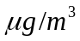 or 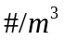 or 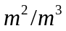for types P (particle mass), PN (particle number) and PA (particle surface area) respectively. The options for non-particle species types are either ‘ppm’ or ‘molecules/cm³’. If ‘ppm’ is specified, results will be shown at standard temperature and pressure (STP). The default is ‘ppm’.
out_species_units - Output concentration units (CHARACTER*80) for concentrations of non-particle species. Aerosol particle species output concentrations are always or or for types P (particle mass), PN (particle number) and PA (particle surface area) respectively. The options for non-particle species types are either ‘’ or ‘ppm’. The default is ‘’
emission_units - Emission rate units (CHARACTER*80). Options are either ‘ppm-m³/s’,’molecules-m³/cm³-s’, or ‘g/s’. Emission rates for the release specified in rel_mc in the Projectname.SCN file. Aerosol particle species emissions are always assumed to be in 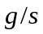 or 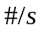 or 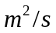for types P, PN and PA respectively. Note that the default emission units for gaseous species is ‘ppm-m³/s’, but the imc files provided with the distribution specify the more standard g/s units
rate_species_units - Concentration units (CHARACTER*80) for the rate constants given under the equations section. Options are either ‘ppm’ or ‘molecules/cm³’. The rate_species_units will be converted to match the species_units. The default is ‘molecules/cm³’.
rate_time_units - Time units (CHARACTER*80) for the rate constants given under the equations section. Options are ‘seconds’, ‘minutes’ or ‘hours’. The default is ‘seconds’.
particle_types - String consisting of comma separated particles types specified in the species section. If no particle type is specified, a default type of ‘P’ is assumed.
particle_units - String consisting of comma separated units for corresponding particle types specified above (CHARACTER*80). The default is. The particle types and units are only used for the GUI plots. The units are not used for converting the emissions or the output concentrations.
rtol - Relative tolerance (REAL*4) used to solve chemical reaction equations. The default is 1.e-2.
An example of a Control Section is shown in Figure 3-4 below.

#CONTROL
&CONTROL
ambient_file = ‘VISTAS_WEST.amb’
emission_units = ‘g/s’
species_units = ‘ppm’
out_species_units = ‘ug/m3’
rate_time_units = ‘min’
particle_types = ‘P, PA, PN’,
particle_units = ‘ug/m3, m2/m3, #/m3’,
rtol = 1.e-3
/

Figure 3-4 Sample Control Section of the IMC file.

Aqueous-Aerosol Section.
The Aqueous-Aerosol module included in SCICHEM-2012 is the CMAQ4.7.1 AERO5 module. Using parameters in the Aqueous-Aerosol Section (#Q), the modules can be turned on or off. The following namelist and namelist parameters are specified for the AERO5 aqueous-aerosol module.
Namelist: AQAER – Aqueous and Aerosol module control flags
aqueous - Specifies whether or not aqueous-phase chemistry will be performed (LOGICAL). Must have certain species defined in the Species Section, as described in the following section. If set to ‘True’, the species names listed will be checked with the list in section 3.3.2 to determine if the aqueous module can be used and if so, aqueous-phase chemistry will be performed in addition to gas phase. Liquid cloud content must be provided on a meteorological input file (Observations or Gridded). The default is ‘False’. Requires the aerosol control flag (see below) to be true

aerosol - Specifies whether or not aerosol equilibrium chemistry will be modeled (LOGICAL). Must have certain species defined in the Species Section, as described in the following section. If set to ‘True’, the species names listed will be checked with the list in section 3.3.2 to determine if the aerosol module can be used and if so, aerosol equilibrium chemistry will be performed in addition to gas phase. The default is ‘False’.
Namelist: AERSPEC
aerp_names - Names of species in particle phase for Aerosol module. Use as provided without any changes.
Namelist: G2AE_SPEC
g2ae_names - Names of gas phase species that participate in aerosol chemistry. Use as provided without any changes.
Namelist: NAQSSPEC
n_g2aq_spc - Number of gas phase species that participate in aqueous chemistry. Use as provided without any changes.

Namelist: G2AQ_SPEC
g2aq_names - Names of gas phase species that participate in aqueous chemistry. Use as provided without any changes.

Multicomponent Species Section.
Each line of the Species Section gives the species name, the species type (F, S, P, or A), the ambient concentration (ppm or molecules/cm³), the absolute tolerance (ppm or molecules/cm³), the gas deposition velocity (m/s), the wet scavenging coefficient (s⁻¹), the molecular weight (g/mole) to be used in solving for the concentration and flags (T/F) for turning on or off the dosage and deposition outputs. There are no defaults for these parameters. The species types are shown in Table 3-2.
Table 3-2 SCICHEM Species Types.
F | Fast | Species concentrations change rapidly and species rate equations will be integrated using LSODE.
S | Slow | Species concentrations change slowly and will be integrated explicitly using a predictor-corrector scheme.
P[N|A] | Particle | Species concentrations are determined through aerosol equilibrium. Species name must match aerosol particles set by aerosol module. If N or A is present after P then the species is particle number type or particle area type.
A | Ambient | Species concentrations do not change by the reaction, such as H₂O or O₂.
The wet scavenging coefficient, s (s⁻¹), is used to define the scavenging rate, sr (s⁻¹), as:
sr = s (R/R₀)
where R is the precipitation rate in mm/hr and R₀ is the reference precipitation rate of 1 mm/hr. The scavenging rate is applied to the gas-phase species after the gas-phase chemistry has been advanced. Scavenging coefficients for aerosol particles specified in the IMC file are ignored. Particle scavenging rates are determined internally based on particle size and precipitation rate based on the approach of Seinfeld (1986). Similarly, dry deposition velocities for aerosol particles are also ignored and dry deposition is computed internally following the approach of Slinn (1982). Note that if the aqueous-phase chemistry option is selected, all the wet scavenging coefficients specified in the IMC file will be ignored and the wet removal of both gases and particles will be carried out inside the aqueous-phase module.
Every species that appears in the Equation Section must also appear in the Species Section. The ambient concentration of H₂O may be set on the species line to a desired concentration or set to –1.0 to be set internally by the meteorological conditions. When set internally, the H₂O concentration is obtained from the humidity given in the meteorological input files or a default value of 30% relative humidity is used. Note that if species other than H₂O are specified as ambient, such as O₂, the correct ambient concentration must be given on the species line. If an ambient file has been specified under the Control Section, the ambient concentrations given in the Species Section will be overridden by the 3D ambient file.
Molecular weights are used to convert the gas-phase emissions to the desired species units and for other unit conversions. Emission rates that are provided in ‘g/s’ will be converted to ‘ppm-m³/s’ using the molecular weight. Standard temperature and pressure (STP; 298 K and 1 atm) are used in the conversion and the output concentrations are provided in µg/m³. The molecular weights for all ‘Fast’ and ‘Slow’ species must be provided on the IMC file. Molecular weights are not required for particle species, since equilibrium concentrations are determined from the ‘Fast’ and ‘Slow’ species concentrations. For aerosol particle species, concentrations are always assumed to be in µg/m³, #/ m³, m²/m³ for types P, PA and PN respectively. The corresponding emission rates for the particle types are in µg/s, #/s, m²/s.
An example of a Species Section is shown in Figure 3-5. In the example, only HNO₃ has a nonzero wet scavenging coefficient and therefore, there will be no wet deposition or scavenging of any species other than HNO₃. HNO₃ is modeled as a fast species with a background concentration of zero and a relative tolerance of 1.e-8. The deposition velocity is 0.02 m/s and the wet scavenging coefficient is 6.e-5 s⁻¹. The ambient H₂O concentration will be determined from the meteorological input data. Molecular weights of non-emitted, equilibrium and ambient species have been set to an arbitrary value of 99.99.
#Species,Type,Ambient,Tolerance,deposition vel,wet scav,mw,dos,dep
NO2 F 2.4000E-03 1.0000E-08 0.0025 0.0 46.00 T T
NO F 2.8000E-05 1.0000E-08 0.0015 0.0 30.00 T T
O F 1.0300E-26 1.0000E-12 0.0 0.0 16.00
O3 F 6.3000E-02 1.0000E-08 0.0 0.0 48.00 T T
NO3 F 2.2000E-05 1.0000E-12 0.0 0.0 62.00 T T
O1D F 1.0000E-30 1.0000E-12 0.0 0.0 16.00
OH F 3.2700E-09 1.0000E-12 0.0 0.0 17.00
HO2 F 6.8900E-06 1.0000E-12 0.0 0.0 33.00
N2O5 F 5.3000E-05 1.0000E-12 0.0 0.0 108.00 T T
HNO3 F 2.1000E-03 1.0000E-08 0.0200 0.0 63.00 T T
HONO F 4.6400E-06 1.0000E-08 0.0020 0.0 47.00 T T
PNA F 1.4243E-05 1.0000E-08 0.0020 0.0 79.00 T T
H2O2 F 3.4100E-03 1.0000E-08 0.0030 0.0 34.00
XO2 F 2.1800E-10 1.0000E-12 0.0 0.0 1.00
XO2N F 4.4200E-10 1.0000E-12 0.0 0.0 1.00
NTR F 6.2879E-05 1.0000E-12 0.0 0.0 130.00 T T
ROOH F 1.0000E-04 1.0000E-12 0.002 0.0 62.00
FORM F 3.4970E-06 1.0000E-08 0.0020 0.0 30.00 T T
ALD2 F 2.5176E-06 1.0000E-08 0.0020 0.0 44.00
ALDX F 5.7932E-06 1.0000E-08 0.0020 0.0 44.00
PAR F 1.7677E-02 1.0000E-08 0.0010 0.0 14.00
CO S 2.2000E-01 1.0000E-04 0.0010 0.0 28.00 T T
MEO2 F 6.8900E-10 1.0000E-12 0.0 0.0 47.00
MEPX F 6.8900E-06 1.0000E-12 0.002 0.0 48.00
MEOH F 0.0000E+00 1.0000E-12 0.001 0.0 32.00
HCO3 F 0.00000+00 1.0000E-12 0.0 0.0 63.00
FACD F 1.0000E-06 1.0000E-08 0.0020 0.0 46.00
C2O3 F 3.1300E-06 1.0000E-12 0.0 0.0 75.00
PAN F 1.5300E-03 1.0000E-08 0.0020 0.0 121.00 T T
…….
AH2OK P 1.0000E-01 1.0000E-08 0.0 0.0 18.00 T T
NH3 S 6.6853E-04 1.0000E-08 0.0 0.0 17.00 T T
SV_ALK S 1.0000E-30 1.0000E-08 0.0 0.0 150.00
SV_XYL1 S 2.2881E-06 1.0000E-08 0.0 0.0 192.00
SV_XYL2 S 9.7113E-06 1.0000E-08 0.0 0.0 192.00
SV_TOL1 S 3.7395E-06 1.0000E-08 0.0 0.0 168.00
SV_TOL2 S 6.9515E-06 1.0000E-08 0.0 0.0 168.00
SV_BNZ1 S 3.7395E-06 1.0000E-08 0.0 0.0 144.00
SV_BNZ2 S 6.9515E-06 1.0000E-08 0.0 0.0 144.00
SV_TRP1 S 2.8001E-05 1.0000E-08 0.0 0.0 168.00
SV_TRP2 S 1.1231E-04 1.0000E-08 0.0 0.0 168.00
SV_ISO1 S 1.0000E-30 1.0000E-08 0.0 0.0 96.00
SV_ISO2 S 1.0000E-30 1.0000E-08 0.0 0.0 96.00
SV_SQT S 4.7256E-06 1.0000E-08 0.0 0.0 378.00
CL2 A 1.0000E-10 1.0000E-08 0.0050 0.0 71.00
CL A 1.0000E-10 1.0000E-08 0.0050 0.0 35.50
HOCL A 1.0000E-10 1.0000E-08 0.0050 0.0 52.50
CLO A 1.0000E-10 1.0000E-08 0.0050 0.0 51.50
FMCL A 1.0000E-10 1.0000E-08 0.0050 0.0 64.50
HCL A 1.0000E-10 1.0000E-08 0.0 0.0 36.50
CO2 A 3.8412E+02 1.0000E-08 0.0 0.0 28.00
H2O A -1.0 1.0000E-06 0.0 0.0 18.02
Figure 3-5. Sample Species sections of the IMC file.
If either the aerosol equilibrium chemistry is turned on (aerosol flag is ‘True’ under the AqAer Section) or the aqueous-phase chemistry is turned on (aqueous and aerosol flags are ‘True’ under the AqAer Section), the species shown in Table 3-3 below must appear in the Species Section, even if they do not all appear in the gas phase mechanism (for example, the aerosol species). Note that the aerosol option can be selected without selecting the aqueous-phase chemistry option, but the converse is not true.
AERO5 uses the modal aerosol treatment with three modes viz. Aitken, Accumulation and Coarse. It is not necessary that all aerosol species will have all 3 modes. For multiple particle modes, the aerosol species names must appear in the Species Section of the IMC file with the mode character. The naming convention used for modal treatment follows that used in CMAQ and is “I” for the Aitken mode, “J” for the accumulation model and “K” for the coarse mode. Note that the chemical species in the provided IMC file are specifically for the AERO5 module and CB05 mechanism and cannot be updated to other schemes without corresponding changes in the SCICHEM code. The required names for either aqueous chemistry or aerosol equilibrium will be as they appear in Table 3-3. The total number of species needed for the aerosol module is 80 (51+29) and 67 (51+16) for the aqueous chemistry module.
Table 3-3 Required species names for the aerosol equilibrium module and aqueous-phase chemistry module
Module | Required Species Names
Both¹ (51) | ASO4J,ASO4I,ANH4J,ANH4I,ANO3J,ANO3I,AALKJ,AXYL1J,  AXYL2J,AXYL3J,ATOL1J,ATOL2J,ATOL3J,ABNZ1J,  ABNZ2J,ABNZ3J,ATRP1J,ATRP2J,AISO1J,AISO2J,  AISO3J,ASQTJ,AOLGAJ,AOLGBJ,AORGCJ,AORGPAJ,  AORGPAI,AECJ,AECI,A25J,A25I,ACORS,ASOIL,  NUMATKN,NUMACC,NUMCOR,SRFATKN,SRFACC,SRFCOR,  AH2OJ,AH2OI,ANAJ,ANAI,ACLJ,ACLI,ANAK,ACLK,  ASO4K,ANH4K,ANO3K,AH2OK
Aerosol (29) | NO2, N2O5, HNO3, HONO, SULF, HCL, NH3, ISOPRXN, TRPRXN, SULRXN, TOLNRXN, TOLHRXN, XYLNRXN, XYLHRXN, BNZNRXN, BNZHRXN, SESQRXN, SV_ALK, SV_XYL1, SV_XYL2, SV_TOL1, SV_TOL2, SV_BNZ1, SV_BNZ2, SV_TRP1, SV_TRP2, SV_ISO1, SV_ISO2, SV_SQT
Aqueous (16) | O3, OH, HO2, N2O5, HNO3, H2O2, MEPX, FACD, PACD, MGLY, SO2, SULF, CL2, HOCL, HCL, NH3
Note: ¹ Aerosol particles must be specified as species type “P[N|A]” (particle).

Multicomponent Equation Section.
Each line of the equations section gives the equation number followed by the chemical reaction. Species names must be placed in square brackets, such as [NO], and stochiometric coefficients are given in parentheses, as in (2.0) [NO]. The maximum number of reactants is 2 and the maximum number of products is 10. The reaction is terminated by a semi-colon followed by the reaction rate coefficient type. The following rate coefficient types are available (not all types are used in the current mechanism, CB05):

ID | Description | Number of parameters
0 | Radiation dependent | 0 ( Need table)
1 | Constant | 1 (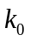)
2 | Temperature dependent | 3 or 2 ( A, B and C)
3 | Temperature and pressure dependent | 4 (, 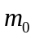, 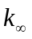and 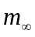)
4 | Temperature dependent and multiplied by the concentration of H2O (for compatibility with previous version) | 3( A, B and C)
5 | Air concentration dependent | 3 (A, B and C)
6 | Cloud liquid water content dependent | 1 ()
7 | Pressure dependent ( type B) | 1 ()
8 | Equilibrium rate | 3 (, 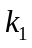and 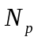)
9 | O₂ concentration dependent | 3 (A, B and C)
10 | N₂ concentration dependent | 3 (A, B and C)
11 | Falloff reaction rate ( type 1) | 4 (A, , B and )
12 | Falloff reaction rate ( type 2) | 4 (A, , B and )
13 | Falloff reaction rate ( type 3) | 6 (A, B, C, D, E and F)
14 | CH₄ concentration dependent | 3 (A, B and C)
15 | H₂O concentration dependent | 3 (A, B and C)
16 | O₂ and air concentration dependent | 3 (A, B and C)
17 | H₂O concentration dependent ( type 3) | 3(A, B and C)
18 | Falloff reaction rate ( type 4) | 7(A, B, m₁, C,D,m₂, and F )
19 | Falloff reaction rate ( type 5) | 4( A, B, C and D)
20 | Falloff reaction rate ( type 6) | 4( A, B, C and D)
21 | H₂ concentration dependent | 3(A, B and C)
22 | Temperature dependent ( type B) | 3(A, B and C)
For the radiation dependent rate constants (Type 0), a table must be provided listing the rate constants as a function of zenith angle (see Section 3.3.5).
For the other reactions, the necessary constants are given after the type number. For type 1, the rate constant itself is provided; for type 2, the constants A and B and optionally C are provided, satisfying the following equation for the rate constant:
Reaction type 22 is similar to type 2 with provided constants A, B and C satisfying the following equation for the rate constant:
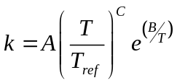
where
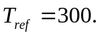
For reaction type 16, the form of the equation is similar to type 22. The rate constant is multiplied by the air and oxygen concentration as given by the following equation
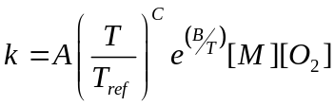
where 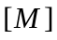 and 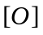 are the concentrations of air and oxygen in molecules/cm³ respectively.
For reaction type 3, constants , , and are provided. The rate constant for this type of reaction is calculated as follows:
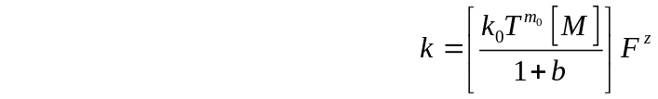
where
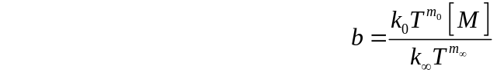
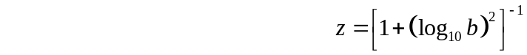
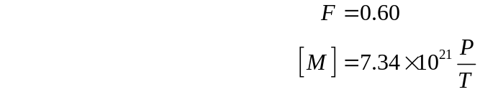
and is the concentration of air in molecules/cm³, P is the ratio of the pressure to standard atmospheric pressure and T is the temperature in degree Kelvin.

Reaction type 18 (Falloff 4) is similar in form to type 3 but uses 7 constants and the values of and are calculated from the constants A, B, m₁, C, D, m₂, and F using the equations given below.
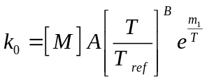
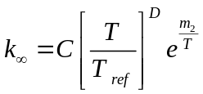
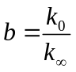
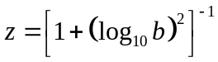
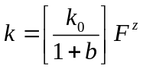
Reaction types 4, 5, 9, 10, 14, 15, 17, 21 represent reactions with [H₂O]_{ppm}, [M], [O₂], [N₂], [CH₄], [H₂O], [H₂O]² and [H₂] dependent rate constants, respectively. Here [S] is the concentration of species 'S' in molecules/cm³ and [S]_{ppm} is the corresponding concentration in ppm. The equations follow the same form as those for type 2. This type must be used for third-order reactions in which 2 SCICHEM chemical species are also reacting with air, O₂, N₂, CH_{4,} H₂O or H₂, since the maximum number of reactants is 2. Even if the rate constant is independent of temperature, instead of using type 1 for two species reacting with M, O₂, N₂, CH₄ or H₂O, use type ID 4, 5, 9, 10, 14, 15, 17 or 21 with B = 0. The rate constant will be multiplied by [H₂O]_{ppm}, [M], [O₂], [N₂], [CH₄], [H₂O], [H₂O]² and [H₂] for reactions of type 4, 5, 9, 10, 14, 15,17 and 21 respectively.
Reactions of type 6 represent those that depend on the cloud liquid water content (not used in the current CB05 mechanism). The rate data provided on the equation line is the diffusivity of the reacting species in air. An example is the heterogeneous conversion of N₂O₅ to HNO₃. The diffusivity of N₂O₅ should be provided on the equation line for this reaction in units of cm²/s. The reaction rate will be calculated internally as the product of a conversion constant, the diffusivity (cm²/s) and the cloud liquid water content (g/m³) divided by the square of the cloud droplet size (m), as follows:
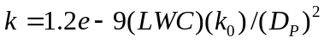
For reactions of type 7, the reaction rate constant is calculated from the provided constant so that
The equilibrium rate constant for type 8 is dependent on the rate of a previous reaction using the provided constants , and such that
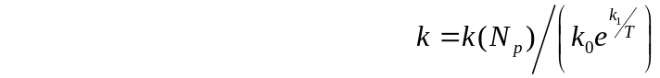
where 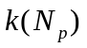is the reaction rate constant for reaction number . The value of must be less than the current reaction number and preferably the one immediately preceding the current reaction.

The rates for reaction types 11 and 12 (Falloff reaction types 1 and 2, respectively) are obtained from the values of constants A, , B and . For type 11 the rate is
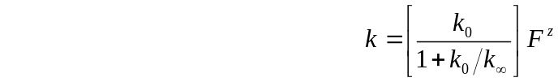
where
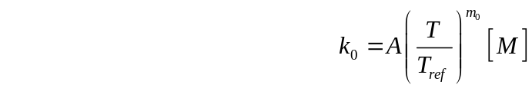
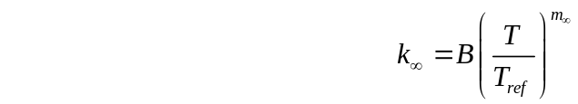
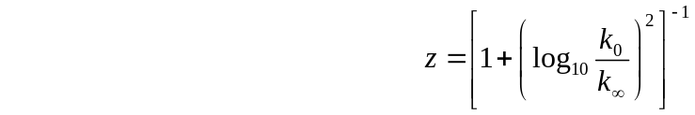
For reaction type 12, the reaction rate is multiplied by the O₂ concentration to give
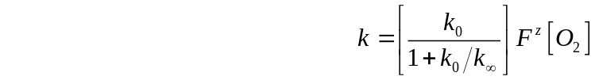
The reaction rate for Type 13 reactions (Falloff reaction type 3) is obtained using the constants A, B, C, D, E and F, so that
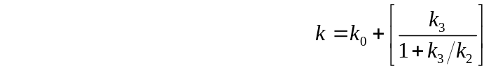
where
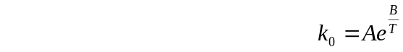
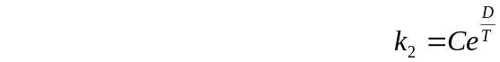
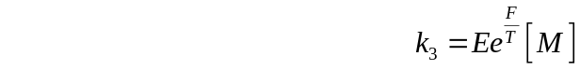
The reaction rates for reaction types 19 and 20 (Falloff reaction types 5 and 6, respectively) are of the same form and are obtained similarly using the three constants A, B, and C so that
for reaction type 19, and the rate is multiplied by [H₂O] for reaction type 20 as shown below
An example Equation Section is shown in Figure 3-6. Spaces must separate different components of the equation line. A plus sign (“+”) is used to separate species, a minus sign followed by a greater-than sign (“->”) separates the reactant species from the product species, and a semi-colon (“;”) begins the rate constant information.
In the example,
is radiation dependent ,
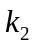 is oxygen and air concentration dependent and is given by
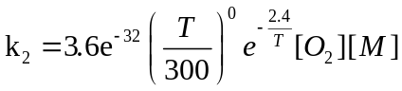
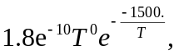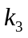 and 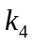 are temperature dependent and are given by
=
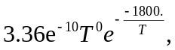 =
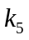 is fall off type 1 reaction rate
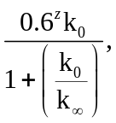 =
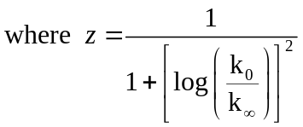

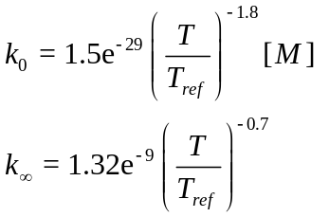and

The concentration and time units of the rate constants must be the same for all and are specified in the Control Section.
# Equations -- CB05 from CMAQ 4.7.1
1 [NO2] -> [NO] + [O] ; 0 0.000E+00 0.0000E+00
2 [O] -> [O3] ; 16 3.600E-32 0.0000E+00 -2.4
3 [O3] + [NO] -> [NO2] ; 2 1.800E-10 -1.5000E+03
4 [O] + [NO2] -> [NO] ; 2 3.360E-10 1.8000E+02
5 [O] + [NO2] -> [NO3] ; 11 1.500E-29 -1.8 1.3200E-09 -0.7
Figure 3-6 Sample Equation Section of the IMC file.

Multicomponent Table Section.
Radiation dependent rate constants appear in the Table Section. The table is of the form:
0, zenith angles( i ) , i = 1, no. zenith angles
equation number, radiation constants( i ), i = 1, no. zenith angles
A zero in the equation number field will indicate that the values to follow are the zenith angles. Each line must begin with a zero or an equation number.

#Table
0 0. 10. 20. 30. 40. 50. 60. 70.
1 5.408E-01 5.374E-01 5.264E-01 5.071E-01 4.762E-01 4.290E-01 3.589E-01 2.535E-01
8 2.498E-02 2.488E-02 2.456E-02 2.402E-02 2.319E-02 2.199E-02 2.026E-02 1.756E-02
Figure 3-7 Sample Table Section of the IMC file.
An example of a radiation constant table is shown in Figure 3-7 for 2 reactions and 8 zenith angles. In the example, 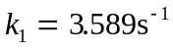at a zenith angle of 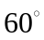. The zenith angle is 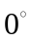at noon and 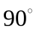at sunrise and sunset. A maximum of 20 zenith angles can be input. The radiation dependent rate constants are set to zero before sunrise and after sunset. Every equation that has a rate constant type 0 must have a corresponding entry in the Table Section.

Ambient Concentration Input.
Three-dimensional time-dependent ambient concentrations may be provided in binary or ASCII MEDOC format to a multicomponent project. A detailed description of the MEDOC format is given in Section 3.5.2 for the meteorological inputs and below for the ambient concentration inputs. The ambient concentration filename is set using the ambient_file parameter in the Control Section of the IMC file. For species ambient concentrations that are not available in the ambient data file, the concentrations from the IMC file are used. If the modeling domain goes further than what is provided in the ambient file, SCICHEM will use the nearest point in space. Likewise, if the calculation begins before the time given on the ambient file, the first time will be used and if it begins after the last time on the file, the last time will be used. A three-dimensional ambient file must hold a minimum of one point in space at one time. Units for the concentrations must be in species_units as set in the Control Section of the IMC file. To use the relative humidity provided in the meteorological observation file for the concentrations of water, negative concentrations for water must be specified on the 3D ambient file. This will indicate the water concentrations should be calculated internally. If relative humidity is not provided on the observation file, a default value of 30% is assumed.
As part of the SCICHEM distribution package, annual ambient concentration files are provided for eight regions of the contiguous US (CONUS). The regions are roughly based on the Regional Planning Organizations (RPOs) domains. The concentrations are calculated from a 36 km CONUS simulation with CMAQ, using the 2005 inputs for the Cross-State Air Pollution Rule (CSAPR). The CMAQ results are horizontally averaged over a given region and hourly varying concentrations are provided for three vertical layers (0 to 300 m, 300 to 1000 m, and 1000 to 3000 m) for each month. The hourly values are the same for each day of the month.
Figure 3-8 shows the eight regions for which concentration files are provided; the regions are listed below (the respective file names are provided in parentheses):
- Western Regional Air Partnership (WRAP) North ("WRAP_NORTH.amb")
- Western Regional Air Partnership (WRAP) South ("WRAP_SOUTH.amb")
- Central Region Air Planning Association (CENRAP) North ("CENRAP_NORTH.amb")
- Central Region Air Planning Association (CENRAP) South ("CENRAP_SOUTH.amb")

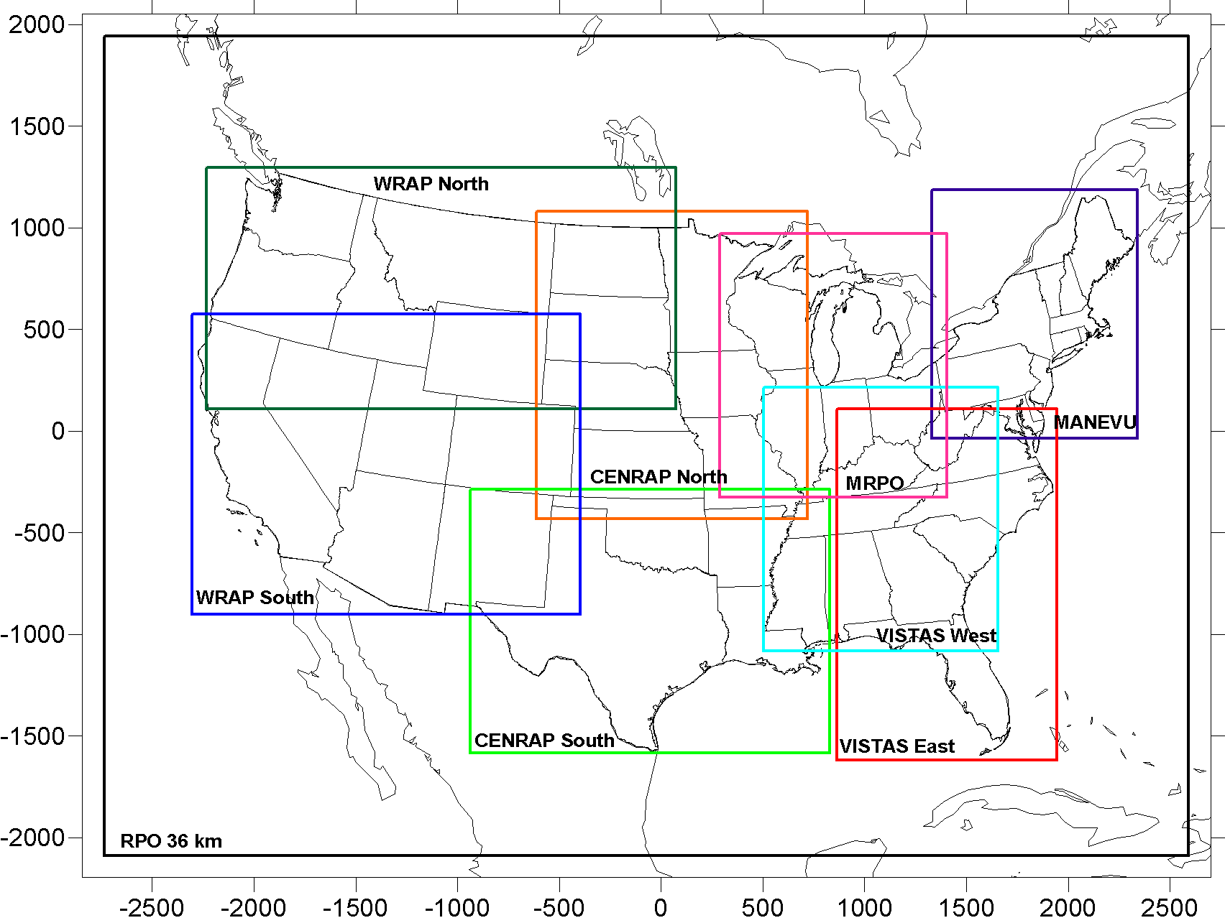

Figure 3-8 Eight regions for which CMAQ-based background chemistry files are provided with SCICHEM.

- Midwest Regional Planning Organization (Midwest RPO) ("MRPO.amb")
- Visibility Improvement State and Tribal Association of the Southeast (VISTAS) West ("VISTAS_WEST.amb")
- Visibility Improvement State and Tribal Association of the Southeast (VISTAS) East ("VISTAS_EAST.amb")
- Mid-Atlantic/Northeast Visibility Union (MANE-VU) ("MANE_VU.amb")

Ambient Concentration File Format
The 3D ambient file contains a header section followed by numerical data for each time. The general format structure is illustrated in Figure 3-, which shows the FORTRAN code used to read the file. For binary files, the read statement is unformatted.
! RECORD 1 - FILE FORMAT (‘FFFFFFFF’ or ‘BBBBBBBB’)
READ (1,’(A8)’) FFLAG

! RECORD 2 - NAME OF CODE - NOT USED IN SCICHEM
READ (1,’(A8)’) CODENAME

! RECORD 3 - TIME
READ (1,’(6(I12,1x))’) IDAY,IMONTH,IYEAR,IHOUR,IMIN,ISEC

! RECORD 4 - INITIAL TIME OF CALCULATION - NOT USED IN SCICHEM
READ (1, ’(6(I12,1x))’) JDAY,JMONTH,JYEAR,JHOUR,JMIN,JSEC

! RECORD 5 - NUMBER OF GRID POINTS, KEY POINTS, VARIABLES
READ (1, ’(6(I12,1x))’) NXA,NYA,NZA,NDUM,NAMB3D,NVAR2D

! RECORD 6 - NOT USED FOR SCICHEM AMB FILE
READ (1, ’(6(I12,1x))’) IDUM,IDUM,IDUM,IDUM,IDUM,IDUM

! RECORD 7 - NOT USED FOR SCICHEM AMB FILE
READ (1, ’(3(I12,1x))’) IDUM,IDUM,IDUM

! RECORD 8 – AMB CONC GRID AND TIMING INFORMATION (KMAX+11 VALUES)
READ (1,9003) (AMBZ(K),K=1, NZA),DXA,DYA,XOA,YOA,LAT0,LON0,
& DUM,DUM,DUM,DUM,ZTOPA

! RECORD 9 – AMB SPECIES NAMES AND DUM UNITS (2*NAMB3D +2*NVAR2D VALUES)
READ (1,9001) (NAME3D(N),N=1,NAMB3D),(NAMDUM,N=1,NAMB3D),
& (NAM2D(N),N=1,NVAR2D),(NAMDUM,N=1,NVAR2D)

! RECORD 10 - NOT USED IN SCICHEM AMB FILE
READ (1,9003) (DUM,N=1,3*NDUM)

! RECORD 11 - 3D VARIABLES
! (NAMB3D SETS OF NXA * NYA * NZA VALUES)
DO N=1,NAMB3D
READ (1,9003) (((CONC3D(I,J,K,N),I=1, NXA),J=1, NYA),K=1, NZA)
END DO

! RECORD 12 - 2D VARIABLES (NVAR2D SETS OF NXA * NYA VALUES)
DO N=1,NVAR2D
READ (1,9003) ((VAR2D(I,J,N),I=1, NXA),J=1, NYA)
END DO

!
9001 FORMAT(6(A8,1X))
9002 FORMAT(6(I12,1X))
9003 FORMAT(6(F12.4,1X))
Figure 3-9 Fortran pseudo-code for reading a formatted ambient concentration file in MEDOC format.

The definitions of the input variables for the rest of the records are as follows:
IDAY, IMONTH, IYEAR, IHOUR, IMIN, ISEC: The day, month, year, hour, minute and second for the ambient concentrations. The time convention used must be the same as specified in the input file as described in section 3.1.1 or 3.2.3.8. If LOCAL is set to true in the inp file then the time is assumed to be LOCAL instead of UTC. For monthly input files, where the hourly concentrations are the same over the whole month, the value of iday and iyear should be set to 99 and 9999 respectively, similar to the ambient files provided with the SCICHEM distribution.
NXA, NYA, NZA: Number of grid points in the (x, y, z) directions, respectively.
NREPER : Number of special points. This information is not used for the SCICHEM input and NREPER should be set to zero.
AMBZ : Array of NZA vertical grid coordinates in meters. SCICHEM assumes a terrain-following coordinate transformation.
DXA, DYA : Horizontal grid spacing in meters.
XOA, YOA : Horizontal grid origin (SW corner) coordinates in km.
LAT0, LON0 : Horizontal grid origin (SW corner) coordinates in degrees.
ZTOPA : Vertical meteorology domain height in meters. If the parameter is not specified , the domain height is assumed to be AMBZ(NZA).
NAMB3D : Number of species with three-dimensional ambient concentration fields
NAME3D : Names of the multicomponent species with three dimensional ambient concentration fields.
NVAR2D : Number of two-dimensional fields.
NAM2D : Names of the two-dimensional variables. SCICHEM recognizes the two-dimensional field ‘REL’ or ‘TOPO’, for reading the terrain elevation in meters.
CONC3D : The 3d (NXA*NYA*NZA) ambient concentrations of NAMB3D species. The concentrations units for non-particle species are assumed to be species_units, as set under the control section of the IMC file (Section 3.3.1). Aerosol particle species concentrations are always assumed to be in or or for types P, PN and PA respectively. Please note that any units specified in the ambient_file (DUM UNITS) are ignored.
The MEDOC file format described in 3.5.2 is more general than that used by SCICHEM ambient concentration file format. Variables not used in the SCICHEM ambient concentration file format are indicated as dummy variables in the figure.

Sampler Location File.
Time histories of concentration, dosage, line-of-sight integrals, and surface deposition for a set of locations can be obtained by specifying a sensor location file in the OPTIONS namelist of the main input data file (Section 3.1.1). The location file is an ASCII text file utilizing a format which allows the specification of moving sensors, multiple materials and a variety of sensor outputs. The first line in the location file must begin with the case-insensitive string “SCIPUFF SENSOR” (read with Fortran 'A11' format).
The general structure of the SCIPUFF format is illustrated in Figure 3-10, where it is shown that the header record begins with the string 'SCIPUFF SENSOR' and contains optional keyword input. Depending on those keywords, the header record may be followed by a list of output times. There follows an unlimited list of sensor definition records; input varies depending on specific sensor characteristics. As also shown in the figure, "moving" sensors require a list of waypoints following the basic sensor definition record.

SCIPUFF SENSOR [keywords]
[outputTime [units] !Optional list of output times
...
END]
[type] input class choice [name] !Define individual sensors
[time location [orientation] !Waypoint list (only for moving sensor)
...
END] !Terminates waypoint records
..
Figure 3-10 General structure of the SCIPUFF format sensor location file.
User-defined inputs are shown in italics; non-italicized strings must appear exactly as shown. Brackets denote optional inputs. (Comments shown after exclamation marks are not present in an actual file.)
The optional keywords on the header record can be used to specify the coordinate system of the sensor locations and control output times and format. Specific keyword descriptions are given in Table 3-4.
Note that some of the keywords require input, which then must immediately follow the particular keyword. No check is made for conflicting keywords, e.g. specifying both 'LL' and 'UTM'. In such cases, the last keyword supersedes. Unrecognized strings are ignored. The absence of these keywords results in the default settings described in the table.

Table 3-4 Header record keywords and input for SCIPUFF sensor location format.
Keyword Description | Keyword | Input | Result
Coordinate system for sensor locations, which may be different from project coordinates. The absence of any of these keywords implies locations are in project coordinates. | LATLON  LL | None | Sensor coordinates in spherical (lat/lon) system
 | UTM | Zone  (INTEGER) | Universal Transverse Mercator
 | CART  KM | None | Cartesian system with origin at project reference location
Start time for sensor output. No output will be given before this time. Default is project start time. Will be superseded if list of output times defined. See below. | START | Time (REAL or [YYYYMMDD:]  HH:MM:SS.SS) | Simple real number interpreted as time relative to project start time. Otherwise absolute time used with the same time convention (local or UTC) as for the dispersion calculation. If date not given, project start date assumed.
 | START | [Time units] | Optional time units for relative start time. Valid units are S, SEC, SECONDS, M, MIN, MINUTES, H, HRS, HOURS. Default is seconds.
Specifying averaging times, either for fixed interval or list of specific times | AVERAGE  TAVG  AVG | Averaging time (REAL) followed by optional time units or character string 'LIST' | A real number is interpreted as the time averaging period. 'LIST' requires a list of averaging periods immediately follow the header record
 | AVERAGE  TAVG  AVG | [Time units] | Optional units for time interval. Valid units are S, SEC, SECONDS, M, MIN, MINUTES, H, HRS, HOURS. Default is seconds.
Specifying output times, either by fixed interval or list of specific times | OUTPUT | Time interval (REAL) or character string 'LIST' | A real number is interpreted as the output time interval. 'LIST' requires a list of times to immediately follow the header record
 | OUTPUT | [Time units] | Optional units for time interval. Valid units are S, SEC, SECONDS, M, MIN, MINUTES, H, HRS, HOURS. Default is seconds.

SCIPUFF SENSOR UTM 18 !Sensor locations in UTM zone 18
...
SCIPUFF SENSOR OUTPUT 1 HOUR !Sensor output in one hour intervals
...
SCIPUFF SENSOR AVERAGE 1 HOUR !Sensor output averaged over one hour
!periods
...
SCIPUFF SENSOR OUTPUT LIST !List of output times must follow
...
SCIPUFF SENSOR START 60 MIN !Output commences one hour after start
!of dispersion calculation
...
SCIPUFF SENSOR START 20070101:12:00:00 !Output commences at
!12:00 January 1, 2007
Figure 3-8 Examples of header records in an SCIPUFF sensor location file
Some examples of valid header records are given in Figure 3-. Note that most of the keywords and input in the examples could be combined, e.g., 'UTM 18' and 'OUTPUT LIST' could go on the same header record.
As shown in Figure 3-, the header record must be followed by a list of output times if the string 'OUTPUT LIST' is present. As with the input associated with the 'START' keyword, output times given as simple real numbers are interpreted as relative to the project start time while those given in [YYYYMMDD:]HH:MM:SS.SS format are absolute. Note that the list cannot have mixed relative and absolute times. Also, as with the 'START' keyword, optional units can be given for relative times. The list of output times is terminated by a line containing the single string 'END'. Two examples of valid output time lists are given in Figure 3-. The first uses time relative to the start of the calculation, the second uses the date and absolute time format.
SCIPUFF SENSOR OUTPUT LIST
30 SEC !First output 30 seconds after start of calculation
5 MIN !Second output at 5 minutes
0.5 HOUR
2 HRS !Last output at 2 hours; no subsequent output
END
...

SCIPUFF SENSOR OUTPUT LIST
20070101:16:00:00 !First output at 16:00 January 1, 2007
20070101:17:30:00
20070101:20:00
20070102:01:00:00 !Final output at 0100 January 2, 2007
END
...

Figure 3-9 Two examples of output time lists in an SCIPUFF sensor location file.
Following the header record and output time list, if present, are the records defining specific individual sensor parameters such as location, output characteristics, material, etc. Since there are so many combinations of sensor types and outputs, it is not possible to illustrate them all concisely in Figure 3-. The general structure of a sensor definition record is shown consisting of optional sensor type keywords followed by input (mostly numerical) that may depend on the sensor type, a class giving the general nature of the sensor output, followed by input choices that depend on the sensor class. Finally, an optional name may be associated with the sensor. Note that all keywords and input must be space delimited; numerical inputs are read in free-format.
Table 3-4 describes the sensor type keywords while Table 3-5 gives the corresponding input requirements. Single point (defined without a sensor type keyword), moving and line-of-sight (LOS) sensors all require the sensor location; it is the starting location for moving sensors. LOS sensors additionally need parameters that define the orientation and range of the line integral. (Note that LOS sensors can also move.)
Table 3-5 Sensor type keywords.
Sensor Type Keyword | Description
None (Default) | The absence of a sensor keyword implies a single-location, stationary, point sensor.
MOVING | Denotes a non-stationary sensor and requires a list of waypoints to follow. Must come first if used with 'LOS' keyword .
LOS | Denotes a "line-of-sight" sensor which outputs a concentration line integral. Keyword 'MOVING', if present, must come first.
Table 3-6 Required sensor input for various sensor types.
Sensor Type Keyword | Input | Input Description
None (Default),  MOVING  LOS | X (REAL)  y (REAL)  z (REAL)  [zRef] | Horizontal location (x,y) in project coordinates, unless specified with a coordinate system keyword (Table 3-4). For lat/lon coordinates, x refers to East longitude, y to North latitude. Vertical location, z, is in meters. zRef is an optional keyword indicating the height reference: 'AGL' for height above local ground level; 'MSL' relative to mean sea level. 'AGL' is used if no reference is given.
LOS | azimuth (REAL)  elevation (REAL)  range (REAL) | Parameters defining line orientation and length. Must follow location input. azimuth is the clockwise rotation in a horizontal plane from North (degrees), elevation is the rotation above the horizon in a vertical plane (degrees), and range is the path length (meters). Setting range ≤ 0 implies an infinite path length (or terminated by intersection with the ground).

Table 3-7 Sensor classes
Class | Description
CONC[:INT]¹ | Instantaneous concentration.
MC[:INT]^{1,2} | Multicomponent species concentrations.
MET² | Output of wind velocity and other meteorological quantities.
Notes:
¹ Appending ':INT' to class string results in time-integrated output. Invalid with LOS sensor.
² Not valid with LOS sensor type.
Table 3-7 gives the sensor classes which generally characterize sensor output. Note that for some classes, the character of the output is modified by appending certain strings to the basic class string, e.g., 'CONC:INT' modifies concentration output (class 'CONC') so that it is integrated in time (':INT')
The input choices for a given sensor class usually consist of a material names, except for 'MET' class, where only a single, optional choice is available. For some sensor classes, additional optional input can be encoded into the choice string by appending appropriate numerical or character input after a colon. These are fully described in Table 3-7. The optional sensor name is limited to 64 characters without spaces. It is basically used to annotate the list of sensors since it does not appear on the output file.

Table 3-8 Choices for various sensor classes
 | Choice | Description
CONC | MatName[:igrp]. | Material name (CHARACTER); must match one of the material names in the project input file. The subgroup identifier (INTEGER), appended after a colon, is optional and can be used to select a particular size group for a particle material, or select vapor (igrp = 1) liquid droplet (igrp = 2) for a liquid material. A value of zero (default value if igrp is missing) implies total concentration for the specified material, i.e. sum over all subgroups
MC | MatName:(s₁, s₂, ... ,s_{n+1}) | Material name (CHARACTER); must match the multicomponent material name. s₁, s₂,... (CHARACTER) represent names of multicomponent species. The names are comma delimited and must be contained within parentheses following the colon. In the absence of any name inputs, all multicomponent species values are output.
MET | [TURB] | The only valid (optional) choice for a MET class sensor is 'TURB' which results in the output of turbulence and boundary layer quantities.
Figure 3- shows that MOVING sensors require a list of waypoints giving location (and orientation for LOS sensors) for times relative to the project start time (Unlike with output start time or time list, absolute times cannot be specified.) This list must immediately follow the basic sensor definition record. There is no limit to the number of waypoints. The format of the location and orientation input is as given in Table 3-5 for the MOVING and LOS sensor input. The trajectory of a moving sensor is defined by linear interpolation in time within the sequence of waypoints.

SCIPUFF SENSOR UTM 18
336 4250 0 CONC TRACER Sensor1
MOVING 338 4250 0 CONC:INT TRACER Sensor2
0.3 336 4251 10
0.5 330 4252 100
0.9 326 4251 10
END
LOS 336 4250 0 150 15 -999 CONC SF6 Sensor3
MOVING LOS 338 4254 0 270 30 -999 CONC SF6 Sensor4
0.25 338 4254 0 360 30 -999
0.50 338 4254 0 90 30 -999
0.75 338 4254 0 180 30 -999
1.00 338 4254 0 270 30 -999
END
336 4250 100 MET Sensor5
336 4250 10 MET TURB Sensor6
336 4250 0 MC TRACER:(NO2,SO2,O3) Sensor7

Figure 3-10 SCIPUFF SENSOR location file showing several examples of sensor input.
Figure 3- is an example of a sensor input file utilizing a number of input options. All sensor locations are in UTM coordinates. The first sensor, labeled 'Sensor1', gives a simple concentration time-history of the material 'TRACER' at ground level. Sensor2 is a moving sensor giving the time-integrated concentration of 'TRACER' along the trajectory. Waypoints for the sensor are specified at 0.3, 0.5 and 0.9 hours after the start of the calculation: the sensor begins at ground level, moves up to 100m at 0.5 hours and back down to 10m at 0.9 hours. The sensor remains fixed at the last location after 0.9 hours.
Also shown are two line-of-sight sensors for the material 'SF6'; the first, Sensor3, is stationary while the second has a fixed location and elevation angle but rotates through 360° over one hour. Both LOS sensors have unlimited range.
Sensor5 and Sensor6 are examples of meteorological sensors. The first gives mean velocity and temperature, while the latter also gives turbulence and boundary layer information.
The last sensor, Sensor 7, shown in Figure 3- is 'MC' and samples the concentrations of 3 species NO₂, SO₂ and O₃ for the multicomponent material 'TRACER'.

Meteorology input.

Observation File Format.
A meteorological observation input file consists of a header section that specifies the file type, the number of observation variables, their names and units, followed by the numerical data.

[# comment]
...
ftype
nvar [nvarp]
name1 name2 name3 ... namenvar
unit1 unit2 unit3 ... unitnvar
[pname1 pname2 pname3 ... pnamenvarp]
[punit1 punit2 punit3 ... punitnvar]
missing [zref]
Figure 3-11: Header structure for a meteorology observation file. Records and variables in brackets are optional or required only if nvarp is given.
The header structure is shown in Figure 3- and individual records are described in the following.
comment : Optional comments are indicated by ‘#’ in the first column. There is no limit to the number of comment lines.
ftype : The file type which can be ‘PROFILE’ or ‘SURFACE’. (Only these two types are recognized by SCICHEM.) A SURFACE file has only one observation for each station and is typically associated with near-surface measurements of wind and/or boundary layer parameters such as surface heat flux or mixing-layer height. A PROFILE file generally has more than one observation height at a station and is used when vertical profiles of wind, temperature, etc. are available, e.g. from upper air soundings.
nvar : The number of observation variables given in the file, read with free format. If nvarp is given, then nvar is the number of fixed variables for a PROFILE file. Fixed variables are not functions of height and these are indicated in Table 5-1. nvar must be at least 4 (station id, time and horizontal position are the minimum requirements). nvar + nvarp cannot exceed 30 for a PROFILE file; nvar cannot exceed 22 for a surface file.
nvarp : The number of profile observation variables, read with free format. This is an option for PROFILE files only. Profile variables typically vary with height. Examples are height, pressure, temperature, humidity and wind velocity. The minimum number is 3 (height and velocity).
name1, ... , namenvar : The observation variable names are read using (30a8) format. There must be nvar names specified and the order here determines the order in which variables are given in each record of the numerical data. Names recognized in SCICHEM are defined in Table 3-9; multiple specific names indicate synonyms. Other names will be ignored without causing an error so that input files with variables not needed in SCICHEM may still be used. If nvarp is given, these are the names of the fixed variables. Acceptable fixed variable names are indicated in Figure 3-. Not all combinations of recognized variable names are permitted. This is discussed below.
unit1, ... , unitnvar : The observation variable units are read using (30a8) format. Only certain variables require that units be specified; otherwise blank spaces are acceptable. Variables requiring units are indicated in Table 5-1 along with those units recognized by SCICHEM. An error message is given if a unit is unrecognized (but only for those requiring units).
pname1, ... , pnamenvarp : The profile observation variable names are read as described for name, if nvarp is given. There must be nvarp names specified.
punit1, ... , punitnvarp : The profile observation variable units are read as described for unit, if nvarp is given.
missing : A character string of up to 8 characters used to indicate a missing or bad value in the numerical data.
zref : Optionally, the reference height in meters above the surface can be specified for SURFACE observations. If the reference height is omitted, a standard value of 10m is assumed, unless the height for each observation is specified in the data record.
The minimum requirements for meteorological observation files are that the station ID, time, location, wind speed and height (for a PROFILE file only) must be specified. Additionally, if certain input options are chosen, such as observational large-scale variability or observational or profile boundary layer then specific combinations of variables must be given. In particular, then, the following variables (or some combination thereof) are required as a minimum:
1) ID,
2) time (TIME, HOUR, YEAR, MONTH, DAY, YYMMDD, JDAY),
3) wind velocity (U, V, WSPD, SPEED, SPD, DIR,WDIR),
4) horizontal location (X, Y, LON, LAT),
5) Z if file type is PROFILE,
6) UL, VL and UVL if observational large-scale variability is specified (ENSM_TYPE=‘OBS’),
7) Both ZI and HFLUX together or PGT or MOL if observational boundary layer is specified (BL_TYPE=‘OBS’),
- UU, VV, WW, WT, SL, and SZ if profile boundary layer is specified (BL_TYPE=‘PROF’).
Cloud names are read with (A5,1.1) format to determine which cloud droplet size section the variable refers to, however, if ncld (specified on the MSC file) is 1, either ‘CLOUD’ or ‘CLOUD1’ may be given in the header. If ncld is less than the number of sections given on the observation file, a warning is displayed and the sections greater than ncld will be ignored.
Some combinations of variables, particularly those concerning time, are not allowed, are mutually exclusive or result in some of the variables being ignored. Also, the presence or absence of certain variables dictates that others be given. These situations are now enumerated:

1) Specifying TIME supersedes HOUR, DAY, MONTH, YEAR, YYMMDD and JDAY. No error message is given, but all other time variables are ignored.
2) HOUR must be specified in the absence of TIME. HOUR must be combined with either YYMMDD, the combination of DAY, MONTH, YEAR or JDAY. Note that YYMMDD supersedes DAY, MONTH, YEAR, which supersedes JDAY. All three variables DAY, MONTH and YEAR must be given together.
3) X and Y must be specified together. X and Y supersede LON and LAT.
4) LON and LAT must be specified together and are required if X and Y are not given.
5) U and V must be specified together. U and V supersede WSPD, etc. and DIR or WDIR.
6) WSPD, etc. and DIR or WDIR must be specified together and are required in the absence of U and V.
7) UL, VL and UVL must be specified together. These can only be used in combination with U and V; an error occurs if they are used with WSPD and WDIR.
- MOL supersedes PGT and HFLUX; PGT supersedes HFLUX.
The numerical data are given after the header section in the order dictated by the list of variable names. The general structure of the numerical data is shown in Figure 3-. If nvarp is given, individual profiles must be separated by the fixed data record, which must begin with the string “ID:”. Vertical profiles must be given with height monotonically increasing. This is also true for time and it is further necessary that all observations at a particular time be grouped together. All nvar and nvarp, if applicable, variables for each station and/or height at a particular time must be contained on a single line of no more than 256 characters. The figure illustrates that all nz heights for station id1 at time1 are given before station id2 and that data from all nsta stations at time1 are given before time2.
Meteorological variables and their units recognized in SCICHEM.
Variable Description | Specific Name | Units | Units as they should appear
Station ID^{(1),(2)} | ID | None | None
Time⁽²⁾  (intended for laboratory or other idealized situations where date and time of day is irrelevant) | TIME | HOURS  HRS  MIN  SEC | HOURS  HRS  MIN  SEC
Time of Day⁽²⁾ | HOUR | HOURS⁽³⁾ | HOURS
Year⁽²⁾ | YEAR | None
Month⁽²⁾ | MONTH | None
Day⁽²⁾ | DAY | None
Year-Month-Day⁽²⁾ | YYMMDD | None
Julian Day⁽²⁾ | JDAY | None
X-location⁽²⁾ | X | KM⁽³⁾ | KM
Y-location⁽²⁾ | Y | KM⁽³⁾ | KM
Longitude⁽²⁾ | LON | E⁽⁴⁾  W | E  W
Latitude⁽²⁾ | LAT | N⁽⁴⁾  S | N  S
Wind Speed | WSPD or  SPEED or  SPD | KNOTS  KTS  M/S  MPH | KNOTS  KTS  M/S  MPH
Wind Direction | DIR or WDIR | DEG⁽³⁾ | DEG
Velocity along X- or Longitude-Axis | U | KNOTS  KTS  M/S  MPH | KNOTS  KTS  M/S  MPH
Velocity along Y- or Latitude-Axis | V | KNOTS  KTS  M/S  MPH | KNOTS  KTS  M/S  MPH
Height | Z | M  FEET  FT | M  FEET  FT
Pressure | P | MB⁽³⁾ | MB
Temperature | T | C  K  F | C  K  F
Humidity | H  HUMID  Q | GM/GM  G/G  GM/KG  G/KG  % | GM/GM  G/G  GM/KG  G/KG  %
Boundary Layer Mixing Height⁽²⁾ | ZI | M  FEET  FT | M  FEET  FT
Pasquill-Gifford-Turner Stability Class⁽²⁾ | PGT | None⁽⁵⁾
Surface Heat Flux⁽²⁾ | HFLUX | K-M/S  C-M/S  W/M/M  W/M2 | K-M/S  C-M/S  W/M/M  W/M2
Monin-Obukhov Length⁽²⁾ | MOL | M | M
Precipitation. Index^{(2),(6)} | PRCP | None | None
Precipitation Rate^{(2),(7)} | PRATE | MM/HR | MM/HR
Fractional Cloud Cover⁽²⁾ | FCC | None | None
Cloud Liquid Water Content⁽⁸⁾ | CLOUD  or  CLOUD1 to CLOUDncld | G/M³ | G/M3
U-Velocity Std. Deviation, Large-Scale Variability | UL | KNOTS  KTS  M/S  MPH | KNOTS  KTS  M/S  MPH
V-Velocity Std. Deviation, Large-Scale Variability | VL | KNOTS  KTS  M/S  MPH | KNOTS  KTS  M/S  MPH
Large-Scale Variability Velocity Correlation Coefficient | UVL | None | None
Shear-Driven Lateral Velocity Variance | UU | M²/S² | M2/S2
Shear-Driven Lateral Velocity Variance | UU | M²/S² | M2/S2
Buoyancy-Driven Lateral Velocity Variance | VV | M²/S² | M2/S2
Vertical Velocity Variance | WW | M²/S² | M2/S2
Boundary Layer Heat Flux | WT | K-M/S  C-M/S | K-M/S  C-M/S
Turbulence Scale (Buoyancy-Driven) | SL | M | M
Turbulence Scale (Shear-Driven) | SZ | M | M

Table 3-9: Meteorological variables and their units recognized in SCICHEM.
Notes:
⁽¹⁾ ID can be an 8 character alphanumeric string if it is the first variable given, otherwise it must be an integer.
⁽²⁾ variable can be specified as fixed data on a PROFILE file.
⁽³⁾ unit assumed regardless of input.
⁽⁴⁾ default unit if none specified.
⁽⁵⁾ standard PGT classes converted to numerical values, i.e. class A = 1, B = 2, ..., G = 7 (non-integer values are permitted).
⁽⁶⁾ precipitation index specified as follows: light rain 1, moderate rain 2, heavy rain 3, light snow 4, moderate snow 5 and heavy snow 6.
⁽⁷⁾ precipitation rate only specifies a liquid form of precipitation (i.e., not frozen).
⁽⁸⁾ if ncld is 1, variable may be specified as either CLOUD or CLOUD1.

var1 ... id1 ... time1 ... z1 ... varnvar (a)
...
var1 ... id1 ... time1 ... znz ... varnvar
var1 ... id2 ... time1 ... z1 ... varnvar
...
var1 ... idnsta ... time1 ... znz ... varnvar
var1 ... id1 ... time2 ... z1 ... varnvar
...

ID: id1... time1 ... varnvar (b)
var1 ... z1 ... varnvarp
...
var1 ... znz ... varnvarp
ID: id2... time1 ... varnvar
var1 ... z1 ... varnvarp
...
var1 ... znz ... varnvarp
...
ID: idnsta... time1 ... varnvar
var1 ... z1 ... varnvarp
...
var1 ... znz ... varnvarp
...
ID: id1... time2... varnvar
var1 ... z1 ... varnvarp
...
var1 ... znz ... varnvarp
...
Figure 3-12: General structure of the numerical data in a meteorological observation file. (a) Without nvarp specified; (b) with nvar fixed variables and nvarp profile variables.

MEDOC Format.
Gridded meteorology is input as a MEDOC file. The original “standard” MEDOC format consists of a header section followed by numerical data for each time. An extension to this format allows SCICHEM to utilize meteorological fields defined in a variety of map projections, vertical coordinates and staggered grid configurations. This information is contained in an optional header section at the beginning of the file. This will be described in the next section, after the standard format is described here.
A sample Fortran code that reads the data for a single time break is illustrated in Figure 3-. The first record must be either ‘FFFFFFFF’ for a formatted file or ‘BBBBBBBB’ for a binary file. The binary file is read with code identical to that shown in Figure 3-, absent the format statements. The definitions of the input variables for the rest of the records are as follows:

IMAX, JMAX, KMAX : Number of grid points in the (x, y, z) directions, respectively.
NREPER : Number of special points. This information is not used for the SCICHEM input and NREPER can be set to zero.
NVAR3D : Number of three-dimensional fields.
NAM3D : Names of the three-dimensional variables. SCICHEM requires at least the 2 horizontal velocity component fields, with the names ‘U’, ‘V’. SCICHEM will also read the vertical velocity component, ‘W’ (required if terrain elevation is given as a two-dimensional field), potential temperature ‘T’ or absolute temperature ‘TA’. In addition, humidity ratio, ‘H’, and cloud liquid water content, ‘CLD’ or ‘CLD1’ to ‘CLDncld’ may be specified. Velocities are assumed to be in ms–1, temperature in °K and humidity and cloud liquid water content in grams moisture per grams dry air. Cloud names are read with (A3,1.1) format to determine which cloud droplet size section the variable refers to, however, if ncld (specified on the MSC file) is 1, ‘CLD’ may be given in the header. If ncld is less than the number of sections given on the MEDOC file, a warning is displayed and the sections greater than ncld will be ignored. All other names are ignored.
NVAR2D : Number of two-dimensional fields.
NAM2D : Names of the two-dimensional variables. SCICHEM recognizes the following two-dimensional fields if provided: terrain elevation in meters (required if vertical velocity is given), ‘REL’ or ‘TOPO’; surface roughness in meters, ‘ZRUF’ [or ‘ZRUF(T)’ if time-varying]; planetary boundary layer height (above surface) in meters, ‘ZI’ or ‘PBL_HITE’; surface heat flux in watts per square meter, ‘HFLX’ or ‘SFC_HTFX’; friction velocity in ms⁻¹, ‘USTR’; precipitation rate in millimeters per hour, ‘PRATE’ or ‘PRECIP’, and fractional cloud cover, ‘FCC’ or ‘CC’. All other variables are ignored.

C RECORD 1 - FILE FORMAT (‘FFFFFFFF’ or ‘BBBBBBBB’)
READ (1,9001) FFLAG
C
C RECORD 2 - NAME OF CODE - NOT USED IN SCICHEM
READ (1,9001) CODENAME
C
C RECORD 3 - TIME
READ (1,9002) IDAY,IMONTH,IYEAR,IHOUR,IMIN,ISEC
C
C RECORD 4 - INITIAL TIME OF CALCULATION - NOT USED IN SCICHEM
READ (1,9002) JDAY,JMONTH,JYEAR,JHOUR,JMIN,JSEC
C
C RECORD 5 - NUMBER OF GRID POINTS, KEY POINTS, VARIABLES
READ (1,9002) IMAX,JMAX,KMAX,NREPER,NVAR3D,NVAR2D
C
C RECORD 6 - NOT USED FOR SCICHEM
READ (1,9002) IDUM,IDUM,IDUM,IDUM,IDUM,IDUM
C
C RECORD 7 - NOT USED FOR SCICHEM
READ (1,9002) IDUM,IDUM,IDUM
C
C RECORD 8 - GRID AND TIMING INFORMATION (KMAX+11 VALUES)
READ (1,9003) (SZ(K),K=1,KMAX),DX,DY,XO,YO,LAT,LON,
& DUM,DUM,DUM,DUM,ZTOP
C
C RECORD 9 - NAMES AND UNITS (NREPER+2*NVAR3D+2*NVAR2D VALUES)
READ (1,9001) (NAMDUM,N=1,NREPER),
& (NAM3D(N),N=1,NVAR3D),(NAMDUM,N=1,NVAR3D),
& (NAM2D(N),N=1,NVAR2D),(NAMDUM,N=1,NVAR2D)
C
C RECORD 10 - NOT USED IN SCICHEM
READ (1,9003) (DUM,N=1,3*NREPER)
C
C RECORD 11 - 3D VARIABLES
C (NVAR3D SETS OF IMAX*JMAX*KMAX VALUES)
DO 21 N=1,NVAR3D
21 READ (1,9003) (((VAR3D(I,J,K,N),I=1,IMAX),J=1,JMAX),K=1,KMAX)
C
C RECORD 12 - 2D VARIABLES (NVAR2D SETS OF IMAX*JMAX VALUES)
DO 41 N=1,NVAR2D
41 READ (1,9003) ((VAR2D(I,J,N),I=1,IMAX),J=1,JMAX)
C
9001 FORMAT(6(A8,1X))
9002 FORMAT(6(I12,1X))
9003 FORMAT(6(F12.4,1X))

Figure 3-13: Fortran pseudo-code for reading a formatted MEDOC input file.
SZ : Array of KMAX vertical grid coordinates in meters. SCICHEM assumes a terrain-following coordinate transformation.
DX, DY : Horizontal grid spacing in meters.
XO, YO : Horizontal grid origin (SW corner) coordinates in km.
LAT, LON : Horizontal grid origin (SW corner) coordinates in degrees.
ZTOP : Vertical meteorology domain height in meters. If the parameter is not specified , the domain height is assumed to be SZ(KMAX).
The MEDOC file format described in Figure 3- is more general than that used by SCICHEM. Variables not used in the SCICHEM application are indicated as dummy variables in the figure.
MEDOC files can be prepared from WRF or MM5 outputs using the Mesoscale Model Interface Program (MMIF), developed for the U.S. EPA by ENVIRON. Alternatively, SCICHEM can read WRF-ARW files directly as well. This feature is described in Section XXX. The MMIF Version 3.0 beta source code and user's guide are available at EPA's SCRAM website (http://www.epa.gov/ttn/scram/dispersion_related.htm#mmif).

Extended MEDOC Header Format.
As mentioned in the previous section, the MEDOC format has been extended to utilize a variety of map projections, vertical coordinates and staggered grids by means of a header section appearing at the beginning of the file. This section is not required for models using spherical or Cartesian (UTM) horizontal coordinates if they also use the standard terrain-following height vertical coordinate (though these too can be defined in the header).
The first line in this section (and, therefore, of the file) consists of a keyword denoting the horizontal map projection. The number of lines in the section varies depending on the specifics of the vertical coordinate and grid. The standard MEDOC header lines will then follow, beginning with the format definition string ‘FFFFFFFF’ or ‘BBBBBBBB’; see previous section. Because the first record of the MEDOC file is used to determine the format of the file (ASCII or binary), the map projection keyword must begin with the letters ‘F’ or ‘B’, as appropriate. The remainder of the string consists of the keywords given in Table 3-10. Thus, the first record of a file using the Lambert Conformal projection is ‘FLAMBERT’ for an ASCII file and ‘BLAMBERT’ for binary.
The records that follow contain information required to define the map projections as well as the vertical coordinate and grid staggering. The general format of these records for an ASCII file is a description of the variable beginning with the character “#” and ending with the character “=”; variables are read from the characters to the right of the equal sign in free-format. The maximum line length is 80, and data is space-delimited; commas are invalid. The general layout of the header section is given in Figure 3-. MapKeyword gives the model map projection; recognized strings are given in Table 3-10. lat1, lat2, UTMzone denote optional inputs for particular map projections, also shown in Table 3-10. VertCoordKeyword represents the vertical coordinate types given in Table 3-11; additional input is required only for SIGMAF. The number of staggered three- and two-dimensional fields is given by nstg3d and nstg2d, respectively; they are followed by the corresponding number of grid location records. The name of the staggered variable, FieldName, must be the same as one of the field names defined in the standard MEDOC header. The integers ix, iy, and iz define the grid location of FieldName relative to a grid cell center for the x–, y–, and z–coordinate directions, respectively. For a binary file, the records will contain only the input data without the descriptions. Note that the description to the left of the equal sign (for ASCII) is ignored and the order of the lines must be as described below.

Table 3-10 Recognized map projections and associated input.
Projection (Keyword) | Description / Input
Lambert Conformal (LAMBERT) | Lat1, Lat2 (REAL) – standard latitudes where map projection is true (degrees North)
Polar Stereographic (POLAR) | Lat1 (REAL) – standard latitude where map projection is true (degrees North)
Rotated Polar Stereographic (ROTPOLE, RPOLE, ROTPOLR) | None
Mercator (MERCATR, MERCATO or MERCTR) | Lat1 (REAL) – standard latitude where map projection is true (degrees North)
Universal Transverse Mercator (UTM) | Zone (INTEGER)
Spherical latitude/longitude (LATLON or LL) | None
Rotated spherical latitude/longitude (RLATLON, ROTLL, or LLROT ) | None
Cartesian (CART or CARTESI) | None

The data required to define the horizontal map projections are given on a single record following the projection keyword. These are defined in Table 3-10. Since no input is required for spherical, rotated polar, rotated spherical and Cartesian coordinates, this record must be omitted for those cases.
[MapKeyword
[# Map Parameters = [lat1 [lat2]] [UTMzone] ]
# Vertical Coordinate = VertCoordKeyword
[# Top & Nominal Press = Pt P00
# Tsrf, Lapse, Tiso = Ts Tlapse Tiso]
# No. Staggered Fields = nstg3d nstg2d
[# Staggered Field = FieldName ix iy iz
...]
FFFFFFFF
...
Figure 3-14: General structure of the special native coordinate header section.
The vertical coordinate definition follows the map projection data record. Currently only two one-dimensional coordinates are recognized: terrain-following pressure (as defined for the non-hydrostatic MM5 model) and terrain-following height coordinate. Only the sigma pressure coordinate requires additional input, which follow on the next two records. To handle all other types of vertical coordinates, a three-dimensional, time-varying height field can be used. This requires the heights for all grid cell centers be defined at each time on the file, but allows the use of any of the many commonly-used one-dimension vertical coordinates not explicitly supported here, such as pressure sigma and hybrid coordinates, as long as the grid heights can be defined.
The last input of this header section defines the grid locations of the model fields (three-dimensional and two-dimensional). The default location for any variable is assumed to be a grid cell center. The shift in location of any variable from this location (grid staggering) is defined here using 3 integers for the coordinate directions x, y and z: 0 for no shift; 1 for a shift in the positive directions; –1 for a shift in the negative direction. (All shifts are assumed to be a half grid length in the appropriate direction, i.e., fields are defined on cell faces or corners.) Typically only the velocity components are shifted while the scalar fields (e.g., temperature) and 2d fields (e.g., terrain height) are located at cell centers. However, to be completely general, the input allows for an arbitrary number of variables to be shifted in any (or all) directions. Thus, the first record (following the vertical coordinate definitions) gives the number of 3d and 2d fields that are shifted from the default cell center location. There follows a corresponding number of records giving the field name (which must match a variable name given later in the standard MEDOC header) and appropriate integers defining it staggered location. If no fields are staggered, only the record giving that information is required. Note that SCICHEM does not currently support staggered locations for any 2d fields. Also, the vertical velocity field may not be staggered unless the horizontal components are also (horizontally) staggered.

Table 3-11 Recognized vertical coordinates and associated input.
Vertical Coordinate (Keyword) | Description / Input
Sigma pressure, non-hydrostatic (SIGMAF)  [“F” denotes that grid point heights are fixed in time] | P_{t}, P₀₀ (REAL) - top level and nominal surface pressure level (Pa)  T_{s0}, A [,T_{iso}] (REAL) – reference surface temperature (K), reference temperature difference (K) and optional isothermal layer temperature (K)  [Input given on two records: P_{t} and P₀₀ first followed by T_{s0}, A, T_{iso}]
Sigma height, referenced to mean sea-level (SIGMAZ) | None
Sigma height, referenced to minimum terrain elevation (SIGMAZM) | None
Sigma height, referenced to minimum terrain elevation (SIGMAZM) | None
3 Dimensional, time-varying height above ground level (HEIGHT, Z3DAGL or HGHT-AGL) | None
3 Dimensional, time-varying height above mean sea level (Z3D, Z3DMSL or HGHT-MSL) | None

Some variables defined in the standard MEDOC header have modified interpretations for the map projections described in the previous section. The projections all need a reference point (latitude and longitude) that defines the origin of the horizontal model coordinates, i.e., where 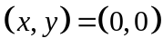. For these projections, this location is defined using the latitude/longitude variables normally giving the South-West corner of the domain. Additionally, the variables normally used to give the UTM or Cartesian coordinates of the SW corner, will instead define the model 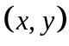 coordinates (in km) of the lower-left corner (cell center) relative to the origin at the reference latitude/longitude. Note that in the case of rotated spherical coordinates, this will be in terms of model longitude and latitude.
Another modification to a standard MEDOC variable involves the vertical coordinate. The standard MEDOC vertical coordinate is terrain-following height (corresponding to the vertical coordinate keyword “SIGMAZ”), but now will be interpreted as the vertical coordinate specified in the special header section. Furthermore, the levels will be given in the order corresponding to the model vertical indexing. For example, the first computational level in some sigma pressure models corresponds to the model top, so the first level given in the MEDOC file would be 0, with subsequent levels increasing monotonically to 1 (at the ground). This implies that the first level of the 3d fields read later from the file is the top level. (SCICHEM will re-order since it works with height increasing from the ground.) Note that some models such as COAMPS that work in sigma height coordinates still use a vertical indexing system that starts at the model top. This requires the vertical coordinate to be specified as monotonically decreasing. In all cases, the sigma levels will correspond to cell centers.

List input
Meteorological files cannot also be specified in a “list” input file. The general form of such an input file is given in Figure 3-. The first record must consist of the string "SCIPUFF_LIST", followed by a list of file type keywords and names. Valid file types are given in Table 3-12 and generally describe the nature of the input file. Note that the file names must include full path information if appropriate.

SCIPUFF_LIST

FileType1 FileName1

[FileType2 FileName2

... ]
Figure 3-15. General structure of a meteorology “list” input file. The first line must consist of the string ‘SCIPUFF_LIST’. The square brackets indicate optional input, i.e., multiple files may be specified but only one is required.

File Type | Description
MEDOC | Gridded input type. See 3.5.2.
PRF, SFC, OBS | Observational input types. See 3.5.1. OBS is used generically for either PRF or SFC types.
AERSFC | AERMET-style surface file.
AERPFL | AERMET-style profile file.
Table 3-12: Valid file types for meteorology list input file.

Terrain File Format.
The terrain input file is an ASCII text file containing a grid description header followed by terrain elevation data defined on a regular two-dimensional grid. The header consists of an optional record followed by two mandatory records. The general structure of the terrain file is illustrated in Figure 3-.
The first record is required only if a landcover description is given on the file. In that case, the keyword “LAND_USE” followed by an equals sign must begin the record. (Any other keyword will result in an error.) The names to the right of the equals sign denote the landcover fields on the file. The permissible names and their meanings are: ZRUF, surface roughness; ALBED, surface albedo; BOWEN, Bowen ratio; HCANP, canopy height; ALPHC, canopy flow index; and CATEGORY, landcover category index. Any combination of the first three fields is allowed, but the canopy height and flow index must be given together. The landcover category is given in lieu of the first five fields. Valid category indices and the corresponding landcover descriptions are given in section 3.5.6. Interpretation of the landcover category input is determined by the landuse data file, which is described in the following section.

LAND_USE = land_key₁ land_key₂ land_key_{N}
grid_type, param₁, param₂
x0, y0, dx, dy, nx, ny
H_{1,1}, H_{2,1},...,H_{nx,1}, H_{1,2},..., H_{nx,ny}
land_key₁
L1_{1,1}, L1_{2,1},...,L1_{nx,1}, L1_{1,2},..., L1_{nx,ny}
...
land_key_{N}
LN_{1,1}, LN_{2,1},...,LN_{nx,1}, LN_{1,2},..., LN_{nx,ny}
Figure 3-16. General structure of a terrain file.
The rest of the header records are defined as follows:
grid_type, param1, param2 : the grid type (CHARACTER*8) can be ‘LATLON’, ‘UTM’, ‘KM’, ‘METERS’ or ‘M’. If grid_type is LATLON, the two numerical parameters are not required. For UTM grids, param1 (INTEGER) contains the UTM zone number; the other parameter is not required. For all other types, if param1 (REAL) and param2 (REAL) are specified, they contain the longitude and latitude of the grid origin, respectively. The numerical parameters are in free format.
x0, y0, dx, dy, nx, ny : the grid origin (REAL) for the east-west coordinate (x0), the grid origin (REAL) for the north-south coordinate (y0), grid spacings (REAL) (dx and dy) and number of grid points in the coordinate directions (INTEGER) (nx and ny). x0 and y0 are in degrees if grid_type is LATLON, otherwise they are in kilometers. dx and dy are in the same units as the origin coordinates unless grid_type is METERS or M in which case they are in meters.
Hi,j : the terrain height in meters read with (12I6) format.
The following records are given only if the first record contains the keyword “LAND_USE”, as described above
Land_KeyN : the name of the landcover field to follow, which must match one of the names given on the first record.
L1i,j , …,LNi,j : the landcover fields corresponding to land_key1 , …, land_keyN, read with (12F10.0) format for all fields except “CATEGORY”, which is read with (12I6) format.
The location (i, j) is taken to be at x0+(i-1)*dx and y0+(j-1)*dy.
Note that fields in both UTM and spherical coordinate systems can be included in a single terrain file essentially by combining two separate files. The UTM fields must come first and conform to the record description just given, including the header information. The spherical coordinate system records then follow, starting with the header records. The coordinate system chosen for the puff calculation will determine which fields are read.
Index | Landuse Type
1 | Developed
2 | Dry Cropland & Pasture
3 | Irrigated Cropland
4 | Missing
5 | Cropland/Grassland
6 | Cropland/Woodland
7 | Grassland
8 | Shrubland
9 | Shrubland/Grassland
10 | Savanna
11 | Deciduous Broadleaf Forest
12 | Deciduous Needleleaf Forest
13 | Evergreen Broadleaf Forest
14 | Evergreen Needleleaf Forest
15 | Mixed Forest
16 | Water
17 | Herbaceous Wetland
18 | Wooded Wetland
19 | Barren
20 | Herbaceous Tundra
21 | Wooded Tundra
22 | Mixed Tundra
23 | Bare Tundra
24 | Snow or Ice
25 | Partly Developed
26 | Not Used
27 | Not Used
28 | Unclassified
Table 3-13: Valid indices and associated landuse types for terrain files with first header record ‘LAND_USE = CATEGORY’.

Landuse File Format.
The landuse data input file is a fixed ASCII text file containing a list of surface parameters that are to be associated with each landcover category appearing in Table 3-13. To utilize the category data in SCICHEM, appropriate physical parameters, namely surface roughness, canopy height, canopy flow parameter, albedo and Bowen ratio, must be assigned. The values of these parameters are generally a function of season and surface moisture condition, e.g., a “wet”, “normal”, or “dry”. Figure 3- shows the header format and a sample of the parameter values currently specified in the landuse data file; the four columns of data represent the four seasons, Winter, Spring, Summer, and Fall. The figure shows surface roughness values for the four seasons and various landuse categories. Other fields in the landuse input file include canopy height, canopy parameter, surface albedo, and Bowen ratio for dry, normal and wet conditions. A simple algorithm determines the “season” based on Julian day and latitude; Spring and Fall are basically assumed to occur for 12% of the year and their time of occurrence changes linearly from an “all summer” condition between 20°S and 20°N to an “all winter” condition at latitudes beyond 70°N or 70°S. The moisture condition is specified by the user and is applied to the entire calculation domain.
In order to handle situations where the input landcover data must be averaged over larger cells, in cases where the model resolution is limited, a set of superclasses is defined. Each individual type appearing in Figure 3- is associated with one of 5 superclasses defined at the end of the same figure. When combining categories from a collection of grid cells, if any particular category accounts for more than 50% of the total area, then the entire grid cell will be assigned that category; otherwise, the grid cell is assigned the most prevalent “superclass”. The line beginning super_class provides the mapping from the basic categories into the 5 superclasses, which are appended to the list of 28 basic categories and assigned indices of 1001 through 1005. Thus, basic category 1 (Developed) maps into superclass 1001 (Urban Superclass), category 2 (Dry Cropland & Pasture) maps into superclass 1002 (Grassland Superclass), etc.
Note that the landuse data file also contains substrate parameters for secondary evaporation modeling. This separate section of the file is added after the landuse category data, and simply provides the number of predefined substrate types together with a name (for display in the User Interface) and values for porosity, tortuosity, and grain size (in meters) as required by the absorption/desorption model.

!Land Use Parameters by Season (spring,summer,autumn,winter)
num_cat= 28
num_sup= 5
super_class= 1 2 2 2 2 2 2 2 2 2 3 3 3 3 3 5 2 3 4 2 3 2 4 4 1 2 2 2

Roughness (m)
2.0e+0 2.0e+0 2.0e+0 2.0e+0 ! 1=Developed
1.0e-2 1.0e-2 1.0e-2 1.0e-2 ! 2=Dry Cropland & Pasture
2.0e-2 1.0e-1 1.0e-2 1.0e-3 ! 3=Irrigated Cropland
5.0e-2 1.0e-1 5.0e-2 1.0e-2 ! 4=Missing
2.0e-2 1.0e-1 1.0e-2 5.0e-3 ! 5=Cropland/Grassland
3.0e-1 3.0e-1 3.0e-1 3.0e-1 ! 6=Cropland/Woodland
5.0e-2 1.0e-1 5.0e-2 1.0e-2 ! 7=Grassland
2.0e-1 2.0e-1 2.0e-1 2.0e-1 ! 8=Shrubland
1.0e-1 1.5e-1 1.5e-1 1.0e-1 ! 9=Shrubland/Grassland
1.0e-1 1.0e-1 5.0e-2 5.0e-2 ! 10=Savanna
1.5e+0 2.0e+0 1.5e+0 1.0e+0 ! 11=Deciduous Broadleaf Forest
1.5e+0 2.0e+0 1.5e+0 1.0e+0 ! 12=Deciduous Needleleaf Forest
2.0e+0 2.0e+0 2.0e+0 2.0e+0 ! 13=Evergreen Broadleaf Forest
2.0e+0 2.0e+0 2.0e+0 2.0e+0 ! 14=Evergreen Needleleaf Forest
1.8e+0 2.0e+0 1.8e+0 1.5e+0 ! 15=Mixed Forest
1.0e-4 1.0e-4 1.0e-4 1.0e-4 ! 16=Water
1.0e-1 1.0e-1 1.0e-1 5.0e-2 ! 17=Herbaceous Wetland
1.0e+0 1.0e+0 1.0e+0 5.0e-1 ! 18=Wooded Wetland
1.0e-3 1.0e-3 1.0e-3 1.0e-3 ! 19=Barren
1.0e-2 1.0e-2 1.0e-2 1.0e-3 ! 20=Herbaceous Tundra
3.0e-1 3.0e-1 3.0e-1 3.0e-1 ! 21=Wooded Tundra
1.0e-1 1.0e-1 1.0e-1 1.0e-1 ! 22=Mixed Tundra
1.0e-3 1.0e-3 1.0e-3 1.0e-4 ! 23=Bare Tundra
1.0e-4 1.0e-4 1.0e-4 1.0e-4 ! 24=Snow or Ice
1.0e+0 1.0e+0 1.0e+0 1.0e+0 ! 25=Partly Developed
5.0e-2 1.0e-1 5.0e-2 1.0e-2 ! 26=Not Used
5.0e-2 1.0e-1 5.0e-2 1.0e-2 ! 27=Not Used
5.0e-2 1.0e-1 5.0e-2 1.0e-2 ! 28=Unclassified
1.5e+0 1.5e+0 1.5e+0 1.5e+0 ! 1001=Urban Superclass
5.0e-2 1.0e-1 5.0e-2 1.0e-2 ! 1002=Grassland Superclass
1.8e+0 2.0e+0 1.8e+0 1.5e+0 ! 1003=Forest Superclass
1.0e-3 1.0e-3 1.0e-3 1.0e-3 ! 1004=Desert Superclass
1.0e-4 1.0e-4 1.0e-4 1.0e-4 ! 1005=Water Superclass

etc.
Figure 3-20: Format and content of the landuse data file.

RUNNING SCIPUFFgui
A Graphic User Interface, SCIPUFFgui.exe, which can be used on the Windows platform, is under development. It can currently be used for reviewing and plotting all projects as described in section 6.3. This GUI can also be used to create and run namelist projects (see Section 3.1) but not keyword projects (Section 3.2). The steps for creating a new namelist project are detailed in the following section.

Creating a new project.
To create a new project, the user will click the New Project button. The following window will appear, prompting the user for a new project name:

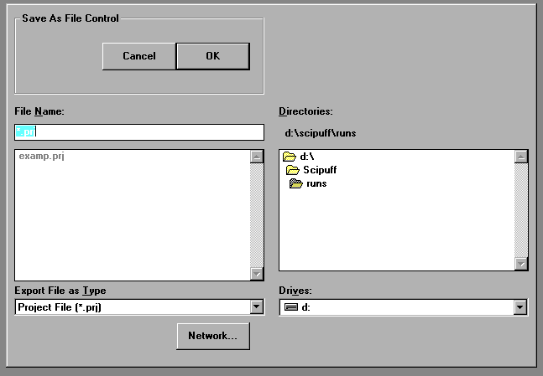
The user can enter the project name and click OK to continue. Afterwards, the following New Project Setup window will appear:

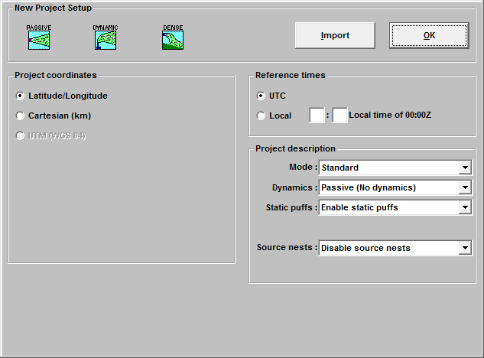

New Project Setup.
The user must select an icon in the upper left corner which determines if dynamic effects will be included in the calculation. Dynamic effects treated are buoyant and momentum plume rise and gases that have densities different from that of air.
Passive -do not include dynamic effects
Dynamic -include dynamic effects
Dense - Include dense gas effects
The user may click Import to import an existing project into the current project. Otherwise, the user will enter all necessary information for the new project in this window and press OK. When importing files, a Restart check box is included with the Open File dialog box. If Restart is selected, the Restart Time Editor dialog box will appear when the OK button is pushed. The start time of the new project is then selected from the Restart time list box.

Project Coordinates.
The user must specify the project coordinate system. The choices are as follows:
Latitude/Longitude
This specifies the SCICHEM coordinate system as Latitude/Longitude (degrees). This is the default coordinate system.
Cartesian
This specifies the SCICHEM coordinate system as rectangular Cartesian (kilometers). If this radio button is selected, you may check the “Lat./Lon. Reference Point” check box.

If the reference point box is checked for Cartesian coordinates, the following edit boxes will appear:
Cart. (X,Y)
This specifies the Cartesian coordinates of the reference point in kilometers.
Default: (0,0)
LLA (E,N)
This specifies the longitude and latitude coordinates of the reference point specified in the X,Y edit boxes. The coordinates can be specified in degrees or degrees/min/sec.
Default: None

Reference times.

The user must specify the project reference times. The choices are as follows:
UTC
This specifies the SCICHEM time to be in the Universal Time Convention, which is equivalent to Greenwich Mean Time (GMT or Z). UTC is the default time reference.
Local
This specifies the SCICHEM time to be in local time.
The following edit box appears with the Local time reference option:
Local time of 00:00Z
This specifies the local time (hours:minutes) of midnight UTC. This is used to convert the meteorology time if it uses a different convention. It is also used to determine some boundary layer parameters depending on boundary layer type.
Default: 00:00

Project Description.

The user must specify additional project options. They include the following:
Mode
This specifies whether to run SCICHEM in Standard or Fast mode.
See 3.1.1 for a description of the two modes.
Dynamics
This specifies whether or not to treat dynamics. It is controlled by icon at top.
Static Puffs
This specifies whether or not to use static puffs in the calculation. Static puffs significantly speed up the calculation, therefore the default is to use them.

Multicomponent
This specifies whether or not to treat material transformations through chemical reactions. The Browse button should be used to select the IMC file (see Section 3.3) if this option is activated.

Figure 4-17 SCICHEM Run Modes

Parameter | STANDARD | FAST | Comments
VERTICAL RESOLUTION
Default height of the vertical domain  Default vertical domain resolution  Default maximum vertical grid points | 2500m  250m  15 | 5000m  1000m  7 | These vertical grid parameters affect the vertical splitting of puffs which affects the total number of puffs. These parameters can also be entered manually by the user.
HORIZONTAL RESOLUTION
Surface resolution [DELMIN] | 0.0 (As needed) | 1/160 of domain | This affects the surface grid and total number of puffs if surface evaporation is occurring This parameters can also be entered manually by the user
MERGE CRITERIA
SiMerge (ratio of internal scales) | 1.25 | 1.5 | This allows more merging between puffs and reduces the total number of puffs. This parameter cannot be manually entered by the user. It is changed internally when the Fast Mode is selected.

New project editor
Once a project has been set up or imported, the New Project Editor window will appear, as follows:

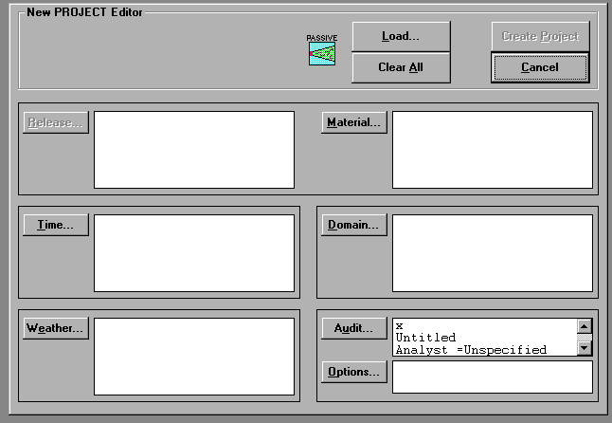
The user must define key areas of the project. A red check mark will appear next to each category once it has been completed. After all categories are complete, the user may click Create Project in order to create the new project files. The key areas that must be defined include the following categories:
- Release  - Time  - Weather | - Material  - Domain  - Audit  - Options

Material Editor
The material editor is used to define the parameters of the material being released. The material must be defined prior to defining the release parameters, therefore, the discussion will begin with the material editor. When the user clicks Material, the material editor window (shown below, top portion only) will appear and can be used to add, change or delete materials and to create or change a material definition.
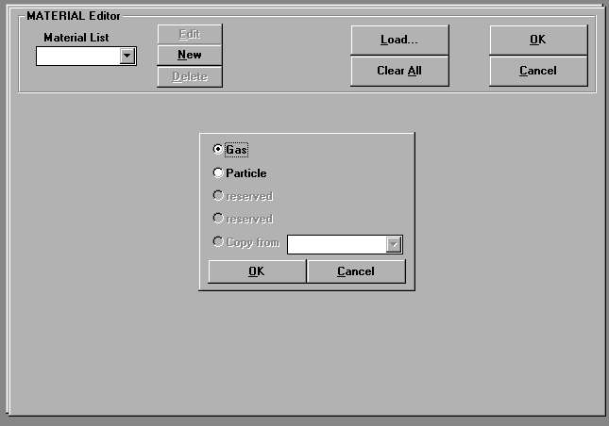
If the user is creating a new material by clicking New, the material dialog box will appear, as shown below, giving choices of materials as Gas or Particle. If a material has already been defined, the user may copy another material by choosing it from a drop-down list.

Gas Material.
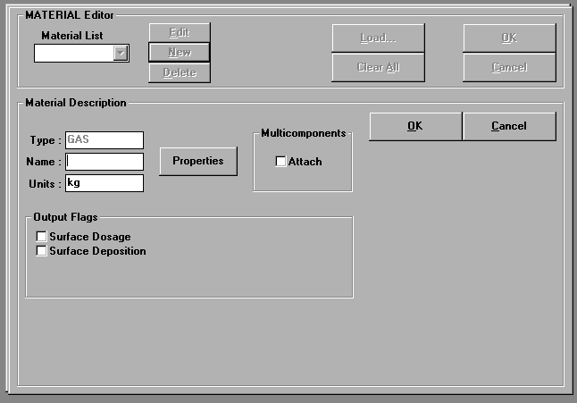
This window is used to define a gas. The MATERIAL Editor window for a gas is shown below.
The input parameters are defined as follows:
Material Description
Type
This specifies the material type (GAS). This parameter cannot be edited from this box.
Name
This is the unique name identifying the material, up to 8 characters in length.
Default: NONE - Must be specified.
Units
This specifies the material mass units. The default is kg.
Multicomponents - Attach
Multicomponent species may be attached to the material using this check box. The species names are taken from the IMC file. This option is only available if the project has been defined Multicomponent.

Output Flags
Surface Dose
This specifies the time-integrated surface dose is written to ProjectName.DOS
Surface Deposition
This specifies the time-integrated surface deposition is written to ProjectName.DEP.
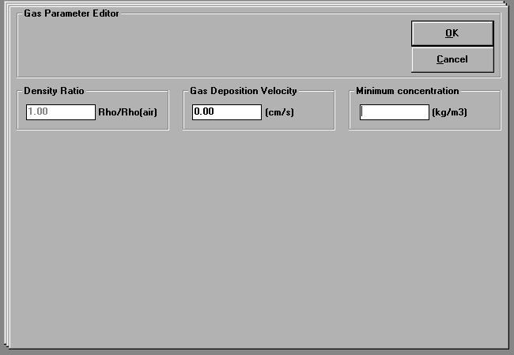
When the user presses the Properties button, the gas parameter editor window will appear, as shown below.
The gas properties are defined as follows:
Density ratio
This specifies the density ratio of material-to-air that is used to determine buoyancy effects.
Default: 1.0
Gas deposition velocity
This specifies the velocity (cm/s) at which the gaseous material deposits to the surface. A zero deposition velocity implies no deposition.
Default: 0.0
Minimum concentration
This specifies the minimum puff concentration (material mass units/m³). A puff with a concentration less than this value does not split or distort due to velocity gradients but it may merge with other puffs. Setting this minimum value may help decrease execution time.
Default: 0.0

Particle Material.
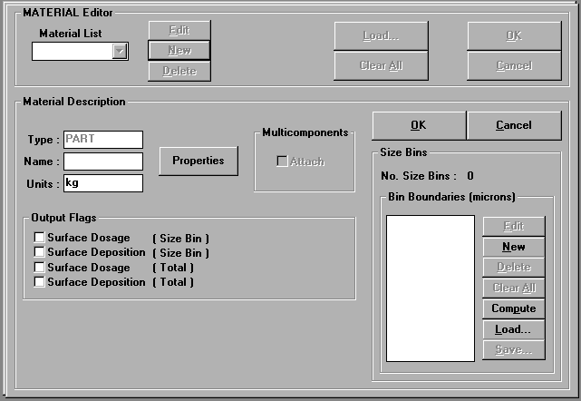
This window is used to define a particle. The MATERIAL Editor window for a particle is shown below.
The input parameters are defined as follows:
Material Description
Type
This specifies the material type (PART). This parameter cannot be edited from this box.
Name
This is the unique name identifying the material, up to 8 characters in length.
Default: NONE - Must be specified.
Units
This specifies the material mass units. The default is kg.
Multicomponents - Attach
Multicomponent species may not be attached to particle materials.
Output Flags
Surface Dose (size Bin)
This specifies the time-integrated surface dose for each size bin is written to ProjectName.DOS
Surface Deposition (size Bin)
This specifies the time-integrated surface deposition for each size bin is written to ProjectName.DEP.
Surface Dose (Total)
This specifies the time-integrated surface dose, summed over all size bins, is written to ProjectName.DOS.

Surface Deposition (Total)
This specifies the time-integrated surface deposition, summed over all size bins, is written to ProjectName.DEP.

Size Bins
The particle size distribution for the material is defined by a number of discrete bins. The size bins are defined in the Bin Boundaries box by copying an existing material, computing bin boundaries based on an assumed distribution or constructing bin boundaries explicitly. The bin boundaries may then be edited as desired.
The No. Size Bins displayed here is the number of bins used to define the size distribution. A single size bin indicates that all released particles of this material fall within the same bin. At least one bin must be defined. The maximum number of size bins is 50.
The Bin Boundaries (microns) determine the range and distribution of the particle sizes. The number of bin boundaries is always 1 greater than the number of size bins. Bin boundaries are used to calculate the increase in the vertical spread of the material due to differential gravitational settling rates, i.e., large particles fallout faster than smaller particles, increasing the vertical extent of the material.
Use the buttons in the Bin Boundaries group to define the size bins:
Edit - Click to change the selected bin boundary to a new value.
New - Click to add a new bin boundary to the list.
Delete - Click to remove a selected bin boundary from the list.
Clear All - Click to remove all bin boundary values from the list.
Compute - Click to calculate bin boundaries based on a particle size range, number of bins and an assumed size distribution.
Load - Click to copy bin boundaries from a file into the list. This is an appending procedure, so the loaded values are added to those already in the list.
Save - Click to save the current bin boundary list to a file.
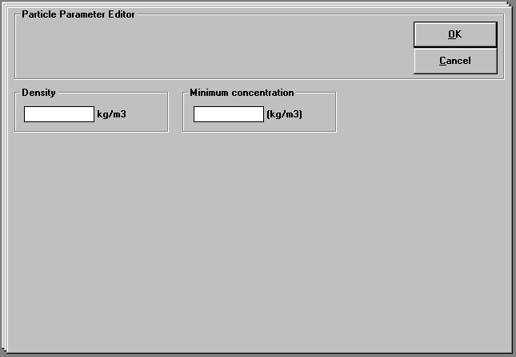
When the user presses the Properties button, the particle parameter editor window will appear, as shown below.
The particle parameters are defined as follows:
Density
This specifies the density of the particle material (kg/m³).
Default: None – Must be specified.
Minimum concentration
This specifies the minimum puff concentration (material mass units/m³). A puff with a concentration less than this value does not split or distort due to velocity gradients but it may merge with other puffs. Setting this minimum value may help decrease execution time. Default: 0.0

Liquid Material.
This window is used to define a liquid. The MATERIAL Editor window for a liquid is shown below.
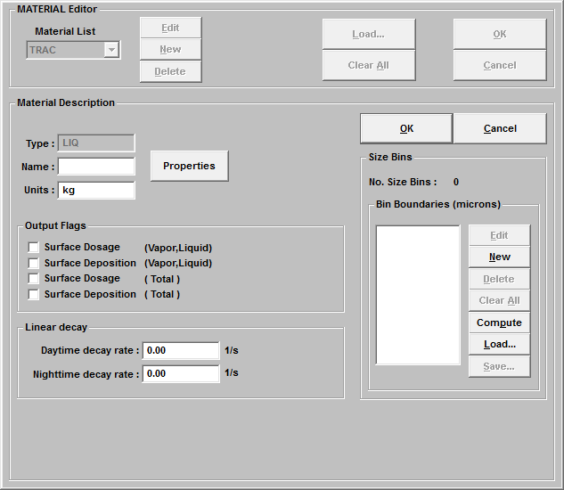
The input parameters are defined as follows:
Material Description
Type
This specifies the material type (LIQ). This parameter cannot be edited from this box.
Name
This is the unique name identifying the material, up to 8 characters in length.
Default: NONE - Must be specified.
Units
This specifies the material mass units. The default is kg.

Output Flags
Surface Dosage(Vapor,Liquid)
This specifies the time-integrated surface dose is written to ProjectName.DOS
Surface Deposition(Vapor,Liquid)
This specifies the time-integrated surface deposition is written to ProjectName.DEP.
Surface Dosage(Total)
This specifies the time-integrated surface dose is written to ProjectName.DOS
Surface Deposition(Total)
This specifies the time-integrated surface deposition is written to ProjectName.DEP.
When the user presses the Properties button, the liquid parameter editor window will appear, as shown below.
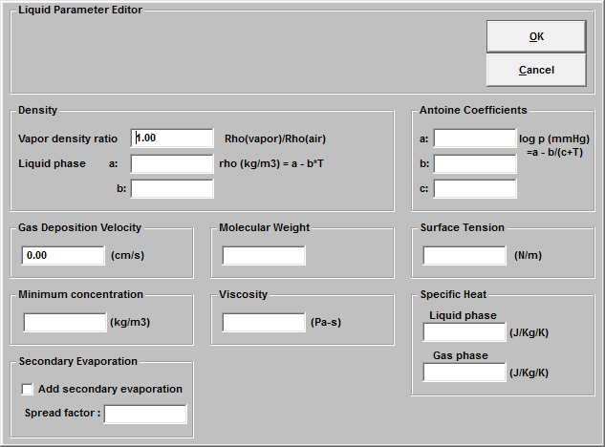
The liquid properties are defined as follows:
Vapor Density ratio
This specifies the density ratio of material-to-air that is used to determine buoyancy effects.
Default: 1.0
Gas deposition velocity
This specifies the velocity (cm/s) at which the gaseous material deposits to the surface. A zero deposition velocity implies no deposition.
Default: 0.0
Molecular weight
This specifies the molecular weight of the gaseous

Surface tension
This specifies the surface tension (N/m) of the liquid material

Viscosity
This specifies the viscosity (Pa-s) of the liquid material

Liquid Phase Specific heat
The specific heat (J/Kg/K) of the material in liquid phase.
Default: 0.0
Gas Phase Specific heat
The specific heat (J/Kg/K) of the material in gas phase.

Secondary evaporation
Logical to turn on evaporation of liquid from surface deposition
Default: False

Release Editor
The Release Editor is used to define the release parameters. When the user clicks Release from the New Project, the release editor window (shown below, top portion only) will appear and can be used to add, change or delete releases.

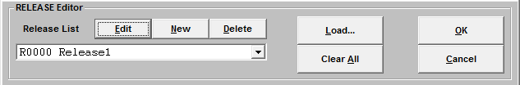
If the user is creating a new release by clicking New, the release dialog box will appear, as shown below, giving choices of release types. If a release has already been defined, the user may copy another release by choosing it from the drop-down list. Multiple releases may be defined for a single project. Section 4.2.1show editing windows for the release of a gas type material. Releases of particle materials are discussed in Section 4.2.2.
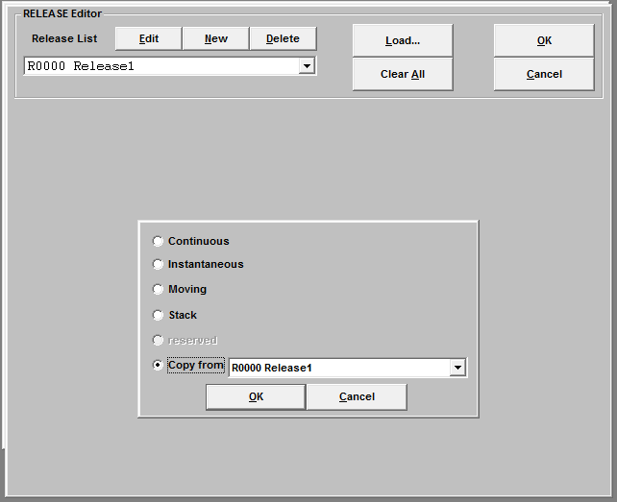
Select the type of release from the displayed options:
- Continuous
- Instantaneous
- Moving
- Stack
- Copy from (an existing release definition)

Continuous Release Type.
This window is used to define a continuous release of a gas. The RELEASE Editor window for a continuous release is shown below.
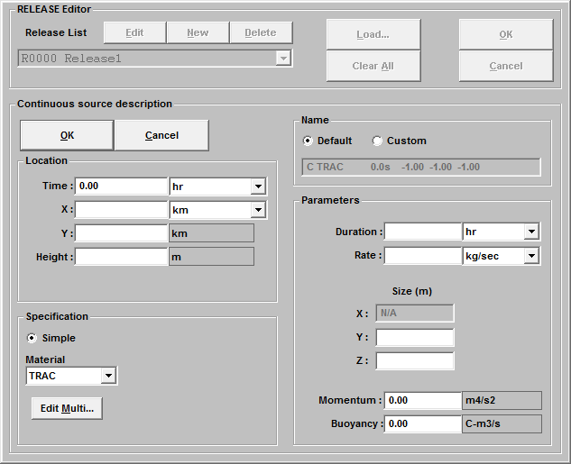
The release parameters are defined as follows:
Location
Time
This specifies the time (hrs) relative to the SCICHEM calculation start time that the material is first released. For example, if a material is released at the calculation start time, the release time is 0. Releases can be input in any order since SCICHEM automatically sorts each release by its release time. The units can be changed with the combo box to the right.
Default: 0.0 hours
X
This specifies the x-coordinate, Cartesian (km), of the release. The units can be changed with the combo box to the right.
Default: Km
Y
This specifies the y-coordinate, Cartesian (km), of the release. The units are the same as the X units.
Default: Km
Height (m)
This specifies the height (m) of the release above the surface.
Default: None - Must be specified.

Specification
Simple
The material is released at the specified location with the mass and size defined in the Parameters group box. This is the only option for a continuous release.
Material
This specifies a four character name identifying the material being released. The drop-down list contains a list of materials defined for this project.
Edit Multi..
If the material multicomponent species are attached to the material, this push button will appear, allowing the user to specify multicomponent emissions.
Name
Default
Use the default release name
Custom
This button allows the user to provide a customized name for the release
Parameters
Duration
This specifies the length of time (hours), relative to the release time, that the material is released. The units are changed with the combo box on the right.
Default: NONE - Must be specified.
Rate
This specifies the material mass release rate (mass units/s). The mass units are taken from the Material Description.
Default: NONE - Must be specified.
X (Size)
This is not applicable for a continuous source.
Y (Size)
This specifies the lateral Gaussian spread parameter (size) of the release source (m).
Default: NONE - Must be specified.
Z (Size)
This specifies the vertical Gaussian spread parameter (size) of the release source (m).
Default: NONE - Must be specified.

Momentum
This specifies the momentum of the effluent (m4/s2) if the project is a Dynamic Run and the material type is Gas. To include the effect of dynamics on materials other than gases, the effluent gas must also be a defined release.
Default: NONE - Must be specified.
Buoyancy
This specifies the buoyancy of the effluent (C-m3/s) if the project is a Dynamic Run and the material type is Gas. To include the effect of dynamics on materials other than gases, the effluent gas must also be a defined release.
Default: NONE - Must be specified.
Multicomponent Releases
If the material being released is a multicomponent material, the Edit Multi push button will appear beside the material combo box to allow editing the release rates of each species. Species emission rates should be expressed in emission_units (either in ppm-m³/sec, 1.e-6 molecules/sec or g/s). The emission_units are given in the IMC file under the control section. For a multicomponent species, the concentration will be displayed in species_units for gases (as specified in the IMC file under the control section). For aerosol particles the emission units is always assumed to be . Additional particle types are denoted by “PA” for particle area emission and have units of m2/s, and “PN” for particle number emissions and have emission units of numbers/s. See Section 3.3 for details on the IMC file.
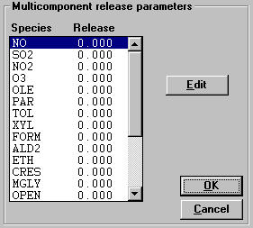
When the Edit Multi is clicked, the following window will appear, allowing the user to edit the multicomponent emission rates.

Instantaneous Release Type.
This window is used to define an instantaneous release of a gas. The RELEASE Editor window for an instantaneous release is shown below.
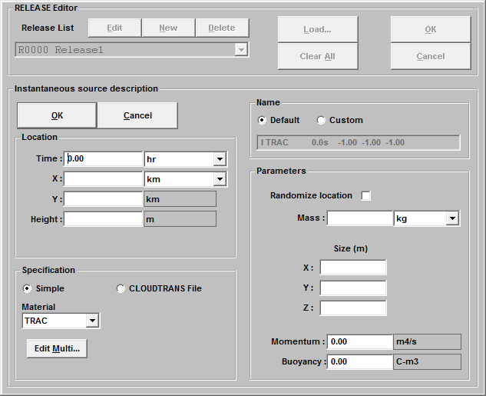
The release parameters are defined as follows:
Location
The definitions of these parameters are the same as those for the continuous release (Section 4.3.1
Specification
Simple
The material is released at the specified location with the mass and size defined in the Parameters group box.
CLOUDTRANS
This specifies that a file containing the release information using the CLOUDTRANS format (See Section 4.7) will be used. If this option is enabled, a Select button appears which will allow the user to specify the name of the CLOUDTRANS release file.
The remaining definitions of these parameters are the same as those for the continuous release (Section 4.3.1)
Name
The definitions of these parameters are the same as those for the continuous release (Section 4.3.1)
Parameters
Randomize location
This allows for a randomization of the source locations within the calculation domain. If this box is checked, a Parameters push button appears
Mass
This specifies the total mass (mass units) of the released material. The mass units are taken from the corresponding Material Description, Gas or Particle, as appropriate.
Default: NONE - Must be specified.
X (Size)
This specifies the x-coordinate Gaussian spread parameter of the release source (m).
Default: NONE - Must be specified.
Y (Size)
This specifies the y-coordinate Gaussian spread parameter of the release source (m).
Default: NONE - Must be specified.
Z (Size)
This specifies the vertical Gaussian spread parameter of the release source (m).
Default: NONE - Must be specified.
Momentum
This specifies the momentum of the effluent (m⁴/s) if the project is a Dynamic Run and the material type is Gas. To include the effect of dynamics on materials other than gases, the effluent gas must also be a defined release.
Default: NONE - Must be specified.
Buoyancy
This specifies the buoyancy of the effluent (C-m³) if the project is a Dynamic Run and the material type is Gas. To include the effect of dynamics on materials other than gases, the effluent gas must also be a defined release.
Default: NONE - Must be specified.

Moving Release Type.
This window is used to define a moving release of a gas. The RELEASE Editor window for a moving release is shown below.
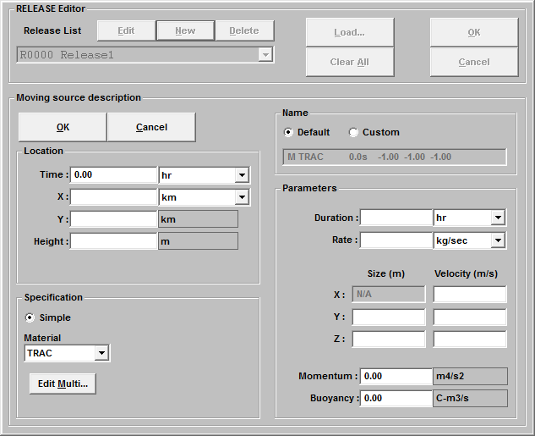
The release parameters are defined as follows:
Location
The definitions of these parameters are the same as those for the continuous release (Section 4.3.1
Specification
The definitions of these parameters are the same as those for the continuous release (Section 4.3.1)
Name
The definitions of these parameters are the same as those for the continuous release (Section 4.3.1)

Parameters
The definitions of these parameters are the same as those for the continuous release (Section 4.3.1) except that the source velocity (m/s) appears next to the source coordinates.
X (Velocity)
This specifies the source velocity component in the x-coordinate direction (m/s).
Default: NONE - Must be specified.
Y (Velocity)
This specifies the source velocity component in the y-coordinate direction (m/s).
Default: NONE - Must be specified.
Z (Velocity)
This specifies the source velocity component in the vertical direction (m/s).
Default: NONE - Must be specified.

Stack Release Type.
This window is used to define a stack release of a gas. The RELEASE Editor window for a stack release is shown below.
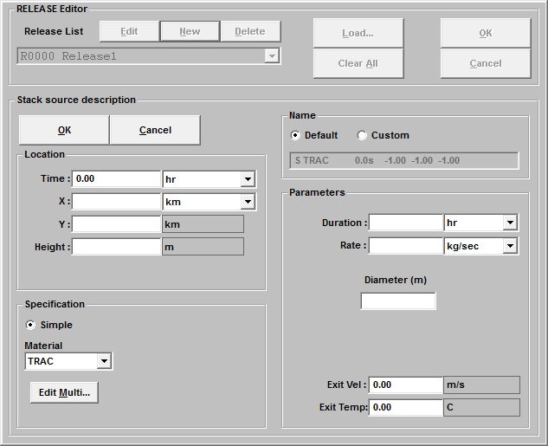
The release parameters are defined as follows:
Location
The definitions of these parameters are the same as those for the continuous release (Section 4.3.1)
Specification
The definitions of these parameters are the same as those for the continuous release (Section 4.3.1)
Name
The definitions of these parameters are the same as those for the continuous release (Section 4.3.1)

Parameters
The definitions of the Duration and Rate are the same as those for the continuous release (Section 4.3.1).
Diameter (m)
This specifies the diameter of the stack (m).
Default: NONE - Must be specified.
Exit Velocity (m/s)
This specifies the exit velocity (m/s) of the stack effluent if the project is a Dynamic Run and the material type is Gas. To include the effect of dynamics on materials other than gases, the effluent gas must also be a defined release.
Default: 0.00.
Exit Temperature (C)
This specifies the exit temperature (C) of the stack effluent if the project is a Dynamic Run and the material type is Gas. To include the effect of dynamics on materials other than gases, the effluent gas must also be a defined release.
Default: 0.00

Release of Particle Materials.
This editor shows the difference when specifying a release using particle materials. All parameters are the same as those defined in Sections 4.3.1 through 4.3.4, except under the Specification editing area if a particle material is chosen. The user may select the particle size group that is released. The figure given below shows an example.
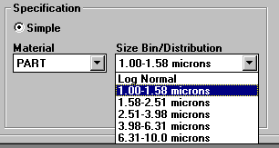
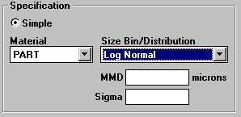
If a Log Normal distribution is chosen, the following edit boxes will appear, as shown below.
When this option is chosen, the user must specify the mass mean diameter, MMD, in microns and the geometric standard deviation, Sigma, (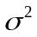). The resulting lognormal size distribution is partitioned into the material size bins, as defined in the particle material description.
If more than 5% of the release mass lies outside the range of the size bins, a warning is issued. Continuing without changing the distribution or the size bins will allocate mass below the lower size bin limit into the first size bin, and mass above the upper size bin into the last bin. In order to change the size bin boundaries, the user must return to the Material Editor
A useful guide for determining the size bin range is that 96% of the total mass in the lognormal distribution is contained between 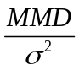 and 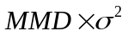. A typical size bin specification would span this range using 10 bins with logarithmic spacing. The resolution of the size distribution depends on the range of the calculation; longer range calculations may need better resolution to prevent separation between bins as the material falls through the atmosphere.

Time Editor
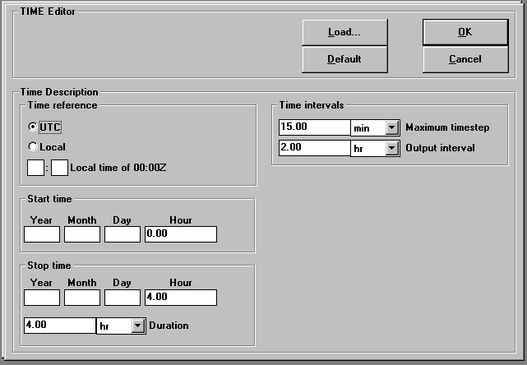
The Time Editor is used to define the duration of the simulation and the time step and output intervals. When the user clicks Time from the New Project, the time editor window (shown below) will appear.
The parameters are defined as follows:

Time Reference
UTC
This specifies the SCICHEM time to be in the Universal Time Convention, which is equivalent to Greenwich Mean Time (GMT or Z). UTC is the default time reference.
Local
This specifies the SCICHEM time to be in local time.
Local time of 00:00Z
This specifies the local time (hours:minutes) of midnight UTC. This is used to convert the meteorology time if it uses a different convention. It is also used to determine some boundary layer parameters depending on boundary layer type. Default: 00:00

Start Time
Year, Month, Day, Hour
This specifies the start time for the SCICHEM calculation. This determines the initial release time for the dispersion calculation.
Default: If Year, Month, Day are left blank, then the release is assumed to start on the first day in the meteorological file. If Year is less than 100, it is assumed to be between 1950 and 2049, e.g., setting Year to 1 is equivalent to 2001 and 99 is equivalent to 1999.

Stop Time
Year, Month, Day, Hour
This specifies the stop time for the SCICHEM calculation. It is specified in the same way as the start time. Duration is automatically computed when this is set.
Default: 4 hours after the start time
Duration
This specifies the total calculation period for the SCICHEM calculation. The stop time is automatically computed when this is set. Time duration units are chosen with the adjacent combo box.
Default: 4 hours

Time Intervals
Maximum time step
This specifies the maximum time step for the dispersion calculation. This should be chosen to smoothly resolve any meteorological variations, including the boundary layer. SCICHEM uses an adaptive time step and reduces the step size as appropriate for each puff. The units for the time step can be changed with the adjacent combo box.
Default: 15 minutes
Output interval
This specifies the time interval between saved output. The output includes the instantaneous fields and optional surface integral fields (surface dose and/or surface deposition). The units for the output interval can be changed with the adjacent combo box.
Default: 2 hours

Restart Time
Time
This specifies the time at which the current project is initialized when restarting from an existing project. This input area is shown for restarts only.

Domain Editor
The Domain Editor is used to specify the domain parameters. When the user clicks Domain from the New Project, the domain editor window (shown below) will appear.
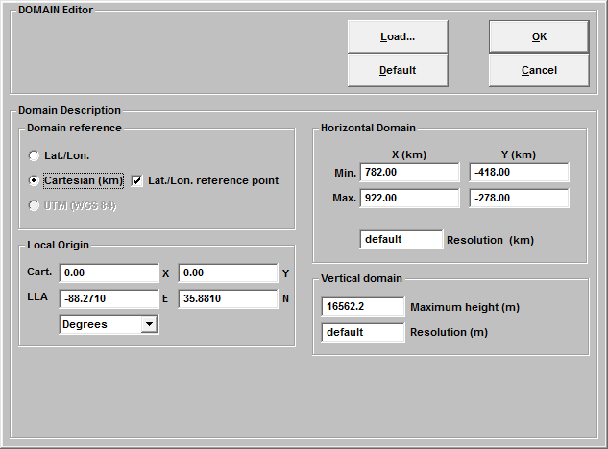
The parameters are defined as follows:

Domain Reference
Lat./Lon.
This specifies the SCICHEM coordinate system as Latitude/Longitude (degrees). This is the default coordinate system.
Cartesian
This specifies the SCICHEM coordinate system as rectangular Cartesian (kilometers). Optionally, the user can specify the Latitude/Longitude reference point for locating the Cartesian domain on the surface of the Earth. Cartesian coordinates do not account for the curvature of the Earth and should therefore be limited to domain sizes less than about 300 km.

Horizontal Domain
Lat.(or X), Lon.(or Y) - Minima and Maxima
This specifies the limits that determine the extent of the SCICHEM dispersion calculation domain. For Latitude/Longitude coordinates, the domain boundaries are positive values in degrees for East and North. Thus the minimum longitudinal coordinate is the Western edge of the domain, and the minimum latitude is the Southern edge. For Cartesian coordinates, the domain extents are specified in kilometers.
Default: Limits must be explicitly set for observational meteorology without terrain input. For gridded meteorology or observational meteorology with terrain/mass-consistency, the limits will be determined from the meteorology or terrain grid.
Resolution (Deg. or km)
This box specifies the spacing (degrees or km) that defines the horizontal numerical resolution of the puff dispersion calculation. Smaller values generally result in longer computation times but allow for better resolution of the flow field. The horizontal growth of the puffs is also a measure of the horizontal resolution and is controlled by the parameter MGRD set in the Options editor. When using gridded meteorology or terrain/mass consistency, it is necessary that the default resolution (denoted by "default" in the edit box) be used. The horizontal resolution will be determined by the meteorological input files. (The horizontal growth of the puffs can still be controlled with MGRD in the Options editor.) For observational meteorology, this parameter determines the horizontal grid size used to interpolate the data.
Default: The resolution is 1/10 of the domain size for observational meteorology. For gridded data, the resolution is taken as that of the meteorology.

Vertical Domain
Maximum Height (m)
This specifies the vertical extent of the calculation domain (m). The lower bound of the domain is always at the surface.
Default: 2500 m
Resolution (m)
This box specifies the spacing (m) that defines the vertical numerical resolution of the puff dispersion calculation. It should be based on the meteorology grid spacing. For example, if the vertical resolution of the meteorological data is 1000 meters, this value should be approximately 1000 meters. Setting the resolution much less than the meteorology grid spacing does not significantly increase the accuracy of the SCICHEM results but does increase the execution time. If it is set larger than the meteorology spacing, the accuracy of the SCICHEM calculation may be decreased. It should be noted that the planetary boundary layer resolution is set independently in the Options section. Default: 250 m

Local Origin
Cartesian
The X and Y coordinates for local origin in km
Default: 0.,0.
LLA
The corresponding Latitude and Longitude coordinates for the origin in degrees
Default: None

Weather Editor
The Weather Editor is used to define the background meteorological conditions. When the user clicks Weather from the New Project, the weather editor window (shown below) will appear.
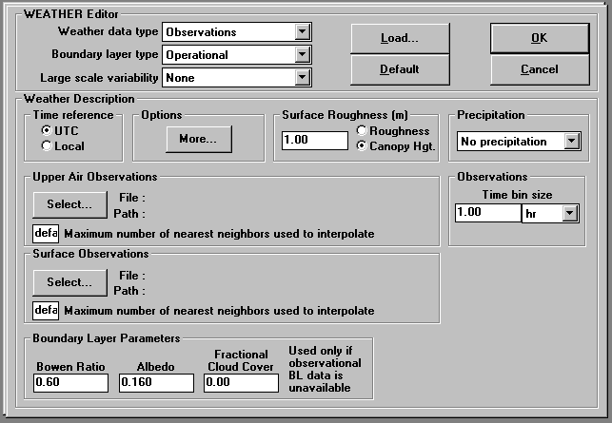

Weather Data Types.
The choices of weather data types are as follows:
- Fixed Winds
- Observations
- Surface Observations Only
- Upper Air Observations only
- HPAC Gridded
- MEDOC Gridded

Weather Data Type: Fixed Winds
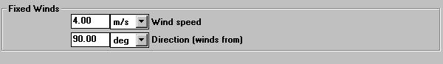
When the Fixed Winds option is chosen, the user will be prompted to enter the following information:

Wind speed
This specifies the wind speed (at 10 meters above the surface) used in translating the effluent. The wind speed is held constant in space and time at this value. The units are selected from the associated list box.
Default: 4.0 m/s
Direction
This specifies the wind direction (at 10 meters above the surface) used in translating the effluent. The wind speed is held constant in space and time at this value. The unit is degrees. It is the direction from which the wind is blowing.
Default: 90.0 degrees

Weather Data Type: Observations
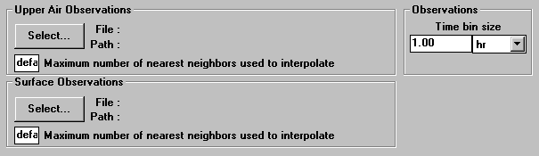
When the Observations option is chosen, the user will be prompted to enter the following information:
When the user clicks the Select button, the Open File dialog box will appear, allowing the user to select the meteorological files. The user must choose both the Upper Air Observations file (PROFILE type) and the Surface Observations (SURFACE type). These files should be formatted as described in Section 3.5.1
Maximum number of nearest neighbors used to interpolate
This specifies the maximum number of observation locations (reporting data at a given time) that are used to interpolate the observations onto the meteorology grid. Decreasing this number will decrease the project run time.
Default: All - Standard observations
4 - Analysis or forecast
Time bin size
This specifies the time bins (and time units) for observational input such that all observations reported within a time bin will be assigned the same time. This feature may avoid overly frequent updating of the meteorology; most notably when SCICHEM is involved.

Weather Data Type: Surface Observations Only
The user will select only a Surface Observations file, formatted as described in Section 3.5.1.

Weather Data Type: Upper Air Observations Only
The user will select only an Upper Air Observations file, formatted as described in Section 3.5.1.

Weather Data Type: MEDOC Gridded Data
The user will select a MEDOC Gridded Data file, formatted as described in Section 3.5.2

Boundary Layer Types.
The choices of boundary layer types are as follows:
- None
- Simple Diurnal
- Calculated
- Observations
- Profile
- Gridded
- Operational

Boundary Layer Type: None
Specifying no boundary layer implies that no small-scale turbulence is included in the calculation. This should only be used under special circumstances, such as conducting simple advection tests. There are no input parameters.

Boundary Layer Type: Simple Diurnal
SCICHEM allows for very simple estimates of boundary layer height and surface height flux using simple functional forms with user-specified nighttime and daytime values. The input parameters are as follows:

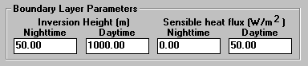
Inversion Height (m) - Nighttime and Daytime
This specifies the minimum and maximum diurnal inversion heights used in calculations of boundary layer parameters.
Default: Minimum = 50; Maximum = 1000
Sensible heat flux (W/m2) - Nighttime and Daytime
This specifies the minimum and maximum daily surface heat fluxes used in calculations of boundary layer parameters.
Default: Minimum = 0; Maximum = 50

Boundary Layer Type: Calculated
SCICHEM calculates surface heat flux using a surface energy balance model. Boundary layer height is estimated from an evolution equation that models growth from convectively- and mechanically-driven entrainment into the overlying stable air. The input parameters are as follows:
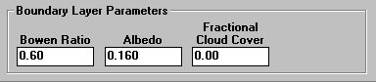
Bowen Ratio
This specifies the ratio of surface sensible heat flux to latent heat flux.
See Table 4-14 for typical values.
Default: 0.5
Albedo
This specifies the fraction of incident light that is reflected by the surface.
See Table 4-15 for typical values.
Default: 0.15
Cloud Cover
This specifies the fractional cloud cover where completely overcast is 1 and clear is 0.
Default: 0
Table 4-14 Typical Bowen Ratios.
Land-use Type | Spring | Summer | Autumn | Winter
Water | 0.1 | 0.1 | 0.1 | 1.5
Deciduous Forest | 0.7 | 0.3 | 1.0 | 1.5
Coniferous Forest | 0.7 | 0.3 | 0.8 | 1.5
Swamp | 0.1 | 0.1 | 0.1 | 1.5
Cultivated Land | 0.3 | 0.5 | 0.7 | 1.5
Grassland | 0.4 | 0.8 | 1.0 | 1.5
Urban | 1.0 | 2.0 | 2.0 | 1.5
Desert Shrubland | 3.0 | 4.0 | 6.0 | 6.0

Table 4-15 Typical Albedo Values.
Land-use Type | Spring | Summer | Autumn | Winter
Water | 0.12 | 0.10 | 0.14 | 0.20
Deciduous Forest | 0.12 | 0.12 | 0.12 | 0.50
Coniferous Forest | 0.12 | 0.12 | 0.12 | 0.35
Swamp | 0.12 | 0.14 | 0.16 | 0.30
Cultivated Land | 0.14 | 0.20 | 0.18 | 0.60
Grassland | 0.18 | 0.18 | 0.20 | 0.60
Urban | 0.14 | 0.16 | 0.18 | 0.35
Desert Shrubland | 0.30 | 0.28 | 0.28 | 0.45

Boundary Layer Type: Observations
SCICHEM uses observations of boundary layer mixing height (ZI) and surface heat flux (HFLUX) or Pasquill-Gifford-Turner stability class (PGT) or Monin-Obukhov length (MOL) that are contained on a SURFACE or PROFILE observations file. MOL supersedes PGT and HFLUX. PGT supersedes HFLUX. PGT and MOL may be used without specifying ZI and assumed mixing heights, shown in Table 4-16, will be used. ZI must be provided if HFLUX is used. See Section 3.5.1 for details regarding SURFACE or PROFILE observations files.
Table 4-16 Assumed Mixing heights for use with PGT or MOL.
Stability Index | PGT | MOL (m) | ZI (m)
1 | A | -5 | 1000
2 | B | -12.5 | 1000
3 | C | -50 | 1000
4 | D | -1000 | 1000
5 | E | 25 | 125
6 | F | 13 | 65
7 | G | 5 | 25

Boundary Layer Type: Profile
SCICHEM reads boundary layer profiles from the PROFILE observations file. In this case, the upper air file can only contain a single profile. The boundary layer variables include the shear-driven lateral velocity variance (UU), the buoyancy-driven lateral velocity variance (VV), the vertical velocity variance (WW), the boundary layer heat flux (WT), the shear-driven turbulence scale (SZ) and the buoyancy-driven turbulence scale (SL). See Section 3.5.1 for details regarding the PROFILE file.

Boundary Layer Type: Gridded
SCICHEM reads boundary layer observations (mixing heights and surface heat flux) from a MEDOC file. This option is only available if the Weather Data Type is also MEDOC Gridded Data.

Boundary Layer Type: Operational
SCICHEM uses boundary layer Observations if available. If not, the boundary layer is Calculated. Also, if one of the two required observational boundary layer variables is provided, surface heat flux (HFLUX) or boundary layer height (ZI), SCICHEM will use the one that is supplied in its calculations.
Note: If Pasquill-Gifford-Turner stability class (PGT) or Monin-Obukhov Length (MOL) is provided without boundary layer mixing heights, SCICHEM uses assumed boundary layer mixing heights (Table 4-16) and the boundary layer type is considered to be Observations.

Large Scale Variability.
The SCICHEM dispersion calculation accounts for mesoscale or synoptic scale variability in the wind field. This is important for long-range transport applications where the range exceeds 100 km and also for incorporating climatological variability or forecast uncertainties.
The large scale velocity fluctuations are assumed to be constrained to the horizontal plane and are characterized by a variance and length scale. These parameters may be specified by the user, computed from a theoretical model or read from a meteorology observation file. The large-scale variability is ignored by selecting None from the combo box.
The choices of large scale variability are as follows:
- Model
- Observations
- Input
- None
- Operational

Large Scale Variability: Model
In this mode, the length scale and variance of the large scale variability are determined from a theoretical model based on climatological statistics. The large-scale variability model used in SCICHEM is based on research by Nastrom and Gage (1985) and a theoretical model proposed by Gifford (1988).
Nastrom and Gage analyzed GASP (Global Atmospheric Sampling Program) wind data and showed a clear spectral break at a horizontal wavelength of about 400 km, with 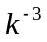spectrum at longer wavelengths and 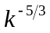for shorter scales. Gifford argues that the large-scale behavior is consistent with the predictions of two-dimension turbulence theory, while the behavior indicates three-dimensional motions in that part of the spectrum.
We assume that the upper-troposphere data is representative of the entire lower atmosphere, although there is probably some vertical variation in reality. However, no data presently exists to define these fluctuation profiles, so, the simplest assumption is made.
Furthermore, the GASP data represent long-term averages and cannot provide any relationship between the local meteorological conditions and the local smaller-scale velocity fluctuations. Use of the GASP data is therefore equivalent to a climatologically averaged spectrum. Using Gifford's suggestions and the GASP profiles, which show an increase in fluctuation variance toward the poles, the horizontal velocity variance is represented as

where is the latitude, fo is twice the rotation rate of the earth and 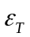is the average tropospheric energy dissipation rate. Gifford suggests a value of 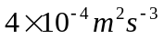for , but the inverse cosine variation is an empirical factor to provide a match with the latitudinal variation observed in the GASP data. The turbulence length scale associated with these dissipative fluctuations is taken to be
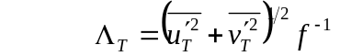
where f is the Coriolis parameter defined as
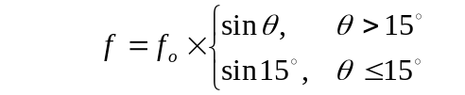
The limit of 15° is necessary to avoid singularities in the equation.
The velocity variance used in the dispersion calculation depends on the resolution of the input wind fields since the turbulence input represents only the unresolved component of the wind. Using the filter scale, 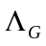,which is related to the wind-field resolution, we define
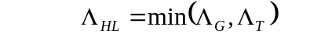
and
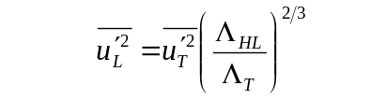
consistent with a 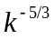spectral behavior. The cross-correlation, 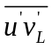, is assumed to be zero in the model.

Large Scale Variability: Observations
The large scale variability parameters (UL, VL and UVL) will be read from the SURFACE and/or PROFILE observation files (see Section 3.5.1). The user must enter the length scale explicitly. The input parameter is as follows:
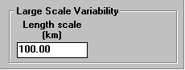
Length scale
This specifies the characteristic length scale (km) of the large scale variability.
Default: 100

Large Scale Variability: Input
In this mode, a single length scale and variance are used to characterize the large scale variability. The user is prompted for the following input parameters:
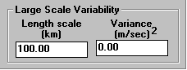
Length scale
This specifies the characteristic length scale (km) of the large scale variability.
Default: 100
Variance
This specifies the large scale velocity variance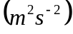.
Default: 0

Large Scale Variability: None
In this mode, large scale variability is ignored. This mode should be selected only for short-range transport applications, i.e., ranges less than 100 km, which do not include climatological variability.

Large Scale Variability: Operational
In this mode, the full effects of large scale variability are applied only when the large scale variability length scale is exceeded by the internal puff scale or by the horizontal boundary layer turbulence scale. Otherwise, a simple energy spectrum assumption is used to determine the reduced variance appropriate for diffusion on scales smaller than the cloud and boundary layer scales.

Additional Weather Input Parameters.
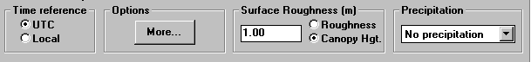
The following additional input parameters may be required.

Time Reference
If the time reference is different from that specified in the TIME setup then the local time of 00:00z must be set there.
UTC
This specifies the time on the meteorology files to be in the Universal Time Convention, which is equivalent to Greenwich Mean Time (GMT or Z). UTC is the default time reference.
Local
This specifies the time on the meteorology files to be in local time.

Surface Roughness
Roughness (m)
This specifies the surface roughness length (m). See Table 4-17 for typical values. The default value for the roughness is 0.03 m
Canopy height (m)
This specifies the actual height (m) of the vegetative canopy. The canopy height is only used as an alternative means of specifying the surface roughness length. Note that the bottom of the SCICHEM calculation domain is assumed to be at the top of the canopy. The default value for canopy height is 1 m.
Table 4-17 Suggested values for surface roughness (Saucier, 1987).
z0 (m) | Surface Description
0.0005 | Bare Ground, Sand Dunes, Water
0.001 | Nearly barren with low growing vegetation
0.01 | Grassland, Cropland, Wetlands
0.05 | Grassland with scattered trees, Brushland, Scrub growth
0.1 | Deciduous Forest, Villages, Forest Clearings
0.5 | Mixed Forest, Towns, Cities
1.0 | Coniferous Forest

Precipitation
SCICHEM includes a washout calculation based on the precipitation category. For Observational meteorology, the precipitation category can be either selected from the drop-down list or specified (as an index or a rate) on an observation file. Refer to Chapter 3.5 for information on providing precipitation data on an observation or MEDOC gridded meteorological file. For other weather data types, the precipitation category must be selected from the drop-down list and cannot be read from a file. The precipitation categories are shown in Table 4-18.
Table 4-18 Precipitation Categories.
Precipitation Rate (mm/hr) | Precipitation Category
0.5 to <3.5 | Light Rain
3.5 to <25.0 | Moderate Rain
25.0 or greater | Heavy Rain
5.0 to <20.0 | Light Snow
20.0 to <100.0 | Moderate Snow
100.0 or greater | Heavy Snow

Meteorological Options
Options are provided for saving a meteorological data used in SCICHEM and for generating mass-consistent winds. The user may click the Options button from the Weather Editor and use one or both of the check boxes provided to enable these options.

Save Meteorology Fields
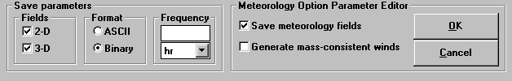
If the user checks the Save Meteorology Fields check box, the following choices are shown:
2-D
This will save the 2-D fields as a MEDOC-type named ProjectName.MCW. 2-D variables include ZI, USTR, HFLX, U, V, REL, PRATE and FCC, which are the boundary layer height, surface friction velocity, heat flux, surface velocities in the x- and y-directions, relief, precipitation rate (mm/hr) and fractional cloud cover, respectively. See Section 3.5.2 for details on the MEDOC format.
3-D
This will save the 3-D fields as a MEDOC-type named ProjectName.MCW. 3-D variables include U, V, W, T, H and CLD, which are the velocities in the x-, y-, and z-directions, temperature, humidity and cloud liquid water content, respectively. See Section 3.5.2 for details on the MEDOC format.
ASCII format
This will save meteorological fields in ASCII format.
Binary format/ASCII format
This will save meteorological fields in binary format. Binary format results in faster writing, smaller files, and faster reading of these files when used as meteorological input.
Frequency
This specifies the frequency for saving the meteorological data.

Generate Mass Consistent Winds
When the Generate mass-consistent winds check box is clicked, a diagnostic three-dimensional wind field is generated using meteorological observations (including upper air profiles, surface observations and fixed input) and the specified gridded terrain file. The wind field is determined by first interpolating from the observations onto the grid and then adjusting the three-dimensional field so that it satisfies mass continuity.
The SCIPUFF mass-consistency solver:
It has been shown that the minimum adjustment (in the least-squares sense) is given by the gradient of a particular scalar potential analogous to a dynamic pressure field. Terrain effects are included through use of a terrain-following coordinate system. Atmospheric stability is accounted for by means of a parameter that weights adjustments to the vertical velocity.
Two methods are utilized in computing the adjusted wind fields. The fastest method employs a Fast Fourier Transform (FFT) technique, but is limited by terrain slope and atmospheric stability. A point relaxation technique is used when the FFT solver is inappropriate.
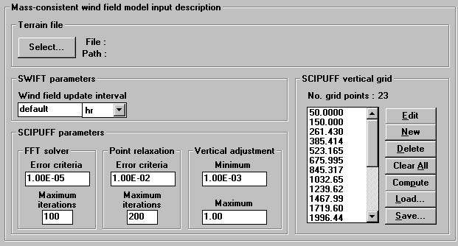
The following screen will be displayed:

Terrain
Select
This brings up an Open File dialog box which allows the user to specify a previously defined terrain file. See Section 3.5.4 for more information on the terrain file format.
SWIFT Parameters
Wind field update interval
This parameter controls the time interval at which the wind field is updated.
FFT Solver
Error criteria
The FFT solver error criterion is based on the ratio of the maximum change in the adjustment potential from the previous iteration to the maximum value of the potential. This ratio should decrease with increasing iterations and the computation ceases once it falls below the specified value. A value of 1.0E-5 will normally be adequate; smaller values will result in greater computation time.
Default: 1.0E-5
Maximum iterations
If the error criterion is not satisfied, the computation will cease after the specified maximum number of iterations. The calculation should normally take no more than 20 iterations.
Default: 100
Point relaxation
Error criteria
The point relaxation error criterion is based on the ratio of the maximum divergence in the adjusted wind field to a tenth of the maximum velocity gradient in the initial, unadjusted field. This ratio should decrease with increasing iterations and the computation ceases once it falls below the specified value. A value of 0.01 will normally be adequate; smaller values will result in greater computation time.
Default: 0.01
Maximum iterations
If the error criterion is not satisfied, the computation will cease after the specified maximum number of iterations. The calculation may take 200 to 300 iterations depending on the problem and the error criterion.
Default: 200
Vertical Adjustment
Minimum/Maximum
The vertical adjustment parameter accounts for atmospheric stability and is a function of temperature gradient and wind speed. Large positive temperature gradients and low wind speeds are associated with stable conditions, resulting in a small value of this parameter and relatively small adjustments in the vertical velocity. A value of 0 results in no vertical velocity and forces the wind to flow around hills rather than over them. A value of 1 corresponds to potential flow. Normally this parameter is computed internally based on temperature and wind speed, but setting maximum and minimum values can force certain flows such as purely horizontal or potential flow.
Default: 1e-3 and 1
SCIPUFF Vertical Grid
Grid Points
A vertical grid for the mass-consistent wind field must be specified. A default grid is provided for typical atmospheric applications. Higher vertical resolution, particularly near the surface of topography with large slopes, can result in excessive computational effort.
Default: A generic grid created with a compromise between vertical extent, resolution, and size.

Audit Editor
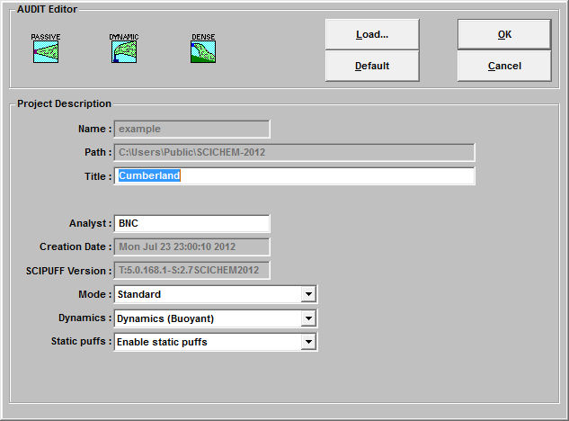
The Audit Editor is used to save additional project information, such as the project title. When the user clicks Audit from the New Project, the Audit Editor window (shown below) will appear.

The icons displayed in the upper left-hand corner determine if the project is Passive, Dynamic or Dense. Dynamic effects treated are buoyant and momentum plume rise and gases that have densities different from that of air. The following input parameters are displayed in this window:
Name
This specifies the project name. This parameter cannot be edited from this screen.
Path
This specifies the path where the project is stored. This parameter cannot be edited from this screen.
Title
This specifies the project title.
Default: Blank (no title)
Analyst
This specifies the name of the person creating the project.
Default: Blank (no analyst)
Creation Date
This specifies the date that the project is created. This parameter cannot be edited from this screen.
SCICHEM Version
This specifies the SCICHEM version number. This parameter cannot be edited from this screen.
The user may also specify additional project options. They include the following:
Mode
This specifies whether to run SCICHEM in Standard or Fast mode.
See Section 3.1.1 for a description of the two modes.
Dynamics
This specifies whether or not to treat dynamics. Also, controlled by the icons at the top left-hand corner of this window.
Static Puffs
This specifies whether or not to use static puffs in the calculation. Static puffs significantly speed up the calculation, therefore it is the default to use them.

Options Editor
The Options Editor is used to define the project options. When the user clicks Options from the New Project, the Options Editor window (shown below) will appear.
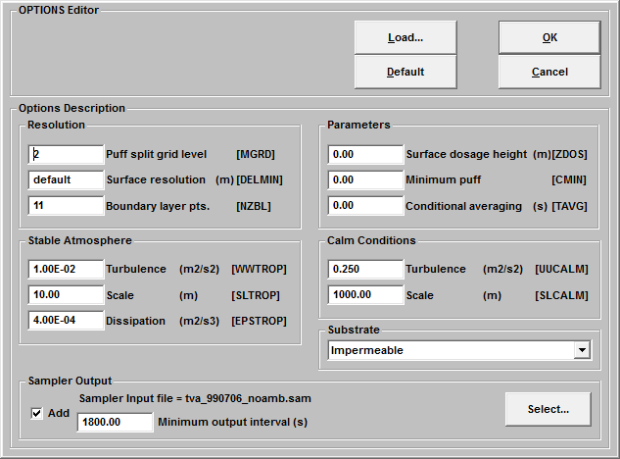
The input parameters are defined as follows:

Resolution
Puff split grid level (MGRD)
This specifies the grid resolution parameter that limits the horizontal growth of a puff. The actual resolution used for limiting the horizontal growth of a puff is , where is the horizontal resolution described in the Domain Setup (see Section 3.6). For example, if is 1 degree and mgrd is 2, the horizontal spacing that limits puff growth is 4 degrees.
The recommended (default) setting of MGRD = 2 assumes a smoothly varying wind field. The puff moment calculation accounts for linear velocity gradients so puffs can usually be allowed to grow larger than the meteorological grid size. Smaller values of MGRD give more detailed resolution of the concentration field at the expense of more puffs and longer execution time.
Default: 2
Surface resolution (DELMIN)
This specifies the minimum grid size (m) for the adaptive grids. SCICHEM uses adaptive grids for surface dose and deposition output and also for internal puff interaction calculations. Under some circumstances, the adaptive grid may exhaust its storage allocation unless a limit is imposed on the minimum grid size. However, setting a limit may result in the loss of small-scale information in the output fields. (It will only affect the efficiency of the internal puff interaction calculation, but not the result.)
Default: 0

Boundary layer resolution (NZBL)
This specifies the number of grid points used in the vertical direction to represent the turbulence profiles in the boundary layer.
Default: 11

Stable Atmosphere
Turbulence (WWTROP)
This specifies the tropospheric vertical velocity variance . This value is used in the stable atmosphere above the planetary boundary layer. It also provides a lower bound on the vertical velocity variance within the boundary layer.
Default: 0.01
Scale (SLTROP)
This specifies the tropospheric vertical length scale (m), used in the stable atmosphere above the planetary boundary layer.
Default: 10
Dissipation (EPSTROP)
This specifies the average tropospheric energy dissipation rate used in the large scale variability model (described in Section 3.7.3) to characterize the mesoscale velocity variance.
Default: 4.0E-4

Parameters
Surface dose height (ZDOS)
This specifies the height (m) above the surface where the surface dose is calculated.
Default: 1.E-20
Minimum puff mass (CMIN)
This specifies the minimum puff mass (material mass units). A puff with mass less than this value does not split or distort due to velocity gradients but it may merge with other puffs. Setting this minimum value may help decrease execution time. Default: 0
Conditional averaging (TAVG)
This specifies the averaging time for defining the diffusive component of turbulence. This parameter is used to scale the velocity variances that determine puff diffusion. To obtain a quasi-deterministic prediction of dispersion by neglecting the "meandering" component of turbulence (length scales greater than the plume or cloud size) TAVG should be set to the smaller of the release duration and the sampling period of interest. This is most useful when attempting to compare sampler output with actual data measurements.
Default: Use the full turbulence spectrum for the diffusion calculation (equivalent to a very large TAVG).

Calm conditions
Turbulence (UUCALM)
This specifies the turbulence value used under light wind conditions.
Default: 0.25
Scale (SLCALM)
This specifies the turbulence scale (m) used under light wind conditions.
Default: 1000

Substrate
This specifies the substrate type for secondary evaporation.
Default: Impermeable

Sampler Output
Sampler (receptor) output provides a time history of point concentration values for the locations specified in the sampler input file. The output file contains the concentration time series (in ASCII format) for the locations specified in the sampler input file. This file can then be read with other plotting software to obtain a graphical representation of the sampler time history. Concentration values are written at the maximum time step interval, as defined in the Time Editor (see Section 4.4 The maximum number of sampler locations is 500. For details on the sampler location file format, see Section 3.3.6. For the format of the resulting output file (ProjectName.SMP), see Section5.3. A sampler input file can be selected by checking the Add box. The minimum output interval(s) specifies the output interval in seconds for the sampler output.

Starting a run.
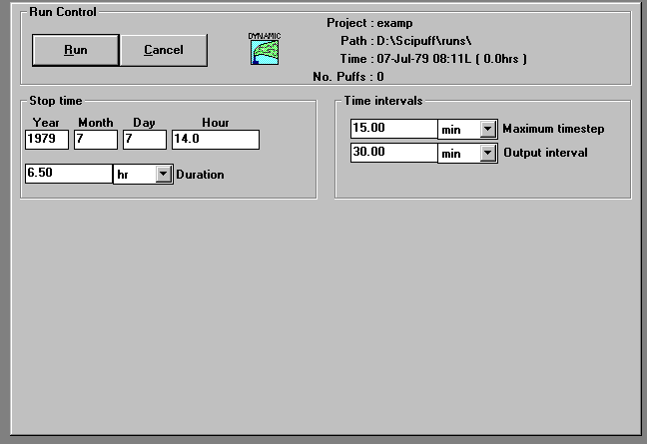
Once a project has been created and the user clicks Continue, the Run Control window will appear, as shown below.
The parameters displayed are those that have previously been defined in the Time Editor (Section 4.4). These parameters can be edited prior to commencing the calculation. The parameters are defined in Sections 4.4.3 and 4.4.4.
When the user clicks the Run button, the run will start. A control box appears which displays the progress of the run, as shown below.
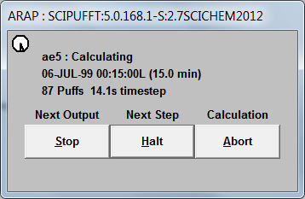
The window displays the current run time, the minimum time step, and the number of puffs. From this secondary window, the run can be stopped with either the Stop, Halt or Abort push buttons. When the Stop button is used, the run is stopped at the next output interval when all of the output files are updated. When the Halt button is used, the run is stopped at the next complete time step and all of the output files are forced to be updated. If the Abort button is used, the run is stopped as soon as possible and the output files are not updated beyond the previous complete time step.

OUTPUT FILES

Surface Output Files
If deposition or dose parameters are set to true in the material definition (group_deposition, total_deposition, group_dose, and total_dose under the MATDEF namelist of the INP file, see Section 4.2), the surface integrals of dose and deposition are stored as adaptive grid files with multiple timebreaks. The dose integral, 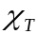, is stored in the surface file, ProjectName.DOS, and the deposition, 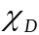, in ProjectName.DEP. These files are direct-access binary files with a record length of 512 bytes (128 words), and consist of a number of timebreaks. Each timebreak contains a header record followed by the field data.
For multicomponent projects, SCICHEM will output additional incremental time averaged concentration field for multicomponent species in the dose file and incremental dry and wet multicomponent species deposition fields, if the species dosage and deposition flags have been set to T in the IMC file.
The Fortran statements to write a timebreak are illustrated in Figure 5-18.

c----- HEADER RECORD
write(nwrt,rec=ir) time, ngrid, nx, ny, xorg, yorg, dx, dy,
$ nvar, (names(i),i=1,nvar), iversion

C----- GRID INDEX ARRAY
do ii = 1,ngrid,128
j1 = min0(ii+127,ngrid)
ir = ir + 1
write(nwrt,rec=ir) (iref(j), j=ii,j1)
end do

C----- FIELD DATA ARRAYS
do ivar = 1,nvar
do ii = 1,ngrid,128
j1 = min0(ii+127,ngrid)
ir = ir + 1
write(nwrt,rec=ir) (fields(j,ivar), j=ii,j1)
end do
end do

Figure 5-18 Fortran statements to write a surface output file timebreak.

The header record consists of the variables:

time (real*4) time of the field in hours from the beginning of the calculation
ngrid (integer*4) total number of grid cells in the adaptive grid. A value of zero indicates the end of the file.
(nx, ny) (integer*4) number of base grid points in the (x, y)-direction
(xorg, yorg) (real*4) origin coordinates of the base grid
(dx, dy) (real*4) grid spacings of the base grid
nvar (integer*4) number of field variables
names (char*4) array of field variable identifying names
iversion (integer*4) SCICHEM version number
The variable names are constructed from the input material list but do not contain direct reference to the material identifier names. The field names are 4-character identifiers, and the first character denotes the type of field. M denotes the mean field, V denotes the fluctuation variance, and S denotes the correlation length scale. Note that the scale variable is multiplied by the fluctuation variance on the output file, since the integral value is weighted by the variance. Units for the various fields are dependent on the type of surface field, but are based on the material mass units (as specified as part of the material properties definitions) and SI units. For gaseous materials or individual particle size bins, the remaining three characters of the name contain the unique type descriptor number. For particle materials with multiple size bins, the total particulate mass variables are represented by a two-character integer, containing the material identifier number, and the last character of the name is T. The material identifier is simply the position in the list of MATDEF namelists in the ProjectName.INP file. Thus, the total mean deposition for the first material in the input file would be named as M01T, while the variance of the fifth particle size bin for the first material would be V005.
The adaptive grid structure is described by the integer*4 index array, iref, and the field data is stored in the real*4 array fields. For each grid cell, iref points to the first refinement sub-cell, if it exists. If the grid cell, i, is not refined, then iref(i) = 0. The first nx*ny cells are the base grid, so ngrid is necessarily greater than or equal to nx*ny. The centers of these cells are located at

xi = xorg + (i – 0.5)*dx, i = 1, nx
yj = yorg + (j – 0.5)*dy, j = 1, ny
and the location (xi, yj) corresponds to cell number (j – 1)*nx + i in the adaptive grid.
If a cell is refined, then the iref array contains the grid cell number of the first of four sub-cells with half the grid size of the parent cell. Suppose i0 is the parent cell number, with grid sizes Δx0 and Δy0 and center location (x0, y0). The parent cell may be a base grid cell but is not necessarily so since the refinement process can be continued without limit. The four sub-cells are numbered consecutively as {i1 + k : k = 0, 3} where iref(i0) = i1. The sub-cells are numbered as shown in Figure 6-1 (i.e., lower left is zero, then lower right, upper left, upper right), and have center locations
and grid size (Δx0/2, Δy0/2).
Each cell has a complete set of field variables associated with it, so the local field value has contributions from all levels of refinement. A simple estimate of the field value at a given location (xp, yp) can be obtained using the pseudo-code illustrated in Figure 6-2. Note that this example uses a recursive subroutine call to scan the list of refinements. The field array in the example represents any one of the nvar variables in the fields array on the file. This estimate simply adds contributions from successive refinement levels without any interpolation across grid cells.

xx = (xp-xorg)/dx
yy = (yp-yorg)/dy

i0 = int(yy)*nx + int(xx) + 1

cval = 0.0

call sum_point_val(i0,xx,yy,cval)

c ---- cval contains the local field value

c-----------------------------------------------------------------------

subroutine sum_point_val(i0,xc,yc,cval)

cval = cval + field(i0)

c *** Check for refinement

if (iref(i0) .ne. 0) then
xc = 2.*(xc - int(xc))
yc = 2.*(yc - int(yc))
i1 = iref(i0) + 2*int(yc) + int(xc)
call sum_point_val(i1,xc,yc,cval)
end if

return
end

Figure 5-19: Fortran statements to calculate field values from the surface output file.

Puff File
The puff file, ProjectName.PUF, is a binary file containing the complete puff data at a number of time breaks together with boundary layer and continuous source information for restart purposes. The file is written using the unformatted Fortran write statement:

write(lun_puf) t,
$ npuf,((puff(i).r(j),j=1,43),i=1,npuf),
$ npaux,(paux(i),i=1,npaux-1),
$ nspecies,
$ nxbl,nybl,dxbl,dybl,
$ xbl(i=1,nxbl),ybl(i=1,nybl),
$ zibl(i=1,nxbl*nybl),
$ ncrel,(c_plen(i),i=1,ncrel),
$ nsrcaux,(src_aux(i),i=1,nsrcaux)
where
t (real*4) time of the data in seconds from the beginning of the calculation
npuf (integer*4) total number of puffs
puff(i).r(*) (real*4) floating point data for puff i
npaux (integer*4) total number of puff auxiliary data values + 1
paux(*) (integer*4) floating point data auxiliary puff data
nspecies (integer*4) number of multicomponent chemistry species
nxbl,nybl (integer*4) horizontal dimensions of meteorology grid
dxbl,dybl (real*4) horizontal grid intervals of meteorology grid
xbl(*),ybl(*) (real*4) horizontal grid locations of meteorology grid
zibl(*) (real*4) boundary layer depth on meteorology grid
ncrel (integer*4) total number of active continuous releases
c_plen(*) (real*4) length scale associated with each release
nsrcaux (integer*4) total number of source auxiliary data values
src_aux(*) (real*4) auxiliary source data
The floating point puff data is stored as follows:

j=1-3 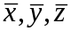 puff centroid coordinates
j=4-9 σij puff spread moments, in the order σxx, σxy, σxz, σyy, σyz, σzz
j=10-15 αij puff inverse moments, in the order αxx, αxy, αxz, αyy, αyz, αzz
j=16 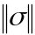 determinant of the puff spread moments
j=17 Q puff mass
j=18 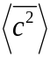 integrated mean square concentration
j=19 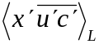 Large-scale diagonal-xx turbulent flux moment
j=20 X12 cross-xy turbulent flux moment
j=21 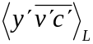 Large-scale diagonal-yy turbulent flux moment
j=22 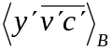 Buoyancy-driven diagonal-yy turbulent flux moment
j=23 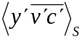 Shear-driven diagonal-yy turbulent flux moment
j=24 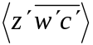 diagonal-zz turbulent flux moment
j=25 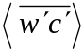 vertical turbulent drift moment
j=26 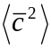 squared mean concentration from overlap calculation
j=27-28 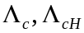 horizontal concentration fluctuation length scales
j=29 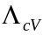 vertical concentration fluctuation length scale
j=30 2Tc correlation time scale for the puff concentration fluctuations
j=31 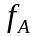 linear decay factor
j=32 zi local mixed layer depth
j=33 zc puff vertical cap height; used to control puff splitting within the planetary boundary layer
j=34-36 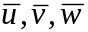 ambient wind velocity for use with Adams-Bashforth scheme
The following 7 data values are integers stores as floating point values:

j=37 type an identifier for the puff material and size bin type
j=38-39 next, prev pointers for the linked list on the spatial grid
j=40 grid grid refinement level for the spatial grid
j=41 tlev refinement level for the puff time step
j=42 tnxt pointers for the linked list for time stepping
j=43 iaux pointer into the auxiliary array for additional puff data. The number of data values in the array for any given puff in dependent on the material type and on the overall dynamics flags
There may be additional puff data values for each puff, depending on the user’s options. These variables would appear in the following order:

j=1 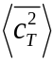 mean square total concentration (for multiple size bin particle materials)
j=2 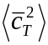 squared mean total concentration (for multiple size bin particle materials)
j=3-10 buoyancy parameters
Next nspectot values multicomponent species masses
Next nspectot values multicomponent species puff overlap concentrations
Next ncorrt values multicomponent species correlations
Next nspectot values multicomponent species end of chemistry concentrations
j=11+3*nspectot+ncorrt inverse puff volume
j=12+3*nspectot+ncorrt puff chemical stage
The puff type identifier is simply allocated sequentially in the order that materials are specified in the ProjectName.INP file. Thus, the first material is type = 1 if it is a gas, or the Nbin size bins are type = 1 up to type = Nbin for a particle material. Identifiers for the second material are then allocated beginning with the next available value for type.

Sampler Time-History File.
The sensor time history file is an ASCII text file containing output from the sensors specified in the sensor definition file described in Section 5.3. The output frequency is controlled by the sampler time step dt_smp specified in the input file. The exact output interval may vary with the adaptive puff time step described in Section 3.5, but will be between dt_smp and the large time step delt, also given in the input file. However, if the 'OUTPUT' keyword is given in the sensor definition file header record, the output interval specified is used as described in Section 3.4.
The output format consists of a header section followed by records for each output time. All records are on a single line (no wrapping) and the data (and variable names) are aligned in columns. The single header record consists of a list of variable names (CHARACTER*8). The data records consist of time (in seconds from the start of the calculation) followed by the output for sensor-1, sensor-2, etc. Note that the output (and variable names) depends on the sensor specification, as given in Table 5-19. Sensor output variables.Table 5-19.
Units for mean concentration output (CONC sensors) is in mass units per cubic meter, i.e., typically kg/m³; variances units are the square of concentration units, e.g., kg²/m⁶. Dosage, (time-integral of concentration) is in concentration units multiplied by time, e.g, kg-s/m³, while the corresponding dosage variance is concentration units squared multiplied by time, e.g., kg²-s/m⁶. The Units for the units for mean concentration output is the same as specified in the
For multicomponent species (MC sensors), the concentrations units are dependent on whether the species are particles or non-particles. For non-particle species, the units are species_units, as set under the control section of the IMC file (Section 3.3.1.). Aerosol particle species concentrations are always assumed to be in or or for types P, PN and PA respectively.
The fluctuation correlation time is in seconds. Mean deposition output is in mass units per area, typically kg/m²; the deposition variance unit is the square of this. The remaining surface liquid variable (Rxxx) is in the same units as the mean deposition. The number density of BY_SIZE output units are simply per cubic meter or s/m³ for a time-integrated sensor.
Table 5-19. Sensor output variables.
Sensor Class | Variable Names¹ | Description
CONC | Cxxx  Vxxx  Txxx | Mean concentration,  Concentration variance, 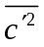  Fluctuation correlation time scale 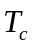
CONC:INT | Dxxx  Vxxx | Mean dosage, 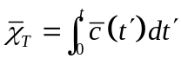  Dosage variance, 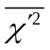
MC | Csss_xxx | Mean concentration for species s, 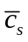
MC:INT | Dsss_xxx | Mean dosage for species s, 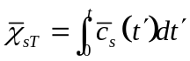
MET  [choice=TURB] ³ | Uxxx  Vxxx  Wxxx  Txxx  ZIxxx  HFLXxxx  Lxxx  UUxxx  VVxxx  WWxxx  USTRxxx | x-component velocity,  y-component velocity,  z-component velocity, 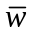  Absolute temperature, T  Boundary layer depth, z_{i}  Sensible heat flux, H  Monin-Obukhov length, L  Shear-driven turbulence, 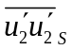  Buoyancy-driven turbulence, 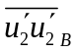  Vertical velocity correlation, 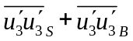  Surface friction velocity, 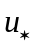
¹ The string ‘xxx’ represents a 3 digit number based on the order in which the sensor was defined in the location file.
² Additional output for DEP class sensors for choice as shown. Applies only to liquid materials in projects specifying a surface substrate.
³ The string ‘bbb’ represents a 3 digit number giving the size bin number corresponding to the sensor choic input (Section ). Output only for liquid droplets or particles with diameters falling into the corresponding size range.
³ Additional outputs for MET class sensors if choice is set to ‘TURB’.

Velocities from MET sensors are in m/s regardless of the units on the meteorological input file. Temperature is absolute in degrees K. The boundary layer depth is in meters, heat flux in W/m², Monin-Obukov length in meters, turbulence velocity variances in m²/s² ,and the surface friction velocity in m/s.
Examples of SCIPUFF output format are shown in Figure 5-20. Figure 5-20 (a) shows output from two sensors. The first is a concentration sensor; the second provides integrated output of some kind, i.e., surface deposition or time-integrated. Figure 5-20(b) shows output from a BY_SPECIES sensor for a single species. These examples show small numbers of sensors and species to limit the length of the output lines. Many more sensors and species can be defined, in which case, the lines for each output time are simply appended (without wrapping) with appropriate sensor output.

(a)
T C001 V001 T001 D002 V002
9.0000E+02 9.1047E-08 5.9028E-14 9.6551E+01 7.5150E-12 7.1547E-19
1.8000E+03 1.0229E-07 9.5524E-14 9.9917E+01 1.2910E-11 9.7301E-19
2.7000E+03 1.6559E-08 7.8615E-15 1.1125E+02 1.2908E-11 9.7268E-19
3.6000E+03 2.1661E-11 3.0766E-18 1.5855E+02 1.2908E-11 9.7268E-19

(b)
T C001 V001 T001 C001_001 C052_001 C004_001 C002 V002 T002
9.0000000E+02 0.0000E+00 0.0000E+00 0.0000E+00 2.4000E-03 3.0000E-03 6.3000E-02 0.0000E+00 0.0000E+00 0.0000E+00
1.8000000E+03 0.0000E+00 0.0000E+00 0.0000E+00 2.4000E-03 3.0000E-03 6.3000E-02 0.0000E+00 0.0000E+00 0.0000E+00
2.7000000E+03 0.0000E+00 0.0000E+00 0.0000E+00 2.4000E-03 3.0000E-03 6.3000E-02 0.0000E+00 0.0000E+00 0.0000E+00
3.6000000E+03 0.0000E+00 0.0000E+00 0.0000E+00 2.4000E-03 3.0000E-03 6.3000E-02 0.0000E+00 0.0000E+00 0.0000E+00
Figure 5-20. Examples of multicomponent sampler output.

Project Log Files
The log messages from SCICHEM is output to the ProjectName.log. Some of the information that is available from the log file is as follows:
SCICHEM version number, the information about meteorology used, domain, etc. For multicomponent project, additional information is output to the log file, namely, the multicomponent species list, background species read from the ambient file, the list of species output to the dos and dep file. If the Aqueous Aerosol module is used, any messages from the module are output to the ProjectName.qlog file. Lastly, any errors or warnings are written to the log file.

Project Err File
Errors, if any, encountered during the project run are also logged to the ProjectName.err file.

POST-PROCESSING PROGRAMS.

Generating Post Files
SMP2POST is a post-processing program that allows the user to generate AERMOD-style POSTFILEs from the SMP file. The header of the SMP file contains all the necessary information to emulate a POSTFILE – with the exception of the significant hill height, which is simply set to the terrain elevation in its output. This post-processor is typically used for near-source impact calculations, e.g., fenceline concentrations.
SMP2POST converts known chemical species from either kg/m³ (single-component runs) or PPM (multi-component runs) to µg/m³, the units used in POSTFILEs. Known chemical species include N, N₂, NO, NO₂, N₂O, S, SO₂, CO, CO₂, O, O₂, O₃, H₂O, and Pb. The conversion factor is given as
1000 × MW / 24.45
where MW is the molecular weight of the chemical species, 1000 converts milligrams to micrograms, and 24.45 is the volume in liters of a mole of gas at one atmosphere and 25°C. User-specified conversion factors can be specified using the -c command-line option.
By default, SMP2POST will convert all chemical species found in the SMP file. It appends the underscore character and the chemical species name before the final “.” in the output filename, to assure unique output filenames. The default “base-name” for the output filename is the same as the input sampler history filename, with the extension changed from SMP to PST. The output base-name can be specified using the -o command-line option. For single-component runs, SMP2POST will use this filename without changes. For multi-component runs, the underscore and chemical species names will still be appended before the filename extension. A sub-set of chemical species can be selected using the -s command-line option.
For example, if the input file is myproject.smp, the default output filename will be myproject.pst, so the NO values found in the SMP file would be written to the file myproject_NO.pst and the NO₂ values would be written to the file myproject_NO2.pst.
AERMOD writes the SRCGROUP name in both the header and each line of a POSTFILE. SMP2POST will, by default, use the source group name “ALL”. The users can specify the source group name to be written using the -g command-line option.

Usage
SMP2POST will print a help message to the screen when given the -h command-line option.

C:\>SMP2POST -h

This program reads SCICHEM Sampler History files (concentrations)
and writes AERMOD-like POSTFILEs.

Usage: SMP2POST [options]

Options:
-i, --smp-file filename Input SAMPLER HISTORY (*.SMP) file name, required.
-o, --postfile filename Output POSTFILE filename or basename, optional.
For multiple species, its name will be appended
before the extension, e.g. filename_NO2.pst.
Default: scichem.pst
-s, --species NO,NO2 Comma-separated list of chemical SPECIES to process,
(no spaces allowed in list).
Default: process ALL species found in SMP file.
-c, --conversion X,Y Comma-separated list of conversion factors to convert
from PPM (SCICHEM standard for multi-component runs)
of kg/m3 (SCICHEM standard for single-component runs)
to ug/m3 (micrograms per cubic meter, AERMOD standard).
Must be in the same order as -s species, or as the
species found in SMP file if no -s given.
Default: use internal look-up tables.
-g, --group Group ID to write inside POSTFILE(s).
-d, --debug Print verbose debugging info to screen.
-q, --quiet No output to the screen, please.
-v, --version Print version info and quit.
-h, --help Print this help message and quit.

Examples:

smp2post -i abc.smp -s NO,NO2 -g ABC
Will create abc_NO.pst and abc_NO2.pst, with the SRCGROUP name 'ABC'.

smp2post -i abc.smp -o basename.pst
Will create basename_NO.pst and basename_NO2.pst, etc.

smp2post -i abc.smp -s NO,NO2 -c 1,1
Will create abc_NO.pst and abc_NO2.pst, in PPM.
The -i option giving an SMP filename is required. Most of the options are discussed above, with the exception of the -d (or equivalently, --debug) and the -v (or equivalently, --version) options. The -v option simply prints the version number and exists, e.g.

C:\>SMP2POST -v
SMP2POST VERSION 0.1 2013-06-07
The -d option causes the program to print debugging information to the screen. It is suggested the user follow along in the Fortran code to assist in debugging.

Class I Analysis Post-processor
One of the uses of SCICHEM in multi-component mode is to perform Class I analyses for Prevention of Significant Deterioration (PSD) permit applications. To facilitate post-processing the SCICHEM outputs, a new post-processor is provided as part of the SCICHEM Beta 2 distribution, named “SciClass1Flag”.
There are three types of “answers” required in a typical Class I analysis, as outlined in FLAG (2010):
- Maximum N-hour average concentration are calculated, and compared to the Class I SILs/NAAQS (where N varies)
- Maximum annual total nitrogen and total sulfur deposition are calculated, and compared to the Deposition Analysis Thresholds (DATs)
- The 98th percentile change to natural background visibility extinction is calculated for each model year, with a target of no more than 5% change
It is often quite useful to know at which Class I area within one’s modeling domain the maxima occurred and even at which receptor within a Class I area the maxima occurred. SciClass1Flag was designed to be flexible enough to provide these details, in addition to the final “answers” required for a Class I analysis.
The program requires several inputs: a control file where the user requests specific answers be calculated, one or more Federal Land Managers (FLM)-supplied files containing receptor locations within a Class I area, comma-separated values (CSV) files containing Tables 6 – 9 from FLAG (2010), and a completed SCICHEM run. The SCICHEM surface dosage and deposition files, *.DOS (dosage) and *.DEP (deposition), are required.
A sample control file is included with the distribution, and can be created at any time by the program itself using the --sample command-line option. See the next section for the details of the control file structure.
The FLM-supplied modeling receptors can be downloaded from the National Park Service website, and should be used verbatim (no pre-processing or GIS re-projecting necessary). Follow the link in the upper-right corner with the text “Download Class I Area Receptor Data”, save and extract the contents of the ZIP file to the ‘Class1Area’ subdirectory under the scidata directory. The scidata directory is set in the ‘scipuff.ini’ file using the SciDataDir variable under the “[Paths]” section. If SciDataDir is not defined in the ‘scipuff.ini’ file, the post processor searches the current run directory for the files by default.
A ZIP file containing both an MS Excel Spreadsheet and CSV files with the data from Tables 5 to 10 from FLAG (2010) is included with the SCICHEM distribution. Extract the contents of the ZIP file to the ‘Flag2010’ subdirectory under the scidata directory. If SciDataDir is not defined in the ‘scipuff.ini’ file, the post processor searches the current run directory for the files by default. Note that typically Table 6 (Annual Average Natural Conditions) is preferred over Table 5 (20% Best Natural Conditions) unless otherwise recommended by the FLM or permitting authority. Table 10 is not used by SciClass1Flag, but is included in case it’s helpful.
The program uses the first four characters of the Class I area receptor filename (e.g. the meve in meve-recep.dat in the example below, representing Mesa Verde National Park) as the key with which to find the proper lines in the FLAG (2010) Tables. Misspelling the receptor file will likely cause the program to fail.
The user may add new lines to the CSV tables, e.g. to account for other areas to be treated like a Class I area, or to account for Native American Indian lands. Care should be taken to choose a unique 4-letter code for the new area, so as not to conflict with the existing 4-letter codes.

Control File Structure
The control file for SciClass1Flag is keyword-driven. Some important features of the control file are:
- Blank lines, and any portion of a line after a comment character (# ; !), are ignored.
- Keywords and values can be either space-delimited or comma-delimited, or a mixture.
- Any number of spaces can be used between words (elements) in a line.
- All words in the control file are case insensitive, except for filenames which are used verbatim.
- Filenames may contain spaces and commas, if enclosed by either single or double quotes.
- Keywords may be repeated. The keywords AREA, CON, DEP, and VIS may be repeated as many times as desired. For other keywords, the value of the last one encountered will be used.
- The order of the lines containing keywords does not matter.
- Primary keywords must be the first word on a line in the control file, but leading spaces are allowed.
A typical control file is given in the following example:

; This is a comment
Project fc_egu1
! FLAG (2010) look-up Tables:
NatCond /home/data/ClassI/flag2010/flag.2010.table.6.annual.csv
LargeRH /home/data/ClassI/flag2010/flag.2010.table.7.FlargeRH.csv
SmallRH /home/data/ClassI/flag2010/flag.2010.table.8.FsmallRH.csv
SeaSalt /home/data/ClassI/flag2010/flag.2010.table.9.FseasaltRH.csv

# Class I areas to include
Area /home/data/ClassI/meve-recep.dat ! Mesa Verde National Park
AREA /home/data/ClassI/wemi-recep.dat ! Weminuche Wilderness

# Outputs:
con no2 1 yr H1H max_concentrations.csv
con pm10 24 hr H1H max_concentrations.csv
con pm10 1 yr H1H max_concentrations.csv
con pm25 24 hr H1H max_concentrations.csv
con pm25 1 yr H1H max_concentrations.csv
con so2 3 hr H1H max_concentrations.csv
con so2 24 hr H1H max_concentrations.csv
con so2 1 yr H1H max_concentrations.csv
dep N 1 yr H1H max_deposition.csv
dep S 1 yr H1H max_deposition.csv
vis dBext 24 hr H8H visibility_results.csv
vis dBext 24 hr >5 visibility_exceedences.csv
vis dBext 24 hr >10 visibility_exceedences.csv
The following describes each keyword of the control file. Italics are used to indicate number values.

Project project_name
This specifies the base filename for the project. The SciClass1Flag program opens and reads project_name.dos and project_name.dep.

NatCond C:\flag2010\flag.2010.table.6.annual.csv
LargeRH C:\flag2010\flag.2010.table.7.FlargeRH.csv
SmallRH C:\flag2010\flag.2010.table.8.FsmallRH.csv
SeaSalt C:\flag2010\flag.2010.table.9.FseasaltRH.csv
These keywords give the path and filename of the look-up tables supplied with the SCICHEM distribution. A Windows-like example is given above, but the path can be anything of the users’ choosing. Pathnames can contain spaces, if enclosed in single or double quotes.

AREA C:\path\to\xxxx-recep.dat
The AREA keyword is repeatable. The 2nd word in the line species the (full or relative) path and filename to some of the FLM-specified receptor files. Note that for some Class I areas, the xxxx codes are only 4 characters (followed by -recep.dat). Other Class I areas use 4-letter codes followed by a “2” or “3”, while still others are 4 letters followed by wild-recep.dat, regardless of whether the Class I area is a National Park or a Wilderness area. To maintain consistency, the SciClass1Flag program only uses the first 4 characters of the AREA filename to look up the appropriate values within the FLAG (2010) CSV files.

con species N period rank filename
con no2 1 yr H1H max_concentrations.csv
The con keyword requests the program to calculate maximum N–hour (or year) average concentration of the given chemical or particulate species, of the requested rank, and write the answer to the given file. If the file exists at the time the program is run, it is over-written. The species name must be one of those included in the SCICHEM run, and is of course converted to upper-case before searching the *.DOS file.
period can be either hr or yr, to request e.g. a 1-hour or 24-hour or 1-year average concentration.
rank can be either of the form HNH or >N. The H1H is the highest 1st high, the highest value over all the receptors, over all the N -hour (or N -year) time periods. The H8H is the highest 8th high, equivalent to the 98th percentile values, which is useful for the visibility obscuration metric. The H8H may also be useful for calculating 1-hour NO₂/SO₂ and 24-hour PM_{2.5} design values concentrations. The >N form can be used to write all exceedences of the specified value to a file. This can be used to find all receptors within a Class I area that exceed a SIL, for example.
filename is the requested output file, which will be a CSV file. A one-line header is included. Columns include Class I area 4-letter code, chemical/particulate species, latitude and longitude of the corresponding receptor, the period of the average, the rank, and finally the concentration value itself.

dep species N period rank filename
dep N 1 yr H1H max_deposition.csv
The dep keyword requests the program to calculate maximum N–hour (or year) average deposition (the sum of dry and wet deposition) of either total nitrogen or total sulfur, of the requested rank, and write the answer to the given file. species must be either “N” or “S”.
period, rank and filename have the same meanings as in the con keyword.

vis species N period rank filename
vis dBext 24 hr H8H visibility_results.csv
The vis keyword requests the program to calculate maximum N–hour (or year) average visibility obscuration (light extinction) of the requested rank, and write the answer to the given file. species is ignored (assumed to be percent change to extinction) but a value, any value, is required. The calculations implement Figure 5 of FLAG (2010), the IMPROVE equation for calculating light extinction.
period, rank and filename have the same meanings as in the con keyword. Note that when using the >N form for the rank, N is in percent. Use >5 to output all locations where the change to light extinction exceeds 5%. period is not required to be 24 hr, but interpretation of other values is left to the user.

Usage
SciClass1Flag will print a help message to the screen when given the -h or --help command-line options. Using the --sample command-line option will cause a sample control file to be printed to the screen, which the user can re-direct to a file (e.g. sciclass1flag --sample > my_project.inp).

Usage: sciclass1flag [-h | --help] [--sample]
Options:"
--sample Print a sample control file to the screen
--help Print this help message
-h Print this help message
Running SciClass1Flag is similar to other SCICHEM programs, in that it prompts the user for the PATH for scipuff.ini file. After that, helpful messages are printed to the screen to indicate progress.

Reviewing using SCIPUFF Graphical User interface (SCIPUFFgui)
Once SCIPUFFgui has been setup and launched following the instructions in Section 7, the following Review Project window will appear.
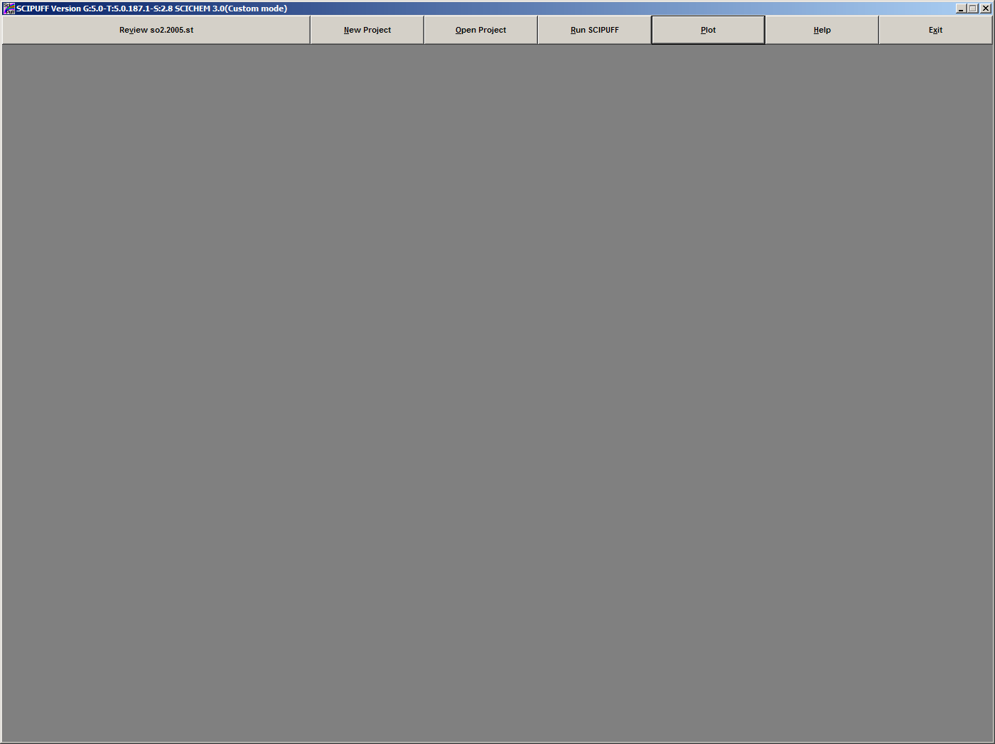
Once this project is opened, the user may use the following push buttons:
- Review ProjectName
- Plot (See Chapter 7)
Please note that the SCIPUFFgui is under development and the KEYWORDS input format type projects cannot be created or run using the present version but all projects whether using KEYWORDS or NAMELISTS input can be reviewed or plotted with SCIPUFFgui.
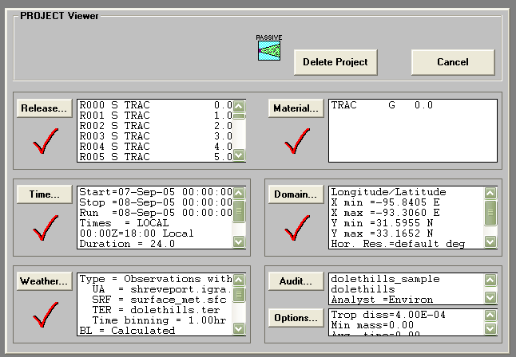
If the Review button is pressed, the following screen will appear:

The check marks indicate that each category has been defined. The user may then push the button for each category to simply review the project. The Delete Project button has been diasbled and does not delete the project files.

Project Viewer
An icon in the upper left corner shows if dynamic effects were included in the calculation. Dynamic effects treated are buoyant and momentum plume rise and gases that have densities different from that of air.
Passive -do not include dynamic effects
Dynamic -include dynamic effects

Project Coordinates
Clicking the domain button shows the project coordinate system. The possible coordinate systems are as follows:
Latitude/Longitude
This specifies the SCICHEM coordinate system as Latitude/Longitude (degrees). This is the default coordinate system.
Cartesian
This specifies the SCICHEM coordinate system as rectangular Cartesian (kilometers).

If the reference point box is checked for Cartesian coordinates, the following
boxes will appear:
Cart. (X,Y)
This specifies the Cartesian coordinates of the reference point in kilometers.
Default: (0,0)
LLA (E,N)
This specifies the longitude and latitude coordinates of the reference point specified in the X,Y edit boxes. The coordinates can be specified in degrees or degrees/min/sec.
Default: None

Project Description

The Audit button shows the additional project options which were used. They include the following:
Mode
This specifies whether SCICHEM was run in Standard or Fast mode.
See Table 6-1 for a description of the two modes.
Dynamics
This specifies whether or not dynamics was treated. It is shown by icon at top.
Static Puffs
This specifies whether or not to static puffs were used in the calculation to speed up it up.

Multicomponent
This specifies whether or not material transformations through chemical reactions was treated.

Table 3-1. SCICHEM Run Modes.

Parameter | STANDARD | FAST | Comments
VERTICAL RESOLUTION
Default height of the vertical domain  Default vertical domain resolution  Default maximum vertical grid points | 2500m  250m  15 | 5000m  1000m  7 | These vertical grid parameters affect the vertical splitting of puffs which affects the total number of puffs. These parameters can also be entered manually by the user.
HORIZONTAL RESOLUTION
Surface resolution [DELMIN] | 0.0 (As needed) | 1/160 of domain | This affects the surface grid and total number of puffs if surface evaporation is occurring This parameters can also be entered manually by the user
MERGE CRITERIA
SiMerge (ratio of internal scales) | 1.25 | 1.5 | This allows more merging between puffs and reduces the total number of puffs. This parameter cannot be manually entered by the user. It is changed internally when the Fast Mode is selected.

The SCIPUFFgui features are described in detail in Chapter 4.

Plotting using SCIPUFF Graphical User Interface
This section describes how to initiate a plot after calculations are complete using the beta version of the SCIPUFFgui. The plot controls and options are defined, as well as procedures for exporting plots. Once a project has finished running, or if an old project is opened, the user may click on the PLOT button.
If the user clicks the DRAW button under the Plot Control section, the default plot will appear to the right of the control area. The default plot is the vertically integrated tracer concentration. An example is shown below.
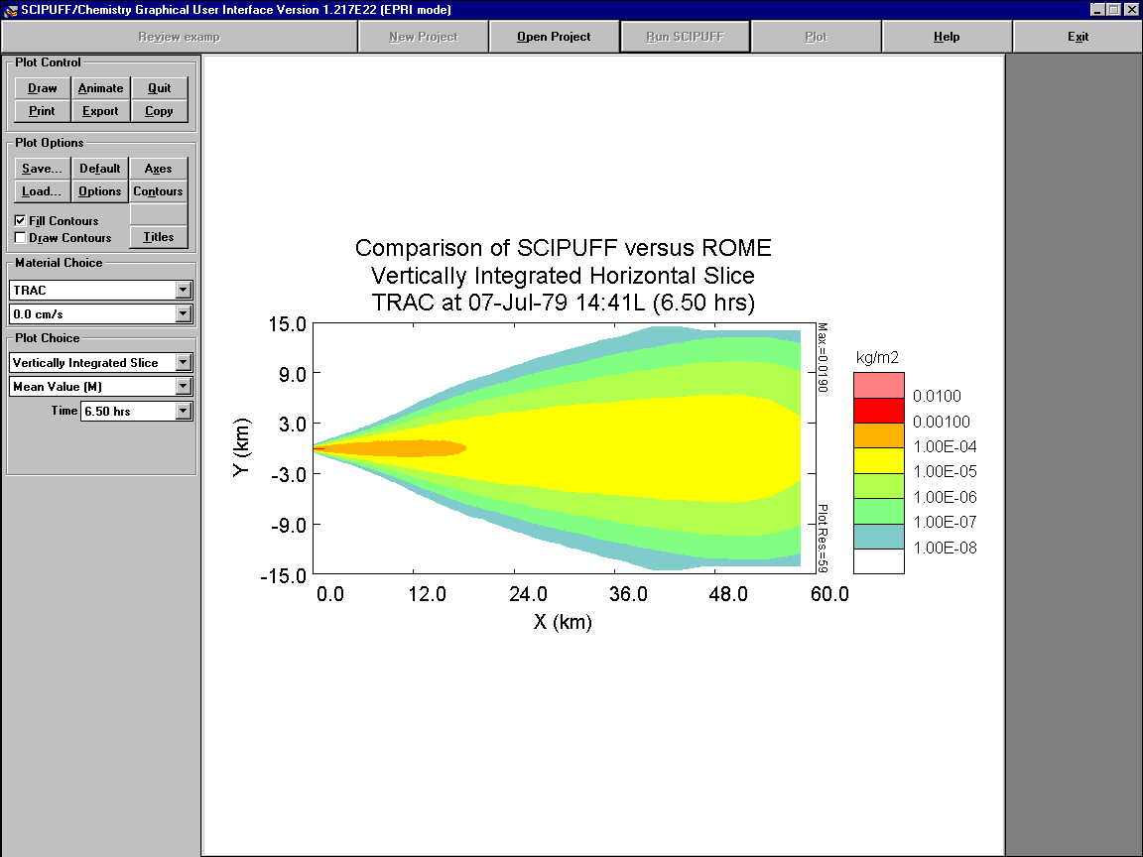

Plot Control
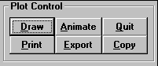
Options under the Plot Control section of the plot window are shown below:
They provide the following functions:
- DRAW – Generates a display in the Plot Area.
- ANIMATE – Generates a time sequence of display bitmap files. See Section 7.2.1.
- QUIT – Returns to the main SCICHEM screen.
- PRINT – Sends the display to a specified printer.
- EXPORT – Saves the display to a file.
- COPY – Copies the current display to the clipboard.

Animate
This push button generates a sequence of bitmaps for animation display. The plot display format (type of plot, domain bounds, labels, etc.) should be defined in the normal way but the contour levels should be fixed so that the entire sequence uses the same values. (Using default contour values can result in changing levels during the sequence.)
The bitmap file sequence uses extensions 001, 002, etc. with the file name and path selected by the user. The output files are 480x480 PCX files and are usually about 20 kbytes each. Existing files are not deleted but are overwritten once the procedure begins. The sequence consists of all output times between the start and stop times selected by the user.

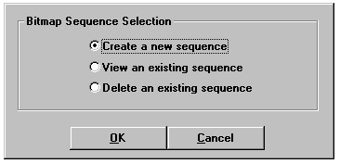
The following screen will be displayed by pressing the ANIMATE button:
The choices are as follows:
- Create a new sequence: Generates a sequence of files that are used for animation.
- View an existing sequence: Plays a sequence of files that have already been generated.
- Delete and existing sequence: Deletes an animation sequence.
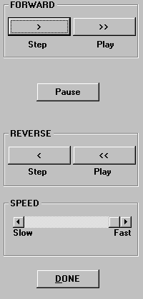
Once one of the radio buttons has been selected, the Open File dialog box appears. From this dialog box, you can select the name of the sequence that is to be created, viewed, or deleted. If creating a new sequence, you can also select the start and end time of the animation. When a sequence is ready for viewing (after selecting an existing sequence or generating a new one), the animation screen will appear, as shown below.
This screen will consist of the plot area at the right and push buttons (shown above) that function like buttons of a tape recorder.
Pause
Temporarily stops the playing of the animation.
Done
Terminates the animation and returns to the original plot screen.
Speed
Adjusts the speed of the animation.
Forward
Step
Advances the sequence one frame.
Play
Cycles through the entire animation sequence.
Reverse
Step
Decrements the sequence one frame.
Play
Cycles through the entire animation in reverse sequence.

Export
The Open File dialog box is displayed with a section for specifying the file format. The available file types are:
- AVS (ASCII) file: See Section 6.4.1.3.
- Bitmap file: Standard Windows bitmap format.
- SCICHEM Overlay file: File can be drawn over a plot of the same coordinate mode in SCICHEM.
- Table (ASCII) file: Tabular output of the plot data in ASCII format.

AVS File
SCICHEM can export plots in the AVS (Application Visualization System)-compatible UCD (Unstructured Cell Data) file format. The format of the file is shown below.
#Comments
Nnode, Ncell, NnodeData, NcellData, NmodelData
Nid, x, y, z (Nnode lines)
.
.
.
Cid, Sid, Typ, N1, N2, NN (Ncell lines)
.
.
.
NnodV, NN1,NN2...NNNnodV
Nlabel, Nunits (NnodV lines)
.
.
.
Nid, Ndat1, Ndat2,...NdatNnodeData (Nnode lines)
.
.
.
NcelV, NC1, NC2...NCNcelV
Clabel, Cunits (NcelV lines)
.
.
.
Cid, Cdat1, Cdat2,...CdatNcellData (Ncell lines)
.
.
.
NmodV, NM1, NM2...NMNmodV
Mlabel, Munits (Nmodv lines)
.
.
.
Mid, Mdat1, Mdat2,...MdatNmodelData (NMod lines)
.
.
.
SCICHEM provides comments in the header with information to identify the data.
Table 6-6. AVS file variables.
Nnode | Total number of nodes
Ncell | Total number of cells
NnodeData | Total number of data values for each node (=1)
NcellData | Total number of data values for each cell (=0)
NmodelData | Total number of data values for each model(=0)
Nid | Node number
x,y,z | Node location
Cid | Cell Number
Sid | Surface number (=1)
Typ | Cell type (=tri)
N1, N2...NN | Node numbers identifying the cell vertices (N=3)
NnodV | Number of nodal data data sets (=1)
NN1 ,NN2...NNNnodV | Number of nodal data values in each set (=1)
Nlabel | Nodal data set label
Nunits | Nodal data set units
Ndat1,Ndat2,...NdatNnodeData | Nodal data values
NcelV | Number of cell data data sets (not on file)*
NC1,NC2...NCNcelV | Number of cell data values in each set (not on file)*
Clabel | Cell data set label (not on file)*
Cunits | Cell data set units (not on file)*
Cdat1,Cdat2,...CdatNcellData | Cell data values (not on file)*
NmodV | Number of model data data sets (not on file)*
NM1, NM2...NMNmodV | Number of cell data values in each set (not on file)*
Mlabel | Model data set label (not on file)*
Munits | Model data set units (not on file)*
Mid | Model number (not on file)*
Mdat1,Mdat2,...MdatNmodelData | Model data values (not on file)*
Note: *Although a part of the general AVS format, this does not appear on the file exported by SCICHEM since NcellData and NmodelData are 0.
Figure 6-1. Sample AVS Export File
#Comments identifying data
.
.
.
2257 4474 1 0 0
1 126.200 34.2000 .000000
2 126.600 34.2000 .000000
3 126.600 34.6000 .000000
4 126.200 34.6000 .000000
.
.
.
2255 129.800 37.0000 .000000
2256 129.800 37.4000 .000000
2257 129.800 37.8000 .000000
1 1 tri 1 2 3
2 1 tri 1 3 4
3 1 tri 4 3 5
.
.
.
4472 1 tri 1900 2256 1901
4473 1 tri 1901 2256 2257
4474 1 tri 1901 2257 1902
1 1
C, KG/M3
1 1.000000E-30
2 1.000000E-30
3 1.000000E-30
.
.
.
2255 1.000000E-30
2256 1.000000E-30
2257 1.000000E-30

Table (ASCII) File
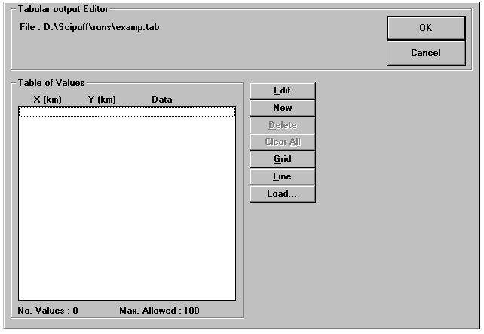
Tables of point values can be exported from a plot in ASCII format. When the EXPORTpush button is selected under the Plot Control interface area, the table (ASCII) file type (*.tab) must be selected and a file name must be entered in the Open File dialog box. After the OK push button is selected, the Tabular output Viewer is displayed, as shown below.
Values can be selected using the displayed Tabular output Viewer, and can also be obtained using the mouse on the plot screen with the Get Value function. The user can click the right mouse button anywhere on the plot to use the Get Value function. When values are selected, they are added to the ASCII file, and not replaced. The Get Value function must be used prior to choosing EXPORT and their values will automatically appear in the Tabular output Viewer.
The buttons of the Tabular output Viewer perform the following functions:
OK
Exports the data listed in the Table of Values and returns to the main plot screen.
Cancel
Returns to the main plot screen without exporting to the Table file.
Edit
Changes the selected table value to a new value.
New
Adds a new table value to the list.
Delete
Removes a selected table value from the list.
Clear All
Removes all table values from the list.
Grid
Calculates table values based on a specified grid domain and the number of points within that domain.
Line
Calculates table values based on a specified line endpoints and the number of points on that line.
Load
Copies the table values from a file into the list. This is an appending procedure, so the loaded values are added to those already in the list.

Plot Options.
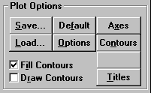
Options under the Plot Options section of the plot window are shown below:

They provide the following functions:
- SAVE – Save selected display settings.
- DEFAULT – Set default display settings.
- AXES – Select display coordinate system, axes range, tick spacing and labeling. See Section 7.3.1.
- LOAD – Load display settings (through the Open File dialog box).
- OPTIONS – Select additional display options. See Section 7.3.2.
- CONTOURS – Define display contours. See Section 7.3.3.
- TITLES - Modify display title text and location. See Section 7.3.4.
- FILL CONTOURS - Fills the area between contour levels of the displayed field using the color palette defined in SCIPAL.DAT.
- DRAW CONTOURS - Draws the contour levels of the displayed field using black lines.

Axes
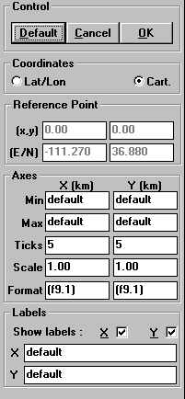
The user may change the axes of the plot by pressing the AXES button. The following screen will be displayed:

Control
Default
Resets all axes parameters to their defaults.
Cancel
Returns to the main plot screen without changes.
OK
Returns to the main plot screen with new settings.

Coordinates
The display coordinate system, Lat/Lon (degrees) or Cartesian (km), can be selected by the user. If it differs from the project coordinate system defined in the Domain Setup, a coordinate transformation is performed based on the Reference Point displayed (and possibly set) below.
To set the display coordinates in Lat/Lon when the project coordinates are Cartesian, the Reference Point must have been set in the Domain Setup or must be set in the Reference Point box below. This is not the case when setting Cartesian display coordinates with Lat/Lon project coordinates since a default Reference Point can be defined, as described in Section 7.3.1.3. The default display coordinate system is the same as that of the project. If the coordinate type is Lat/Lon, the plot boundaries are positive East and North.

Reference Points
This section is enabled only if the reference point has not been defined in the Domain Setup.
X,Y
This specifies the Cartesian coordinates of the reference point in kilometers.
Default: (0, 0)
E/N
This specifies the longitude and latitude coordinates of the reference point specified in the X,Y edit boxes. Default: Center of the domain if project coordinates are Lat/Lon; none if project coordinates are Cartesian.

Axes
Min X, Min Y, Max X, Max Y
This specifies the plot axes minima and maxima given in degrees for Latitude/Longitude display coordinates and km for Cartesian display coordinates. If Scale is used, the axes limits should be set accordingly, i.e., the values entered here should be appropriate for the display domain after the coordinates have be multiplied by Scale. Default: The project domain limits used in the SCICHEM calculation (transformed if the display coordinates are different from the project coordinates).
Ticks
This specifies the number of major divisions for labeling along the X and Y axes.
Default: 5
Scale
This specifies the axes multiplication factor. For example, to convert from kilometers to meters, Scale is set to 1000.
Default: 1
Format
This specifies the display format of the axes values. The standard FORTRAN format convention is used and must be enclosed in parentheses.
Default: (f9.1)

Labels
Show labels X, Show labels Y
This specifies the character string labels are displayed along the axes.
X, Y
This specifies the character string labels that are displayed along each axis.
Default: "Latitude" and "Longitude" for Lat/Lon display coordinates and "X (km)" and "Y (km)" for Cartesian display coordinates.

Options
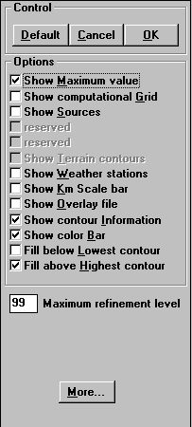
The user may change other plotting options by pressing the OPTIONS button. The following screen will be displayed:

Control
Default
Resets all parameters to their defaults.
Cancel
Returns to the main plot screen without changes.
OK
Returns to the main plot screen with new settings.

Options
Show Maximum value
The maximum value in the selected field is displayed on the upper right-hand side of the plot.
Show computational Grid
The SCICHEM computational grid is superimposed on the plot.
Show Sources
The sources are displayed as symbols on the plot. Continuous and instantaneous sources are represented by downward and upward pointing triangles, respectively.
Show Terrain contours
The terrain contours are displayed on the plot. Only enable for projects that have terrain defined.
Show Weather stations
The locations of weather stations are displayed as boxes that are labeled with an S for surface observations or a P for profile observations. This option is available for observations type weather only.
Show Km Scale bar
A bar that displays the distance scale in kilometers is shown at the bottom of the plot. This bar is for Cartesian coordinates only.
Show Overlay file
Overlay files are drawn on top of the current drawing. When this option is checked, the Open File dialog box will appear and the overlay file must be specified.
Show contour Information
The number of contours and contour level values are given below the plot. This information is displayed only when the Show color Bar option is off.
Show color Bar
A color bar matching colors to contour levels is displayed on the right of the plot when filling contours.
Fill below Lowest contour
The area having values less than the lowest contour is filled (when filling contours).
Fill above Highest contour
The area having values greater than the highest contour is filled (when filling contours).
Maximum refinement level
This specifies the maximum level of refinement for plotting. If a large value is chosen, the plot contains finer resolution, but takes more time to generate. SCICHEM automatically ignores refinement smaller than display resolution.
Default: 99

More Options
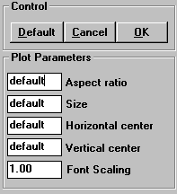
The user may change more plotting options by pressing the MORE button from the Plot Options edit screen. The following screen will be displayed:
Default
Resets all parameters to their defaults.
Cancel
Returns to the Plot Options screen without changes.
OK
Returns to the Plot Options screen with new settings.
Aspect Ratio
This specifies the ratio of the Y-axis length to X-axis length.
Default: 1
Size
This specifies the size of the plot relative to the size of the plot area (given as a fraction of the plot area). Default: To fill the plot area as much as possible
Horizontal Center, Vertical Center
This specifies the center of the plot relative to the plot area (given in fractions of the plot area dimensions) Default: Centered
Font Scaling
All of the plot text sizes are scaled by this value. Default: 1

Contours
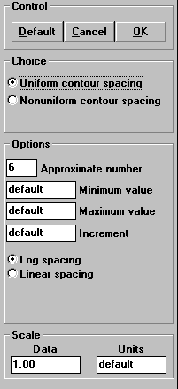
The user may change the contours of the plot by pressing the CONTOURS button. The following screen will be displayed:

Control
Default
Resets all contour parameters to their defaults.
Cancel
Returns to the main plot screen without changes.
OK
Returns to the main plot screen with new settings.

Choice
The user may use uniform contour levels or non-uniform contour levels. The Options Section of this window changes, depending on which choice is selected.

Options
Uniform Contours
Approximate number
This specifies the approximate number of contours plotted. The actual number of contours is calculated based on the minimum, maximum, and increment which are either specified in this group box or determined from the display field selected.
Default: 6
Minimum value
This specifies the minimum contour level display.
Default: The minimum value of the display field.
Maximum value
This specifies the maximum contour level display.
Default: The maximum value of the display field.
Increment
This specifies the contour spacing used for displaying the selected field.
Default: Determined from the Minimum and Maximum values and the Approximate number of contours.
Log Spacing
Logarithmic plot contour spacing is used. Log spacing is the default for mean value plots.
Linear Spacing
Linear plot contour spacing is used. Linear spacing is the default for probabilistic plots.
Non-uniform Contours
Contour Values
Displays contour values.
Edit
Changes the selected contour value to a new value.
New
Adds a new contour value to the list.
Delete
Removes a selected contour value from the list.
Clear
Removes all contour values from the list.
Compute
Calculates contour values based on a specified range, number of values and an assumed distribution.
Load
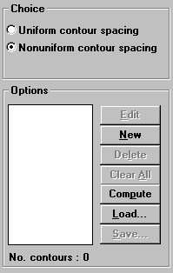
Copies contour values from a file into the list. This is an appending procedure, so the loaded values are added to those already in the list.
Save
Saves the current contour value list to a file.

Scale
Data
This specifies the value that the plotted data is scaled by.
Units
This specifies the units used for labeling the data contours.

Titles
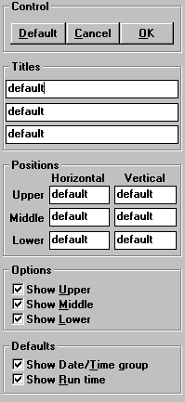
The user may change the titles of the plot by pressing the TITLES button. The following screen will be displayed:

Control
Default
Resets all parameters to their defaults.
Cancel
Returns to the main plot screen without changes.
OK
Returns to the main plot screen with new settings.

Titles
There are three edit boxes for the upper, middle and lower titles.
Defaults:
Upper title: Project Title
Middle title: Plot type
Lower title: material, size group if appropriate and time.

Positions
Upper, Middle, Lower
There are three sets of edit boxes for the horizontal and vertical positions of the three titles. The positions are specified in fractions of the plot window and refer to the location of the center of the title string baseline. The default locations center the titles above the plot.

Options
Show Upper, Show Middle, Show Lower
There are three check boxes which control the drawing of the titles on the plot

Defaults
Show date/time group
The time in day-month-year-hour format is displayed in the lower title (default title only).
Show run time
The time from the start of the run is displayed in the lower title (default title only).

Material Choice.
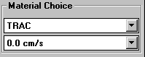
SCICHEM allows multiple materials and particle size groups, as well as multicomponent materials. The user must select the material and also the size group or species name, if appropriate, for display. The Material Choice section of the Plot Control window is shown below:
The two drop-down lists are as follows:
Material Name
This specifies that the name of the material will be displayed.
Species Name or Particle Size Group
This specifies the species name for a multicomponent material or the size group for a particle material selected for display. Total denotes the sum of all the size bin contributions when multiple size bins are specified for a particulate. This box displays the deposition velocity for a gaseous material or a single size bin particle material. For multicomponent materials, vertically integrated plots cannot be displayed for due to the presence of background concentrations, and therefore, species names are not available for these plots.

Plot Choice.
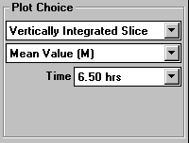
The Plot Choice section of the Plot Control window is shown below:

Plot type
The following is a complete list of the plot types. Some may not be available due to the selected project type and/or output flags for the selected display material.
Vertically-Integrated Slice
The vertically-integrated material concentration field will be plotted.
Horizontal Slice (Instantaneous)
A horizontal cross-section through the material concentration field will be plotted. The slice altitude in meters is specified in the associated edit box.
Vertical Slice (Instantaneous)
A vertical cross-section through the material concentration field will be plotted. The slice parameters are selected in the associated Select dialog box.
Surface Concentration
The instantaneous material concentration at the surface will be plotted (only available for terrain runs).
Surface Dose (Integrated)
The time-integrated material concentration at the surface will be plotted.
Surface Deposition (Integrated)
The time-integrated mass of material deposited on the surface will be plotted.
Terrain
Terrain elevations will be plotted (only available for runs with terrain).

Plot value
Mean (M)
Displays contours of the mean field selected for display.
Prob(V>E)
Displays contours of the probability that the selected field will exceed a prescribed value. The exceedance value is entered in an associated edit box.
Exceed. Value (V[Pc>P])
Displays areas where the conditional probability of exceeding the contour value is greater than the value given in the Probability edit box (see below). For example, if the number in the Probability edit box is 0.5, the area inside of a contour value of 1.0 corresponds to the region where the conditional probability of values exceeding 1.0 is equal to or greater than 50%.
Exceed
This specifies the exceedance value used for probabilistic plotting. This edit box only appears when the Prob(M>E) plot type is selected. The units are the same as the display contours.
Default: 0
Probability
This specifies the probability value used for the Exceed. Value (V[Pc>P]) plot type.
Default: 0.5

Time (hrs)
The output time in hours from the start of the calculation. Only the times saved on the SCICHEM output files are available for plotting and are displayed in the list box. The default is the last time break on the output files.

Additional parameters
The following additional parameters will be required, depending on the plot choice:
Height (m)
This specifies the height above the ground level (m) for an instantaneous horizontal slice. This edit box only appears when the plot type is a horizontal slice. The default is 0.
Select
This specifies the horizontal limits and vertical extent of the vertical slice, either through dialog box input or by mouse selection. This push button only appears when the plot type is a vertical slice. See Section 7.5.5.

Selecting vertical slices
Use the SELECT push button to define the location and extent of a vertical slice through the instantaneous concentration field. The slice location can also be specified by dragging the mouse if the plot window is displaying a horizontal field. When the mouse is positioned in the plot area, the cursor becomes a pair of scissors (for determining the cross-sectional cut) with the "hot spot" at the intersection of the scissors blades. The vertical cross-section location is specified by clicking the mouse at the start point and dragging to the end point. The following edit screen appears when the SELECT button is pushed:
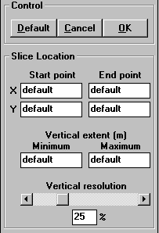
The choices are defined as follows:

Control
Default
Resets all parameters to their defaults.
Cancel
Returns to the main plot screen without changes.
OK
Returns to the main plot screen with new settings.

Start Location
Start point, End point
This specifies the start and end points of the slice in display coordinates. (The display coordinate system can be set using the Axes options.)
Default: The start and end points are the coordinates of the lower left and upper right corners of the horizontal calculation domain.
Vertical Extent
This specifies the Minimum and Maximum height range of the slice in meters.
Default: The defaults are the lowest and highest points in the SCICHEM domain.
Vertical Resolution
This controls the number of vertical grid points of the slice, between 0% (5 points) and 100% (105 points). A larger number improves the quality (resolution) of the display but it also increases the plotting time. The slider bar also allows the user to change the resolution.
Default: 25%

INSTALLING AND RUNNING SCICHEM

Installation
SCICHEM can be run on WINDOWS or Linux from the command line using the runsci.exe executable (runsci on Linux). The pre-built binaries of the four executable files METSCI.exe, RUNSCI.exe, SMP2POST.exe and SciClass1Flag.exe are available for Windows and metsci, runSCI, smp2post and sciClass1Flag for Linux. The runsci executable requires the scipuff.ini file which is located in the bin/Win32 or bin/Linux directories. The landuse file named “landuse.dat” file is located in the SciData directory and the files required for Class1 analysis and the Flag2010 files are provided in the Class1Area and Flag2010 subdirectories in the SciData. The scipuff.ini file has to be edited so that the variable LandUseDataFile under the “Land_Use” section points to the landuse.dat file with the full path name. The SciDataDir variable under the “[Paths]” must also be edited in the scipuff.ini file to point to the SciData directory.
A developmental version of a GUI executable, SCIPUFFgui.exe is also available on the Windows platform. This GUI can be used for reviewing a completed project or for plotting the species incremental concentrations for all projects. The GUI can be launched from a DOS window or the user can simply double click on the icon. In order to use the SCIPUFFgui executable, the user must also have the following files:
- SCIPUFFgui.exe - model executable file
- SCICHEM.chm - SCICHEM help file
- SCIPUFF.INI - initialization file to set directories
- MASSC.GRD - default vertical grid for mass-consistent runs
- SCIPUFF.PAL - defines colors for the GUI
- MAPS Directory – Includes all the data files required for drawing maps

These files are typically distributed together in a ZIP file. The following instructions will allow the user to properly install SCIPUFFgui and the executable files onto their PC. The steps for installing the executables for Linux are similar except for the default installation directory name:
Make a main directory for SCICHEM preferably D:\EPRI\SCICHEM3.0b2 (~/EPRI/SCICHEM3.0b2 for Linux) which will be referred to as $SCICHEM_BASEDIR
Extract all files from the zip file to $SCICHEM_BASEDIR
If the $SCICHEM_BASEDIR is not “D:\EPRI\SCICHEM3.0b2” then edit the scipuff.ini file to replace “D:\EPRI\SCICHEM3.0b2” with the actual directory name.
You can now run SCIPUFFgui from a DOS window in the main directory by typing SCIPUFFgui or by double clicking the SCIPUFFgui icon.
The details for running the command line executable runsci.exe are provided in Section 7.2.

Running the Model
An example run_scichem.bat file has been provided for Windows and a run_scichem.sh script file has been provided for Linux. A brief description for running the runSCI executable is provided
The runSCI executable file opens the KEYWORDS input file ProjectName.sci, if it is available, otherwise SCICHEM looks for the namelist input files viz. ProjectName.inp, ProjectName.scn and ProjectName.msc and creates output files such as ProjectName.dos, ProjectName.dep, ProjectName.prj, ProjectName.puf, ProjectName.log, ProjectName.err and/or ProjectName.smp output files on successful completion of the project. The model can be executed from the command prompt by simply typing the name runSCI, as follows:
C:\> runSCI
The runSCI executable file and the dlls need to be in the directory from which the user is attempting to run the model, or in a directory that is included on the PATH command. The KEYWORDS input file (ProjectName.sci) or the NAMELIST input files must also be located in the directory from which the model is being executed.
For multicomponent runs, an imc file must be present and the FILE_NAME in the MATDEF namelist section of the ProjectName.INP file should be set to the name of the imc file.
The DOS version will prompt the user for the Project Name and the path for the scipuff.ini file. Note that some or all of the following project output files will be created or overwritten based on the run settings.
- ProjectName.ERR
- ProjectName.LOG
- ProjectName.PRJ
- ProjectName.PUF
- ProjectName.SMP
- ProjectName.MCW
- ProjectName.DEP
- ProjectName.DGN
- ProjectName.DOS
The tutorials accompanying this User’s Guide provide a step-by-step approach to running the model for a number of different scenarios. The inputs and limited outputs from these case studies are also provided as part of the distribution. All the outputs are not provided due to file size restrictions.

Building from Source
The script name makeall.sh for building the code from source using the Portland Group compiler has been provided under the build/linux directory. The script can be run using the following command
> bash makeall.sh
This will build the executable files using the Portland Group compiler under the pg directory. In this version, the code has not been built and fully tested using other compilers.

REFERENCES.
Bass, A. (1980), "Modelling long range transport and diffusion", Second Joint Conf. on Appl. of Air Poll. Met., AMS & APCA, New Orleans, LA, pp193-215.
Donaldson, C. du P. (1973), "Atmospheric turbulence and the dispersal of atmospheric pollutants", AMS Workshop on Micrometeorology, ed. D. A. Haugen, Science Press, Boston, pp313-390.
EPA, 2004. User’s Guide for the AERMOD Meteorological Preprocessor. Final Report, EPA-454/B-03-002, November, 2004, U.S. Environmental Protection Agency, Office of Air and Radiation/Office of Air Quality Planning and Standards, Research Triangle Park, North Carolina.
Chowdhury, B, R.I. Sykes, D.Henn, 2013. SCICHEM Version 3.0 (Beta 1) Technical Documentation. Sage Management, 15 Roszel Road, Suite 102, Princeton, NJ 08540
Gifford, F. A. (1988), "A similarity theory of the tropospheric turbulence energy spectrum", J. Atmos. Sci., 45, 1370-1379.
Karamchandani, P., A. Koo and C. Seigneur (1998), “A reduced gas-phase kinetic mechanism for atmospheric plume chemistry”, Environ. Sci. Technol., 32, 1709-1720.
Lewellen, W. S. (1977), "Use of invariant modeling", Handbook of Turbulence,
ed. W. Frost and T. H. Moulden, Plenum Press, pp237-280.
Martin, L. R. (1984), "Kinetic studies of sulfite oxidation in aqueous solution", in SO₂, NO and NO₂ Oxidation Mechanisms: Atmospheric Considerations. Edited by J. G. Calvert. Butterworth, Stoneham, MA, pp.63-100.
Martin, L. R. and T. W. Good (1991), "Catalyzed oxidation of sulfur dioxide by hydrogen peroxide at low pH", Atmos. Environ., 25A, 2395-2399.
Nastrom, G. D. and K. S. Gage (1985), "A climatology of atmospheric wavenumber spectra of wind and temperature observed by commercial aircraft", J. Atmos. Sci., 42, 950-960.
Saucier, R. (1987), "NUSSE3 model description", Chemical Research and Development & Engineering Center, CRDEC-TR-87046.
Seinfeld, J.H. (1986). Atmospheric Chemistry and Physics of Air Pollution, Wiley, New York.
Schulman, L.L., D.G. Strimaitis, and J.S. Scire. 1997. Addendum To ISC3 User’s Guide: The PRIME Plume Rise and Building Downwash Model.
Slinn, W. G. N. (1982). "Predictions for particle deposition to vegetative canopies", Atmos. Environ., 16, 1785-1794.
Sykes, R. I., W. S. Lewellen, S. F. Parker and D. S. Henn (1988), "A hierarchy of dynamic plume models incorporating uncertainty, Volume 4: Second-order Closure Integrated Puff", EPRI, EPRI EA-6095 Volume 4, Project 1616-28.
Sykes, R. I., S. F. Parker, D. S. Henn and W. S. Lewellen (1993), "Numerical simulation of ANATEX tracer data using a turbulence closure model for long-range dispersion", J. Appl. Met., 32, 929-947.
Sykes, R. I., L. P. Santos and D. S. Henn (1998), “Large Eddy Simulation of a turbulent reacting plume in a convective boundary layer”, Proc. 10th Conference on Appl. of Air Pollut. Meteor., Jan. 11-16, 78th Annual AMS Meeting, Phoenix, AZ, 539-543.
Vijayaraghavan, K., P. Karamchandani, C. Seigneur and S. Y. Chen (2008), “Plume-in-grid modeling of atmospheric mercury”, J.GeoPhys. Res., 113

The FLAG (2010) document is available at http://www.nature.nps.gov/air/pubs/pdf/flag/FLAG_2010.pdf.
See http://www2.nature.nps.gov/air/maps/Receptors/index.cfm
Direct link: http://www2.nature.nps.gov/air/maps/Receptors/download/ClassIData.zip

