SCICHEM Version 3.0 (Beta 2)

Technical Documentation

Prepared for
EPRI
3412 Hillview Avenue
Palo Alto, CA 94304

Prepared by
Biswanath Chowdhury, R. Ian Sykes and Douglas Henn
SAGE MANAGEMENT
15 Roszel Road, Suite 102
Princeton, NJ 08540

Prakash Karamchandani
ENVIRON
773 San Marin Drive, Suite 2115
Novato, CA 94998

March 2014

SUMMARY
The Second-order Closure Integrated Puff model (SCIPUFF), with gas and aqueous phase chemistry and aerosol thermodynamics is described. The reactive model is referred to as SCICHEM. SCICHEM is an atmospheric dispersion model with a wide range of applications. The turbulent diffusion parameterization is based on second-order turbulence closure theory, which relates the dispersion rate to velocity fluctuation statistics. In addition to the average concentration value, the closure model provides a prediction of the statistical variance in the concentration field resulting from the random fluctuations in the wind field. The variance is used to estimate a probability distribution for the predicted value.
SCICHEM uses a collection of Gaussian puffs to represent an arbitrary three-dimensional, time-dependent concentration field, and incorporates an efficient scheme for splitting and merging puffs. Wind shear effects are accurately modeled, and puffs are split when they grow too large for a single point meteorology to be representative. These techniques allow the puff model to describe complex flow effects on dispersion, such as terrain-driven circulation.
SCICHEM has been developed with a flexible interface, to describe many types of source geometry and material properties. The model also uses several types of meteorological inputs, including surface and upper air observations or three-dimensional grid data. Planetary boundary layer turbulence is represented explicitly in terms of surface heat flux and shear stress using parameterized profile shapes.
The technical basis of SCICHEM 3.0 (Beta 1) is described in this document. A section describing a number of test calculations and comparison with observational data is also included (see Section 13).

TABLE OF CONTENTS
Section Page
1. Introduction 10
2. TRANSPORT AND DIFFUSION 12
2.1. PUFF MOMENT EQUATIONS. 12
2.2. CONCENTRATION FLUCTUATION VARIANCE. 26
2.3. SURFACE DEPOSITION. 42
2.4. SURFACE INTEGRALS. 43
3. REACTIVE CHEMISTRY 47
3.1. GAS PHASE CHEMISTRY. 47
4. Numerical techniques 51
4.1. FINITE DIFFERENCE SCHEMES. 51
4.2. PUFF SPLITTING. 54
4.3. PUFF MERGING SCHEME. 62
4.4. PUFF INVERSION CAPPING. 67
4.5. ADAPTIVE TIMESTEPS. 69
4.6. STATIC PUFFS. 71
4.7. ADAPTIVE SURFACE GRIDS. 74
4.8. CHEMISTRY SOLVERS. 75
5. GAS MATERIALS AND DYNAMIC EFFECTS 77
5.1. GAS MATERIAL PROPERTIES. 77
5.2. BUOYANCY AND MOMENTUM RISE. 77
5.3. DENSE GAS EFFECTS. 85
6. Particle materials 94
6.1. Particle material properties. 94
6.2. Particle gravitational settling. 94
6.3. Particle Dry deposition. 97
6.4. Precipitation washout 102
6.5. Effects on diffusion 102
7. MULTICOMPONENT materials 104
7.1. MULTICOMPONENT material properties. 104
7.2. MULTICOMPONENT dry deposition. 104
7.3. MULTICOMPONENT PRECIPITATION WASHOUT. 105
8. Source specification 106
8.1 Continuous sources. 106
8.2 Instantaneous sources. 107
8.3 LINEAR DECAY. 108
9. Meteorology specification 110
9.1. Background. 110
9.2. Observational input. 110
9.3. Gridded input. 115
9.4. Mean field interpolation. 116
9.5. Mass-consistency. 117
9.6. NESTED METEOROLOGICAL FIELDS. 119
9.7. SMOOTHED METEOROLOGICAL FIELDS. 120
10. Planetary boundary layer 122
10.1. Governing parameters. 122
10.2. SPECIFYING PBL PARAMETERS. 126
10.3. PBL MEAN PROFILES. 137
10.4. VEGETATIVE/URBAN CANOPY PROFILES. 140
10.5. SURFACE LAYER INTERPOLATION 142
11. Turbulence specification 149
11.1. PLANETARY BOUNDARY LAYER. 149
11.2. VEGETATIVE/URBAN CANOPY LAYER. 152
11.3. MESOSCALE/SYNOPTIC SCALE. 152
11.4. METEOROLOGICAL UNCERTAINTIES. 154
12. Model output 160
12.1. Local concentration values. 160
12.2. Probabilistic calculation. 166
13. MODEL EVALUATION STUDIES 167
13.1. SHORT RANGE DIFFUSION. 167
13.2. LONG RANGE DIFFUSION. 180
13.3. DYNAMIC RISE EFFECTS. 184
13.4. DENSE GAS EFFECTS. 192
13.5. CHEMICAL TRANSFORMATIONS 194
14. References 201

FIGURES
Figure Page
Figure 0-1. Vertical velocity probability density functions for neutral (solid line) and free convection (dashed line) conditions, based on the model of Luhar et al. (1996). 30
Figure 0-2. Non-dimensional fluctuation dissipation timescale as a function of dimensionless time for a shear-distorted Gaussian puff. The solid line is the analytic solution . Dashed line is the model prediction from and . 39
Figure 0-1. Maximum dimensionless error, εs, from splitting a single Gaussian puff as a function of separation distance, δs. The error is relative to the maximum concentration value in the original Gaussian, and the separation distance of the puffs after splitting is relative to the original Gaussian spread. Results are shown for both one-dimensional and two-dimensional splits. 62
Figure 0-2. Schematic illustration of puff reflection for a split below the ground surface. 63
Figure 0-3. Schematic illustration of the adaptive multi-grid for locating puffs. Grid cell numbers are represented as C-n, and two levels of refinement are shown. See text for a description of the cell storage rules. 70
Figure 0-4. Schematic illustration of the use of static puffs to represent a continuous source. The shaded puff is stored as the release description at the end of the static phase. 77
Figure 0-1. Schematic illustration of slumping dense cloud. 91
Figure 0-2. Simplified velocity field representation for a dense cloud. 92
Figure 5-1. Scavenging coefficient versus particle diameter. Solid lines denote the model described above and the dashed lines denote the model of Nieto et al. (1994) (with a Marshall and Palmer raindrop size distribution). The precipitation rate () is equal to 0.5 and 25 mmh⁻¹ for drizzle and heavy rain, respectively. 110
Figure 5-2. Scavenging coefficient versus particle diameter. Solid lines denote the model implemented in SCICHEM and the dashed lines denote the model of Horn et al. (1988). The precipitation rate () is equal to 0.5 and 10 mmh⁻¹ for the drizzle and moderate rain, respectively. 111
Table 0-1. Suggested values for surface roughness (Saucier, 1987). 137
Table 0-2. Relationship between stability index, PGT stability class, Monin-Obukhov length, L, and an assumed boundary layer depth, , if not specified as input. 138
Table 0-3. Suggested values for surface albedo as a function of land-use and season (Paine, 1987). 142
Table 0-4. Suggested values for Bowen ratio as a function of land-use and season (Paine, 1987). 143
Figure 0-1. Schematic illustration of the idealized velocity profile in the planetary boundary layer. 149
Figure 0-2. Canopy velocity profile shapes from and compared with the experimental data of Cionco (1972). 152
Figure 0-3. Example of surface layer interpolation. Open circles indicate observation or outer domain velocities used for interpolation. The solid line is the interpolated velocity profile. The long dash lines are surface layer profiles scaled to pass through the interpolating points below the surface layer height . Sections of the interpolated profile are labeled with the corresponding cases (i) – (iv) from the text. 154
158
Figure 0-4. Example of surface layer interpolation for inhomogeneous land-cover. This example shows how an idealized surface layer profile with no canopy is interpolated to a location where and . 158
Figure 0-1. Normalized error variance growth for forecast and persistence assumptions. 166
Figure 9-1. Schematic illustration of a positive species perturbation concentration. 172
Figure 9-2. Schematic illustration of a negative species perturbation concentration. 173
Figure 9-3. Local total concentration with and without enhanced spread. 175
Figure 0-1. Comparison between SCIPUFF predictions (solid lines) and the PGT dispersion curves for categories A through F. 178
Figure 0-2. Comparison between the observed maximum concentrations and SCIPUFF predictions for the passive releases in the Model Data Archive. Various experiments are indicated by the letter codes. 181
Figure 0-3. Comparison between SCIPUFF predictions and the observational data of Weil et al. (1993). 182
Figure 0-4. Comparison between SCIPUFF predictions and the observational data of Mikkelsen et al. (1987). 184
Figure 0-5. Comparison between SCIPUFF predictions and the observational data of Högström (1964). 185
Figure 0-6. Comparison between SCIPUFF predictions of mean concentration and the observational data from CONFLUX 1994. 187
Figure 0-7. Comparison between SCIPUFF predictions of standard deviation to mean concentration ratio and the observational data of CONFLUX 1994. 188
Figure 0-8. Comparison of mean concentration between SCIPUFF predictions and ETEX data (Mosca et al., 1997). Contours are 0.01, 0.02, 0.05, 0.1, 0.2, 0.5, 1, 2, 5, 10, 20, and 50 ngm⁻³. 190
Figure 0-9. Comparison between 3-hr average concentrations from SCIPUFF predictions (dashed) and ETEX data (solid line) at 9 selected locations (Mosca et al., 1997). Concentration is in ngm⁻³. 191
Table 0-1. Statistical measures for the SCIPUFF prediction of ETEX data. 193
Figure 0-10. Momentum (non-buoyant) jet centerline height, , as a function of downstream distance for a range of R. Symbols are the data of Gordier (1959) - from Hirst (1971); solid lines are the SCIPUFF predictions. 195
Figure 0-11. Comparison between SCIPUFF predictions of momentum jet centerline heights for a range of R (solid lines) and the “one-third” law, , with two values of β (short dashes, β = 0.6; long dashes, β = 0.5). 196
Figure 0-12. Comparison between SCIPUFF predictions for buoyancy-dominated jet centerline heights (solid lines) and theory given by (dashed lines). Case A: R = 10, ; Case B: R = 10, ; Case C: R = 1, . 198
Figure 0-13. Comparison of SCIPUFF buoyancy-dominated jet centerline heights in a uniformly stratified background (solid lines) with (dashed lines). For all cases, R = 10. Case A: , ; Case B: ,; Case C: , . 199
Figure 0-14. Centroid height of a light bubble released into a neutral quiescent background. Symbols are the data of Mantrom and Haigh (1973), solid lines are the SCIPUFF predictions. The Reynolds number for the experiments is based on the initial bubble diameter and the terminal velocity of a corresponding non-entraining sphere. Case A is for a single puff release with a Gaussian spread of D₀/2; Case B is for a release comprised of 136 puffs representing a uniform distribution of mass within a spherical bubble of diameter D₀. (a) Early time behavior; (b) expanded scale showing late time behavior. 200
Figure 0-15. Comparison between the observed maximum concentrations and SCIPUFF predictions for the dense gas releases in the Model Data Archive. Various experiments are indicated by the letter codes. 202
Figure 0-17: Results for plume 7 at 55 km on August 25, 1998 204
Figure 0-19: Results for plume 4 at 27 km on August 26, 1998 205
Figure 0-20: Results for plume 2 at 11 km on July 6th, 1999 206
Figure 0-21: Results for plume 9 at 65 km on July 6th, 1999 206

TABLES
Table Page
No table of figures entries found.

Introduction
SCIPUFF is a Lagrangian transport and diffusion model for atmospheric dispersion applications. The acronym SCIPUFF stands for Second-order Closure Integrated PUFF and describes two basic aspects of the model. First, the numerical technique employed to solve the dispersion model equations is the Gaussian puff method (Bass, 1980) in which a collection of three-dimensional puffs is used to represent an arbitrary time-dependent concentration field. Second, the turbulent diffusion parameterization used in SCIPUFF is based on the second-order turbulence closure theories of Donaldson (1973) and Lewellen (1977), providing a direct connection between measurable velocity statistics and the predicted dispersion rates. SCIPUFF has now been expanded to include gas and aqueous phase chemistry and aerosol thermodynamics. The reactive SCIPUFF model is referred to as SCICHEM.
The Lagrangian puff methodology affords a number of advantages for atmospheric dispersion applications from localized sources. The Lagrangian scheme avoids the artificial diffusion problems inherent in any Eulerian advection scheme, and allows an accurate treatment of the wide range of length scales as a plume or cloud grows from a small source size and spreads onto larger atmospheric scales. This range may extend from a few meters up to continental or global scales of thousands of kilometers. In addition, the puff method provides a very robust prediction under coarse resolution conditions, giving a flexible model for rapid assessment when detailed results are not required. The model is highly efficient for multi-scale dispersion problems, since puffs can be merged as they grow and resolution is therefore adapted to each stage of the diffusion process.
The efficiency of SCICHEM has been improved by the implementation of adaptive time stepping and output grids. Each puff uses a time step appropriate for resolving its local evolution rate, so that the multi-scale range can be accurately described in the time domain without using a small step for the entire calculation. The output spatial fields are also computed on an adaptive grid, avoiding the need for the user to specify grid information and providing a complete description of the concentration field within computational constraints.
The generality of the turbulence closure relations provides a dispersion representation for arbitrary conditions. Empirical models based on specific dispersion data are limited in their range of application, but the fundamental relationship between the turbulent diffusion and the velocity fluctuation statistics is applicable for a much wider range. Our understanding of the daytime planetary boundary layer velocity fluctuations provides reliable input for the second-order closure description of dispersion for these conditions. For larger scales and upper atmosphere stable conditions, the turbulence description is based on climatological information, but the closure framework is in place to accept improvement as our understanding of these regimes improves. The closure model has been applied on local scales up to 50km range (Sykes et al., 1988) and also on continental scales up to 3000km range (Sykes et al., 1993c).
The second-order closure model also provides the probabilistic feature of SCICHEM through the prediction of the concentration fluctuation variance. In addition to giving a mean value for the concentration field, SCICHEM provides a quantitative value for the random variation in the concentration value due to the stochastic nature of the turbulent diffusion process. This uncertainty estimate is used to provide a probabilistic description of the dispersion result, and gives a quantitative characterization of the reliability of the prediction. For many dispersion calculations, the prediction is inherently uncertain due to a lack of detailed knowledge of the wind field and a probabilistic description is the only meaningful approach.
SCICHEM is capable of modeling two material types, gases and particles, and multiple sources, both continuous plumes and instantaneous puffs. The following sections will describe the technical basis of the SCICHEM dispersion prediction, as well as the treatment of additional physical phenomena, such as particle deposition rates and reactive chemistry.

TRANSPORT AND DIFFUSION

PUFF MOMENT EQUATIONS.

Gaussian Moment Definition.
SCIPUFF uses a Gaussian puff representation for the concentration field of a dispersing contaminant. In this section, we will restrict discussion to gaseous materials; solid particles are discussed in Section 5. A three-dimensional Gaussian is completely described by its spatial integral moments up to second-order, and can be written in the form
For general atmospheric dispersion problems, we must also consider the effects of the ground surface and the capping inversion at the top of the planetary boundary layer, which are usually represented as reflective surfaces. The reflection description for the generalized Gaussian will be described in Section 12.1. For our present discussion, we restrict attention to the moment equations, which are independent of the shape assumption.
Using an angle bracket to denote an integral over all space, the spatial moments in are defined as
Zeroth moment - mass
First moment - centroid
Second moment - spread
Note that this generalized tensor definition of the moments is completely independent of any specific coordinate system, and can therefore describe an arbitrarily oriented Gaussian shape. The full moment description requires 10 numbers to represent the mass, the 3 centroid coordinates, and 6 spread moments since σij is a symmetric second-rank tensor. The moments describe the unreflected Gaussian shape, but local concentration values must account for surface reflection as described in Section 12.1. The evaluation of the ambient meteorological variables should also strictly use the true centroid location of the reflected puff, but this involves complex calculations. We therefore simply use the larger of and as the height (above the ground surface) at which the meteorological field variables, such as velocity and turbulence, are evaluated.
The specific Gaussian variation applies to an individual puff, but in general the local concentration field will be composed of a sum of contributions from a number of such puffs. The details of the concentration calculation are described in Section 12.1 here, we describe the transport and diffusion model equations for the individual puff moments.

Moment Transport Equations.
The advection-diffusion equation for a scalar quantity in an incompressible flow field can be written as
where is the turbulent velocity field, k is the molecular diffusivity, and S represents the source terms. Surface deposition, described in Section 2.3, is an example of a source term, but other terms associated with different materials are described in Sections 6.
The atmospheric velocity field is generally turbulent, so we use the Reynolds averaging technique to define a mean and a turbulent fluctuation value. Denoting the mean by an overbar and the fluctuation by a prime, we have , and a similar decomposition can be applied to the concentration, c. The Reynolds averaged conservation equation for the mean scalar concentration is thus
where is the turbulent concentration flux.
At this point, the averaging in the overbar involves an unspecified ensemble of velocity fields. In some cases, the ensemble may be considered to include the conventional planetary boundary layer turbulence only, and the mean wind, , is defined in the usual sense. The dispersion framework developed here is more general, however, and can include larger scale variability, or may be more restrictive and ignore meandering motions. The specification of the turbulent fluctuation values will be discussed more fully in Section 11.
Neglecting source terms, S, for the present, is readily integrated over the spatial dimensions to give conservation of mass
where Q now represents the integrated mean concentration, . Note that applies to an inert conserved tracer, with no loss or transformation processes; these effects will be described later.
Equations for the higher spatial moments of are obtained similarly, but require some assumption about the spatial variation of the velocity field. The simplest assumption is a constant velocity based on the value at the puff centroid, but this neglects any effect of shear. We therefore use a linear representation for the local velocity field
where the velocity gradient is also evaluated at the centroid location.
Multiplying by xi and integrating by parts gives
where the first term on the right-hand side represents transport by the mean wind and the second term is the turbulent drift. The latter arises from correlation between the velocity fluctuations and the concentration fluctuations. Substituting for from and assuming any symmetric spatial distribution for c, the velocity gradient term vanishes to give
The second-moment equation is obtained by multiplying by , where , and integrating by parts to give
where the first two terms represent the shear distortion of the puff and the second two terms represents the turbulent diffusion, as described by Sykes and Henn (1995). The pairs of terms are required for the ij-symmetry of the second moment tensor.
This completes the specification of the moment equations in the absence of external source terms, S, but we have introduced turbulent flux moments in and . This is the essence of the turbulence closure problem, in which the Reynolds average operator always introduces higher-order fluctuation correlations. The turbulent fluctuations must be modeled empirically at some level and we next discuss the turbulence closure technique used in SCIPUFF.

Turbulence Closure Diffusion Model.

Second-order Closure Framework. The diffusion model in SCIPUFF is based on second-order turbulence closure, which provides a transport equation for the second-order fluctuation terms. First-order closure prescribes the turbulent fluxes in terms of the local mean gradients using an empirical turbulent diffusivity, but a more general relation can be obtained from a higher-order closure. It is not our intention to review turbulence closure theory here, we only provide the basic model description; the interested reader can find detailed discussions in the literature, e.g., Mellor and Herring (1973), Launder et al. (1975), Lewellen (1977).
The equations for the puff moments involve the turbulent flux of concentration, and a rigorous conservation equation can be derived for this quantity from the scalar and momentum equations. Neglecting the molecular diffusion terms, the flux transport equation can be written in the form
This equation involves higher-order terms, such as the triple correlation and the pressure correlation, which must be modeled empirically. We use the model of Lewellen (1977) to form a closed equation for the turbulent flux, giving
where A = 0.75 and vc = 0.3 are empirical model constants. The turbulent velocity scale, q, is defined as , and Λ is the turbulent length scale; these quantities will be discussed more fully below. The buoyancy term uses the Boussinesq approximation, and is the gravitational acceleration, T0 is the reference temperature, and is the potential temperature fluctuation.
The general equation for the turbulent fluxes can be integrated spatially to provide transport equations for the flux moments in and . However, the multiple tensor indices give a large number of correlations to consider in the general case. We therefore introduce some restrictions for the atmospheric dispersion cases that allow us to neglect many of the correlations. First, we only consider the vertical component of the turbulent drift, , since advection by the mean wind will generally dominate in the horizontal directions. Second, the only off-diagonal component of the flux moment tensor, , to be considered will be the symmetric horizontal term
In general, the off-diagonal terms represent puff distortions due to velocity covariances. Such covariances are usually generated by wind shear, which will dominate the distortion process through the mean shear terms in . The horizontal distortion is retained for the special case of large-scale horizontal fluctuations, as described in Section 11.3. With these restrictions, we now describe the horizontal and vertical diffusion representations.

Horizontal Diffusion. Equations for the two diagonal horizontal moments are derived directly from (2.13) as
and
where we have used the component values for the velocity and position vectors, i.e., and .
Under steady homogeneous conditions, gives a very simple prediction for the effective horizontal diffusivity and lateral spread. The diffusivity in the y-direction can be defined as
Then, if at t = 0, the solution for is
where the horizontal timescale . The solution for the lateral spread, , is then
where is the initial spread.
The solution is consistent with Taylor's (1921) exact analytic result for turbulent diffusion in homogeneous stationary conditions, with an exponential form for the Lagrangian velocity autocorrelation function and an integral timescale of τ.
The above discussion uses a single length scale, Λ, to describe the horizontal turbulence spectrum, but this is insufficient for a proper description of the atmospheric spectrum. The wide range of length scales demands a more complicated treatment, since each length scale is associated with a distinct timescale. We consider three distinct horizontal turbulence components, representing shear-driven turbulence, buoyancy-driven turbulence, and a large-scale component representing mesoscale or synoptic scale velocity fluctuations. The three components will be denoted by subscripts S, B, and L, respectively. The specification of the three components is discussed in Section 11. The three components are assumed to be statistically independent, so that the correlations can simply be summed, giving
and a similar relation for the x-component.
Evolution equations for the horizontal velocity correlation integrals are exactly like , except that the turbulent velocity and length scales represent the specific component, i.e.,
Similar equations are used for the B and L components.
We generally assume that the boundary layer components are isotropic (in the horizontal plane), so that we only require a single correlation variable for the S and B terms. Buoyancy generation is clearly isotropic in the horizontal, but the shear component implies a preferred direction. It is also well known that the shear-driven streamwise turbulence intensity is larger than the lateral component. In the presence of a mean wind shear, the explicit velocity gradient terms in enhance the spread in the streamwise direction, but this has been found to underestimate streamwise diffusion in the surface layer. An empirical enhancement factor is therefore included to increase the turbulent diffusivity in the mean wind direction within the surface layer. Comparison with field data for instantaneous puff releases indicated that a factor of approximately 10 is required to match observations. This factor is much larger than the ratio of the velocity variances and is presumably associated with an increased Lagrangian correlation time scale for streamwise velocity fluctuations. In practice, therefore, we define an enhancement factor
where the surface layer depth, z_{s}, is defined in Section 10. In , the surface layer depth is not allowed to exceed −5L in convective conditions; L is the Monin-Obukhov length, also defined in Section 10.
The total correlation integrals are then written as
where the shear-enhancement factors are , and is the mean flow direction, . An off-diagonal term is also generated by the arbitrary tensor rotation, and is added to the anisotropic large scale component, X12.
Since the large scale component is not assumed to be isotropic, it requires both x- and y-components, and also the off-diagonal X12 defined by , which satisfies
Details of the specification of the velocity fluctuations and length scales are provided in Section 11.

Vertical Diffusion. The vertical diffusion parameterization is more complicated than the horizontal for two reasons. First, the inhomogeneity is more pronounced in the vertical direction, so that vertical gradients cannot be ignored, and second, the buoyancy forces introduce an additional phenomenon in the vertical direction. Dealing first with the first moment of the vertical flux, , integration of the full second-order closure expression gives
where the subscript V denotes the vertical component for the turbulence velocity and scale.
A similar equation can be derived for the temperature correlation, using the model equations of Lewellen (1977), as
where b = 0.125 and s = 1.8 are turbulence model constants.
Equations and represent the full second-order closure model for the vertical flux, but give oscillatory solutions for stable temperature gradients and can lead to negative values of the diffusivity. A more robust scheme is obtained by relaxing the vertical flux moment toward its equilibrium value on the appropriate timescale, similar to the horizontal equation . The equilibrium (steady-state) solution for the vertical diffusivity, defined as
is obtained from as
where
Using a similar assumption for the temperature correlation, we obtain
so that the equilibrium diffusivity is given by
A simple equation for the vertical flux moment that satisfies the equilibrium equation and evolves on the proper timescale is therefore
and this is the model equation employed in SCIPUFF. The use of the late-time equilibrium value in over-estimates the early time growth of the diffusivity under convective conditions, however, since the buoyancy term in develops on the same turbulence time scale as the diffusivity itself. We therefore approximate the equilibrium diffusivity in using but with a scaled value for . The buoyancy term is scaled by the ratio of K_{z} to , so that the growth of the buoyancy correlation is represented as being proportional to the growth of the diffusivity.
The zeroth moment of the vertical flux, the turbulent vertical drift, is important in regions with vertical gradients of the turbulent correlations. The role of the drift term in the model is to account for non-uniformity in the vertical diffusivity, and the equilibrium drift velocity must be equal to the gradient of the equilibrium diffusivity. We therefore define a simplified equation for the flux moment as
It is emphasized that is required for consistency with the simplified diffusivity moment equation , and is not directly derived from the second-order closure model. The main purpose of is to maintain a uniform concentration distribution across a well-mixed layer with when puffs are splitting, as described in Section 4.1. Vertical variations in the turbulence fields lead to differential diffusion rates, which can distort an initially uniform concentration profile unless the drift term is included. A similar effect is found in stochastic particle dispersion models as discussed by Thomson (1987).

Skew Turbulence. Under convective conditions, where the turbulence is driven by heating of the ground surface, it is well known that the buoyancy-driven eddies are asymmetric with respect to the vertical motion. Upward motions tend to be concentrated in narrow regions of relatively high velocity, while the downward motions are slower and occupy a larger area fraction. This asymmetry was first observed in the vertical dispersion of passive plumes in the laboratory experiments of Willis and Deardorff (1976, 1978). Lamb (1982) examined the probability distribution function (pdf) of the vertical velocity fluctuations in Deardorff’s (1974) numerical simulations of the convective boundary layer, and clearly showed the positive skewness over most of the boundary layer depth.
The Gaussian puff modeling described in the previous sections uses only the second moment of the velocity fluctuations and consequently produces a vertically symmetric dispersion result, in the absence of wall or inversion reflections, and cannot represent the skewness effects as observed in the laboratory experiments. However, several researchers (e.g., Misra, 1982; Baerentsen and Berkowicz, 1984) have noted that the skew pdf can be reasonably well represented by the sum of two Gaussian distributions, in the form
where the two components represent the updraft and downdraft populations. Note that the Gaussian components do not have zero mean velocity, and represent mean motion within the population; the parameters of the distribution are chosen to match the overall moments of the vertical velocity field which has zero mean. This formulation has the convenient property that the individual Gaussians are compatible with the SCIPUFF Gaussian closure model, so the skewness effects can be modeled using a two-population collection of Gaussian puffs. We associate one set of puffs with the updraft population and use the moments of the first term in in the vertical diffusion equations, while the second set use moments from the second term and represent the downdraft population.
The general constraints on the parameters in are that the probability density must integrate to unity, so
The mean vertical velocity is zero, therefore
The vertical velocity variance is , therefore
Finally, the additional parameters also allow the skewness to be defined, so we also require
where the skewness is defined as .
The number of free variables in the general expression is actually 6, so that it is strictly possible to fit up to 5 moments of the vertical velocity pdf. However, most formulations impose further simplifications, and we therefore limit the constraints to the first 3 moments. There have a been a number of suggested parameterizations for the skewed pdf shape, but we choose the approach of Luhar et al. (1996) since this has the desirable property that the pdf collapses smoothly toward the simple Gaussian form as the skewness tends to zero, which is the assumed value for neutral conditions.
Luhar et al. (1996) suggest making the mean velocities associated with the two Gaussians proportional to their standard deviations, with a proportionality constant that depends on skewness. Thus
where . The value of 2/3 is chosen to optimize the agreement with observations of the kurtosis (based on the 4th order moment) of the vertical velocity fluctuations. The constraints through now determine the other parameters, so that we obtain
and
where .
It remains to specify the skewness, S, which we choose to represent simply as a constant value for the boundary layer above a height L, where L is the Monin-Obukhov length (see Section 10). We define the skewness in terms of the surface conditions as
so that S is zero in neutral conditions and 0.6 for free convection. Below a height L, the turbulence is increasingly dominated by the shear stress productions term as we approach the surface. We define a “local” skewness value based on the shear- and buoyancy-driven vertical velocity variance contributions, see Section 11, in place of and respectively in . The final value of skewness below height L is then linearly interpolated between the “local” value at the surface and at height L.
The result of the model through is a skewed Gaussian with when the skewness is 0.6. This implies 62% of the area is in the downdraft population, with a mean vertical velocity of and standard deviation , while the remaining 38% is in the updraft population with a mean velocity of and standard deviation . Here is the standard deviation of the vertical velocity fluctuations, i.e. .
The comparison of the pdf shapes for neutral conditions, , and free convection conditions, , is shown in Figure 0-1.
Figure 0-1. Vertical velocity probability density functions for neutral (solid line) and free convection (dashed line) conditions, based on the model of Luhar et al. (1996).
If the skewness defined in is non-zero, then the two-population skew distribution is used to drive the two types of puff, which are released with the fraction of release mass equal to as defined in . Each puff derives its mean vertical velocity and velocity variance from the appropriate population and only changes its association with the skew population when it reaches a boundary or grows large enough to be effectively treated as well-mixed. A downdraft population puff switches to the updraft population when it reaches the ground, while an updraft puff switches when it reaches the capping inversion. Puffs are deemed to be well-mixed when their internal vertical scale, defined below in Section 2.2, becomes larger than 40% of the mixed layer depth.

CONCENTRATION FLUCTUATION VARIANCE.

Concentration Variance Equation.
The probabilistic aspect of the SCIPUFF dispersion prediction is based on the second-order closure model for the concentration fluctuation variance. The dispersion of any species in a turbulent velocity field is a random process since the turbulent fluctuations are effectively chaotic and cannot be measured or predicted in detail. The scalar concentration is therefore a stochastic quantity, with a probability distribution that depends on the distribution of velocity fluctuations. Traditional deterministic estimates of atmospheric dispersion only provide a single concentration value as a function of space and time, and this corresponds to the mean value, , for some definition of the statistical ensemble. The mean value is the first moment of the probability distribution, and contains no information about the statistical variability in the prediction. Higher moments are required to give a quantitative description of the variability. The probabilistic aspect of the SCIPUFF dispersion prediction is based on a transport equation for the statistical variance in the concentration value, which is the second moment of the probability distribution. The transport equation is based on the same second-order turbulence closure theory described in Section 2.1 for the mean dispersion rates. The mean and the variance are then used to provide a probabilistic prediction using a parameterized probability density function, described in Section12.2. The concentration fluctuation variance equation can be obtained from the scalar mass conservation equation in the form
where the first three terms on the right-hand side are identified as turbulent production, turbulent diffusion, and turbulent dissipation, respectively. The last term is direct molecular diffusion of the scalar variance, and is negligible for the small values of molecular diffusivity relative to atmospheric dispersion scales. However, it is important to note that the only dissipation mechanism is molecular, as is evident from consideration of the total scalar variance equation
where it can be seen that all the terms except dissipation are in flux form.
For very high values of the Schmidt number, i.e., very small values of k, the molecular terms in both equations are effectively equal to the turbulent scalar dissipation
which is modeled using a dissipation timescale as
From the above, it is clear that the statistical variance in concentration due to random fluctuations in the velocity field is controlled by the turbulent flux and turbulent dissipation rate. SCIPUFF employs closure models for these terms to provide a prediction of the scalar fluctuation variance. The critical aspect of the prediction lies in the determination of the dissipation timescale, , associated with the turbulent eddies responsible for the dispersion, and the recognition that large scale eddies can simply meander the complete concentration field without producing a reduction in the variance.

Scalar Fluctuation Dissipation Timescale.
The key aspect of the scalar variance prediction is the dissipation timescale. Proper characterization of the dissipation timescale allows an accurate prediction of the concentration fluctuation variance, as has been demonstrated in comparison with laboratory data (Sykes, Lewellen, and Parker, 1986) and also with large-scale atmospheric dispersion observations (Sykes et al., 1993c). The second-order closure model for the dissipation rate was originally developed by Sykes et al. (1984) using the laboratory data of Fackrell and Robins (1982). A fundamental discovery in that study was that the scalar dissipation scales were an internal property of the scalar field itself, rather than being determined exclusively by the velocity fluctuations. Essentially, velocity eddies with scales larger than the scalar plume or cloud meander the entire scalar distribution but do not cause any nonlinear cascade of scalar fluctuation variance onto smaller scales. The turbulent cascade process is only driven by eddies with scales similar to the instantaneous plume size. This is not the case for persistent mean wind shear, which can distort a cloud by means of the continued stretching, and this phenomenon is discussed separately in Section 2.2.3.
The general form for the scalar dissipation time scale is
where and represent the velocity and length scales for the scalar fluctuations. The velocity scale is obtained from a simplified description of the turbulent kinetic energy spectrum, and the length scale is predicted from a transport equation. Before discussing the details of these parameterizations, however, we introduce a generalization of the dissipation model to account for the anisotropy between horizontal and vertical directions, and the differences between plume and puff meandering.
The scalar variance dissipation model introduced by Sykes et al. (1984, 1986) uses a single estimate of the velocity and length scales to define the dissipation timescale in . This is appropriate for the case of plume dispersion in two dimensions with near-isotropic turbulence. Under the more general conditions of larger scale horizontal dispersion and arbitrary sources, we require a characterization of the different dissipation rates associated with each direction. The vertical direction must be distinguished, and we also need two horizontal scales. The horizontal information is needed to distinguish between plume-type sources, where the diffusion occurs in two spatial dimensions, and puff-type sources, which diffuse in all three dimensions. As part of the concentration fluctuation prediction, we therefore require three length scales in addition to the fluctuation variance. The internal scales are denoted as , , and for the horizontal lateral and streamwise, and vertical directions, respectively.
The initial conditions for the internal length scales will be described as part of the source definition in Section 8. In this section, we describe the dissipation length and time scale parameterization. The two scales, and , are used to characterize the horizontal and vertical concentration fluctuation length scales. The second horizontal scale is used to determine the dissipation timescale only. We use these two concentration length scales to estimate the dissipation velocity scales, using a simplified Kolmogorov spectrum assumption to determine the appropriate energy for each of the ambient turbulence populations. Thus, the horizontal velocity scale for the concentration fluctuations is modeled as
where
Note that the large scale contribution in contains an additional factor, f_{L}, which is applied to prevent double counting of the boundary layer turbulence in the dissipation rate. The factor is unity if ; otherwise we define the effective large scale energy at the boundary layer scale as
For the factor is defined as
so that for scales smaller than the boundary layer scale, Λ_{B}, we effectively subtract the boundary layer scale energy from the large scale component. A simple interpolation is used to provide a continuous factor between the two constant values, so that for , we have
where the interpolation function is defined as
so that the slope is continuous at the transition points.
The vertical dissipation fluctuation velocity scale is defined as the smaller of the two estimates
where the second estimate accounts for the reduced dissipation under stable conditions. The turbulence model constants, b and s, were introduced in the previous section and take the values 0.125 and 1.8, respectively (Lewellen, 1977). The equilibrium vertical diffusivity, , is defined in .
Using the two velocity scales defined above, the scalar dissipation timescale is then modeled as
where is a dissipation enhancement factor, which has been found to be necessary in situations where there is no meander component of the turbulence.
The basic dissipation model, as noted above, was based on the elevated releases of Fackrell and Robins (1982) which contain significant meander. In situations where there is little or no meander, such as the surface releases of Fackrell and Robins, the basic model was found to over-predict the concentration fluctuation variance and the effective dissipation rate must be doubled to achieve a good match. We therefore apply an enhancement factor based on the meander intensity, which is defined as the difference between the total turbulence and the dissipation scale turbulence as defined in through . This difference is only computed for components where the turbulence scale is larger than the internal scale, , since this is the definition of meander. The meander component is therefore defined as
and the total turbulence is simply
The enhancement factor is then defined as
so that the dissipation is doubled for no meander and is unchanged for meander intensity greater than 25% of the total turbulence.
The internal fluctuation scales grow with the turbulent diffusion, and the internal velocity scale gives a measure of the growth rate. The model for the horizontal lateral internal length scales is
where and . The larger coefficient for the large scale turbulence is required to match idealized ensemble calculations, and is due to the two-dimensional nature of the turbulence. We also note that the reduction of the coefficient at late time, as discussed in Sykes et al. (1984), has also been eliminated as a result of comparison with the ensemble calculations. The horizontal streamwise scale equation includes shear-dependent terns, and is discussed in the next section.
The vertical scale growth is represented by

Vertical Wind Shear Effects.
The effect of a sustained vertical wind shear is to elongate a cloud along the direction of the shear, producing a thin 'sheet' of material if the vertical diffusivity is relatively small. This process is often observed in dispersion in the free atmosphere above the turbulent boundary layer, and also near the surface under stable (usually nocturnal) conditions. If the vertical diffusivity is small, then the internal scale of the cloud can be reduced as the cloud is thinned by the shear, and the effect of the vertical diffusivity is enhanced. A representation of this effect is included in the SCIPUFF model equations, based on an analytic result for the shear-modified diffusion problem.
We consider an initial spherical Gaussian of material, with spread , in a wind shear, S, and a constant vertical diffusivity, Kz. We non-dimensionalize time using the shear rate, so that is the time variable, and use as the unit length, so that . Then the dimensionless solution for the concentration field can be expressed in terms of a single parameter
For a constant shear and vertical diffusivity and zero horizontal diffusion, the non-dimensional solution to the Gaussian moment equations is
A simplified approximation for the dissipation timescale is obtained from the logarithmic rate of change of . This is strictly only valid for high fluctuation intensity, since we assume that the total mean square concentration is approximately equal to the variance, i.e., the square of the mean is negligible. This is the regime where the dissipation is most critical, however. Using the solution , the dissipation timescale is found to be
The behavior of the dissipation timescale is illustrated by the solid lines in Figure 0-2 for a range of values of B. For small values of B, i.e., for small diffusivity, the timescale is almost constant until . Since time was non-dimensionalized using the shear rate, this implies that the distortion must proceed for about one shear timescale before there is a significant change in the dissipation rate. As the cloud becomes sheared the timescale is reduced, corresponding to the reduced local thickness, and reaches a minimum value. The minimum depends on the diffusivity, and smaller values of diffusivity give a lower minimum (relative to the initial value) at later time. Eventually, however, the diffusivity dominates as the cloud becomes thinner, and thereafter the dissipation timescale increases linearly with time.
The dashed lines in Figure 0-2 show the predictions of a simplified model for . Using for the velocity scale, we modify the vertical scale equation to include a term describing the shear-driven reduction, giving
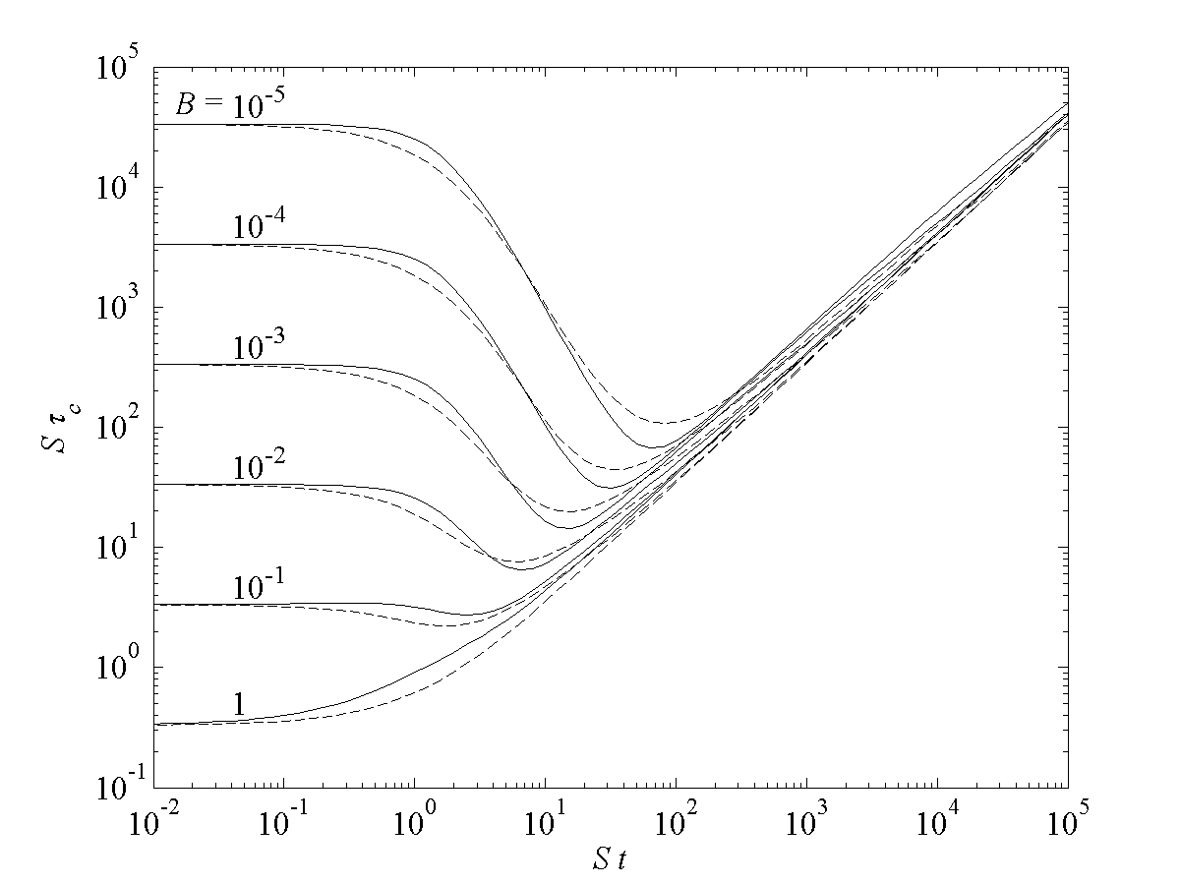
Figure 0-2. Non-dimensional fluctuation dissipation timescale as a function of dimensionless time for a shear-distorted Gaussian puff. The solid line is the analytic solution . Dashed line is the model prediction from and .
The factor has been included to reduce the shear effect slightly under strongly stable conditions, where the shear reduction has been found to dissipate the variance too rapidly. The reduction factor is only applied in stable conditions when the Monin-Obukhov length, L, is less than the mixing layer depth, , and in this case we define
so that under very strongly stable conditions we obtain the maximum reduction factor, with a value of.
The shear term in depends on the horizontal scale, , which is generally increased by the wind shear, and is modeled as
The last term in is included to reduce the shear effect when the two scales are comparable and the diffusivity is significant compared with the shear distortion. The scale ratio is raised to the power, p, which is defined as
This adjustment gives a slightly better agreement with the analytic result for the higher diffusivity range, since it allows the horizontal scale to grow more rapidly in the early times.
In the SCIPUFF model, the terms involving the wind shear, S, from and are added to the scale equations and with an appropriate definition of the shear rate. Note that only one of the horizontal scales, , is increased by the presence of shear. For general meteorology, the shear rate is defined as

This includes an estimate of the large scale fluctuating shear in addition to the mean wind contribution. The fluctuation contribution assumes a linear velocity distribution with height as typical of the instantaneous distribution. This is a plausible assumption for large scale variations, where the thermal wind relation dominates the tropospheric wind profile.

Puff Interaction Treatment.
In addition to the three internal fluctuation length scales discussed in Section 2.2.2, the puffs must also include an equation for the concentration fluctuation variance. This is a nonlinear quantity and therefore requires a treatment of puff interactions. We have found that it is easier to deal with the total square concentration, , since the conservation equation is simpler than the fluctuation variance, , cf. and . Since the total square concentration equation only involves a dissipation term, the puff transport equation is simply
where the dissipation timescale, , has been defined in the previous section.
Note that the puff integral on the right-hand side of is the fluctuation variance, which must be estimated from the relation
If we represent the mean concentration as a sum of Gaussian puffs, then the expression for the local concentration is
where the sum is taken over all the contributing puffs, denoted by a superscript α, and represents the spatial Gaussian distribution of puff-α. The square of the mean concentration is therefore
and requires a sum over all puff pairs. The distribution of amongst the individual puffs for substitution in is not unique, but an obvious partition is given by
where the interaction integral is defined as
i.e., the overlap integral between the two Gaussian puffs.
Ignoring surface reflections for the present, the Gaussian shape is conveniently specified using the inverse of the spread tensor as
where and denotes the determinant. The exponential argument is
and
The product of the two Gaussians is then
and the exponential argument can be written in the form
where
Here is the inverse of the moments of puff-β, defined similarly to
The overlap integral can then be computed directly as
Puff reflections at the surface and at a capping inversion are also accounted for in the puff interactions. We modify the interaction term to account for reflections as
where the subscript R represents the reflected Gaussian and the volume integral is taken over the region . This gives four terms in the interaction integral, i.e.,
As shown in Section 12.1, the reflected Gaussian distribution for an individual puff is described by a simple multiplicative exponential factor. The distribution for a puff reflected at the ground surface is therefore obtained by multiplying the original Gaussian by , where is defined in . Applying this reflection factor to the two interacting puffs and performing the overlap integral in the region introduces a factor, , in the integral , where
Here,
and
The first two terms in the integrand in can be combined to give a simple integral over all space of if the reflected Gaussian satisfies the property
This is not true in general for skewed puffs, since we represent the reflected puff using a centroid that is displaced horizontally along the line from the original puff centroid to the surface maximum concentration location. However, if both puffs have the same skewness, so that the lines from the centroid to the surface maximum are parallel, then the horizontal displacements will be the same for both reflected puffs. Since the integral is taken over all space, the horizontal displacement is immaterial and the sum of the two terms is again equivalent to a complete space integral of the unreflected Gaussian. We use this approximation for all interactions, in order to save computational time, since we expect puffs that interact significantly to have similar skewness. The skewness is generated by the wind shear, and puffs in the same region will be subjected to the same shears, so that it is unlikely for puffs to overlap significantly with different skewness. The simplified surface reflection factor is therefore given by
The capping inversion reflection is treated in a similar way, with a simple reflection at the puff capping height, . The reflection factor is comprised of two factors, one for each puff but the enhanced factor (the error function term) is only added if the effective displacement is positive, i.e. the overlap centroid lies below the reflection level.
In principle, the interaction calculation described above should be made for all possible pairs of puffs. This is clearly impractical for a large number of puffs and is usually unnecessary since many pairs will be separated in space and the overlap integral will be negligible. SCIPUFF uses a three-dimensional grid with a multi-level adaptive technique in the horizontal plane to determine near-neighbor puffs. The technique is described in Section 4.3 in connection with the merging process. The multi-level technique allocates each puff to a horizontal grid cell based on the puff size. Interactions are only calculated for puffs in neighboring cells on this grid, since contributions to the overlap integral from puffs more remote than the neighbor cells are small.
The overlap integral is only calculated for puffs on the same horizontal grid, so that the interaction between puffs with different horizontal sizes is neglected. This is equivalent to an assumption of no correlation between such puffs, since the total variance is calculated as a sum of the contributions from each puff. If the variance is computed without interaction, then a simple sum of variances implies uncorrelated fluctuations. This is a reasonable assumption for puffs with different size, since they must have different transport histories and are generally uncorrelated.
We also note that SCIPUFF can calculate multiple species and/or particle size groups in a single computation and each puff is assigned a specific type descriptor to designate its material properties. Interactions are only computed for puffs of the same type, and correlations between different types are not calculated. Any subsequent combination sum of material types or particle size groups must estimate a cross-correlation if the variance is required. For the special case of multiple particle size bins, two variance calculations are stored so that statistics for the total material concentrations are available. SCIPUFF accounts for interactions between all puffs in the same size group, and also between all puffs of the same material and any size group. This provides a variance calculation for the concentration of the individual size group, and also a variance for the total concentration obtained as the sum over all size bins.

Conditional Average Dispersion.
The second-order closure framework of SCIPUFF provides a prediction of the statistical variance in the concentration value, as described above. This variance gives a measure of the uncertainty in the concentration prediction and depends on the velocity fluctuation statistics used to determine the dispersion rates. Under some circumstances, a meaningful quasi-deterministic prediction can be obtained by restricting the definition of the turbulent velocity fluctuations. By ignoring the large-scale meandering motions in the turbulence, a conditional average result can be generated in which the uncertainty in the plume/cloud location is ignored. It must be recognized that the conditional average simply neglects the meandering component of the turbulence and provides a prediction of the small-scale diffusion effects.
The conditional average is obtained by specifying an averaging time, Tav. This time scale is converted into a length scale, Λav, using the local wind speed, and used to restrict the velocity variance to the diffusive range of scales. The averaging time should be thought of as a sampling time, but can also be considered to be the release duration if this is shorter than the sample time. Thus, an instantaneous measurement or an instantaneous release both imply a zero averaging time.
A reduction factor is applied to the velocity variances if the length scale of the velocity fluctuations is larger than the conditional average scale, which is defined as the larger of Λav and the instantaneous cloud scale. Turbulent motions on scales smaller than the instantaneous cloud are always diffusive in character, so this part of the spectrum must be included in the conditional average. When the instantaneous cloud is smaller than the conditional average scale, the averaging time determines the range of scales. A simple power law reduction, consistent with the Kolmogorov inertial range behavior of the energy spectrum, is assumed. Thus the boundary layer turbulence used in the dispersion model equations in Section 2.1.3 is defined as
where the conditional filter scales are
The new velocity correlations and length scales, defined in -, are then used in the dispersion model equations. A similar procedure is applied to the large-scale velocity correlations and length scale.
The conditional average length scale, Λav, is defined in terms of the averaging time scale as
where V is the local velocity scale, which includes both the mean velocity and the turbulence. Thus
and the conditional boundary layer component uses the boundary layer turbulence. The length scale for the large-scale component uses the large-scale velocity variance in
The conditional averaging representation is described in detail and compared with field data by Sykes and Gabruk (1997); the field data comparisons are included in evaluation studies section of this document.

SURFACE DEPOSITION.
Surface deposition of the gaseous material introduces a source term into the concentration equation and therefore modifies the puff moment equations. A simple constant deposition velocity, v_{D}, is used, so the puff mass conservation equation becomes
where the mass flux at the surface is defined as
Other deposition effects for particles are discussed in Section 6. Integrating the mean surface concentration for the generalized Gaussian puff gives
where is defined in as half the inverse of the puff moment tensor , D is the determinant of , and
The expression in includes a factor of 2 to account for the surface reflection, as discussed in Section 12.1.
The flux term in can be used to define a deposition time scale
which is then used to decay all the other concentration-weighted puff moments, such as .

SURFACE INTEGRALS.

Surface Dose or Dosage Integration.
The integrated surface dose is one of the optional output choices, and is defined as
This quantity is accumulated on an adaptive grid as described in Section 4.7.
The probabilistic aspect of the SCIPUFF prediction is also incorporated into the surface integral fields through a calculation of the variance of the integral, . From , we obtain the equation for the mean-square fluctuation integral as
which involves a two-time correlation for the concentration field. We have omitted the spatial coordinates in since the time variation is the only concern in the present discussion.
We make the assumption that the time correlation is exponential, i.e.,
where Tc is the integral time scale for the concentration fluctuations. Substituting in , and assuming that the time integration covers the range of the autocorrelation function, we obtain
The estimation of the integral timescale for the surface concentration fluctuations, Tc, is currently based on the simplified meandering plume analyses of Gifford (1959) and Sykes (1984). These analyses show that the effect of intermittency is to reduce the integral time scale dramatically from the Eulerian wind fluctuation time scale and also to introduce a logarithmic correction factor. The intermittency is measured by the concentration fluctuation intensity, and Sykes (1984) suggests the approximation
for the meandering plume case, where T_{E} is the Eulerian velocity time scale. For the meandering plume model, the fluctuation intensity can be related to the concentration fluctuation scale, , and the scale of the ambient turbulent velocity fluctuations, . A generalized approximation for the intensity is then given by
where the modified streamwise scale, is defined as , so that it is equal to the concentration fluctuation scale for a puff release, or the ambient scale for a plume.
Using this estimate of the intensity, we define an effective length scale as
for . The additional limit is applied for short duration integrals associated with instantaneous releases in the near field and is independent of the effective fluctuation intensity; gives a scale in this case. For , we use , and the proportionality constant in is chosen to match the two estimates at .
The use of the generalized notation for the ambient scale is due to the fact that there are 3 components of the ambient turbulence, and the various weighting factors in preclude the use of a composite scale based on the ambient velocity variances. The effective horizontal turbulence scale used to define the correlation timescale, , is estimated using an energy-weighted average of the three horizontal scales obtained from for the three ambient components. Thus
where is the total turbulent energy.
We estimate the Eulerian scale of the turbulence as
The estimate in is appropriate for continuous plumes, but instantaneous sources may have shorter time scales due to the short duration of passage. We therefore define a "time-of-passage" time scale as
using the second horizontal concentration fluctuation scale. This time scale will be large for a continuous source, since represents the streamwise length scale. The correlation time scale is defined as the smaller of the two estimates, i.e.,
The variance contribution is accumulated on the same surface grid as the mean, using the Gaussian shape of the mean concentration, so that
In addition, the effective length scale of the fluctuations is calculated using the variance as a weighting factor applied to .

Surface Deposition Integration.
The mass deposited on the surface is computed in a very similar way to the surface dose. In this case, the deposition is defined as
where vD is the total deposition velocity, including gravitational settling for particles or droplets and turbulent dry deposition. The mean and variance of the deposition are calculated exactly the same as the dose but with the extra factor of the deposition velocity. Conservation of total mass is ensured by estimating the deposited mass as the actual loss of mass from the puff in the time step Δt.

REACTIVE CHEMISTRY

GAS PHASE CHEMISTRY.

3.1.1 General Approach.
The chemical reaction processes are described in SCIPUFF by using the concept of multi-component material. The tracer or non-reactive contaminant is associated with a set of species concentrations, . It is assumed that the associated species are transported and diffused in the same way as the conserved tracer material. The quadratic overlap term is already calculated by SCIPUFF for use in the concentration fluctuation variance equation. The mean squared scalar concentration, for puff is written as
where the sum is taken over all the puffs and , the interaction coefficient or the overlap integral between two Gaussian puffs is given by . The overlap definition is extended to the reactive species and the effective species-A concentration perturbation for puff is defined as
In SCICHEM, the reactions are written in a generalized form as
where represent individual species concentration, is the reaction rate and and are the stoichiometric coefficients. If is non-zero, the reaction is assumed first order in, and first order in and the overall reaction is considered as second order. Note that the coefficient is a multiplicative factor and does not imply higher-order reactions. If is zero, the reaction is first order decay of. The total reaction rate for the general reaction in equation 9 using the concentration perturbation for puff is given by
where, and are the ambient concentrations of species and respectively. Since we step only the perturbation concentrations, the background reaction rate is excluded in the equation so that
This gives the desirable result that a release of zero emissions of reactive species does not cause any reactions to occur in the puffs. If there are M reactions, then the species perturbation concentrations are advanced using a system of n differential equations summarized as
where are the stoichiometric coefficients. For the bimolecular reaction in equation 9, the coefficients become
Here, index A denotes the species A etc. For linear reactions does not exist. Similarly, the product species may also be absent.
In addition to the species concentrations, the set of species masses are advanced as described below.
The set of species masses associated with each puff- are adjusted using the advanced perturbation concentrations and the overlap volume.
where the overlap volume is defined as
To account for the fact that the perturbation concentration in some puffs may be dominated by surrounding puffs, the reaction rate coefficients are multiplied by a reaction volume factor, f. Equation 19 for first-order reaction can then be written as
and for second-order reaction it becomes

The equations can be rewritten as
and

The reaction volume factor for a first-order reaction must be
and using this definition, the second-order reaction would be
Typically, the ratio of the species masses to overlap concentrations is the same for all species for a given puff and the value of f should be
However, in some circumstances, it is not the case and we use the corresponding reaction rate factor for each species. The transport and diffusion terms are omitted from the evolution of the species concentration equations, since these processes are represented by the evolution of the puff moments, which are calculated separately for the tracer material. Dry deposition of the reactive species is treated at the end of the chemistry step.

Numerical techniques

FINITE DIFFERENCE SCHEMES.
The ordinary differential equations for the puff moments and properties are generally solved using a simple, explicit forward time-difference. However, all linear damping terms are represented implicitly, so that an equation of the form
is represented numerically as
i.e.
The puff mass and velocity-concentration moment equations can be expressed in the general form . The mean-square concentration integrals are treated differently using an exponential approximation, which gives an exact solution for a constant damping rate, μ and forcing function, F. Thus, for mean-square concentration
The puff centroid is advanced using the second-order Adams-Bashforth scheme
This technique gives accurate trajectory calculations for idealized velocity fields such as the solid-body rotation flow, and avoids the numerical diffusion produced by the trajectory divergence errors of a first-order scheme.
The puff second-moment tensor requires special treatment, since it is important to maintain a realizable tensor with a positive determinant. The effective volume of the generalized Gaussian described by the six independent moments, σ_{ij}, is proportional to the square root of the determinant D = Det(σ), and this quantity is used to determine local concentrations and interaction terms. The evolution equation for the individual moments is given in , but the turbulent diffusivities are only modeled for the diagonal components. Thus, we have
for the diagonal components, and
for the off-diagonal components (). The Greek subscript implies no summation in -. The volume of a fluid parcel is conserved in an incompressible flow, and in the absence of (turbulent) diffusion, conservation of the determinant is implied by if the velocity field is solenoidal. It is very important that the velocity gradient terms conserve the determinant numerically, and this is therefore a necessary property of the numerical scheme.
The evolution of σij over one timestep is computed using a sequence of steps, with the intermediate results for step m denoted by a subscript, e.g., the m-th step for σxx is . The initial step, with m = 0, accounts for the turbulent diffusion of the diagonal components, i.e.
Here, Δt is the numerical timestep and indicates the value at the start of the timestep. Equation is used for both horizontal components, but the vertical diffusion is split into two partial steps, before and after the shear terms are included, and is discussed below. Off-diagonal components are not affected by this step, i.e.,
The next step applies the diagonal velocity gradients using the relation
for all three diagonal components. The vanishing velocity divergence ensures the conservation of D after this step. Note that the zero divergence condition is enforced by setting . Again the off-diagonal components are unchanged, so .
The six off-diagonal velocity gradients are then applied sequentially in three pairs, and . The first step uses as , and the level-1
The remaining diagonal moment, , is unaffected by these two components of the velocity gradient. The other two off-diagonal velocity gradient pairs are included in a similar manner by cycling the indices and velocity components, and , and the advanced time level with all the shear terms is obtained as . This scheme is more complicated than the single gradient component used in earlier versions of SCIPUFF, but it reduces the errors arising from sequential application of the shear components and still preserves the value of the determinant exactly. The relations - are strictly only first-order accurate in time for a general shear tensor, but the conservation of the determinant is a more important property than the accuracy for long term stability of the scheme.
The interaction between strong vertical diffusion the vertical wind shear can produce inaccurate distortion of the puffs if the vertical spread is fully advanced with the diffusion prior to the shear effects. The coupled shear-diffusion in is complex, but if we consider only one vertical shear component then it can be shown that the shear terms are second-order accurate. Also, the second-order accuracy of the coupled shear-diffusion can be obtained by application of one third of the diffusion in the vertical spread as the initial estimator, i.e.,
The remaining diffusion is included after the shear distortion so the final estimate for the vertical diagonal component is

PUFF SPLITTING.

Splitting Scheme.
The puff moment evolution equations given in Section 2.1 generally increase the size of the puff through turbulent diffusion and elongation along the direction of the wind shear. As the puff grows, the local representation of the turbulence and velocity fields using the puff centroid location becomes increasingly inaccurate. When the meteorological fields are inhomogeneous, the accuracy of the calculation can only be maintained by splitting puffs into smaller components that can sample the variations in the meteorology explicitly. A grid-based method for splitting puffs was presented by Sykes and Henn (1992), where the moment method of Egan and Mahoney (1972) was extended to include some shear effects. In this scheme, grid cells can be thought of as each containing a Lagrangian puff. As the puffs move and spread into neighboring grid cells in a time step, the masses are redistributed so as to maintain a single puff within each cell. We wish to avoid any numerical grid in the current method, however, so the redistribution cannot be based on the rectangular grid cells.
The objective of puff splitting is to represent the original Gaussian puff with several smaller, overlapping puffs that conserve all the puff moments and only change local concentration values by a small amount. For a split in the x-direction, the original puff is replaced by two smaller puffs as follows. The new centroid locations are displaced by a fraction, r, of the puff spread in the x-direction, and by a distance proportional to the off-diagonal moment in the other two coordinate directions. Thus
where α = {1, 2} corresponds to the plus and minus sign, respectively. The diagonal moments for the new puffs are obtained using the following relations
and the new off-diagonal moments are
Conservation of all puff moments is ensured by this procedure, and the moments of the new puffs are all reduced and are also realizable. The realizability constraints involve the Schwartz inequality between the diagonal and off-diagonal moments, e.g., and the strictly positive value for the determinant. These properties can be verified directly from the above relations.
The generalized puff description contains other information in addition to the moments discussed above. The additional variables fall into two categories, either a conserved puff integral property (similar to the puff mass) or a puff value property (such as turbulence length scale). Integral properties are simply divided equally between the two new puffs, and the value properties are assigned equally to both.
The reduction in puff size is controlled by the parameter r, but a larger reduction in puff size reduces the amount of overlap between the new puffs and gives a poorer representation of the original Gaussian shape. For a puff with diagonal moment tensor, the splitting scheme described by - creates a pair of Gaussian puffs with a dimensionless separation
where Δ is the distance between the new centroid positions and is the new spread in the x-direction.
In general, the difference in concentration distribution resulting from the splitting operation is difficult to specify for an arbitrary Gaussian, but the simple spherical puff with diagonal moments provides an idealized case. Figure 0-3 shows the maximum difference between the original Gaussian and the sum of the two smaller Gaussians after splitting in one-dimension, i.e., x-direction only, and also for a two-dimensional split in both x and y, which creates 4 puffs. The difference is given relative to the maximum concentration value in the original Gaussian, and is plotted as a function of the dimensionless separation, δs. It is clear that the one-dimensional case provides better overlap between the new puffs and smaller differences for the same separation. A maximum local concentration change of 20% requires a dimensionless separation of less than 2.25 for a one-dimensional split, but must be less than 1.8 for two dimensions. In practice, there will usually be additional overlap from other puffs and we have found that r = 0.75. i.e., δs = 2.25, gives the optimum size reduction with acceptable overlap. In diffusive applications, the puff size increases after splitting and reduces the effective separation and overlap errors.
Figure 0-3. Maximum dimensionless error, εs, from splitting a single Gaussian puff as a function of separation distance, δs. The error is relative to the maximum concentration value in the original Gaussian, and the separation distance of the puffs after splitting is relative to the original Gaussian spread. Results are shown for both one-dimensional and two-dimensional splits.
The vertical displacement involved in splitting a puff can cause creation of puffs below the ground surface, so a reflection condition must be imposed in these cases. The reflection adjustment is applied if the newly created puff is below the ground. In this case, the puff centroid is relocated by reflecting the vertical coordinate and positioning the centroid along the original displacement line, as illustrated in Figure 0-4.
A similar condition is imposed at the boundary layer capping inversion, z = zi, to prevent diffusion of material through the interface from below. The inversion reflection is applied when a puff within the PBL splits and creates a new puff with . In this case, the puff will be reflected back along the line joining its centroid to the original puff centroid.
In a stable boundary layer, there is no reflective capping inversion and puffs can exit the boundary layer through vertical splitting. Above the boundary layer, diffusion rates are very small so the time for an external puff to grow large enough to split back down into the boundary layer is relatively long. The imbalance between the effective mass flux out of the boundary layer through the splitting mechanism and the return flux from above can cause a buildup of mass just outside the boundary layer. In order to prevent this non-physical accumulation, a partial reflection is included in the splitting algorithm at the top of the stable layer. Thus, if splitting a puff inside a stable layer produces a puff outside the layer, then the equilibrium vertical diffusivity at the new puff location is compared with its current diffusivity value. Thus
where the numerator is defined in and is calculated at the new puff location outside the boundary layer, and the denominator is defined in . If the ratio is less than one, then the mass of the external puff is scaled by , and the remaining mass is restored to the lower puff inside the boundary layer.

Figure 0-4. Schematic illustration of puff reflection for a split below the ground surface.

Splitting Criteria.

Vertical Criterion. The vertical puff moment, , gives the effective length of the puff in the vertical direction, and the basic criterion for vertical splitting is given by a fixed size, ΔV. We choose to split a puff in the z-direction, say, when . Here ΔV should be chosen so that the linearization of the velocity and turbulence fields is valid for a Gaussian with smaller spread. In principle, ΔV should be based on the vertical structure of the wind field, but is currently specified by a user input. The user specifies the vertical grid size, Δz_{merge} used for checking for puff merging, see Section 4.3, with a default value of 250m. The split criterion, ΔV is then half Δz_{merge}; this ensures that puff overlap is limited to neighboring grid levels.
Near the surface, where the wind field is known to vary rapidly in the vertical, a more restrictive criterion may be applied. There are two such cases. The first is for puffs within a canopy; see Section 10.2 for the wind profile description. If the canopy height is given by h_{c}, the puff centroid is lower than 2h_{c}, and the puff vertical scale, , is also less than h_{c}, then the split criterion is set to the smaller of ΔV and h_{c}/4.
The second case is for puffs inside the boundary layer, where the split criterion is set to the smaller of ΔV and z_{i}/8, where z_{i} is the boundary layer depth. A puff is judged to be inside the boundary layer if its centroid is within the layer and its vertical scale, , is also less than z_{i}. Note that with the default vertical resolution of 250m, this criterion will be imposed for puffs inside a boundary layer that is less than 1000m deep.

Horizontal Criterion. Horizontal splitting is generally controlled by the meteorological grid size, since that provides the scale for horizontal variations. The use of high resolution meteorology or terrain can therefore lead to large numbers of puffs, because splitting generates puffs more rapidly when the size criterion ΔH is smaller. This is because it takes a shorter time for the puff to grow large enough to split, and the split also occurs in two horizontal dimensions. The default criterion is twice the meteorological grid size (the smaller of the x- and y-directional sizes), based on the assumption that the wind field is well-resolved, but user control is provided to adjust the criterion to be larger or smaller by factors of 2. Although the number of puffs can be reduced by increasing the value of ΔH, the accuracy of the calculation is impaired since the estimation of the velocity and velocity gradients can become unreliable. This is because the evaluation of the meteorological fields at the puff centroid may apply small-scale gradients to a larger puff that spans many grid lengths.
In order to obtain a more representative field estimate for a puff, SCIPUFF uses a hierarchy of horizontally smoothed, or filtered, fields to evaluate the meteorology. The construction of the smoothed fields is described in Section 9.7, with each level of smoothing effectively increasing the grid size by a factor of 2, but for the purposes of this section we assume that all required fields exist. When a puff requests the local meteorology, the appropriate field is chosen based on the horizontal size of the puff, defined as
The field is selected so that the grid size, defined as the square root of the horizontal area of the grid cell, is closest to the puff size. If multiple nested domains are present, see Section 9.6, only domains containing the puff centroid are considered. Note that the fixed size criterion, ΔH, is based on the original unsmoothed field covering the selected domain, i.e., this basic criterion does not depend on the size of the puff, but rather on the actual resolution of the local meteorology. However, we apply further checks to determine whether the size criterion, ΔH, is necessary.
Since the puff distortion representation is exact for a linear velocity variation, it is only necessary to split a puff when the velocity gradient varies significantly across the puff. The split criterion is therefore based on a measure of the second derivative of the velocity, where all derivatives are estimated using centered finite differences on the selected field. Further, a high rate of diffusion can dominate any shear distortion and also make puff splitting unnecessary. Accordingly, the puff is split if
where
and the repeated indices are summed over 1 and 2 only. Splitting may still be avoided if the diffusivity is large, so the puff must also satisfy
where
and the total effective diffusivities are defined in and . The constants in and are chosen empirically to minimize the number of puff splits without degrading the accuracy of the calculation. The values are chosen as , and , and the actual split criterion is the largest of L₂, L_{K}, and ΔH. Note that if a puff succeeds in growing without splitting, it will use a velocity-based criterion from a smoothed field, which inherently gives a larger split criterion due to the filtering of the gradients. This process is justified by the observation that smaller scale inhomogeneities are insignificant for a large puff, since the concentration field is essentially constant on the smaller scale so advection and diffusion are negligible.
An additional splitting criterion is checked in the presence of terrain if the puff centroid is within of the ground surface. This is to ensure that variations in terrain slope are resolved, which, in the case of a dense gas release for example, may be important even in the absence of strong velocity variations. Instead of estimating second derivatives numerically, the terrain is evaluated at points offset from the puff centroid along the directions defined for horizontal splitting, namely at the four points , , and . The split criterion is set to ΔH if the terrain elevation at any of these locations differs from that at the centroid by an amount larger than .
A further splitting criterion involves the splitting of puffs over a sloping surface, where it has been determined that the simplified location adjustment for off-diagonal moments in - can result in a non-physical rotation of the puff under certain conditions. The adjustment does ensure realizable puffs, but it does not perfectly conserve the orientation of the puff. If the splitting algorithm used the principal axes for the split directions, then the orientation would be preserved, but calculation of the principal axes is computationally expensive. The small errors from the Cartesian split can accumulate if the puff persists on a fixed slope over a long period. Under nocturnal conditions where the puff diffuses much more rapidly along the slope compared with the vertical direction, it is possible for a puff to rotate into a horizontal orientation after many splitting operations over a period of hours, and this produces an erroneous surface concentration pattern. This phenomenon is avoided by rotating the puff into a coordinate frame aligned with the slope prior to the splitting algorithm, then rotating the puffs back into the Cartesian frame after the split operation. The rotation is applied if the terrain slope is significant and the puff is close to the surface. Since the rotation is an additional computational burden, a further check to determine if the puff is anisotropic is applied. This rotation is only used if the normal puff spread is less than half the vertical moment, , indicating a tilted anisotropic puff. The normal spread moment is defined as
where is the unit normal to the ground surface.

PUFF MERGING SCHEME.
Unfortunately, the splitting process can rapidly lead to excessive numbers of puffs unless some form of merging is employed to reduce the numbers. In general, splitting the puff distribution will create many overlapping puffs that can be merged together as a single Gaussian. The merging rules are actually much simpler than the splitting rules, since the only requirement is moment conservation. Thus, if superscripts 1 and 2 represent two puffs deemed sufficiently close to each other to merge, then they can be combined as follows:
where .
Other puff variables are combined according to their type. Integral properties are combined, like the puff mass in , as a sum of the two values. Value properties are mass weighted and combined like the puff centroid in .
The difficulty associated with merging lies in deciding which puff pairs are eligible. In general, if we have N puffs, there are possible pair combinations and it rapidly becomes impractical to consider all such pairs when N is large. Some techniques have been suggested for ordering randomly located, multi-dimensional data with the objective of determining nearest neighbors, (e.g., Boris 1986) but we have chosen to use an adaptive multi-grid location scheme.
The basic concept of the grid location scheme is to assign each puff to a particular grid box, and then a search for near-neighbors can be carried out by searching over the neighboring grid cells. There are two technical difficulties that arise in the application of this concept. First, the grid cell size should be determined by the size of the puff itself, so that a puff overlaps only a finite number of neighboring grid cells. Second, we must account for an arbitrary number of puffs within each grid cell. Thus, we cannot simply allocate storage for a fixed grid with a fixed number of puffs in each cell.
The first problem is solved by means of an adaptive grid in the horizontal plane. In atmospheric cases, the vertical resolution is restricted by the stable stratification, so a fixed grid size of Δz_{merge} is used. However, the horizontal scale varies widely so an initial coarse grid is defined with size Δ₀ equal to half the size of the calculation domain. Each cell of this coarse grid can be individually refined to create 4 additional cells with size Δ₁ = Δ₀/2. The new cells are simply added to the end of the list of cells, and a pointer from the Δ₀-cell contains the location of the first of the 4 refined cells. This procedure can be continued as far as computer storage allows.
This successive refinement procedure has the advantage that all coarser levels of the grid are available in addition to the most refined level. Each cell of the grid stores two integer variables, the pointer for the subsequent refinement (if it exists) and the number identifier of the puff located in that cell. The choice of refinement level for locating a puff on the adaptive grid is determined by the largest of the horizontal moments, i.e., the grid size Δ_{n} = Δ₀/2^{n} such that
where . The factor of 4 ensures that , so non-neighbor cells are separated by at least and their neglect in the overlap calculation of Section 2.2.4 is justified.
A schematic illustration of the puff allocation is shown in Figure 0-5, where a single puff with index number α is located in cell number 12 (denoted by C12). The puff is allocated to the second level of grid refinement, and the grid system generated by this puff is also shown. The grid cells are indicated by the C-number and the two numbers stored for each cell are given in parentheses below. The first number is the first grid cell of a refined block of four cells, and is zero for no refinement. The second number is the index of the puff contained in this cell, and a zero indicates no puff in the cell. When both numbers are zero for a cell, we have omitted the number pair in some cases. Thus, all cells except C12 contain no puffs and show the second number as zero. Cell 4 shows the refinement to the first level and points to cell 5, which is further refined and points to cell 9. Clearly, a large number of puffs will produce a much more complicated grid and index structure, but this simple adaptive refinement provides an efficient location scheme for locating arbitrary collections of puffs.

Figure 0-5. Schematic illustration of the adaptive multi-grid for locating puffs. Grid cell numbers are represented as C-n, and two levels of refinement are shown. See text for a description of the cell storage rules.

In locating the puffs on the grid, the index number of the first puff placed in a particular cell is stored in the grid cell storage location, but if other puffs share the same cell then their indices must be saved elsewhere. Unlimited numbers of puffs can be accommodated by using a linked list; each puff carries a pointer to designate the next puff in the cell. Thus, if puff number j is found to share a grid cell with a previous occupant, say puff number i, then the list pointer in puff i is set to point to puff j. In practice, the entire list for the cell must be scanned and the new puff added to the end of the list. However, since the cells are adapted to the puff size it is highly unlikely that a single cell will contain more than a few puffs.
The use of the adaptive grid technique in conjunction with the linked list provides a very efficient method for sorting a large number of puffs with arbitrary locations and moments, giving a compact list of puff pairs to test for possible merging. We note that a search over the list in each grid cell finds most of the candidate pairs, although puffs allocated to different cells but lying very close to each other across the boundary will be missed. In practical terms, it is more efficient to miss some merges rather than scan multiple cells.
The actual merging of a candidate pair is based on the overlap integral of the two Gaussian functions, which can be written in the form
where D12 is a combination of the two determinants and the exponential argument depends on both puff moments and their separation. This integral is computed as part of the concentration fluctuation variance calculation (see Section 2.2). For two identical, spherical Gaussians with separation distance, Δ and diagonal moments, σ ², the argument can be written very simply as . A pair is merged if , so that δm is a measure of the centroid separation relative to the size of the two puffs. We note that the separation is not a direct indication that the two puffs are nearly coincident, since they could be of different size or shape. However, the multigrid sorting scheme ensures that the pair have similar overall size and it is unlikely that two such puffs will arrive at the same spatial position with very different shear histories. A more reliable merge criterion can be developed to account for the shape differences as well as the centroid separation, but we have not found this to be necessary yet.
As discussed in connection with the splitting process, the merging criterion determines the extent of puff overlap, since a small value for δm will maintain more overlap before merging a pair of puffs. It is important to ensure consistency between the split and merge criteria, however, in the sense that a newly created split pair should not satisfy the merge criterion. In practice, we maintain a distinct gap between the two criteria, and a reasonable value for δm is found to be 1.73 in conjunction with the split criterion, r = 0.75, i.e., δs = 2.25.
In addition to the overlap criterion, merging is restricted to puffs of the same material type and particle size bin, and position relative to the boundary layer cap, zi. Puffs within the mixed layer, , are not merged with puffs outside the mixed layer since this could result in artificially diffusing material across the capping inversion. The puffs are also required to have similar concentration fluctuation scales, Λc, so that puffs of significantly different size cannot be merged even if they are spatially coincident.

PUFF INVERSION CAPPING.
Under daytime mixing conditions, the atmospheric boundary layer is typically capped by a temperature inversion, which provides a limit on the vertical extent of the turbulent layer. The depth of the mixed layer is denoted by zi, and the specification of this inversion height is described in Section 10.2. Although there is entrainment across this layer, the flux through the inversion is relatively small and the vertical diffusivities are also usually much smaller in the free atmosphere above the boundary layer. The simplest assumption is therefore to approximate the inversion as an impenetrable surface and apply a perfect reflection condition for the puff concentration distribution.
The level at which the reflection is applied cannot simply be defined as the local inversion height, zi, since the inversion can move up or down as the turbulent layer grows during the daytime or collapses in the evening. If the capping level were reduced, then the local concentrations would increase as the mass became compressed into a thinner layer, and this would violate the mass conservation law. We therefore associate a capping height, zc, with each puff and adjust the capping level in response to the local boundary layer changes experienced by the puff. A capping height of zero is used to indicate no reflection.
We first define a capped boundary layer as one in which the surface heat flux is non-negative and the overlying atmosphere is stable, i.e., a positive potential temperature gradient. The specification of the surface heat flux is described in Section 10.2. Upon release of a puff, z_{c} is initialized as
so that zero indicates no cap. At each timestep the puff cap is modified according to the following rules:
Case A: Boundary layer capped, and
This implies the puff centroid lies inside a capped boundary layer. If the puff is effectively contained within the layer, then is set to the larger of and the existing cap. Containment is defined by the condition that either the puff is almost entirely within the boundary layer, or the puff is already capped and the cap is within or close to the current boundary layer. The former condition is defined as , and the latter as where and the tolerance is defined below.
If the puff is not contained then it extends beyond the current boundary layer. This situation can arise when a convective boundary layer grows and partially entrains an existing puff, or a puff advects through an inhomogeneous boundary layer. In this case, the vertical diffusivity calculated at the puff centroid within the boundary layer is inappropriate for the part of the puff outside the boundary layer. Therefore a correct description requires that the puff be split into two parts, one contained within the capped boundary layer and the other outside. The puff within the boundary layer receives the appropriate mass calculated from an integral of the Gaussian distribution up to the boundary depth, , but its centroid location and moments are maintained. The external puff receives the remaining mass with a centroid location and vertical moments calculated from the Gaussian shape function.
The tolerance is included to avoid excessive creation of puffs with small mass outside the boundary layer when the boundary layer depth changes slightly. The tolerance is set to the larger of and , and thus allows puffs to become completely contained if they are already capped within 30% of the boundary layer depth. The tolerance is further relaxed for shallow boundary layers, when the vertical splitting resolution is larger than . Note that this tolerance does not apply to uncapped puffs that are partially entrained; creation of small mass puffs is avoided in this case when the fractional mass above the boundary layer is less than 5%.
Case B: All other situations
This includes puffs above the boundary layer or uncapped boundary layers, such as found under stable conditions. If the puff is already uncapped then it remains in that state, otherwise a check is made to test whether the cap should be moved or completely removed. If the puff is sufficiently below its cap, i.e., , then the cap is removed, otherwise the new cap is defined as
The cap is allowed to move due to advection by the mean vertical velocity component, and also grows due to turbulent diffusion by the vertical velocity fluctuations. The 1% factor on the vertical velocity standard deviation is included to allow the cap to dissipate slowly under stable nocturnal conditions. The cap is not allowed to fall below the current boundary layer depth, or the vertical puff spread, σ_{z}.

ADAPTIVE TIMESTEPS.
The description of dispersion over a wide range of spatial scales, from a small source up to hundreds of kilometers for example, also involves a wide range of time scales. Small spatial scales are usually associated with short time scales, so close to a localized source an accurate description of the dispersion process requires a small time step. As the plume or cloud spreads onto larger scales, however, the time scales will also increase. The discrete Lagrangian framework of the Gaussian puff model allows an efficient treatment of the time dependence since puffs can be advanced individually using an appropriate step for each one. The only interaction between puffs is through the overlap integrals in the interaction terms, and these are the only terms that require special consideration when using multiple time steps.
A large time step, ΔtL, is defined for the calculation. This time step must resolve the meteorological changes and any other time dependence in externally specified parameters, such as source variations. The large time step is successively halved to obtain appropriate puff time steps, and the multiple time steps are forced to bring all the puffs into synchronization at intervals of ΔtL. External parameters are updated only on the large time step. Within a large time step, however, an individual puff uses its own locally determined step to integrate for the period ΔtL.
At the beginning of a large time step, the list of puffs is scanned to determine the smallest step required for this period. This gives the number of small internal steps for the period, which must be of the form 2M since the local steps are obtained by successive halving. Although a puff can change its time step during the ΔtL interval, the smallest time step is not allowed to fall below the initial level of 2–M ΔtL, so that the number of steps is fixed for the period. In practice, this is not restrictive since the time scales are usually increasing as the puff grows.
The time step for each puff is chosen as the minimum from a list of requirements. Thus,
where the subscripts, c, u, w, K, shear denote the time step limits for dissipation of concentration fluctuation variance, horizontal advection, vertical advection, vertical diffusion, and velocity shear, respectively. These time step limits are defined below.
The dissipation time step is determined from the fluctuation variation dissipation timescale, as
where τc is defined in .
The horizontal advection restriction is determined by the horizontal flow speed,
where ΔH is the local horizontal meteorological grid spacing. Additionally, if the puff is contributing to a surface integral computation, its horizontal motion is restricted so that it does not travel more than one standard deviation in one time step. Thus ΔH is not allowed to exceed
where Δmin is the user-specified minimum surface resolution.
The vertical advection time step is determined as
where ΔV is the vertical puff resolution (specified by the user), and w_{T} is the total vertical velocity defined as the rate of change of in , i.e., the sum of the meteorological component, the gravitational settling, and the turbulent drift.
A diffusive time step limits given by
is applied to puffs inside a vegetative/urban canopy (see Section 10.4 ) or inside a stable boundary layer. For the canopy, ΔK is defined as one quarter of the canopy height. For a stable boundary layer, ΔK is defined as one eighth of the boundary layer depth. In all cases, ΔK is not allowed to exceed ΔV . The puff vertical diffusivity, Kp, is defined as .
Finally, the shear time step limit is determined so that the Δt2 term in does not change the diagonal puff moments by more than 25%. This limit is applied to each off-diagonal shear component individually. The diagonal shear components collectively restrict the time step so that no diagonal moment changes by more than a factor of e1/2.

STATIC PUFFS.
Continuous releases may involve the generation of many puffs with a small timestep, since the step size is determined by the source dimensions, which are often relatively small. Puffs will merge as they grow downstream, but the computational time can become restrictive if the source continues for a long duration. In these cases, it is reasonable to approximate the early development of the release as a steady-state plume, since the timescales of the plume are much faster than the changes in the meteorology. This could be achieved by means of an initial steady state calculation to march the plume out to some downstream distance, at which point the puffs could be released into the general flow field with a larger timestep. The difficulty with this approach is that some method of incorporating the plume phase into the output displays and surface integrals would need to be developed, so that the initial part of the plume would not be neglected. In addition, a plume description would need to be stored in association with each continuous release.
A more integrated approach uses the concept of "static" puffs; these are puffs that represent the steady-state phase of the plume, and are not advanced every timestep. The advantage of this approach is that the quasi-steady plume is represented by the same type of puff as the general unsteady dispersing field, so that inclusion in the output calculations is facilitated. The concept is illustrated schematically in Figure 0-6.

Figure 0-6. Schematic illustration of the use of static puffs to represent a continuous source. The shaded puff is stored as the release description at the end of the static phase.
The static puffs are generated by a steady plume calculation, described below, and are removed and regenerated when the meteorology is updated every large timestep, ΔtL. The static puffs are also deleted from the calculation when the release terminates. The steady plume calculation is terminated after integrating the plume for 0.5ΔtL since we are assuming that the wind field is fixed for the large timestep. The static integration is also terminated at 10% of the source duration time, if this is smaller than 0.5ΔtL, since we cannot consider the plume to be steady on timescales comparable with the release duration.
The static integration is not allowed to proceed if the puff splitting criterion is satisfied, or if plumes from different sources interact since neither of these phenomena are described by the steady state calculation. However, this restriction is relaxed for multiple plumes from the same source, e.g., a distribution of particle or liquid droplet size groups. In this case, a collection of static puffs is advanced, calculating dynamic interactions and evaporative effects. Multiple materials, including dynamic gas releases, can be treated using static puffs provided all the releases share the same location and geometry.
A static integration is initiated by creating the first puff exactly as a normal continuous release; the specification of continuous releases is described in Section 8.1. This puff is first copied as a static puff, then a normal timestep if taken to produce the next static puff. At each integration step, a new timestep is calculated so the integration is as efficient as possible. When the timestep changes, the puff moments must be adjusted to reflect the change since the puff now represents a different duration of the release. If the timestep changes from to , we use the change ratio
to adjust all the mass-weighted integral puff moments as
The puff moments are also adjusted to reflect the relationship between the timestep and the streamwise length of the plume segment. Thus
where the superscript (1) on the velocity denotes the value from the previous step. This adjustment ensures that the puff overlap is maintained as the timestep increases.
The nonlinear interactions in the static puff integration are estimated by correcting the single puff interaction to account for the difference between a fully three-dimensional Gaussian puff and the two-dimensional Gaussian cylinder. The cylinder approximation is more representative of a steady-state plume, and the ratio of the overlap integrals for these two shape functions is
where s denotes the streamwise direction, L_{s} is the cylinder length, and
gives the Gaussian moment in the direction of the mean velocity. For low wind speed situations, where the turbulent diffusion dominates the mean advection, the Gaussian approximation is more appropriate than the cylinder, so we define an adjustment factor as
The factor in becomes unity when the turbulence dominates and provides a smooth transition to the cylindrical plume segment factor . The puff overlap integrals are therefore computed from the self-interaction term multiplied by the adjustment factor, fs.

ADAPTIVE SURFACE GRIDS.
The wide range of scales needed to describe the dispersion from a small source is encountered in the surface dosage and deposition integrals described in Section 2.4. Close to the source, for example, the deposition field may be very narrow but effects may be required over a very large domain. Using a uniformly spaced receptor grid to accumulate the integrals makes it difficult to resolve the values close to the source. Under specialized circumstances, it is possible to use locally refined grids such as an expanding radial distribution, but this is impractical for multiple sources and complex flows.
An adaptive grid technique is employed in SCICHEM to provide enhanced resolution wherever it is required. A coarse grid is defined to cover the calculation domain with a mesh of roughly square cells. Grid refinements are then defined with a factor of 2 decrease in cell size for each horizontal dimension. Grid cells finer than the top-level coarse grid are created as required during the calculation.
At each puff timestep, the surface integrals are updated if the puff contribution is significant. Puffs with centroid locations more than 3σ_{z} above the local terrain are neglected in the surface calculation, and the local terrain is defined as the highest elevation within the horizontal area of the puff. The latter is estimated as
where the slopes are also estimated at the centroid location. Additionally, a minimum concentration of interest can be specified, and surface contributions will be ignored if the maximum concentration in the puff falls below the minimum value.
For puffs that contribute to the surface integrals, a resolution scale is determined from the smaller of the two puff principal axes in the plane parallel to the local surface. Thus,
where the tensor α is defined in as half the inverse of the spread tensor, σ. Note that over sloping terrain, the tensor is rotated into the local coordinate frame. For a circular puff, the resolution scale is .
Having determined the resolution scale, the grid level is selected as the largest cell that is smaller than δ_{res}. A scan over cells at the appropriate grid level is then made to calculate the Gaussian puff contribution at each cell out to roughly 6σ from the maximum surface concentration location. If a cell already exists then the contribution is simply added; otherwise a new cell is created.

CHEMISTRY SOLVERS.
The system of stiff ordinary differential equations representing the chemical reactions is be solved using the Livermore Solver for Ordinary Differential Equations (LSODE) package (Hindmarsh, 1983), which is available as public domain software. While LSODE provides an accurate numerical solution to the stiff equation system, based on the user-defined tolerances, it is relatively expensive in computational terms. Therefore, the model allows the user to define ‘fast’ and ‘slow’ species for the reaction scheme. If a species is only involved in relatively slow transformations (compared with the dispersion timescale), then a simple explicit scheme can be used. Slow species use the explicit scheme, while fast species use LSODE.

GAS MATERIALS AND DYNAMIC EFFECTS

GAS MATERIAL PROPERTIES.
Gas materials are relatively simple, and in the absence of buoyancy and momentum dynamics are transported as passive scalars, using the representation described in Section 2.1.2. Gas materials can specify a constant deposition velocity, described in Section 2.3, and may also include a decay factor, described below in Section3.1. However, the most significant effects of gas material dispersion are due to dynamically induced motions, resulting from either initial release momentum, or buoyancy effects arising from density perturbations from the ambient air. The density differences may be due to release temperature differences, or a buoyant gas with a different density from air. Inclusion of dynamic effects is an option, controlled by an input specification, and may be ignored for a faster calculation.
The treatment of dynamic effects is described in the following sections. We also note that the vapor phase of a liquid material is treated the same as a gas material, and can include the same dynamic effects.

BUOYANCY AND MOMENTUM RISE.

Mean Flow Dynamics.
Many releases into the atmosphere involve a vertical rise phase since they are associated with heat or vertical momentum. This includes vertical jets and buoyant plumes from continuous sources, and buoyant clouds from explosive releases. The buoyant rise is important since it can strongly influence the effective release height and the initial source size for the subsequent dispersion in the atmosphere. While the rise dynamics can be incorporated into the source specification for a passive dispersion calculation, there are several reasons for providing an internal representation in the puff dispersion code.
First, the duration of the rise phase may preclude treatment as a source term, since this phase is ignored by the dispersion calculation. Initialization at the end of the dynamic rise may be some considerable distance downstream of the source, and effects calculations in the intervening region would need to account for the rise phase. Second, the transition to a passive dispersion code requires an arbitrary choice for the position at which the dynamics can be neglected; an internal representation allows a continuous decay of the dynamic effects. Furthermore, the dispersion calculation provides a more consistent treatment of the meteorology, which can be inhomogeneous in both space and time. Finally, simplified algorithms for plume and puff rise may not be appropriate for finite duration or time-dependent sources.
In order to represent the buoyant rise dynamics, additional variables must be stored for each puff. The dynamic model is described by Sykes et al. (1999), and is based on the conservation equations for both buoyancy, , and vertical momentum, , where θ is the potential temperature, w is the vertical velocity, and the subscript p denotes the dynamic puff perturbation from the local ambient atmospheric value. The angle brackets denote the volume integral over an individual puff. Only gaseous materials (including the vapor phase of a liquid material) can carry mean dynamics, since we envision the materials being transported by a fluid medium. As we shall show below, the dynamic gas puffs will transport particles or any other material if the puffs overlap spatially.
The evolution of the mean dynamic variables is based on the Boussinesq momentum equation and the conservation of potential temperature, giving
where is the ambient potential temperature. These equations neglect the pressure gradient in the momentum equation, and simply represent the buoyant acceleration term in and the change in buoyancy due to vertical motion through a potential temperature gradient in .
The mean dynamic variables in and determine the equilibrium rise of a buoyant puff in a stable atmosphere, where the ambient temperature gradient is positive. The solution to - will oscillate indefinitely about the equilibrium level. The vertical velocity itself will be damped, due to turbulent entrainment, which increases the effective puff volume, but the integrated momentum and buoyancy will be undamped. While the buoyancy is strictly conserved, the integrated vertical momentum will actually be reduced due to the generation of gravity waves, and the oscillation will be damped. We represent this effect with a simple linear damping on the vertical velocity integral, so that becomes
where N is the Brunt-Vaisala frequency, and cw = 0.1. N is only defined non-zero for stable temperature gradients, and the damping coefficient is arbitrarily chosen as 0.1 to provide a reasonably rapid adjustment to the equilibrium height.
Tracking the independent evolution of the dynamics of each puff is not sufficient to model the buoyant rise effects, however, since these effects are interactive. A plume of buoyant gas rises differently from an isolated buoyant puff because the flow field induced by the buoyancy has an influence on other parts of the plume. These effects are represented by means of correlation integrals for the momentum and buoyancy, which account for turbulent fluctuations in addition to the nonlinear interactions. The correlation equations are written as
where is the fluctuation dissipation timescale, defined in , which must be modified to account for the dynamically-induced turbulence. The turbulence model will be described in the next section.
Note that the turbulent dissipation terms, the last terms in equations and , involve the fluctuation correlations, which are defined as
The mean overlap integrals, and , are calculated in SCIPUFF in a similar manner to the mean concentration overlap terms, , as described in Section 2.2.4. This effectively assumes the same Gaussian distribution for both vertical velocity and potential temperature. The reflection assumption on the vertical velocity field at the surface is a zero value condition, however, rather than a zero slope.
As noted above, only gaseous materials can carry mean vertical momentum and perturbation temperature integrals. However, all puffs carry the dynamic correlation integrals in - since their species concentrations can be correlated with dynamic variables due to overlapping with gaseous puffs. This phenomenon is accounted for through the puff interaction calculations, where the overlap integral with dynamic gaseous puffs is computed for every type of puff. Thus, passive gas materials or particle materials co-located with a buoyant gas source will experience the same vertical velocity field as the buoyant gas itself.
The dynamic correlations provide an additional vertical velocity component, which is added to the ambient velocity field used to transport the puff centroid. Thus, the equation for the vertical component of the centroid location becomes
where is the integrated species mass, is the ambient vertical velocity, and the dynamic rise velocity is given by
We note that the model only represents the vertical component of the internal puff momentum, so that the rise can be calculated. The horizontal velocity is not perturbed from the ambient wind field.

Buoyant Gas Representation.
Buoyancy effects can arise directly from a density difference between the ambient air and the gas material. This is particularly important for dense gas effects, discussed in the next section, but is introduced here for the simpler case of buoyant rise. If the gas is lighter than air, then it will tend to rise without any temperature perturbation. In this case, the buoyancy variable is actually
where m is the mass mixing ratio, is the ambient air density, and is the density difference . Since the local species concentration value, cgas, is equal to , we can define a buoyancy factor
and write the buoyancy term as
In order to treat non-Boussinesq density perturbations associated with very dense gases, we modify the gravity term to give
so that the effective acceleration due to the gas density difference cannot exceed g. The correction factor in the denominator is only applied for positive density perturbations, since lighter-than-air materials must still accelerate the surrounding air mass
For cases with buoyant gas materials, i.e., for at least one gas material, every puff must calculate an overlap integral with all the buoyant gases. Thus
where the sum is taken over all overlapping gas puffs. The dynamic puff integral equations are then modified to give
for the buoyant gas puffs, and
for all puffs. The non-Boussinesq density correction is defined as
Note that the buoyancy correlation term is simply damped toward the mean overlap value, which is computed in the same way as the temperature overlap.

Turbulent Entrainment.
The velocity field induced by the dynamic rise of a cloud is turbulent, and the ambient diffusion is enhanced by the internal turbulence of the cloud. The additional entrainment and dissipation is modeled using an estimate of the internal turbulent velocity and length scales. The entrainment model is based on earlier work on power plant plume rise (Sykes et al., 1988) and relates the turbulent velocity to the vertical rise rate. We define
where V is the ambient wind speed, and
is a buoyancy factor, representing the increased turbulent energy production due to gravitational instabilities. The puff Richardson number is defined as
where Λp is the length scale of the internal turbulence. The dynamic temperature and buoyancy variables are defined similarly to the dynamic vertical velocity as
The dynamic length scale, Λp, is defined equal to the length scale, from Section 2.2.2, since this represents an instantaneous scale for the dispersing cloud. The empirical coefficients in are chosen as and from fitting jet rise data, as discussed in Section 13.3. Additionally, an upper limit of 2 is imposed on Fp to prevent excessive entrainment velocities.
The dynamic velocity and length scales are used to define a dynamic diffusivity that is added to the spatial moment equations to give
where
The internal dynamics also provide additional turbulent dissipation, and we modify the dissipation rate as
The internal turbulence also modifies the rate equations for the internal length scales, so that we obtain
where the first term arises from the ambient turbulence . The same additional velocity is added to vertical internal scale equation.

Inversion Penetration.
When a dynamically rising puff encounters a capping inversion at the top of a mixed layer, the puff can either penetrate through the inversion into the stable atmosphere above, or it may be trapped within the mixed layer. A simple energy test is used to determine one or the other alternative; SCIPUFF does not address partial penetration, where part of the puff is trapped and the rest passes through into the overlying stable region.
We assume that the ambient potential temperature profile is represented by a discontinuous jump of magnitude Δθ_{inv} at the inversion, with a linear gradient Γ above. A buoyant puff within the mixed layer has an effective temperature excess that includes both the dynamic temperature perturbation, , and the buoyant gas contribution, . If a puff moves from the mixed layer up at a height z_{p} above the inversion, it experiences a temperature change from initially to finally (all relative to the mixed layer temperature). The potential energy associated with raising this temperature difference through the height z_{p}, is given by
where .
The available kinetic energy is simply , and equating kinetic and potential energies gives a maximum penetration distance
where
We define the inversion temperature jump as
based on the assumption that the entrainment region is roughly 1/7 of the boundary layer depth, z_{i}.
The criterion for puff penetration is that
i.e., the puff energy must be sufficient to carry it past the capping inversion by either 10% of the boundary layer depth or its own internal length scale, whichever is larger.

DENSE GAS EFFECTS.

Mean Flow Dynamics.
The puff treatment of buoyancy-driven dynamics described in the previous section must be modified for the description of dense gas dispersion. The most important feature of dense gas dynamics is the interaction with the solid ground surface, which causes lateral spreading as a dense cloud collapses and suppresses the vertical diffusion due to the stable buoyancy distribution. We first address the dynamic spreading effect, where the gravitational forcing term drives motion parallel to the ground instead of a vertical acceleration. The gravitational force is still directed vertically, but the lateral motion is induced by the pressure gradient, which was ignored in the buoyant rise situation. We therefore require a treatment of the equations of motion that include the surface-induced pressure gradient.
A convenient starting point for modeling the dynamics is the vorticity equation, obtained by taking the curl of the momentum equation, as described by Sykes et al. (1999), giving
where is the vorticity and ν is the kinematic viscosity. The buoyancy forcing is written using the Boussinesq approximation in the above equation, and we note that the pressure gradient term vanishes. Forming the vertical component of the vorticity moment
where e3 is the unit vector in the vertical direction, and integrating over all space, we obtain
where the angle brackets denote a spatial integral and SP represents a surface integral term. Ignoring the surface term for the moment, it is evident that P is very closely related to the vertical momentum integral of the previous section. In fact, far from a solid boundary, satisfies exactly the same evolution equation as and can therefore be identified with the integrated vertical momentum.
In order to use as a basis for the dense gas puff dynamics, we must represent the surface integral term and also relate the puff motions to the vorticity moment integral. Since the velocity field strictly vanishes at a solid boundary, the surface integral SP involves only the viscous diffusion terms; we therefore represent it as a drag term, whose detailed specification will be described below. The relationship between the vorticity moment integral and the puff dynamics is based on a simple shape assumption for the induced velocity field, since the relation between velocity and vorticity is linear. This allows us to superpose the velocity fields from neighboring puffs by simple addition, and represent the interactions between a collection of dense puffs. The vorticity moment evolution equation also depends linearly on the buoyancy integral, so that the total vorticity moment can be represented by summing the moments of individual puffs. The puff evolution is still nonlinear since the dynamic fields are composed of the summation over all puffs, but the puff moments evolve independently and the basis of the dynamics is contained in the shape assumption for the velocity field.
In general, the velocity field induced by a dense gas cloud involves an outward radial flux in the cloud itself, spreading the material horizontally over the ground surface. This horizontal divergence is accompanied by a vertical velocity gradient as material moves downward toward the ground. A schematic cross-section is illustrated in Figure 0-7. This flow field is associated with azimuthal vorticity, and we can obtain a general relation between the velocity magnitude and the vorticity moment.

Figure 0-7. Schematic illustration of slumping dense cloud.

We further simplify the representation by assuming that the vorticity is concentrated in a horizontal sheet where the velocity is discontinuous, as illustrated in Figure 0-8. The horizontal velocity components, u and v, are independent of z below the sheet, and are zero above. The horizontal velocity field below the discontinuity is then used to move the scalar field. The vertical velocity is proportional to z, and is determined by the horizontal divergence. This ignores the return circulation outside the dense gas cloud, but captures the essential features of the motion of the dispersing contaminant.

Figure 0-8. Simplified velocity field representation for a dense cloud.
A simple assumption for the radial velocity field uses the Gaussian form to give
This satisfies the linear gradient requirement at the center of the puff and vanishes at large distances. We cannot assume circular symmetry, however, since SCIPUFF uses a generalized Gaussian description and the velocity shape assumption must be applied to elliptical puffs. When a puff is non-circular, the outflow along the longer axis of the ellipse is smaller than that along the shorter axis, since the pressure gradient driving the flow is smaller. If we weight the outflow using the inverse of the axis length, then the radial distribution given in can be generalized to an elliptical shape as
where X and Y are the principal axis coordinates in the horizontal plane with the puff centroid as origin, and . The length scales LX and LY are related to the semi-major axes of the puff as
and the empirical coefficient is chosen to be 1.5. Note that the velocity components in - must be rotated from the frame of the principal axes into the (x, y) calculation coordinates. Horizontal velocity gradients are computed by differentiating and rotating the four components appropriately. In the principal axis coordinates, the velocity gradients are
The scaling velocity, U0, is related to the vorticity moment, which we identify with . Integrating the moment of the vorticity based on vertical gradients of the velocity field -, we obtain
Specification of the velocity field of an individual puff leads to the evolution equations for the puff moments, using both the velocity and the velocity gradients. These quantities are calculated at the puff centroid location by summing the contributions from all the overlapping puffs. Note that a single puff has no mean velocity at its centroid, since the components - vanish at the centroid, where X = Y = 0. Thus, the total dynamic velocity perturbation from dense gas interactions is
where the sum is taken over all dense gas puffs, and the summand represents the velocity field -, after rotation into the project coordinate frame, evaluated at the centroid of puff-α. The other velocity component and all the horizontal gradients are computed in a similar manner.
The dynamically-induced velocity and velocity gradients are simply added to the ambient flow field to produce the total transport and distortion of the puffs. The vertical velocity gradient is defined from the sum of the two horizontal divergence components, maintaining a total divergence of zero. The vertical component of velocity is defined from the velocity gradient, assuming zero as the surface boundary condition. Thus
where the subscript d denotes the overlap sum from all contributing puffs with dense dynamics. The vertical velocity is defined as
where is the puff centroid height, and is a representative vertical scale height for the puff. The exponential decay factor is introduced to reduce the velocity for puffs further from the surface.
The dense gas effects are only calculated for puffs that interact with the ground surface. Negatively buoyant puffs remote from the surface will simply fall downward under the buoyancy forcing described in Section 5.2.1. Puffs are judged to interact with the ground when they have negative vertical momentum, , and their centroid is less than above the ground. The first requirement ensures that they are descending, and the second checks that they are in contact with the ground. When these conditions are satisfied, the ambient temperature gradient term in the buoyancy equations, and , is neglected, since the vertical velocity integral is interpreted as a vorticity moment and there is no vertical transport at the solid surface.

Dynamics with Uncertainty.
In situations where the ensemble mean dispersion includes significant meandering, the horizontal scale assumption in is not representative of the near-instantaneous scales which drive the dynamics. The gradients will actually be underestimated, since they use the ensemble puff spread in the denominator; however, the velocity gradients are applied to the ensemble puff moments and the effective rate of spread is overestimated We therefore modify the estimate of the horizontal velocity gradients to include a multiplicative factor of
on the expressions - . The reduction factor is empirical and is only intended to eliminate over-prediction of the horizontal spread when horizontal meandering is significant. The exponent discriminates between the one-dimensional meander of plumes, where Λ_{cH} is typically much larger than Λ_{c}, and two-dimensional meander for puffs, where the two scales are equal. The reduction factor is not applied to the vertical velocity gradient, , however, since dense clouds do not meander in the vertical and the vertical velocity gradient controls the slumping of the cloud.

Turbulent Entrainment.
The presence of the ground introduces stability effects on the turbulence in addition to the pressure gradient effects of the mean velocity field. In a free atmosphere, any density perturbation forms a stable vertical gradient on one side and unstable on the other. A free dense cloud is unstable on the lower side, while a positively buoyant perturbation is unstable on the upper side. However, when the density perturbation is constrained by the ground surface, a stable gradient is established throughout the cloud. The density gradient suppresses vertical turbulent diffusion since vertical motions transfer kinetic energy to potential energy as the density perturbations are mixed. This mechanism applies to the ambient turbulent motions as well as the dynamically-induced motions in the slumping dense cloud.
When a puff is in dense ground effect, as determined by the ground interaction criterion in the previous section, a dense cloud turbulence entrainment model is applied. The framework is similar to the buoyant rise parameterization in Section 5.2.3, but we use different velocity, length scales, and stability dependence.
The internal velocity scale for a dense gas puff is based on the lateral velocities since the vertical motion is constrained. Similarly, we base the length scale on the vertical scale of the cloud since the turbulent eddies are also constrained by the solid boundary. The internal turbulent velocity scale is given by
where
and
The dynamic velocity scale Vd represents the lateral 'slumping' motion in the dense cloud. The gradient term is required to provide the velocity scale for the self-induced motions in a puff, since the mean self-induced velocity is zero at the puff centroid. The internal dynamic scale, Λd, is defined as the vertical puff scale, ΛcV, since the vertical depth of the dense cloud characterizes the shear-generation scale. We note that the Richardson number is based on the total velocity, because the balance between buoyancy and shear in the cloud determines the effective stability and ambient motions are included in the balance. The coefficient in , C_{d2}, is chosen to be 10 on the basis of comparisons with laboratory data; note that the value of this coefficient is modified from previous versions of SCIPUFF due to the incorporation of the uncertainty effects as described in Section 5.3.2.
In addition to the stability effect on the internally generated turbulence, the formation of a stable layer at the ground affects the ambient turbulence and also the ambient velocity profile. Since boundary layer turbulence is principally driven by interaction with the ground surface, the reduction of vertical transport through the dense cloud layer can significantly modify the local profiles. We represent this effect by applying the damping factor Fd to the equilibrium eddy diffusivity, , defined in
.
The mean ambient velocity is also reduced, due to the suppression of vertical mixing, using a factor
as suggested by Puttock (1988), based on field experiments. This simple factor gives a maximum speed reduction of 30% when the Richardson number is very high.
The turbulent diffusivity, dissipation timescale and internal horizontal scale equation are modified as in -, but using qd and Λd in place of qp and Λp. Additionally, the vertical compression effect is included in the equation for the internal vertical scale, ΛcV.

Surface Drag.
As the dense cloud moves over the ground surface, the frictional drag of the rough surface tends to reduce the lateral slumping rate. This effect is represented by the surface integral terms in . We represent the drag effect through a damping coefficient on the vertical momentum (or vorticity moment) integrals, (or ) and . In addition, the interaction with the ground introduces a heat flux directly into the cloud, and we assume that this exchange rate occurs at the same rate as the momentum exchange. The damping is therefore applied also to the temperature perturbation integrals.
The surface time scale is based on the roughness length and a wall-layer assumption. If we define an inverse time scale as
and assume that
where τ is the turbulent momentum flux, then using the height scale of the cloud and the wall-layer relation between the surface stress and local wind speed, we obtain
$τ_{w}^{−1}={\left(κ/\text{log}\left(1+\frac{Λ_{d}}{z_{0}}\right)\right)}^{2}\frac{\sqrt{V^{2}+V_{d}^{2}}}{Λ_{d}}$

Terrain Effects.
In the presence of sloping terrain, a dense cloud will tend to move down the slope under the influence of the gravitational forcing. A simplified description of this effect can be included in the model using an equilibrium relation between the buoyancy force and the surface drag to provide a horizontal velocity perturbation. Since the vertical momentum is simply an integral of the balance between the buoyancy force and the surface drag, as in , we further assume that the terrain-induced horizontal motion is determined from the relations
where is defined by .
The terrain-induced velocity is added to the dynamic velocity, (ud, vd) computed from the puff interactions as in . The additional terrain component is used to move the centroid, and also appears in the turbulent entrainment and surface drag terms.

Particle materials

Particle material properties.
SCICHEM allows several classes of material to be specified; this section describes the modeling of solid particle materials. Particles require a size description and include gravitational settling effects, in contrast to gaseous materials, which are absorbed at the surface with a fixed velocity. Each material is described by an 8-character identifier which is used for output selection in cases with multiple materials. The user-specified choices of integrated surface output are also characteristics of each material, and are specified as part of the material properties.
Particulate materials require a material density, p, and a set of size bin ranges which defines Np bins or subgroups. The underlying concept is a representation of a continuous particle size distribution (PSD) by a discrete set of size bins. A unique puff "type" is associated with each bin, so that each size group is tracked separately through the dispersion calculation. Puffs are only allowed to merge with other puffs of the same type, i.e., same size bin, so that differential settling effects are represented correctly. The density and size range are used to determine the deposition effects as described in Sections 5.3 and 5.4.

Particle gravitational settling.

Particle Fall Velocity.

Particle fall velocities are computed using an equilibrium assumption and an empirical drag law relationship. The steady state fall speed is obtained from the balance between gravitational acceleration and the aerodynamic drag force, giving
where is the equivalent spherical particle radius, is the particle material density, and is the drag force.
The drag force is written in terms of a drag coefficient, , as
where is the air density, and is the particle fall speed. The drag coefficient is parameterized as a function of particle Reynolds number (Friedlander, 1977) as
where
and the viscosity of air, , is assumed to be constant at kgm–1 s–1. The air density is computed using the local temperature and pressure to account for variations with altitude.
The above equations can be solved, using iteration for Re < 1000, to determine the fall speed, , as a function of air density, particle density, and particle size, i.e.,
Any realistic calculation of particle dispersion must recognize a particle size distribution, so that a puff representation must describe a finite range of particle sizes. If a particle bin is defined for the range , we define the mean particle diameter, , as the arithmetic mean of and and estimate the fall speed variation across the bin using a three-point distribution with an inverse particle size weighting. Thus the mean fall speed is given as
and a fall speed variance can also be defined using the same weighting
The implementation of the gravitational settling process in the puff model using the mean and the variance of the fall speed is described next.

SCICHEM Implementation.

Gravitational settling introduces a source term into the concentration equation and therefore modifies the puff moment equations. The source term can be written as
to represent a downward vertical mass flux. Since S does not vanish at the surface, the addition of gravitational settling implies a loss of material as it is deposited on the ground. The mass loss can be written as an integral over the surface area, A, giving
and the puff mass conservation equation must be modified to account for the deposition; this is described in Section 2.3.
The puff centroid equation reflects the settling velocity directly through the addition of the vertical velocity component, giving
and the effects of the finite range of particle sizes on the vertical spread must also be considered. The difference in settling velocity of the different particle sizes within a size bin causes a vertical separation to develop and hence leads to an increase in the puff moment, . The variation in settling velocity acts in exactly the same way as the ambient vertical velocity fluctuations, but with a sustained effect since a particle size is fixed. The fall speed variation gives a linear growth of the vertical spread and is modeled simply as
This is not an accurate representation of particle size variability, but provides a simple estimate of the increase in vertical spread and improves the ability to describe a continuous size distribution. The particle size bins should contain a relatively small variation in fall speed for an accurate calculation.
The equation for the squared concentration integral also includes extra damping terms to represent the loss of concentration at the surface and also the diffusive effects of particle size variations. The equation becomes

Particle Dry deposition.

Surface Deposition Process.
Dry deposition refers to non-gravitational surface processes that remove material from the atmosphere, including collection and absorption phenomena. The surface deposition rate depends on both the contaminant material properties and also on the character of the surface and the local meteorology. Gaseous deposition mechanisms are different from particle mechanisms, and different models are employed for the two types of material. The particle model is complicated by the dependence on particle size and on the surface roughness or vegetative canopy description. The SCICHEM representation is based on the description in Sykes et al. (1993a).
Dry deposition is typically described in terms of the deposition velocity , which is defined by,
where c is the particle concentration and Fc is the total vertical particle flux near the surface, that is the sum of the turbulent flux and molecular diffusion flux. This expression is derived from the scalar conservation equation by assuming stationarity and horizontal homogeneity (Businger, 1986). Note that c, Fc and therefore, should strictly be defined at a specific reference height, typically 1m to 100m above the surface or vegetative canopy height.
The representation in SCICHEM is simply achieved by adding the dry deposition velocity, , to the gravitational fall speed, in the surface removal calculation . The remainder of this section describes the parameterization scheme for .
The gaseous dry deposition rate depends on chemical properties of the gas, such as solubility or reactivity, and is currently specified as a constant value for each gaseous material. Thus, is a fixed input value for gases.
The dry deposition model for particles is based on the approach of Slinn (1982), who postulates that deposition velocity is equal to a collection efficiency multiplying the momentum deposition velocity,
where is the surface friction velocity and is the wind speed at the reference height, . Slinn defines the total collection efficiency, E, in terms of the individual collection mechanism efficiencies as
where EB is the efficiency of the viscous sublayer flow within a millimeter of the surface elements, EIN represents particle interception and EIM represents particle impaction. This approach is also taken by Davidson, et al. (1982).
A simple logarithmic profile relation is used to determine the reference velocity in terms of the friction velocity, which is obtained from the local meteorological wind field as described in Section 11.1.2. However, under free convection conditions, the mean wind speed is very small and vanishes. The turbulent deposition process does not vanish in this situation, since individual convective eddies will transport momentum (and particles) to the surface. For the deposition parameterization, we need to define the average local friction speed, , based on the fluctuating surface momentum flux but independent of the horizontal direction of the flux. Sykes et al. (1993b) have used Large-Eddy Simulation to determine a simple expression for this mean friction velocity under free convection conditions, and find that a good description is given by
where is the convective velocity scale, is the mixed layer depth, and is the surface roughness length. These quantities are defined in Section 11.1.
We combine this free-convection limit with the shear-driven friction velocity in to give a final expression for the deposition velocity as
where is von Kármáns constant, and is the displacement height. The next section describes the specification of the particle deposition efficiency, E. For the rest of the discussion, we shall use the effective value of the friction velocity in place of .

Particle Deposition Efficiencies
Vegetative Canopy Model. In the region very close to a relatively smooth surface such as water, a flat plate or canopy elements such as leaves or grass, Brownian motion can be important in transporting particles to the surface (assuming that surface roughness elements do not protrude through the viscous sublayer). This is particularly true for very small particles (diameter<0.1µm) which, because of their small inertia, are able to follow small scale velocity fluctuations. Brownian motion results in the diffusion of particles, i.e., transport from high to low concentration regions. As discussed in Lewellen (l985), experimental evidence indicates that the deposition due to Brownian motion can be expressed in terms of the Schmidt number, , where is the kinematic viscosity of air and D is the particle diffusion coefficient. Values of D as a function of particle radius can be found in Friedlander (1977). The molecular collection efficiency is modeled as
where fD is the ratio of the viscous drag to the total canopy drag including pressure forces. This factor is needed since the particle deposition scales only with the momentum transport due to viscous forces, and we use a constant value to represent the canopy effects. We follow Lewellen and Sheng (1980) in using a value of 0.7 for the power law dependence in ; this is close to Slinn's value of 2/3.
Interception is essentially filtration in that particles are deposited when they are within a particle radius of the collecting elements (the characteristic size of the element is much greater than the particle radius). Particle inertia is ignored so that the particles are moving with the fluid around the collecting element. Many interception models are based on the filtering efficiency of cylindrical fibers in potential flow,
where is the particle radius and af is the filter fiber radius (Fuchs, 1964). However, for the more complex situation in a canopy, Slinn considers both "small" collectors such as vegetative hairs and "large" collectors such as grass blades and pine needles and proposes
where As is the characteristic radius of "small" collectors, f is the fraction of total interception by these collectors and AL is the characteristic radius of large collectors. Slinn (l982) shows that this formulation is in good agreement with Chamberlain's (1967) wind tunnel measurements of deposition to grass for his chosen parameters. We use Slinn's expression with , , and .
Particles are subject to impaction when they are much smaller than the collection elements but large enough so that their inertia prevents them from following the fluid flow around the elements. Collection efficiency by impaction is a function of a Stokes number, which is the ratio of the particle "stop-distance" to a characteristic canopy element length. Following Slinn, we define the Stokes number
where g is the particle relaxation time. Slinn gives the impaction efficiency as
The bulk canopy model used in SCICHEM involves an assumption about the velocity and turbulent diffusivity profiles, since the expression gives the local deposition rate as a function of position within the canopy. A simplified representation for the dry deposition velocity for the entire canopy is needed for implementation in SCICHEM. If we assume E is small, then the overall efficiency from Slinn's model can be written in the form
where E is defined by and  is a parameter which in general will vary for different canopies and velocity profiles. This overall collection efficiency is then used in to determine the dry deposition velocity. Slinn gives some data which indicate that the range of  is approximately 0.1 to 0.3 for a wide variety of canopy types. Fits to the data of Chamberlain (l967) using with  = 0.16, along with the full Slinn model, are shown in Sykes et al. (1993a).
For a vegetative canopy with height , we specify a displacement height, , and a reference height, . Note that the canopy height only affects the reference heights as used in . The increased deposition for a deeper canopy is represented by an increased surface roughness and friction velocity.
Rough Surface Model. In situations where there is no canopy, e.g., deposition to water, bare soil or rock, some modifications to the collection efficiency terms are necessary. Naturally, there is no interception, so EIN = 0. For EB and EIM, we use a generalization of Lewellen and Sheng's (1980) model for particle deposition to a smooth flat surface. Thus, we set
and
where
In this case, the Stokes number is given by
Predictions from this model compare favorably with Sehmel's (1973) experimental data on deposition to a smooth surface.
For the rough surface, we specify a displacement height, , and a reference height, in .

Precipitation washout

Effects on diffusion

Heavy particles can only respond on a finite timescale to turbulent velocity fluctuations and are also falling rapidly through the turbulent velocity field. In general, the effects of the finite timescale due to particle inertia are insignificant in atmospheric dispersion, since the timescale is relatively short. The response time is related to the equilibrium settling velocity as
so that a fall velocity of 10ms1 implies a response time of about 1s. Atmospheric eddy timescales are generally much longer than one second, except very close to the surface, and the dominant effect for larger particles is therefore the vertical motion through the eddies. If the settling velocity is not much larger than the atmospheric eddy component in the vertical then the response timescale will clearly be very fast and the particles can be considered to be in equilibrium. We therefore only represent the fall velocity effect in SCICHEM.
The main effect of a particle falling through a random velocity field is a decorrelation of the eddy forcing term. The dispersion rate is determined by the velocity variance and the Lagrangian correlation timescale, so a simple representation is obtained by modifying the timescale in the turbulent correlation equations. The timescale is modeled as in , and similar estimates are used in the other diffusivity correlations using the appropriate length and velocity scales. For falling particles, the timescale is modified by a factor
so that the effective diffusivity is also reduced by this factor.

MULTICOMPONENT materials

MULTICOMPONENT material properties.
SCICHEM allows the treatment of reactive chemistry (see Section 3) by specifying a gas material type as “multicomponent”. The gas-phase reaction mechanism is read by SCICHEM as input. The aqueous-phase mechanism is described in Section 3.2. The aerosol equilibrium relationships are given in Section 3.3. Aqueous-phase chemistry and aerosol thermodynamics may be treated optionally. Reactive chemistry depletes the species masses as described in Section 3.1.1.
The user provides the individual chemical species properties as input. Properties include the molecular weight, deposition velocity and wet scavenging parameter, as well as the absolute tolerances for the solution of the rate equations. A multicomponent puff has all species associated with it. Individual puffs are not used to specify individual species, as is the case with the particle material size bins (Section 5). The multicomponent species include gas, aqueous and aerosol particle phase species.

MULTICOMPONENT dry deposition.

Dry Deposition and Gravitational Settling of Aerosols.
The fall velocity of a multicomponent aerosol species is calculated according to the equations given in Section 6.2.1 for particle materials. The dry deposition is treated identically as it is for particle materials, as described in Section 6.3.

6.2.2 Dry Deposition of Gases.
The dry deposition velocity (m/s) of each gas-phase species is provided by the user as input.

MULTICOMPONENT PRECIPITATION WASHOUT.

Wet Deposition of Multicomponent Aerosols.
The wash-out of a multicomponent aerosol species is treated identically as it is for particle materials, as described in Section 7.3.

Wet Deposition of Multicomponent Gases.
The wet scavenging coefficient that is provided by the user as input for each gas-phase species, s (s⁻¹), is used to define the scavenging rate, sr (s⁻¹), as:
sr = s (R/R₀)
where R is the precipitation rate in mm/hr and R₀ is the reference precipitation rate of 1 mm/hr. The scavenging rate is applied to the gas-phase species after the gas-phase chemistry has been advanced. If the aqueous-phase chemistry module is turned on, the wet scavenging coefficient will be ignored and the wet removal will be carried out inside the aqueous-phase module.

Source specification

8.1 Continuous sources.
A continuous source is specified as a constant mass release rate, , for a finite duration period, TR, starting at time, tR. The material type and the release location, , must also be defined. The source geometry is simply defined in terms of the spread parameter, σR. If a ‘stack’ type source is defined, the source is converted internally to a continuous source type, and the spread parameter is set equal to the stack radius.
At each model time step during the active period of the release, , a new puff is initialized and added to the existing list. If the model time step is Δt, then the mass of the new puff is readily determined as
The centroid location of the new puff accounts for the passive transport by the mean wind, giving
which represents the center of mass of a plume segment of duration Δt originating at the source position.
The second-moment tensor also accounts for the mean transport, so that
The addition of the mean velocity terms in produces an elongation of the puff in the downstream direction, and a smooth overlap between consecutive puffs.
The turbulent flux correlation moments, , are all initialized to zero, since there is no flux at the source, and the mean-square concentration integral is
where
The initial concentration fluctuation variance is thus effectively set to zero.
The internal fluctuation length scales, Λc and ΛcV, are set equal to σR, but the second horizontal scale, ΛcH, reflects the continuous 'plume' nature of the release. Thus
where is the composite horizontal turbulence scale defined in and the integral represents the length of the plume.

8.2 Instantaneous sources.
Instantaneous sources only involve a single puff creation stage, and are specified by a release time, tR, a release location xR, and a CLOUDTRANS puff file (Henn et al., 1995). When the SCICHEM calculation reaches the release time, the puffs in the CLOUDTRANS file are released into the dispersion domain. A collection of puffs can be released in a single source event to describe an arbitrary spatial distribution, and this input is translated directly into initial conditions for each puff. The CLOUDTRANS input must contain material identifiers that correspond to existing SCICHEM material types, and must also provide mass, centroid location, and spread parameters for each puff.
The centroid location for each puff is used as a three-dimensional offset from the general release location, xR, and the puff moments σij, can be specified directly. The CLOUDTRANS file can also neglect the off-diagonal moments by specifying σx, σy and σz, or simply σ. In the latter case, a spherical puff will be released.
As for the continuous release, the turbulent flux moments are initialized to zero. The mean-square concentration integral is calculated using the interaction integrals in Section 2.2 for all the puffs in the release. This strictly gives the square of the mean, but this is equal to the mean-square under the assumption of zero fluctuation variance. The internal fluctuation scales are initialized using the puff spread moments if the scales are not directly provided on the CLOUDTRANS file. Currently, SCICHEM uses

8.3 LINEAR DECAY.
Linear decay can be applied to any material in SCICHEM to represent a simple reduction in concentration due to a linear chemical reaction or other linear decay effects. Each puff carries a decay coefficient, fA, which is initialized to unity at release time. During the transport calculation, the coefficient evolves according to the relation
where kA is the user-specified decay rate. The decay rate specification includes a diurnal variation, so that effects that depend on solar radiation can be described. The actual rate is obtained from the daytime maximum, , and nocturnal minimum, , as
where is the solar elevation angle. To use a constant decay rate, the user must specify equal maximum and minimum decay rates.
All deposition and dosage integrals use the decay factor-weighted concentration, fA c, so that deposition, for example, is computed as
The decay calculation continues after material has been deposited on the surface, so that
This assumes that the decay process is equally effective for material on the surface and in the air. The variance of the deposition decays at twice the rate, i.e.,

Meteorology specification

Background.
The advection and diffusion processes modeled with SCICHEM require meteorological input of some kind. The minimum requirement is a single wind vector. Obviously, more meteorological input is usually desirable and SCICHEM can assimilate observational data ranging from a single wind measurement to multiple profiles which include turbulence measurements and/or boundary layer parameters such as mixing layer height and Pasquill-Gifford-Turner stability class. Additionally, with the specification of topography, SCICHEM will calculate an adjustment to the three-dimensional velocity field obtained from interpolating observations so that it has very low divergence, i.e., conserves mass. Alternatively, three-dimensional gridded wind and temperature fields generated by some prognostic model or analysis may be input.
SCICHEM meteorological input is specified as one of two generic types: observational or gridded. Observational data are characterized by irregularly spaced vertical profiles with irregular horizontal locations, as well as irregular reporting times. The number and locations of observations can vary from one time to the next. Observational input is specified through a file of with vertical profiles and/or a file of single level surface data. Gridded meteorological input is defined on a regularly spaced three-dimensional grid; time need not be regularly spaced. The gridded input option is intended for use with numerically-generated wind fields.

Observational input.
Observation input can be of two types. A SURFACE observation file contains multiple records of the mean wind, temperature, and possibly boundary layer parameters. Each record represents a station location at a specified time, and the file can contain multiple stations and multiple times stored in chronological order. The surface observations are assumed to be given at the reference height, zref, unless the height is provided as part of the observation record. The reference height can be specified on the surface file, or is otherwise assumed to be 10 m. If the height is given with each observation, then the winds are adjusted to the mean observation height using a simple logarithmic profile assumption before any interpolation takes place. A PROFILE observation file is similar in character to the surface file and in fact it can optionally contain surface observations such as heat flux and mixing-layer height. For a given station, there are typically multiple levels of observations, although a single observation level can be specified.
The meteorological observations are interpolated onto a rectangular grid for use in SCICHEM, so that local values can be rapidly found for arbitrary puff locations. When the mass-consistent adjustment option is invoked, the vertical grid must be input. Otherwise the vertical grid is defined from the observational input. If PROFILE data are given, the vertical grid is based on the heights from the station which has the most levels with valid wind measurements up to Zmax (the puff calculation domain height) at the nearest time before the start of the run. If required, the grid is extended to Zmax with a grid spacing defined by the two uppermost observation levels. If the number of levels on this profile is less than a minimum NZmin (= 3 currently), then a uniform vertical grid is constructed based on Zmax and NZmin. Finally, the grid is checked and modified if necessary so that it has at least one level near the ground suitable for SURFACE data if given. However, if only SURFACE data are available, only one vertical level is used.
The horizontal grid is initially assumed to be a single point but is expanded if and when the number of observation stations is two or more during the SCICHEM calculation. A uniform horizontal grid is then constructed based on the puff domain boundaries, xmin , xmax , ymin , ymax and horizontal resolution H. It is assumed for the following discussion that the horizontal grid has more than a single point.
The assimilation of observational data into the three-dimensional gridded wind field is based on a weighted interpolation scheme. The weights given an observation are functions of the horizontal and vertical distances, temporal separation and terrain elevation relative to the grid points. In the following, it is assumed that both Surface and PROFILE observations are available, but the methodology is also valid if either set is missing: The terms corresponding to the missing data type are simply ignored. Data assimilation is performed at times for which either Surface or PROFILE observations are available. At such a time, the interpolation scheme for any point on the grid gives
where represents any variable such as u, v, T, etc. at time , is the interpolated value from the previous time , is the observation at the i^{th} Surface station at time , is its corresponding weight, is vertically interpolated from observations at the i^{th} PROFILE station at time , is its corresponding weight, and are the number of valid surface and profile observations respectively at and , and is a weight assigned to the field at . Note that either or , so that . Also note that the weights can vary for different field variables (but for visual clarity this dependence is not indicated in the notation). The definition of the weights, which depends somewhat on whether an observation is Surface or PROFILE, will now be discussed.
In general, an observation weight is determined as the product of three functions dependent on the horizontal, vertical and temporal separations between the observation and grid point:
where represents or , r is the horizontal distance from the observation location to the grid point, is a measure of the vertical separation (accounting for terrain differences) and is or as appropriate.
The horizontal weighting function is simply based on the inverse distance squared:
where the “core” radius a is used to avoid the singularity as r approaches zero and reduces the complete dominance of an observation near the grid point; where Δx and Δy are the horizontal grid spacings.
The vertical weighting function has a similar form:
where C is a constant set to 1000. The purpose of setting C large is to give extra weight to observations which are close vertically in preference to observations which may be close horizontally but relatively distant vertically. Although will defined shortly, for the time being assume that it is simply the vertical separation (which is the case over flat terrain). Then, an observation with but is given the same weight as one with no vertical separation but (assuming ). This is motivated primarily by the vertical stability of the atmosphere, which tends to reduce velocity correlations as vertical separation increases. The following expression for is an ad hoc attempt to account not just for vertical separation but also for terrain differences:
where , h is the terrain height at the grid position, is the terrain height at the observation location, , z is the grid height (above the reference or zero height level), , and is the height of the nearest observation level used to interpolate linearly to . is a small number (set to ) which avoids division by zero when .
As indicated above, is found from a linear interpolation of the profile data at the height . However, if is below the lowest observation level, is set to the value at the lowest level for temperature and humidity while horizontal velocity components are reduced using a neutral logarithmic profile (see Section 11). If is above the highest observation level, is set to the value at that level, except for temperature which is extrapolated using the temperature gradient from the U.S. Standard Atmosphere.
The vertical weight, , for temperature is modified for a Surface observation: if the height of the grid point above ground is greater than 500 m, is set to zero; otherwise, the expression from is multiplied by a factor . Thus, the temperature weight is unchanged for , but goes linearly to zero at 500 m. This factor is used since a surface temperature measurement will usually not be representative of the atmosphere well away from the surface, particularly above a mixed layer or under stable conditions.
The temporal weight uses a simple exponential “aging” function:
The time constant is set to 6 hours if is beyond the last or ahead of the first observation time; otherwise it is based on the time between observations and the number of observations so that times with many observations are given relatively large weights. Thus,
where is an empirical constant set to 0.4323, is the time between the current and previous observations and is or . is a measure of the number of observations from the previous time which accounts for time-smoothing and is dependent of the history of the data assimilation. It is updated when using from and the current number of observations:
where initially is set to zero. As an example, if and are fixed, then rapidly approaches an asymptotic value of .
Temporal smoothing is chiefly implemented though the weight given to the fields at . It is a function of the time between updates, , and the observation weights used at . For a given grid location, a time-smoothed sum of SURFACE observation weights is defined as
where is the time constant from appropriate to SURFACE observations and . The sum for PROFILE observations, , is defined similarly. Then,
This definition is an attempt to quantify the relative quality of the interpolated three-dimensional fields, e.g., fields at which assimilated many observations will dominate over a single observation at as long as they are not too old.

Gridded input.

File Format Types.
SCICHEM supports gridded format designated as MEDOC (Multiscale Environmental Dispersion Over Complex terrain). The MEDOC format is based on the French Electricity Board pollutant dispersion programs as developed for Defense Nuclear Agency application under contract number DNA001-92-C-0151. Gridded data in other formats must first be converted to the MEDOC formats.

Terrain.
The MEDOC format allows the input of terrain elevation information. If this is the case, it is assumed that the coordinate system on the file, , is terrain-following as defined by the transformation introduced by Clark (1977):
where
Here h(x,y) is the local terrain elevation, x and y are the Cartesian horizontal coordinates, z is the Cartesian vertical coordinate, and D is the depth of the model domain. It is assumed that the Cartesian velocity components are on the file. Then, only spatial gradients need be transformed in SCICHEM as follows:
where  represents any variable such as a velocity component or temperature and
The vertical gradient of vertical velocity, w, is treated as a special case and is set to insure satisfying continuity:
This estimate of is then used in the calculation of the horizontal cartesian gradients of w in . Simple finite differencing is employed in computing the partial derivatives in -.

Mean field interpolation.
The mean meteorological fields are updated every large timestep ΔtL using simple linear interpolation. If (t) represents a field at time t , then the time interpolation is defined by
where TM is the next time when the fields are given. Note that storage for only two time levels is required.
The computation of mean wind and temperature at a puff centroid can depend on its proximity to the surface and its vertical position relative to the inversion (if one exists) in conjunction with the meteorological input type and boundary layer specifications. However, under all circumstances, horizontal interpolation is required (except for the trivial case of a single location for the meteorology). Therefore, we now describe the simple bilinear interpolation employed in SCICHEM.
The background meteorology is always defined on a rectangular, uniformly spaced horizontal grid so that with defined similarly. The locations of the four surrounding grid locations are , where is the puff centroid, and jp is defined similarly. Then, the value of any field at the centroid location, represented by , is
where
and is the field variable at . In cases where vertical interpolation is required a similar procedure is used, i.e., will have a third summation with a vertical factor .
The interpolation scheme is used for upper air fields, i.e., gridded or PROFILE observations interpolated using and , and SURFACE fields if available (again interpolated using and ). If the puff centroid is located above the top of the boundary layer or if the boundary layer type is PROFILE or NONE, then the above scheme using the upper air fields fully describes the interpolation procedure. Otherwise the puff is located within the planetary boundary layer. The procedure for setting the velocity and temperature is then modified as described in Section 11.

Mass-consistency.
A simplified three-dimensional mass-consistency scheme is available as part of the SCICHEM meteorological input. If terrain input is specified in conjunction with observational wind input or certain kinds of gridded input, the interpolated wind field is then adjusted to ensure mass conservation, i.e., its divergence is zero (or at least very small). It should be noted that this feature is invoked only if the mass-consistent module SWIFT is unavailable.
The adjustment procedure uses either an iterative FFT solver, or a point relaxation scheme, depending on the magnitude of the effective terrain slopes. The FFT solver is faster, but converges only for relatively small slopes. The effective slope is defined as the actual slope, s, divided by the vertical partition parameter, α. The partition parameter depends on the vertical stability and is usually small, resulting in near-horizontal flow around terrain features. The adjusted velocity fields are calculated as
where is the interpolated field based on the input winds, and satisfies the Poisson equation
This equation is solved in a non-orthogonal terrain-following coordinate system, but the departure from a Cartesian system is small for small slopes. In this case, the direct FFT scheme is convergent. However, the slopes are too large in most cases, and a time-like iteration based on the artificial compressibility method is used. For each iteration, denoted by n, we define
and the 'time-step', β, is chosen locally to satisfy a Courant condition. Note that the vertical velocity adjustment is made implicit by coupling it with the calculation of . This helps avoid restrictive Courant conditions in the typical case where the vertical grid resolution is much finer than the horizontal. The damping coefficient was found necessary to achieve numerical convergence. However, since approaches zero as the velocity field becomes divergence-free, should not affect the final solution.
The iterative scheme is continued until the maximum divergence in the domain falls below the convergence criterion, , where the divergence scale, ,, is and ε can be selected by the user. The default value for ε is 0.01.
For small slopes, the elliptic equation is cast as the sum of the standard separable Cartesian operator plus non-orthogonal terrain terms.
where the spatial coordinates are now the transformed variables, and L represents the terrain terms. This equation is solved directly for using on the right hand side. The iteration is continued until the maximum change in divided by the maximum value of is less than the specified criterion.
The vertical partition factor, α, is defined empirically as
where the Froude number is given by and is the Brunt-Vaisala frequency. It should be noted that corresponds to potential flow (the flow tends to go over and around terrain) while results in flow constrained to a horizontal plane (around terrain). The user can specify maximum and minimum values for .

NESTED METEOROLOGICAL FIELDS.
As part of the modifications for SCIPUFF Version 2.0, the meteorological field description was generalized to allow multiple fields to be specified. This was specifically implemented to allow nested domains for use with urban dispersion modeling , where detailed description of a small sub-domain is required. Each meteorological field contains a complete description of the spatial grid, surface terrain and landcover, and all the associated dynamic, thermodynamic and boundary layer field variables.
Nested meteorological fields can be specified through the gridded MEDOC input format . For nested MEDOC files, the fields are completely defined by the input files, since they define the spatial grid and field variables. Any fields not defined on the MEDOC file will assume the default inputs for the project, e.g., surface roughness. Note that the user is responsible for the consistency of the nested MEDOC input; SCIPUFF will simply use the meteorological information in the input files. Also, since the fields from the multiple nested MEDOC files are treated independently, they are not required to contain the same variables or the same time breaks. However, the first file in the list is assumed to be the “outer” field, which must cover the project domain, i.e., subsequent MEDOC files are assumed to be nested inside the first field.

SMOOTHED METEOROLOGICAL FIELDS.
As described in Section 4.2.2, puffs are permitted to grow in size commensurate with the variations in the velocity field. For relatively smooth fields, this implies that puffs may extend horizontally over many cells of the background meteorology grid. In this case, the interpolation procedure described in Section 9.3, where the mean velocity and gradients are based only on the grid cell containing the puff centroid, is inappropriate. Some kind of averaging or smoothing of the velocity field over the puff volume would be ideal but computationally time-consuming. Therefore, a series of smoothed fields are constructed from the “base” gridded meteorology, with a doubling of the horizontal grid spacing for each successive field. Interpolation on the smooth fields is then as described in Section 9.3. Note, however, that these fields are only constructed if necessary, i.e., a puff has grown so that where and are the meteorology grid sizes. Also note that smoothing only affects horizontal resolution; vertical resolution is unchanged from the base meteorology.
A smoothed field is conceptually based on a simple 1-2-1 filtering of the base field. This filter is applied along the x- and y-coordinate directions to all fields associated with the background meteorology, namely velocity components (except in the case of a staggered grid; see below), terrain elevation, landuse/urban parameters, boundary layer parameters, etc. The number of grid points in the x-direction of the smoothed field is set to and similarly for y. When n_{x} is odd, this results in a doubling of the grid sizes for the smoothed field. If, however, it is even, the grid size is defined as so that it is slightly less than double the base grid and the filter is based on a triangular shape with base width .
The velocity fields generated by the mass-consistency models SWIFT and that described in Section 9.5 are on “staggered” grids, i.e., the velocity components are shifted a half grid length along their respective coordinate directions. (Velocity fields with staggered grids can also be input through the MEDOC file format; see Section 9.3 One of the fundamental features of these fields is that the divergence is nearly zero, and it is desirable that the smooth fields based on these maintain that feature. Although applying a 1-2-1 filter to all components does not guarantee that, it can be shown that applying a 1-2-2-1 filter to the horizontal velocity components in conjunction with a 1-2-1 filter on the vertical component does, at least for flat terrain. Therefore, a 1-2-2-1 filter is applied to the horizontal velocity components on staggered grids. As above, if the smoothed grid size is less than twice the base grid, the filter is defined by its shape, which here is a symmetric trapezoid with base width .
Smooth fields can themselves be filtered to generate meteorology on coarser grids if puffs grow to the appropriate size. Clearly the process cannot continue if the base grid (which may be the result of several smoothing operations) does not have enough points to implement the filters defined above. As a practical limit, smooth fields are only generated if the base grid has at least six points in each horizontal direction.

Planetary boundary layer

Governing parameters.
Defining the mean wind and turbulence profiles is essential in characterizing the transport and turbulent diffusion rates in the planetary boundary layer (PBL). However, since it is unlikely that detailed profiles will be available in routine use of SCIPUFF, it is necessary to consider some idealizations of the PBL structure. Extensive research on the PBL has led to a general consensus on its overall structure, the applicability of similarity laws and the governing parameters, at least for stationary flow over flat, homogeneous surfaces (see Wyngaard, 1985; Venkatram and Wyngaard, 1988; or Lewellen, 1981). It is now recognized that under ideal conditions both the mean wind and turbulence are functions principally of the following parameters:
1) surface roughness length, z0,
2) boundary layer depth, zi,
3) Monin-Obukhov length, L, and
4) surface friction velocity, .
Except for the boundary layer depth and possibly the roughness length, these parameters are not measurable quantities. Therefore, they must be related to other quantities that may be directly measured or at least estimated sensibly. So, instead of friction velocity and Monin-Obukhov length, SCIPUFF utilizes a reference velocity, uref = (uref,vref), defined at a height, zref, and the sensible heat flux, H. The various ways of specifying the input parameters will be discussed in the following section, but first we relate them to the PBL parameters L and as well as the temperature scale, , and the convective velocity scale, , which is used to characterize turbulence under convective conditions. (Two other important parameters, Ug, the geostrophic wind and f, the Coriolis parameter, are not considered here since they determine the "turning" of the wind over the boundary layer depth due to the earth's rotation. This effect is not incorporated into SCIPUFF unless it is explicitly provided in the upper air wind fields.)

Monin-Obukhov length, L.
The Monin-Obukhov length is defined as
where κ is von Kármán's constant, T is the air temperature (either the actual absolute temperature if available or more typically the base temperature T0 used for the Boussinesq approximation), ρa is the air density, and cp is the specific heat at constant pressure. L represents the ratio of the shear-driven turbulence production to buoyant production and as such is a measure of the flow stability. Unstable convective conditions (positive heat flux) are associated with a negative L while stable flows (negative heat flux) are associated with a positive L. For neutral flow, L becomes infinite.

Friction velocity, .
The surface friction velocity, , is defined by
where is the average surface stress. Except for special output from numerical weather models, the surface stress will typically be unavailable from meteorological input data, so the surface friction velocity is determined from the well-known logarithmic velocity profile law, corrected for stability effects (see for example Businger, 1973):
where Uref is the reference speed and is the stability correction term. Uref is determined from
where and are the horizontal large-scale variances, all given at the reference height. The large-scale variances are included in the definition of the reference speed since they represent wind velocity fluctuations on time scales longer than the boundary layer response time and therefore contribute to the average surface friction velocity. (The reference height, zref, used in will, under certain circumstances, be the "surface layer height" defined in Section 10.3; zref is required to be less than or equal to the surface layer height in order for the surface layer relation to apply.)
For neutral flow (), . For the unstable case (), is given by
where the non-dimensional velocity gradient is given by
The most commonly used form for under stable conditions (), is (e.g., Businger et al. 1971; Dyer 1974; Högström 1987)
where A_{m} has a value around 5. However, as Carson and Richards (1978) and others point out, this form is valid only for . They suggest that the Wangara data presented by Hicks (1976) are suitable for describing for ; and this is confirmed by Holtslag’s (1984) analysis of data from Cabauw. Van Ulden and Holtslag (1985) give an empirical function which matches for and is also a good fit to the observations at larger z:
Due to uncertainties of the observations, there is some question as to the behavior of at large values of (above 5 to 10). However, as described in Section 10.3, (and in general) is applied only within the “surface layer” and, under stable conditions, the surface layer is limited to a maximum height of 5L.
The non-dimensional velocity gradient, as used in , is defined as
For stable conditions, using in gives
The calculation of requires an iterative procedure since is a function of L, which in turn is a function of . Also, the calculation is modified under stable conditions if a CALCULATED boundary layer mode is specified; see Section 10.2.
As implied above, special numerical weather model output may include and this can be utilized by SCIPUFF if given as a two-dimensional field on a MEDOC file (Section 9.3and the PBL mode is METFILE or OPERATIONAL, as described in Section 10.2 below. In this case, the input friction velocity may be increased to account for the inclusion of horizontal large-scale variances in the definition of the reference velocity. Thus, the enhanced friction velocity will be
where is the input friction velocity, and is defined in . (Clearly, in the absence of large-scale variance.) Then, will be used subsequently in place of , including the calculation of Monin-Obukhov length .

Temperature scale, .
The temperature scale for stable conditions is defined as
and it appears in the temperature profile equation given by
where is the temperature at . We make use of only under stable conditions, in which case . It should be noted that L can be defined in terms of and as follows,

Convective velocity scale, .
Deardorff (1970) introduced the convective velocity scale, , defined as
as the appropriate scale for convection-dominated turbulence (). It is related to L and by

SPECIFYING PBL PARAMETERS.
Specifying z0 and uref is generally straightforward, but other input requirements depend on the PBL calculation mode chosen. There are four standard PBL modes referred to as SIMPLE, METFILE, CALCULATED and OPERATIONAL. A fifth mode, BLPROFILE, is used when detailed turbulence profiles, as described in Section 11.1, are available from measurements or modeling. In the SIMPLE mode, boundary layer height and surface heat flux are estimated using simple functional forms with user-specified minimum and maximum values. The METFILE mode can be used if measurements (or estimates) of zi and H, or L or stability class (PGT) are available on the meteorology input files. In the CALCULATED mode, H is estimated from a surface energy balance model and an evolution equation is solved for zi. The OPERATIONAL mode is intended to utilize whatever relevant input is given in the meteorological files and is essentially reset to METFILE or CALCULATED mode accordingly. Thus, the METFILE mode is invoked if zi and H or L or PGT are given, the CALCULATED mode is invoked if none of these variables are given; if either zi or H is available, the other will be calculated as with the standard CALCULATED mode.
The boundary layer mode is specified with the variable bl_type in the meteorology scenario file (Section 9.3SIMPLE, CALCULATED or OPERATIONAL mode is invoked by setting bl_type = ‘SBL’, ‘CALC’ or ‘OPER’, respectively. The bl_type string associated with METFILE mode depends on the meteorology input type: ‘OBS’ when using observational input; ‘MEDOC’ for MEDOC format gridded input. (See Section 9.3describing various meteorology input file types.) Of course, OPERATIONAL mode becomes METFILE mode if the meteorology file contains complete boundary layer input. Although not discussed further in this section, the BLPROFILE mode is invoked by setting bl_type = ‘PROF’.
The specification of z₀ and uref applies to all three modes. The CALCULATED mode requires additional inputs including cloud cover and surface characteristics, as discussed below.

Roughness Height.
Roughness length, z0, is a parameter related to the height of the roughness elements (i.e. trees, buildings, etc.). Suggested roughness heights from Saucier (1987) are given in Table 0-1. SCIPUFF accepts only one roughness height for the entire domain and duration of the run.
Table 0-1. Suggested values for surface roughness (Saucier, 1987).
z₀ (m) | Surface Description
0.0005 | Bare Ground, Sand Dunes, Water
0.001 | Nearly barren with low growing vegetation
0.01 | Grassland, Cropland, Wetlands
0.05 | Grassland with scattered trees, Brushland, Scrub growth
0.1 | Deciduous Forest, Villages, Forest Clearings
0.5 | Mixed Forest, Towns, Cities
1.0 | Coniferous Forest

Reference Height and Velocity.
For the purpose of defining PBL profiles, zref is taken from the lowest level of the vertical grid. The vertical grid is defined either directly through the gridded meteorology input file as described in Sections9.3 and or constructed from observational profiles as described in Section 9.2. uref is then the velocity at the lowest grid level after the interpolation procedure (Section 9.4) and mass-consistent adjustment (Section 9.5), if appropriate, are completed.

Surface Heat Flux.
The surface heat flux may be specified in three ways, depending on the PBL mode selected:
1) METFILE - through meteorology input files,
2) SIMPLE - as a simple diurnally-varying function with prescribed daytime and nighttime values,
3) CALCULATED - using a surface energy balance model which accounts for solar radiation, cloud cover and surface characteristics.
In the METFILE PBL mode, surface heat flux is specified directly (typically in Wm–2 units) on the meteorology input file(s). Alternatively, if observation-type meteorology is given, the surface heat flux can be calculated from the Pasquill-Gifford-Turner (PGT) stability class or Monin-Obukhov length. The stability class is indicated on an observation file with a stability index. An average Monin-Obukhov length is assumed within each stability class according to the scheme described in Sykes and Lewellen (1992). The stability index and the corresponding PGT stability class and Monin-Obukhov length are given in Table 0-2. Stability classes A, B, and C correspond to unstable conditions, D to neutral conditions, and E, F, and G to stable conditions.
Stability classes A, B, and C correspond to unstable conditions, D to neutral conditions, and E, F, and G to stable conditions. The heat flux is then calculated from equation as

Table 0-2. Relationship between stability index, PGT stability class, Monin-Obukhov length, L, and an assumed boundary layer depth, , if not specified as input.
Stability Index | PGT Class | L (m) | (m)
1 | A | -5 | 1000
2 | B | -12.5 | 1000
3 | C | -50 | 1000
4 | D | -1000 | 1000
5 | E | 25 | 125
6 | F | 13 | 65
7 | G | 5 | 25

When the SIMPLE mode is specified, the surface heat flux is calculated as
where Hc is the constant nighttime heat flux, Hd is the maximum daytime heat flux, and td is the time of day in hours. Typical values of Hc are between zero and –60 Wm–2. Hd can vary widely depending on cloud cover, time of year, surface characteristics, and latitude. For example, on an overcast spring day in northern Russia, Hd might be only 10 Wm–2, while it could be around 200 Wm–2 on a summer day in the southwest U.S.
In CALCULATED mode, SCIPUFF computes the sensible heat flux using a surface energy balance method similar to that used in METPRO (Paine, 1987). The method differs for daytime and nighttime conditions Daytime Heat Flux Calculation An analysis of the energy budget at the earth's surface balances the net incoming radiation with the total surface heat flux. This requires the partitioning of the surface heat flux into sensible and latent components. A simple parameterization for such a partition proposed by Holtslag and van Ulden (1983) is
where LvE represents the latent heat flux due to surface evaporation, Rn is the net solar radiation at the earth's surface, G is the soil heat flux, estimated as 0.1Rn, α is an empirical surface moisture parameter defined below and is related to the Bowen ratio, , is an empirical constant set to 20 Wm–2, s is the slope of the saturated vapor-pressure curve and . Here, cp is the specific heat of air at constant pressure and Lv is the latent heat of water vaporization.
The net radiation is estimated from the total incoming radiation using the method of Holtslag and van Ulden (1983),
where R is the total incoming radiation, r is the surface albedo, nc is the fractional cloud cover, c1 = 5.31×10–13 Wm–2 K–6, c2 = 60 Wm–2, c3 = 0.12 and σSB is the Stefan-Boltzman constant, 5.67×10–8 Wm–2 K–4.
The total incoming solar radiation is a function of solar angle (ζ) and cloud cover and is computed from a formula suggested by Kasten and Czeplak (1980),
where R0, the incoming radiation for clear skies, is a function of ζ and b1 and b2 are empirical constants set to –0.75 and 3.4, respectively. A simple parameterization for R0 suggested by Holtslag and van Ulden (1983) is
where the empirical constants a1 and a2 are set to 990 Wm–2 and −30 Wm–2, respectively, based on a survey of values for different northern mid-latitude sites.
The solar angle is determined from
where λ is the geographical latitude, δ is the declination and h is the hour angle (all in radians). Given the approximate nature of these calculations, we follow Holtslag and van Ulden (1983) in using simplified expression for δ and h, rather than the more accurate formulas in Paltridge and Platt (1976), for example. Thus, δ is given by
where σs, the solar longitude in radians, is evaluated from
and , dn being the Julian day number. The hour angle is given by
where t is universal time in hours, and φ is the Easterly longitude in radians.
Albedo is relatively constant for solar angles, ζ, above 30°, but increases for angles below that. An empirical formula given by Paine (1987) is used to model the variation of surface albedo with solar angle (in degrees):
where r₀ is the albedo for the sun directly overhead, r1 = –0.1 and .
As mentioned above, the surface moisture parameter α is related to B, the Bowen ratio. Since B is a commonly used parameter, α is expressed in terms of B using equations and to give
This completes the description of the sensible heat flux computation in the CALCULATED mode. It requires three more input parameters than the other two modes, namely, fractional cloud cover, nc, surface albedo for the sun directly overhead, r₀, and Bowen ratio, B. The specification of cloud cover is self-evident. Table 0-3 and Table 0-4 (from Paine, 1987) give suggested values for r0 and B as functions of land-use and season.
In the CALCULATED mode, the heat flux may be used in computing the boundary layer depth, as described in Section 10.2.4. It is also used to compute in conjunction with zi using and using . It should be noted that H could be negative just after sunrise or before sunset. In that case, the calculation of proceeds as for nighttime, as described in the next section.

Table 0-3. Suggested values for surface albedo as a function of land-use and season (Paine, 1987).
 | Land-use Type | Spring | Summer | Autumn | Winter
 | Water | 0.12 | 0.10 | 0.14 | 0.20
 | Deciduous Forest | 0.12 | 0.12 | 0.12 | 0.50
 | Coniferous Forest | 0.12 | 0.12 | 0.12 | 0.35
 | Swamp | 0.12 | 0.14 | 0.16 | 0.30
 | Cultivated Land | 0.14 | 0.20 | 0.18 | 0.60
 | Grassland | 0.18 | 0.18 | 0.20 | 0.60
 | Urban | 0.14 | 0.16 | 0.18 | 0.35
 | Desert Shrubland | 0.30 | 0.28 | 0.28 | 0.45

Table 0-4. Suggested values for Bowen ratio as a function of land-use and season (Paine, 1987).
 | Land-use Type | Spring | Summer | Autumn | Winter
 | Water | 0.1 | 0.1 | 0.1 | 1.5
 | Deciduous Forest | 0.7 | 0.3 | 1.0 | 1.5
 | Coniferous Forest | 0.7 | 0.3 | 0.8 | 1.5
 | Swamp | 0.1 | 0.1 | 0.1 | 1.5
 | Cultivated Land | 0.3 | 0.5 | 0.7 | 1.5
 | Grassland | 0.4 | 0.8 | 1.0 | 1.5
 | Urban | 1.0 | 2.0 | 2.0 | 1.5
 | Desert Shrubland | 3.0 | 4.0 | 6.0 | 6.0

Nighttime Heat Flux Calculation The method used under stable conditions follows Venkatram (1980), with a first estimate of based on an empirical equation due to van Ulden and Holtslag (1983):
which is independent of and H, although they show that is subject to the constraint . Further work by Holtslag and de Bruin (1988) shows that is dependent on , especially at low wind speeds, but that gives a reasonable maximum value. The semi-emperical model in Holtslag and de Bruin (1988) is rather complicated and requires more input than is typically available. Therefore, we follow (Paine, 1987) in defining another estimate of that depends on :
where . Although is only based on realizability considerations when using in , it does provide a simple, robust estimate for low wind speed conditions. The heat flux is then found iteratively using
where equals 1200 Jm–3 K–1, and . is initially estimated using assuming neutral conditions. Subsequently, L is computed using , is recomputed and substituted back into . This procedure continues until the relative changes in L are less than 0.1%.
It should be noted that the heat flux itself is not of primary importance here. The friction velocity, , is the key quantity since it is used to set the mean velocity profile near the surface, in scaling the turbulence profiles and in determining the boundary layer height in the CALCULATED mode.

Boundary Layer Height.
As with the surface heat flux, the planetary boundary layer height may be specified three ways depending on the PBL mode:
1) METFILE − through meteorology input files
2) SIMPLE − a simple diurnally varying function with a prescribed daytime maximum and nighttime minimum
3) CALCULATED − using a model that accounts for convection and shear-stress induced mixing as well as entrainment of an overlying stable layer.
When the METFILE PBL mode is used, the boundary layer height can be specified directly on the meteorology input file(s). However, if the PGT class or L is given without specifying a boundary layer height (for observational input only), one will be assumed as follows: under neutral or unstable conditions and for stable conditions. The assumed boundary layer heights corresponding to the PGT stability classes are shown in Table 0-2.
In the SIMPLE PBL, the boundary layer height is given by
where and are the minimum and maximum daily boundary layer depths, respectively. This equation approximates typical daily boundary layer evolution by setting the depth to a minimum value during nocturnal hours, maintaining a linear growth during morning hours, and holding a constant depth during afternoon hours. Typical values for range from 30m to 100m while might range from 300m on an overcast day to 2000m on a sunny summer day.
In CALCULATED PBL mode, SCIPUFF computes boundary layer height using the H, , L and other parameters. Again, the method differs for stable and unstable conditions. However in both cases, an evolution equation for the boundary layer is integrated in step with the dispersion calculation. This evolution equation is derived by assuming the top of the boundary layer represents a material surface, i.e., there is no fluid transport across this surface and noting that the total derivative of a material surface in a fluid is zero in the absence of source terms. An equation for a material surface in this case is given by , so gives
where the velocity vector is evaluated at the boundary layer height. To account for boundary layer growth due to thermodynamic (convective) or mechanical mixing, a general source term is added to the right-hand side of the tendency equation, so the final evolution equation becomes
where the source term is described below for daytime and nighttime conditions.
The utility of lies mainly in its smoothing properties, minimizing grid point-to-point variations that might arise from using the source term alone (i.e., ). Accordingly, and for the sake of computational efficiency, the horizontal advection terms in are implemented with first-order upwind differencing using from the previous timestep. The equation is updated at every large timestep, ΔtL. Daytime Boundary Layer Height Calculation The dominant mechanism driving the boundary layer growth during daytime is usually entrainment of the overlying air by convective eddies resulting from the surface heat flux. However, during early morning hours, surface shear stress induced (mechanical) mixing may be important. The model for includes simple parameterizations of these mechanisms but ignores subsidence, latent heat effects, radiation and advection.
The boundary layer is assumed to be capped by a thin interfacial layer separating it from the stable air above. The temperature within the boundary layer is assumed to be uniform. The heat flux at the interfacial region due to entrainment, Hi, is assumed to be proportional to the surface heat flux, following Carson (1973) and Deardorff (1980):
where A = 0.2. It can be shown (Carson, 1973) that the local growth rate due to convective mixing is
where Γi is the potential temperature gradient at zi .
Mechanical mixing is modeled assuming no surface heat flux and the entrainment flux is given by (Kato and Phillips, 1969)
where B = 2.5. Then, analogous to , we define
SCIPUFF assumes that the two mechanisms are independent and that the stronger one dominates. Thus,
Nighttime Boundary Layer Height Calculation Under stable conditions, zi is found from an equation due to Nieuwstadt (1981) which interpolates between Zilitinkevich's (1972) expression for very stable conditions and the neutral case solution of :
which is a quadratic equation for the equilibrium boundary layer height . To avoid unrealistic changes in due to sudden changes in or L (during the transition from an unstable to stable boundary layer, for example), a source term that damps toward the equilibrium height is used:
where the relaxation timescale is set to 900 s. Although somewhat arbitrary, this value for is reasonable if we assume that it is equal to multiplied by an order 1 constant. For typical stable conditions, is on the order of 0.1 to 0.2 m s^{–1} and ranges from 25 to 500 m. Lacking a theoretically rigorous way or experimental data to determine , we have chosen a timescale consistent with these values of and L that provides reasonable temporal smoothing of the numerical integration while insuring is not far from the equilibrium height.

PBL MEAN PROFILES.
The mean velocity profile in the PBL depends on height, especially with respect to the "surface layer height". The surface layer is the region of the boundary layer next to the surface where the fluxes of momentum and temperature are essentially constant. Here Monin-Obukhov similarity is valid, which implies that the velocity and temperature profiles are functions only of the surface friction velocity , the surface temperature flux H, the surface roughness z₀ and the normalized height above the surface, . Below zs, the surface layer height, SCIPUFF utilizes the similarity profile to determine the mean velocity, i.e., . The definition of zs is given by
where
The factor of 0.1 for neutral and convective conditions is a rough estimate used by many investigators, e.g., Schumann (1988) and Wyngaard (1988). Sykes, Henn and Lewellen (1993b) show that the surface layer depth under free convection conditions is dependent on surface roughness and can be much less than 10% of the mixed-layer depth. However, the presence of a mean wind is assumed here, and the resulting turbulent energy production by the mean shear will increase the surface layer depth so that the 0.1 factor is a reasonable estimate.
The asymptotic limit for the very stable case is 1, which implies that the surface layer extends over the entire (but typically shallow) boundary layer. Recalling that, under stable conditions, represents the height where shear-driven turbulence production is balanced by turbulence destruction due to the buoyancy flux, it is reasonable to assume that the there is no well-mixed outer layer when L is comparable to or less than z_{i} . The expression gives a surface layer of when and when .
Figure 0-9. Schematic illustration of the idealized velocity profile in the planetary boundary layer.
The velocity at the top of the surface layer, us, is set to uref if zs ≤ zref ; otherwise it is adjusted according to
where the surface layer profile function is defined as
and the functional dependence of on height is emphasized. Note that if zs ≤ zref, then zs is used in equation instead of zref to calculate . Thus, zs must be found iteratively under stable conditions since it depends, through , on L, which depends on , which in turn may depend on zs through .
Figure 0-9 shows a schematic illustration of the idealized wind profiles used in SCIPUFF depending on the relative position of zref and zs. Note that if zs ≤ zref, the velocity profile is held constant from zref down to zs. Below zs,, the similarity profile is used, i.e.,
These particular examples show a constant velocity over the entire boundary layer above the surface layer. This is the case only if fewer than two upper air levels are located below zi; otherwise the velocity is interpolated from the upper air fields, as described below in Section 10.5.
The mean temperature is determined by simple interpolation. Surface similarity is used only in defining the potential temperature gradient, , under stable conditions, where
The gradient is assumed to be zero for neutral and convective conditions, since the temperature is well-mixed except in a thin superadiabatic layer at the surface.

VEGETATIVE/URBAN CANOPY PROFILES.
As part of the surface land-cover description, the detailed profile within a canopy layer can be described. In this context, a canopy is considered to be an extended layer next to the surface containing a distribution of solid obstacles which the air must flow around. This includes vegetative canopies, such as crops or forests, and also urban canopies, with collections of buildings forming the flow obstruction.
The canopy parameters are specified on the same surface grid as terrain elevation, and include both the canopy height and the canopy flow parameter which determine the profile shape within the canopy. The velocity profile is assumed to be exponential, since this shape has been determined to give a good representation for a wide range of experimental data (Cionco, 1972). The data include both isolated obstacles, such as pegs, in addition to vegetative canopies. Also, Macdonald et al. (1998) have shown that the exponential profile shape is a reasonably good approximation for moderate building densities in an urban canopy.
The canopy velocity profile is usually given as
where the canopy profile function is
Here, is the canopy height, and is the canopy flow parameter. Above the canopy, the velocity profile is as described in Section 10.3, but is shifted upward in the vertical by the displacement height, , so that
In order to provide a smooth transition across the canopy top, the canopy profile and the surface layer profile are blended together, so that within the canopy we assume
where the velocity at the canopy top, , is given by . The "blending" function, F_{c}, depends on the canopy parameter, , and is given by
where . The function F_{c} varies smoothly from 0 to 1 as increases from zero, and allows the canopy profile to change smoothly into the undisturbed surface layer profile as the canopy parameter tends toward zero. The displacement effect of the canopy is also a function of , and is simply modeled as
giving a limiting displacement of 70% canopy height for a dense canopy.
The final profile shapes are illustrated in Figure 0-10, where they are compared with the experimental data of Cionco (1972).

Figure 0-10. Canopy velocity profile shapes from and compared with the experimental data of Cionco (1972).

SURFACE LAYER INTERPOLATION
In the course of interpolating wind profiles, both irregularly spaced observations and on regular grids, surface layer shape assumptions are utilized, as described in Sections 10.3 and 10.4. The procedure is straightforward when the surface characteristics are uniform, or differ only slightly; this is described in Section 10.5.1. However, it is often necessary to apply these profile assumptions to locations where the surface characteristics such as canopy height or roughness are substantially different from the original profile location. Generally, we consider the surface characteristics to be “substantially different” if the canopy or roughness heights differ by more than 20%. In that case, modifications to the interpolated surface layer profile are necessary, as described in Section 10.5.2.
In the discussion that follows, we will refer to the interpolating profiles with superscripts “(o)”. This may be thought of as denoting “observation” for the case where irregularly space observation profiles are interpolated onto a regular grid using the weights described in Section9.2, or “outer” in the case where profiles from an outer domain are interpolated onto a finer “inner” domain using bilinear weights. The interpolated profiles will be indicated with a superscript “(n)” (for “nest”, say).

Homogeneous land-cover.
The vertical interpolation factors must be modified only if either an interpolating or interpolated level is below the surface layer height, . (For the case here of homogeneous land-cover, we ignore any possible difference in zs between the interpolating and interpolated points; this is not the case in the next section.) is computed from , which requires ; this in turn requires estimates of heat flux and friction velocity. These quantities will be available at the grid point locations when interpolating onto a nested domain. When interpolating from observations, they are computed using the observed velocity at the lowest level and any observed boundary layer information such as sensible heat flux, stability class, etc. Lacking these, estimates are derived as appropriate using the methods in Sections 10.2.3 and 10.2.4. This process may be iterative because of the relationships between , and . Also, this process gives an estimate of , the velocity at the surface layer height. However, this estimate may be modified to be consistent with any observations near the surface layer height.
Assume that N interpolating heights are given at where and the interpolated height is . Note that all heights are relative to the local terrain elevation. For the general case of interpolation between two levels, denoted with subscripts K and K+1, we use linear vertical interpolation outside the surface layer. However, a linear profile is not appropriate inside the surface layer, so the interpolation must be modified to account for the surface layer profile shape. In general, the interpolating velocities in the surface layer will not match the idealized velocity profile, where and . Here, is the profile shape function implicit in the surface layer descriptions, given by , and . Our interpolation procedure, therefore, is essentially a weighted combination of surface layer profiles extrapolated from the interpolating points, with the weights taken from standard linear interpolation. This is illustrated in Figure 0-11. However, we must account for a number of possible situations based on the heights , , and relative to , and relative to . Note that because of the effects of terrain elevation on the interpolation of observations, it is not necessarily true that .

Figure 0-11. Example of surface layer interpolation. Open circles indicate observation or outer domain velocities used for interpolation. The solid line is the interpolated velocity profile. The long dash lines are surface layer profiles scaled to pass through the interpolating points below the surface layer height . Sections of the interpolated profile are labeled with the corresponding cases (i) – (iv) from the text.
There are several height combinations that require special interpolation modifications near the surface layer. In the case of flat or no terrain, there are 4 distinct situations, numbered (i) through (iv) and illustrated in Figure 0-11. Note that (i) covers the typical cases requiring extrapolation, e.g., the interpolation height is above or below all observation levels, including the special case of . Other cases arise in the presence of terrain because of the interpolation rules accounting for elevation differences, as previously noted, and will be discussed below.
(i) Interpolated height is outside (above or below) the range of the interpolating heights, i.e., . Use surface layer profile to extrapolate:
Note that if then .
(ii) Interpolated height is between interpolating levels K and K+1, both inside the surface layer, i.e., . Use weighted average of the two surface layer profiles through the interpolating points:
(iii) Interpolated height is inside the surface layer and between interpolating levels K and K+1, but the upper interpolating level is outside the surface layer, i.e., . Use weighted average of surface layer profiles through lower interpolating point and the surface layer height:
(iv) Interpolated height is outside the surface layer and between interpolating levels K and K+1, but the lower interpolating level is inside the surface layer, i.e., . Use weighted average of upper interpolating point and surface layer height:
The surface layer profile functions at the interpolated and interpolating levels are defined as , and similarly for .
The presence of terrain introduces further complexity, since the interpolation rules account for differences in elevation between the interpolated location and the interpolating point. The choice of interpolating levels is based on the higher of the interpolated height above the local terrain or the height above the interpolating terrain. The effect is to use elevated observation levels when interpolating from a low-lying observation onto an elevated location. The surface layer profile shapes at the interpolating and interpolated locations are still used to estimate the velocity profile behavior.

Inhomogeneous land-cover.
The surface layer interpolation described above must be modified if the surface characteristics at the interpolation point differ substantially from the points used for the interpolation. This is especially critical in the region most affected by the specific canopy or roughness of the points involved. We define a canopy influence height basically as twice the maximum canopy height at the interpolation point, namely
where is an effective canopy height that accounts for the influence of the canopy at neighboring points. The factor of 10 on the roughness height is based on a "rule-of-thumb" that the effective roughness height is approximately 1/10 of the canopy height.
For the case of interpolating observations is simply at the observation location. Note that a canopy height is associated with an observation only if it is explicitly defined in the observation input file (see Section 15.2.1). For the (typical) case where no such information is available, is assumed even if a canopy height is nominally defined either as a user-specified uniform value (h_cnp in Section 15.1.4) or from terrain file input (Section 15.2.5). In these cases, will be used. ( can also be specified explicitly for an observation; see Section 15.2.5.)
For interpolation onto a nested domain,
where
and is the horizontal location of the interpolating grid point, is a location relative to , and is the effective radius of influence at . is set to 10 times the canopy height (at a grid point) for area densities greater than 0.25, with a linear decrease for smaller values.
Given the surface inhomogeneity, it is necessary to estimate surface layer parameters at the interpolation point, namely , and . This is done as for the homogeneous case, although we use (horizontally interpolated or from the observation location) as a reference velocity. We also avoid using velocities at levels within or just above the canopy (if it exists) since the large gradients in the canopy profile may result in unrealistically large velocities. Accordingly, we define the height as the lowest interpolation height that exceeds . (if or the lowest level of exceeds .) The profile modifications only affect levels below . The basic idea is to rescale the profile to account for the different shape due to the different land characteristics, namely, by a factor where the superscripts indicate which surface layer parameters are used, i.e., and . However, to ensure that the results match the homogeneous results at we set
If , we use a simple local surface layer shape function below , i.e.,
where and
A schematic illustration of the interpolation from a profile at a location with no canopy to an interpolated location with a canopy is shown in Figure 0-12.
While the adjustments to the velocity profiles described above apply to interpolation from observations or gridded fields, a similar adjustment may be required to the original gridded velocity fields themselves if the canopy influence height from a user-specified uniform canopy is greater than the height of the lowest grid level. Note that this only applies if neither canopy height nor roughness height is specified for the gridded fields, see Section 15.2.2. In that case, a simple canopy profile (without stability effects) is used to extract velocities down from the lowest grid level greater than .

Figure 0-12. Example of surface layer interpolation for inhomogeneous land-cover. This example shows how an idealized surface layer profile with no canopy is interpolated to a location where and .

Turbulence specification

PLANETARY BOUNDARY LAYER.
The small-scale turbulence of the planetary boundary layer is typically described analytically in terms of surface heat and momentum fluxes. However, SCIPUFF can use measured turbulence profiles through the observational meteorology input format in conjunction with the BLPROFILE boundary layer mode. In that case, all of the profiles described in this section, namely , , , , , and , must be given on the observation input file.
There are two idealized situations where turbulence profiles are well understood, namely neutral conditions and free convection conditions. In neutral flow, the surface heat flux is zero, or at least is negligible in comparison with the mechanical shear effects. Free convection occurs under very light wind conditions with a positive surface heat flux, and the turbulence is proportional to the convective velocity scale, . For the idealized situations, we can represent the vertical profiles of the turbulence velocity correlations using analytic shape functions as
for the shear-driven component, and
for the buoyancy-driven component. Note that we only use the lateral () and vertical () components of the boundary layer velocity fluctuations in the closure model described in Section 2.1.3.
Neutral profiles are relatively close to simple linear functions. Wind tunnel studies of the aerodynamic boundary layer (Klebanoff, 1955; Townsend, 1976), and numerical calculations of the neutral Ekman layer (Spalart, l989, Mason and Thompson, l987) both support velocity variance profiles proportional to . Appropriate dimensionless profiles are
Free convection profiles are available from the laboratory experiments of Deardorff (1970), and Large Eddy Simulation (LES) calculations (Mason, l989; Schmidt and Schumann, l989). A reasonably good representation is provided by the expressions
These representations approximate the boundary layer turbulence profiles under idealized conditions. In general, the boundary layer is characterized by a spectrum of turbulence energy over a range of eddy scales. This spectrum is modeled as made up of two distinct turbulence populations both governed by the Kolmogorov law: shear-driven, near-surface turbulence with energy given by and convection-driven turbulence with energy given by . The latter type of turbulence is characterized by large eddies on the scale of the mixed-layer depth, so a characteristic length scale for the horizontal components of the buoyancy-driven turbulence is
The appropriate lengthscale for the shear-driven turbulence is related to distance from the surface and is modeled very simply as
providing a transition from the linear behavior near the surface to a constant value in the mixed layer. The vertical length scale, , is equal to . For stable conditions, the convective velocity scale is zero and only the neutral profile shape with scale should be used. However, the surface friction velocity will generally be reduced by the presence of stable stratification near the surface. In practice, the dispersion model uses the lateral component, , for both horizontal components, since we do not account for the cross-correlation for the boundary layer turbulence and the lateral dispersion is most important in actual applications.
Numerous experimental measurements and LES have shown that the heat flux profile can be represented as a linear function
The turbulence specifications given above are all based on boundary layer parameters, and are valid only within the surface-driven boundary layer, i.e., . For situations where the plume is released above the surface boundary layer, the turbulence conditions must be specified differently. At present, turbulence conditions in the stable atmosphere above the boundary layer are poorly understood, so we can only suggest a very crude representation. A typical value for the vertical velocity variance, , is 0.01m2s–2 and a typical vertical length scale, , is 10m. We suggest using these values for all locations above the boundary layer. The equilibrium vertical diffusivity implied by these values depends on the stability, but if we assume a Brunt-Vaisala frequency of 10⁻²s⁻¹ in , we obtain a diffusivity of 0.39m²/s. This value is consistent with the results of Rosenberg and Dewan (1974), who analyzed the stability characteristics of detailed vertical profiles in the lower stratosphere and suggested an average effective diffusivity of 0.4m²/s due to intermittent wave breaking in regions of shear and low Richardson number, and is also consistent with the turbulence spectrum analysis of Lilly et al. (1973). We note that these results are large-scale average results for the upper atmosphere, and although the model diffusivity will depend on the local stability, there is significant uncertainty in the local variation of vertical velocity variance and length scale, especially near the surface.
The horizontal fluctuations are more difficult to specify, since horizontal motions in a stably-stratified fluid can persist long after their generation by flow over terrain or wave-breaking events. Hanna (1983) and Etling (1990) discuss some of the possible mechanisms for horizontal meandering under stable conditions and show that there is typically a r.m.s. lateral velocity fluctuation between 0.5 and 1ms–1, even under very light wind conditions. The time scales of these fluctuations indicate a horizontal length scale of the order of 1000m. We therefore suggest that horizontal velocity variances, and , be taken as 0.25m2s–2 and the horizontal scale, ΛB, as 1000m outside the boundary layer.
In the standard application of the model, the stable value for the horizontal velocity variance is used as a minimum for the boundary layer values. If the surface generation mechanisms imply a smaller variance, then a secondary component is added to the B-component with the stable length scale and the composite length scale is calculated as the energy-weighted average of the two scales.

VEGETATIVE/URBAN CANOPY LAYER.
In conjunction with the velocity profile assumptions for the vegetative/urban canopy layer in Section 10.4, we also specify modified profiles for turbulence quantities. Experimental observations of turbulence profiles within either vegetative or urban canopies are very limited (Raupach et al., 1986; Baldocchi and Meyers, 1988; Shaw et al., 1988; Amiro, 1990; Brunet et al., 1994), and the summary by Raupach et al. (1996) displays significant scatter. One of the simplest assumptions for the profile shape is that it is similar to the velocity profile. Thus, we assume
where the canopy turbulence profile function, f_{c}, is the same as the velocity profile function, given by . The use of the velocity shape factor implies that the turbulence intensity will increase as the canopy flow parameter, , increases since the intensity involves the square root of the shape factor. The same reduction factor is applied to all boundary-layer scale turbulence components within the canopy layer, i.e.,

MESOSCALE/SYNOPTIC SCALE.
Large-scale variability is assumed to be constrained to the horizontal plane with no vertical heat flux or length scale. Therefore, the only parameters needed for large-scale characterization are the velocity fluctuation correlations , , and and the horizontal length scale . These parameters can be specified by model, as meteorological input, or as direct input.
The large-scale variability model used in SCIPUFF is based on research by Nastrom and Gage (1985) and a theoretical model proposed by Gifford (1988). Nastrom and Gage analyzed GASP (Global Atmospheric Sampling Program) wind data and showed a clear spectral break at a horizontal wavelength of about 400km, with k–3 spectrum at longer wavelengths and k–5/3 for shorter scales. Gifford argues that the large-scale behavior is consistent with the predictions of two-dimension turbulence theory, while the k–5/3 behavior indicates three-dimensional motions in that part of the spectrum.
We assume that the upper-troposphere data is representative of the entire lower atmosphere, although there is probably some vertical variation in reality. However, no data presently exist to define these fluctuation profiles, so, the simplest assumption is made. Furthermore, the GASP data represent long-term averages and cannot provide any
relationship between the local meteorological conditions and the local smaller-scale velocity fluctuations. Use of the GASP data is therefore equivalent to a climatologically averaged spectrum. Using Gifford's suggestions and the GASP profiles, which show an increase in fluctuation variance toward the poles, the horizontal velocity variance is represented as
where is the latitude, is the twice the rotation rate of the earth, and is the average tropospheric energy dissipation rate. A value of = 4×10–4 m2s–3 is suggested by Gifford, but the inverse cosine variation is an empirical factor to provide a match with the latitudinal variation observed in the GASP data. The turbulence length scale associated with these dissipative fluctuations is taken to be
where f is the Coriolis parameter, defined as
The limit of 15° is necessary to avoid the singularity in the definition of ΛT.
The velocity variance used in the dispersion calculation depends on the resolution of the input wind fields since the turbulence input represents only the unresolved component of the wind. We therefore define a filter scale, , obtained from the wind-field grid spacing (Δx_{G}, Δy_{G}) as , then
and
consistent with a k–5/3 spectral behavior. The cross-correlation, , is assumed to be zero in the model.
The large-scale variability parameters, , , and , can also be specified explicitly or read from the SURFACE and/or PROFILE observation files if available. Only the velocity variances can be read from the observation file; the turbulence length scale must be given explicitly. Velocity variances read in from observation files are interpolated in the same fashion as the mean fields; see Section9.4.
Near the surface, the large-scale velocity variances behave similarly to the mean wind, and are therefore scaled using the velocity profile shape functions. The variances are reduced from the free atmosphere values within the surface layer, using the surface layer shape function, . Within a surface canopy layer, the additional reduction due to the canopy profile function is also incorporated.

METEOROLOGICAL UNCERTAINTIES.
Characterizing the state of the atmosphere always entails a degree of uncertainty. Even assuming that “perfect” measurements or gridded analysis fields are available, there is uncertainty in interpolating to other locations and times. Of course, numerical weather predictions grow more uncertain with forecast time, even when starting from accurate initial conditions. Characterizing the meteorological uncertainty depends on a number of factors including the data quality, spatial and temporal separation from observations or calculation points as well as features of a particular locale such as terrain or proximity to water bodies that may induce quasi-deterministic flows. However, a full treatment of these factors is beyond our current capabilities. Here we attempt only to make plausible quantitative estimates of the uncertainties inherent in meteorological data that can be utilized within the probabilistic framework of SCIPUFF.The general idea is to treat uncertainty in a fashion similar to large-scale variability. The further away in time or space from an observation or grid location, the greater the inherent uncertainty or variance, with the asymptotic limit being the climatological variance. If suitable statistics characterizing the uncertainty of the meteorological input are available, these may be used directly through the observation file format Some examples might be error estimates generated by numerical models as a function of space and time or long-term wind statistics given in terms of means and variances. However, this information is rarely available and therefore we must construct appropriate models of meteorological uncertainty.
Studies on error growth in numerical weather prediction models, e.g., Leith (1978), have generally found that the r.m.s. error-doubling time is about 2 to 3 days, assuming small initial errors, with a shorter time appropriate for a null model or persistence assumption, i.e., no changes from the initial state. So, in the case of forecast models, we make a crude estimation of error growth using a function that interpolates between fairly rapid error growth on the timescale of a few days and slow asymptotic growth to the climatological variance:
where is the error variance for the east-west wind component, is the initial error, is the climatological variance and is a timescale appropriate to error growth in numerical forecast models which we set to 3 days. Here, t is time from an initial analysis time (which is assumed to be the first time in a gridded meteorology input file or specified in the header information of a special PROFILE file.The S-shaped interpolating function is given by
Error growth under the assumption of persistence is modeled with the same functional form as , but with a timescale of days. The normalized error growth curves for forecast and persistence models, i.e., function evaluated with and , are shown in Figure 0-13.
Separate calculations analogous to of the north-south velocity variance and uv-correlation are made if the corresponding climatological values and are available. SCIPUFF utilizes a climatology data base containing , and as functions of latitude, longitude, altitude, month and time of day. Linear interpolation to the meteorology input grid and time is then employed. If the data base is not available, we set and and assume a linear variation in from the surface to the top of the troposphere:
where and are values typical of the atmospheric boundary layer and tropopause, respectively, and represents the top of the troposphere. We tentatively set and based on an analysis of wind fields from the National Meteorological Center’s Nested Grid Model for North America (Sykes, et al., 1993c).
Figure 0-13. Normalized error variance growth for forecast and persistence assumptions.

A length scale is also associated with the meteorology uncertainty. Again the functional form of is used so that is found from an interpolation between the climatological value and the initial length scale . The climatology length scale is determined as a function of the total variance and altitude. Based on the discussion in the Section 11.3, we use a k–5/3 assumption to extend the Gifford spectrum and set a climatological length scale representative of the troposphere as
However, we expect shorter length scales near the surface, especially below the mixed layer height. Therefore, we set by interpolating between and a length scale representative of the atmospheric boundary layer:
where
We tentatively set based on a case study using observational data from a 365 day period over the Korean peninsula. We choose as a representative mixed-layer height and a “transition” depth of .
The initial variance is found by scaling the climatological variance down to the initial length scale,
with and determined similarly.
A slight modification to is required when t is beyond the last available forecast time since the variance grows up to that time on the timescale , while, subsequently, it grows on the timescale . In this case we have
where is the last forecast time (relative to the analysis time) and is found from . Similar modifications are made for Λ and , and , if appropriate.
Note that equations or are applied at grid locations. When interpolating to puff centroids, an additional variance should be included to account for the uncertainty due to subgrid motions, but this effect is probably small and currently ignored.
Modeling the uncertainty associated with observational meteorology is conceptually similar but we also include spatial separation from the “nearest” observation location. Here, we work on a three-dimensional grid that is generally of finer resolution than the one described in Section 9.1for the mean field interpolation. The observation nearest to any location on this grid is taken to be the one that produces the greatest weight as defined in Section 9.2. The weight is then converted into a horizontal distance based on Section 9.3 so that
where the core radius a is defined as in Section 9.2using the finer grid spacing. is the maximum weight from the SURFACE or PROFILE observations (but is never greater than unity) and is a function of horizontal separation, vertical separation and possibly temporal separation as given by . We then use and in to estimate the uncertainty variance on the grid as
and similarly for and . can be evaluated at each observation time , but since we generally are interpolating wind fields between observation times, we must also account for added uncertainty due to temporal separation. The total variance associated with a given observation time is therefore
where the persistence timescale is used. The total variance at time t, , is then found by linear interpolation between the values of evaluated at the two bracketing observation times. Obviously, no interpolation is required if t is before the first observation time or after the last one.
The length scale associated with observational uncertainty is found from the Gifford spectrum as
Since the calculations for observational meteorology are performed on a three-dimensional grid, the variance and lengthscale at a puff centroid are found from linear interpolation. This means that if no grid point corresponds exactly with the observation location, there will be a non-zero uncertainty associated with a puff even if it coincides exactly in time and space with an observation. This dependence on the grid is certainly not ideal, but the methodology allows an initial examination into the effects of uncertainty. For calculations involving extrapolations of more than a few hours from observation times, this effect is probably negligible.
The observational input can be characterized as standard ‘OBSERVATION’ type (just described), ‘ANALYSIS’ type or ‘FORECAST’ type. The latter two are intended for use with profiles extracted from numerical models. ‘ANALYSIS’ profiles are assumed to represent the numerical model after suitable assimilation and analysis of observations, i.e., appropriate for initializing a numerical prediction model. In this case, the meteorological uncertainty is treated as described above for standard observational input, with the “observation locations” corresponding to the selected model grid points. Thus, the meteorology at grid locations is assumed to be “perfect”. The initial uncertainty for ‘FORECAST’ input is also set as for standard observational input. This is assumed to correspond to an “analysis time” given in the PROFILE file or the first time on the profile file if no analysis time is explicitly given. The subsequent time evolution is then described by equation .

Model output

Local concentration values.

Tracer Concentration.
The description of the concentration field is based on summing contributions from each puff using the generalized Gaussian shape given in . The only complicating factor in this process is the treatment of reflections at the surface and possibly at the boundary layer capping inversion. The notation is simplified by using D = Det(σ), and using the tensor α defined as
Using these variables, the mean concentration field of an individual puff is
The usual reflection condition corresponds to a zero normal gradient boundary condition on c, which is consistent with zero flux through the surface. In general, there is a deposition flux at the ground but we assume that the flux is small so that a zero gradient is justified. When the Gaussian is skewed in the vertical, however, there is no simple reflection condition that maintains a zero normal gradient. The skewness effects are most pronounced under stable conditions with vertical wind shear, and are generally small under the diffusive conditions of the turbulent surface layer. The skewness can be important under stable conditions with terrain, where horizontal impact on a hillside can occur. We therefore require a simple self-consistent reflection condition for skewed puffs.
For a surface reflection, the location of the maximum surface concentration in the unreflected Gaussian is obtained by examining the exponential argument at z = h. Here, h is the local terrain elevation, and if the terrain slopes are non-zero then the puff moments are all rotated into the local coordinate frame one axis normal to the surface prior to the reflection calculation. The surface location, , is given by
where
The reflected puff is then positioned on the projection from the original puff centroid through the surface maximum location, i.e.
where . The reflected puff moments are the same as the original puff, so that the skewness is the same. For a non-skewed puff, the reflection is the normal vertical reflection but a skewed puff will reflect from the surface maximum point back toward the original centroid. For the special case where , the reflection will simply double the concentrations in z > 0. This reflection does not give a zero slope at z = 0 for a skewed puff, but is the simplest mass-conserving scheme that maintains a smooth transition as a puff approaches the surface.
The total concentration in z > 0 can be written as the sum of the original and reflected puffs, giving
where is defined by . Using the definition of the reflected centroid in , can be rewritten as
where the reflection coefficient, R, is given by
For puffs located within the planetary boundary layer, i.e., , the puff mass is assumed to be entirely contained within the turbulent layer. This is consistent with the assumption that vertical diffusion across the capping inversion is small. Reflection at the inversion, z = zi, is treated similarly to the surface reflection and gives an additional reflection factor of
for points within the boundary layer, where
If the puff centroid is within the boundary layer, then c = 0 for .

9.1.2 Multicomponent Species Concentration.
Equation , as well as the reflection methods that follow, are also applied to determine the multicomponent species concentrations, , using the individual species masses, Q_{k} in place of the tracer mass, Q to define a perturbation concentration. The species perturbation concentrations are then added to the background concentrations to define the total species concentrations. Figure 9-1 and 9-2 illustrate the two possible scenarios for the species concentrations. If the species mass is positive, the total concentration will be above the background. This is the situation for species that are emitted or formed through chemical reaction. If the species mass is negative, the total species concentration will be below the background, as is the case for species that are depleted through chemical reaction.
Figure 9-1. Schematic illustration of a positive species perturbation concentration.
Figure 9-2. Schematic illustration of a negative species perturbation concentration.
Since the chemistry simulation maintains the average puff concentration at minus the ambient concentration, it is possible for the minimum local concentration to fall below this limit. Therefore, the total concentration is adjusted using both a modified Gaussian function with a spread that is increased by a factor of and the original Gaussian shape function. This is done to ensure that the final total concentration will be equal to or greater than zero. The amount of enhanced spread that is needed is determined by the ratio of the puff-average total concentration to the ambient. For example, the ratio for species-A is as follows:
where is the average puff perturbation concentration and S_{A} is the ambient concentration. The factor used to determine the local perturbation concentration is then:
for puff-α is (as shown in )
where
and
for puff-α is then
As an example, consider a species whose background concentration is 12 ppb. If the average perturbation concentration is –10 ppb, the total average concentration is 2 ppb. However, if the average perturbation concentration is –10 ppb, then the minimum perturbation concentration can be approximately –16 ppb, giving a non-physical total concentration of –4 ppb at the minimum. Using an enhanced spread adjusts the perturbation concentrations so that the total concentrations will not fall below zero at any point along the Gaussian shape. Figure 9-3 illustrates the example, showing the local total concentration with and without the enhanced spread.
Figure 9-3. Local total concentration with and without enhanced spread.

Probabilistic calculation.

Probability Density Function.
The SCICHEM prediction does not provide a complete description of the probability distribution for the concentration value, but the two moments (mean and variance) can be used to generate an empirical distribution function with a specified shape. Analysis of atmospheric observations (Lewellen and Sykes, 1986; Yee, 1990) has shown that the truncated Gaussian or clipped normal distribution provides the best description of short-term concentration fluctuations if only the mean and variance are available. The clipped normal distribution is obtained by replacing all the non-physical negative values in a general Gaussian distribution with zero values. Thus a Gaussian distribution
with mean , and standard deviation , becomes
where the intermittency, γ, is given by
The mean and variance of the clipped distribution, pC, can be related to the Gaussian parameters.
and
SCICHEMgui displays contours of the probability that the concentration will exceed a user-prescribed value. SCICHEMgui can also plot contours of the areas where the probability of exceeding concentrations is greater than the user-specified probability.

MODEL EVALUATION STUDIES

SHORT RANGE DIFFUSION.

Pasquill-Gifford-Turner Stability Categories.
The commonly used Pasquill-Gifford-Turner (PGT) stability curves for plume dispersion are valid for short-range dispersion from surface releases and are based on an averaging time of about 10 mins. The PGT dispersion estimates are empirical fits to atmospheric observations, and are therefore representative of real data. The PGT classification system requires a self-similar solution to the diffusion equation, so that the plume spread is a function of downstream distance and stability class only. This is possible if the turbulent velocity scales are proportional to the transport speed and the turbulent length scales are only dependent on the vertical height. The standard surface layer representation fulfills most of these conditions, since the turbulence and mean wind speed are generally specified in terms of and dimensionless height z/L, where L is the Monin-Obukhov length.
We note that the buoyancy component requires knowledge of the mixed layer depth, and we assume a fixed value of 1000m for these comparisons. The Monin-Obukhov length corresponding to each stability category is given Table 0-2. The contributions from the shear and buoyancy components are scaled as described in Section 11.1. With this specification for the atmospheric turbulence, we can compute an almost self-similar solution for the vertical dispersion using the closure model, but the horizontal dispersion is more complicated. We use a release at zrel = 5m with a surface roughness length of 3cm and a wind speed of 5ms–1 at z = 10m, although it should be noted that the results are dependent on all these choices. The SCIPUFF predictions for horizontal and vertical plume spread are shown in Figure 0-14, and stable conditions are omitted since the horizontal turbulence generation mechanisms in a stable stratification are poorly understood. The closure model is in reasonable agreement with the generally accepted dispersion curves for surface layer dispersion, although we note the dependence on wind speed and other input choices.

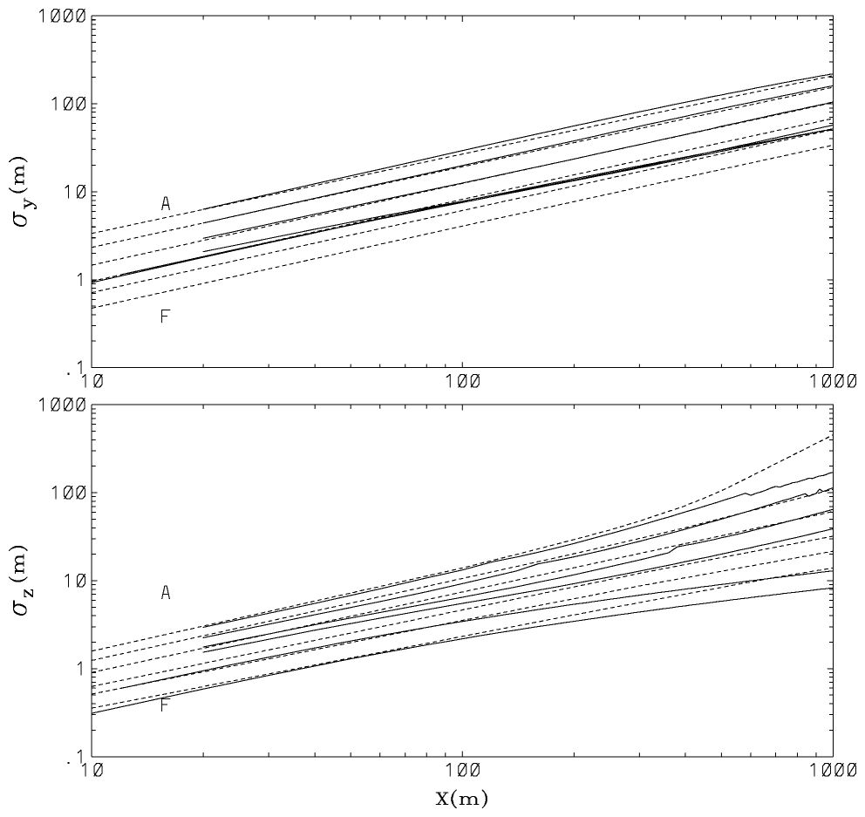
Figure 0-14. Comparison between SCIPUFF predictions (solid lines) and the PGT dispersion curves for categories A through F.

Model Data Archive.
The Model Data Archive (MDA), compiled by Sigma Research Corporation, is an extensive collection of field experiment data for both dense and passive tracer gas releases. The data set contains both continuous and instantaneous sources with different sampling times, and has been used to evaluate a number of existing atmospheric dispersion models (Hanna et al., 1991). Using the model coefficients defined from the preliminary test calculations, SCIPUFF has been compared with the test cases in the Model Data Archive (MDA). The experimental data are divided into a passive release set and a dense gas release set but we deal only with the passive cases here; the dense gas comparisons are described in Section 13.4.
The passive releases are relatively straightforward, since the only source parameters are the mass flow rate and the source size. The initial standard deviation of the puffs is set equal to the source radius for these releases, which include the Prairie Grass and Hanford data. The meteorology for the dispersion calculation was specified as a single wind speed at the appropriate observation height, together with a surface heat flux and a boundary layer depth, zi. The Prairie Grass data set includes an estimate of the Monin-Obukhov length, L, and the surface friction velocity, which directly provide a heat flux. The Hanford data includes a vertical temperature difference, which was used in conjunction with the wind speed to determine the surface heat flux. Measurements of the boundary layer depth were not available, so zi was set to 1000m for neutral and unstable cases, and to 5L for the stable cases.
The data specifies an averaging time for the concentration data, and both short and long duration measurements are included. The observed values represent the maximum recorded, over all sampling locations at a given distance and over the sampling period. For the long duration measurements, which usually correspond to the release duration, the model is run using the conditional dispersion mode, described in Section 2.2.5. The concentration sampling period, Tavg, is the appropriate averaging time for filtering the turbulence, and the centerline maximum prediction at the sampler downstream distance is then used for comparison.
For the short duration data, we use the statistical SCIPUFF prediction to estimate the expected value. When a short duration peak, say a 1-second average, is reported from a number of samplers over a sampling period, Tsample, it must be recognized that this is a random variable. For an idealized continuous release of infinite duration, we expect the maximum observed value to increase as the sampling period increases, since there is a higher probability of measuring an extreme value. In order to model the expected peak value, we use the predicted probability distribution for the centerline concentration, c0, using a turbulence filter of Tavg. If only one measurement (in time) of the maximum concentration over a number of sampler locations across the plume is made, then the expected value would be . However, if we sample for a longer time, then the expected value must increase since the chances of encountering a higher value are increased.
Suppose that the probability density function for c0 is such that
Then, if the maximum from N independent observations of c0 is denoted as cN, then
since all N observations must be less than X. If we can estimate N, therefore, we can determine the expected value of cN as the predicted value for the observed maximum concentration. N is estimated from the reduction in the concentration fluctuation variance with averaging time (Sykes, 1984). If we identify this reduction with the factor 1/N for the variance reduction from averaging N independent samples of a discrete variable, then we obtain
where and Tc is the integral timescale of the fluctuations.
The calculation procedure, therefore, is:
(1) reduce to account for the averaging time, Tavg,
(2) determine the clipped normal distribution P0(X) for the reduced variance,
(3) determine the exponent N from ,
(4) calculate the expected maximum value from the distribution PN.
This procedure is applied to the sampler time series to obtain the predicted maximum value.
Results for the overall comparison are shown in Figure 0-15, for the passive data sets. The overall agreement with the range of data is relatively good. Most of the predictions are within a factor of 2 of the observations, and there is reasonable skill in predicting the effect of time averaging on the maximum concentration. The values for two of statistical measures proposed by Hanna et al. (1991), the geometric mean and geometric variance are 0.952 and 1.263 respectively, indicating very small bias (<5%) and small variance.

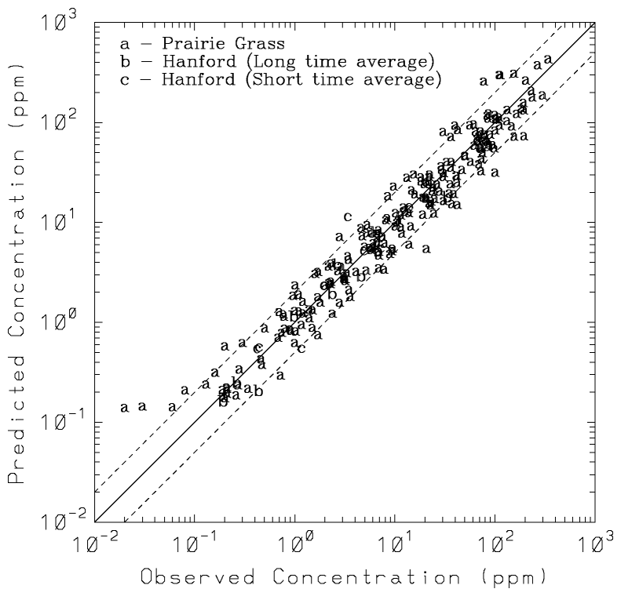
Figure 0-15. Comparison between the observed maximum concentrations and SCIPUFF predictions for the passive releases in the Model Data Archive. Various experiments are indicated by the letter codes.

Instantaneous Dispersion.
Several short-range instantaneous dispersion experiments have been compared with SCIPUFF predictions. These comparisons are presented in the paper by Sykes and Gabruk (1997) and are only briefly described here.
The first data comparison uses the ice crystal experiment results of Weil et al. (1993). A cluster of ice crystals was formed within a natural cloud by seeding with dry-ice pellets from an aircraft, and the evolution of the ice crystal cloud was then measured from the aircraft along with relevant turbulence statistics. Weil et al. present averaged results for the dimensionless cloud spread from an ensemble of about 25 releases, and the data are compared with the closure model prediction in Figure 0-16. We use an initial source size of 53m, which corresponds to the larger of the source sizes considered by Weil et al., and the data have been made dimensional using the observed average values, = 3.6m2s–2 and ε = 0.013m2s–3. We assume isotropic conditions to determine the other velocity variances, and the turbulence length scales are obtained from the dissipation rate (see Lewellen, 1977) as
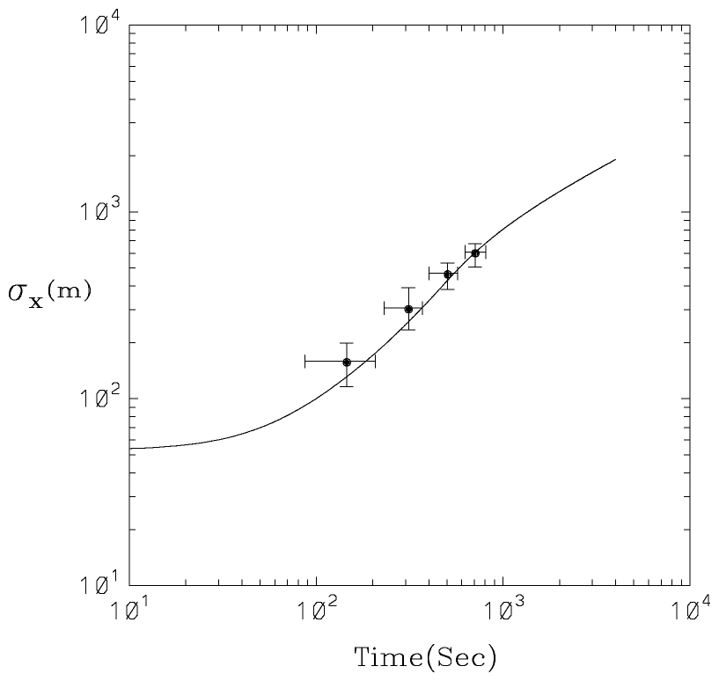
Figure 0-16. Comparison between SCIPUFF predictions and the observational data of Weil et al. (1993).
which implies = 341m for the Weil et al. data.
Figure 0-17 shows the SCIPUFF comparison with the data of Mikkelsen et al. (1987) for smoke dispersion in atmospheric surface layer. The lateral turbulent velocity variance, , was measured as 0.98m2s–2, and the Lagrangian integral time scale was estimated to be 100s from the measured Eulerian spectrum. The mean velocity at the plume height was 4.72ms–1. We again assume isotropic conditions for simplicity since the other turbulence components were not reported, although we note that this assumption is not strictly valid in the atmospheric surface layer. The length scale is derived from the Lagrangian time scale, which corresponds to Λ/Aq in the closure model, and the vertical and horizontal scales are assumed to be equal. The initial source size is taken to be 0.5m, corresponding to the larger value tested by Mikkelsen et al. The results are not sensitive to the assumption of isotropy, since we use the observed value of the Lagrangian time scale to determine the length scale. A test calculation using ΛS = 6.5m, as appropriate for a plume at z = 10m, and reducing the vertical velocity variance in accord with the –5/3 law, gave almost identical results to the isotropic calculation.
Figure 0-18 compares the closure model prediction with the neutral relative dispersion data of Högström (1964), as described by Sawford (1982). The release was made at 50m and there is considerable uncertainty with regard to the turbulence conditions. We follow Sawford in determining the effective length scale from the late-time dispersion measurements. We use a turbulence intensity of 0.1, as suggested by Sawford, and again assume isotropic conditions. Thus, = = = 0.01, and the length scales, ΛS and ΛV, were taken to be 16m. A source size of 1m was used in the calculation, since this is the midrange value considered by Sawford. The turbulence specifications enforce agreement with the data at late time, but the model does predict the proper early time growth of the plume.

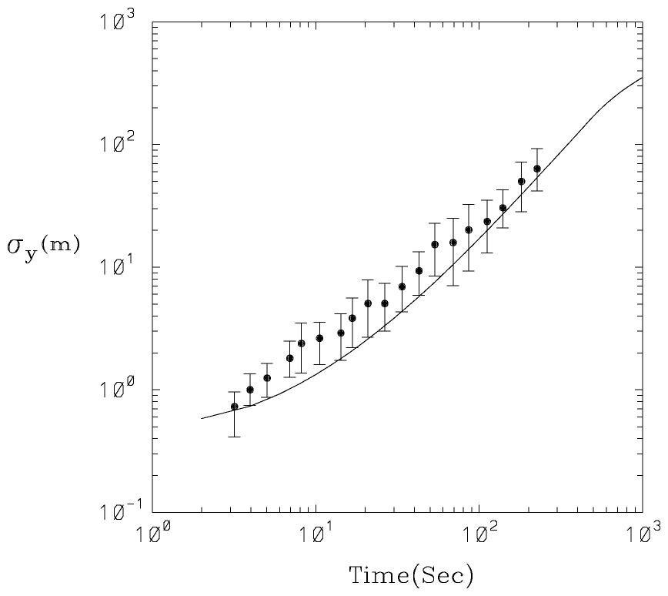
Figure 0-17. Comparison between SCIPUFF predictions and the observational data of Mikkelsen et al. (1987).

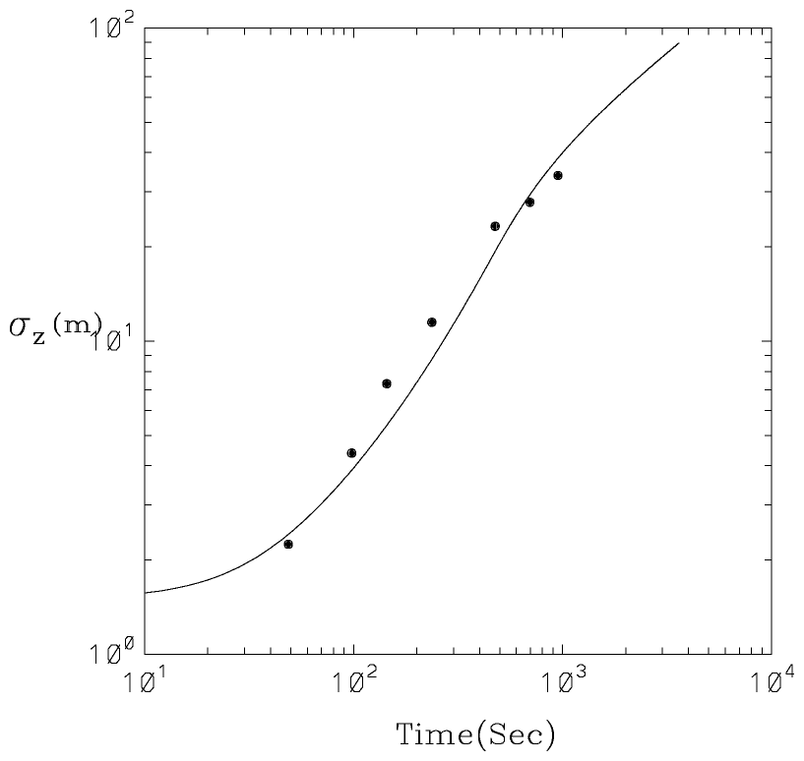
Figure 0-18. Comparison between SCIPUFF predictions and the observational data of Högström (1964).

CONFLUX.
SCIPUFF simulations were compared with data from the Concentration Fluctuation Experiments (CONFLUX) project of 1994 (Biltoft, 1995). Figure 0-19 and Figure 0-20 show the vertical profiles of mean concentration and standard deviation to mean concentration ratio of the CONFLUX data and SCIPUFF simulations.
In this field study, concentration time series were constructed from measurements of neutrally buoyant plumes in slightly convective to moderately stable meteorological conditions. All concentration data were obtained with a vertical array of 16 photoionization detectors at downwind locations between 12.5 and 100m. Contemporaneous measurements of wind velocity and temperature supplied the meteorological input needed to perform SCIPUFF simulations. We assumed isotropic conditions and partitioned the horizontal velocity variance into shear and buoyant components as described in Section 11.1, with length scales, ΛB and ΛS, of 250m and 0.65z, respectively. The shear component was determined from the observed shear stress, using , and the remainder of the horizontal energy was assigned to the buoyancy-driven component. A source size of 0.05m with a release height of 3m was used in the calculation. The sampling period of the concentration measurements was approximately 35 minutes, which was sufficiently long to sample most of the turbulent energy spectrum. Profiles of mean concentration and concentration variance were calculated by time averaging the data. SCIPUFF simulations were conducted in the conditional dispersion mode using a concentration averaging time, Tavg, equal to the measurement sampling period.
The comparisons indicate reasonably good agreement on the vertical dispersion rate, and concentration levels. Note that the scales are linear, so that most of the predictions are closer than a factor of 2. The concentration fluctuation intensity is also in good agreement with the observations, and high values are observed. This is due to the small source size, which produces a narrow plume that is meandered by the large atmospheric eddies. Both the magnitude and shape of the distribution is predicted accurately.

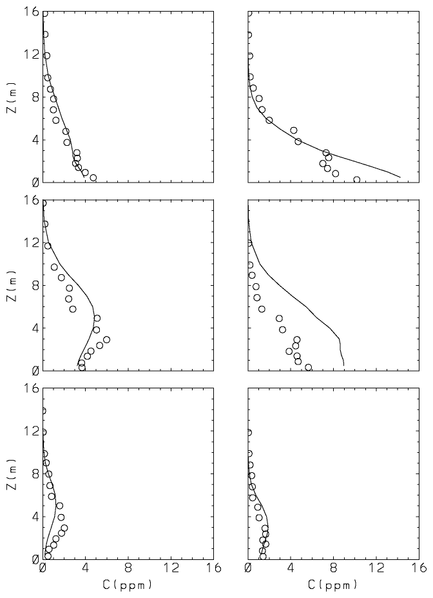
Figure 0-19. Comparison between SCIPUFF predictions of mean concentration and the observational data from CONFLUX 1994.
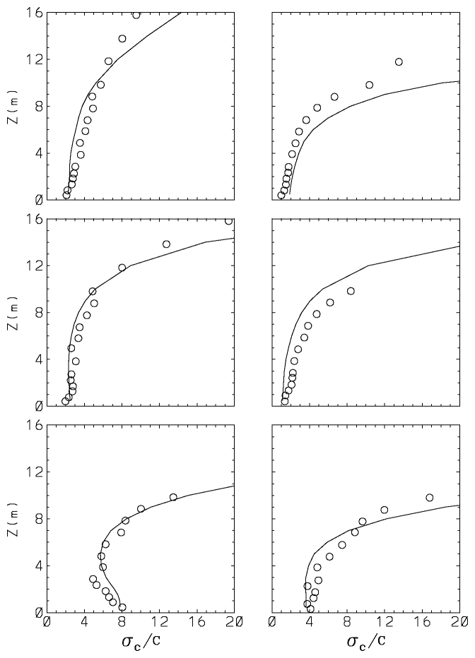
Figure 0-20. Comparison between SCIPUFF predictions of standard deviation to mean concentration ratio and the observational data of CONFLUX 1994.

LONG RANGE DIFFUSION.
SCIPUFF has been tested against two major long-range atmospheric dispersion experiments. First, the Across North America Tracer Experiment (ANATEX) comparisons were described by Sykes et al. (1993c). The published results were obtained using an earlier version of SCIPUFF, but the dispersion algorithms are effectively the same. A more sophisticated treatment of the different turbulence populations from the boundary layer and mesoscale has been implemented, as described in Section 2.1.3, but the longer range predictions are dominated by the mesoscale component and are not sensitive to the combination methodology.
The second experiment is the more recent European Tracer Experiment (ETEX) (Mosca et al., 1997). Figure 0-21 shows a comparison between a SCIPUFF simulation and ETEX data at several times after the start of the release. In this study, an inert tracer was released for 12 hours at an average rate of 7.95 gs⁻¹. The evolution of the tracer cloud was measured for a period of 72 hours (from the beginning of the release) with a sampling network of 168 sites. The meteorological input to SCIPUFF was the uninitialized, gridded analysis supplied by the European Centre of Medium Range Weather Forecasts (ECMWF). Additionally, turbulence input for the second-order closure model was specified as two separate populations, representing the planetary boundary layer eddies and the larger scale contribution. Boundary layer turbulence profiles were determined using the diurnal boundary layer calculation described in Section 10.2 with no cloud cover. We used a Bowen ratio of 0.6, and a surface albedo of 0.16; these values are typical of mid-latitude rural terrain, but clearly cannot represent the detailed variations over the dispersion domain. The large-scale turbulence represents the mesoscale fluctuations, and is based on the work of Gifford (1988).
The comparison with the observations shows that the location and shape of the cloud is reasonably well predicted as it travels across the continent, and the magnitude of the predicted surface concentration is also in reasonable agreement with the observed values. Figure 0-22 shows the measured concentration at a number of sampler locations and also the SCIPUFF prediction. The concentrations are averaged over 3 hour periods, and the time is shown relative to the start of the release. The agreement in arrival time and peak concentration magnitude is reasonably good.
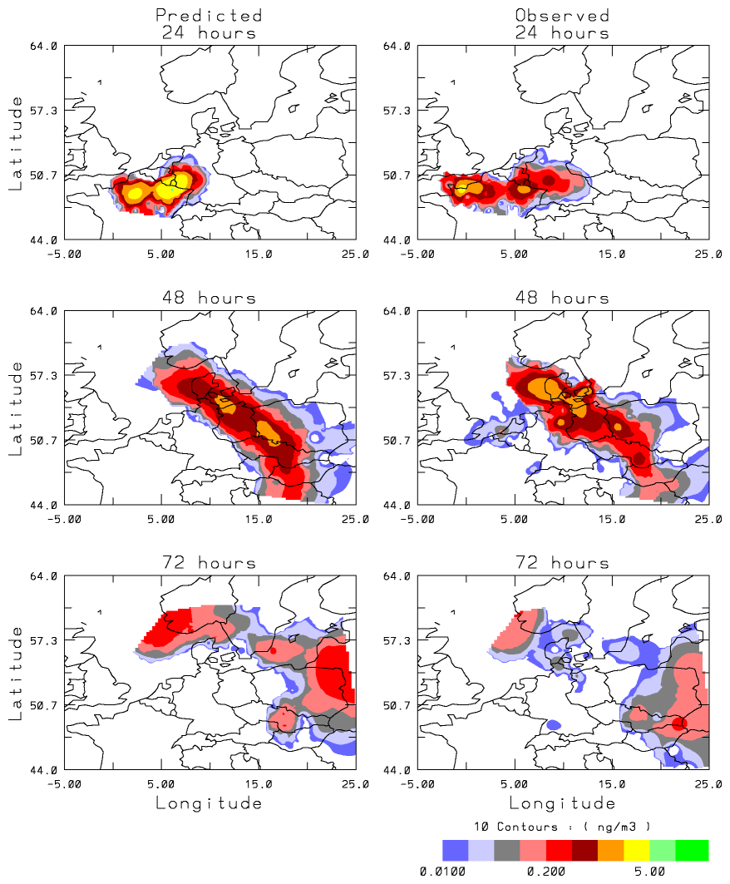
Figure 0-21. Comparison of mean concentration between SCIPUFF predictions and ETEX data (Mosca et al., 1997). Contours are 0.01, 0.02, 0.05, 0.1, 0.2, 0.5, 1, 2, 5, 10, 20, and 50 ngm⁻³.

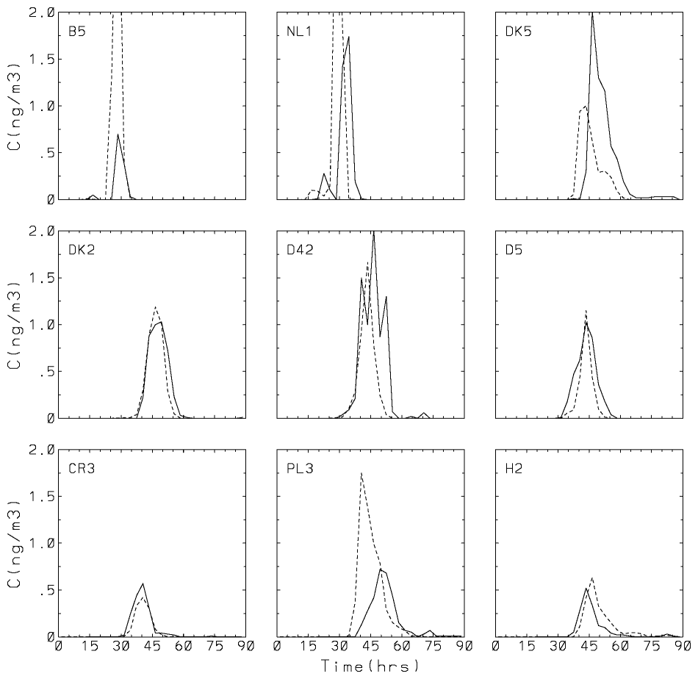
Figure 0-22. Comparison between 3-hr average concentrations from SCIPUFF predictions (dashed) and ETEX data (solid line) at 9 selected locations (Mosca et al., 1997). Concentration is in ngm⁻³.
The 9 stations were chosen from the two sampler arcs analyzed by Mosca et al., showing passage of the plume at roughly 24 hours and 48 hours. Only 2 samplers from the middle of the first arc are shown; there are 2 other samplers on this arc but they generally showed the poorest model performance. The reason for this is apparently that the actual plume moved further to the North than predicted by the given wind field. Most of the models underpredict the Northern station and overpredict the Southern station, and we note that the SCIPUFF results are consistent with this trend although they are not shown here.
The results shown in the Figure 0-22 are not identical to the SCIPUFF predictions reported by Mosca et al. (1997), since an older version of the model was used there. However, the ETEX predictions have not been changed significantly by the model enhancements, so some comment on the relatively low ranking of SCIPUFF by Mosca et al. is in order. The official model evaluation exercise reported by Mosca et al. uses a number of statistical measures to compare observations and predictions. The two measures that influenced the ranking of SCIPUFF most adversely were the bias and normalized mean square error (NMSE). These measures are defined as
where
are the mean measured and predicted values, respectively. N is the number of observations, and the subscript i denotes individual samplers.
The difficulty with these measures is the lack of normalization of the concentrations, so that errors in the large values can dominate the statistics. In the SCIPUFF predictions, the sampler location closest to the release completely determines these two statistics, since it contains the highest observations and SCIPUFF overpredicts the values. The sampler at Rennes, which is about 20km east of the source, is located close to the centerline of the predicted plume, and therefore receives a high concentration. The meteorological data provided for the calculation also lacked a boundary layer description, so the early plume development is strongly influenced by the model choice for the boundary layer. Since SCIPUFF does not routinely accept the ECMWF data as input, and no special effort was made to develop an interface, the boundary layer description was relatively uncertain.
Table 0-5 shows the two statistics computed for all the samplers and also with the Rennes sampler omitted. The numbers are not identical to those reported by Mosca et al., but illustrate the effect of this one location on a very similar SCIPUFF prediction. The total number of samplers was 168, so the influence of Rennes is clearly disproportionate. The bias and NMSE without Rennes data lies well within the range of the other models used in the ETEX study, although it is noted that the reported statistics all contain the Rennes data so we cannot directly compare these values with the report. The conclusion of Mosca et al. that SCIPUFF overpredicts the concentration is obviously restricted to the Rennes location; there is very little bias for the remainder of the data.

Table 0-5. Statistical measures for the SCIPUFF prediction of ETEX data.
 | (ngm⁻³) | Bias (ngm⁻³) | NMSE
All ETEX data | 0.212 | 1.59 | 2160
Rennes omitted | 0.193 | 0.06 | 14.8

DYNAMIC RISE EFFECTS.
The vertical rise dynamics in SCIPUFF has been validated principally against idealized laboratory experiments or in comparison with well-accepted empirical relations based on laboratory and field experiments. These include momentum jets in a crossflow, buoyant plumes in neutral or stable temperature gradients with a crossflow and buoyant spherical bubbles released into a neutrally-stable quiescent background.

Momentum Jet.
The first experiments considered are momentum jets (no buoyancy) in a crossflow. Gordier (1959) (from Hirst, 1971) presents near-source data for a variety of exit velocity ratios, , where Ua is the crossflow velocity and W0 is the jet exit velocity. The jet source in SCIPUFF is characterized by a momentum flux Fm and Gaussian spread σ0, so that W0 is estimated by assuming an initially uniform velocity distribution such that where r₀ is the source radius. [Fm is related to the SCIPUFF momentum flux Q_{m} by ]. We assume that . A comparison with the mean jet centerline data of Gordier is shown in Figure 0-23. SCIPUFF tends to under-predict the jet heights; this is particularly so near the source, but the discrepancies tend to decrease with downstream distance. The high R data show much less downstream displacement of the jet close to source; this is probably due to distortion of the background flow, a phenomenon not included in the SCIPUFF model.
The asymptotic behavior of the momentum jet far downstream is also of interest and here we compare SCIPUFF with the well-known expression (see Weil, 1988 or Briggs, 1975)

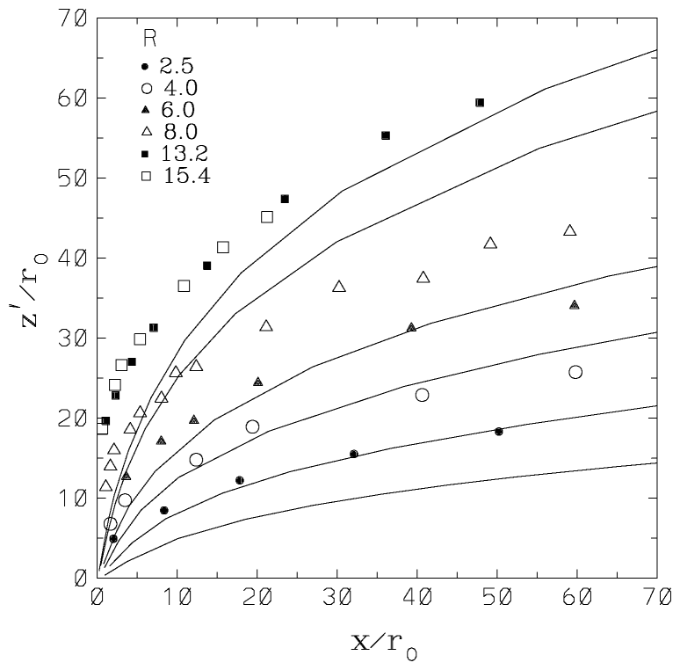
Figure 0-23. Momentum (non-buoyant) jet centerline height, , as a function of downstream distance for a range of R. Symbols are the data of Gordier (1959) - from Hirst (1971); solid lines are the SCIPUFF predictions.
where x is downstream distance, is the jet centerline height above the source, β is an empirical entrainment constant typically set to 0.6 and the momentum length scale . Figure 0-24 shows the SCIPUFF calculations for three exit velocity ratios compared with . It can be seen that, while there is naturally some initial dependence on R, the three cases show the same asymptotic behavior. The model predictions are consistent with the one-third power law but indicate a value for β around 0.5.

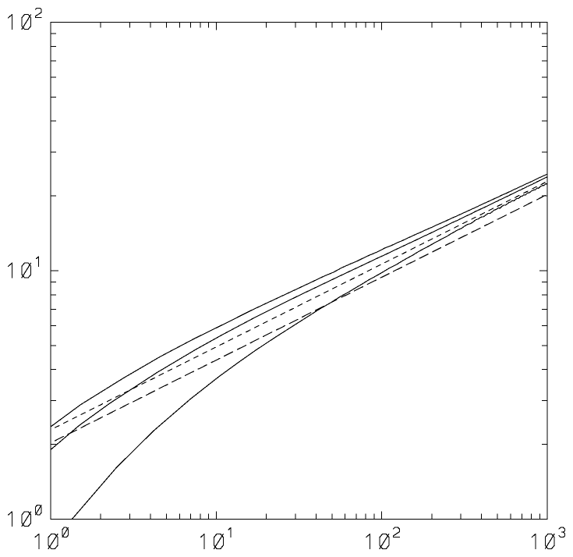
R=15.4
R=8.0
R=2.5
SCIPUFF
“One third” law β =0.5
“One third” law β =0.6
Figure 0-24. Comparison between SCIPUFF predictions of momentum jet centerline heights for a range of R (solid lines) and the “one-third” law, , with two values of β (short dashes, β = 0.6; long dashes, β = 0.5).

Buoyant Plume.
For a buoyancy-dominated plume in a neutral background, the plume height is given by the “two-thirds” power law (Briggs, 1975):
where the buoyancy length scale is given by . The buoyancy flux, Fb, is defined as where is the source temperature perturbation relative to the ambient temperature Ta. [Fb is related to the SCIPUFF buoyancy flux Q_{T} by ]. The “two-thirds” law has been shown to compare well with numerous field and laboratory data (Briggs, 1975). The “one-third” and “two-thirds” laws are essentially limiting cases of a more general expression. Thus, for plumes with significant buoyancy and momentum fluxes, the trajectory is given by
which reduces to for and to with . A comparison of with the SCIPUFF predictions for a range of buoyancy fluxes and source sizes is shown in Figure 0-25. As expected, there are some discrepancies near the source, but the agreement with the two-thirds law is excellent further downstream.
Plume rise in a uniformly stratified environment (N2 = a positive constant) has been investigated by Briggs (1975) who gives the following expression, which accounts for the “added mass” due to the displacement of ambient fluid by the plume:
for where , and kv is the added mass coefficient (set to 1, the value for a circular cylinder). Based on an extensive survey of field and laboratory data, Briggs (1975) also determined an empirical expression for the “final” plume rise in stable air as
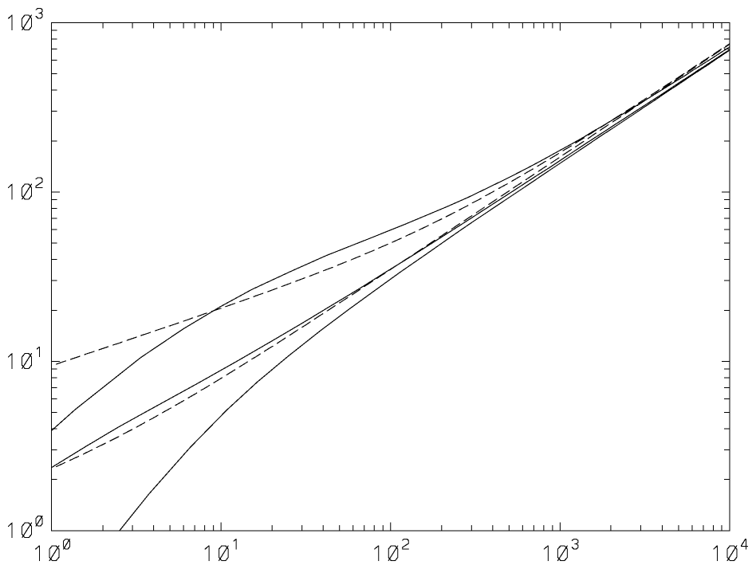
A
B
C
SCIPUFF
Theory
Figure 0-25. Comparison between SCIPUFF predictions for buoyancy-dominated jet centerline heights (solid lines) and theory given by (dashed lines). Case A: R = 10, ; Case B: R = 10, ; Case C: R = 1, .
SCIPUFF predictions for a range of buoyancy fluxes and N compare quite favorably with and , as shown in Figure 0-26.

Buoyant Puff.
The plume rise relations just presented are based on extensive laboratory and field experiments and are universally accepted, at least under the idealized conditions assumed. In contrast, the paucity of data for short duration or nearly instantaneous buoyant releases precludes any generally accepted simple formulae. The only data we currently can compare SCIPUFF with come from experiments on the rise of light density spherical bubbles conducted in the early 1970’s under DNA sponsorship (Mantrom and Haigh, 1973). These tests involved the release of helium bubbles in air or N2 bubbles in SF₆ for a range of Reynolds numbers. The backgrounds were neutrally stratified and quiescent. For large enough Reynolds numbers, the bubble rise data generally collapse to a single curve of vs. where, is the bubble centroid height above its release point, D0 is the initial mean bubble diameter and t is time after release. The SCIPUFF predictions are compared with the data in Figure 0-27. Two releases are considered for the model calculations, the first using a single spherical puff with an initial Gaussian spread equal to the bubble radius while the second uses 136 puffs in an attempt to model explicitly an initial spherical bubble with a uniform mass distribution. It can be seen that the agreement with the data is generally quite good for both releases, although the multi-puff calculation tends to under-predict the bubble rise slightly. The late time behavior in both the data and model calculations seems consistent with a power law exponent slightly less than two-thirds.

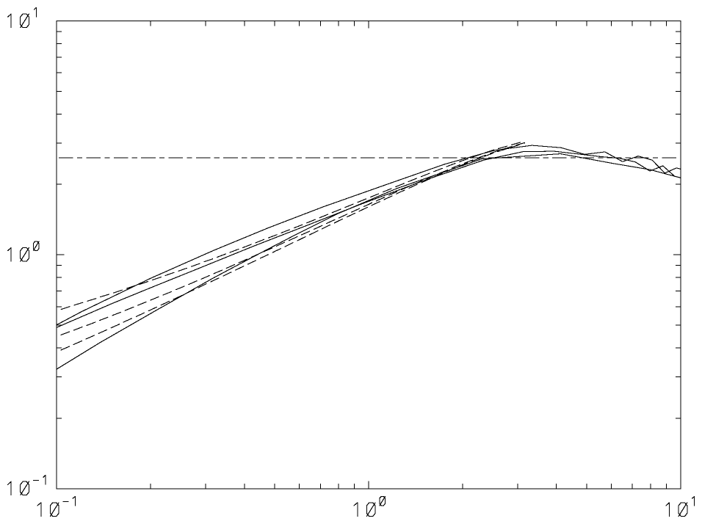
A
C
B
SCIPUFF
Theory
Final Rise
Figure 0-26. Comparison of SCIPUFF buoyancy-dominated jet centerline heights in a uniformly stratified background (solid lines) with (dashed lines). For all cases, R = 10. Case A: , ; Case B: ,; Case C: , .
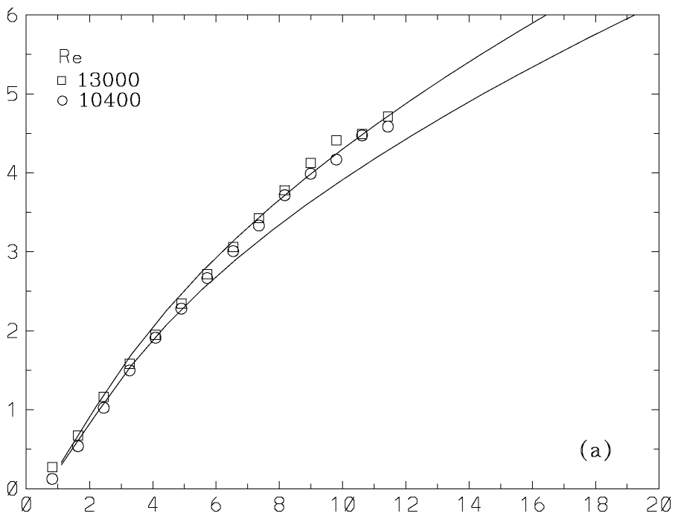
A
B
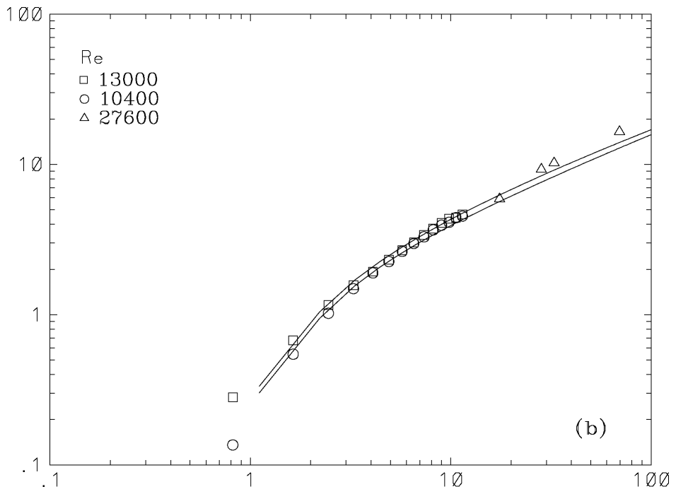
A
B
Figure 0-27. Centroid height of a light bubble released into a neutral quiescent background. Symbols are the data of Mantrom and Haigh (1973), solid lines are the SCIPUFF predictions. The Reynolds number for the experiments is based on the initial bubble diameter and the terminal velocity of a corresponding non-entraining sphere. Case A is for a single puff release with a Gaussian spread of D₀/2; Case B is for a release comprised of 136 puffs representing a uniform distribution of mass within a spherical bubble of diameter D₀. (a) Early time behavior; (b) expanded scale showing late time behavior.

DENSE GAS EFFECTS.
The Model Data Archive (MDA), discussed in Section 13.1.2, also contains a dense gas release set comprised of several experiments. The dense releases include evaporating pools (Burro, Coyote, and Maplin Sands experiments), continuous plumes and instantaneous clouds of heavy gas (Thorney Island) and two-phase aerosol jets (Desert Tortoise and Goldfish).
The Thorney Island tests used Freon gas and involved no evaporative effects, so the mass and mass fluxes were used directly for the continuous and instantaneous releases respectively. The standard deviations were set to 75% of the specified source diameter.
For evaporating pools, we use a lateral standard deviation equal to 75% of the specified pool radius and a vertical standard deviation of 0.5m for all cases. The vertical size is chosen arbitrarily to represent a typical vertical growth during transport across the pool, and results are not sensitive to the precise value. The initial buoyancy flux was determined from the given mass flux and the difference between the gas boiling temperature and the ambient value. We assume that the vaporizing material is released at the boiling point, so that the buoyancy flux is
where cp is the specific heat, Tb is the boiling point, Ta is the air temperature, and Q is the mass flow rate.
The Desert Tortoise and Goldfish releases involve a two-phase aerosol jet and exothermic reaction with the environment. Since SCIPUFF does not contain a model for aerosol evaporation, and also the thermodynamics of the reactions were not prescribed, any model result will depend significantly on the choice for initial buoyancy conditions. We use a simplified representation, modeling the source jet as an expanding 7º cone until the sufficient air has been entrained to evaporate the liquid aerosol. The SCIPUFF source is then initialized at this downstream location at the boiling temperature. The initial size is chosen to match the area implied by the expanding cone but with a horizontal spread that is twice the vertical. This procedure is similar to that used by Hanna et al. (1991) for other models that do not address the phase change effects.
The meteorology was specified in the same way as for the passive releases, except that no surface heat flux information was available for the Thorney Island continuous releases. For these cases, the estimate of the Monin-Obukhov length provided by Hanna et al. (1991) as input for the SLAB model was used.
The effects of time averaging were accounted for as described in Section 13.1.2, and the predicted centerline maxima are compared with the MDA observations in Figure 0-28. Agreement with the observations is slightly better the passive releases shown in Figure 0-15; the geometric mean is 1.098 and the geometric variance is 1.355.
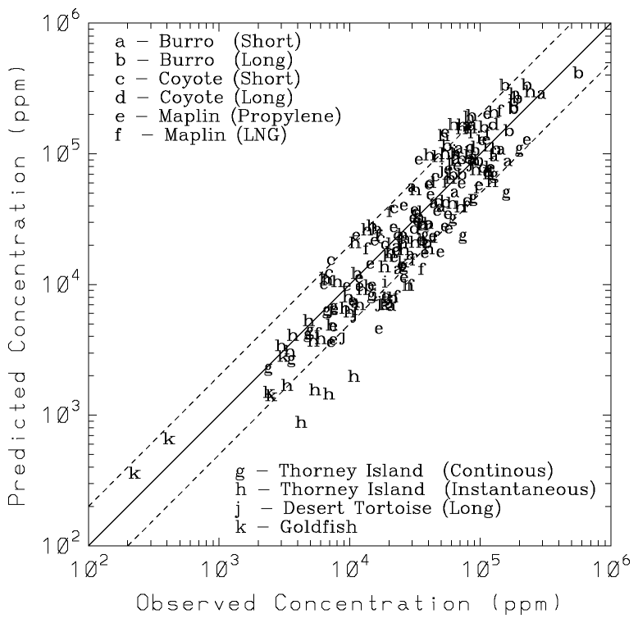
Figure 0-28. Comparison between the observed maximum concentrations and SCIPUFF predictions for the dense gas releases in the Model Data Archive. Various experiments are indicated by the letter codes.

CHEMICAL TRANSFORMATIONS
In 1998 and 1999, the Tennessee Valley Authority (TVA), the Department of Energy National Energy Technology Laboratory (DOE-NETL), and EPRI conducted an extensive study of secondary pollutant formation downwind of the Cumberland Power plant (Tanner et al. 2002). The TVA helicopter made multiple traverses to collect samples of the Cumberland plume at various downwind distances.
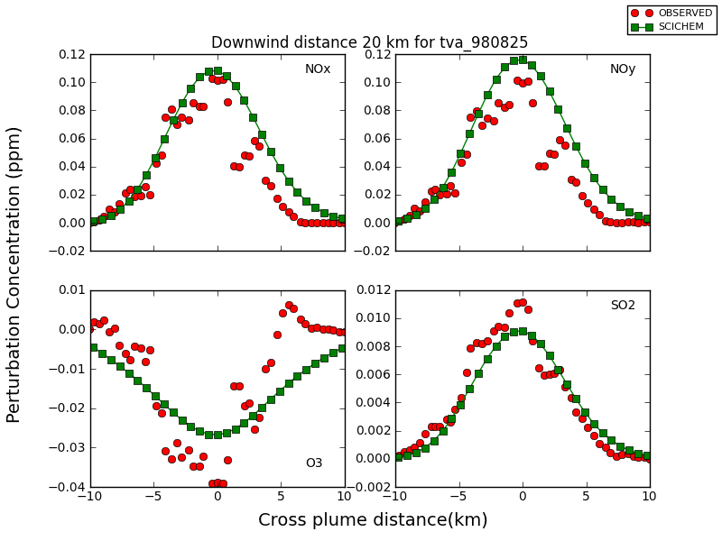
The SCICHEM model is used to simulate the Cumberland plume events and compare the results with helicopter measurements on the 25th and 26th of August, 1998 and the 6th and 15th of July, 1999. The simulations were run for a period of 17- 24 hours starting at midnight for a 300km x 300km x 2km domain. The profiler meteorological data from Cumberland was used for the 1998 simulation (Figure 0-29 - Figure 0-32) and the metrological data from Dickson (30 miles SE) was used for the 1999 simulation (Figure 0-33 - Figure 0-36).

Figure 0-29: Results for plume 5 at 20 km on August 25, 1998

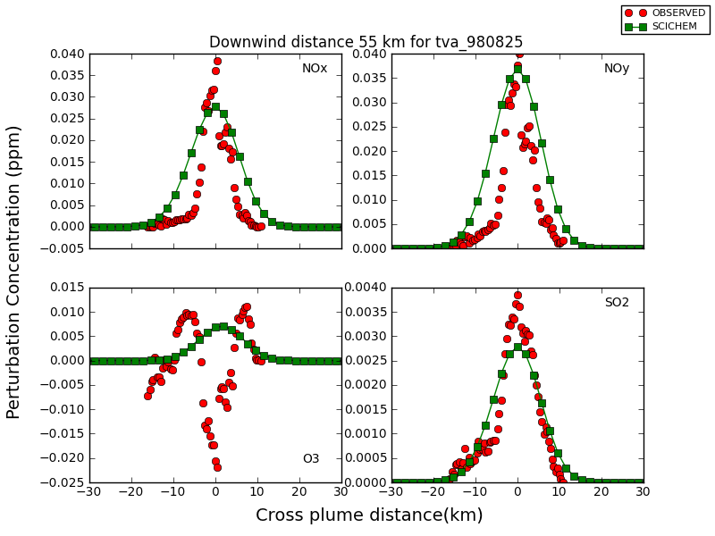
Figure 0-30: Results for plume 7 at 55 km on August 25, 1998

Average hourly emissions were obtained from Continuous Emission Monitoring Systems (CEMS) data and the values are presented in Table 0-6. The species used in the comparison study were SO₂, NO_{x} (NO and NO₂), NO_{y} (NO, NO₂, NO₃, N₂O₅, HNO₃, HONO and PAN) and O₃. The preliminary SCICHEM results are compared at the mean time and height, with the average observed concentrations at various downwind distances. There was some deviation in the observed and modeled plume centerlines due to the difference between the actual and modeled wind fields. So, for ease of comparison, the plume centerlines are aligned with each other. To remove any differences due to the species background, the cross plume concentration perturbation are compared, where the perturbation is the difference between the actual plume concentration and the background or ambient concentration.

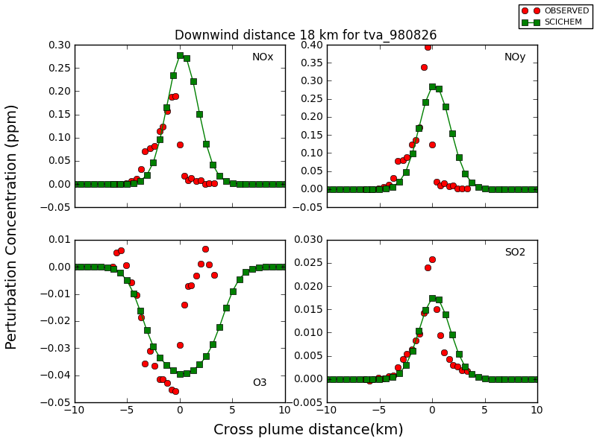

Figure 0-31: Results for plume 2 at 18 km on August 26, 1998
The evolution of the plume chemistry for a power plant plume has been studied extensively (Sillman et al. 2000; Ryerson et al. 2001) and the factors influencing the ozone production efficiency are well documented. Some of the important factors affecting the formation of ozone are the meteorological conditions such as boundary layer height, emission rates and the NO_{x} to volatile organic compound (VOC) ratios.
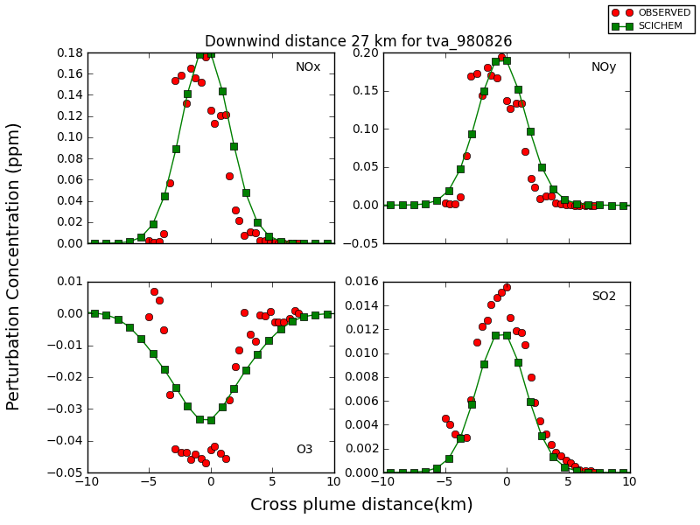

Figure 0-32: Results for plume 4 at 27 km on August 26, 1998

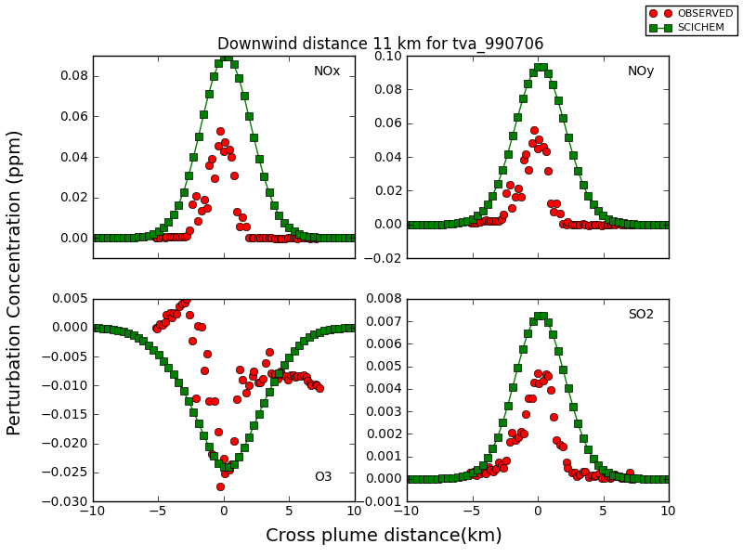
Figure 0-33: Results for plume 2 at 11 km on July 6th, 1999

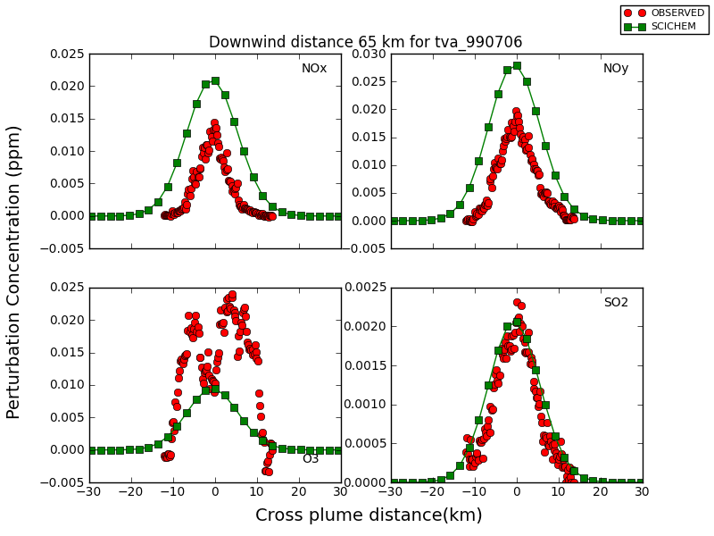
Near the source, the background O₃ is scavenged by the excess NOx in the plume, resulting in plume concentrations that are lower than the background. This plume behavior is captured by the model simulation as seen from the concentrations perturbation plots of the different species near the source in Figure 0-29,Figure 0-31,Figure 0-35 and Figure 0-33.
Figure 0-34: Results for plume 9 at 65 km on July 6th, 1999

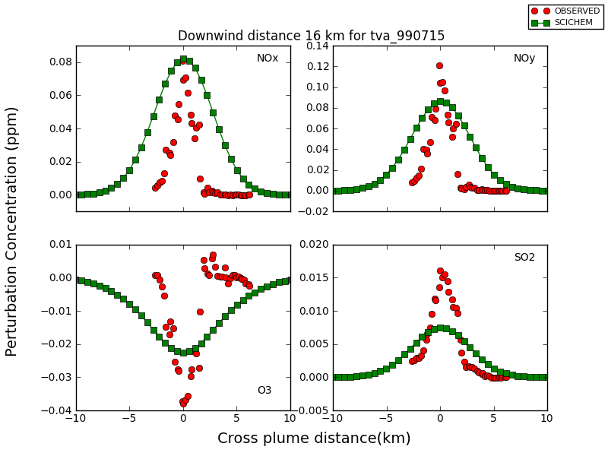

Figure 0-35: Results for plume 2 at 16 km on July 15th, 1999
At this distance, there are large uncertainties in the measured values for the different traverses, especially for the nitrate species, due to the difficulty in measuring the concentrations for these species (Luria et al. 2000). The model predicted values at these distances differ from the mean observed concentration but the values are within 1 standard deviation. Further downwind, at distances greater than 30 km, the NO_{x} to VOC ratios are more favorable for O₃ production but the levels of O₃ still stay below the ambient levels. From Figure 0-32, we can see that the SCICHEM model predicts depletion of O₃ concentration in the plume center and that the minimum predicted values matched the observed minimums. However at these distances, the observed O₃ concentrations show wing-like structures that are formed due to the difference in NO_{x} concentrations at the edge of the plume and the plume center. In SCICHEM, the puff splitting is based on the meteorology and the puff resolution is adapted to the appropriate length scale for computational efficiency. Using the default resolution, the plume cross section is represented by a fewer number of Gaussian puffs and hence the model is unable to capture the non-Gaussian shape of the wings at the plume edges. As the plume moves further downwind, VOC entrainment leads to the production of excess O₃ as shown by the predicted and observed values in Figure 0-34 and Figure 0-36.
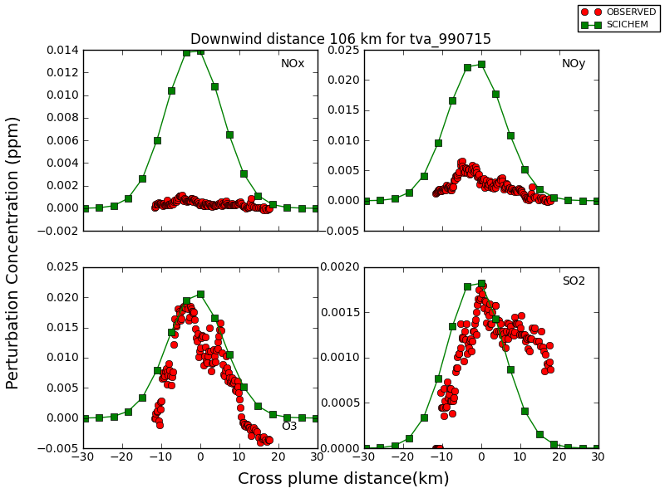

Figure 0-36: Results for plume 11 at 106 km on July 15th, 1999
The downwind distance at which the ozone production starts is sensitive to the VOC concentration, such as isoprene that is emitted from biogenic sources (Ryerson et al. 2001). Similarly, the background concentration values of radical species such as OH and HO₂ also play a vital role in determining the ozone production efficiency. The range of concentrations in the background for VOC and radical species are very broad as they depend on various conditions such as the temperature, cloud cover etc. For isoprene, the background concentration values can range from 1.5 ppb to 10 ppb near the surface to lower values at higher altitude (Luria at al. 2000). Similarly, the background OH and HO₂ concentration as reported by Martinez et al. (2003) varied day to day during the 1999 Southern Oxidant Study at Nashville. Hence, some of the difference in the predicted and observed values can be attributed to incorrect or varying VOC and OH background concentrations as well as measurement errors in recording the observations. Another factor that influences the width of the predicted plume is dependent on the large scale variances in the troposphere. The large scale variance is a function of, the tropospheric energy dissipation rate which varies over a wide range of values as reported by Siebert, H. et al. (2006). In this study we found that the lower values of provided a better estimate of the plume width.

Date | SO₂ (Tonnes/hr) | NO_{x}(Tonnes/hr)
08/25/1998 | 2.5 | 15.2
08/26/1998 | 2.0 | 15.8
07/06/1999 | 1.1 | 6.7
07/15/1999 | 2.1 | 11.5

Table 0-6: Average hourly emissions data

References
Arellano, J. V.-G. de, A. M. Talmon and P. J. H. Builtjes (1990), "A chemically reactive plume model for the NO-NO2-O3 system", Atmos. Environ., 24A, 2237-2246.
Bange, P., L. H. J. M. Janssen, F. T. M. Nieuwstadt, H. Visser, and J. J. Erbrink (1991), "Improvement of the modelling of daytime nitrogen oxide oxidation in plumes by using instantaneous plume dispersion parameters", Atmos. Environ., 25A, 2311-2328.
Bass, A. (1980), "Modelling long range transport and diffusion", Second Joint Conf. on Appl. of Air Poll. Met., AMS & APCA, New Orleans, LA, pp193-215.
Biltoft, C. A. (1995), "Surface effects on concentration fluctuation profiles", Joint Contact Point Directorate, Dugway Proving Ground, DPG/JCP-95019.
Boris, J. (1986), "A vectorized 'near neighbors' algorithm of order N using a monotonic logical grid", J. Comp. Phys., 66, 1-20.
Briggs, G. A. (1975), "Plume rise predictions", Lectures on Air Pollution and Environmental Impact Analysis, 59-111, ed. D. A. Haugen, Am. Met. Soc., Boston MA.
Businger, J. A. (1973), "Turbulent transfer in the atmospheric surface layer", Workshop on Micrometeorology, ed. D. A. Haugen, American Meteorological Society, Boston, MA.
Businger, J. A. (1986), "Evaluation of the accuracy with which dry deposition can be measured with current micrometeorological techniques", J. Clim. & Appl. Met., 25, 1100-1124.
Byun, D. W. and F. S. Binkowski (1991), "Sensitivity of RADM to point source emissions processing", Proceedings of the 7th Joint Conference on the Applications of Air Pollution Meteorology with the Air and Waste Management Association, January 14-18, 1991, New Orleans, LA.
Carson, D. J. (1973), "The development of a dry inversion-capped convectively unstable boundary layer", Quart. J. Roy. Met. Soc., 99, 450-467.
Carson, D. J. and P. J. R. Richards (1978), "Modelling surface turbulent fluxes in stable conditions", Boundary-Layer Met., 14, 67-81.
Chamberlain, A. C. (1967), "Transport of Lycopodium spores and other small particles to rough surfaces", Proc. Roy. Soc., 296A, 45-70.
Clark, T. L. (1977), "A small-scale dynamic model using a terrain-following coordinate transformation", J. Comp. Phys., 24, 186-215.
Coats, C. J. (1996), "High performance algorithms in the Sparse Matirx Operator Kernel Emissions Modeling System (SMOKEMS) for mesoscale air quality modeling in EDSS", Proceedings of the 9th Joint Conference on the Applications of Air Pollution Meteorology with the Air and Waste Management Association, January 28-February 2, 1996, Atlanta, GA.
Davidson, C. I., J. M. Miller and M. A. Pleskow (1982), "The influence of surface structure on predicted particle dry deposition to natural grass canopies", Water Air Soil Pollut., 18, 25-43.
Deardorff, J. W. (1970), "Convective velocity and temperature scales for the unstable planetary boundary layer and for Rayleigh convection.",
J. Atmos. Sci., 27, 1211-1213.
Deardorff, J. W. (1980), "Progress in understanding entrainment at the top of a mixed layer", Workshop on the Planetary Boundary Layer, Amer. Meteor. Soc., 36-66.
Donaldson, C. du P. (1973), "Atmospheric turbulence and the dispersal of atmospheric pollutants", AMS Workshop on Micrometeorology, ed. D. A. Haugen, Science Press, Boston, pp313-390.
Egan, B. A. and J. R. Mahoney (1972), "Numerical modeling of advection and diffusion of urban area source pollutants", J. Appl. Met., 11, 312-322.
Etling, D. (1990), "On plume meandering under stable stratification",
Atmos. Env., 24A, 1979-1985.
Fackrell, J. E. and A. G. Robins (1982), "Concentration fluctuations and fluxes in plumes from a point source in a turbulent boundary layer",
J. Fluid Mech., 117, 1-26.
Friedlander, S. K. (1977), "Smoke, Dust and Haze", Wiley, New York, 317pp.
Fuchs, N. A. (1964), "The Mechanics of Aerosols", Pergamon, New York.
Gabruk, R. S., R. I. Sykes, C. Seigneur, P. Pai, P. Gillespie, R.W. Bergstrom and P. Saxena (1998), "Evaluation of the reactive and optics model of emissions (ROME) ", Atmos. Environ., 33, 383-399.
Gautney (1998), Personal Communication.
Gifford, F. A. (1959), "Statistical properties of a fluctuating plume dispersal model", Adv. Geophys., 6, 117-137.
Gifford, F. A. (1988), "A similarity theory of the tropospheric turbulence energy spectrum", J. Atmos. Sci., 45, 1370-1379.
Gillani, N. V., J. F. Meagher, R. J. Valente, R. E. Imhoff, R. L. Tanner, and M. Luria (1998), "Relative production of ozone and nitrates in urban and rural power plant plumes 1. Composite results based on data from 10 field measurements days", J. Geophys. Res., 103, 22593-22615.
Gillani, N. V. and J. E. Pleim (1996), "Sub-grid-scale features of anthropogenic emissions of NOx and VOC in the context of regional eulerian models", Atmos. Environ., 30, 2043-2059.
Gordier, R. L. (1959), "Studies on fluid jets discharging normally into moving liquid", St. Anthony Falls Hyd. Lab., University of Minnesota, 28, Series B.
Hanna, S. R. (1983), "Lateral turbulence intensity and plume meandering during stable conditions", J. Clim. Appl. Met., 22, 1424-1431.
Hanna, S. R., D. G. Strimaitis and J. C. Chang (1991), "Hazard response modeling uncertainty (a quantitative method). Volume II. Evaluation of commonly-used hazardous gas dispersion models", Air Force Engineering and Service Center.
Henn, D. S., R. S. Gabruk, S. F. Parker and R. I. Sykes (1995), "CLOUDTRANS: A TASS and DIAL-A-CLOUD Output Translator Code", Defense Nuclear Agency, DNA-TR-94-85.
Hindmarsh, A. C.(1983), "ODEPACK: a systematized collection of ODE solvers", in Numerical Methods for Scientific Computing (edited by Stepleman, R.S., et al.), p. 55-64, North-Holland, New York.
Hirst, E. A. (1971), "Analysis of round, turbulent, buoyant jets discharged to flowing stratified ambients", Oak Ridge National Laboratory, ORNL-4685.
Högström, U. (1964), "An experimental study on atmospheric diffusion", Tellus, 16,
205-251.
Holtslag, A. A. (1984), "Estimates of diabatic wind speed profiles from near-surface weather observations", Boundary-Layer Met., 29, 225-250.
Holtslag, A. A. M. and A. P. van Ulden (1983), "A simple scheme for daytime estimates of the surface fluxes from routine weather data",
J. Clim. & Appl. Met., 22, 517-529.
Horn, H.-G., M. Maqua and H. Bonka (1988), "Nasse und trockene Ablagerung radioaktiver Stoffe auf die Vegetation und den Erdboden", Schriftenreihe Reaktorsicherheit und Strahlenschutz Der Bundesmeminister für Umwelt, Naturschultz und Reaktorsicherheit.
Houyoux, M. R., C. Coats, A. Eyth, and S. Lo (1996), "Emissions modeling for SMRAQ: A seasonal and regional example using SMOKE", Proceedings, Computing in Environmental Resources Management, Dec. 2-4, 1996, Research Triangle Park, NC, Air and Waste Management Association, pp. 555-566.
Houyoux, M. R. (1998), "Plume rise algorithm summary for the Sparse Matrix Operator Modeling System (SMOKE)", MCNC Technical Report, ENV-98TR004-v1.0.
Imhoff, R. E, Personal communication (1998).
Jayson G.G., Parsons B.J., and Swallow A.J.,(1973). "Some simple, highly reactive, inorganic chlorine derivatives in aqueous-solution". Trans. Faraday Soc. 69, 1597-1607.
Karamchandani, P., A. Koo and C. Seigneur,(1998). "A reduced gas-phase kinetic mechanism for atmospheric plume chemistry", Environ. Sci. Technol., 32, 1709-1720.
Kasten, F. and G. Czeplak (1989), "Solar and terrestrial radiation dependent on the amount and type of cloud", Solar Energy, 24, 177-189.
Kato, H. and O. M. Phillips (1969), "On the penetration of a turbulent layer into a stratified fluid", J. Fluid Mech., 37, 643-655.
Kim, Y. P., J. H Seinfeld, and P. Saxena (1993a), "Atmospheric gas aerosol equilibrium, I: thermodynamic model", Aerosol Sci. Technol., 19, 157-181.
Kim, Y. P., J. H Seinfeld, and P. Saxena (1993b), "Atmospheric gas aerosol equilibrium, II: analysis of common approximations and activity coefficient calculation methods", Aerosol Sci. Technol., 19, 182-198.
Kim, Y. P and J. H. Seinfeld (1995), "Atmospheric gas-aerosol equilibrium III: thermodynamics of crustal elements Ca²⁺, K⁺, and Mg²⁺", Aerosol Sci. Technol., 22, 93-110.
Klebanoff, P. S. (1955), "Characteristics of turbulence in a boundary layer with zero pressure gradient", Nat. Adv. Ctee. Aero., Wash., Report no.1247.
Launder, B. E., G. J. Reece and W. Rodi (1975), "Progress in the development of a Reynolds-stress turbulence closure", J. Fluid Mech., 68, 537-566.
Le Henaff, P.,(1968). "Methodes d'etude et proprietes des hydrates, hemiacetals et hemiacetals derives des aldehydes et des cetones", Bull. Soc. Chim. Fr., 4687-4700.
Lewellen, W. S. (1977), "Use of invariant modeling", Handbook of Turbulence,
ed. W. Frost and T. H. Moulden, Plenum Press, pp237-280.
Lewellen, W. S. (1981), "Modeling the lowest 1km of the atmosphere", AGARD, AGARD-AG-267.
Lewellen, W. S. (1985), "Modeling turbulent exchange in forest canopies", The Forest-Atmosphere Interaction, ed. B. A. Hutchison and B. B. Hicks, D. Reidel, Dordrecht, pp481-499.
Lewellen, W. S. and Y. P. Sheng (1980), "Modeling of dry deposition of SO2 and sulfate aerosols", EPRI, EA-1452, Project 1306-1, 67pp.
Lewellen, W. S. and R. I. Sykes (1986), "Analysis of concentration fluctuations from lidar observations of atmospheric plumes", J. Clim. & Appl. Met., 25, 1145-1154.
Mantrom, D. D. and W. W. Haigh (1973), "Fireball Entrainment Study", Defense Nuclear Agency, DNA 3248F.
Martin, L. R. and T. W. Good, (1991). "Catalyzed oxidation of sulfur dioxide by hydrogen peroxide at low pH", Atmos. Environ., 25A, 2395-2399.
Marsh A.R.W. and McElroy W.J.,(1985). "The dissociation constant and Henry's law constant of HCl in aqueous solution", Atmos. Environ. 19, 1075-1080..
Marshall, J. S. and W. M. Palmer (1948), "The distribution of raindrops with size", J. Met., 5, 165-166.
Mason, P. J. (1989), "Large-eddy simulation of the convective atmospheric boundary layer", J. Atmos. Sci., 46, 1492-1516.
Mason, P. J. and D. J. Thompson (1987), "Large-eddy simulations of the neutral-static-stability planetary boundary layer", Quart. J. Roy. Met. Soc.,
113, 413-444.
Meagher, J. F., E. B. Cowling, F. C. Fehsenfeld and W. J. Parkhurst (1998), "Ozone formation and transport in southeastern United States: Overview of the SOS Nashville/Middle Tennessee ozone study", J. Geophys. Res., 103, 22213-22223.
Mellor, G. L. and H. J. Herring (1973), "A survey of mean turbulent field closure models", AIAA J., 11, 590-599.
Meng, Z., J.H. Seinfeld, P. Saxena and Y.P. Kim, (1995), "Atmospheric gas-aerosol equilibrium, IV: Thermodynamics of carbonates", Aerosol Sci. Technol., 23, 131-23,154.
Mikkelsen, T., S. E. Larsen and H. L. Pécseli (1987), "Diffusion of Gaussian puffs", Quart. J. Roy. Met. Soc., 113, 81-105.
Mosca, S., G. Graziani, W. Klug, R. Bellasio and R. Bianconi (1997), "ATMES-II - Evaluation of long-range disperions models using 1st ETEX release data: Volume 1", JRC-Environment Institute.
Nastrom, G. D. and K. S. Gage (1985), "A climatology of atmospheric wavenumber spectra of wind and temperature observed by commercial aircraft", J. Atmos. Sci., 42, 950-960.
Nieto, P. J. G., B. A. Garcia, J. M. F. Diaz and M. A. R. Brana (1994), "Parametric study of selective removal of atmospheric aerosol by below-cloud scavenging", Atmos. Env., 28, 2335-2342.
Nieuwstadt, F. T. M. (1981), "The steady-state height and resistance laws of the nocturnal boundary layer: Theory compared with the Cabauw observations", Boundary-Layer Met., 20, 3-17.
Odman, T. and C. L. Ingram (1996), "Multiscale Air Quality Simulation Platform (MAQSIP): Source Code Documentation and Validation", MCNC Technical Report, ENV-96TR002-v1.0.
Paine, R. J. (1987), "User's guide to the CTDM meteorological preprocessor (METPRO) program", Atmos. Sci. Res. Lab., USEPA, Contract No. 68-02-3421.
Pandis, S. and J.H. Seinfeld, (1989). "Sensitivity analysis of a chemical mechanism for aqueous phase atmospheric chemistry", J. Geophys. Res., 94, 1105-1126.
Pandis, S., (1999). Personal Communication.
Paltridge, G. W. and C. M. R. Platt (1976), "Radiative Processes in Meteorology and Climatology", Elsevier, 318pp.
Perrin, D.D.,(1982). Ionization constants of inorganic acids and bases in aqueous solution, 2nd Edition. Pergamon Press, New York.
Saucier, R. (1987), "NUSSE3 model description", Chemical Research and Development & Engineering Center, CRDEC-TR-87046.
Sawford, B. L. (1982), "Comparison of some different approximations in the statistical theory of relative dispersion", Quart. J. Roy. Met. Soc., 108, 191-206.
Schmidt, H. and U. Schumann (1989), "Coherent structure of the convective boundary layer derived from large-eddy simulations", J. Fluid Mech., 200, 511-562.
Schumann, U. (1988), "Minimum friction velocity and heat transfer in the rough surface layer of a convective boundary layer", Boundary-Layer Met., 44, 311-326.

Schwartz, S. E., (1984). "Gas- and aqueous-phase chemistry of HO2 in liquid water clouds", J. Geophys. Res. 89, 11589-11598.
Schwartz, S. E. and White W. H., (1981). "Solubility equilibrium of the nitrogen oxides and oxyacids in dilute aqueous solution", Adv. Environ. Sci. Eng. 4, 1-45.
Sehmel, G. A. (1973), "Particle eddy diffusivities and deposition velocities for isothermal flow and smooth surfaces", Aerosol Sci., 4, 125-138.
Seinfeld, J. H. (1986), "Atmospheric chemistry and physics of air pollution", Wiley, New York, 738pp.
Seinfeld, J. H. and S. N. Pandis, (1998). Atmospheric chemistry and physics: from air pollution to global change. J. Wiley, New York.
Slinn, W. G. N. (1982), "Predictions for particle deposition to vegetative canopies", Atmos. Env., 16, 1785-1794.
Smith, R.M. and A. E Martell, (1976). Critical stability constants, Volume 4: inorganic complexes. Plenum Press, New York.
Sorensen P.E. and V. S. Andersen, (1970). "The formaldehyde-hydrogen sulphite system in alkaline aqueous solution: kinetics, mechanism, and equilibria", Acta Chem. Scand. 24, 1301-1306.
Spalart, P. R. (1989), "Theoretical and numerical study of a three-dimensional turbulent boundary layer", J. Fluid Mech., 205, 319-340.
Sparmacher, H., K. Fülber and K. Bonka (1993), "Below-cloud scavenging of aerosol particles: Particle-bound radionuclides-experimental", Atmospheric Environment, 27A, 605-618.
Strader, R., C. Gurciullo, S. Pandis, N. Kumar, and F. W. Lurmann, (1998). "Development of Gas-phase Chemistry, Secondary Organic Aerosol, and Aqueous-phase Chemistry Modules for PM Modeling". Sonoma Technology, Inc. Report, STI-997510-1822-FR.
Sykes, R. I. (1984), "The variance in time-averaged samples from an intermittent plume", Atmos. Env., 18, 121-123.
Sykes, R. I., W. S. Lewellen and S. F. Parker (1984), "A turbulent-transport model for concentration fluctuations and fluxes", J. Fluid Mech., 139, 193-218.
Sykes, R. I., W. S. Lewellen and S. F. Parker (1986), "A Gaussian plume model of atmospheric dispersion based on second-order closure", J. Clim. & Appl. Met., 25, 322-331.
Sykes, R. I., W. S. Lewellen, S. F. Parker and D. S. Henn (1988), "A hierarchy of dynamic plume models incorporating uncertainty, Volume 4: Second-order Closure Integrated Puff", EPRI, EPRI EA-6095 Volume 4, Project 1616-28.
Sykes, R. I. and D. S. Henn (1992), "An improved moment conservation method for the advection-diffusion equation", J. Appl. Met., 31, 112-118.
Sykes, R. I. and W. S. Lewellen (1992), "Review of potential models for UF6 dispersion", Martin Marietta energy Systems, Inc., K/GDP/SAR-19.
Sykes, R. I., Henn, D. S. and S. F. Parker (1992), "Large-eddy simulation of a turbulent reacting plume", Atmos. Environ., 26A, 2565-2574.
Sykes, R. I., D. S. Henn and C. P. Cerasoli (1993a), "Near surface dust: Late time atmospheric effects", Defense Nuclear Agency, DNA-TR-93-175.
Sykes, R. I., D. S. Henn and W. S. Lewellen (1993b), "Surface-layer description under free-convection conditions", Quart. J. Roy. Met. Soc., 119, 409-421.
Sykes, R. I., S. F. Parker, D. S. Henn and W. S. Lewellen (1993c), "Numerical simulation of ANATEX tracer data using a turbulence closure model for long-range dispersion", J. Appl. Met., 32, 929-947.
Sykes, R. I., Parker, S. F. and D. S. Henn (1994), "Turbulent mixing with chemical reaction in the planetary boundary layer", J. Appl. Met., 33, p. 825-834.
Sykes, R. I. and R. S. Gabruk (1997), "A second-order closure model for the effect of averaging time on turbulent plume dispersion", J. Appl. Met, 36, 165-184.
Sykes, R. I., L. P. Santos and D. S. Henn (1998), "Large Eddy Simulation of a turbulent reacting plume in a convective boundary layer", Proc. 10th Conference on Appl. of Air Pollut. Meteor., Jan. 11-16, 78th Annual AMS Meeting, Phoenix, AZ, 539-543.
Taylor, G. I. (1921), "Diffusion by continuous movements", Proc. Lond. Math. Soc.
(Ser. 2), 20, 196-211.
Thomson, D. J. (1987), "Criteria for the selection of stochastic models of particle trajectories in turbulent flows", J. Fluid Mech., 180, 529-556.
Townsend, A. A. (1976), "The structure of turbulent shear flow", Cambridge University Press, Cambridge, 429pp.
Turner, D. B. (1985), "Proposed pragmatic methods for estimating plume rise and plume penetration through atmospheric layers", Atmos. Env., 19, 1215-1218.
Ulden, A. P. van and A. A. M. Holtslag (1983), "The stability of the atmosphere surface layer during nighttime", Sixth Symp. on Turbulence and Diffusion, American Meteorological Society, Boston, MA, 257-260.
Venkatram, A. K. (1980), "Estimating the Monin-Obukhov length in the stable boundary layer for dispersion calculations", Boundary-Layer Met., 19, 481-485.
Venkatram, A. and J. C. Wyngaard (1988), "Lectures on air pollution modeling", American Meteorological Society, Boston, MA.
Weil, J. C. (1988), "Dispersion in the convective boundary layer", Lectures on Air Pollution Modeling, 167-227, ed. A. Venkatram and J. C. Wyngaard, Amer. Met. Soc., Boston.
Weil, J. C., R. P. Lawson and A. R. Rodi (1993), "Relative dispersion of ice crystals in seeded cumuli", J. Appl. Met., 32, 1055-1073.
Wyngaard, J. C. (1985), "Structure of the Planetary Boundary Layer and Implications for its Modeling", J. Climate Appl. Meteor., 24, 1131-1142.
Yee, E. (1990), "The shape of the probability density function of short-term concentration fluctuations of plumes in the atmospheric boundary layer", Boundary-Layer Met., 51, 269-298.
Young, T. R. and J. P. Boris (1997), "A numerical technique for solving stiff ordinary differential equations associated with the chemical kinetics of reactive-flow problems", J. Phys. Chem., 81, p. 2424-2427.
Zilitinkevich, S. S. (1972), "On the determination of the height of the Ekman boundary layer", Boundary-Layer Met., 3, 141-145.

