Introduction to SPSS



Getting Started

The survey data for your research projects can be accessed on the course website at http://faculty.washington.edu/tamre/stp.shtml. Click on the Data Sets link in the upper left of the page and then select “StudentSurveyData06-08.sav” and save the file to your computer.

Open SPSS. When prompted, select the “Open an existing data source” radio button. Click OK. Select the dataset you just downloaded named “StudentSurveyData06-08.sav” and click open. (Note: if there is no prompt, you can open a dataset by drop-down menu at File -> Open -> Data… and selecting the dataset).

Notice that there are numeric values for the Gender variable. Does the value 1 represent “Male” or “Female”? To display the labels instead of the numeric values, go to the drop-down menu View -> “Value Labels”. (Note: a response of “999” means the respondent did not answer the question).

Summary Statistics – Using the Explore tool
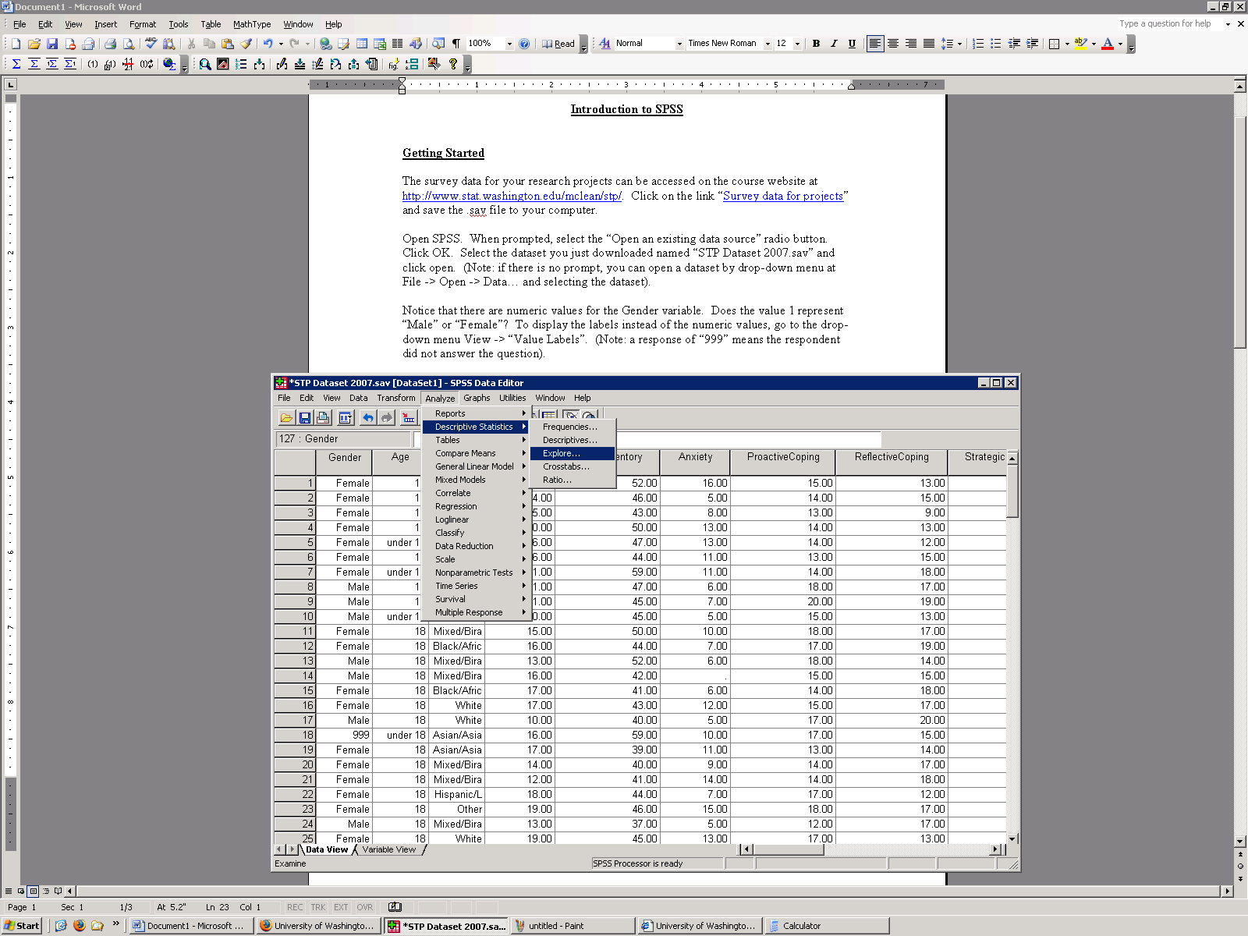

The “Explore…” tool is an easy way to get summary statistics (like mean, median, standard deviation, etc.), as well as plots (box plots and histograms) for continuous variables. This tool can be accessed by the drop-down menu Analyze -> Descriptive Statistics -> Explore…

2. Move the selected variable to the “Dependent List:” by clicking the arrow button. (Note: you can analyze more than one variable at a time)
Click “OK” to finish

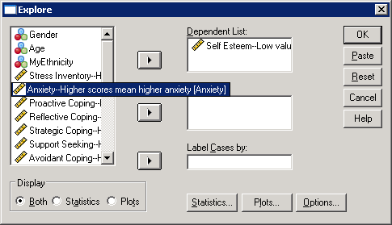
1. Select Variable to analyze

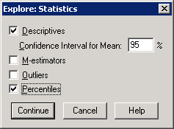

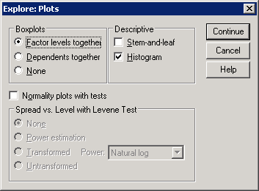
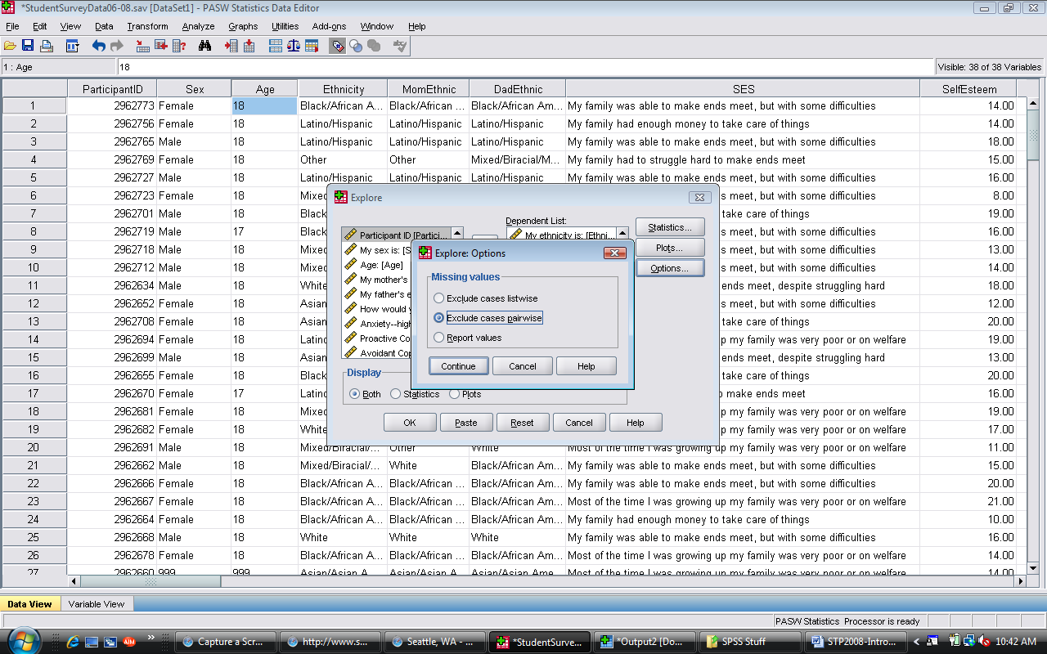
Check the “Histogram” box
Check the “Percentiles” box to calculate Q1 and Q3. This produces two methods of calculating the 25th (Q1) and 75th (Q3) percentiles. The “Tukey’s Hinges” method is the method used in this class.
Check the “Exclude cases pairwise” box
Summary Statistics Exercises

1. How many people did not answer the “My ethnicity is…” question? In other words, for how many people is this information missing for?

2. What is the median stress score (not the student stress score)?

3. What is the third quartile (Q3) for sexism scores (remember to use “Tukey’s Hinges”)?

4. Find/create this plot in the Explore output:

Graphics
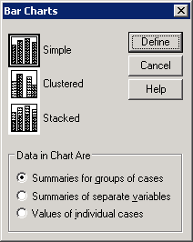
Click “Define”
Bar plots

To make a bar plot, go to the drop-down menu “Graphs” and choose “Bars…”.

Selecting a “Simple” bar chart creates a bar chart for a single variable (for example, ethnicity).

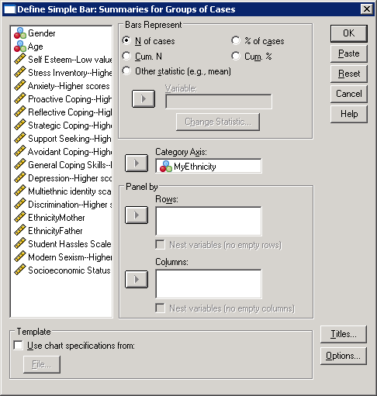
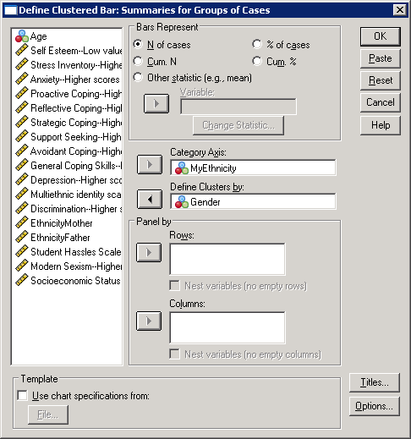
If you want to see a variable broken down by specific groups (for example, ethnicities for females versus males), you can do so selecting a “Clustered” bar chart.
Select variable
Select group you want to break down the main category by

Edit Titles

Note: your results will be somewhat different because you are using the data set with three years of data—these results are based on 06-07.
Bar Plots Exercises

1. Recreate the plot (Make sure to specify the title). How would you describe the plot?

2. Recreate the plot. What can you say about the plot? Explain in a sentence or two.

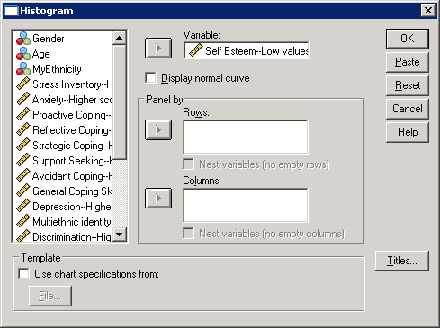
Histograms
Change Titles
Select variable
Click OK

To make a histogram, go to the drop-down menu “Graphs” and select “Histograms…”

Use the “Panel by” section to break down the histograms by group

Changing the bins:

In SPSS, you can easily change the number of bins and the width of the bins that are displayed in your histogram.

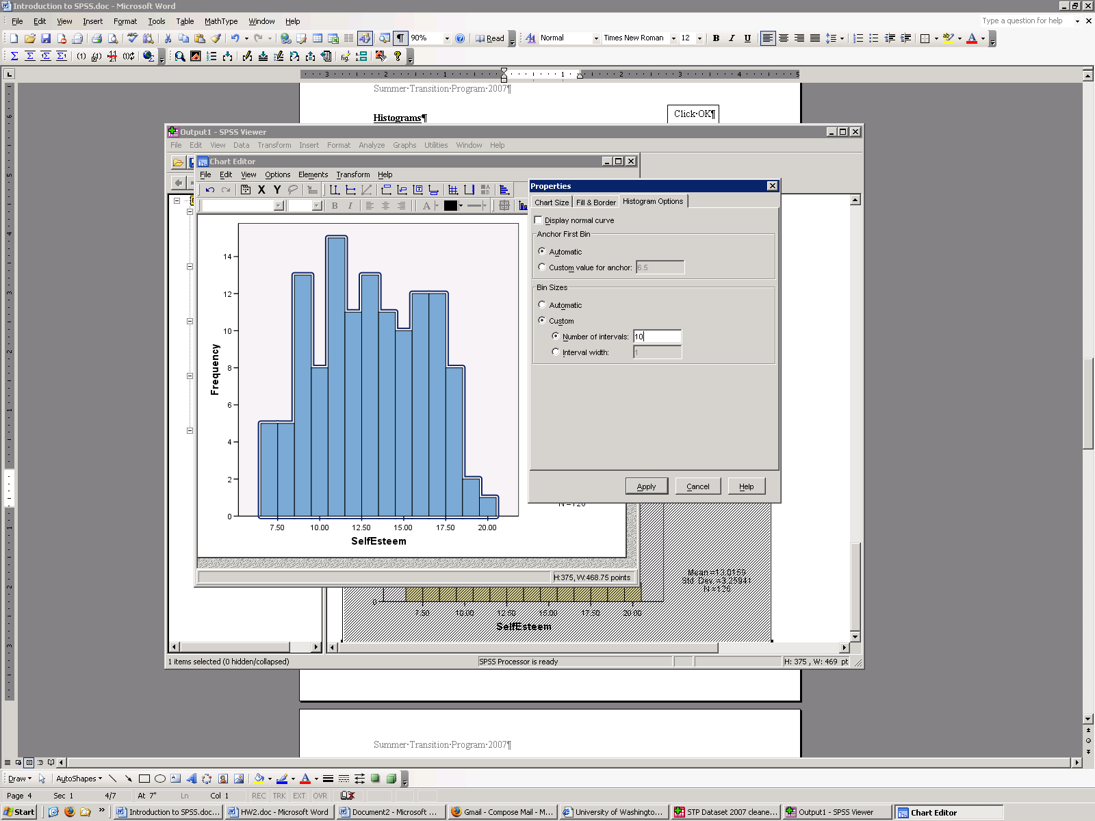
To do so, double-click your histogram in the output window. This will open a “Chart Editor”, where you can change the appearance of just about everything in your chart.
Change bins

Double-click the shaded bars to open up the “Properties” window. Click on the “Histogram Options” tab to change the number/width of the bins.
Double-click the bars

Histogram Exercises
1. Recreate the plot below. Note: you will need to use the “Chart Editor” in order to change the color of the bars, the bin size, and the x-axis. Once in the chart editor double-click on the bars to change their color and double-click on the x-axis to change it range. Make the bin interval width 2. How would you summarize the plot?
2. Recreate the plot below. Remember to increase the size of all titles and axes labels. How would you summarize the plot?
Note: For your posters it with be VERY important to increase the size of the titles and axes labels!
Box plots
To create a boxplot, go to the “Graphs” drop-down menu and choose “Boxplot…”

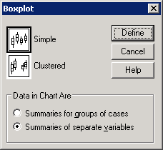
Like the bar charts and histograms, we can make boxplots for our entire sample, or broken up by groups.

If you want to see a variable broken down by specific groups (for example, self esteem for females versus males), you can do so selecting the “Summaries for groups of cases” option.

Selecting “Summaries of separate variables” creates a boxplot for a single variable (for example, self esteem).

Select Variable
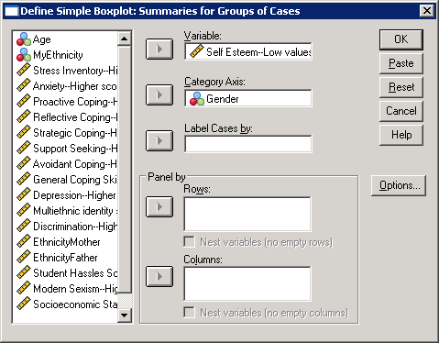
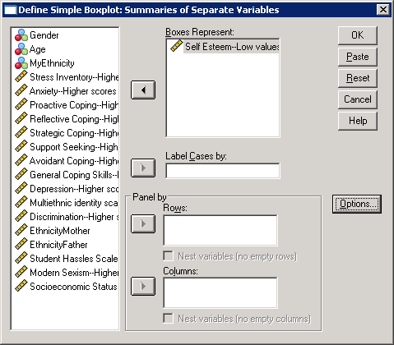
Select group you want to break down the main category by

Boxplot Exercises

1. Recreate the plot below. In order to add a title to the graph you may need to go into the “Chart Editor” and right click on the plot and select “Add Title” from the drop-menu.

2. Recreate the plot below. Can you figure out how to change the y-axis label? Can you figure out how to change the background color in the plot? How would you summarize the plot?

Scatter plots

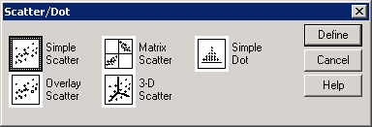
To create a scatter plot, go to the “Graphics” drop-down menu and choose “Scatter/Dot”.
Choose a “Simple Scatter” and click the “Define” button.

Select the variables you want on the X-Axis (left-to-right axis) and Y-axis (up-and-down axis)

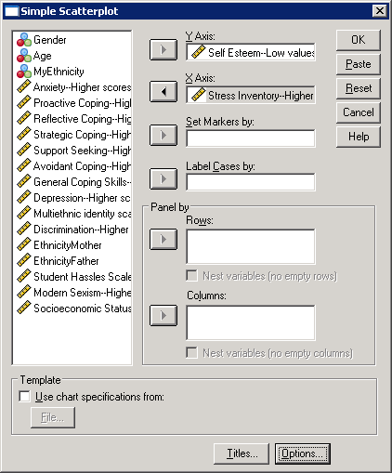

Select variables

Change Titles
Use the “Panel by” section to break down the scatterplots by group

Scatter plot Exercises

1. Recreate the plot below. Be sure to change the point type to an “X”.
2. Recreate the plot below. Use the “Set Markers by” option in the “Simple Scatter plot” window. Summarize the plot.
Saving graphics to import into PowerPoint/Word (as a WindowsMetafile)
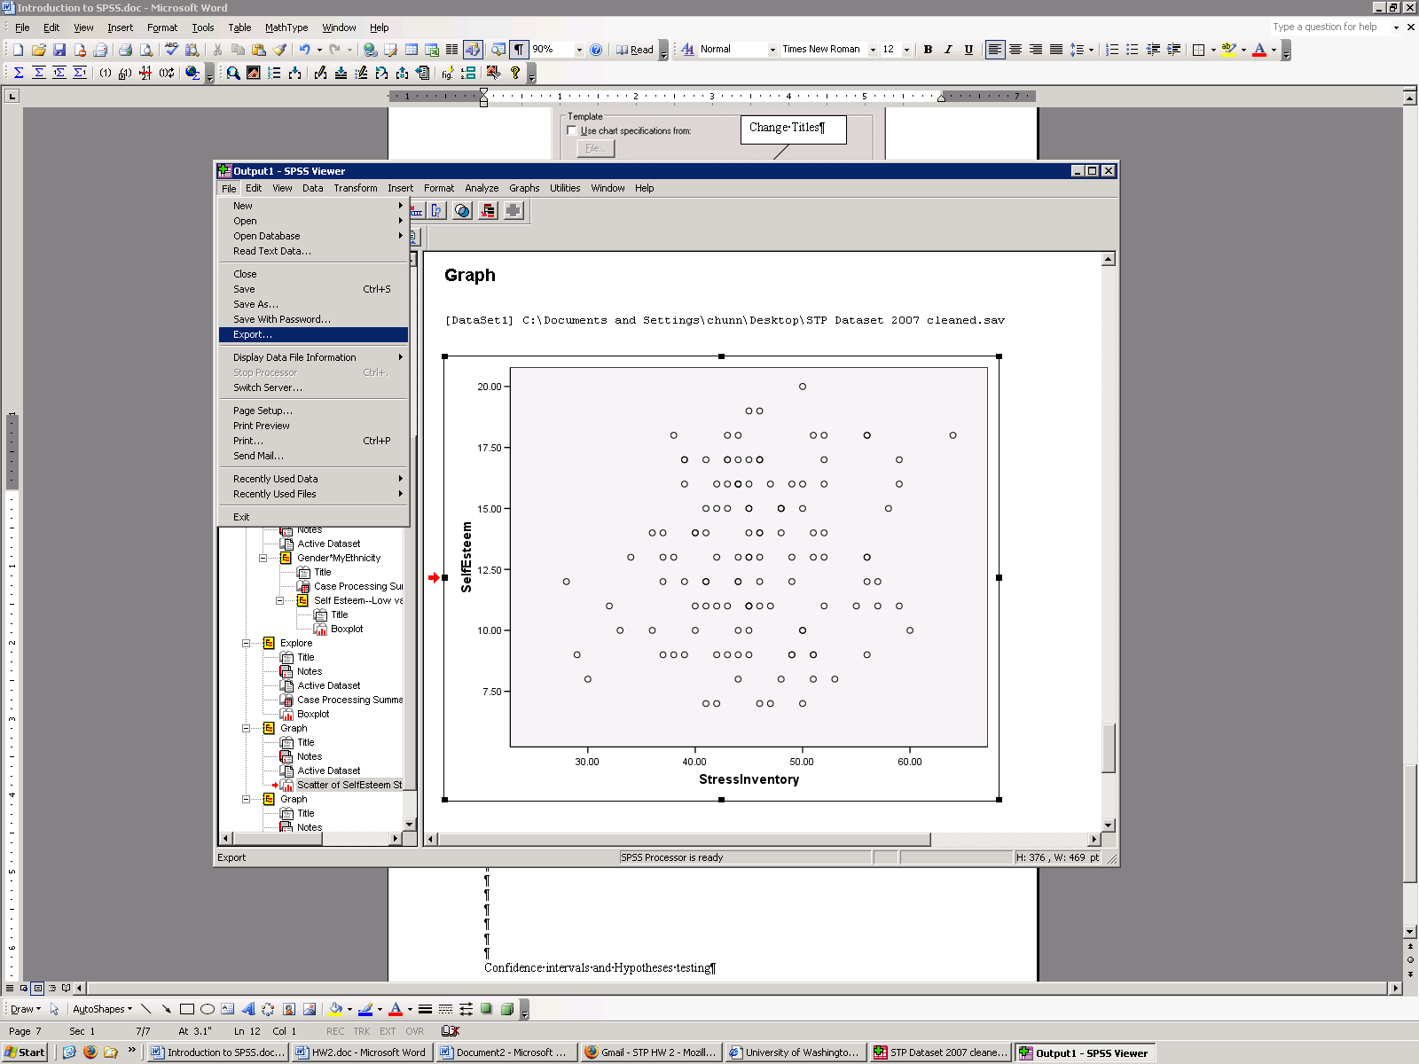

Select the graphic you want to save. (There’s a red arrow next to the graphic you selected)

Go to the “File” drop-down menu and click “Export…”

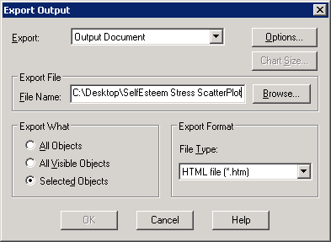

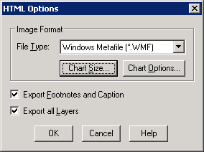

Be sure to tell SPSS where to save your chart and what to call it. Name it something appropriate so you won’t forget what it’s a graph of!
Select the “Image Format” as a “Windows Metafile (*.wmf)” from the drop-down list

When you want to import your graphic into your Word/PowerPoint file, from the drop-down menu, click “Insert” -> “Picture” -> “From File …” and select the file you just saved!

Last Exercise

1. Save one of the plots you have created and import it into a Word or PowerPoint document.

