Introduction to SPSS



Getting Started

The survey data for your research projects can be accessed on the course website at http://faculty.washington.edu/tamre/stp.shtml. Click on the Data Sets link in the upper left of the page and then select “StudentSurveyData06-08.sav” and save the file to your computer.

Open SPSS. When prompted, select the “Open an existing data source” radio button. Click OK. Select the dataset you just downloaded named “StudentSurveyData06-08.sav” and click open. (Note: if there is no prompt, you can open a dataset by drop-down menu at File -> Open -> Data… and selecting the dataset).

Notice that there are numeric values for the Gender variable. Does the value 1 represent “Male” or “Female”? To display the labels instead of the numeric values, go to the drop-down menu View -> “Value Labels”. (Note: a response of “999” means the respondent did not answer the question).

Summary Statistics – Using the Explore tool
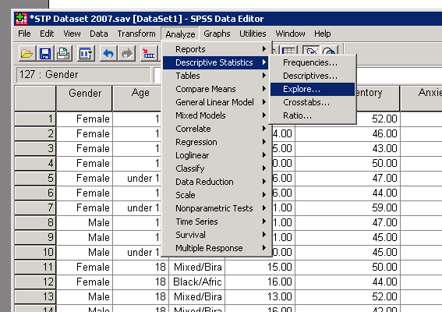

The “Explore…” tool is an easy way to get summary statistics (like mean, median, standard deviation, etc.), as well as plots (box plots and histograms) for continuous variables. This tool can be accessed by the drop-down menu Analyze -> Descriptive Statistics -> Explore…

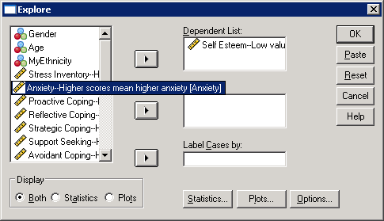
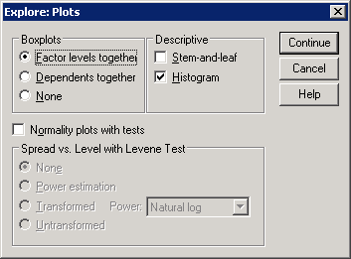
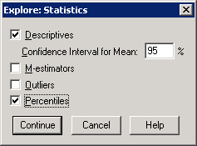
2. Move the selected variable to the “Dependent List:” by clicking the arrow button. (Note: you can analyze more than one variable at a time)
1. Select Variable to analyze

2. Move the selected variable to the “Dependent List:” by clicking the arrow button. (Note: you can analyze more than one variable at a time)
Check the “Histogram” box
Click “OK” to finish
Check the “Percentiles” box to calculate Q1 and Q3. This produces two methods of calculating the 25th (Q1) and 75th (Q3) percentiles. The “Tukey’s Hinges” method is the method used in this class.

Click “OK” to finish

1. Select Variable to analyze

Check the “Histogram” box
Check the “Percentiles” box to calculate Q1 and Q3. This produces two methods of calculating the 25th (Q1) and 75th (Q3) percentiles. The “Tukey’s Hinges” method is the method used in this class.
Graphics
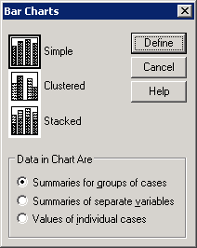
Click “Define”
Bar plots

To make a bar plot, go to the drop-down menu “Graphs” and choose “Bars…”.

Selecting a “Simple” bar chart creates a bar chart for a single variable (for example, ethnicity).

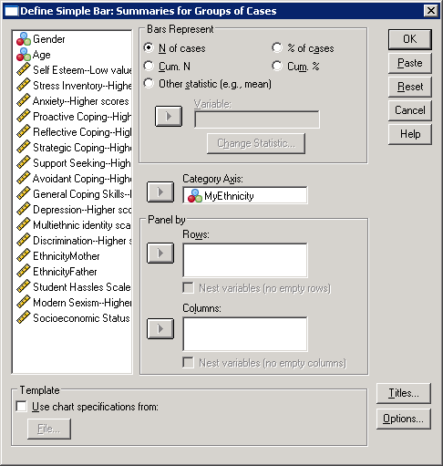
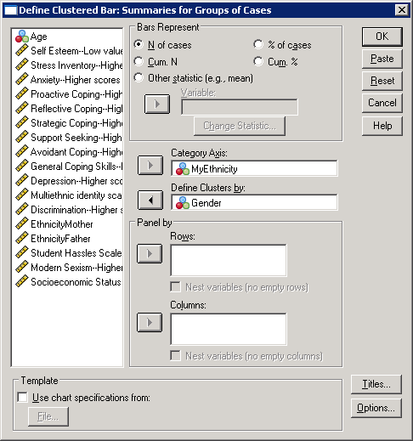
If you want to see a variable broken down by specific groups (for example, ethnicities for females versus males), you can do so selecting a “Clustered” bar chart.
Select variable
Select group you want to break down the main category by

Edit Titles

Note: your results will be somewhat different because you are using the data set with three years of data—these results are based on 06-07.
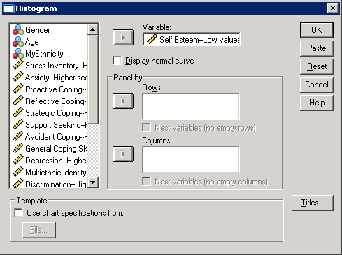
Histograms
Change Titles
Select variable
Click OK

To make a histogram, go to the drop-down menu “Graphs” and select “Histograms…”

Use the “Panel by” section to break down the histograms by group

Changing the bins:

In SPSS, you can easily change the number of bins and the width of the bins that are displayed in your histogram.

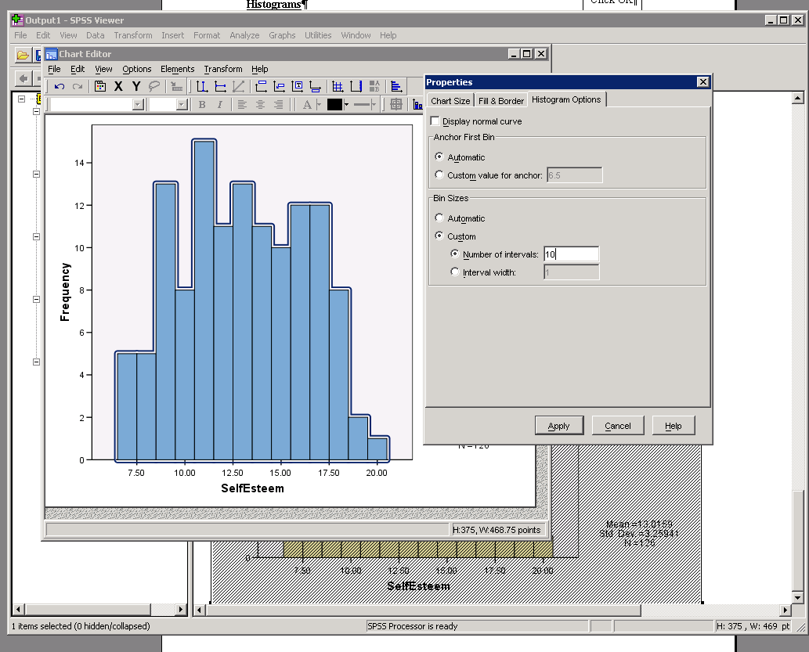
To do so, double-click your histogram in the output window. This will open a “Chart Editor”, where you can change the appearance of just about everything in your chart.
Change bins

Double-click the shaded bars to open up the “Properties” window. Click on the “Histogram Options” tab to change the number/width of the bins.
Double-click the bars

Box plots
To create a boxplot, go to the “Graphs” drop-down menu and choose “Boxplot…”

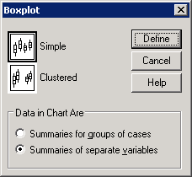
Like the bar charts and histograms, we can make boxplots for our entire sample, or broken up by groups.

If you want to see a variable broken down by specific groups (for example, self esteem for females versus males), you can do so selecting the “Summaries for groups of cases” option.

Selecting “Summaries of separate variables” creates a boxplot for a single variable (for example, self esteem).

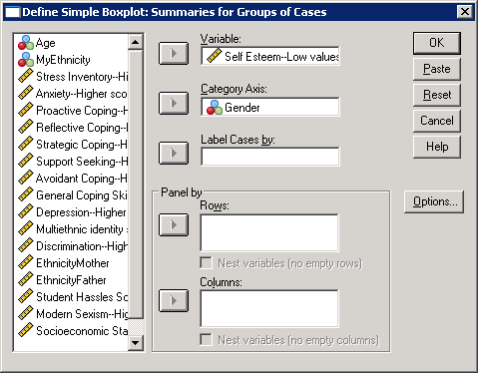
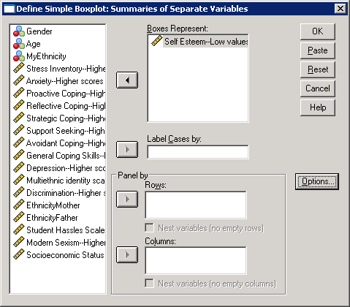
Select Variable
Select group you want to break down the main category by

Scatter plots

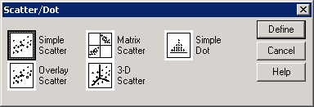
To create a scatter plot, go to the “Graphics” drop-down menu and choose “Scatter/Dot”.
Choose a “Simple Scatter” and click the “Define” button.

Select the variables you want on the X-Axis (left-to-right axis) and Y-axis (up-and-down axis)

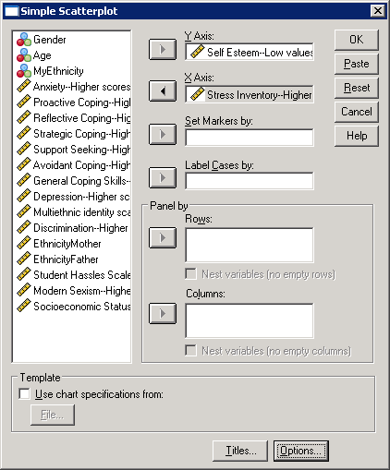

Select variables

Change Titles
Use the “Panel by” section to break down the scatterplots by group

Saving graphics to import into PowerPoint/Word (as a WindowsMetafile)
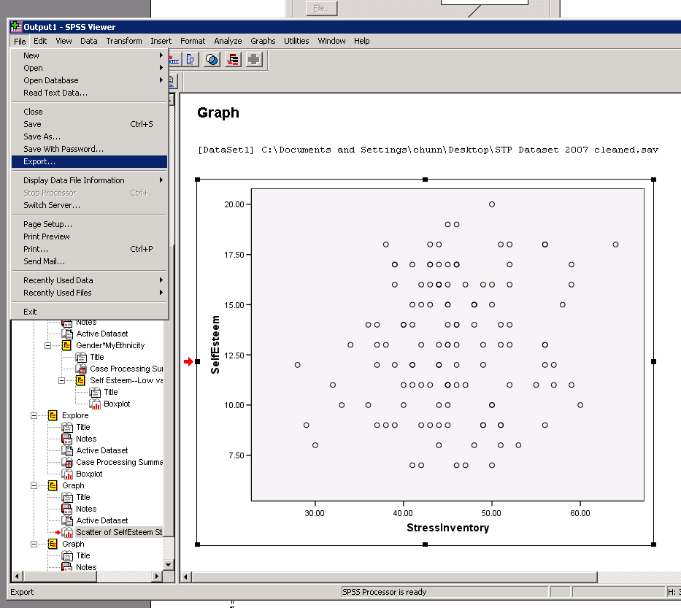

Select the graphic you want to save. (There’s a red arrow next to the graphic you selected)

Go to the “File” drop-down menu and click “Export…”

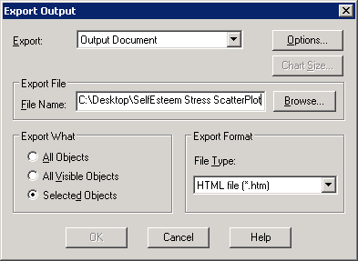
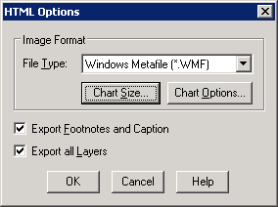
Be sure to tell SPSS where to save your chart and what to call it. Name it something appropriate so you won’t forget what it’s a graph of!
Select the “Image Format” as a “Windows Metafile (*.wmf)” from the drop-down list

When you want to import your graphic into your Word/PowerPoint file, from the drop-down menu, click “Insert” -> “Picture” -> “From File …” and select the file you just saved!

