Crystal Chemistry, Mineral Structures and Element Substitution - part I

The objective of this lab is to review your understanding of the relative sizes of the major cations and anions that make up common minerals, to recall concepts of symmetry in minerals, and to begin to explore the ways in which trace elements can substitute for the major-element constituents of minerals.

We will begin by doing some very simple experiments in arranging Styrofoam balls in ways that proxy for atomic arrangements in minerals. Before we begin, recall that anions are negatively charged ions and that cations are positively charged ions. Also recall that anions are generally considered "larger" than cations because their electron clouds have probability distributions that extend further from the nucleus than those of cations. The atomic structures of minerals can be thought of as arranging anions in some symmetric pattern in such a way that the arrangement provides holes or interstices for the cations. Which cations occupy which interstices and in what arrangements will depend on the size and charge of the cation and upon principles of thermodynamics that govern the overall energy of the atomic arrangement.

The most common anion in minerals is oxygen (O⁻²) which has a radius of about 0.14 nm (nanometers, 10⁻⁹ meters). The second most common is sulfur (S⁻²), with a radius of about 0.18 nm. Common cations (and their radii) include: Na⁺ (0.102 nm), K⁺ (0.138 nm), Mg⁺² (0.072 nm), Al³⁺ (0.054 nm), Ca⁺² (0.100 nm), Ti⁺⁴ (0.061 nm), Cr⁺³ (0.062 nm), Ni²⁺ (0.069 nm), Co²⁺ (0.075 nm), Fe⁺² (0.078 nm), and Fe⁺³ (0.065 nm). These radii are for six-fold co-ordination in the valence states shown. Highly charged cations such as Si⁺⁴ (0.026 nm) typically occupy sites with 4-fold co-ordination. Al⁺³ and Ti⁴⁺ can also occupy 4-fold sites, and when doing so have smaller radii (0.039 nm and 0.042 nm, respectively) than in 6-fold co-ordination. Other useful radii are P⁺⁵ (0.038 nm; 6-fold) and S⁺⁶ (0.029 nm, 6-fold).
Web reference (2015): http://abulafia.mt.ic.ac.uk/shannon/ptable.php

In ESS 212 you studied silicate minerals. We understood the structures of these minerals in terms of the arrangement of SiO₄⁻⁴ "tetrahedral" units in relation to cations and paid particular attention to the degree to which these silicon-oxygen tetrahedra were connected with each other (i.e. the extent to which they shared oxygens). It turns out the silicates are fairly complicated mineral structures. We studied them in ESS 212 because they constitute the essential rock-forming minerals, but other mineral groups like the sulfides and oxides have structures that are a bit easier to understand and from which we can deduce a number of principles ("crystal chemical rules") which can be applied in general to mineral structures.
So, with this introduction, let's investigate the crystal chemical principles that are operative in simple mineral structures. In the front of the lab you will find boxes of Styrofoam balls of various sizes and colors. For this first lab, we will use either the white 2 inch diameter balls or the 2-1/2 inch diameter balls; either size ball will proxy for O⁻² or S⁻² anions in the exercises that follow. Assemble yourselves into groups, and each group should get about 30-40 balls to work with. Each group should also take a handful of toothpicks to hold the balls into the arrangements you will make. You might want to break the toothpicks in half when you use them.

(1) Arrange your Styrofoam balls in one layer to form a pattern that has an axis of 4-fold symmetry (i.e. "square" symmetry). This arrangement is called a square-planar lattice.

Draw a picture of the arrangement you have made and on this picture indicate all the elements of symmetry that are embodied by the arrangement.

- Now add a second layer of anions on top of the first, and do so in such a way that the symmetry of the square planar lattice is maintained. You should find that there are two ways of adding this second layer. The first will produce what is called a "simple cubic" or "primitive cubic" lattice and the second a "body centered cubic" lattice.

Pictures of these arrangements (http://en.wikipedia.org/wiki/Cubic_crystal_system) are shown below.

Name | Primitive cubic | Body-centered cubic | Face-centered cubic
Unit cell | 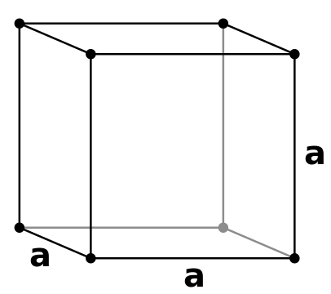 | 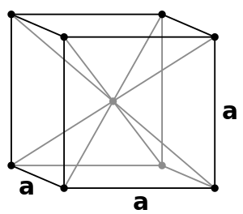 | 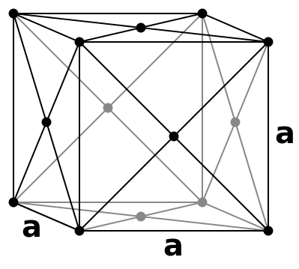

Note - the diagrams above are showing only the anion lattice for each arrangement.

- Now, for the simple cubic lattice examine the interstices between the anions.

What is the "coordination number" of these interstices (i.e. how many anions surround each of the holes)? What is the biggest cation that will fit in these interstices? Experiment with different size Styrofoam balls (the colored ones from the front of the room) or try to work out the problem geometrically.

The size of the cavity is of course related to the size of the anion, but it turns out that the relative size of these "holes" is uniquely defined in terms of the ratio of the radius of the hole to the radius of the anion. This is the so-called radius ratio of the cation/anion pair which is a good parameter to keep in mind when considering where cations "fit" in crystal structures or alternately, what cations substitute for each other in a mineral.

- Do the same exercise as above for the body-centered cubic lattice.

Are the interstices different sizes? Coordination numbers?

On the assumption that cations "prefer" to fit into interstices between anions without distorting the anion arrangement (they will actually be preferentially accommodated in an interstice that is slightly too small but rarely in one that is too big – called the “no rattle” rule), would the crystal structure of CaO more likely involve a simple cubic arrangement of anions or a body centered cubic arrangement of anions? Explain.
(Ionic radius of Ca²⁺ is 0.100 nm in 6-fold co-ordination; 0.112 nm in 8-fold co-ordination).

(2) It turns out that a simple cubic or body-centered cubic arrangement of anions is not the only way or the most efficient way to arrange anions in a plane or in three dimensions. Disconnect all of your Styrofoam balls and arrange them into another planar pattern, this time trying to minimize the space between the spheres as much as possible. The arrangement you will come up with has six-fold symmetry and is called a "close-packed" layer.

Draw this arrangement, and indicate on your drawing elements of symmetry.

- Now add a second layer of anions on top of the first, and do so in such a way that the symmetry of the close packed layer is maintained and that anions remain as close together as possible (i.e. occupy the least space).

What kinds of interstices are formed between the first and second layer as a result of this arrangement?

Now add a third close-packed layer to your model. You should see that there are two ways of doing this that satisfy the requirement that anions occupy the least space, but that only one of the two arrangements preserves the six-fold symmetry of the lattice. By preserving the 6-fold symmetry, you have made an "hexagonal close packed" (hcp) lattice of anions. Note that in this case the third layer is directly above the first layer.

Here is a tough problem: Try to determine how many of each kind of interstice is present in this lattice for each anion in the structure.

- Go back to the two layers of close-packed anions and place a third layer on top, which, as before, satisfies the requirement that the anions occupy the least space, but this time destroys the 6-fold symmetry.

What symmetry, if any, does the resulting lattice have? Hint: the name of this lattice is "cubic close packed" (ccp) and the symmetry may be very hard to see.

In the ccp structure are there different kinds of interstices compared to the hcp structure? Different numbers of each?

In relation to the first, second and third layers in the ccp structure, where would a fourth layer go?

There are hundreds of minerals that can be described as either hcp or ccp structures.
Most sulfides and oxides fall into this category. In fact, at high enough pressures the most stable mineral structures (even silicate minerals!) are those that are close-packed structures. Why? Because these structures occupy the least volume, and as we will find out in lectures, the energy of a substance increases as volume multiplied by pressure, so at high pressures, the mineral which is most stable (has the lowest energy) is the one with the smallest volume.

