Stench Chemicals (thiols) SOP

CHEMICAL AND PHYSICAL PROPERTIES
Stench chemicals are a group of chemicals that exhibit an extremely foul smell. Even though most stench chemicals have little direct impact on the physical health and safety of researchers, use of these chemicals without an odor control plan can have an effect on both the laboratory environment as well as the outside environment. Therefore, it is important that researchers carefully control their use of all stench chemicals in order to minimize the impact on other workers and neighbors.

Examples of Stench Compounds
A few examples of stench chemicals are listed below. Use of any amount of a chemical with an overwhelmingly bad smell (e.g., thiols, selenides, sulfides) must be carefully executed.

- thiols (mercaptans)
- sulfides
- selenides
- amines
- phosphines
- butyric acid
- valeric acid

Among the chemicals listed above, thiols, also referred to as mercaptans, are the most commonly used group, and are therefore discussed in further detail below.

Thiols (Mercaptans)
Thiols are a class of organosulfur compounds characterized by the presence of one or more sulfhydryl (-SH) groups. Since 1937, thiols have been added to natural gas (which is naturally odorless) as an odorant to assist with detecting natural gas leaks.

Thiols exhibit a moderate level of toxicity, and their use does not require special safety precautions. Thiols are characterized by their disagreeable odors at parts per million (ppm) concentrations, and have an odor threshold of only 0.011 ppm. Due to their addition to natural gas, the detection of their odor automatically leads to suspicion of natural gas leaks in or near buildings where they are used. Thus, the use of even small quantities of thiols in laboratory experiments without odor control measures in place can cause concern for other building occupants, people passing by outside, or even the occupants of adjacent buildings.

SAFE HANDLING and STORAGE
Administrative Controls
Use of stench chemicals in the lab must be documented in the Laboratory Safety Plan. Written Safe Operating Procedures (SOPs) describing the safe use, handling, odor control measures implemented must be maintained in the laboratory and reviewed by all laboratory staff prior to beginning any work with stench chemicals.
Engineering Controls
Extreme caution must be exercised when working with stench chemicals. These chemicals should only be handled inside a fume hood to prevent the release of noxious vapors into the local laboratory environment. Precautions must also be taken to prevent these vapors from being exhausted out of the building via fume hoods or house vacuums. In addition to affecting the outside environment, these noxious odors can be re-introduced into other buildings via air intakes and distributed to locations that are distant from the original laboratory source. The following precautions must be taken when working with stench chemicals in your laboratory:
- Use the minimum amount of stench chemical possible (avoid using excess);
- Perform liquid transfers by using a syringe or cannula. Never pour or pipette solutions of volatile compounds;
- Keep the hood sash down as low as possible; and
- A cold trap or a bleach trap should be employed to prevent vapors from exhausting into the fume hood (Figure 1).

Bleach Traps
Thiols, sulfides, phosphines, and disulfides can be oxidized to less malodorous sulfoxides, sulfones, and phosphine oxides (or other more highly oxidized phosphorous compounds) before venting to the environment. This oxidation can be most easily accomplished using a bleach solution.

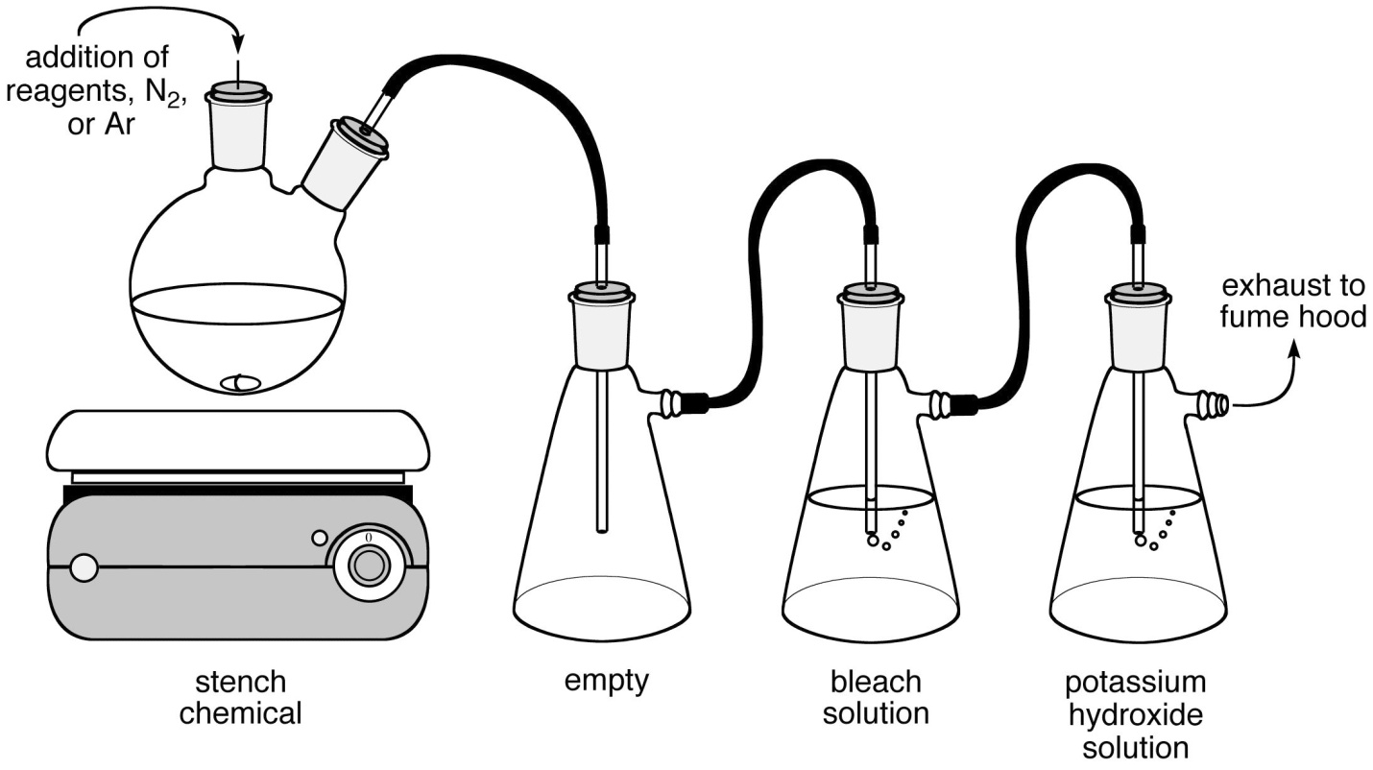

Figure 1: The diagram above shows the set-up for a typical bleach trap. The reaction is first vented into an empty trap, to prevent back flow, and then into a bleach solution. As shown in the figure above, the trap should be filled half way through with bleach (Clorox bleach is 6.15% sodium hypochlorite by weight). The hydrochloric acid generated from the oxidation reaction is neutralized by connecting the bleach trap to a potassium hydroxide trap before venting to the fume hood. The oxidation reaction is exothermic, thus if a large amount of stench chemical is being oxidized then cooling of the traps will be necessary to keep their temperature from rising. The cooling can be achieved by placing the trap in a container filled with water and ice cubes, ensuring that the water level does not surpass the level of the trap vents.

Solvent Evaporation
A cold-finger trap (cooled at least to -78 °C) must be used when evaporating solvent under reduced pressure when a stench chemical is present. The collection bulb must be cooled as well. Inadequate cooling of the condenser and collection flask when using the house-vacuum will result in a release of noxious vapors via the vacuum pump exhaust. If a rotary evaporator is used, it should be located inside of a fume hood. The placement of cooled trap and collection bulb is the same as shown in the figure above.

EMERGENCY and SPILL INFORMATION
If a stench chemical is spilled in the laboratory, including the fume hood, please report the incident to DEHS at (612) 626-6002. Small spills can be cleaned up by placing absorbent material on top of spill. Gloves, lab coat, and safety glasses must be worn. All disposable cleanup materials such as gloves and absorbent pads should be sealed in a zip-lock bag, placed in a wide-mouth plastic jar, labeled as hazardous waste, and disposed of as hazardous waste. Call DEHS at (612) 626-6002 for assistance with larger spills.

CHEMICAL WASTE and CLEAN-UP PROCEDURES
- Tighten cap of stench chemical bottles and seal them with Teflon tape.
- All glassware, syringes, cannula, septa, and other labware that came into contact with malodorous compounds that can be oxidized (e.g. thiols, disulfides, phosphines, etc.) should be rinsed and/or submerged in a bleach solution IN THE FUME HOOD to oxidize all traces of the noxious chemical. The oxidation reaction can be slow, so soaking for 24 hours may be necessary.
- If disposable items such as gloves, paper towels, and septa are malodorous, they should be enclosed in a zip-lock bag, placed in a wide-mouth plastic jar, labeled as hazardous waste, and disposed as hazardous waste.
- The malodorous contents of a cold-trap should be carefully added to a cooled bleach solution and the glassware rinsed and/or submerged in a bleach bath ALL IN THE FUME HOOD.
- Bleach solutions should be combined into an appropriate container, labeled with a hazardous waste sticker, and disposed of as hazardous waste. Potassium hydroxide solutions should be added to a separate container, labeled with a hazardous waste sticker, and disposed of as hazardous waste.

REFERENCES
http://www.chemistry.ucla.edu/file-storage/publicview/pdfs/Stench_Chemicals_SOP.pdf

Sarah Keller
July 21, 2014

