Standard Operating Procedure

Sodium Tetraborate
CAS# 1330-43-4

Section 1 – Lab-Specific Information
Building/Room(s) covered by this SOP: BAG 005, 023
Unit or department: Chemistry
Principal Investigator Name: Sarah Keller
Principal Investigator Signature/Date: 28 Feb 2025
This SOP was created by (if not PI): Sena Noaman/Graduate Student/
Name/Title/Date/Signature 28 Feb 2025/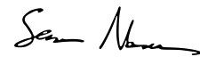

Section 2 – Hazards
Physical hazards
- Sodium tetraborate is incompatible with potassium and acid anhydrides.
- Under fire conditions, hazardous decomposition products may be formed: borane/boron oxides, sodium oxides.
- With any solid material, avoid buildup of dusts that could be combustible.
Health hazards
- Sodium tetraborate causes serious eye irritation. Avoid contact with skin and eyes through physical contact or formation of dust and aerosols. Do not inhale vapors, mist, or gas.
- Ingestion presents the most significant risk. Borates may cause nausea, vomiting, diarrhea, abdominal cramps, and in extreme cases circulatory collapse, convulsions, coma or even death from 5 to 20 grams. Do not ingest.
- Exposure to sodium tetraborate may cause reproductive toxicity and damage fertility or unborn child.
Environmental hazards
- Sodium tetraborate is harmful to aquatic life. Avoid release to environment.
The SDS for sodium tetraborate is found at https://mychem.ehs.washington.edu/Chemical/ViewSDS/74519.
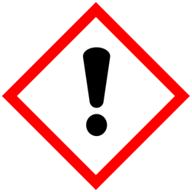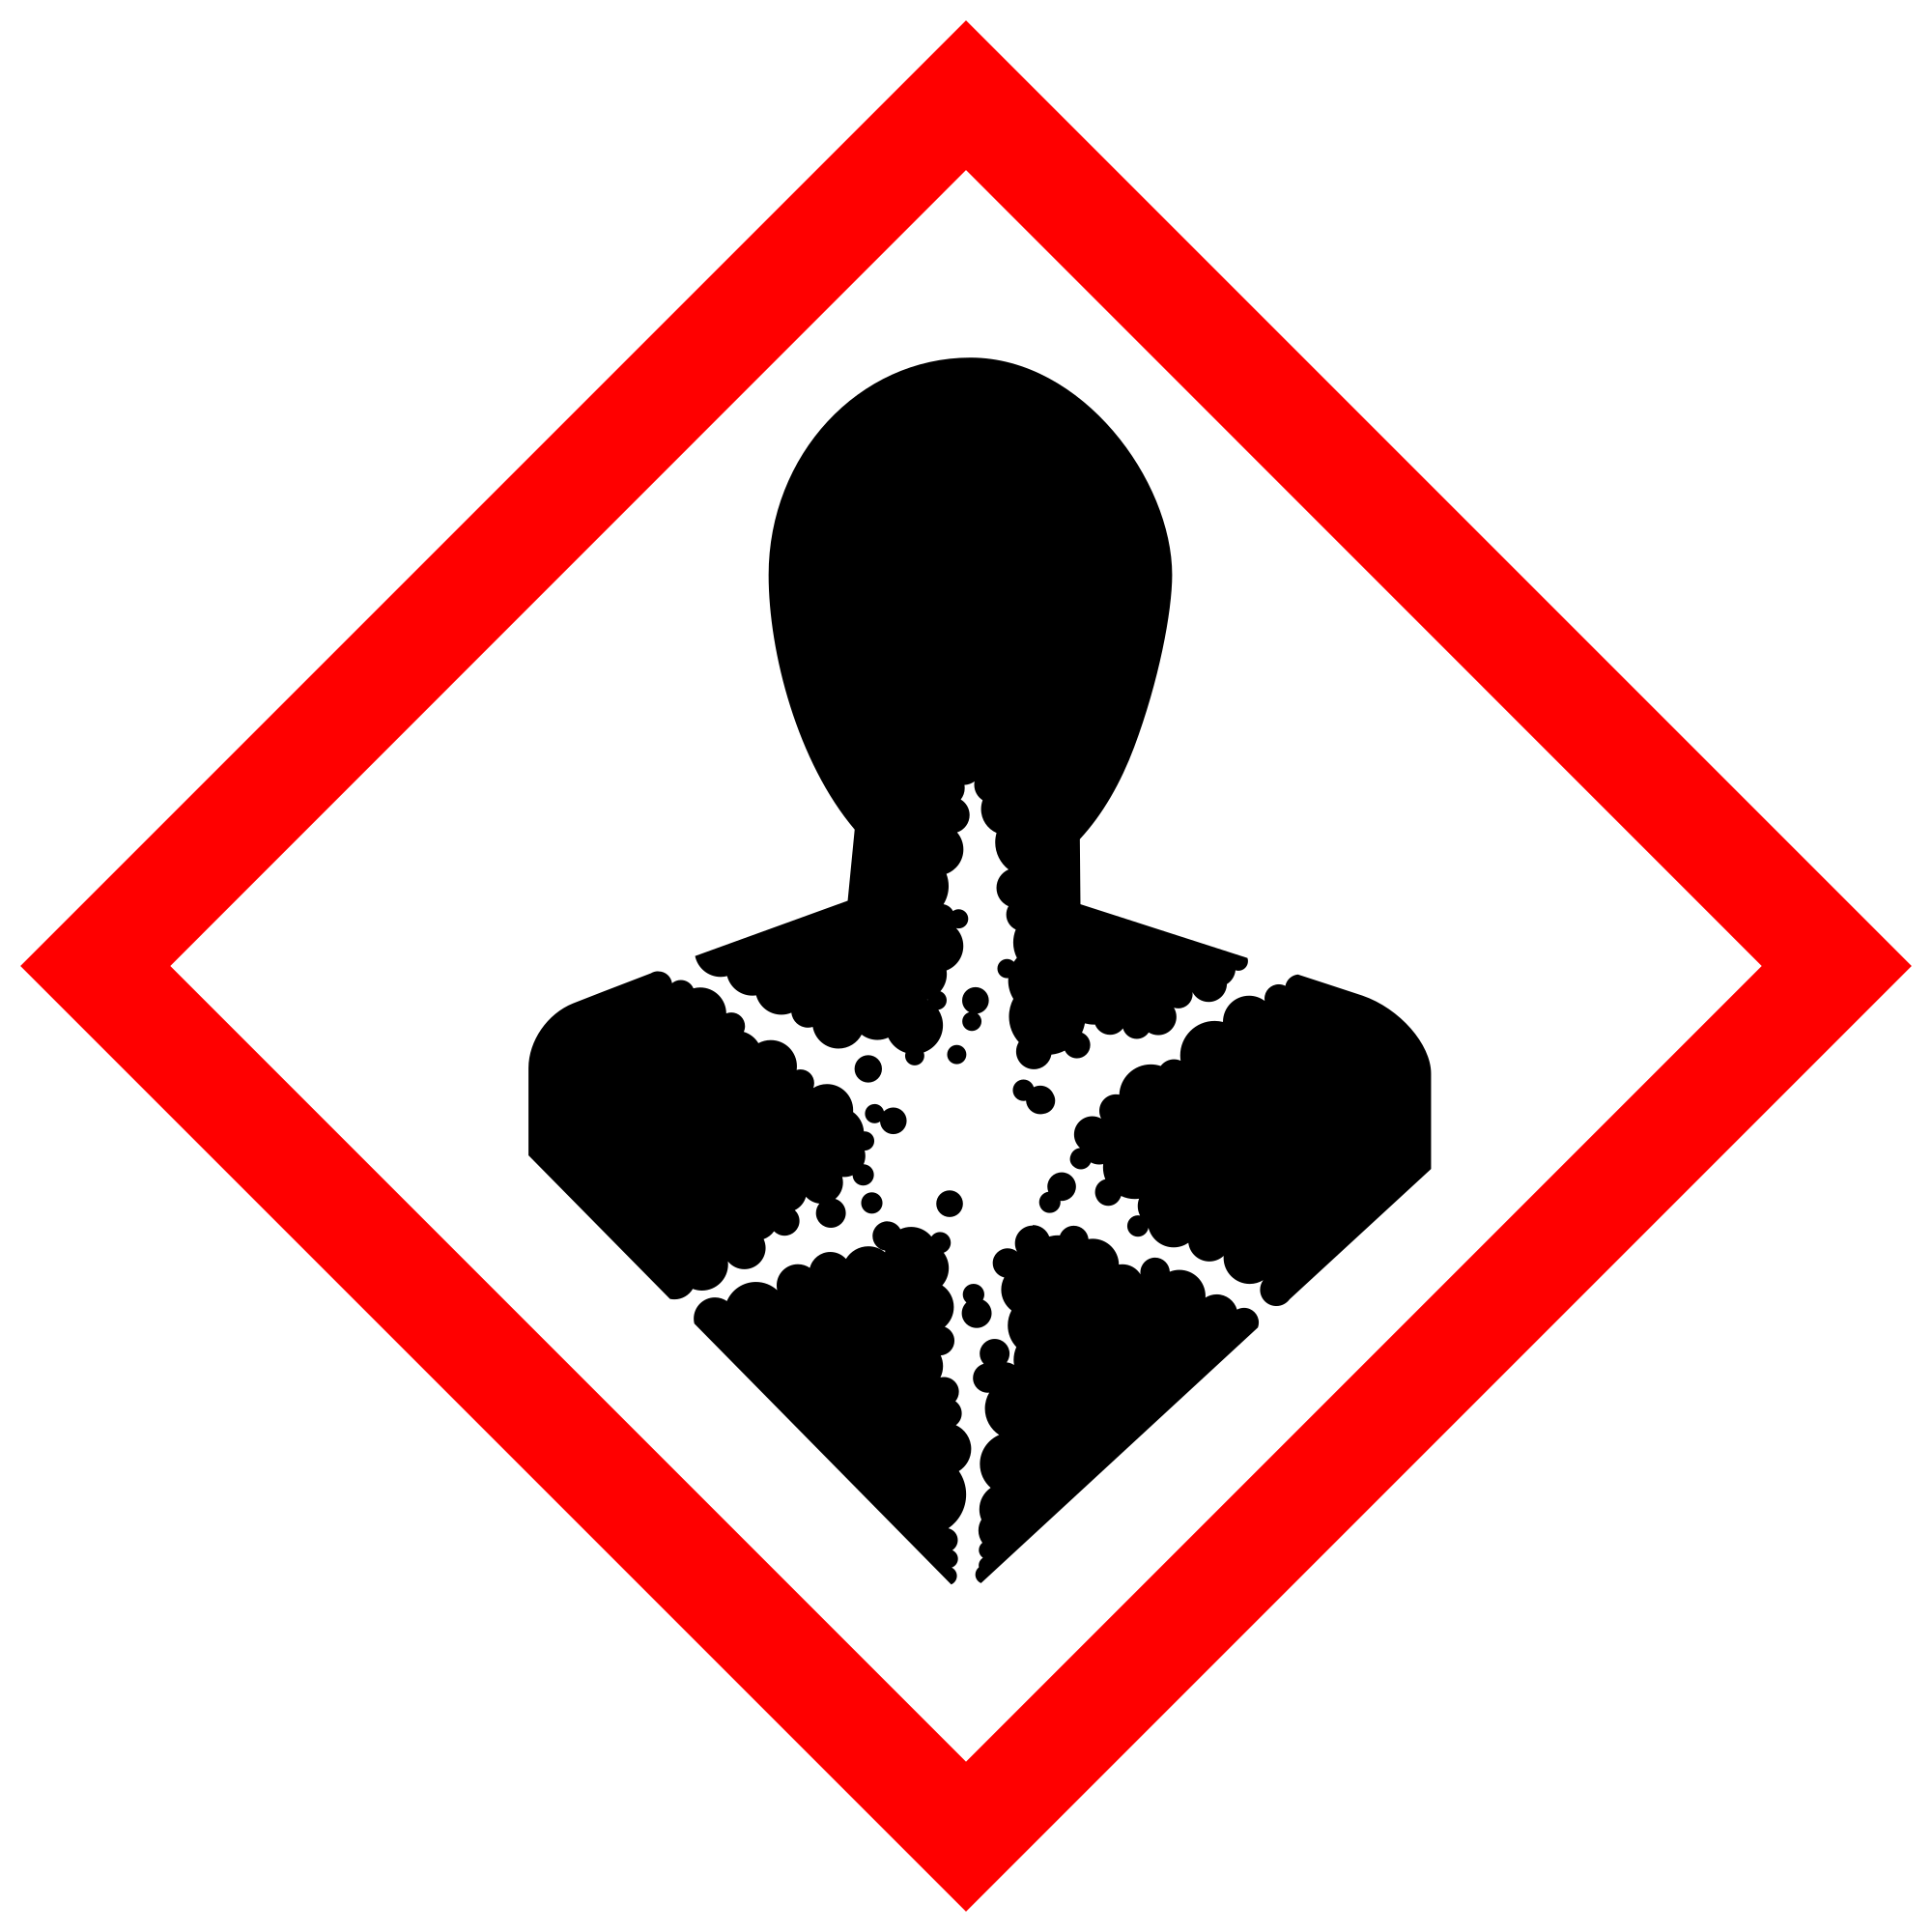

Section 3 – Engineering Controls and Personal Protective Equipment (PPE)

Engineering controls
- While it is not required to perform work in a fume hood, appropriate exhaust ventilation is required at places where dust is formed. Any chemical fume hood used must be tested and passed by EH&S.

Hygiene measures
Avoid contact with skin, eyes, and clothing by using PPE of safety glasses with side-shields, gloves, and impervious clothing. Wash hands after removing PPE, before breaks, and immediately after handling the chemical. If sodium tetraborate comes into contact with any PPE, the PPE shall be immediately removed and discarded properly. Any potentially exposed body parts should be washed immediately.

Skin and body protection
Impervious clothing is required. A lab coat is not required but may provide the best measure for avoiding skin contact. Chemically compatible laboratory coats that fully extend to the wrist may be worn and must be appropriately sized for the individual and buttoned to their full length. These can be found in the UW Chem Stockroom. Personnel must also wear full-length pants, or equivalent, and close-toe shoes. The area of skin between the shoe and ankle must not be exposed.

Hand protection
Hand protection is required for the activities described in this SOP. Nitrile rubber gloves, which may be found in the UW Chem Stockroom, are sufficient for work with sodium tetraborate. Gloves must be inspected prior to use, including a check for pinholes.
Use proper glove removal technique (without touching glove’s outer surface) to avoid skin contact with this product. Dispose of contaminated gloves after use in accordance with applicable laws and good laboratory practices. Wash and dry hands immediately after glove removal.

Eye protection
ANSI Z87.1-compliant eye protection is required for all work with sodium tetraborate. Safety glasses with side-shields are required. Ordinary prescription glasses will NOT provide adequate protection unless they also meet the Z87.1 standard and have compliant side shields.

Respiratory protection
Respiratory protection is not required for the activities described in this SOP. If there is no risk of dust, sodium tetraborate may be used outside of a fume hood.
Respirators should be used as a last line of defense or when any Action Limit (AL) or Occupational Exposure Limit (OEL) has been exceeded or when there is a possibility that an AL/OEL will be exceeded. Respiratory protection may be needed if a dust, aerosol or vapor hazard is present and work is conducted outside of the fume hood or if an individual is experiencing irritation.
If a potential exposure hazard cannot be eliminated, contact the EH&S Respiratory Protection Program administrator at uwresp@uw.edu, or call 206.543.7388 to discuss respiratory protection or to enroll in the program so a respiratory protection analysis can be performed. Program enrollment includes medical evaluation, training and fit testing for an appropriate respirator. Where air-purifying respirators are appropriate, use a full-face respirator with appropriate respirator cartridges as a backup to engineering controls. Use a full-face supplied air respirator if it is the sole means of protection.

Section 4 – Special handling and storage requirements
- Avoid contact with skin and eyes.
- Avoid formation of dust and aerosols. Appropriate exhaust ventilation must be present as places where dust is formed.
- Container must be kept tightly closed in a dry and well-ventilated place.
- Sodium tetraborate is incompatible with potassium and acid anhydrides.
- Sodium tetraborate does not classify as dangerous goods for transportation.
- Keep sodium tetraborate away from fire to avoid formation of decomposition products (borane/boron oxides, sodium oxides).
- Upon completion of tasks, clean all surfaces with soap and water, and then dry.
- Place all contaminated disposable items in appropriate laboratory waste for disposal.
- Do not pour down drain. When cleaning, sweep and shovel without creating dust. Keep in suitable, closed containers for disposal.
- Non‐disposable/re‐usable utensils, glassware, and other surfaces contaminated with sodium tetraborate must be decontaminated at the end of the laboratory work session
- When work is completed, remove gloves and wash hands with soap and water.
Users of chemicals are required to follow labeling requirements when transferring chemicals to secondary containers and when labeling containers with chemical waste, UW-synthesized chemicals, peroxide-forming chemicals, and Chemicals of Interest. Requirements for labeling containers and templates for creating labels are available on the EH&S website.
Check Section 2 of the Lab Safety Manual and the Chemical Compatibility Chart on the EH&S website for incompatible chemical groups.
Special storage precautions may include keeping away from heat, light, air, flames, sources of ignition.
Check Section 2 of the Lab Safety Manual for information on chemical transport practices.

Section 5 – Spill and accident procedures
Avoid breathing dust of sodium tetraborate.
Take the following steps in case of the following exposures:
- Inhalation: move to fresh air. If the exposed individual is not breathing, give artificial respiration. Consult a physician.
- Skin contact: wash off with soap and plenty of water. Consult a physician.
- Eye contact: Rinse thoroughly with plenty of water for at least 15 minutes. Consult a physician.
- If swallowed: rinse mouth with water. Do not give anything by mouth to an unconscious person. Consult a physician.
For advice, call the UW Employee Health Center (206-685-1026). For emergency help, call 911.

If the spill is fully contained inside the fume hood, close the sash and prepare yourself to clean it up. Access the closest spill kit. Make sure you have the appropriate PPE on (lab coat, nitrile gloves, eye protection). Do not allow the substance to enter the drain. Put all generated waste into a bag if you have a lot of debris and a plastic container if you have only a small amount of debris. See Waste section below.
If the spill is outside of the hood, do not breathe dust and ensure adequate ventilation. Do not let anyone enter the contaminated space until the air is cleared or proper PPE has been donned. Grab the closest spill kit. Make sure you have the appropriate PPE on (lab coat, nitrile gloves, eye protection). Do not allow the substance to enter the drain. Put all generated waste into a bag if you have a lot of debris and a plastic container if only a small amount of debris. See Waste section below.
Do not attempt to clean up any spill if not comfortable doing so. Instead, evacuate the area and call 9-1-1 on campus phone for help. If the spill is out of control, call 9-1-1. If a person is injured, exposed or suspected of being exposed, call 9-1-1.
For questions on spill cleanup, contact EH&S spill consultants at 206‐543‐0467 during normal business hours (Monday-Friday, 8 a.m. to 5 p.m.).
Any spill, exposure or near miss incident requires the involved person or supervisor to complete and submit the UW Online Accident Reporting System (OARS) form on the EH&S website within 24 hours (certain types of incidents require immediate notification).
Get Help.
- Call 9-1-1 or go to nearest Emergency Department (ED); provide details of exposure:
    - Agent
    - Dose
    - Route of exposure
    - Time since exposure
- Bring the SDS and this SOP to the Emergency Department
- Notify your supervisor as soon as possible for assistance
- Secure the area before leaving; lock doors and indicate spill if needed
Report the incident to Environmental Health & Safety.
- Notify EH&S immediately after providing first aid and/or getting help.
  - During business hours (M‐F/8‐5), call 206‐543‐7262.
  - Outside of business hours, call 206‐685‐UWPD (8973) to be routed to EH&S Staff On Call.
- Any spill, exposure or near miss incident requires the involved person or supervisor to complete and submit the UW Online Accident Reporting System (OARS) form on the EH&S website within 24 hours (certain types of incidents require immediate notification).

Section 6 – Waste accumulation and disposal procedures
If you are cleaning up after a spill and have a bag of debris, ensure the bag is sealed and use multiple bags as needed. Complete an EH&S Hazardous Waste Label and adhere it to the bag. Here are instructions for how to label chemical waste containers.
Put all waste, solid or liquid, into a plastic container. Complete an EH&S Hazardous Waste Label and adhere it to the bottle. Here are instructions for how to label chemical waste containers.
More generally, refer to the SDS and UW Laboratory Safety Manual, Section 3 for guidance on waste handling, labeling, accumulation, storage and pickup.
Per UW Administrative Policy Statement 11.2, the University of Washington Environmental Health & Safety Department has full responsibility for collection of hazardous waste for the University, all its campuses, and off-site locations; University laboratories cannot contract with an outside vendor to collect hazardous waste.
Be aware that many laboratory accidents happen from inadvertent disposal of incompatible wastes into the same waste container. Therefore, identify different waste streams as appropriate.
Manage chemical and hazardous chemical waste separately from other waste streams such as biohazardous waste. Never autoclave chemical waste because it can produce hazardous chemical vapors, aerosols, and explosive reactions.
All chemical waste containers must be labeled with a UW Hazardous Waste Label. Refer to How to Label Chemical Waste Containers.
To request a collection of chemical waste, submit a form on the Chemical Waste Disposal webpage on the EH&S website or directly in MyChem inventory. Contact EH&S at 206.616.5835 or chmwaste@uw.edu with questions.
Work area decontamination procedures as appropriate for the chemical in use should be followed.
Visit the Hazardous Material Disposal and Recycling webpage on the EH&S website for information on disposing, recycling and surplusing materials.

Section 7 – Protocol
Protocols for handling sodium tetraborate in the Keller lab are the same as outlined in Sections 3 and 4 above.
Refer to Section 2 of the UW Laboratory Safety Manual on the EH&S website for additional guidance on chemical management and preparation for use for particularly hazardous substances (PHSs).
NOTE: Any deviation from this SOP requires approval from Principal Investigator.

Section 8 – Special Precautions for animal use (☐Yes ☒ No)
This section is not applicable (“N/A”) because our lab does not use animals.

PARTICULARLY HAZARDOUS SUBSTANCE INVOLVED?
☒YES: Sections #9 to #11 are Mandatory.
☐NO: Sections #9 to #11 are Optional.

Section 9 – Approvals required
All staff working with sodium tetraborate must be trained on this SOP prior to starting work. They must also review the chemical’s SDS, which is available through the Keller Laboratory website and EH&S.

Section 10 – Decontamination
- If the eyes or body of any person may have been exposed, a safety shower/eye wash should be immediately used. Personnel who are working with acrylamide must be aware of location of nearest Safety Shower/Eye Wash and verify that a current certification of performance tag is present.
- Personnel shall rinse exposed areas of skin and/or eyes with copious amounts of water for at least 15 minutes.
- All equipment, materials and work surfaces that have/ potentially have become contaminated shall be cleaned in accordance with those identified for small spill in Section 5.

Section 11 – Designated area

Sodium tetraborate powder can become airborne and may result in personal exposure and area contamination. Use care to avoid dispersing dust. If this is a risk, especially for mixing and dispensing, work should be performed within a fume hood.

Section 12 – Documentation of training
- Lab members are expected to review the laboratory’s inventory of chemicals to identify any “Particularly Hazardous” substances. The inventory appears in MyChem with the letters “P” or “B” in the column labeled “Reg”.
- Before working with any of the “Particularly Hazardous” substances, lab members must review the laboratory’s SOP for that substance to learn how to protect themselves from the hazards and how to enact emergency procedures.
- Ready access to SOPs and to a Safety Data Sheets for all Particularly Hazardous materials used in the Keller Lab are available through the Keller Lab website.
- If any lab member determines that the SOP should be revised or if the substance is being used in a way that is not covered in the SOP, the lab member should bring it to the attention of the PI and propose changes to this SOP.
- Lab members must attest (in a separate document that applies to all Particularly Hazardous substances) that they will adhere to the policies in this SOP.

