Low Dissolved Oxygen levels
And the Impact on Crop Growth Potential

By Cheryl Watts
Spring Quarter 2010
BIS 490 Senior Seminar
Sustainability Research for community Enhancement
Professor Robert Turner PHD
May 22nd 2010

Abstract

Studies have shown that low oxygen concentrations in the root zone of agricultural soils can adversely impact crop production. 21 Acres has low dissolved oxygen concentrations in their well water which raises concerns for crop potential. This study monitored the well water variations in dissolved oxygen concentrations and a controlled agriculture experiment was performed. Cucumber plants were grown from seed in a controlled environment, using organically rich soil from 21 Acres. The cucumber plants were separately watered with well water that contained low dissolved oxygenated water and oxygenated water. The plants that received the oxygenated water were by far more uniform, taller and healthier overall than the plants that were watered with the low dissolved oxygen water.

Table of contents

Abstract
Introduction 3
Study Site Characteristics 5
Methods 7
Results 8
Discussion 12
Conclusion 13
Bibliography 14
Raw Statistical Data 16
Acknowledgements 21

Introduction

Irrigation has been an important part of agriculture in society for many thousands of years. Crops that are irrigated to supplement natural rainfall typically produce better crop yields. The amount of water applied to crops is critical in controlling yield, but the quality of the water is also critical to overall plant health. In particular dissolved oxygen can impact plant health and previous studies have shown that irrigation water with low dissolved oxygen concentrations will have a negative impact on plant health. (1)
My study focuses on dissolved oxygen (DO) levels in the well water at the Center for Local Food and Sustainable Living (21 Acres) in Woodinville Washington. (see Figure 1). In April of 2007, 21 Acres installed their own private well and cistern with a solar pump for crop irrigation. (2) (see Figure 2). 21 Acres is a community-based nonprofit organization that has over 80 community garden plots and approximately 11 acres in crop production. They are also building an educational facility that will have a community kitchen as well as a year-round retail store that will focus on local produce. (3)
On April 21st 2008, UWB students conducted water quality testing of the well water and found that the DO levels were approximately 1.8 mg/L. (4). This is low compared to levels one would expect in surface waters, where < 3mg/L is considered stressful for heterotrophic organisms. (4) Since the water was only tested on one occasion, it was thought that this low value could be an artifact of a dysfunctional DO meter. During February and March of 2010, a UWB research group of BES 318 went back to 21 Acres for more monitoring of the well. Parameters measured included PH, temperature, dissolved oxygen, conductivity, turbidity, nitrate, ammonia, phosphate, and fecal coliform. The DO levels averaged 1.78 mg/L from the 2 visits.
This research confirmed that the well water at 21 Acres at least periodically exhibits low dissolved oxygen levels. The three measurements of low oxygen levels in the 21 Acres well water prompted me to conduct this follow-up research study. My objectives were to better assess the variability of the well water DO concentrations, as well as to evaluate potential impacts to 21 Acres agricultural activities. Accordingly, I assessed the well water quality by monitoring temperature and dissolved oxygen levels on a weekly basis from 4/22/2010 to 5/18/2010. With regard to potential impacts, my null hypothesis was that low dissolved oxygen concentrations in the well water does not negatively affect plant growth. I tested this hypothesis by conducting a controlled experiment of the impact of the well water on plant growth with cucumber plants grown from seed in organic-rich soil supplied from 21 Acres. This report shares the findings of both my well water sampling and my growth experiment, and considers the implications of my results.
Why is this research important? If low dissolved oxygen levels adversely affect crop growth then 21 Acres would be negatively affected. Poor crop development, reduced quality and yield would have a negative impact on the economics of the farm and their mission to be sustainable.

Study Site Characteristics
21 Acres is a community based, nonprofit organization located in the heart of Woodinville Washington. The site map in figure 1 below shows 21 Acres and the location of the well. In 2007 they constructed a well and above ground storage tank for crop irrigation that is solar powered. The cistern can hold up to 5000 gallons of water collected from the aquifer. (2) The well site is located at 47º 44’ 53.879” North latitude and -122º 099’21.529” West Longitude.
“Aquifers in the Woodinville area are in a shallow zone between 0 and 400 feet from the
surface and a deep zone more than 500 feet below the surface. The shallow and deep
aquifers are typically separated by 100 to 400 feet of low-permeability silt and clay.
The aquifers recharge in the upland areas on both sides of the valley and discharge to the
Little Bear Creek and Sammamish River valley floors in the Woodinville area. The
shallow aquifer system is assumed to maintain a general equilibrium between recharge
and discharge flows. Recharge is estimated to be approximately nine inches per year in
the uplands and 15 inches per year in the valley areas.” (5)
The results from the data obtained were a good indicator that future crop management using different methods for irrigating could possibly be implemented. Other wells in the area also had low dissolved oxygen levels and likely the reason for this is a combination of the geology of the area and how clean the aquifer is. (6,7). The geology of 21 Acres is in a valley of floodplains and glacial deposits and the soil characteristics is mainly Alderwood gravelly loam and silt loam. (8)

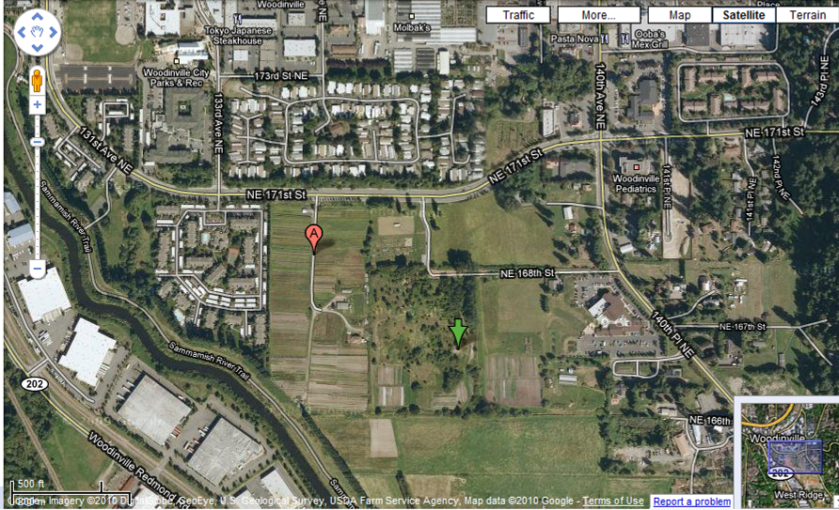

Figure 1 The green arrow indicates the approximate location of the well and cistern.
(www.googlemaps.com)

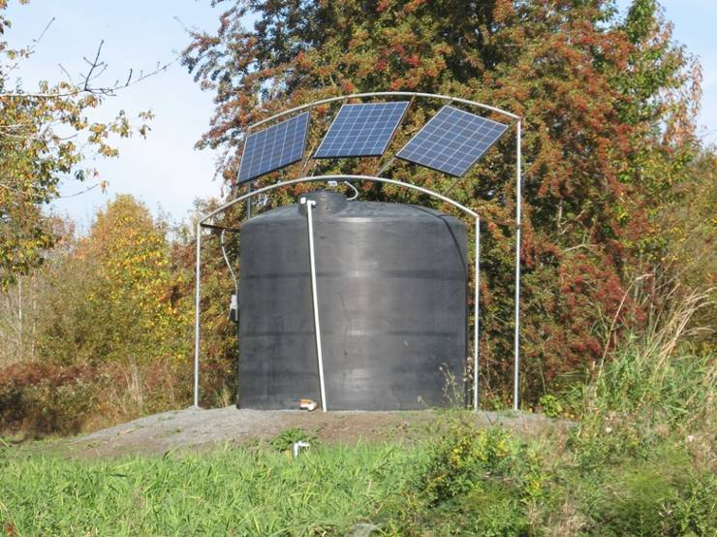
Figure 2 Cistern and Well. Turner, Robert (2010)

Methods
A YS158 dissolved oxygen meter was used for measuring dissolved oxygen levels of the water in the cistern and of groundwater at 21 Acres. The device needs to be warmed up for 15 minutes prior to use. Once warmed up the machine was calibrated to zero and the probe was inserted into the first sample beaker of well water which was drawn from the cistern. The first parameter measured was temperature in degrees Celsius. Once the temperature was obtained, dissolved oxygen levels were measured in mg/L and percent saturation. The probe was gently swirled in the water sample for several minutes to make sure an accurate reading was obtained. After dissolved oxygen measurements were acquired for the cistern, the well was purged by running the water for at least 15 minutes so that the second sets of measurements were of water from the aquifer. After the DO measurements were taken, ground water was collected in two separate containers for the crop experiment.
For the crop experiment, cucumber seeds, soil and water were obtained from 21 Acres. I planted cucumber seeds in two separate containers. Each container had 16-3inch cells and two seeds were planted in each cell. To water the plants 2 containers were used to collect water from the well at 21 Acres. One was marked A and the other one B. Each sampling period the containers were rotated to avoid the carboy effect. A carboy is a plastic container used to store liquids. (9) Half of the water for the experiment was oxygenated using a small aquarium pump and air stone. One set of plants received regular (low oxygen) well water and the other set received the oxygenated water. The plants were located in a sunny window and were rotated every couple days to maximize sun exposure.
Height measurements in inches were done on 5/09/2010, 5/14/2010 and 5/22/2010. The largest plant in each cell was measured using a small ruler. The leaf area was measured in square inches on 5/22/09 using the same sample plants in each cell. Statistical analysis was done showing mean, standard deviations and confidence interval (Student’s t test).

Results
This study measured dissolved oxygen levels at 21 Acres in Woodinville WA for a period of six weeks starting on 4/22/2010-5/18/2010. The dissolved oxygen levels averaged 1.86 mg/L. over the six week time frame. This is low compared to levels one would expect in surface waters.
A controlled experiment was also performed to test the impact of watering cucumber plants with low DO water. On 4/30/2010 cucumber seeds from 21 Acres were planted using organically rich soil from the farm. On 5/4/2010 the plants started to sprout. Right away it was obvious that the plants that were watered with the oxygenated water had some significant differences. They sprouted first, grew at a more uniform rate and had a broader leaf area. As time went on the oxygenated plants continued to grow taller and more uniform, compared to the low DO water plants which were shorter, more uneven in height and had a less broad leaf area.

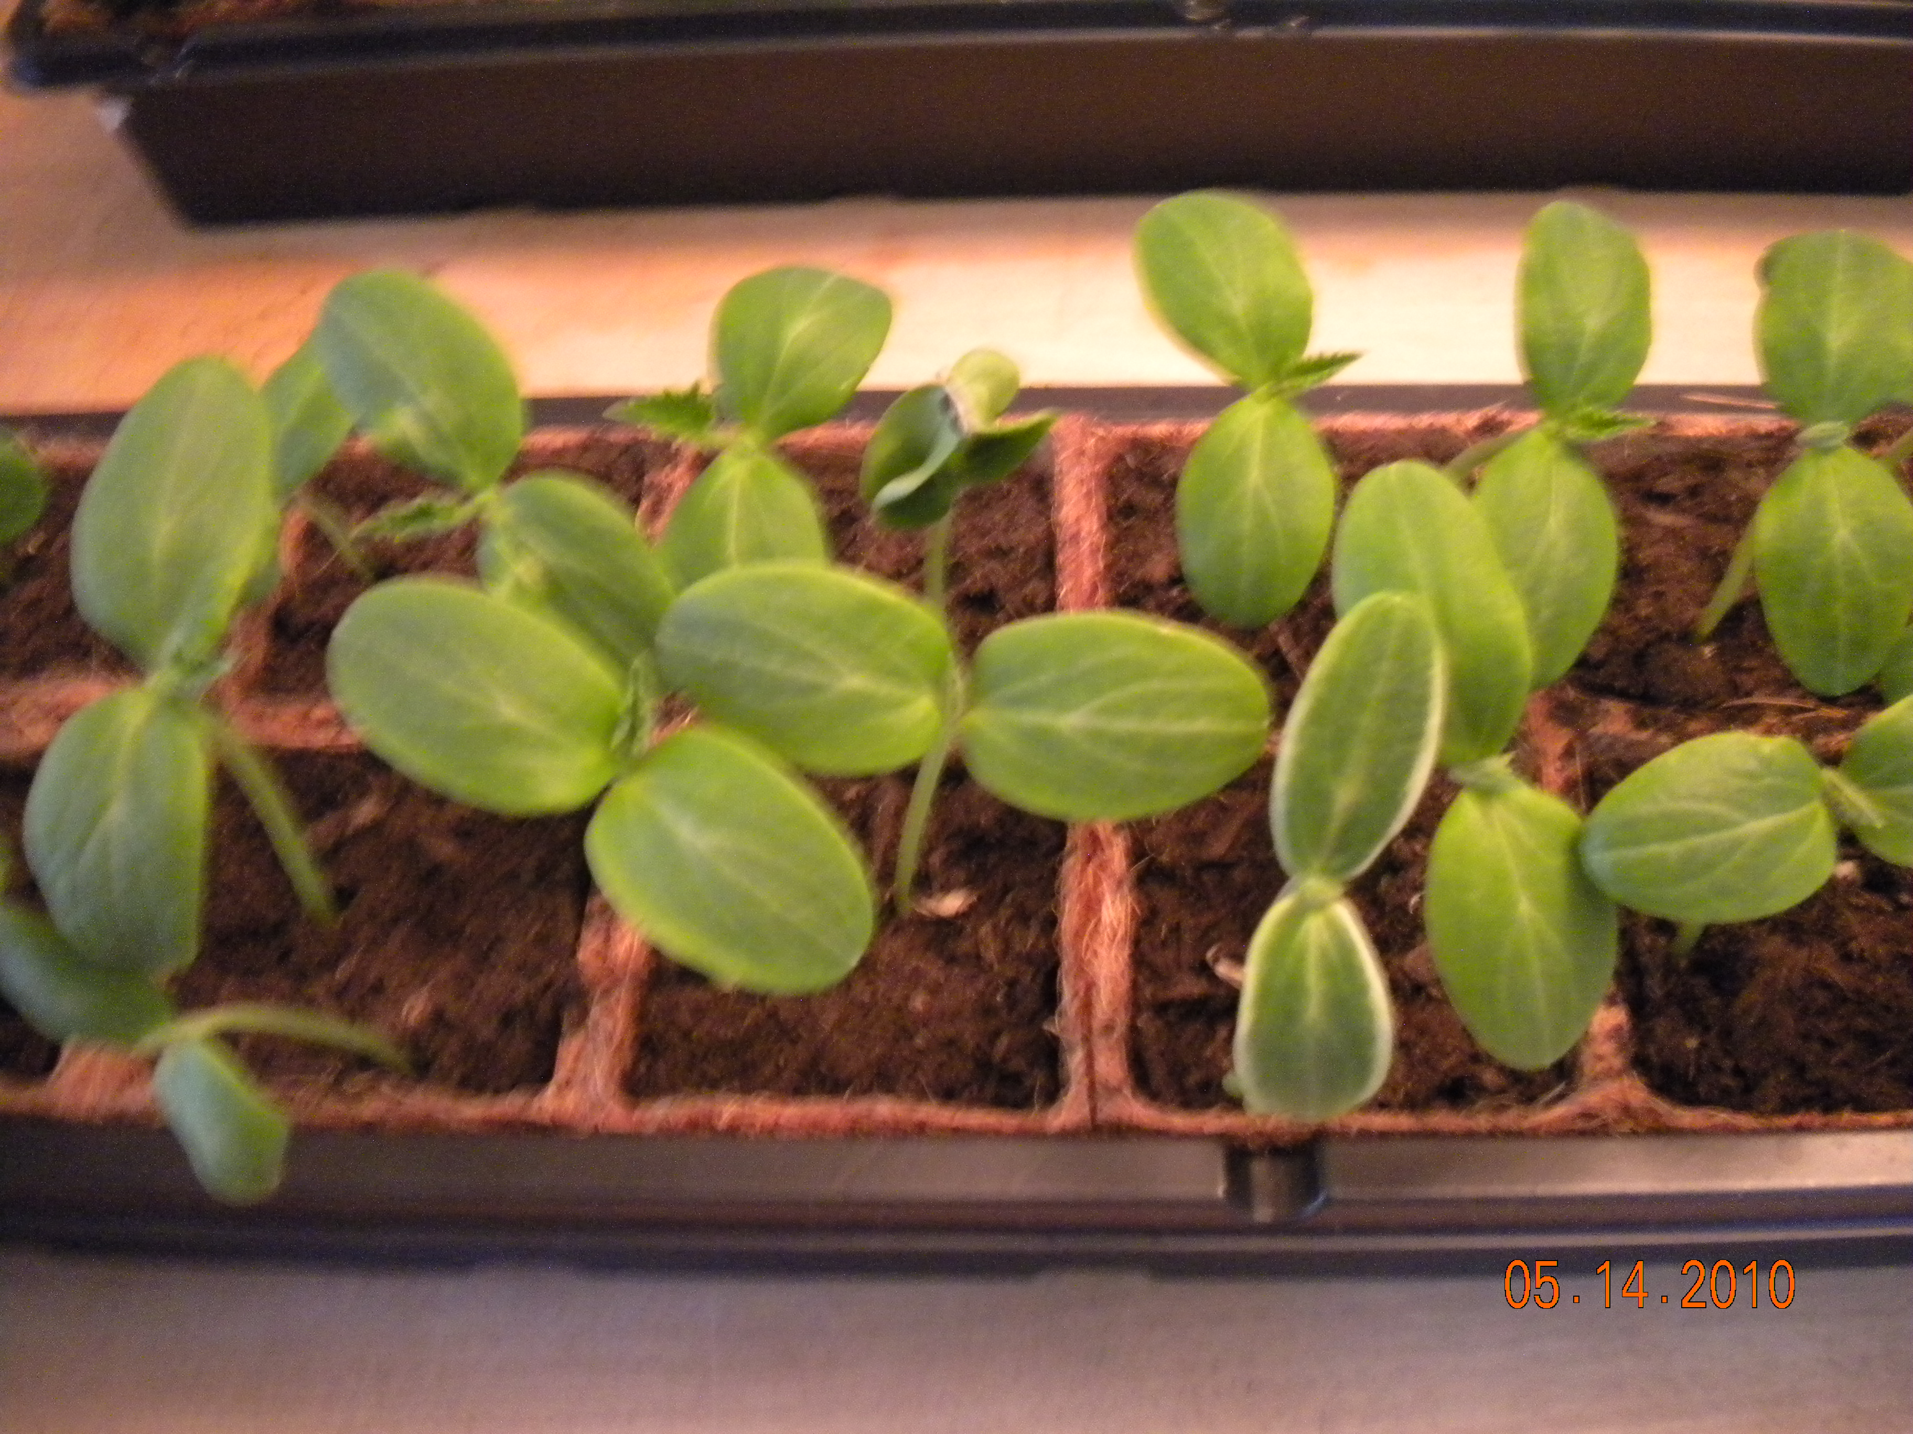
Figure 3 Cucumber plants Watts, Cheryl (2010)

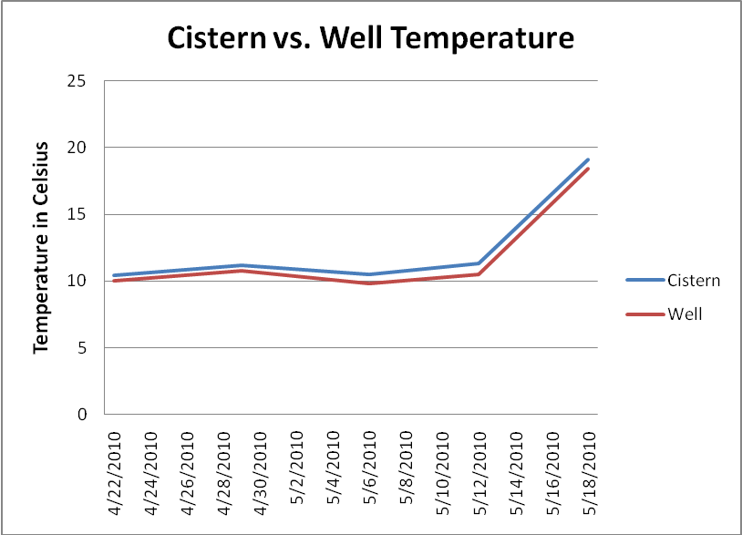
Figure 4
Temperature readings were consistent with the exception of 5/18/2010 when warmer temperatures were observed. Consistent temperature readings are important to give a more accurate dissolved oxygen reading. The water in the cistern was slightly warmer than the well water, thus will hold less oxygen. (10)
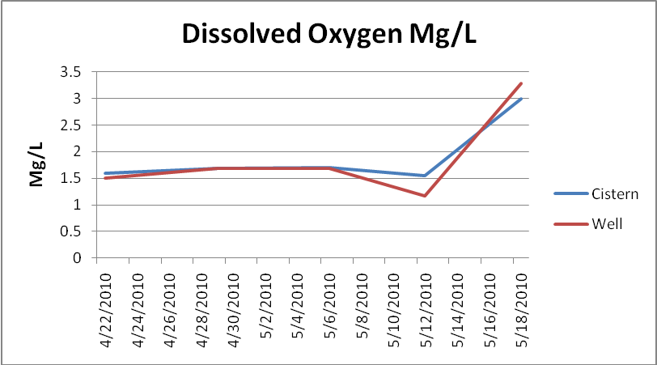
Figure 5
Dissolved oxygen levels in Mg/L were consistently low (average DO 1.866 mg/L from the well) with the exception of 5/18/2010 when levels recorded were above 3 mg/L. < 3 mg/L is considered stressful for heterotrophic organisms in surface water.

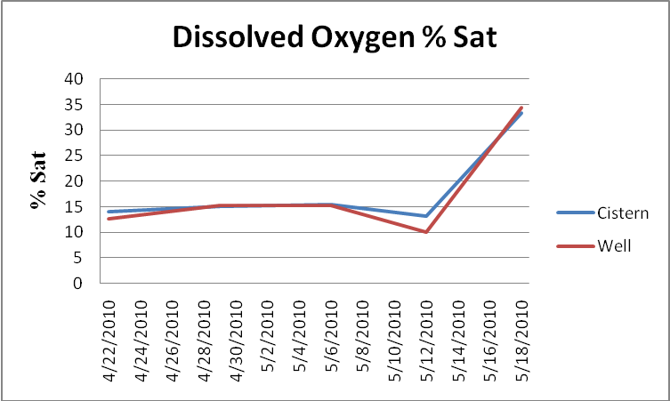
Figure 6
Dissolved oxygen levels in % saturated.
Statistical analysis results

 | Oxygenated Well Water (height in inches) | Low-Oxygen Well Water (height in inches) | P-Value
May 9, 2010 | 2.24 ± 0.36 a | 1.72 ± 0.41 b | P = 0.00032
May 14, 2010 | 2.72 ± 0.36 a | 2.19 ± 0.51 b | P = 0.00095
May 20, 2010 | 3.26 ± 0.46 a | 2.94 ± 0.61 a | P = 0.05351
Leaf Area oxygenated plants Leaf Area Low Oxygen P-Value
(Inches squared) (Inches squared)
May 22, 2010 | 1.25 ± 0.13 a | 1.10 ± 0.29 b | P= 0.041

Table 1: Mean values for height in inches of cucumber plants watered with oxygenated well water and plants watered with low-dissolved oxygen levels in well water on three separate dates. Means (n=16) are shown ± 1 Standard Deviation. Different letters (a,b) indicate significant difference (p < 0.05) between plants watered with oxygenated well water and plants watered with low-dissolved well water by Student’s t-test. Same letters (a,a) indicate no significant difference using student’s t-test.

Discussion
21 Acres in Woodinville Washington is committed to sustainability. Their mission statement from their website says: “Our mission is to cultivate, demonstrate and advance systems that support sustainable agriculture. 21 Acres is a non-profit organization with a vision to create and operate a vital, open public space for all of us to rediscover the agricultural heritage of our region and learn about cutting-edge, sustainable agricultural design and technologies as well as ways to maximize the beneficial aspects of fresh local produce and farm products”(3).
It is hopeful that this research study will help 21 Acres continue in the spirit of their mission statement of learning about cutting edge sustainable agricultural design and technologies, so their crops can be maximized to their fullest potential.
21 Acres uses rainwater, well water and supplements their irrigation practices with water from the city of Woodinville. Most of the water that the city provides is from the South Fork Tolt River Watershed, which is located in the Cascade Mountains (11).
Growing crops requires soil, water & oxygen. The water for 21 Acres’ crops is obtained from a combination of rainfall, supplemented with well water and city water. The well water that 21 Acres uses has low dissolved oxygen concentration levels and the purpose of this study was to monitor the well water to see if the low dissolved oxygen concentration levels were consistently low and to perform a controlled experiment using cucumber seeds, soil and water from 21 Acres to see if there was a significant difference in cucumber plants grown with low dissolved oxygen well water vs. plants grown with oxygenated well water.
This study concluded that there are consistent levels of low dissolved oxygen concentrations in the well water coming from the aquifer at 21 Acres and that cucumber plants grown with low dissolved oxygenated water are affected negatively.

Conclusion
Various wells in the Woodinville area seem to have low dissolved oxygen water concentrations. 21 Acres’ aquifer has low dissolved oxygen concentration levels and there are significant differences between the cucumber plants watered with low oxygenated well water vs. oxygenated well water. The cucumber plants that were watered using oxygenated well water were more uniform, taller and had a broader leaf area. The cucumber plants watered with low dissolved oxygen well water were shorter, non uniform in height and had a smaller leaf area.
Possible suggestions for improving well water quality would be to incorporate a sprinkler system that will oxygenate the water before it gets to the crops. Since 21 Acres already uses a drip system, there are also alternative methods that aerate the well water in the cistern. (12).
If a future group continues this research, it would be interesting to take the experiment to harvest and see if there may be a difference in the size of the cucumbers watered with low DO well water and oxygenated well water at harvest and if overall taste is affected as well.

Bibliography

Holtman, W, Van Duijn, B, Blaakmeer, D, Blok,C. published December 31, 2005. International Symposium on Soilless Culture and Hydroponics. Optimalization of oxygen levels in root systems as effective cultivation tool. Retrieved on May 2, 2010 From ISHA web site: http://www.actahort.org/books/697/697_5.htm

- 21 Acres. Water Storage tank with solar pump. Retrieved on May2, 2010 from 21 Acres Web site: http://21acres.org/back18acres/farm-at-21-acres/water-and-soil/water-storage-tank-with-solar-pump

- 21 Acres. About Us . Retrieved on May 2, 2010 from 21 Acres Web site: http://21acres.org/aboutus

- Turner, Robert (2010) personal communication

- City of Woodinville/ Master plan. Retrieved on May 31,2010 from City of Woodinville Website.

http://www.ci.woodinville.wa.us/Documents/Work/MasterPlans/PRO/PRO01.pdf

- King County Water and Land Services. Well Data. Retrieved on June 1st, 2010. https://mail.google.com/mail/?ui=2&view=bsp&ver=ohhl4rw8mbn4

- King County Water and Land Services. Well data Retrieved on June 1st, 2010. http://www5.kingcounty.gov/groundwater/Details.aspx?Equis_ID=SAMM_W7A

- City of Woodinville. Shoreline Inventory and Characterization published Oct. 2006, Adolfson Associates, Inc. Retrieved on June 1st2010 from City of Woodinville Website. http://www.ci.woodinville.wa.us/Documents/Work/MasterPlans/Shoreline_Master_Program_Update_Shoreline%20Inventory_and_Characterization.pdf

- Muehleisen, Dave (2010) personal communication

- U.S. Environmental Protection Agency. Dissolved Oxygen and Biochemical oxygen Demand. Retrieved on May 2, 2010 from EPA Web site: http://www.epa.gov/volunteer/stream/vms52.html

- 2009 Annual Drinking Water Report. Retrieved on May 2,2010 from Woodinville Water District Web site: http://www.woodinvillewater.com/Water%20Quality/Water%20Quality%20Reports/CCRs/2009%20CCR.pdf

- Beneficiation of soil with dissolved oxygen for growing crops. Retrieved on June 5, 2010 from Patent Storm.us web site.http://www.patentstorm.us/patents/6173526/description.html

Raw Statistical Data

Date | Cistern | Well | Cistern | Well | Cistern | Well
 | Temp Celsius | Temp Celsius | DO(mg/L) | DO(mg/L) | DO % Sat | DO % Sat
4/22/2010 | 10.4 | 10 | 1.59 | 1.5 | 14.1 | 12.7
4/29/2010 | 11.2 | 10.8 | 1.68 | 1.69 | 15.1 | 15.2
5/6/2010 | 10.5 | 9.8 | 1.7 | 1.69 | 15.4 | 15.2
5/12/2010 | 11.3 | 10.5 | 1.55 | 1.17 | 13.1 | 10
5/18/2010 | 19.1 | 18.4 | 3 | 3.28 | 33.3 | 34.3

Average 1.904 Mg/L for the cistern

Average 1.866 Mg/L for the well

5/09/2010
Oxygenated Plants (inches) | Low oxygen Plants
 | (inches)
1.5 | 0.55
1.75 | 1.87
1.95 | 2
2 | 1.75
2 | 2.12
2 | 2.25
2.21 | 2.27
2.25 | 1.75
2.25 | 1.5
2.25 | 1.5
2.5 | 1.4
2.55 | 1.87
2.62 | 1.62
2.63 | 1.81
2.7 | 1.5
2.75 | 1.82

t-Test: Two-Sample Assuming Unequal Variances in inches | 5/09/2010
 | Oxygenated Plants | Low oxygen Plants
Mean | 2.244375 | 1.72375
Standard Deviation | 0.363078848 | 0.409306324
Variance | 0.13182625 | 0.167531667
Observations | 16 | 16
Hypothesized Mean Difference | 0
df | 30
t Stat | 3.806182746
P(T<=t) one-tail | 0.000324286
t Critical one-tail | 1.697260851
P(T<=t) two-tail | 0.000648572
t Critical two-tail | 2.042272449

5/14/2010
Oxygenated Plants (inches) | Low Oxygen (inches)
2 | 0.75
2.5 | 2.25
3 | 2.78
2.75 | 2.25
3.22 | 2.5
2.75 | 2.7
3 | 2.87
2.35 | 2
2.25 | 1.87
2.35 | 2
2.87 | 1.87
3.15 | 2.25
3.25 | 2.12
2.65 | 2.62
2.65 | 1.86
2.82 | 2.3

t-Test: Two-Sample Assuming Unequal Variances in inches | 5/14/2010
 | Oxygenated Plants | Low Oxygen
Mean | 2.7225 | 2.186875
Standard Deviation | 0.363143681 | 0.505881656
Variance | 0.131873333 | 0.25591625
Observations | 16 | 16
Hypothesized Mean Difference | 0
df | 27
t Stat | 3.440509498
P(T<=t) one-tail | 0.00095141
t Critical one-tail | 1.703288423
P(T<=t) two-tail | 0.00190282
t Critical two-tail | 2.051830493

5/20/2010
Oxygenated Plants (inches) | Low Oxygen (inches)
2.61 | 1.31
2.93 | 3.37
3.75 | 3.43
3.25 | 3.06
3.81 | 3.5
3.87 | 3.75
3.5 | 3.75
2.75 | 2.87
2.93 | 2.43
2.62 | 2.5
3.5 | 2.5
3.62 | 3.18
3.93 | 2.75
3 | 3
2.87 | 2.62
3.16 | 3

t-Test: Two-Sample Assuming Unequal Variances in inches | 5/20/2010
 | Oxygenated Plants | Low Oxygen
Mean | 3.25625 | 2.93875
Standard Deviation | 0.458110249 | 0.609785481
Variance | 0.209865 | 0.371838333
Observations | 16 | 16
Hypothesized Mean Difference | 0
df | 28
t Stat | 1.665148401
P(T<=t) one-tail | 0.053517521
t Critical one-tail | 1.701130908
P(T<=t) two-tail | 0.107035042
t Critical two-tail | 2.048407115

5/22/2010

Leaf area oxygenated plants  (inches) | Low Oxygen (inches)
1.25 | 0.125
1.21 | 1.22
1.4 | 1.41
1.31 | 1.17
1.12 | 1.22
1.12 | 1.25
1.22 | 1.26
1.21 | 1.01
1.31 | 1.17
1.12 | 0.938
1.37 | 0.984
1.46 | 1.22
1.31 | 1.13
1.01 | 1.22
1.12 | 1.08
1.42 | 1.26

t-Test: Two-Sample Assuming Unequal Variances in inches | 5/22/2010
 | Leaf area oxygenated plants | Low Oxygen
Mean | 1.2475 | 1.1041875
Standard Deviation | 0.129073622 | 0.287128826
Variance | 0.01666 | 0.082442962
Observations | 16 | 16
Hypothesized Mean Difference | 0
df | 21
t Stat | 1.820961421
P(T<=t) one-tail | 0.041446362
t Critical one-tail | 1.720742871
P(T<=t) two-tail | 0.082892724
t Critical two-tail | 2.079613837

Acknowledgements

I would like to thank Robert Turner for his guidance, Christy Cherrier for providing equipment for measuring dissolved oxygen levels and Dave Muehleisen for allowing me to continue my research at 21 acres on their well this quarter.

