Tammy Awe, Lindsey Bissell, and Joanna Kim
Final Project
BIS 392

Soil Assessment at 21 Acres

Introduction
21 Acres is a sustainable agricultural nonprofit organization that provides the community with garden plots and organic produce. The purpose of this assignment is to assess the soil quality at 21 Acres. To make sure we met the adequate requirements for the soil assessment assignment, we met with the educational director at 21 acres to discuss their needs. We came to an agreement that the soil tests that we have performed include: pH testing, hand texture, soil classification, fauna, soil density, water content, and organic matter. These tests will provide beneficial data to assist 21 Acres in their field production. To make sure we were thorough, we chose three sites for our soil assessment, and named each location from a nearby landmark; the geese field, the chard field, and the tent field. We then started our sample collections and experiments.
What we intend to find in our experiments are general views of the soil conditions. The fauna experiment is a test to see if there are any fauna in the soil. We had hopes to find fauna because organisms are an indicator of healthy soil. On the other hand, too much fauna can indicate an infestation. The hand texture experiment was done on site and identified how coarse the soil was. Observing the soil up close gave us an opportunity to identify the color, texture, thickness and sometimes aroma. Soil density was included in our line of experiments to measure the density of the soil and the porosity. Although the soil may be porous, it may not be permeable. Permeability is important to soil conditions because it allows the water to move within the soil. In other words the porous soil is only permeable when the pores connect and water can flow between the grains/minerals. In order to test the permeability of the soil we continued to search for water content. Along with testing the water content of the soil we measured for pH to see if the soil is claimed fit for crops. The ideal unit on the pH scale for crops is 6-7. Another test we did was organic matter percentage, and this tested the soil for biodegradable items that were mixed in with the soil. Our evaluations of the soil of 21 Acres are meant to be a preliminary glimpse to the conditions at this organic farm.
Geese site
Chard site
Tent site

Experiments and Results
Fauna Experiment:
The fauna experiment is important because healthy soil is alive and has living “critters” in it and abundance or lack of fauna can be used as an indicator of soil health. For our experiment we collected soil samples from the Chard garden. We started the experiment 10/30/2009 4:20 PM. To start the experiment we first weighed the soil sample and got 287.9g. We then set up the fauna collecting apparatus a funnel with a mesh screen and then placed the soil sample in the center. We then set the fauna extracting apparatus under the heat lamp for seven days. Under the funnel there was a beaker with 1/2 inch of alcohol.
We checked the fauna sample on Monday 11/02/2009, 1:00PM. There was an unidentifiable white fauna in alcohol. We checked fauna sample Wednesday 11/04/2009, 1:00PM. There was one larvae fauna in the alcohol. We later determined it was most likely a type of beetle larvae.
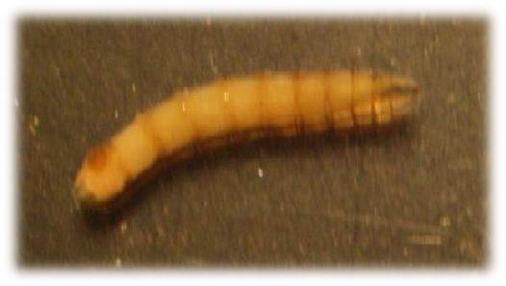
We checked fauna sample Friday 11/06/2009, 10:05 AM. No new fauna. End of the experiment.
On 11/19/2009 we collected a soil sample from the Tent field. We placed the soil sample under the heat lamp for six days. There was no fauna collected. We ended the experiment on 11/25/2009.On 11/25/2009 we collected a soil sample from the Geese field. We placed the soil sample under the heat lamp for six days. We checked the fauna experiment on 11/30/2009, there was a very small spider in the alcohol. We ended the experiment on 11/30/2009.

Hand Texture:
On Friday 11/06/2009 we went to 21 Acres to do the hand texture experiment.
First we went to the Chard field, we determined that the soil was Sandy loam Medium Course. The second area was the Geese field, we determined that the soil was silty clay loam fine course. The last area was the Tent field, We determined the soil was a sandy loam medium course.

Soil Density:
Geese: 257.7g/ 656.53629g= 0.39251g cm3
Chard: 174.9g/ 580.9392g= 0.30106g cm3
Tent: 196.7g/ 504.56032g=0 .38984g cm3
Sites | g/cm3
Geese | 0.39251
Chard | 0.30106
Tent | 0.38984

Water Content:
To get the accurate water content we had to make sure each sample was fresh, and had adequate time to dry in the oven. We weighed two samples of soil, and then placed the samples in the oven on 11/06/2009. The third sample was weighed and placed in the oven 11/09/2009. We weighed all three samples on 11/12/2009. Our results are as follows:
Geese: 250.4g- 105.2g (beaker) = 145.2g

Chard: 242.6g- 105.2g (beaker)= 137.4g

Tent: 268.7g- 105.2g= 163.5g

Weighed again on 11/10/2009

Geese: 142.4g a loss of 2.8g

Tent: 143.7g a loss of 19.8g

The chard we weighed 11/12/2009.

Final weight

Geese: 142.4g

Chard: 137.4g

Tent: 143.7g

Water Content
Sites | 1st weight | 2nd weight | Final weight | Total loss
Geese | 145.2g | 142.4g | 142.4g | 2.8g
Chard | 137.4g | — | 137.4g | 0g
Tent | 163.5g | 143.7g | 143.7g | 19.8g

pH:
Taking dry soil samples from each testing site, we rehydrated each with distilled water. After agitating the soil and letting it sit for ten minutes we placed the calibrated pH probe into each sample making sure to recalibrate after each test. Our final pH for each site are as follows:

Site | pH
Geese | 4.9
Chard | 5.1
Tent | 4.7

Organic Matter:
We took soil samples from each field. Next we placed them into the oven at 105˚C for twenty-four hours. The following day we weighed the soil samples and then placed them into the furnace at 450˚C for another eight hours. After the soil samples have baked for eight hours we took them out and weighed them.
We Placed samples in the oven on 11/18/2009 at 3:45.

Chard
C 3.4456g
C2 4.344g
C3 7.329g
The average percentage of organic matter from the Chard field is 13.38%.
Tent
T 6.9214g
T2 5.5359g
T3 4.8725
The average percent of organic matter from the Tent field is 13.34%.
Geese
G 1.192g
G2 5.0597g
G3 3.2917g
The average percentage of organic matter for the Geese field is 9.82 %.

Crucibles(cups)
C1 9.7047g
C2 13.9175g
C3 11.4757g
T1 10.0431g
T2 12.4130g
T3 11.2577g
G1 10.4465g
G2 11.2321g
G3 11.5544g
105C dried
(Already subtracted from cup weight)
C1 1.8438g
C2 2.6173g
C3 4.5254g
T1 4.4813g
T2 4.0568g
T3 3.4437g
G1 8.4023g
G2 3.0659g
G3 2.3111g

Soil Classification: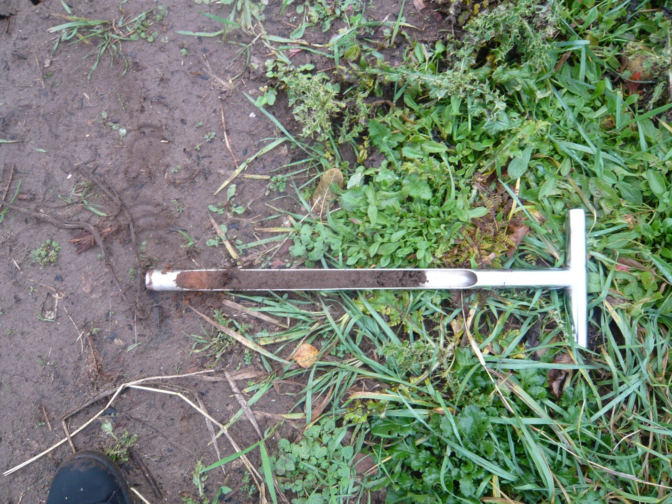
Tent site
(B)Subsurface Horizon
(A)Surface Horizon

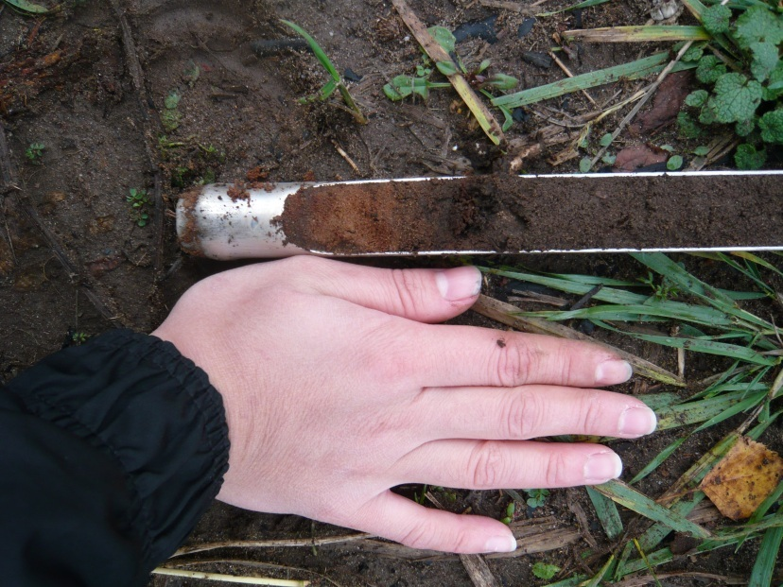
Closer look of subsurface horizon
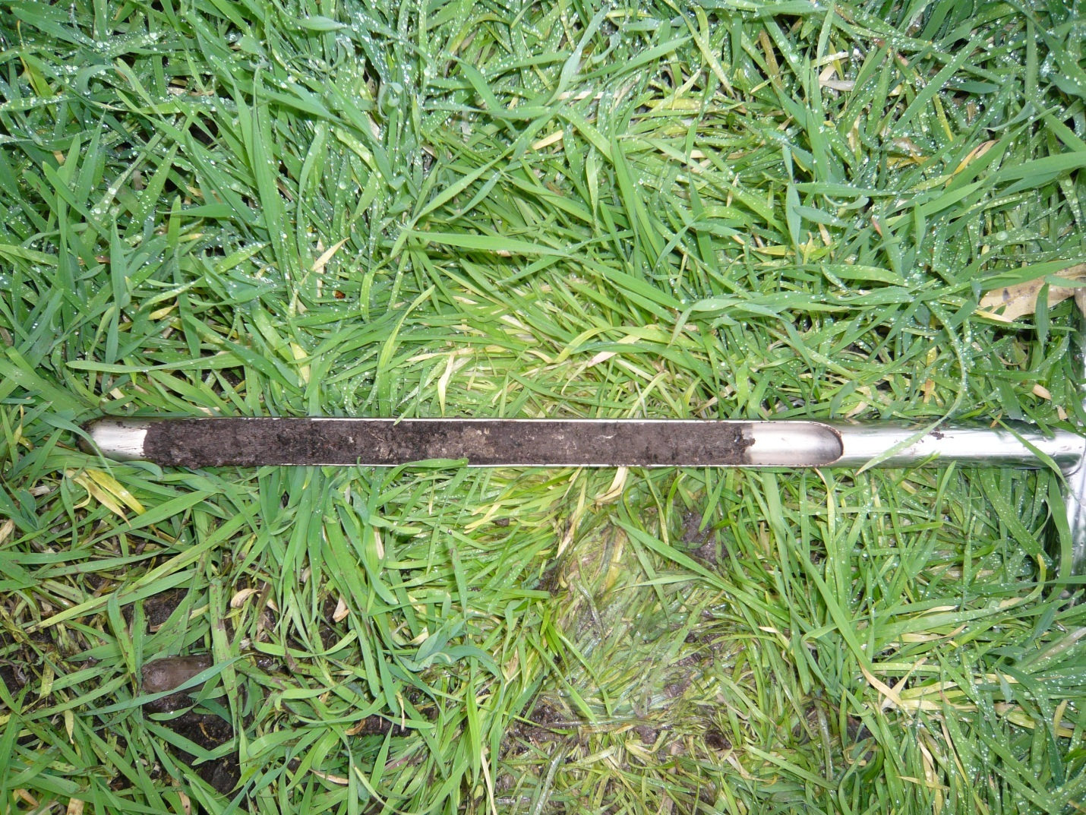
Chard site
(B) Subsurface Horizon
(A)Surface Horizon
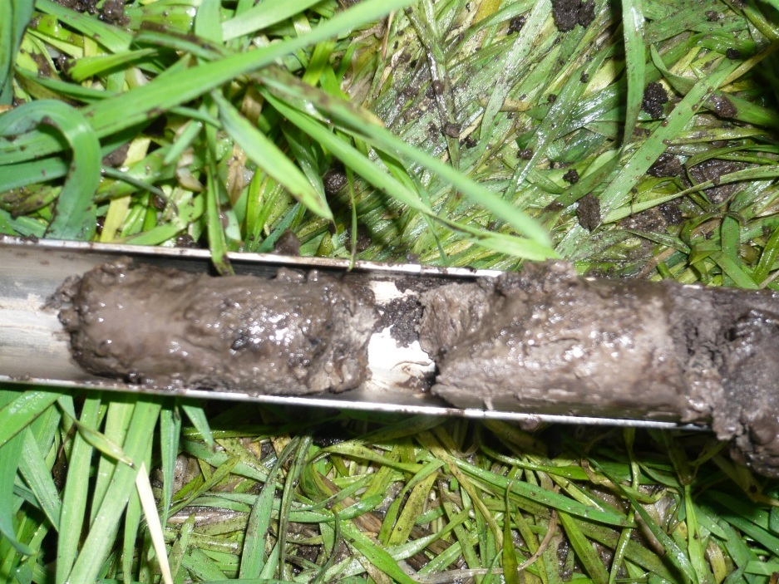
The subsurface horizon close up

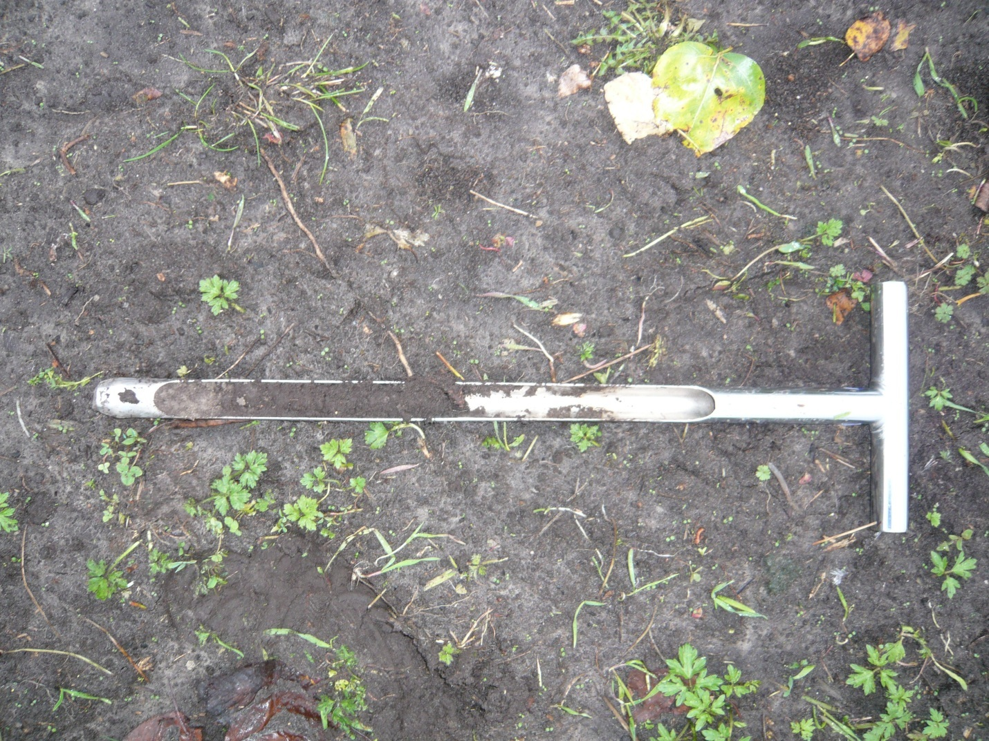
Geese site
(B) Surface Horizon
(A)Surface Horizon
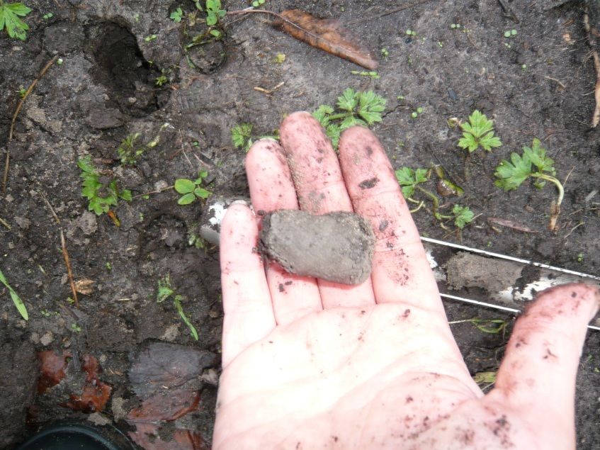
Close up of subsurface horizon

Soil from chard and tent site had similar surface horizon depths, approximately a foot deep. The depth of the geese surface horizon was approximately six inches. Although the chard and tent site had similar surface horizons, the geese and chard sites had similar subsurface horizons. The subsurface horizons at the geese and chard site had a dark grey hue with a clay texture and the tent subsurface horizon with a reddish brown color.

Conclusion

After performing several experiments on soil samples collected from 21 Acres, we have some interesting results. Our results from the hand texture experiment allowed us to determine what type of soil is in each location such as the Tent field and Chard field are both sandy loam medium coarse. The Geese field is a silty clay loam fine coarse. We found this interesting when comparing all of the experiments with each location. The Geese field also has a lower percentage of organic matter and a higher density. Therefore, the Tent and Chard field will be a better location for crop production due to a higher level of organic matter and better soil drainage. When performing the fauna experiment we discovered one fauna in three areas. This would be a great experiment to perform again with a more secure container. We suggest a glass container to hold the soil sample, to allow the light through, but not allow the fauna to crawl out of the sides instead of down the funnel hole.

