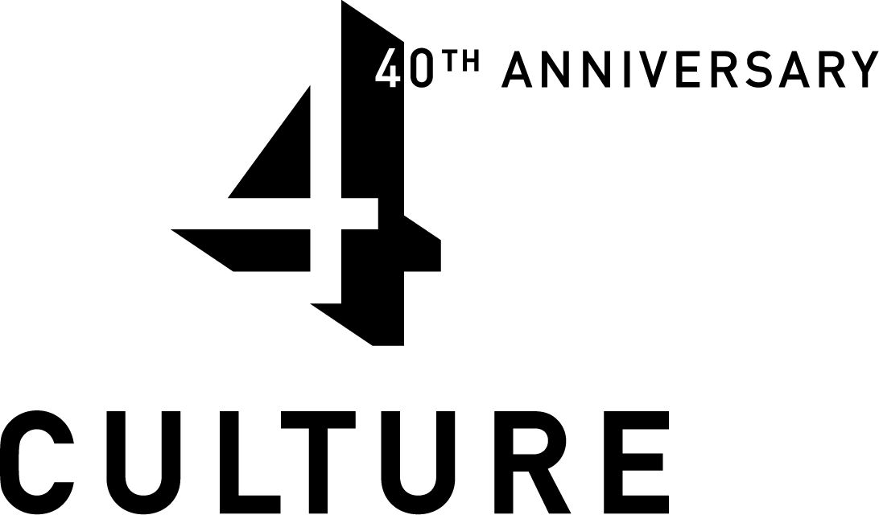
2007 Heritage Special Projects Program Application
4Culture, 101 Prefontaine Place South, Seattle WA 98104, 206-296-7580, www.4culture.org
Deadline  June 25, 2007 |  |  |  | - Applications must be received in the office by 5 p.m. on June 25, 2007 or postmarked by June 25, 2007. Late applications will not be accepted.  - Answer all questions in the space and format provided – application should be exactly 6 pages. Do not use smaller than 10 point type.  - Signatures of the applicant and authorized representative are required.  - Submit 1 signed original and 8 copies of the application, 3-hole punched on left side, preferably double-sided. Please clip together rather than staple.  - Submit TWO sets of support materials with original application (resumes, brochures, references, work samples, etc.) as described in guidelines.
1. Organizations ONLY |  |  |  | Organization: Burke Museum Association
 |  |  |  | Director or Primary Contact: Judy Davis, Administrator
 |  |  |  | Address: Box 353010 University of Washington
 |  |  |  | City: Seattle |  |  |  |  |  |  | Phone:206-685-1734
 |  |  |  | Zip: 98195-3010 |  |  |  |  |  |  | Fax: 206-685-3039
 |  |  |  | E-mail: jadavis@u.washington |  |  | Website: www.burkemuseum.org
 |  |  |  | Federal Tax ID#: 91-2151686 |  |  | Previous Yr.’s Operating Expenditures $ 3365995
 |  |  |  | Fiscal Year End Date: |  |  | Previous Yr.’s Revenues $ 3387366366
 |  |  |  | Project Director (if applicable): Peter Lape |  |  |  |  |  | Title Curator of Archaeology
2. Individuals  ONLY |  |  |  | Name:
 |  |  |  | Address:
 |  |  |  | City: |  |  |  |  | Phone:
 |  |  |  | Zip: |  |  |  |  | Fax:
 |  |  |  | E-mail: |  |  |  |  | Website:
3a. Districts  Call Records & Elections Division at 206-296-1581 to verify King County Council Districts |  |  |  | Applicant's King County Council District # 2  District(s) of Project Activity# 2 State Legislative District # 7  (maps: www.metrokc.gov/mkcc/distmap2006.htm and http://www1.leg.wa.gov/legislature)
3b. Project |  |  |  | Project Title Duwamish #1 Archaeology Collection
Project Description (Max. 3 lines) This project will conserve, catalogue, and provide access to valuable archaeological collections from a significant site along the Duwamish River.

Project Budget $ 19,900 |  |  |  |  | Amount Requested $ 10,000 |  |  |  | # People served by this project (see #2C)
4. Project Description and Concept. Explain the proposed project. What do you plan to do? When? Where? Include specific information regarding dates, location, and activities, as well as general information regarding the historical or heritage content and heritage significance of the proposed project.
This project will conserve, catalogue, and improve access to valuable archaeological collections from a site along the Duwamish River (see details below). These collections are currently endangered by storage methods and materials that do not meet contemporary curation standards, and, because of poor collection arrangement and the lack of an electronic catalogue, they are not readily available for study or display.
Research interest in the collection is strong and is expected to increase substantially as new excavations decrease—due to theoretical changes in the field of archaeology—and as the Duwamish Tribe moves forward with plans to construct a tribal long house near the site. Re-housing the collection will also reduce its size and free up much-needed storage space for additional Washington State collections.
The funds we are requesting will be used to replace and upgrade storage containers and labels; catalog the collection using PastPerfect collections management software; create an accompanying professional-standard archive; and provide access to this information through the Burke Museum’s web site. Work will take place at the Burke Museum as soon as funding is secured.
BACKGROUND: Duwamish No. 1 Site (45-KI-23), a late prehistoric shell midden located at Port of Seattle Terminal 107, encompasses approximately 60 acres bordering the west bank of the Duwamish waterway. Radiocarbon dates from the site indicate occupation for a variety of subsistence and domestic activities from at least 670 A.D. until after 1700 A.D. In 1976 and 1978, Sarah Campbell, then affiliated with the University of Washington’s Office of Public Archaeology, conducted archaeological investigations at Duwamish No. 1 that produced 82 cubic feet of excavated material. In 1986,an additional 67 cubic feet of material were collected as part of the Renton Effluent Transfer System project. The collections include artifacts from stone and bone, a single ceramic sherd (uncommon for this area), and bulk samples of shell, soil and stone. (The project will also make it easier to research across these two collections.)
The Burke Museum was contracted by the Port of Seattle to store the collections, with the provision that the materials be available to the Duwamish Tribe, researchers and others as appropriate. Since then, two research projects have been conducted using the collections, and selected artifacts have been loaned to the Log House Museum. Because of the poor state of the collection, however, additional research and exhibition requests have had to be denied

Summarize the Project Objectives:
- Protect the Duwamish #1 site archaeology collection to ensure its survival
- Document the collection by creating an electronic catalogue and improving archival managerment
- Make the collection accessible for use by researchers, members of the Duwamish tribe, students, teachers, and the publc

5. Applicant Information
Describe the mission and/or goals of your work as an organization or as an individual. How does the proposed project relate to and enhance them? Why is the proposed project a priority at this time?
The Burke Museum of Natural History and Culture is a state museum, founded in 1885 and located at the University of Washington,. The mission statement reads: "The Burke Museum is dedicated to creating a better understanding of the world and our place in it. The museum is responsible for Washington State collections of natural and cultural heritage and for sharing the knowledge that makes them meaningful. The Burke welcomes a broad and diverse audience and provides a community gathering place that nurtures life-long learning and encourages respect, responsibility, and reflection."
The Burke Museum Association is a private nonprofit organization, established in 2001 to actively support the museum and is authorized to receive funds on the museum's behalf.
The Burke Museum began acquiring archaeological collections in the late 1800s and now houses more than one million artifacts from all over the world, including the Americas, Europe, the Middle East, Japan, and Oceania. We are best known for our extensive collections from the Lower Columbia River and the Puget Sound Region of Washington State. The Burke also holds several collections in-trust for public agencies, including several from King County and the Port of Seattle collection addressed by this grant.
This project is a priority for the reasons discussed in #4 above.

6. Application Review Criteria

A. Qualifications and Project Quality. What are the qualifications and accomplishments of the project director, heritage specialists or other personnel? Cite examples of similar project-based work that has been successfully managed and/or administered. What project planning and preparation has been done? What professional standards or best practices are involved in developing the project and how will they be implemented?
This project is similar to many previous efforts of the Burke Museum Archaeology Division, including conservation of archaeological collections from the Black River in Renton—a project supported by King County Landmarks and Heritage Commission in 2001.
Dr. Peter Lape directed that project as well as the current one. He received his Ph.D. in Anthropology from Brown University in 2000 and has been the Burke's archaeology curator since that year. He also holds a faculty position in the UW Department of Anthropology.
Under his guidance, an analysis of the Duwmaish #1 conservation needs was carried out by Burke Archaeology staff and a work plan was developed to bring the collection up to professional standards.
These tasks include, for example: Create electronic catalog using PastPerfect collections management software and integrate photos taken for Log House Museum loan in 2000. Replace adhesive, ink-jet printed labels and wire hang tags with archival, foil-backed labels. Replace non-zip lock enclosures (plastic and paper bags) and 2-mil polyethylene bags with 4-mil, polyethylene, zip-lock enclosures. Replace existing non-archival boxes with archival storage containers to reduce effects of handling. Integrate 2 cubic feet of material delivered to the Burke Museum in 2000. (A similarly detailed task list was developed for other phases of the project.)

- Project Impact. What is the intended impact of this project in the community? What lasting effect or contribution do you expect to generate through this project and how will you achieve it? What resources, programs or products will be developed as a result of project activities?
This project will conserve an irreplaceable primary source of information about King County heritage and make it available to students, scholars, and members of the public, now and in future generations.

The significance of Duwamish #1 is noted by Ruth Kirk and Richard Daugherty in their 1978 book, "Exploring Washington Archaeology":
"This site, occupied from about 1,300 to 200 B.P., had a fairly high concentration of tools and probable evidence of a cedar plank house—a chance for the Duwamish Indian people to recover their past, and, to date, the earliest chapter in the saga of Seattle’s habitation available for archaeological investigation.”

The collections may help future researchers address questions on the of impact of seismic activity and environmental change in the Puget Sound Basin, changes in resource procurement over time, fluctuations of marine species populations over time, and cultural change in pre-contact Native American communities.
- Publicity and Audiences Served. What King County population(s) will be served? What methods of publicity and outreach will be used? How will your project raise the visibility of King County heritage?
This project will be publicized primarily through the Burke Museum’s award-winning webstie, which currently reaches about 2 million visitors a year. King County 4Culture heritage programs will be credited as a sponsor in the website and museum newsletter.
The project will serve several audiences, including:
• Researchers and scholars, investigating questions such as those mentioned above
• Members of the Duwamish tribe, who wish to learn more about their heritage
• Local museums—such as the Renton Historical Museum, the Log House Museum, the White River Valley Museum, and the planned Duwamish Tribe cultural center—that may incorporate these artifacts into future exhibits; and visitors to the museum who will see them
• K-12 teachers and their students, who are seeking primary sources of information on Washington State history to meet the new state Social Studies CBAs.

Application Review Criteria continued
- Evaluation and Documentation. How will you measure success in achieving the goals of the project? How will you document project activities?
- Public Benefit and Access. How are you providing public benefit and access to the resources, programs, and products associated with the component of the project for which you are seeking funds?
Public access will be available through the Burke Museum website, initially. We expect that, once this project is complete, the collection will be used to help create future exhibit displays, educational materials, and research-generated information of importance to Puget Sound residents (see Audiences above).

- Past King County Support. List any prior County support (4Culture, King County) received during the past 3 years. Please list name of funding program, year, amount, and project title. Please indicate whether past funded projects have been completed; or if still in process, please indicate status.
2006 ($8,000) and 2007 ($9,600): Arts Sustained Support
2006, Arts Special Projects ($3,500): for A Celebration of Souls: Day of the Dead in Southern Mexico, artist residency
(just awarded) $2,000 Arts Special Projects Support, for Plateau Artistry

7. Budget: Expenditures and Income
- Total expenditures must equal total income, including in-kind contributions (cash value of donated materials and services), other cash income (for proposed project only), and requested 4Culture grant funds.
- Break down expenditures by category to include rate of pay, cost of materials, etc.
- Indicate specific use of requested 4Culture grant funds. Matching funds are strongly encouraged.
- See Guidelines (page 9) for information about eligible expenses.
- You may provide additional budget information if necessary in Budget Narrative Section 8.
 |  |  |  |  |  | Project Expenditures |  | Project Income
 |  |  |  |  |  | Column 1 |  | Column 2 |  |  |  | Column 3 | Column 4
 |  |  |  |  |  | Total  Project  Expenditures |  | In-kind Contribu-tions |  |  |  | Other Cash Income | Requested 4Culture Grant Funds
- Fees: (indicate rate of pay)
Project Director / Administration
 |  |  |  |  |  | $ |  | $ |  |  |  | $ | $
 |  |  |  |  |  | $ |  | $ |  |  |  | $ | $
Professional Fees
(student assistant $____/hr. x ___ hours) |  |  |  |  |  | $ 14,900 |  | $ |  |  |  | $ 4,900 | $ 10,000
 |  |  |  |  |  | $ |  | $ |  |  |  | $ | $
 |  |  |  |  |  | $ |  | $ |  |  |  | $ | $
- Supplies / Materials:
packaging & labeling |  |  |  |  |  | $ 2,000 |  | $ |  |  |  | $ 2,000 | $
Archive review and copying |  |  |  |  |  | $ 2,500 |  | $ |  |  |  | $ 2,500 | $
 |  |  |  |  |  | $ |  | $ |  |  |  | $ | $
- Promotion / Publicity / Outreach:
 |  |  |  |  |  | $ |  | $ |  |  |  | $ | $
 |  |  |  |  |  | $ |  | $ |  |  |  | $ | $
- Transportation (Who and Where):
 |  |  |  |  |  | $ |  | $ |  |  |  | $ | $
 |  |  |  |  |  | $ |  | $ |  |  |  | $ | $
- Assessment and Documentation:
 |  |  |  |  |  | $ |  | $ |  |  |  | $ | $
 |  |  |  |  |  | $ |  | $ |  |  |  | $ | $
- Other Expenditures and Income (Identify):
 |  |  |  |  |  | $ |  | $ |  |  |  | $ | $
 |  |  |  |  |  | $ |  | $ |  |  |  | $ | $
GRAND TOTALS  (Total expenditures listed in Column 1 must equal total income listed in Columns 2-4.) |  |  |  |  |  | $ 19,900 |  | $ |  |  |  | $ 9,900 | $ 10,000
8. Budget Narrative
Please use this space to provide additional information about your project budget. Describe how project expenses were derived and how you intend to provide or solicit in-kind and/or cash contributions to the overall project budget. Note other sources of income including earned revenue; contributions from corporate, business, or foundation sources; and municipal or other public support. Indicate if these contributions are confirmed.
The budget is based on the costs involved in similar ongoing and past conservation projects, including conservation of archaeological collections from the Black River in Renton, an effort supported by a King County Landmarks and Heritage Commission grant in 2001.
Administration of the project, linking of data to the museum website, and other overhead costs not shown in this budget will be covered by the Burke Museum.
The collection addressed by this conservation project is owned by the Port of Seattle, which pays the Burke Museum a $4248 annual curation fee. Part of this fee would be applied to the current proposed project; and we would request additional funding support from the Port for this project as needed.
In the event that full funding is not immediately available, the project can be undertaken in stages. The highest priority is to conduct a complete inventory of the collection and create an electronic catalog. This will better enable project staff to prioritize remaining tasks and determine the scope of work required. Rehousing is integral to the long-term preservation of this important regional collection and should occur as soon as reasonably possible.

9. Signatures |  |  | Each signatory declares that s/he is an authorized official of the applicant non-profit organization or individual representative, is authorized to make this application, and will assure that any funds received as a result of this application are used only for the purposes set forth herein.
 |  |  | - Applicant Organization or Individual:
 |  |  | Signature of individual authorized to commit applicant in financial matters |  |  |  |  |  |  |  |  |  |  | Date
 |  |  | - Project Director: (If different from applicant, above)
 |  |  | Signature of Project Director |  |  |  |  |  |  |  |  |  |  | Date
10. Applicant Check List: Have you completed the following?
 |  | King County Council district information on page 1
 |  | Signature of individual authorized to commit applicant in financial matters
 |  | One original and 8 copies of the application, standard three-hole punch on the left side
 |  | TWO sets of support materials with the original application (resumes, references, work samples, etc.)
 |  | Self-addressed stamped envelope for any support materials that you want returned (Please list them).
This information is available upon request in alternative formats for persons with disabilities at (206) 296-8574 TTY.

