This is to certify that Marie Ayer (Loyola # 532150066) has successfully completed a course of studies in Spanish with the University of Washington “NW Cádiz Program” in the College of Philosophy and Letters at the University of Cádiz (Cádiz, Spain) during the spring semester of 2001. Her course work and grades are recorded below.

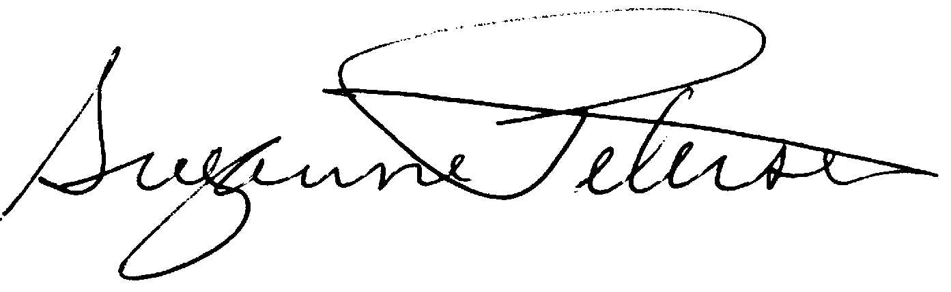
Assoc. Professor Suzanne H. Petersen
Resident Director 2000-2001
NW Cádiz Program
Associate Professor of Spanish
Division of Spanish & Portuguese
University of Washington

Ayer, Marie |  |  | ss 532150066 |  |  |  |  | UW Concurrent /Loyola
Quarter
Credits
Course |  |  |  | Grade |  |  | Instructor |  | Description
Span 302 |  | 5 |  |  | 3.8 | Javier De Cos |  |  | Advanced Spanish Grammar
Span 485 |  | 5 |  |  | 3.3 | Alberto Gullón |  |  | Spain in America
Span 463 |  | 5 |  |  | 3.7 | Alberto Ramos |  |  | Spanish Civilization (1700- )
Span 408 |  | 5 |  |  | 3.0 | María Carmen Fernández |  |  | Translation
Span 390 |  | 2 |  |  | CR | Carmen Tejera |  |  | Dance (Sevillanas)
Span 390 |  | 2 |  |  | CR | Teresa Posada |  |  | Ceramics
Total Cr: |  | 24

