This is to certify that Mia Shaw (Seattle University # 0583096) has successfully completed a course of studies in Spanish in the College of Philosophy and Letters at the University of Cádiz (Cádiz, Spain) during the spring semester of 2004. Her course work and grades are recorded below:

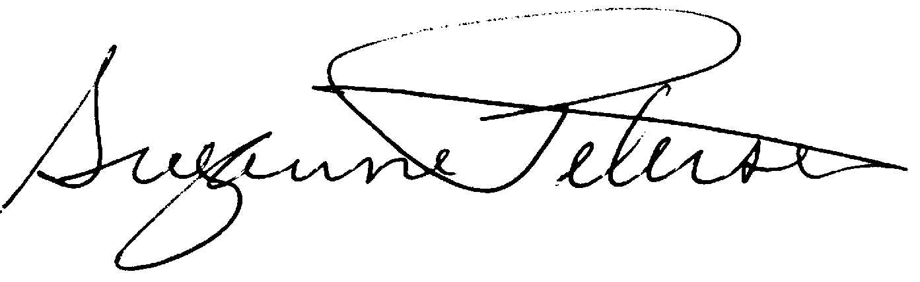

Assoc. Prof. Suzanne H. Petersen
Resident Director 2003-2004
NW Cádiz Program
Associate Professor of Spanish
Division of Spanish & Portuguese
University of Washington

Shaw, Mia |  |  |  | 0583096 |  |  | Seattle U
Quarter
Credits
Course |  |  | Grade |  |  | Instructor |  | Description
Span 302 |  | 5 | 2.9 |  | Teresa Bastardín |  |  | Lengua española avanzada-nivel 2
Span 321 |  | 5 | 4.0 |  | José Jurado |  |  | Literatura española andaluza
Span 328 |  | 5 | 3.1 |  | Alberto Gullón |  |  | España en América
Span 393 |  | 5 | 3.7 |  | Gloria Espigado |  |  | España y la Unión Europea
Span 337 |  | 5 | 3.5 |  | María Carmen Fernández |  |  | Traducción
Total Cr: |  | 25

