This is to certify that Deborah Schmidt (UW # 0120267) has successfully completed a course of studies in Spanish in the College of Philosophy and Letters at the University of Cádiz (Cádiz, Spain) during the spring semester of 2004. Her course work and grades are recorded below:

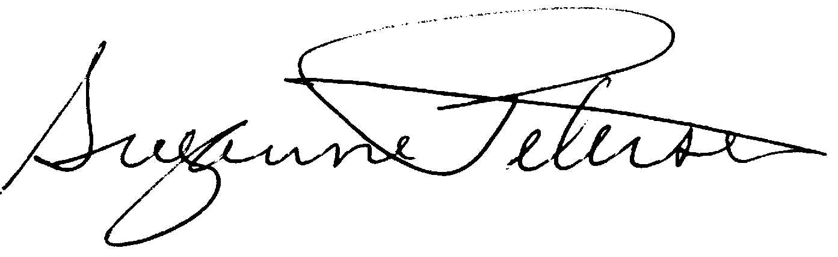

Assoc. Prof. Suzanne H. Petersen
Resident Director 2003-2004
NW Cádiz Program
Associate Professor of Spanish
Division of Spanish & Portuguese
University of Washington

Schmidt, Deborah |  |  |  | 0120267 |  |  | UW
Quarter
Credits
Course |  |  | Grade |  |  | Instructor |  |  | Description
Span 408 H |  | 5 | 4.0 |  | María Carmen Fernández |  |  |  | Traducción
Span 493 |  | 5 | 4.0 |  | Gloria Espigado |  |  |  | España y la Unión Europea
Span 393 |  | 5 | 3.9 |  | Alberto Gullón |  |  |  | España en América
Span 438 H |  | 5 | 4.0 |  | José Jurado |  |  |  | Literatura andaluza
Span 490 H |  | 5 | * |  | Nieves Vázquez |  |  |  | Honors Essay
Total credits |  | 25

* Entregado el ensayo. Espero la nota. Profesora tiene a su niña en el hospital. Tardará un par de días. Envío otra copia de esto completado lo antes posible.

