This is to certify that Genevieve Hayton (UW # 0039192 has successfully completed a course of studies in Spanish in the College of Philosophy and Letters at the University of Cádiz (Cádiz, Spain) during the spring semester of 2004. Her course work and grades are recorded below:

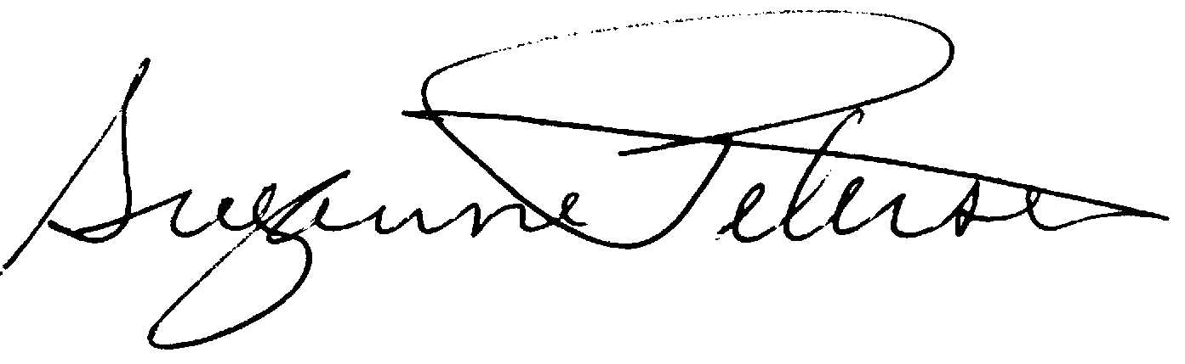

Assoc. Professor Suzanne H. Petersen
Resident Director 2003-2004
NW Cádiz Program
Associate Professor of Spanish
Division of Spanish & Portuguese
University of Washington

Hayton, Genevieve |  |  |  | 0039192 |  |  | UW
Quarter
Credits
Course |  |  | Grade |  |  | Instructor |  |  | Description
Span 406 |  | 5 | 3.5 |  | Felipe Rodríguez |  |  |  | Lengua española avanz.-nivel 4
Span 323 |  | 5 | 3.9 |  | María Carmen Merino |  |  |  | Introd. a la Lingüística
Span 322 |  | 5 | 3.0 |  | Alberto Gullón |  |  |  | España en América
Span 306 |  | 5 | 3.7 |  | José Jurado |  |  |  | Literatura andaluza
Span 393 |  | 5 | 3.6 |  | María Carmen Fernández |  |  |  | Traducción
Span 390 |  | 2 | CR |  | Paco Rey |  |  |  | Guitarra clásica
Total credits |  | 27

