This is to certify that Rachel Anne Donnor (UW # 0234796) has successfully completed a course of studies in Spanish in the College of Philosophy and Letters at the University of Cádiz (Cádiz, Spain) during the spring semester of 2004. Her course work and grades are recorded below:

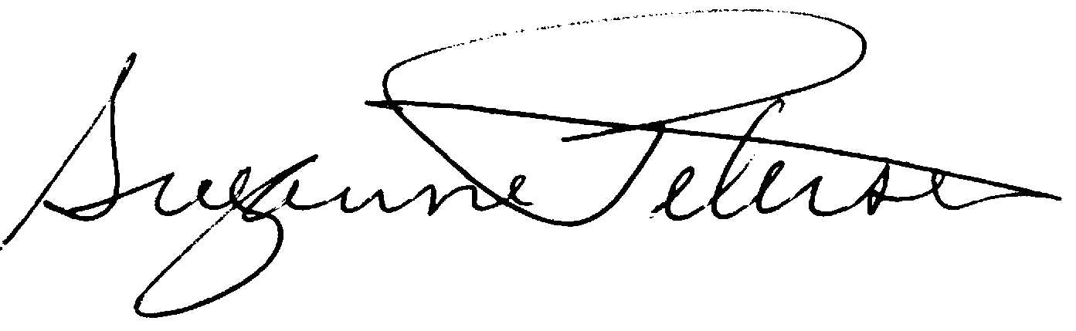

Assoc. Prof. Suzanne H. Petersen
Resident Director 2003-2004
NW Cádiz Program
Associate Professor of Spanish
Division of Spanish & Portuguese
University of Washington

Donnor, Rachel Anne |  |  |  | 0234796 |  |  | UW
Quarter
Credits
Course |  |  | Grade |  |  | Instructor |  |  | Description
Span 323 |  | 5 | 3.9 |  | María Carmen Merino |  |  |  | Introducción a la lingüística
Span 406 |  | 5 | 3.3 |  | Felipe Rodríguez |  |  |  | Lengua española superior
Span 408 |  | 5 | 3.8 |  | María Carmen Fernández |  |  |  | Traducción
Span 493 |  | 5 | 3.7 |  | Gloria Espigado |  |  |  | España y la Unión Europea
Span 493 |  | 5 | 3.6 |  | Alberto Gullón |  |  |  | España en América
Total Cr: |  | 25

