This is to certify that Alexander Casey (UW # 0121902) has successfully completed a course of studies in Spanish in the College of Philosophy and Letters at the University of Cádiz (Cádiz, Spain) during the spring semester of 2004. His course work and grades are recorded below:

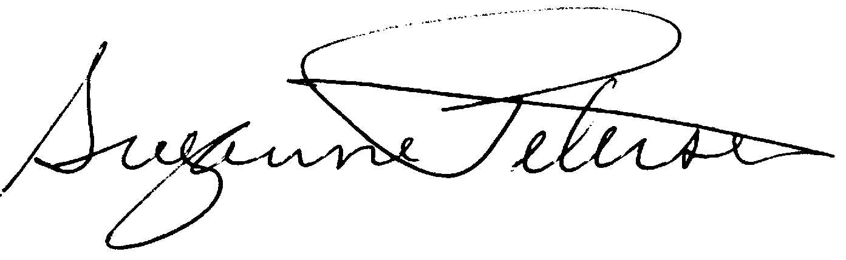

Assoc. Prof. Suzanne H. Petersen
Resident Director 2003-2004
NW Cádiz Program
Associate Professor of Spanish
Division of Spanish & Portuguese
University of Washington
Casey, Alexander |  |  |  | 0121902 |  |  | UW
Quarter
Credits
Course |  |  | Grade |  |  | Instructor |  |  | Description
Span 406 |  | 5 | 3.5 |  | Felipe Rodríguez |  |  |  | Lengua española superior
Span 438H |  | 5 | 4.0 |  | José Jurado |  |  |  | Literatura andaluza
Span 408 |  | 5 | 3.8 |  | María Carmen Fernández |  |  |  | Traducción
Span 493H |  | 5 | 4.0 |  | Gloria Espigado |  |  |  | España y la Unión Europea
Span 490H |  | 5 | 3.9 |  | Alberto Gullón |  |  |  | Honors Essay
Total Cr: |  | 25

