This is to certify that Nicoletta Beyer (UW # 0129523) has successfully completed a course of studies in Spanish in the College of Philosophy and Letters at the University of Cádiz (Cádiz, Spain) during the spring semester of 2004. Her course work and grades are recorded below:

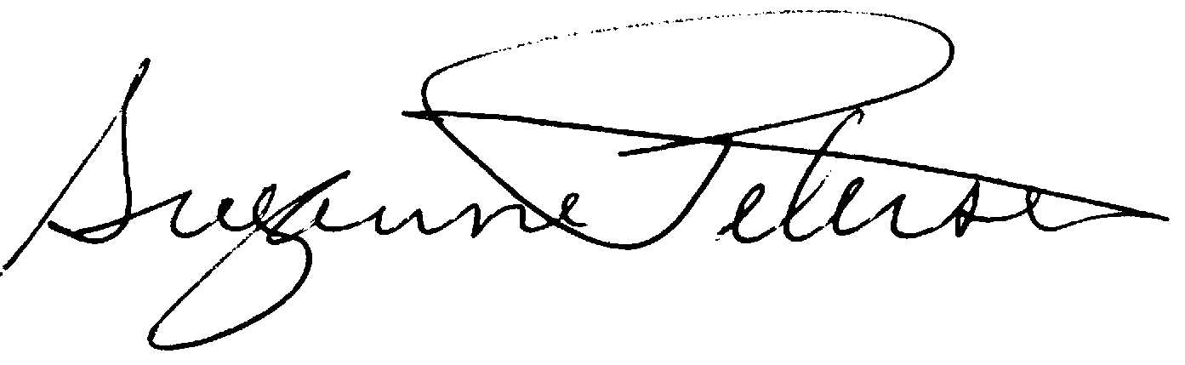

Assoc. Prof. Suzanne H. Petersen
Resident Director 2003-2004
NW Cádiz Program
Associate Professor of Spanish
Division of Spanish & Portuguese
University of Washington

Beyer, Nicoletta |  |  |  | 0129523 |  |  | UW
Quarter
Credits
Course |  |  | Grade |  |  | Instructor |  |  | Description
Span 302 |  | 5 | 3.5 |  | Teresa Bastardín |  |  |  | Lengua española avanzada-nivel 2
Span 303 |  | 5 | 3.5 |  | Carmen Ramos |  |  |  | Composición y Estilística
Span 323 |  | 5 | 3.7 |  | María Carmen Merino |  |  |  | Introducción a la lingüística
Span 328 |  | 5 | 2.9 |  | Alberto Gullón |  |  |  | España en América
Span 393 |  | 3 | 4.0 |  | Apolonia Pinteño & Suzanne Petersen |  |  |  | Estudio Independiente - Colegio Carlos III
Span 408 |  | 5 | 3.1 |  | María Carmen Fernández |  |  |  | Traducción
Span 390 |  | 2 | CR |  | Paco Rey |  |  |  | Guitarra clásica
Total Cr: |  | 28-30

Quiere los crédito de guitarra?

