HIV-1 virologic and immunologic progression and antiretroviral therapy initiation among HIV-1-infected participants in an efficacy trial of recombinant glycoprotein 120 vaccine

Peter B. Gilbert¹, Marta L. Ackers², Phillip W. Berman³, Donald P. Francis³, Vladimir Popovic⁴, Dale J. Hu², William L. Heyward⁵, Faruk Sinangil⁶, Bryan E. Shepherd⁷, Marc Gurwith⁶
¹ Statistical Center for HIV/AIDS Research and Prevention, Fred Hutchinson Cancer Research Center, Seattle WA
² Centers for Disease Control and Prevention, Atlanta, GA
³ Global Solutions for Infectious Diseases, Brisbane, CA
⁴ Janssen Ortho Inc., Toronto, ON
⁵ Quattro Clinical Research, Oakland, CA
⁶ VaxGen, Inc., Brisbane, CA
⁷ Department of Biostatistics, University of Washington, Seattle, WA

Word Count

Abstract: 138
Text: 4010
Keywords: antibody-mediated vaccine; CD4 cell count; HIV-1 vaccine efficacy trial; post-infection end point; recombinant glycoprotein envelope vaccine; surrogate marker; viral load
FOOTNOTES
- Presented in part: AIDS Vaccine 2003, New York, NY, September 2003 (abstract 147).
- The study was conducted in accordance with the Declaration of Helsinki, local Institutional Review Board (IRB) requirements and with approval from appropriate regulatory authorities. Written informed consent was obtained from all volunteers.
- Conflicts of Interest: Marc Gurwith and Faruk Sinangil are employed by VaxGen; Phillip W. Berman, Donald P. Francis, William L. Heyward, and Vladimir Popovic are former VaxGen employees; Peter Gilbert in the past received consulting fees from VaxGen.
- Financial Support: VaxGen funded the vaccine trial (Brisbane CA), with additional funding from the National Institutes of Health including 1 RO1 AI054165-01; and SAIC, Inc., Contract 23XS119 (Frederick, MD).
- Address correspondence and reprint requests to Dr. Marc Gurwith at VaxGen, 1000 Marina Blvd., Brisbane, CA 94005-1841 (mgurwith@vaxgen.com).
ABSTRACT
The first efficacy trial of an HIV-1 vaccine was conducted in North America and the Netherlands between 1998 and 2003. This multicenter, randomized, placebo-controlled trial of a recombinant glycoprotein 120 vaccine monitored 5403 initially HIV-negative volunteers for 3 years. The 368 participants who acquired HIV-1 were monitored for 2 years using the following post-infection endpoints: plasma HIV-1 RNA, CD4+ lymphocyte counts, initiation of antiretroviral therapy (ART), and HIV-1 related clinical outcomes. This article reports the study results pertaining to the effect of vaccination on the post-infection end points. The time until ART initiation and the time until virologic failure or ART initiation were similar in the vaccine and placebo arms. The pre-ART viral and CD4+ lymphocyte count trajectories were also comparable between the groups. Evidently the vaccine did not impact HIV-1 disease progression.
INTRODUCTION
Two preventive vaccine efficacy trials of a recombinant glycoprotein 120 (rgp120) vaccine were conducted from 1998 to 2003 [1]. The first trial tested a bivalent subtype B/B vaccine in North America and the Netherlands and the second trial tested a bivalent subtype B/E vaccine in Thailand. For each trial, the primary objective was to assess whether vaccination reduced the incidence of HIV-1 infection, while the secondary objective was to assess whether vaccination delayed disease progression for participants who acquired HIV [2]. The results on primary end points for the first trial (VAX004) were reported in [3], and here we report the results on secondary post-infection end points for VAX004. Many licensed vaccines protect partly or wholly by ameliorating disease, which make important assessments of possible disease-modifying effects of the HIV-1 vaccines.
The secondary objective was assessed by comparing outcomes based on antiretroviral therapy (ART) initiation, plasma HIV-1 RNA (viral load), and CD4+ lymphocyte counts between vaccine and placebo recipients. Since plasma viral load and CD4+ lymphocyte counts are strong and independent predictors of subsequent clinical HIV-1 disease progression and mortality [4–9], these surrogate end points have been used to support the licensure of antiretroviral drugs [10–13] and will be increasingly useful in evaluating the potential impact of HIV-1 vaccine candidates in Phase III trials [14–15]. Furthermore, in the current era of ART, it is neither feasible nor ethical to study vaccine effects on long-term HIV-1 disease progression in the absence of treatment, so that the analyses of early viral and immunologic events prior to ART initiation will become increasingly important.
The rgp 120 study vaccine was designed to prevent HIV-1 infection by eliciting anti-HIV-1 neutralizing and binding antibody responses, which it induces in virtually all recipients [2]. Other vaccine candidates under development have focused on the elicitation of CD8+ cytotoxic T lymphocyte (CTL) and CD4+ T helper responses [16–17]. Several such vaccines have shown the ability to control viremia and prevent disease in non-human primate models [18–21]. Although rgp120 does not generate CD8+ CTL responses and the vaccine was not designed specifically to impact the post acquisition disease course, it stimulates proliferation of CD4 lymphocytes in most vaccine recipients, which provide a helper function for antibody producing B cells and CD8+ CTLs [2]. Furthermore, Israel et al. [22] found that rgp120-immunized macaques were infected upon challenge with SIVmac251 clone BK28, but had lower viral load and the absence of disease compared to control animals, and Voss et al. [23] observed a similar result for macaques challenged with SHIV89.6P. These data raise the hypothesis that a gp120 envelope antigen vaccine could potentially ameliorate HIV-1 progression. A preventive HIV-1 vaccine that durably controls viral load potentially could slow the epidemic by reducing infectiousness [24–27], and a vaccine that delayed or prevented initiation of ART would extend the AIDS-free period and save treatment and care resources.

METHODS
Study Design
VAX004 enrolled healthy, HIV-negative, 18–60 years old, non-injection–drug using men who have sex with men (MSM), and women at high risk for heterosexual transmission of HIV. Participants were randomized in a 2:1 ratio to receive the vaccine or placebo. The study vaccine contained two rgp120 HIV-1 envelope antigens derived from 2 different subtype B strains (300 μg each of MN and GNE8 rgp120/HIV-1 [28]) (AIDSVAX® B/B, VaxGen, Inc., Brisbane, CA, USA) adsorbed onto 600 μg of alum. The placebo consisted of alum only. Participants received immunizations at months 0, 1, 6, 12, 18, 24, 30, and were tested for HIV-1 infection at months 6, 12, 18, 24, 30, 36 using HIV-1 ELISA and confirmatory immunoblot. When subjects were diagnosed with HIV-1 infection, their immunizations were discontinued, and if they consented, they entered the infected cohort study, which followed them at months 0, < 1, 1, 2, 4, 8, 16, 20, 24 post infection diagnosis. At each visit, the volunteer’s viral load was determined by the Amplicor 1.0 HIV-1 RNA polymerase chain reaction assay, and his/her CD4+ lymphocyte count was determined by the Coulter system. Whether the participant initiated ART was also recorded at each visit. VAX004 was conducted in accordance with ethical requirements as described by [3].

Statistical Methods
The protocol specified two main analyses of the post-infection end points. The first analysis assesses a composite end point defined as the first occurrence of virologic failure (viral load > 10,000 copies/mL) or initiation of ART, whichever occurs first. The composite endpoint is motivated by its interpretation and by its amenability to valid analysis by standard time-to-event methods; see [14] for a rationale for its use. Vaccine efficacy to prevent the composite end point, VEc, was defined as the percent reduction (vaccine versus placebo) in the probability of the composite end point occurring by 12 months post-infection diagnosis. End points occurring over at least a one-year period were included to ensure that an observed vaccine effect to control viremia would be robust to the possible emergence of HIV-1 vaccine resistance mutations [29–31]. VEc was estimated using Kaplan-Meier estimates of the event-free probabilities at 12 months. The vaccine effect on three additional composite end points with virologic failure thresholds of 1500, 20,000, or 55,000 copies/mL were also assessed. The 4 thresholds were chosen based on the Rakai study data which suggested that persons with viral load < 1500 copies/mL rarely transmit HIV-1 heterosexually [25–26], and on the Multicenter AIDS Cohort Study (MACS), which demonstrated discrimination of AIDS progression rates by viral load thresholds of 10,000, 20,000, and 55,000 copies/mL [32] in MSM. The MACS population was similar to the VAX004 study population, which was 94.3% MSM.
The second main analysis assesses jointly VEc^{PH} and VEs, where VEc^{PH} is the percent reduction in the hazard rate (vaccine/placebo) of the composite end point (with a 10,000 copies/mL failure threshold) during the first 12 months after infection diagnosis, and VEs is the percent reduction in the hazard rate of HIV-1 infection diagnosis within 36 months after randomization. The parameter pair (VEs,VEc^{PH}) was estimated with a joint 95% confidence region, based on Cox proportional hazards models for the 2 time periods (i) between randomization and infection diagnosis and (ii) between infection diagnosis and the composite end point. The joint method accounts for correlation in the estimates of VEs and VEc^{PH} [33]. Joint analysis of (VEs,VEc^{PH}) summarizes the aggregate effect of vaccine to prevent infection and the post-infection composite end point, and has relatively high statistical power if the vaccine has beneficial effects on both infection and progression.
The time to ART initiation and the longitudinal profiles of pre-ART viral loads and CD4+ lymphocyte counts were also analyzed. Only biomarker values measured prior to ART initiation were included in the analyses because ART suppresses viremia and maintains CD4+ lymphocytes in most patients [32], which complicates assessment of the effect of vaccine. Generalized estimating equations (GEE) models [34] were used for testing whether mean pre-ART biomarker trajectories differed between the vaccine and placebo arms, and for assessing the proportion of subjects with pre-ART viral load below 1500 or 400 copies/mL over time. In all GEE models, biomarker trajectories were censored at the time of ART initiation. These models may give biased results because ART initiation depends on the responses: multivariable Cox proportional hazards models showed that both pre-ART viral load and pre-ART CD4+ lymphocyte count were significant independent predictors of ART initiation, whether entered into the model as the values at the month 1 visit or as time-dependent covariates. Predictors of ART initiation were controlled for in the GEE models to minimize possible bias stemming from this dependent censoring.
The time-to-event end points were analyzed both in the group of HIV-1-infected participants and in the entire randomized cohort. The former analyses are important because vaccine effects on HIV-1 pathogenesis are most clearly measured in infected persons. However, these analyses are not intent-to-treat (ITT) and are susceptible to post-randomization selection bias [15]. Therefore, it is useful to also conduct unbiased ITT analyses of the post-infection end points in all randomized subjects. These analyses evaluate the time between randomization and the post-infection end point, and approximate a classical assessment of vaccine efficacy to prevent clinically significant disease [35]. For analyses of the randomized cohort, subjects who did not experience the post-infection end point within 36 months of randomization were censored at 36 months, and for analyses of the infected subcohort, subjects who did not experience the post-infection end point by the month 24 post infection diagnosis visit were censored at the month 24 visit date. In both analyses subjects lost to follow-up were censored at the date of last visit.
Viral load is highly variable during the first several weeks following HIV-1 acquisition [9,37–39]. Based on the semi-annual HIV-1 testing schedule, on average HIV-1 infection was detected 3 months after transmission, and a small fraction of infected participants may have had a month < 1 viral load value sampled during the acute phase. To minimize the effect of the extremely wide variability of acute viral loads, month < 1 values were not used for determining composite end points. Therefore, composite end points were registered at the earliest date of ART initiation or virologic failure based on a viral load measurement at the month 1 visit or later.
Self-reported risk behavior was assessed on all participants using standard questionnaires administered at entry and at 6-month intervals. Based on multivariable Cox regression analysis, 9 baseline behavioral variables were found to be independent predictors of infection risk (listed in footnotes of Table 1). Behavioral risk was discretized into low, medium, and high risk groups, defined as the presence of 0, 1–3, or > 3 of the 9 risk factors, respectively [3].
Time-to-event end points were assessed using Kaplan-Meier curves and log-rank tests. All analyses included all subjects regardless of the number of immunizations received; results were generally similar for “fully immunized” subjects who received the month 0, 1, and 6 immunizations prior to HIV-1 infection. All p-values are 2-sided and no adjustments were made for multiple testing except where indicated.

RESULTS
Follow-up and Characteristics of Infected Participants
Figure 1 illustrates the number of subjects by arm in the different stages of the trial. Of the 5403 randomized subjects, 368 acquired HIV; 241/3598 (6.7%) in the vaccine group and 127/1805 (7.0%) in the placebo group. VEs was estimated as 5.7% [95% CI, –17.0% to 24.0%, p = 0.59]. Of the 368 infected subjects, 347 enrolled into the infected cohort and were evaluable for post-infection end points (225 vaccine, 122 placebo). Of these, the median follow-up was 19.7 months. The rate of dropout did not differ by study arm (log-rank p = 0.79). Participants were unblinded on June 1, 2003, after which no further visits were scheduled. Of the 335 subjects diagnosed with HIV before June 1, 2002, 269 (80%) reached the 12 month visit (176 vaccine, 93 placebo), and of the 239 subjects diagnosed before June 1, 2001, 153 (64%) reached the 24 month visit (94 vaccine, 59 placebo).
Table 1 summarizes characteristics of the 347 subjects who enrolled into the post-infection cohort. Most subjects were men (98.3%), ages were predominantly 26–50 years, most were white non-Hispanic (83.9%), education was high (60.5% college graduates), and most had medium (62.3%) or high (22.3%) baseline risk. HIV-1 infections occurred between 1998 and 2002 with the majority occurring in 2000–2001, and 271 (78.1%) of the 347 infected subjects received the Month 0, 1, and 6 immunizations prior to infection. Only 5 (1.4%) of 347 infected subjects (all vaccine recipients) and 108 (2.0%) uninfected subjects (vaccine: 70/3598, 1.9%; placebo: 38/1805, 2.1%) reported receiving post-exposure prophylaxis.

Vaccine Effect on Antiretroviral Therapy Initiation and Virologic Failure
Figure 2 shows Kaplan-Meier curves of the time to ART initiation and the time to composite end point (ART initiation or viral failure) with a viral failure threshold of 10,000 copies/mL. For the infected cohort, 99 of 225 (44.0%) vaccine and 53 of 122 (43.4%) placebo recipients started ART within 24 months; the rate of ART did not differ between the groups (log-rank p = 0.61). A total of 183 of 225 (81.3%) vaccine and 96 of 122 (78.7%) placebo recipients reached the composite end point within 24 months, with no difference between arms (log-rank p = 0.48). In the randomized cohort, there was a trend toward a longer time to ART in vaccine recipients, with 59 of 3598 (1.6%) vaccine and 42 of 1805 (2.3%) placebo recipients starting ART within 36 months (log-rank p = 0.07), but there were no differences in the rate of composite end point (vaccine: 163/3598, 4.5%; placebo: 89/1805, 4.9%; log-rank p = 0.43).
Based on the infected cohort, for the viral failure thresholds of 1500, 10,000, 20,000, and 55,000 copies/mL, respectively, VEc was estimated as –3.3% [95% CI, –9.2% to 2.6%], 1.0% [95% CI, –10.8% to 12.9%], 2.8% [95% CI, –10.8% to 16.5%], and 0.3% [95% CI, –19.5% to 20.1%], where a simulation procedure was used to compute the 4 confidence intervals such that they include all 4 true VEc parameters simultaneously with ≥ 0.95 probability. Using a Cox model controlling for region, sex, age, race, education, baseline risk score, and calendar time at infection diagnosis (described in Table 1), the parameter VEc^{PH} with 10,000 copies/mL threshold was estimated as –8.1% [95% CI, –40.8% to 17.1%, p = 0.57].
Vaccine Effect on Pre-ART Viral Loads and CD4+ Lymphocyte Counts
Figure 3 shows the viral loads and CD4+ lymphocyte counts that were measured prior to ART initiation. On average infected subjects had 4.5 pre-ART viral load measurements, with range 0 values (3 subjects) to 10 values. Of the 1657 total values, 302 (18.2%) were outside of the quantifiable range 400 to 750,000 copies/mL of the assay, with 259 values < 400 copies/mL and 43 values > 750,000 copies/mL. As prespecified, values below and above the quantification limit were set at 399 and 750,000 copies/mL, respectively. On average infected subjects had 4.0 pre-ART CD4+ lymphocyte counts, with range 0 values (9 subjects) to 9 values. Pooled over the study arms, across the visits at month < 1, 1, 2, 4, 8, 12, 16, 20, 24, the median log₁₀ pre-ART viral load was 4.37, 4.17, 3.94, 3.99, 4.27, 4.23, 4.29, 4.21, and 4.14 copies/mL, respectively, and the median pre-ART CD4+ lymphocyte count was 596, 602, 586, 606, 552, 557, 546, 506, and 492 cells/mm³, respectively. At the month 2 visit, the mean pre-ART (set-point) viral load was 4.33 and 4.26 log₁₀ copies/ml in the vaccine and placebo arms, respectively (mean difference 0.07 copies/ml, 95% CI –0.18 to 0.33), and the mean pre-ART CD4+ lymphocyte count was 635 and 609 cells/mm³ in the vaccine and placebo arms (mean difference 26, 95% CI –90 to 40 cells/mm³). A likelihood-based sensitivity analysis of the vaccine effect on pre-ART set-point viral load that accounted for the assay-censoring of viral load values and for substantial levels of possible selection bias further supported that the vaccine had no significant effect on early viral load [40].
GEE models were fit with and without adjustment for the covariates region, sex, age, race, education, baseline risk score, and the calendar time at infection diagnosis. The mean pre-ART viral load trajectories were comparable between the study arms (unadjusted: p = 0.81; adjusted: p = 0.80). Linear mixed effects models that accounted for the quantification-limit-censoring of viral loads [41] and controlled for time-dependent CD4+ lymphocyte count as well as other covariates also showed no differences. In addition, GEE models for the pre-ART CD4+ lymphocyte trajectories showed no difference between arms (unadjusted: p = 0.43; adjusted: p = 0.77).
The ability of vaccination to control pre-ART viral load below 1500 or 400 copies/mL was also assessed. At months 1, 4, 12, and 24, respectively, 22 (17.3%), 16 (13.8%), 10 (13.0%), and 4 (10.3%) vaccine recipients versus 13 (18.6%), 10 (14.5%), 5 (10.2%), and 3 (13.0%) placebo recipients had pre-ART viral loads < 1500 copies/mL; and 11 (8.7%), 8 (6.9%), 6 (7.8%), and 4 (10.3%) vaccine recipients versus 9 (12.9%), 3 (4.4%), 3 (6.1%), and 2 (8.7%) placebo recipients had pre-ART viral loads < 400 copies/mL. Based on binary GEE models with or without covariate adjustment, there were no significant differences in the proportion of subjects suppressed below 1500 or 400 copies/mL between the study arms (p-values > 0.20).

Joint Assessment of the Vaccine Effect on HIV-1 Infection and HIV-1 Progression
(VEs,VEc^{PH}) was estimated as (8.5%,-10.2%), with 95% confidence region depicted in Figure 4. The confidence region is mostly contained within the null hypothesis region, strongly supporting that VEs ≤ 30% and VEc^{PH} ≤ 40%.

HIV-1 Progression, AIDS, and Death
Forty-eight of 225 (21.3%) infected vaccine recipients and 29 of 122 (23.8%) infected placebo recipients progressed to an HIV-related clinical outcome as defined by categories B or C in the 1993 Revised Classification System for HIV Infection and Expanded Surveillance Case Definition for AIDS Among Adolescents and Adults [42]. The time to first HIV-related clinical outcome was comparable between the study arms (log-rank p = 0.95). Of the 77 subjects with a clinical outcome, 48 (vaccine: 30/225, 13.3%; placebo: 18/122, 14.8%) had a category B event as the first event. These events were diarrhea > 30 days (18 vaccine, 13 placebo), neuropathy (5 vaccine, 1 placebo), lymphadenopathy (2 vaccine, 4 placebo), oral candidiasis (4 vaccine), and fever > 30 days (1 vaccine). In addition, 29 had a category C event (an AIDS-defining illness) [42] as the first clinical outcome: CD4 < 200 cells/mm³ (6 vaccine, 6 placebo), aphthous stomatitis > 30 days (5 vaccine, 1 placebo), clinical herpes > 30 day (4 vaccine, 1 placebo), pneumonia (1 vaccine, 3 placebo), Kaposi’s sarcoma (1 vaccine), fungal infection (1 vaccine). No infected participants died during follow-up.

Subgroup Assessments
As reported in [3], exploratory analyses suggested that VEs may have varied between whites and non-whites and among subjects with low, medium, and high baseline risk scores. Based on these results, we repeated the analyses of the post-infection end points within race/ethnicity and behavioral risk subgroups. The results for each subgroup were comparable to those for the overall cohort, suggesting no vaccine effects on HIV-1 progression (not shown).

DISCUSSION
Vaccine effects on several end points based on ART initiation, viral load, CD4+ lymphocyte count, and AIDS were assessed in VAX004 study subjects who acquired HIV-1 while enrolled in the trial, over a 2 year follow-up period following HIV-1 infection diagnosis. No effects of vaccination on any of the post-infection end points were observed, and the study strongly supports that the tested vaccine had neither beneficial nor harmful effects on HIV-1 progression. There was concern that the tested vaccine could possibly exacerbate disease, based on in vitro HIV-1 studies [43-45] and on studies for other infectious diseases that showed disease-enhancement by envelope-based vaccines [46-52], and therefore it is an important result that in VAX004 the rgp120 vaccine did not enhance HIV-1 progression.
The first event of virologic failure or ART initiation (the composite end point) was used as a main end point for measuring the vaccine effect on HIV-1 progression. Inferences on this end point are most clearly interpreted for trials with standardized ART initiation guidelines that are adhered to [14]. Standardized guidelines were not used in VAX004, and therefore the results must be interpreted carefully. Of the 279 total composite end points registered during the trial, 208 (74.6%) were due to viral failure > 10,000 copies/mL and 71 (25.4%) were due to ART initiation prior to viral load > 10,000 copies/mL. The CD4+ lymphocyte count for 61 of these 71 subjects (85.9%) never dropped below 350 cells/mm³; therefore these 61 subjects started ART prematurely based on the 2002 ART guidelines [32]. Consequently, 61 of the 279 (21.9%) composite end points can be viewed as possible noise that could attenuate a real vaccine effect. When these 61 events were excluded the composite end point rates were still comparable among the vaccine (136 of 225, 60.4%) and placebo (82 of 122, 67.2%) arms, lending robustness to the inference of no significant vaccine effect. The trial of rgp120 B/E in Thailand operated under standardized ART initiation guidelines, as is the ongoing Phase 3 trial in Thailand, and future efficacy trials are planned to follow standardized guidelines. For these trials, inferences on the composite end point will be more clearly interpretable.
Participants infected earlier in the trial (1998–1999) tended to start ART more quickly than participants infected later (2001–2002) (p < 0.0001, data not shown). This pattern reflects the evolving recommendations for when to start ART, from the prevailing view near the beginning of the trial to “hit early and hard” [53] to the 2002-2003 recommendations to defer ART until clinical symptoms, low CD4+ lymphocyte count, or high viral load [32,54]. The more recent recommendations will facilitate analyses of forthcoming HIV-1 vaccine efficacy trials, since fairly long ART-free periods for most infected trial participants are necessary for reliable assessments of the durability of vaccine effects (in the absence of ART) on viral load and other biomarker end points.
A limitation of the assessments of vaccine effects on HIV-1 progression in VAX004 is that the results are based on surrogate end points that are not validated as reliable replacements for the clinical end points of interest (AIDS-defining illnesses and secondary transmission). Surrogacy of these end points for therapies may not translate into surrogacy for vaccines, due to different mechanisms of efficacy. There was low statistical power to assess the vaccine effect on progression to AIDS, since only 77 of 347 (22.2%) infected participants experienced an HIV-related clinical event within the relatively short follow-up period of 2 years. Although it is not possible to verify that the absence of vaccine effects on the early biomarker surrogate end points imply the absence of vaccine effects on progression to AIDS, this seems likely based on natural history studies [7-10]. In future trials it may be important to collect data on a variety of clinical end points over several years [55], to allow identification of trends of vaccine effects on clinical end points, and to help interpret observed vaccine effects on biomarker end points.

ACKNOWLEDGMENTS
The authors would like to thank the study volunteers and the study staff.

REFERENCES
1. Harro CD, Judson FN, Gorse GJ, et al. Recruitment and baseline epidemiologic profile of participants in the first phase 3 HIV vaccine efficacy trial. J Acquir Immune Defic Syndr 2004;37:1385–92.
- Francis DP, Gregory T, McElrath MJ, et al. Advancing AIDSVAX to phase 3. Safety, immunogenicity, and plans for phase 3. AIDS Res Hum Retroviruses 1998;Suppl 3:S325-31.
- rgp120 HIV Vaccine Study Group. Placebo-controlled trial of a recombinant glycoprotein 120 vaccine to prevent HIV infection. J Infect Dis 2004; in press.
- Margolick JB, Farzadegan H, Hoover DR, Saah AJ. Relationship between infectious cell-associated human immunodeficiency virus type 1 load, T lymphocyte subsets, and stage of infection in homosexual men. J Infect Dis 1996; 173:468-71.
- Katzenstein DA, Hammer SM, Hughes MD, et al. The relation of virologic and immunologic markers to clinical outcomes after nucleoside therapy in HIV-infected adults with 200 to 500 CD4 cells per cubic millimeter. AIDS Clinical Trials Group Study 175 Virology Study Team. N Engl J Med 1996; 335:1091-8.
- Mellors JW, Munoz A, Giorgi JV, et al. Plasma viral load and CD4+ lymphocytes as prognostic markers of HIV-1 infection. Ann Intern Med 1997;126:946-954.
- O'Brien TR, Blattner WA, Waters D, et al. Serum HIV-1 RNA levels and time to development of AIDS in the Multicenter Hemophilia Cohort Study. J Amer Med Assoc 1996; 276:105-10.
- HIV-1 Surrogate Marker Collaborative Group. Human immunodeficiency virus type 1 RNA level and CD4 count as prognostic markers and surrogate end points: A meta-analysis. AIDS Res Hum Retroviruses 2000;16:1123–33.
- Lyles RH, Munoz A, Yamashita TE, et al. Natural history of human immunodeficiency virus type 1 viremia after seroconversion and proximal to AIDS in a large cohort of homosexual men. Multicenter AIDS Cohort Study. J Infect Dis 2000;181:872–80.
- Hammer SM, Squires KE, Hughes MD, et al. A controlled trial of two nucleoside analogues plus indinavir in persons with human immunodeficiency virus infection and CD4 cell counts of 200 per cubic millimeter or less. AIDS Clinical Trials Group 320 Study Team. N Engl J Med 1997; 337:725-33.
- Vittinghoff E, Scheer S, O’Malley P, Colfax G, Holmberg SD, Buchbinder SP. Combination antiretroviral therapy and recent declines in AIDS incidence and mortality. J Infect Dis 1999; 179:717-20.
- Centers for Disease Control and Prevention. Update: AIDS—United States, 2000. MMWR 2002;51:592-5.
- Gilbert PB, DeGruttola V, Hammer SM, Kuritzkes DR. Virologic and regimen termination surrogate end points in AIDS clinical trials. J Amer Med Assoc 2001;285: 777–84.
- Gilbert PB, DeGruttola VG, Hudgens MG, Self SG, Hammer S, Corey L. What constitutes efficacy for a Human Immunodeficiency Virus vaccine that ameliorates viremia: Issues involving surrogate end points in Phase 3 trials. J Infect Dis 2003;188: 179–93.
- Hudgens MG, Hoering A, Self SG. On the analysis of viral load end points in HIV-1 vaccine trials. Stat Med 2003;22:2281–98.
- Nabel GJ. Challenges and opportunities for development of an AIDS vaccine. Nature 2001;410:1002–7.
- Graham BS. Clinical trials of HIV-1 vaccines. Ann Rev Med 2002;53:207–21.
- Barouch DH, Santra S, Schmitz JE, et al. Control of viremia and prevention of clinical AIDS in rhesus monkeys by cytokine-augmented DNA vaccination. Science 2000;290: 486–92.
- Amara RR, Villinger F, Altman JD, et al. Control of a mucosal challenge and prevention of AIDS by a multiprotein DNA/MVA vaccine. Science 2001;292:69–74.
- Rose NF, Marx PA, Luckay A, et al. An effective AIDS vaccine based on live attenuated vesicular stomatitis virus recombinants. Cell 2001;106:539–49.
- Shiver JW, Fu T-M, Chen L, et al. Replication-incompetent adenoviral vaccine vector elicits effective anti-immunodeficiency virus immunity. Nature 2002;415:331–5.
- Israel ZR, Edmonson PF, Maul DH, et al. Incomplete protection, but suppression of virus burden, elicited by subunit simian immunodeficiency virus vaccines. J Virol 1994;68: 1843–53.
- Voss G, Manson K, Montefiori D, et al. Prevention of disease induced by a partially heterologous AIDS virus in rhesus monkeys by using an adjuvanted multicomponent protein vaccine. J Virol 1999; 77:1049-58.
- Anderson RM, May RM. Infectious diseases of humans: dynamics and control. Oxford: Oxford University Press, 1991.
- Quinn TC, Wawer MJ, Sewankambo N, et al. Viral load and heterosexual transmission of human immunodeficiency virus type 1. N Engl J Med 2000;342:921–9.
- Gray RH, Wawer MJ, Brookmeyer R, et al. Probability of HIV-1 transmission per coital act in monogamous, heterosexual, HIV-1 discordant couples in Rakai, Uganda. Lancet 2001;357:1149–53.
- Stover J, Walker N, Garnett GP, et al. Can we reverse the HIV/AIDS pandemic with an expanded response? Lancet 2002;360:73–7.
- Berman PW. Development of bivalent rgp120 vaccines to prevent HIV type 1 infection. AIDS Res Hum Retroviruses 1998; 14:S277-89.
- Barouch DH, Kunstman J, Kuroda MJ, et al. Eventual AIDS vaccine failure in a rhesus monkey by viral escape from cytotoxic T lymphocytes. Nature 2002; 415:335-9.
- Barouch DH, Kunstman J, Glowczwskie J, et al. Viral escape from dominant simian immunodeficiency virus epitope-specific cytotoxic T lymphocytes in DNA-vaccinated rhesus monkeys. J Virol 2003; 77:7367-75.
- Lukashov VV, Goudsmit J, Paxton WA. The genetic diversity of HIV-1 and its implications for vaccine development. In: Wong-Staal F, Gallo RC, eds. AIDS vaccine research. New York: Marcel Dekker, 2002:93-120.
- DHHS Guidelines. Panel on Clinical Practices for Treatment of HIV-1 Infection. Department of Health and Human Services. Guidelines for the use of antiretroviral agents in HIV-infected adults and adolescents. Feb 4, 2002. Available at: http://www.aidsinfo.nih.gov/guidelines/
- Cai T, Gilbert PB, Self SG. Cox model inferences on relative risks linked in two stages. Technical report, Harvard University 2004.
- Liang KY, Zeger SL. Longitudinal data analysis using the generalized linear model. Biometrika 1986;73:13–22.
- Clements-Mann ML. Lessons for AIDS vaccine development from non-AIDS vaccines. AIDS Res Hum Retroviruses 1998;14 Suppl 3:S197–203.
- Mellors JW, Kingsley LA, Rinaldo CR Jr, et al. Quantitation of HIV-1 RNA in plasma predicts outcome after seroconversion. Ann Int Med 1995;122:573–9.
- Schacker T, Collier AC, Hughes J, Shea T, Corey L. Biological and virologic characteristics of primary HIV-1 infection. Ann Int Med 1998;128:613–20.
- Hu DJ, Vanichseni S, Mastro TD, et al. Viral load differences in early infection with two HIV-1 subtypes. AIDS 2001;15:683–91.
- Sterling TR, Vlahov D, Astemborski J, Hoover DR, Margolick JB, Quinn TC. Initial plasma HIV-1 RNA levels and progression to AIDS in women and men. N Engl J Med 2001;344:720–5.
- Shepherd B, Gilbert P, Gurwith M, Francis D. Assessment of HIV vaccine effects on viral load in the Phase III trial of AIDSVAX B/B. In: Program and abstracts of the Eleventh Conference on Retroviruses and Opportunistic Infections, San Franciso, 2004, Abstract 284.
- Hughes JP. Mixed effects models with censored data and application to HIV RNA levels. Biometrics 1999;55:625–9.
- 1993 revised classification system for HIV-1 infection and expanded surveillance case definition for AIDS among adolescents and adults. MMWR 1992;41:1–19.
- Robinson WE, Montefiori DC, Mitchell WM. Antibody-dependent enhancement of human immunodeficiency virus type 1 infection. Lancet 1988;1:790–4.
- Takeda A, Tuazon CU, Ennis FA. Antibody-enhanced infection by HIV-1 via Fc receptor-mediated entry. Science 1989;242:580–3.
- Homsy J, Meyer M, Levy JA. Serum enhancement of human immunodeficiency virus (HIV) infection correlates with disease in HIV-infected individuals. J Virol 1990;64:1437–40.
- Kliks SC, Nisalak A, Brandt WE, Wahl L, Burke DS. Antibody-dependent enhancement of dengue virus growth in human monocytes as a risk factor for dengue hemorrhagic fever. Am J Trop Med Hyg 1989;40:444–51.
- Burke DS. Human HIV vaccine trials: Does antibody-dependent enhancement pose a genuine risk? Perspectives in Biology and Medicine 1992;35:511–30.
- Mascola JR, Mathieson BJ, Zack PM, Walker MC, Halstead SB, Burke DS. Summary report: workshop on the potential risks of antibody-dependent enhancement in human HIV vaccine trials. AIDS Research and Human Retroviruses 1993;9:1175–84.
- Morens DM. Antibody-dependent enhancement of infection and the pathogenesis of viral disease. Clin Infect Dis 1994;19:500–12.
- Polack FP, Hoffman SJ, Crujeiras G, Griffin DE. A role for nonprotective complement-fixing antibodies with low avidity for measles virus in atypical measles. Nat Med 2003;9:1209–13.
- Porter DD, Larson AE, Porter HG. The pathogenesis of Aleutian disease of mink II. Enhancement of tissue lesions following the administration of a killed virus vaccine or passive antibody. J Immunol 1972;109:1–7.
- Siebelink KH, Tijhaar E, Huisman RC, et al. Enhancement of feline immunodeficiency virus infection after immunization with envelope glycoprotein subunit vaccines. J Virol 1995; 69:3704–11.
- Ho DD. Time to hit HIV, early and hard. N Engl J Med 1995; 333:450-1.
- WHO. Scaling up antiretroviral therapy in resource limited settings: Guidelines for a public health approach, executive summary, April 2002. Available at: http://www.who.int/HIV_AIDS/first.html
- Morgan D, Mahe C, Mayania B, Whitworth JA. Progression to symptomatic disease in people infected with HIV-1 in rural Uganda: prospective cohort study. Brit Med J 2002; 324:193-6.

Table 1. Characteristics of HIV-1 Infected Participants in VAX004 by Vaccine/Placebo Arm
 | Vaccine (n=225) |  | Placebo (n=122) |  | Total (n=347)¹
Geographic Region²
Midwest | 22 | 9.8% | 21 | 17.2% | 43 | 12.4%
Netherlands | 4 | 1.8% | 1 | 0.8% | 5 | 1.4%
Northeast | 49 | 21.8% | 35 | 28.7% | 84 | 24.2%
South | 43 | 19.1% | 17 | 13.9% | 60 | 17.3%
Southwest | 49 | 21.8% | 19 | 15.6% | 68 | 19.6%
West Coast | 58 | 25.8% | 29 | 23.8% | 87 | 25.1%
Sex at birth
Male | 223 | 99.l% | 118 | 96.7% | 341 | 98.3%
Female | 2 | 0.9% | 4 | 3.3% | 6 | 1.7%
Age
18-25 | 30 | 13.3% | 17 | 13.9% | 47 | 13.5%
26-30 | 48 | 21.3% | 23 | 18.9% | 71 | 20.5%
31-40 | 96 | 42.7% | 54 | 44.3% | 150 | 43.2%
41-50 | 39 | 17.3% | 23 | 18.9% | 62 | 17.9%
>50 | 12 | 5.3% | 5 | 4.1% | 17 | 4.9%
Race/Ethnicity
White non-Hispanic | 197 | 87.6% | 94 | 77.0% | 291 | 83.9%
Black non-Hispanic | 5 | 2.2% | 9 | 7.4% | 14 | 4.0%
Hispanic | 13 | 5.8% | 9 | 7.4% | 22 | 6.3%
Asian/Pacific Islander | 3 | 1.3% | 3 | 2.5% | 6 | 1.7%
Other | 7 | 3.1% | 7 | 5.7% | 14 | 4.0%
Education
Less than High School | 3 | 1.3% | 3 | 2.5% | 6 | 1.7%
High School Graduate | 84 | 37.3% | 47 | 38.5% | 131 | 37.8%
College Graduate | 98 | 43.6% | 51 | 41.8% | 149 | 42.9%
Advanced Degree | 40 | 17.8% | 21 | 17.2% | 61 | 17.6%
Baseline Risk Score³
Low (score 0) | 28 | 12.4% | 10 | 8.2% | 38 | 15.4%
Medium (score 1-3) | 167 | 74.2% | 87 | 71.3% | 154 | 62.3%
High (score > 3) | 30 | 13.3% | 25 | 20.5% | 55 | 22.3%
Calendar Time at Infection Diagnosis
1998-1999 | 27 | 12.0% | 17 | 13.9% | 44 | 12.7%
2000 Jan 1 to June 30 | 39 | 17.3% | 29 | 23.8% | 68 | 19.6%
2000 Jul 1 to Dec 31 | 52 | 23.1% | 22 | 18.0% | 74 | 21.3%
2001 | 73 | 32.4% | 36 | 29.5% | 109 | 31.4%
2002 | 34 | 15.1% | 18 | 14.8% | 52 | 15.0%
Fully Immunized⁴
No | 49 | 21.8% | 27 | 22.1% | 76 | 21.9%
Yes | 176 | 78.2% | 95 | 77.9% | 271 | 78.1%
Post Exposure Prophylaxis
No | 220 | 97.8% | 122 | 100.0% | 342 | 98.6%
Yes | 5 | 2.2% | 0 | 0.0% | 5 | 1.4%
¹347 of 368 infected participants enrolled into the post infection phase of the trial.
²Midwest = IL, IN, MN, OH, WI; Northeast = DC, MA, MD, NJ, NY, Ontario, PA, RI; South = AL, FL, GA, LA, MO, NC, Puerto Rico; Southwest = AZ, CO, NM, NV, OK, TX; West Coast = British Columbia, CA, HI, OR.
³The baseline risk score is the number of the following risk factors that a subject reported at baseline to have during the past 6 months: (1) unprotected receptive anal sex with an HIV+ male partner, (2) unprotected insertive anal sex with an HIV+ male partner, (3) unprotected receptive anal sex with an HIV- male partner, (4) 5 or more episodes of unprotected receptive anal sex with an HIV-1 status unknown male partner, (5) 10 or more sexual partners, (6) anal herpes, (7) hepatitis A, (8) use of poppers, (9) use of amphetamines [3].
⁴An HIV infected subject is fully immunized if he/she received the month 0, 1, and 6 immunizations and was infected subsequent to the month 6 immunization.
Figure 1. Flowchart of participants in the VAX004 Phase 3 HIV-1 vaccine efficacy trial.
Figure 2. Kaplan-Meier curves of the (a) time between randomization and ART initiation; (b) time between infection diagnosis and ART initiation; (c) time between randomization and the composite end point (viral load > 10,000 copies/ml or ART initiation); (d) time between infection diagnosis and the composite end point. The vaccine group curves are indicated by solid lines and the placebo group curves are indicated by dashed lines.
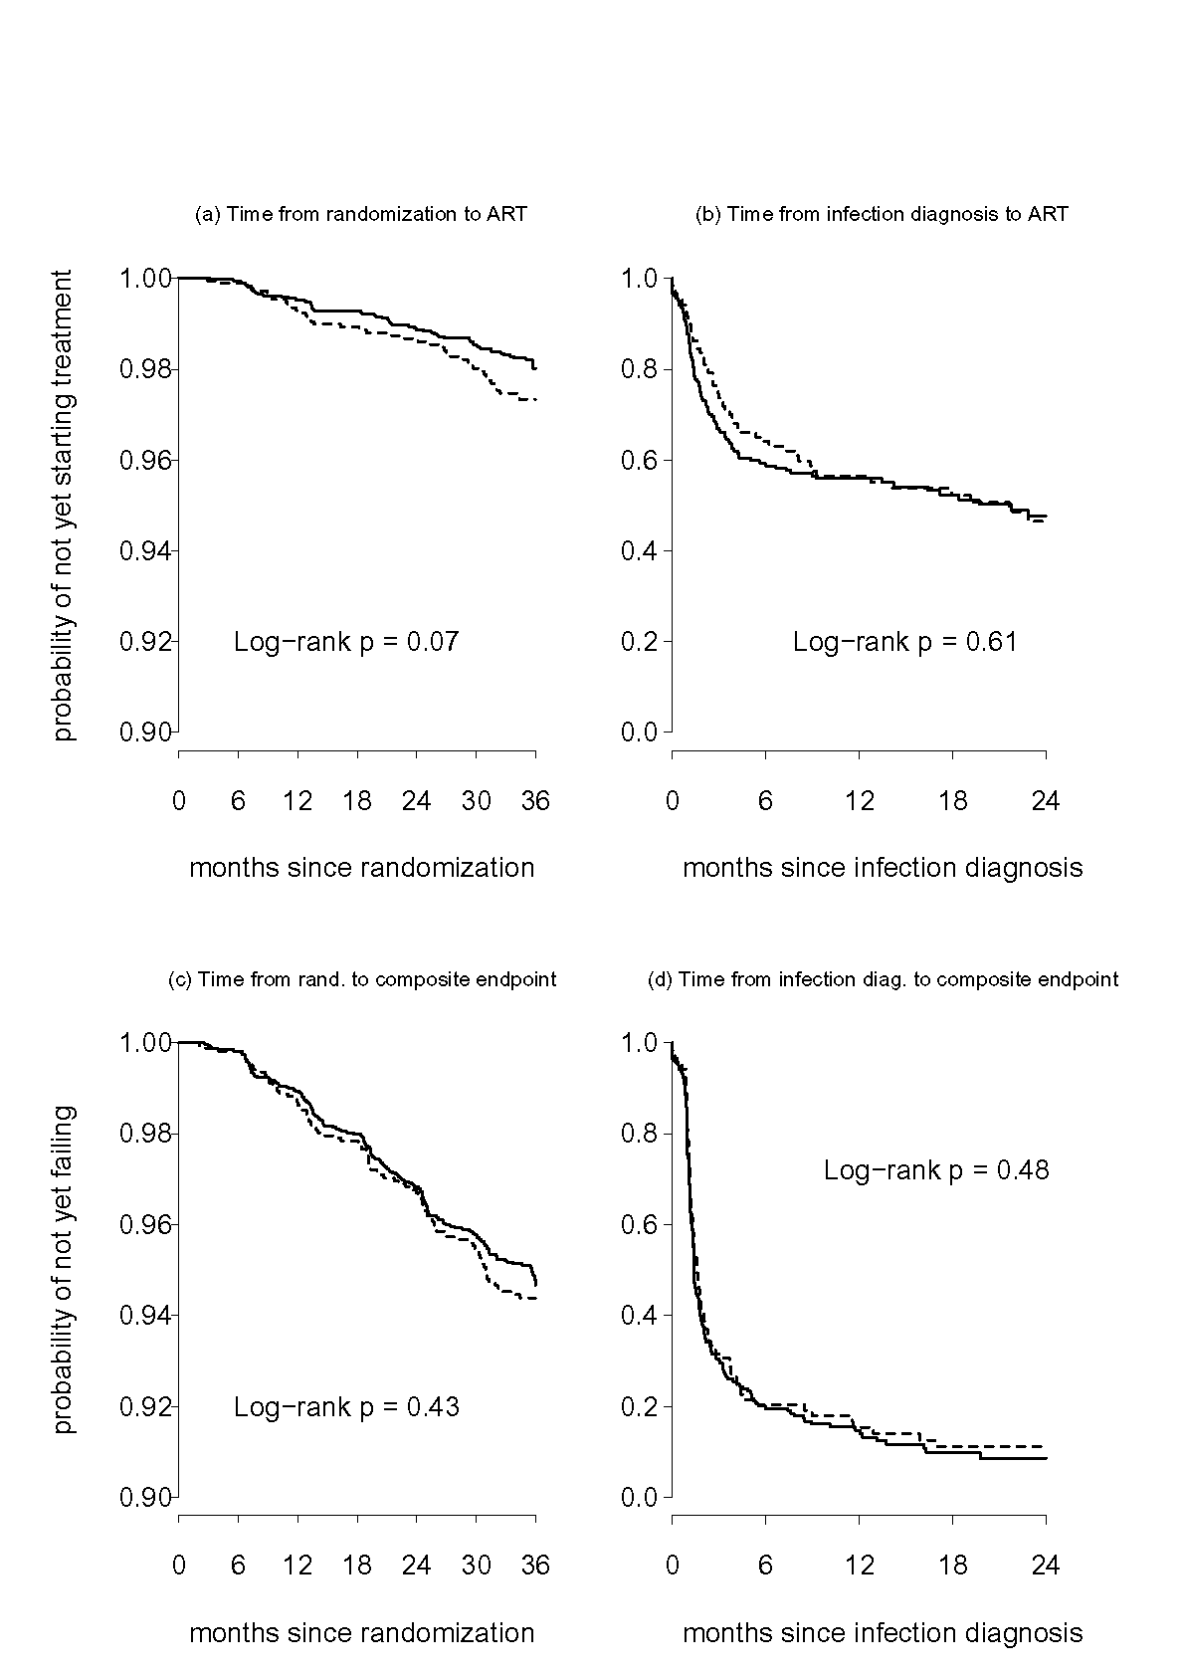
Figure 3. Pre-ART measurements of (a) log₁₀ viral load for the vaccine group; (b) log₁₀ viral load for the placebo group; (c) CD4+ lymphocyte count for the vaccine group; (d) CD4+ lymphocyte count for the placebo group. For pre-ART measurements sampled at the month 0.5, 1, 2, 4, 8, 12, 16, 20, 24 visits, the solid lines are mean estimates and the dotted lines are 95% confidence intervals.
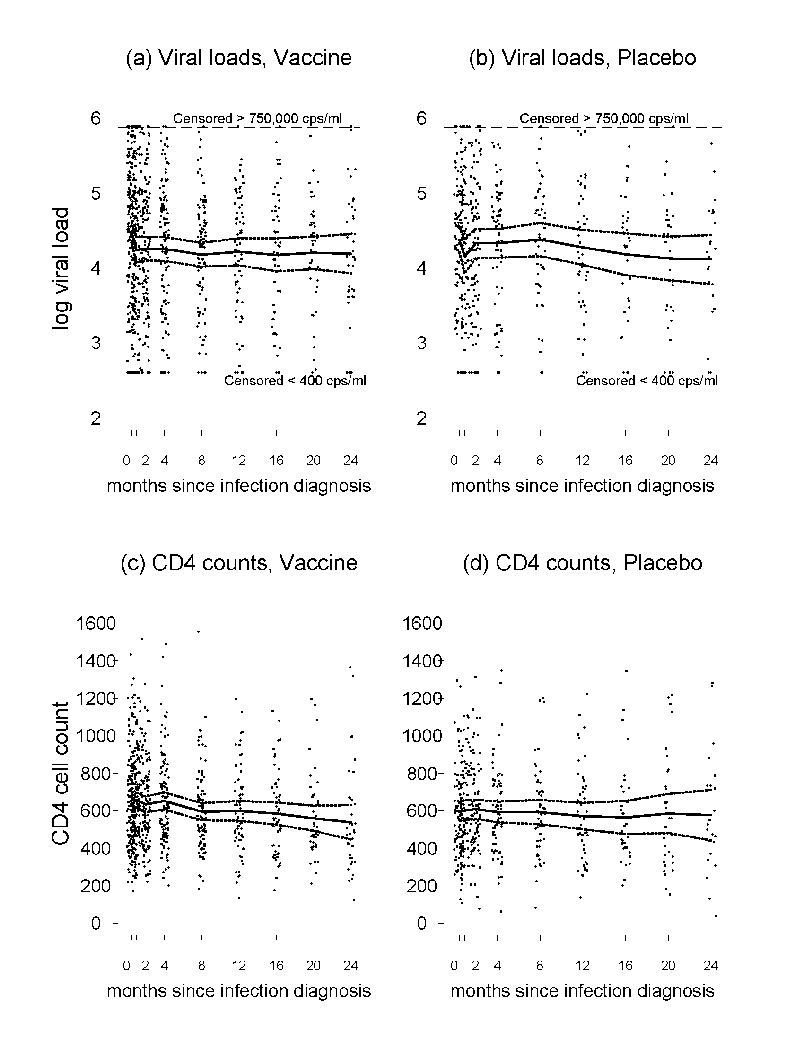
Figure 4. Cox proportional hazards based estimates of (VEs,VEc^{PH}) (indicated by X) with a joint 95% confidence region for (VEs,VEc^{PH}) (solid lines). VEs is the vaccine efficacy to prevent infection by the month 36 post randomization visit [VEs = (1 - relative risk)×100%] and VEc^{PH} is the vaccine efficacy to prevent the composite end point (viral load > 10,000 copies/ml or ART initiation) by the month 12 post infection diagnosis visit [VEc^{PH} = (1 - relative risk)×100%]. The shaded area marked “Null Hypothesis Region” indicates the set of (VEs,VEc^{PH}) values pre-specified as clinically nonsignificant.
