ME 354, MECHANICS OF MATERIALS LABORATORY

STRUCTURES
February 2007 / R. Wingerter and P. Labossiere

PURPOSE

The purpose of this exercise is to study of the effects of various assumptions in analyzing the forces, stresses, and strains in an engineering structure using analytical, experimental and numerical techniques.

BACKGROUND

Engineering structures may take many forms, from the simple shapes of square cross section beams to the complex and intricate shapes of trusses. Trusses are one of the major types of engineering structures, and provide both practical and economical solutions to many engineering situations. Trusses consist of straight members connected at joints
In general, truss members are slender and can support little lateral force. Major forces must be applied at the various joints. In addition, truss assumptions entail that the members are pinned together even though the joints are actually riveted or welded (i.e., the force acting at the end of each truss member is a single force with no bending moment). Each truss member may then be treated as a two-force member and the entire truss is treated as a group of pins and two force members.

A bicycle frame, on first inspection, appears to be an example of a truss. Each tube (or truss) is connected to the other at a joint; the principal forces are applied at these joints (e.g., seat, steering head, and bottom bracket), and the reaction forces are also carried at joints (e.g., front and rear axles). Although the joints are not pinned, a reasonable first approximation for analyzing forces, deflections, and stresses in the various tubes of the bicycle frame is made using simple truss analyses.

In order to get a more accurate prediction of the internal forces, stresses and strains in a bicycle frame, a mechanical engineer can use numerical techniques, namely finite element analysis (FEA). Here we present solutions to two different approaches, one in which the bicycle was modeled as an assembly of beam elements and one in which a two-dimensional representation was modeled.
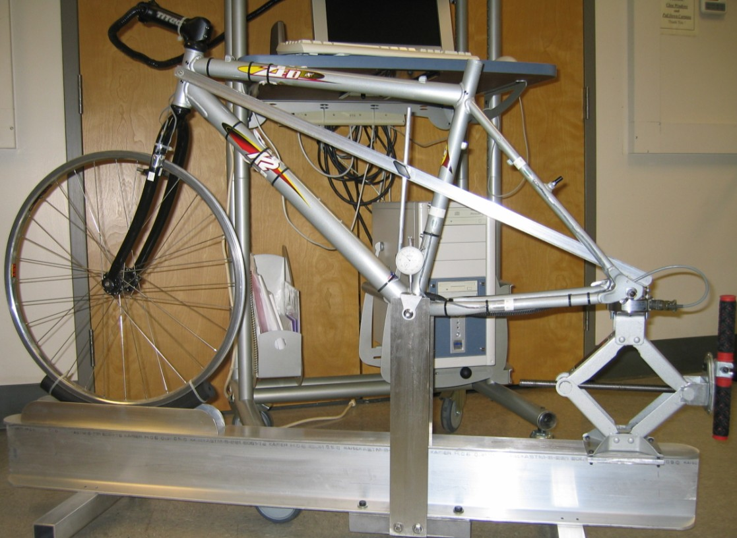

EQUIPMENT

- K2 test bicycle and load frame.
- Six stacked rectangular strain gage rosettes 2.15με±1%.
- Six axial strain gages 2.14με±1%.
- 3000# load cell, Transducer Techniques® LPU-3k, Sn:167758
- Data acquisition equipment.
- Dial indicator.

PRE-LAB
- Review the lecture notes on “Strain gages”. What is the end-use difference between an axial strain gage and a rectangular strain gage rosette?

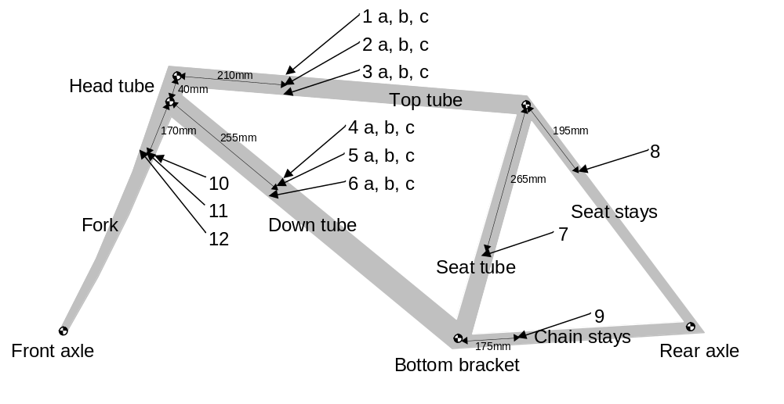
Figure 1: Schematic of the bicycle frame showing the locations of the strain gages.

PROCEDURE

Note: Six stacked rectangular strain gage rosettes (numbers 1-6 a,b,c) and six axial strain gages (numbers 7-12) have been mounted at various locations on the bicycle frame (see Figure 1). Each strain gage rosette has 3 strain gages, therefore, there is a total of 24 strain gage circuits in the test structure; however, due to the limitations of the test system, only 19 strain gages can be evaluated at any one time. Furthermore, the experimental procedure has been simplified so that only strains oriented along the longitudinal axes of the tubes will be measured.

a) Locate all of the strain gages attached to the bicycle frame.
Why are the rectangular strain gage rosettes attached to only two tube members?

b) Note the geometric shape of each tube.
Will this affect the truss analysis for uniform axial forces?

c) Locate the scissor jack (at the rear of the bicycle frame). Ensure that the bicycle is load-free by turning the jack handlebars counter-clockwise until the load-cell mounted to the top of the scissor jack barely touches the rear axle of the bicycle frame.

d) Locate the dial indicator, and zero it out.

e) Initiate the Data Acquisition System

- Verify the System 5000 Scanner is switched to the on position (located above the computer screen).

- Start the program by double clicking on the “Strain Smart” icon (on the desktop)

- Using the drop down FILE menu, and open the following file:
C:\Program Files\MeasurementsGroup\StainSmart\Projects\ME354 Bicycle Lab.5k1

- Answer “No” to the question:
Do you wish to save the project ‘filename.5k1”?

- Select “Online” (lower left hand corner of the Window)

- Select “New Scan” (from the top menu bar)

- On the screen that pops-up, select “Next”

- Select setting for “Manual recording”

- Select “Next”

- Select setting “Record one scan when the Record button is pressed”

- Select “Next”

- Select “Finish”

- Select “zero/Cal” (from top menu bar)

- Select “Zero” (Note: Channels 6 and 7 are “offscale”)

- Select “Close”

- Select “Arm” (from top menu bar)

- Select ”Start”

- Select “Display”

- Select “other online display”

- Select “online display #1”

Note: A combined “meter” display and digital readout for 12 different channels, as well as the load cell meter should now appear on screen (see table 1). These are the strains sensed by the individual strain gages measured in μstrain (x10⁻⁶ m/m). Positive values signify tensile strains, and negative values signify compressive strains. The Load Cell (meter one) reads the vertical load applied to the rear axle or the bike (just above the scissor jack).

Table 1: On-screen positions of the strain gage meters.

Load Cell | 1b | 2b | 3b
4b | 5b | 6b | 7
8 | 9 | 10 | 11
12

f) Apply a load force of 500 Newton’s to the rear axle of the bicycle frame by slowly turning the scissor jack handlebars clockwise.

g) At 500 Newton’s, freeze the gage window by pressing the RED icon on the display bar (“stop scanning and record”).

h) Record the reading for each strain gage channel in the Table 2a included below.

i) Record the dial reading of the displacement in the table also.

j) Restart the gages by pressing the “arm” icon on the display bar.

k) Press the “Start Scan” icon on the display bar (next to the “arm” icon).

l) Repeat steps (f-l) for load values of 800, 1200, 1600 and 2000 N.

Table 2a: Strain gage readings (applied load = 400 N).
(Load Cell) | (1b) | (2b) | (3b)
(4b) | (5b) | (6b) | (7)
(8) | (9) | (10) | (11)
(12) |  | (Displacement)

Table 2b: Strain gage readings (applied load = 800 N).
(Load Cell) | (1b) | (2b) | (3b)
(4b) | (5b) | (6b) | (7)
(8) | (9) | (10) | (11)
(12) |  | (Displacement)

Table 2c: Strain gage readings (applied load = 1200 N).
(Load Cell) | (1b) | (2b) | (3b)
(4b) | (5b) | (6b) | (7)
(8) | (9) | (10) | (11)
(12) |  | (Displacement)

Table 2d: Strain gage readings (applied load = 1600 N).
(Load Cell) | (1b) | (2b) | (3b)
(4b) | (5b) | (6b) | (7)
(8) | (9) | (10) | (11)
(12) |  | (Displacement)

Table 2e: Strain gage readings (applied load = 2000 N).
(Load Cell) | (1b) | (2b) | (3b)
(4b) | (5b) | (6b) | (7)
(8) | (9) | (10) | (11)
(12) |  | (Displacement)

m) Completely remove the load from the bicycle frame.

n) Turn off the System 5000 Scanner.

ANALYSIS

1) Draw the free body diagram of the truss, showing the boundary conditions and reaction forces at the front head tube joint and bottom bracket joint.

F
(0,0)
(125,420)
(415,12.5)
(-550,480)

Figure 2: Joint locations (in mm) for the truss analysis.

2) For an applied force at the rear axle, F = 1000N, use the joint locations of Figure 2 to complete table 3 for a truss analysis. Note: For forces use + to indicate tensile force and - to indicate compressive force.

Table 3. Truss analysis results.
Applied Force, F | 1000 | N
Reaction at Front head tube, R_{f} |  | N
Reaction at Bottom bracket, R_{r} |  | N
Force in Top tube F_{tt} |  | N
Force in Down tube F_{dt} |  | N
Force in Seat tube F_{st} |  | N
Force in Seat stays F_{ss} |  | N
Force in Chain stays F_{cs} |  | N

3) Predict (using a least squares approach to all of the data obtained in Tables 2a-2e), the strains at each of the strain gage locations for an applied force at the rear axle of F = 1000N. Include these values in the appropriate columns in Tables 4 and 7.
.
4) Use Generalized Hooke’s Law to find the average stress acting along the longitudinal axis of each tube. From the stress and the cross sectional area of each tube, listed in Table 5, determine the average longitudinal force in each tube (Note: The bicycle frame is made of 6061-T6 Aluminum, E = 68.5GPa, ν = 0.33, and σ_{o} = 275MPa and the fork is made of 4130 CroMoly Steel E = 205GPa, ν = 0.3, and σ_{o} = 360MPa).

Table 4: Experimental results for the longitudinal strains, stresses and average force from strain gage measurements for F = 1000N.

Tube Member  (strain gage number) | predicted ε_{x}  (μstrain) | σ_{x}  (MPa) | Average σ_{x}  (MPa) | Area  (mm²) | Average Force (N)
Top Tube (1b)
Top tube (2b)
Top Tube (3b)
Down Tube (4b)
Down Tube (5b)
Down Tube (6b)
Seat Tube (7)
Seat Stay (8)
Chain Stay (9)
Fork (10)
Fork (11)
Fork (12)

The cross sectional dimensions for the members are as follows.

Table 5: Bicycle frame tube dimensions.

Tube set | Inside Diameter | Outside Diameter
 | ID (mm) | OD (mm)
Top | 34.80* | 38.00
Down | 40.50* | 44.10
Seat | 27.40 | 31.80
Head | 33.20 | 39.20
Seat Stay** | 15.60 | 19.20
Chain Stay** | 18.60 | 22.20
Fork** | 18.00 | 22.40
* Butted tubes (See note 1)
** Indicates a 2-tube member (See note 2).

Note 1: The top and down tubes are double-butted. This means that the tubes are twice as thick at 10 cm from the joints at each end. The thickness is increased on the inside diameter only; (i.e. Top tube thickness increases from1.60 mm to 3.20 mm along the 10 cm butted length at both ends of the tube).

Note 2: The Seat Stay, Chain Stay, and Fork assemblies are made up of 2-tubes each.

5) Compare the longitudinal forces you calculated using the simple truss analysis (Table 3) to the longitudinal forces determined from the strain gage measurements (Table 4).

Table 6: Comparison of analytical and experimental results.

Tube Member | Longitudinal Force | Average Longitudinal Force | %
 | from Truss Analysis (N) | from Strain Gage Analysis (N) | Difference
Top Tube
Down Tube
Seat Tube
Seat Stays
Chain Stays
Fork | --- |  | ---

Explain any differences by answering the following questions;

- What assumptions were made in the truss analysis?

ii) What assumptions were made in analyzing the strain gage results to find the forces?

iii) From the strain gage results for the top tube, is the stress distribution truly uniform across the cross section of the tube? If not, is the truss analysis of uniform axial forces valid?

6) Because of the choice of the locations for obtaining strain information, it is possible to separate the axial stresses due to longitudinal loading 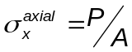 from the stresses due to bending 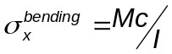. By taking the average of the longitudinal stress at strain gage 1b and the longitudinal stress at strain gage 3b, the bending component cancels out; and the stress due to longitudinal loading acting in the top tube can be determined.

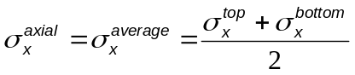 (2)

The longitudinal force can then be obtained by multiplying the axial stress times the cross sectional area.

(Longitudinal Force) = 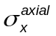 x (Cross Sectional Area) (3)

The principal of superposition is valid if we assume the material response is linear elastic, the strains are infinitesimal and the deformations are small. This allows the addition of the axial and bending stresses because they are the same type of stress (normal) acting in the same direction. Therefore, once the axial stress is found, the stress due to bending can be obtained by subtracting the axial stress due to longitudinal loading from the total axial stress.

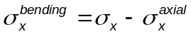 (4)

7) You should have noticed that the stress state in a bicycle frame is more complex than can be accurately determined using a simple truss analysis based on the assumption of uniformly stressed tubes. Numerical techniques such as Finite Element Analysis (FEA) have been developed to predict the internal stresses in complex structures.

Figure 4 shows a FEA model consisting of two-dimensional 8-noded biquadratic elements and the applied boundary conditions. Figures 5-7 show the corresponding solutions for the von Mises stress and maximum and minimum principle strains, respectively for the applied force (F = 1000N). Figures 8 and 9 show the axial stress component and the von Mises stress (including bending), respectively, for an FEA model consisting of one-dimensional beam elements. The results for the longitudinal stress components at the locations of the strain gages have been summarized in columns 4 and 5 of Table 7.

Using the results from the FEA models of the bicycle frame, compare the stresses in the various tube sets quantitatively and qualitatively. Answer the following questions;

i) Are the stresses uniform across the cross sections?

ii) What are the effects of bending and torsion on the stress state?

iii) Are the axial, bending, and total stresses constant over the lengths of the tubes?

iv) Are there any stress concentrations (i.e. are the maximum stresses greater at the joints than in the middle)?

- Compare the axial (longitudinal) forces for the truss analysis results of Table 4 and the strain-gage analysis results of Table 6 to the axial forces determined from the FEA for the top tube. Does bending significantly affect the results?

Figure 4: 2-D Finite Element Analysis (FEA) model of the bicycle frame.

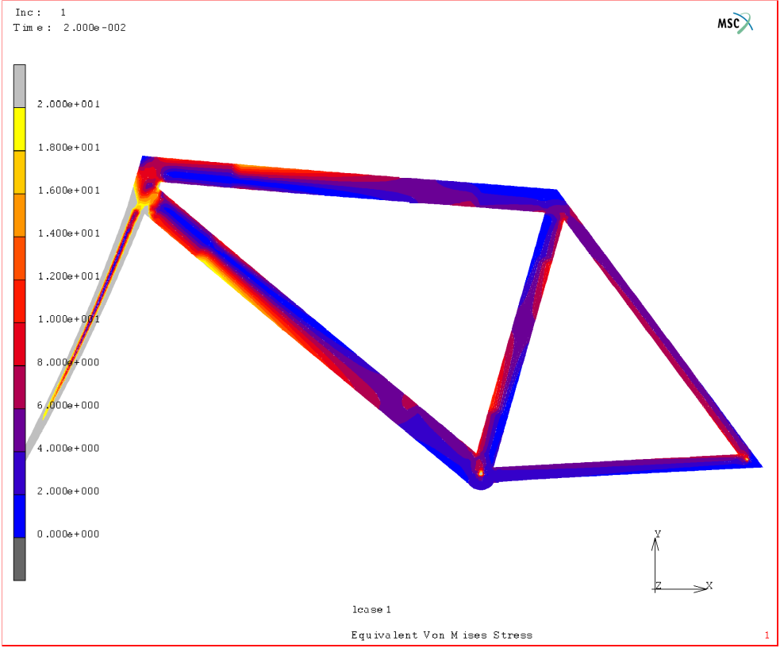

Figure 5. Von Mises (effective) stress (MPa) for a 2-D FEA model (force, F = 1000N).

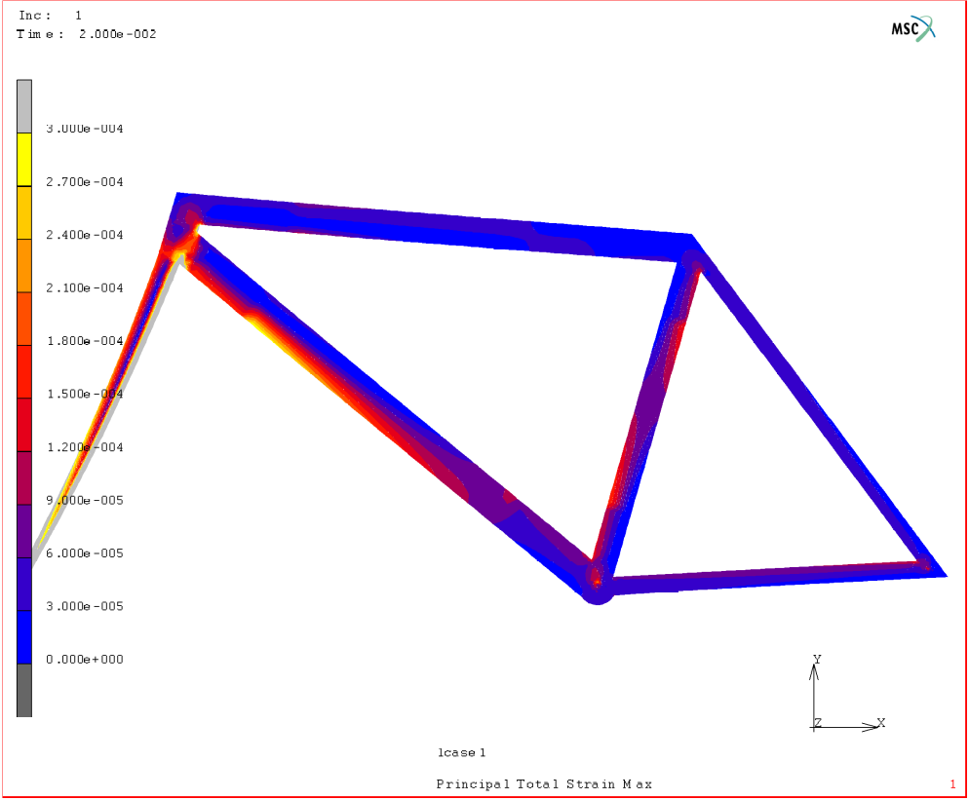

Figure 6. Maximum principal strain for a 2-D FEA model (force, F = 1000N).

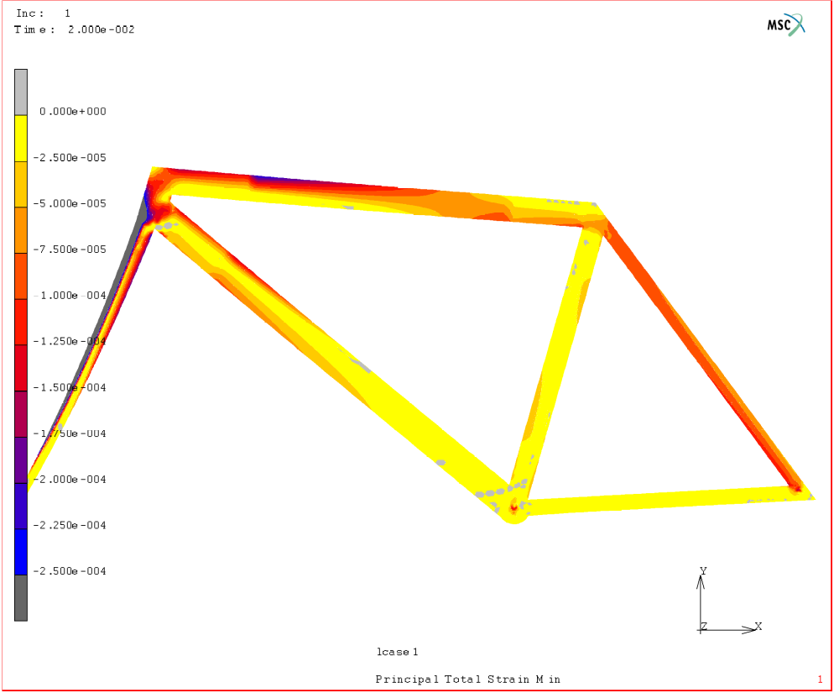

Figure 7. Minimum principal strain for a 2-D FEA model (force, F = 1000N).

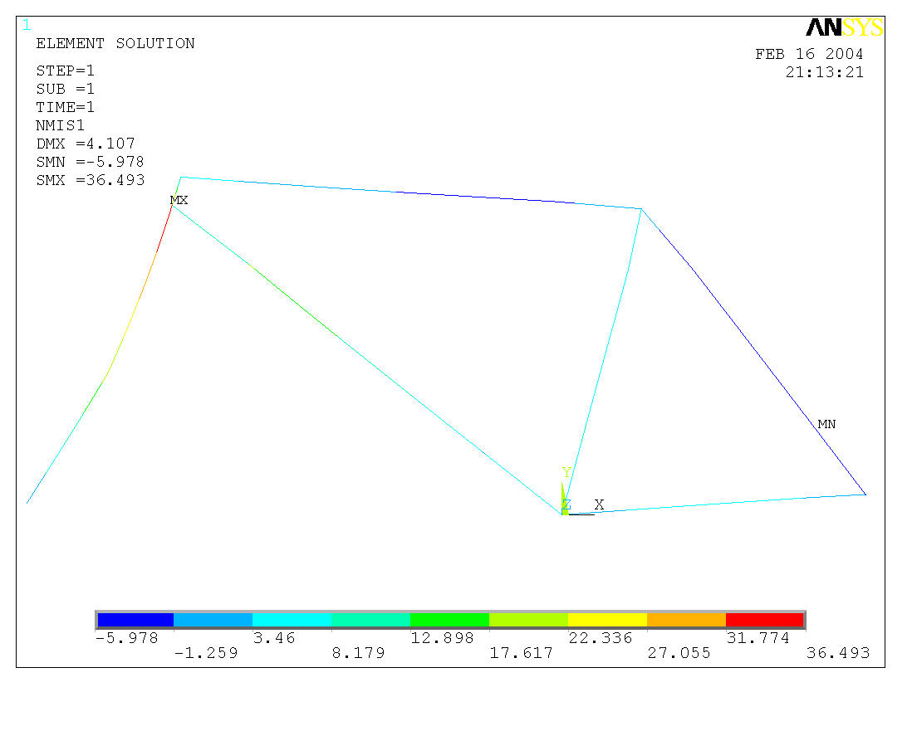

Figure 8. Axial stress (MPa) for a beam FEA model (force, F = 1000N).

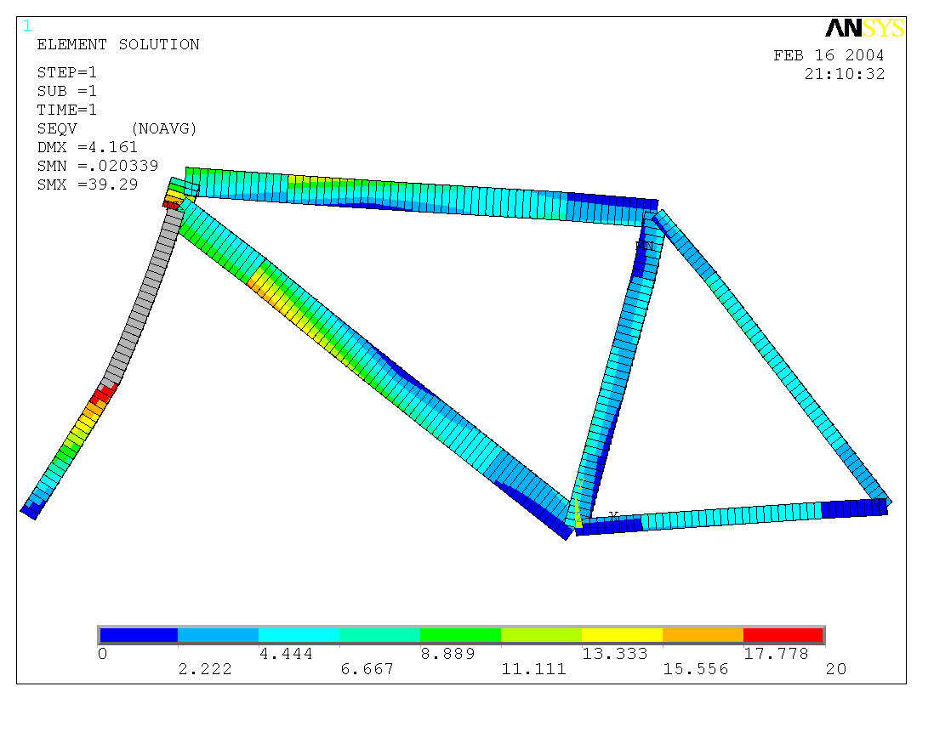

Figure 9. Von Mises (effective) stress (MPa) for a beam FEA model (force, F = 1000N).

Table 7: Summary of the numerical, analytical and experimental results for F=1000 N.

 |  |  | Numerical |  | Analytical | Experimental
Gage number | Tube set | Location on tube | 2-D FEA  model  (μstrain) | Beam FEA model  (μstrain) | Truss analysis  (μstrain) | Measured strain  (μstrain)
1b | top tube | top | -192 | -181
2b | top tube | middle | -63.6 | -81.1
3b | top tube | bottom | 66.1 | 19.0
4b | down tube | top | -76.0 | -46.3
5b | down tube | middle | 80.6 | 76.9
6b | down tube | bottom | 235 | 200
7 | seat tube | middle | 77.7 | 62.9
8 | seat stay | middle | -80.8 | -88.3
9 | chain stay | middle | 52.5 | 45.0
10 | fork | back | 339 | 357 | -
11 | fork | middle | -13.9 | -15.2 | -
12 | fork | front | -342 | -387 | -
Deflection |  |  | .310 mm | .208mm

8) Deflections in trusses can often be found using energy methods. To simplify the analysis it is assumed that the axial force in each tube only acts at the joints and therefore the axial force is constant throughout the length of each member. The unit force method is used as follows in which the deflection at the point of interest is:

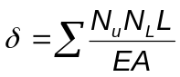 (5)

Where N_{u} and N_{L} are the forces in each member due to unit (F = 1N) and actual forces (F = 1000N, in this case), respectively, L is the length of each member, E is the elastic modulus of each member and A is the cross sectional area of each member. Here, the deflection, which is in the same direction and at the same location as the applied force, is determined at the rear axle by filling in the appropriate sections of Table 8 with the appropriate results from the truss analysis.

We are not directly interested in the deflection at the rear axle, but rather the deflection of the bottom bracket joint relative to the head tube and rear axle joints. A little coordinate geometry can be used to determine that the relative bottom bracket deflection corresponds to 57% of the deflection at the rear axle joint.

Table 8: Unit Force Analysis.

Member | L  (mm) | A  (mm²) | N_{L}  (N) | N_{u}  (N) | 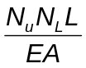
Top tube
Down tube
Seat tube
Seat stays
Chain stays

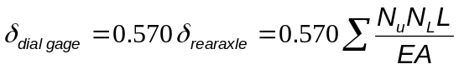= _______________

9) Compare the deflection predicted by the unit force method (due to the axial forces only) and the FEA models (see Table 7) with the measured deflection for a force, F = 1000N.

- Comment on any differences and the reasons for the differences.

- Suggest other ways to predict the deflections at joints.

Table 9: comparison of analytical, numerical and experimental deflections.

Measured Deflection (mm) | Deflection from Unit Force Method (mm) | % Difference | Deflection from 2D FEA Model (mm) | % Difference | Deflection from beam Model (mm) | % Difference
LABORATORY REPORT

Use the formal lab report format and discuss the following in the laboratory report:

1) Answer questions 5(i-iii). Include the answers as part of your discussion.

2) The following questions relate to the strain gage results for the top tube;
a. Is the stress distribution uniform across the cross section of the tube?
b. Can the stress due to pure axial loading be determined from the actual internal stress in the tubes?
c. If the stress distribution is not uniform, is the method of truss analysis valid when assuming uniform axial forces?

3) Answer questions 7(i-v). Include the answers as part of your discussion.

4) Include a graph of stress vs. applied load for the top tube. Include the following results in the graph.
    - Truss analysis (FBD)
    - Strain gage analysis
    - Finite Element Analysis (FEA)

5) As a minimum include the following figures and tables in the body of the report:

a. Free body diagram (FBD) of the truss, showing your assumptions for the reactions at the front head tube joint and rear axle joint.
- Tables 6, 7 and 9.

6) Include all other tables as part of your Raw Data Appendices. Please try to use the following appendix headings:
Appendix A Raw strain gage data (Tables 2a-2e) and bike frame details (Table 5).
Appendix B All calculations and details of the truss analysis (Table 3).
Appendix C Least squares fit to the strain gage data to predict the strains at F=1000N.
Appendix D Experimental longitudinal strains, stresses and internal forces (Table 4).
Appendix E Details of the unit force analysis (Table 8).
Etc.

7) Predict the maximum force that can be safely applied to the bicycle frame and justify your prediction.

