**CEE 345 Part 2, Win 2012 Exam #1**

**Note: In cases where explanations are requested, no more than two sentences are required!**

1. (5) The flow in a 2.4-m-diameter pipeline with relative roughness of 0.0008 is fully turbulent. Over what length of pipe does the water lose an amount of head equal to 10 times its velocity head?
2. (5) When analyzing a pipe network with interconnected loops, the calculated *Q* for any given loop must be applied to all the pipes in the loop. Why is this necessary? Put another way, what problem would arise if one attempted to compute and apply different values of *Q* to each pipe in a loop?
3. (9) Since pumps increase the head of the water that passes through them, it would seem that having a pressure at the pump inlet that is greater than the vapor pressure would assure that cavitation could not occur. Yet, cavitation *can* occur under those conditions.
4. Explain briefly how this is possible. (Note: do not just reiterate the equation that indicates whether cavitation is possible. Rather, focus on how cavitation can occur even if the pressure at the pump inlet is higher than the vapor pressure.)
5. How much greater than the vapor pressure must the suction pressure actually be to prevent cavitation? Give your answer in terms of conventional parameters that are used to describe pump capabilities and performance.
6. Does the damage from cavitation occur slightly upstream, slightly downstream, or at the same location where the cavitation itself occurs? Explain briefly.
7. (9) Define the following terms:
8. Shutoff head
9. Static suction head
10. Maximum suction lift
11. (15) Three identical, 1.0‑m‑diameter pipes with a Hazen-Williams friction coefficient of 130 are connected in parallel. An engineer has determined that, for the purposes of hydraulic analysis, this combination of pipes is equivalent to a single, 2.5‑km-long, 1.5‑m-diameter pipe with a *CHW* value of 105. What is the length of each pipe in the actual system?
12. (15) Pump and system curves for circulating water through a swimming pool are shown in the following diagram. Belatedly, the engineer who prepared these curves realizes that minor headlosses which were ignored in the original analysis might actually be important. Sketch revised curves that take the minor headlosses into account, if those losses are about one-half as large as the headlosses through the straight pipe sections. (Note: 10 pts. for showing the correct changes in the shapes and/or locations of the curves; 5 pts. for drawing curves that are correct in terms of their quantitative relationships to the ones shown.)

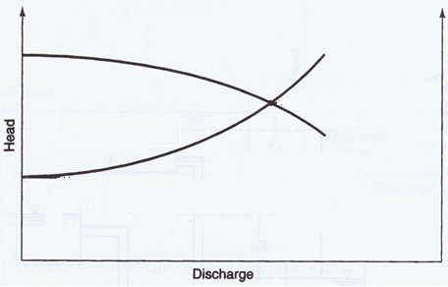

1. (15) A series of homologous pumps is characterized by the curves shown in the following figure. One of the pumps in this group has an impeller diameter of 0.75 m and operates with maximum efficiency at 1500 rpm. If the impeller speed of this pump is adjusted to 2000 rpm, and a valve on the pump outlet is adjusted so that the discharge remains at the initial value, how much head will the pump add to the water?

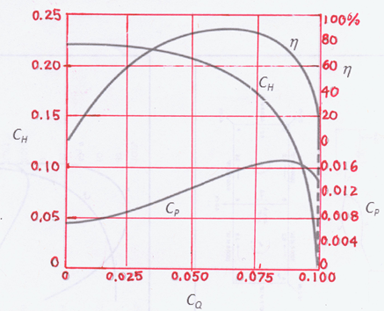

1. (Street 9.165, p.797 Solution Manual) (30) In the system shown below, the friction factors in both 1500-ft-long pipes are 0.02.

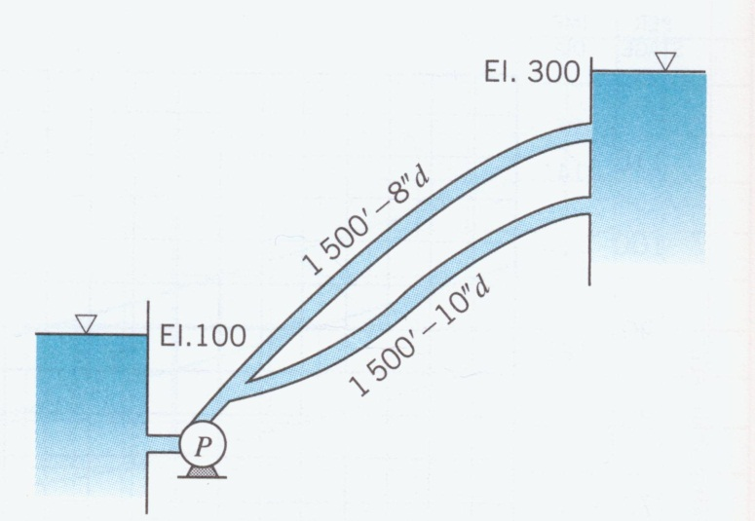

1. (10) Develop an equation for the headloss in each pipe as a function of the flowrate through it, and determine the ratio of the flowrates in the two pipes.
2. (10) On the following plot, sketch a system curve that accounts for the combined flow in the two pipes.
3. (10) How much power must be delivered to the water to pump 4 cfs to the upper reservoir?

**CEE 345, Part 2; Win 2012, Exam #1 Solutions**

1. From the Moody diagram, the friction factor for fully turbulent flow in a pipe with relative roughness of 0.0008 is *f*=0.019. The water therefore loses an amount of energy per unit weight equal to 1.9% of its velocity head whenever it travels a distance equal to one pipe diameter (2.4 m). Correspondingly, the energy loss equals 10 times the velocity head over a distance of:



1. If different values of *Q* were applied to different types of loop, continuity would be violated at the junctions between those pipes.
2. (a) Cavitation can occur because, even though the overall effect of the pump is to increase the head (and the pressure) of the water, the water first loses pressure as it accelerates inside the pump. As a result, the point of minimum pressure is not at the pump inlet, but rather between the eye and the outer edge of the impeller.Since the point of installing a pump in a pipeline is to increase the head of the water, it would seem that having a pressure at the pump inlet that is greater than the vapor pressure would assure that cavitation could not occur. Yet, cavitation *can* occur under those conditions.
3. The difference between the vapor pressure and the suction pressure is the net positive suction head required, NPSHR.
4. Cavitation is the formation of bubbles in the fluid. The damage caused by cavitation occurs when these bubbles collapse downstream of the point where they form.
5. (a) Shutoff head: The head developed by a pump when the discharge is zero.
6. Suction head: The total dynamic head (pressure head plus velocity head) at the inlet to a pump. (Alternatively, if you interpreted the question to be asking about the *static* suction head, an acceptable answer is the *increase* in static head [i.e., the *decrease* in elevation] between the surface of a reservoir and a pump that it feeds.)
7. Maximum suction lift: The maximum distance above the surface of a reservoir that a pump can be placed without any risk of cavitation.
8. The equivalent pipe must have the same *hL*‑*Qtot* relationship as the real system with three individual pipes. Thus, if the equivalent pipe has a headloss of *hL* when the flow through it is *Qtot*, the same *hL* must be present in the real system when the flow through that system is *Qtot*. In the real system, when the flow rate is *Qtot*, *Q* through each of the individual pipes is *Qtot*/3, and the headloss through each pipe is the same as the headloss across the whole system.

There are many ways to solve for the pipe length in the real system. One approach is to arbitrarily choose a flow rate in the equivalent pipe, find *hL* in that pipe by substituting values into the Hazen-Williams equation, and then determine what length of pipe in the real system would generate the same headloss. For instance, choosing *Qeq* to be 3.0 m3/s, we find:



The individual pipes must therefore have a headloss of 37.2 m when each carries a flow of (3.0 m3/s)/3, or 1.0 m3/s. Once again applying the Hazen-Williams equation, but using the values of *Q*, *D*, and *CHW* for the real pipes (which we designate by the subscript ‘1’), we find:





Thus, each of the real pipes is 3933 m long.

Alternatively, we can equate the expressions for headloss in the two systems without specifying an arbitrary value for *Qeq*, as follows:



Noting that *Q*1=*Qeq*/3, we can write:





Finally, we could carry out the calculations using the equation for the effective *K* value for pipes in parallel, as follows:



This *K* value is related to the *K* values of the individual pipes by:



Since all the pipes in the real system are identical, this expression can be rewritten as:



Then, substituting values and solving for *l*1, we obtain:



Thus, as must be the case, all of these approaches lead to the same result.

1. The inclusion of the minor headlosses has no effect on the elevation difference between the system inlet and outlet (i.e., the static system head), and it has no effect on the pump curve. However, it does increase the coefficient in the expression *hsys*,*tot*=*KQsysn*. The system curve therefore starts at the same value of *hsys*, but increases more steeply. If the minor headlosses are 50% as large as those in the pipe sections, then the new value of *K* is 1.5 times the earlier value, and *hsys*,*tot* increases 1.5 times as steeply.



*x*

0.5*x*

Without minor *hL*

With minor *hL*

1. The plot indicates that the maximum efficiency occurs at a *CQ* value of approximately 0.065. *CQ* is defined as *Q*/(*D*3), and in the scenario of interest, *Q* and *D* remain the same while ** increases by 33%. Therefore, the new value of *CQ* is:



At this value of *CQ*, we can read *CH* from the graph as approximately 0.21. Then, from the definition of *CH*, we compute:





1. (Street 9.165, p.797 Solution Manual) (a) We can develop these curves by inserting the given information into the Darcy-Weisbach equation, written in terms of *Q* instead of *V*:



The expressions for the headlosses in the two pipes are therefore:





Because the headloss must be the same in the two pipes, the ratio of the flow rates in the two pipes can then be found as:





1. The head required to drive water through the pipes individually can be plotted as a function of *Q*. For each pipe and each *Q*, this head equals the value of *hL* computed in part *a* plus the static head of 200 ft. Thus, the equations of these curves are:





The system curve that accounts for the combined flow in the two pipes can be developed by plotting curves corresponding to the above equations, and then adding the values of *Q* at each value of *h*. All three curves are shown in the following plot.

1. The power acquired by the water can be expressed as:



The ratio was computed in part *a* to be 0.574, so , . Therefore, when *Qtot* is 4.0 ft3/s,  is 1.46 ft3/s and  is 2.54 ft3/s. The head required to generate these flow rates is the same through the two pipes. Calculating that value in the 8" pipe, we find:



Because this amount of head is added to the whole flow, the power delivered to the water is:

