**CEE 345**

**Spring 2012**

**EPANET**

EPANET is a free hydraulic simulation program, developed by the EPA. EPANET is used to analyze water distribution systems consisting of pipes, junctions, valves, storage tanks, and reservoirs. The software can also be used to model drinking water constituents, such as residual chlorine, through pipe networks as well optimizing system operations. The following activity will guide you through building a simple water system for a small village in South America.

**Background**

As an enthusiastic up and coming engineer, you have decided to join the UW chapter of Engineers Without Boarders (EWB). Your chapter is working on designing an irrigation and drinking water distribution system for the village of Yanayo Grande. Yanayo Grande is located in the municipality of Asacio in a remote sub-Andean valley in Central Bolivia. The location of Yanayo Grande can be seen in the image below.

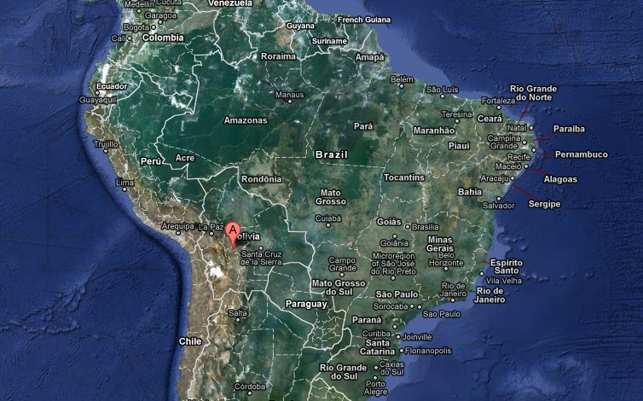

Source: Google Maps

The communities in this region speak both the native language of Quechua as well as Spanish. Like other villages in this region, agriculture is the primary source of food and income. Rainfall is the principal source of crop irrigation and due to a 15 year drought, the community of Yanayo Grande would benefit greatly from the implementation of a reliable irrigation system.

EWB approaches a project by first conducting a site assessment to collect as much project data as possible. Using this data, the EWB chapter then develops a solution to the problem and returns to the site for project implementation. Often EWB chapters will develop a strong relationship with the communities and return for several seasons of project implementation.

As part of the EWB-UWS assessment team, you discovered that twenty five years ago UNICEF built a water reservoir and water distribution system in the community of Yanayo Grande. The distribution system has since deteriorated, but this project will be able to utilize the reservoir. You have been asked to model a simple gravity driven water distribution system based on data collected during a site assessment trip. The distribution system will start with the existing water storage tank and travel downhill to one of the town’s primary agriculture areas (labeled Ag. Area #2). Next, the system will travel westward where it will split between a second field (labeled Ag. Area #1), and a water main through the center of town ending at a schoolhouse. An aerial view of the town can be seen in the image below. This is the same image that will be used to design the water distribution system.

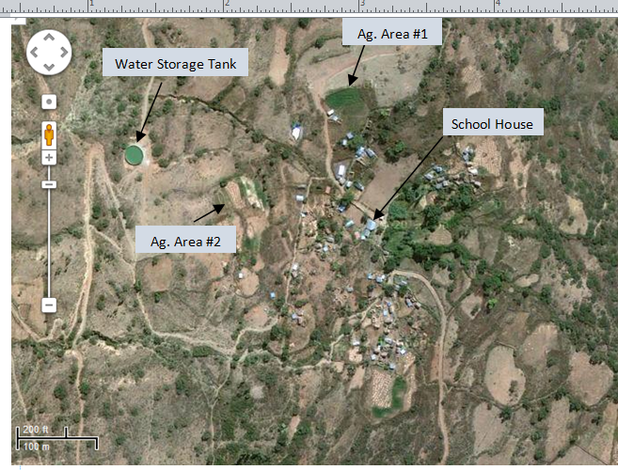

Source: Google Maps

**Getting Started**

To start designing this water distribution system, first open EPANET in the windows program browser. Building a model in EPANET involves selecting and installing components of a distribution system, providing them specific design parameters (tank depths, roughness coefficients, etc.), and running the model. For this activity you will be working from the toolbar across the top of the screen. Here is a quick overview of the primary icons you will be using.

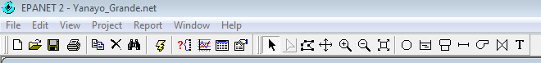

Pipe

Zoom Out

Pan Across Image

Select Object

Run Model

Water Tank

Nodes/ Pipe Junctions

Zoom Inodel

Start by opening the file titled Yanayo_Grande.net found on the course website. This should load the same aerial image seen on the previous page.

To start, we need to set some of the basic parameters of our model. EPANET allows the user to tailor their model by adjusting parameters such as headloss formula and pipe roughness coefficient. The instrumentation you used to collect data during the assessment trip recoded everything in BG units, so that is what we will use for our simulation.

Start by selecting “project” in the toolbar and clicking “defaults.” Selecting the “Hydraulics” tab make sure the flow units are in gallons per minute (GPM) and the head loss formula is H-W (Hazen-Williams). Next, under the properties tab, turn on “Auto Length” and set the roughness coefficient to 130 and pipe diameter to 2”. Auto length will allow us to create a scaled model and a roughness coefficient of 130 corresponds to cast iron piping that will be available during project implementation. The settings should appear as follows.

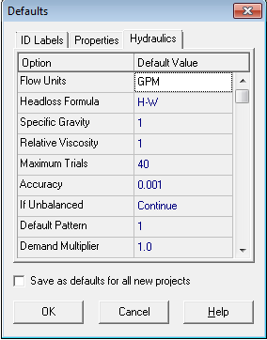 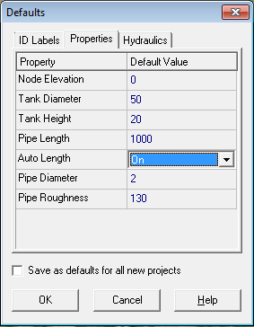

Next, in order to ensure that model calculations are correct, the scale of any imported background images or files must be calibrated. We need to check to see if this has already been done with the Yanayo_Grande.net file.

Using the zoom tool, zoom in very close on the scale bar at the bottom right corner of the aerial image. Select a the junction icon  and add two junctions to the scale bar, one on the far left side and one at the 200 ft. mark. Next, click on the pipe icon  and connect the junctions with a pipe.



Add junctions here and connect with a pipe

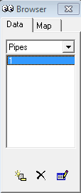Now select the black cursor in the toolbar  and click on the newly added pipe. A properties table should appear, if the pipe length is close to 200 ft. (+/- 5 ft.) the background image has been properly scaled.

Close the properties box and turn your attention to the Browser box in the top right next to your model screen. Every time a new component is added to the model, it will appear in this browser menu. If you want to delete an item, select the actual picture of the item with the cursor and click the black x at the bottom of this box. The program will ask if you are sure you want to delete this item, if so hit yes. Do this for the pipe and two junctions you built on the scale bar. This should clear all items out of your browser.

**Building your distribution system model**

Now that you are comfortable using some of the basic components of EPANET, let’s start constructing your distribution system model. To start, select the add tank icon  and place it over the image of the water storage tank. With the cursor, double click on the tank so we can adjust its parameters. Set the tank elevation to 9400 ft. To keep this model simple, we will assume the spring feeding the tank provides an infinite supply, therefore we will make the tank geometry very large. Set the diameter to 1000 ft., initial level to 10 ft., and max level to 10 ft. This will ensure our model does not run out of water.

**The design parameters of the remaining model components are provided in a table on the next page.**

Now add two more tanks, one at the very top right corner of ag. area #1 and one at the school house.

Our next step is to add junctions at points along out distribution system. You will add a total of four junctions, the first at the top of ag. area #1, the second midway between the two agriculture areas, and the third and fourth along the main road through the village. Refer to the following image before placing your junctions. Try to place your components so they match this image as close as possible.

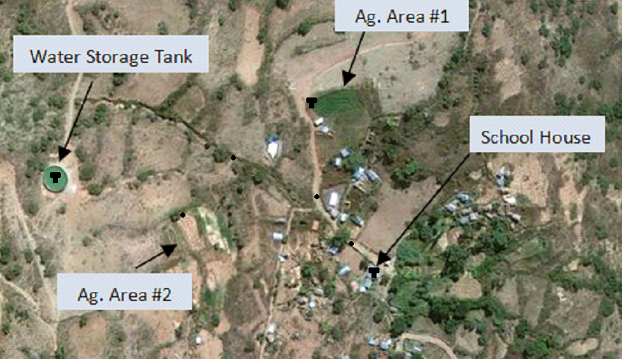

**Tank 3**

**Jct. 1**

**Tank 1**

**Jct. 2**

**Tank 2**

**Jct. 4**

**Jct. 3**

|  |  |  |  |  |  |
| --- | --- | --- | --- | --- | --- |
| Component Type | Elevation (ft) | Initial Level* (ft) | Min Level* (ft) | Max Level* (ft) | Diameter* (ft) |
| Tank 1 | 9400 | 10 | 0 | 10 | 1000 |
| Tank 2 | 9100 | 0 | 0 | 12 | 12 |
| Tank 3 | 9040 | 0 | 0 | 12 | 12 |
| Junction 1 | 9172 | - | - | - | - |
| Junction 2 | 9117 | - | - | - | - |
| Junction 3 | 9070 | - | - | - | - |
| Junction 4 | 9050 | - | - | - | - |

*Tanks only

Once all of your components are added and you have input their elevations and sizes, connect them with pipes using the following configuration:

Tank 1🡪 Junction 1

Junction 1🡪Junction 2

Junction 2🡪 Tank 2

Junction 2🡪 Junction 3

Junction 3 🡪 Junction 4

Junction 4 🡪 Tank 3

Your final distribution system should look like the following image.

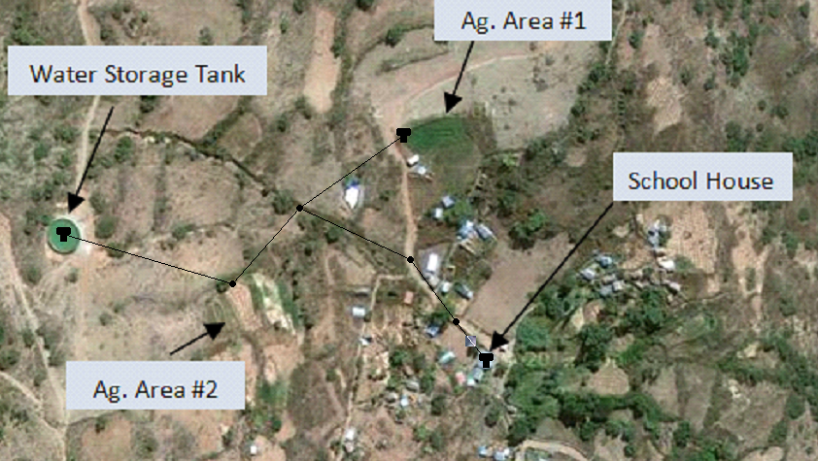

**Evaluating your model**

So far you have built a simulated water distribution model based on the needs of Yanayo Grande. Run the model by clicking this icon . You should receive a message letting you know the model was run successfully. Answer the following questions based on your simulation, don’t forget units!

1. What is the elevation head at junction 1?
2. What is the total head of junction 1?
3. Calculate the following: (total head)-(elevation head) and convert* this pressure head to psi. Does this number match the pressure at junction 1 provided by your model?

*Required conversion: Pressure head = pressure(2.31)

Now record the pressure at junction 1. Next, set the base demand for junction 1 at agriculture area #2 to 20 gal/min by double clicking on the junction and changing base demand to 20. Re-run your model.

1. After setting the base demand to 20 GPM, what is the new pressure at junction 1?
2. The community decided that they would like to construct a new leg of the distribution network capable of drawing 30 GPM from the existing system at junction 3. Will this be possible? If not, suggest a few design considerations that could help make this demand possible.