Open Channel Lab

Thursday, May 24, 2012

This exercise deals with two instances of steady, non-uniform (varied) flow. Both experiments will be performed in the Harris Hydraulics Laboratory horizontal rectangular flume of width = 314.3 mm. All calculations for this lab should be carried out in SI units.

Part I - Rapidly Varied Flow over a Sill:

1. Open the wooden manhole lid at the downstream end of the flume, and open the valve to allow flow into the tank at the upstream end of the flume. Note that this tank will occasionally overflow, so it is a good idea to keep a consistent eye on its water level.
2. With both sluice gates (there is one at either end of the flume) raised out of the flow, establish a flow rate of between 0.025 and 0.030 cubic meters per second through the flume. To do this, you will need to measure both the depth and velocity of flow. The depth should be measured in the centerline of the flume at the location of the two threaded screw holes (about half-way down the length of the flume) and should fall in the range of 0.10 to 0.12 m. The velocity should be determined by measuring the time it takes a floating object (an orange peel, a small piece of paper, etc.) to travel between two points along the length of the flume and should fall in the range of 0.7 to 0.9 m/s. Record these data and verify the flow rate before proceeding to the next step.
3. Install the sill in the flume so that the holes on the sill align (approximately) with the threaded holes on the flume sidewalls. It is not necessary to secure the sill with the screws.
4. Obtain depths of flow in the centerline of the channel at the five locations indicated on the sketch below. Record your values in the data table provided.

**1**

**2**

**3**

**4**

**5**

**5 cm**

**5 cm**

**2 cm**

**2 cm**

# C

### L

**10.1 cm**

**28.8 cm**

**46.5 cm**

**26.5 cm**

Flow Direction

## Schematic for Rapidly Varied Flow over Sill

Part II - Gradually Varied Supercritical Flow:

1. Using the same flow rate as in Part I, lower the upstream sluice gate so that the depth at the vena contracta (location of yo) is approximately 0.03 – 0.04 m. The downstream sluice gate should remain open.
2. Obtain depth measurements at the four locations indicated on the sketch below. It is not necessary to measure accurately the depth at yo. Record your values in the table provided.

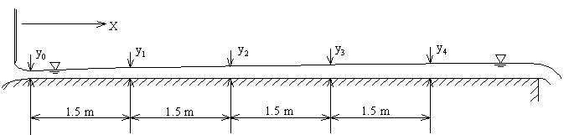

Schematic for Gradually Varied Supercritical Flow

To read a Vernier scale (in case you forgot):

1. First, position the metal hook so that the point end of the hook is at the level of the water surface.

2. Next, measure to units of tenths by finding where the 0 lines up with respect to the right side of the scale. In the picture below, the measurement is a little greater than 38.6.

3. Finally, measure to units of hundredths by finding where a marker on the left lines up with a marker on the right. In the picture below, this occurs at the 7th marker, so the measurement is 38.67.

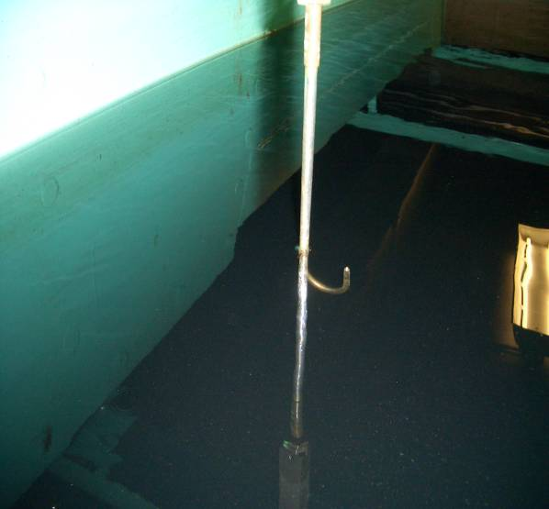

Step 1

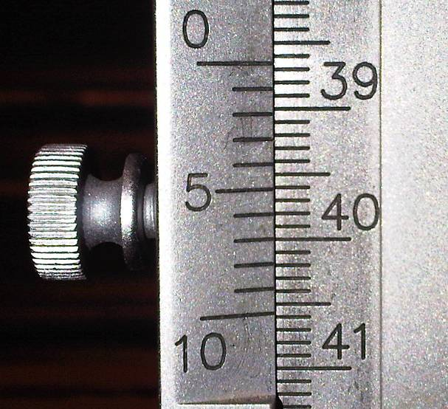

Step 2

Step 3

Metal hook Vernier scale

LAB REPORT:

Please include the following items in your report:

1. A cover sheet.

2. For Part I:

1. Calculate the discharge, *Q*, using the initial flow depth and velocity.
2. Plot the calculated specific energy diagram (*y* vs. *E*) for your calculated unit discharge (*q* = *Q*/*b*) using Microsoft Excel or an equivalent program. Use values for y ranging from 0.02 m to at least 0.4 m. Label both axes, include a title, and try to make the scales of the axes equal.
3. Locate the initial measured depth without the sill, *yo*, and the measured depths with the sill in place, *y1* – *y5*, on the specific energy diagram. How does the sill act as a choke in this flow? What is the nature of the flow upstream and downstream of the sill?
4. Hand-sketch the water surface profile for the flow over the sill. Use a horizontal scale of 1 inch = 0.2 meters and a vertical scale of 1 inch = 0.05 meters (indicate these on your sketch). What is the critical depth for your calculated flow rate? Estimate where it occurs along the sill.
5. What would be the maximum height for a sill in this flow that would NOT cause choking (backwater effect)?
6. Hand-sketch the energy grade line for flow over the sill on your sketch from Part I (d). Label both axes and include a title.
7. What is the inlet head loss, *h*LI, for the flow over the sill (from *y*1 to *y*2)? What is the outlet head loss, *h*LO, (from *y*4 to *y*5)? Compare and comment on the magnitudes of the two head loss terms. Calculate the inlet head loss coefficient, *K*I, as defined by *h*LI = *K*I (*V*22/2*g*) and the outlet head loss coefficient, *K*O, as defined by *h*LO = *K*O (*V*42/2*g*).

3. For Part II:

1. Using the four measured depths, calculate the experimentally determined values of Manning’s *n* based on the reaches 1–2, 2–3 and 3–4. What is your estimate for Manning’s *n* value?
2. Using the Chezy equation, what is the friction factor, *f*, for each of the three reaches? How does the experimental *f* value compare to what you would estimate using the Moody diagram? (Plastic and glass are generally considered to be smooth).
3. A Manning roughness of *n* = 0.008 is a common one used for glass, a surface which approximates the plexiglass used in the channel. Using *n* = 0.008 and the measured *Q* and *y*1, calculate the predicted depth, *y*2, via the standard step method, and then use this predicted *y*2 to predict a value for *y*3 and, similarly, use *y*3 to predict *y*4.
4. Hand-sketch the measured water surface profile and the predicted water surface profile from Part II (c) on the same diagram using a horizontal scale of 1 inch = 1.0 meters and a vertical scale of 1 inch = 0.05 meters (indicate these on your sketch). On the same drawing, sketch the energy grade lines for both profiles and clearly label both depth and velocity heads. Label both axes and include a title.

4. The handwritten data sheet.

Note: The repetitive nature of many of these computations is best handled by a spreadsheet. Please include formulas, references, and sample calculations for each of your computations, along with figures and derivations if necessary.

DATA SHEET:

Part I:

Initial conditions:

|  |  |  |
| --- | --- | --- |
|  | y0 | Distance from point A to point B: _______ m |
| Top (m) |  | Travel time from point A to point B: _______ s |
| Bottom (m) |  | Velocity of flow: _______ m/s |
| Depth (m) |  | Flow rate: _______ m3/s |

Depths at Stations 1 through 5 (in meters, taken at centerline of flume):

|  |  |  |  |  |  |
| --- | --- | --- | --- | --- | --- |
|  | y1 | y2 | y3 | y4 | y5 |
| Top (m) |  |  |  |  |  |
| Bottom (m) |  |  |  |  |  |
| Depth (m) |  |  |  |  |  |

Part II:

Depths at Stations 1 through 4 (in meters, taken at centerline of flume):

|  |  |  |  |  |  |
| --- | --- | --- | --- | --- | --- |
|  | y0 | y1 | y2 | y3 | y4 |
| Top (m) |  |  |  |  |  |
| Bottom (m) |  |  |  |  |  |
| Depth (m) |  |  |  |  |  |