**CEE 345 Part 2, Assignment #2, Due 5/16, 11:30am**

1. Solve Question #8 from HW#1.
2. Munson 12.30.
3. Munson 12.37. Answer only the first part of the question (i.e., you need not assess whether the pump is a good choice for the given application).
4. (Houghtalen Example 5.5, p.161) In the figure below, *EA* is 110 ft, *EB* is 120 ft, and *EC* is 140 ft. The Darcy-Weisbach friction factor in both pipes is 0.02. Pipes 1 and 2 are 10,000 ft and 15,000 ft long, respectively, and both pipes are 2.5 ft in diameter. The pump characteristics are given in the following table. Determine the discharge in each pipe. Assume that the minor headlosses are much smaller than the losses in the pipes themselves.

|  |  |
| --- | --- |
| Head (ft) | *Q* (cfs) |
| 80 | 0 |
| 78.5 | 10 |
| 74.0 | 20 |
| 66.5 | 30 |
| 56.0 | 40 |
| 42.5 | 50 |
| 26.0 | 60 |

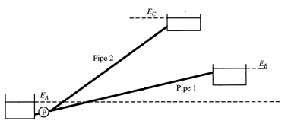

1. (Mays, Example 12.5.4, p.510) A water supply facility consists of two reservoirs, two pumps, and connecting pipelines. A schematic of the installation is shown below. Water is supplied to reservoir 2 from reservoir 1. Each line has a check valve, so that flow can go in the direction of reservoir 2 if sufficient head is provided to cause flow and direction, but no flow passes through the line if the head is insufficient to drive the water toward reservoir 2.

The elevation of the water surface in reservoir 1 is 100 ft and that in reservoir 2 is 250 ft. The suction and discharge lines are all located 10 ft below the water surfaces. The Darcy-Weisbach friction factor is 0.021 for all pipes. The pump characteristics are shown in the figure provided and can be reasonably approximated by the following equations.

For Pump A:  TDH = 8.29E09*Q*3 + 6.12E06*Q*2  0.0129*Q* + 225

For Pump B:  TDH = 1.04E08*Q*3 + 1.30E05*Q*2  0.0163*Q* + 200

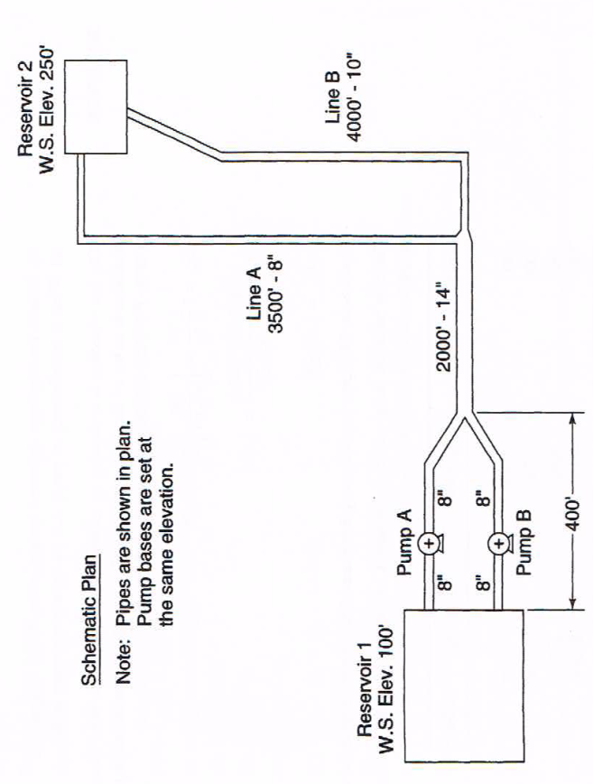

Pipe 3

Pipe 1 (top),  
Pipe 2 (bot)

Pipe 5

Pipe 4





1. Using the elevation of the suction to the pumps as the datum, develop modified pump curves for Pumps A and B. These modified curves should show, for each pump, the head at the end of the 400‑ft line as a function of the flow rate through the pump and the corresponding pipe. Show the modified curves on a copy of the given plot.

These modified curves are convenient for this analysis, because they characterize the parts of the system where the water that passes through Pump A experiences different conditions from the water that passes through Pump B; downstream of the point characterized by these pump curves, the flow that has passed through Pump A is indistinguishable from the flow that has passed through Pump B.

1. On the plot, draw a curve that represents the modified head vs. discharge for the combination of Pumps A and B.
2. Draw the modified system curve on the plot and determine the total discharge to reservoir 2 when both pumps are operating.
3. What fraction of the total discharge to reservoir 2 passes through Pipe 4?