TCSS 372A

Computer Architecture

Final Exam – Fall 2006

December 11, 2006

Name ______________________Solution_____________________________
15 points
1) Given a computer with: 64 K bytes (8 bits per byte) of main memory
1K bytes of cache memory
transfers of 8 bytes between main and cache memory
- Design a direct mapping cache memory system.

Main memory address mapping:
____Tag____________Line_________________Word(s)______
6 bits | 7 bits | 3 bits

Main memory layout:
64K (2¹⁶ ) main memory
{64 (2⁶ ) 1 K partitions}

Cache Layout: CACHE
6 bit tag 32 bit (8 byte) block lines - 128 (2⁷ ) lines

- Design an associate mapping cache memory system.

Main memory address mapping:
Tag Word(s)
13 bits | 3 bits

Main memory layout:

64K (2¹⁶ ) main memory
Cache layout:
CACHE
13 bit tag 32 bit (8 byte)block lines - 128 (2⁷ ) lines

- Design a two-way set associate mapping memory system.

Main memory address mapping:
Tag Line Word(s)
7 bits | 6 bits | 3 bits

Main memory layout:

64K (2¹⁶ ) main memory
{32 (2⁷ ) 2 K partitions}

Cache Layout:
CACHE
7 bit tag 32 bit (4 byte) block lines - 64 (2⁶ ) lines

7 bit tag 32 bit (4 byte) block lines - 64 (2⁶ ) lines

15 points
2) a) Show a timing diagram for a synchronous bus, showing the signals for both read and write operations:

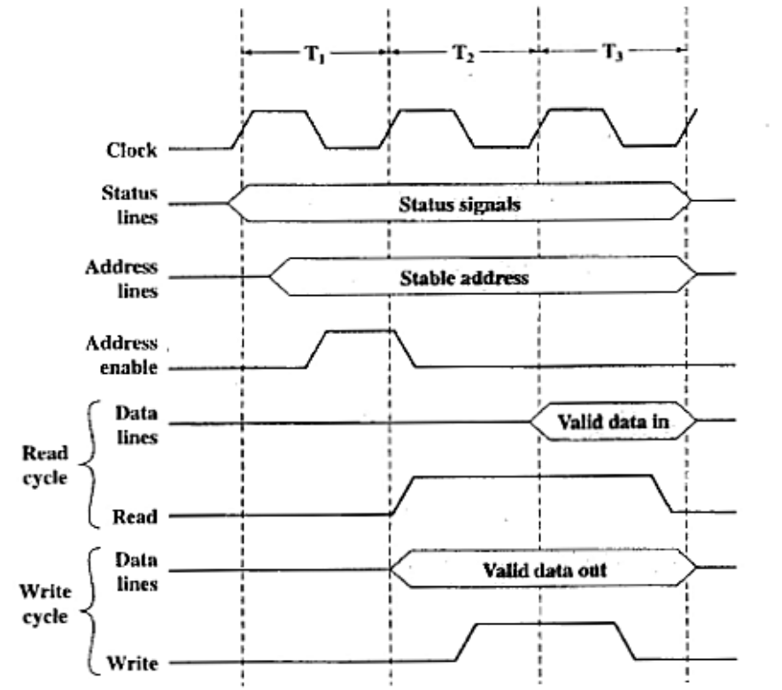

b) Show a timing diagram for an asynchronous bus, again showing the signals for both read and write operations:

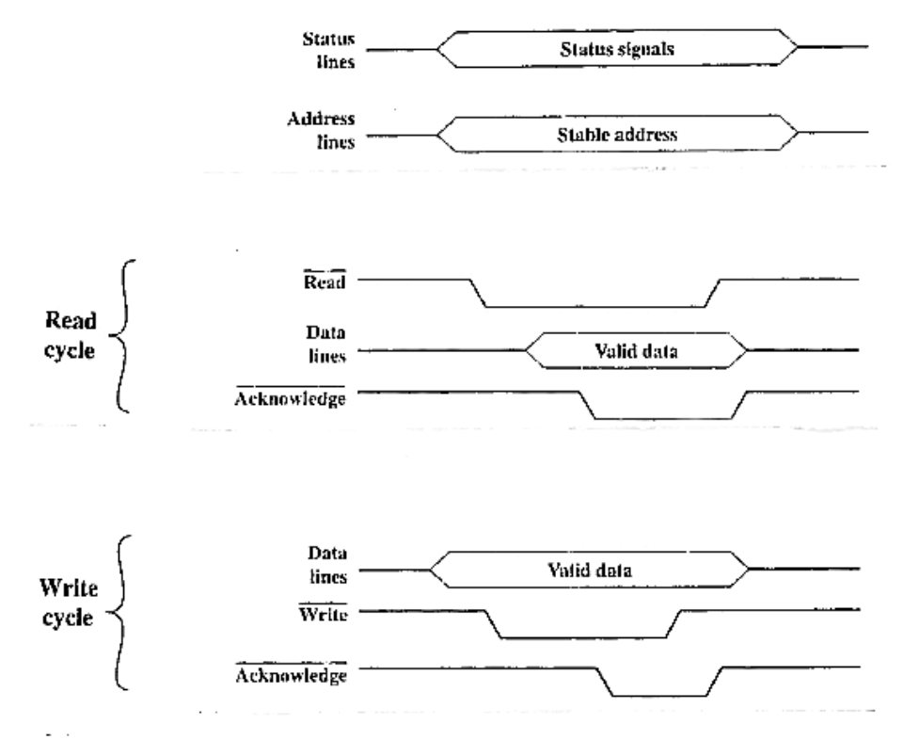
15 points
3) Name the two major operating system functions we studied:

a) Scheduling

b) Memory Management

c) Show the Five-State Process Model for an operating system.
d) Identify the actions that cause processes to move from one state to another.
e) Identify the states that manage the long-term queue, the short-term queue, and the I/O queues.

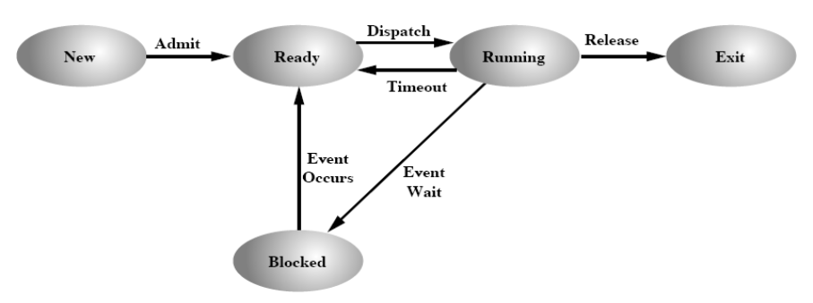
The Ready State manages:
the long-term queue (add to pool to be given resources) and
the short-term queue (dispatching)

The Blocked State manage:
The I/O queues

Show how a page table is used to map logical addresses into physical addresses, specifying the frame number and the relative address within the frame.
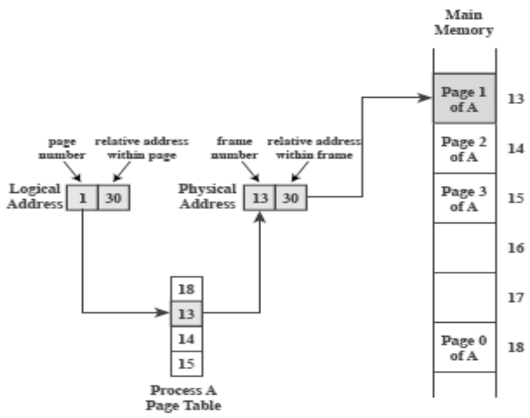

What is an inverted page table, why is it needed, and how does it work?

An inverted page table is used to a virtual address to a physical address. Virtual addresses can be
unlimited in size, so there can’t be an entry for every virtual address page. Inverted page tables have
one entry for every physical frame. A function, like a hashing function determines which table entry to
use.

15 points
4) What are four important characteristics of classic RISC computers?

a) Lots of registers, typically 32 at a time

b) Uniform, short instruction length, typically 4 bytes

c) A minimum of addressing formats, and no more than one memory load or store per instruction

d) Maximum uses of memory management

Show the use of “delayed branching” to speed up a RISC pipeline.

Original set of Instructions:
100 LOAD X, R1
101 ADD 1, R1
102 JMP 105
103 ADD R1, R2
104 ADD 1, R3
105 STORE R1, Y
106

Flow through the RISC pipeline
I | E | D
 | I | E
 |  | I | E
 |  |  | I
 |  |  |  | I | E | D

Modified set of Instructions Flow through the RISC pipeline
I | E | D
 | I | E
 |  | I | E
 |  |  | I | E | D
100 LOAD X, R1

101 JMP 105

102 ADD 1, R1

103 ADD R1, R2

104 ADD 1, R3

105 STORE R1, Y

106

107

Explain what is happening and why “delayed branching” works?

As can be seen above, in the original set of instructions the instruction ADD R1, R2 had to be flushed from the pipeline when the branch was taken, and that delayed the fetching of the instruction
STORE R1, Y. In the modified set of instructions, the JMP 105 entered the pipeline first, the instruction immediately preceding it entered the pipeline next and the branch target instruction next with no need for flushing the pipeline and no delays.

10 points
5) a) What is a superscalar computer?

A superscalar machine exploits instruction-level parallelism by employing multiple independent multistage instruction pipelines.

b) Name three important methods superscalar machines employ to achieve extra speed:

1) Fetch multiple instructions simultaneously

2) Process instructions out-of-order

3) Use additional registers and employ register renaming

c) Explain how out-of-order issue / out-of-order completion of instructions is implemented in superscalar machines:

The Decode and Execute pipe stages are decoupled using a Window Buffer. The Window Buffer issues instructions in the optimal order to insure dependencies can be satisfied in the Execute and Write stages. A depiction of the organization is shown below:

Multiple Decode Pipe Stages |  |  | Window Buffer |  | Multiple Execute Pipe Stages |  |  |  | Multiple Write Pipe Stages
(Decodes Instructions) |  |  | (Issues Inst) |  | (Executes instructions) |  |  |  | (Writes Results)

10 points
6) What are the important methods employed by the IA-64 architecture:

- Predicated execution. Speculative execution is done in both paths following a branch. Predicate
registers are used to save the instructions in the chosen path.

- Control Speculation. Load instructions are speculatively moved forward to eliminate load delays. A
check determines if the speculation is used.

- Data Speculation. A load of data is moved before a possible overwrite. A check determines the
correct value is used.

4) Software pipelining. The compiler separates loops in prolog, kernel, and epilog phases, “unrolls
loops”, and employs automatic register renaming to schedule the execution of multiple loops
simultaneously.
10 points
7) Explain the fundamental difference between a hardwired computer control unit and
micro-programmed computer control unit.

a) Hardwired:

A hardwired control unit used state machines and logic to create the sequence of control signals
to sequence the fetch and execution of instructions, and to control the memory, interrupt, and
DMA timing.

b) Micro-programmed:

A micro-programmed control unit uses a simple micro computer which executes sequences of
micro instructions, each of which provides one cycle of the control signals, and specifies which
micro-instruction will be executed next.

Describe Horizontal & Vertical microinstructions and show typical formats:

c) Horizontal:

Horizontal microinstructions have a lot bits, most of which have a one-to-one correspondence
with control signals and provide the logic level for it at the point in time at which the
microinstruction is executed. The rest o the bits are used to determine if a branch is to be taken
and if so what the next microinstruction address is.

 | branch
control bits | conditions |  |  |  |  | branch address

d) Vertical:

Vertical microinstructions have function codes that need to be decoded or transformed to
provide the control bits. Vertical microinstructions also have branch condition bits and at
least one branch address.

 |  |  | branch
function codes |  |  | conditions |  |  |  |  | branch addresses

10 points
- a) Show a circuit of a modulo 16 binary counter. Use J-K flip flops.

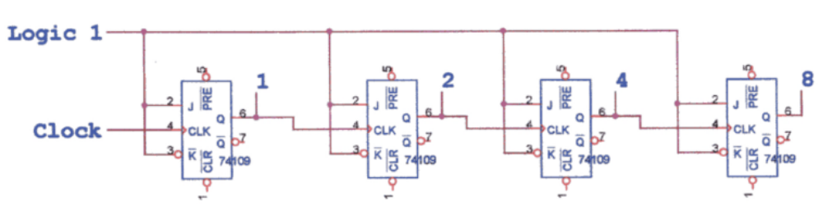

The J-K’s are used in the toggle mode since both the J and the K inputs are at a logic 1 level.

b) Make it a modulo 10 binary counter.

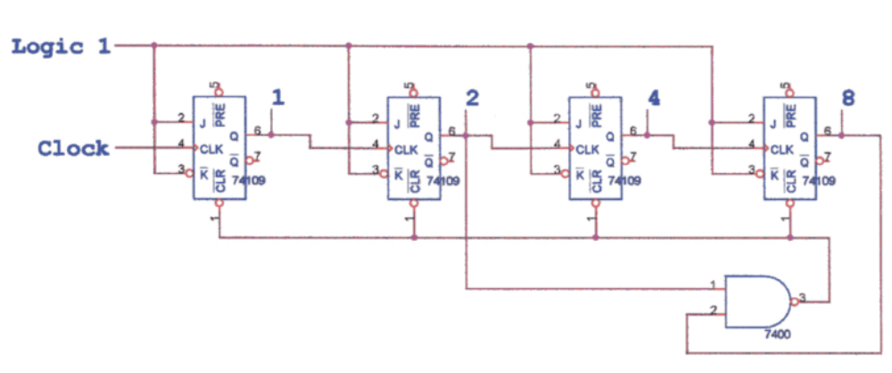

This circuit will count from 0 through 9, and then at 10 it resets to 0. It will produce a spike on “2” before the reset occurs. If that is unsatisfactory, then the inputs to the j-K’s will have to designed so that at the count of 10 the inputs to the “2” and “8” flip-flops are logic zeros, rather than clear the flip-flops.

