Course Announcement

BRT 501 – Fundamentals of Biorenewable Resources
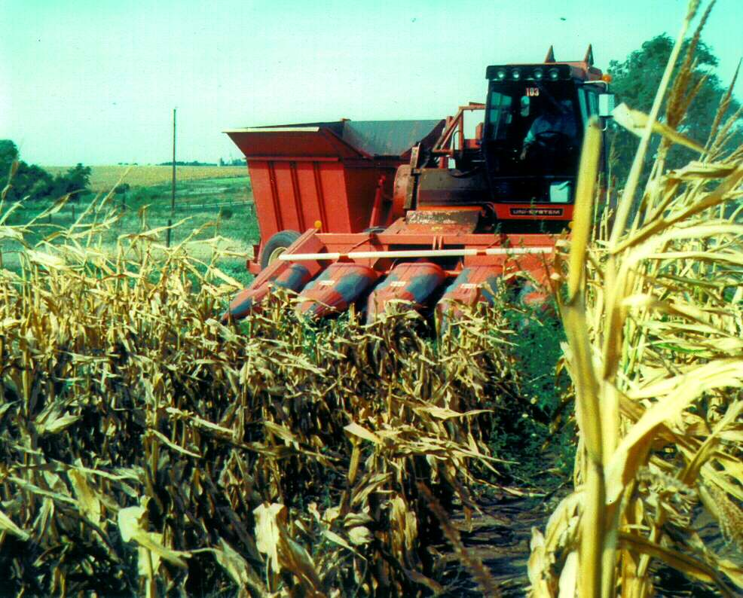
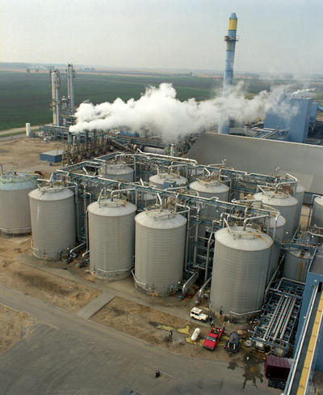
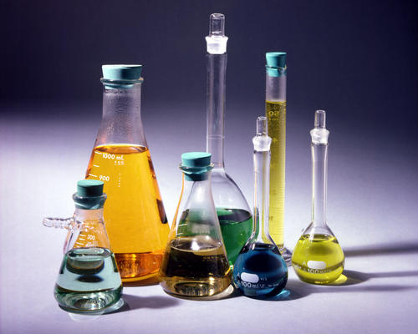
The Coordinating Committee of the new interdisciplinary Biorenewable Resources and Technology (BRT) Graduate Program is pleased to announce that a new graduate course — BRT 501, Fundamentals of Biorenewable Resources — will be offered in the Fall semester, 2003:
BRT 501 – Fundamentals of Biorenewable Resources. Fall, 2003. Cr. 3.0 Section A, MWF 2:10-3:00. 1651 Gilman Hall. Prerequisites: undergraduate training in engineering or physical or biological discipline or degrees in agriculture or economics.

Course Description
This course will introduce students to the science and engineering of converting biorenewable resources into bioenergy and biobased products. It will be team-taught, with lectures organized and/or given by faculty from the Departments of Chemistry, Food Science & Human Nutrition, Mechanical Engineering, Chemical Engineering, Ag & Biosystems Engineering, Forestry, and Economics. Topics of discussion will include: survey of biorenewable resource base and properties; description of biobased products; methods of biorenewable resource production; processing technologies for fuels, chemicals, materials and energy; environmental impacts; and economics of biobased products and bioenergy (see attached for a more detailed list of lecture topics).

Enrollment Procedures
This course is available in the Fall 2003 Schedule of Classes and ISU web registration system. Students can add it to their Fall schedules on-line using AccessPlus (click on Register for Classes).
Lecture Topics

BRT 501 – Fundamentals of Biorenewable Resources
Fall 2003  Section A, MWF 2:10-3:00  1651 Gilman Hall

- Introduction
Definition of terms; history of biorenewables; challenges; foundations of the BioEconomy; DOE vision/roadmap.
- Engineering Concepts
- Chemistry Concepts
- Biochemistry and Plant Science Concepts
- Plant Separation Concepts
- Carbohydrates, Lignocellulose, Oils, and Protein
- Biorenewable Resource Base
Wastes; dedicated energy crops; herbaceous energy crops; woody crops.
- Production of Biorenewable Resources
Herbaceous crops (planting, harvesting, storage); woody crops (planting, harvesting, storage); transgenic crops.
- Products from Biorenewable Resources
Bioenergy and fuel cells; transportation fuels; chemicals; materials (bioplastics, biocomposites, fiber products).
- Conversion of Biorenewable Resources into Heat and Power
Combustion; gasification; biological routes.
- Processing of Biorenewable Resources to Chemicals and Fuels
Fermentation of sugars (PLA); conversion of lignocellulosic feedstocks; thermochemical conversion; catalysis (biodiesel); biorenewable resources to natural fibers.
- Environmental Impact of the BioEconomy
Soil fertility; erosion; global warming.
- Economics of Biorenewable Resources
Cost of feedstocks from biorenewable resources; cost for manufacturing biobased products; public policy (present status of the bioenergy industry and the case for government involvement); products and pricing in markets with quality standards
(a review of specific instances of competition between bioproducts and petrochemical products, e.g., ethanol and MTBE, ethylene and lactic acid plastics).

