ENGL 282: Resources & Strategies for Multimodal Composition for the Web
Librarian: Amanda Hornby, hornbya@uw.edu

1. Your PSA topic and audience
Please respond to the following questions – be prepared to share them with a classmate:
What topic do you want to explore for your Public Service Announcement?

Who is your audience?

What action might you want your audience to take?

What research will your audience find credible?

2. Open vs. Closed Web
Open Web
Strengths:
Contains very current information
Includes information from professional organizations and blogs
There are billions of web pages available

Considerations:
Information may be inaccurate or biased because no one is reviewing the content
There is so much information available that it is hard to find what you are looking for
The information isn't organized

Closed Web
Strengths:
The library pays for access to electronic databases, full-text journals, and ebooks
Information has been carefully chosen and reviewed by experts
The information is organized

Weaknesses:
May not include the most current information on some topics
The amount of information may be limited for some topics

Credibility scale: Evaluate your sources based on how credible they are for your audience, issue and purpose.
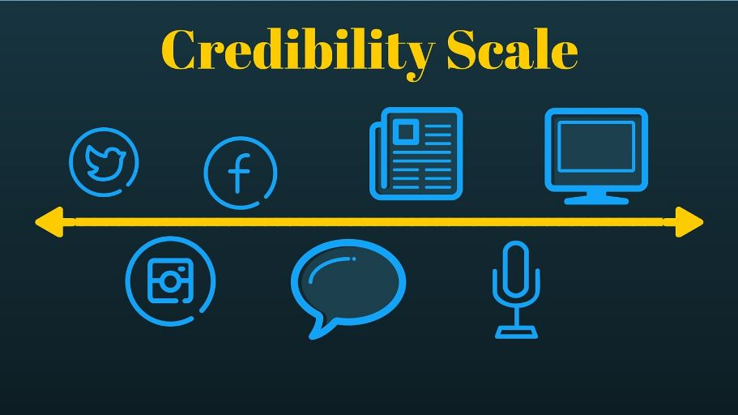

Sources for PSA Research: https://canvas.uw.edu/courses/988878/pages/sources-for-psa-research
Research your audience:
International Data
World Development Indicators
United Nations data - search by topic, country, country demographic data

U.S. Census 2010 - most current U.S. demographic data
national
WA state fact sheet
WA state, county & city data - Puget Sound Regional Council
Seattle

Mintel Academic - UW only
Filter by Sector - Health & Wellness, Personal Care
Filter by Theme - Healthy Lifestyle, Ethical & Green
Filter by Demographic - Teens, Kids

Research your issue:
CQ Researcher - UW only
Browse topics
Browse reports - Issue Tracker ; Pro/Con

Libraries search - UW only - http://lib.washington.edu
Research guides - list of recommended resources by academic subject

Google search tip:
Search Google for your PSA topic and filter by national, local or Seattle government organizations, for example:
hunger inURL:.gov
"emergency preparedness" inURL:wa.gov
"teen homelessness" inURL:seattle.gov

You can also search by inURL:.org

