Advanced R

Exercises for Session 4: Objects and Methods.

1. (a) Write a summary() method for the S3 ROC curve object that calculates the partial area under the curve (pAUC). That is, given an upper and lower endpoint for the false positive rate (x-axis), it computes the area under the curve between the upper and lower endpoints. The endpoints should default to 0 and 1, and the user should be able to specify both, just one, or neither.
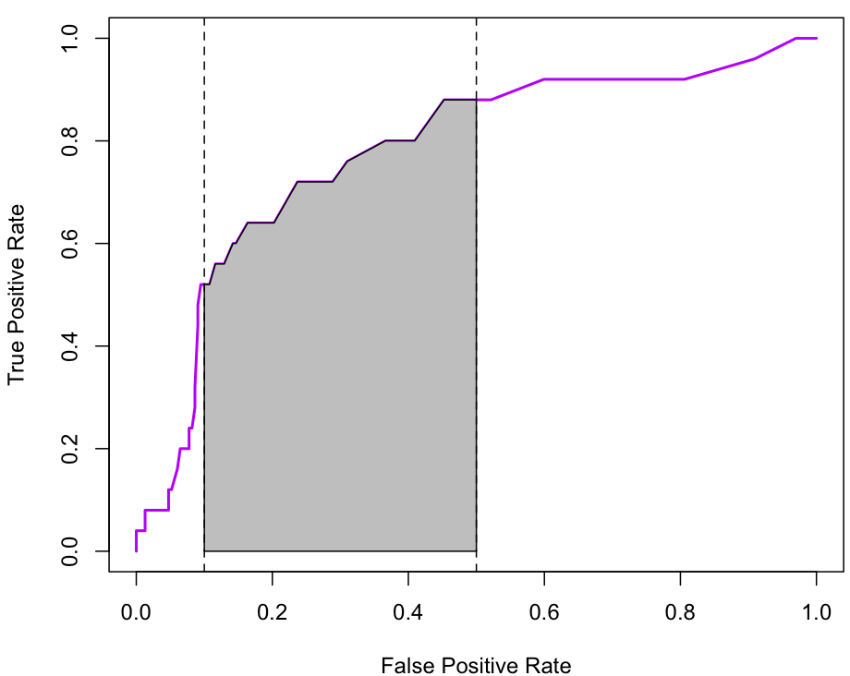
Shaded area is partial AUC between false positive rates of 0.1 and 0.5
(b) Repeat for the S4 ROC curve objects. For debugging, try using trace() with the signature= argument set to follow the S4 methods.

2. ROC curves are also useful for summarizing logistic regression models. Given a logistic regression model object model of class glm, we can extract the predicted values with fitted(model) and the observed binary outcome with model$y and then use the same computations to produce an ROC curve for the model.
(a) Write a function that computes the ROC curve for a logistic regression model.
(b) Write a generic function ROC() with methods that compute the ROC curve when the user supplies either a continuous test variable and binary outcome or a glm object.

3. The data file sequence.rda has DNA sequences for 5000 people and 4028 rare sequence variants (simulated using MaCS). The Matrix package provides tools for handling sparse (ie, mostly zero) matrices. Compare the time and memory taken for

crossprod(sequence)

and

library(Matrix)
M<-Matrix(sequence)
crossprod(M)

Look at the class of M and the methods available for that class. What can you find out about how M is actually stored internally?

