Advanced R Programming for Bioinformatics

Exercises for Session 4: Objects and Methods.

1. (a) Write a summary() method for the S3 ROC curve object that calculates the partial area under the curve (pAUC). That is, given an upper and lower endpoint for the false positive rate (x-axis), it computes the area under the curve between the upper and lower endpoints. The endpoints should default to 0 and 1, and the user should be able to specify both, just one, or neither.
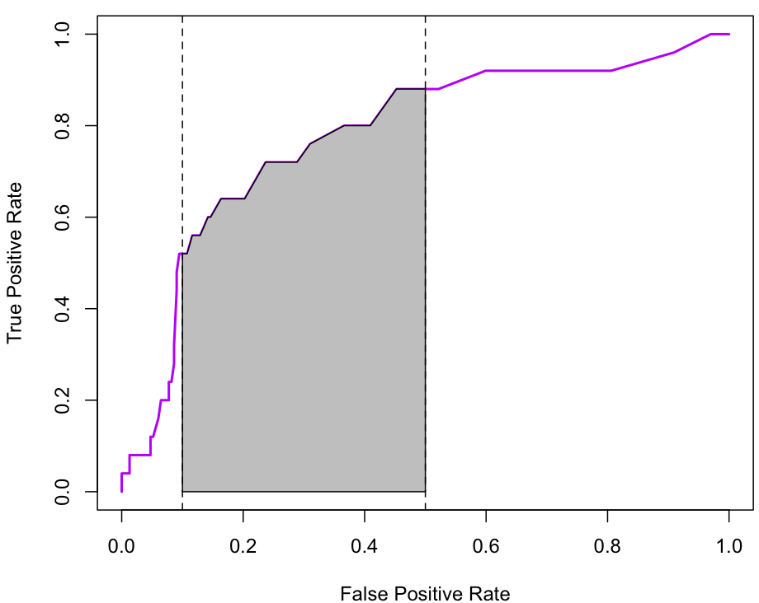
Shaded area is partial AUC between false positive rates of 0.1 and 0.5
(b) Repeat for the S4 ROC curve objects. For debugging, try using trace() with the signature= argument set to follow the S4 methods.

2. ROC curves are also useful for summarizing logistic regression models. Given a logistic regression model object model of class glm, we can extract the predicted values with fitted(model) and the observed binary outcome with model$y and then use the same computations to produce an ROC curve for the model.
(a) Write a function that computes the ROC curve for a logistic regression model.
(b) Write a generic function ROC() with methods that compute the ROC curve when the user supplies either a continuous test variable and binary outcome or a glm object.

3. Bioconductor packages come with vignettes describing how to do some specific tasks. Pick one of the following vignettes to work through. You may need to install additional Bioconductor packages – see the class site for commands to do this.

A: Sequence data;

vignette("GenomeSearching", package="BSgenome")

B: Flow cytometry data; (large, not very high-dimensional)

vignette("GettingStartedWithFlowStats", package="flowStats")

C: Gene expression data: Biobase package
vignette("Qviews")
vignette("ExpressionSetIntroduction")

