Introduction to R Markdown
2018-07-11
This is an R Markdown document. Markdown is a simple formatting syntax for authoring HTML, PDF, and MS Word documents. For more details on using R Markdown see http://rmarkdown.rstudio.com.
A quick references to the most commonly used R Markdown syntax can be found here: http://rmarkdown.rstudio.com/authoring_basics.html
An extensive R Markdown cheatsheet can be found here: https://www.rstudio.com/wp-content/uploads/2016/03/rmarkdown-cheatsheet-2.0.pdf
When you click the Knit button in Rstudio, a document will be generated that includes both content as well as the output of any embedded R code chunks within the document. You can embed an R code chunk like this:
In an R Markdown file you type the R code that you want in “chunks” as follows:
fevdata <- read.csv("http://faculty.washington.edu/tathornt/Biost509/DataSets/fev2.csv",header=TRUE)
plot(fev ~ height, data=fevdata)
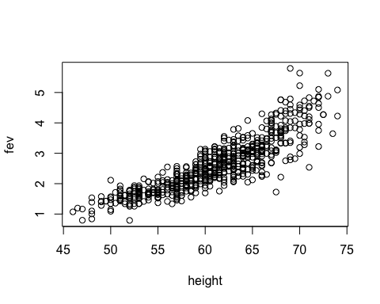
Note the first and last lines of the chunk. These are required to show when a chunk begins and ends. The R code follows the same syntax in R markdown as in an R script file.
To run a chunk of R code, place your cursor anywhere in the chunk, click the “Chunks” button and select “Run Current Chunk”.
To execute the entire file, click the arrow to the right of the “Knit” button and select your desired output format (pdf, html or word). A document will be generated that includes the text content outside of the chunks as well as the output of the R code chunks.
The files you create will open automatically and will also be saved in the working directory.

Look at the first few lines of the file and obtain summary statistics for each variable
head(fevdata)
## seqnbr subjid age fev height sex smoke
## 1 1 301 9 1.708 57.0 2 2
## 2 2 451 8 1.724 67.5 2 2
## 3 3 501 7 1.720 54.5 2 2
## 4 4 642 9 1.558 53.0 1 2
## 5 5 901 9 1.895 57.0 1 2
## 6 6 1701 8 2.336 61.0 2 2
summary(fevdata)
## seqnbr subjid age fev
## Min. : 1.0 Min. : 201 Min. : 3.000 Min. :0.791
## 1st Qu.:164.2 1st Qu.:15811 1st Qu.: 8.000 1st Qu.:1.981
## Median :327.5 Median :36071 Median :10.000 Median :2.547
## Mean :327.5 Mean :37170 Mean : 9.931 Mean :2.637
## 3rd Qu.:490.8 3rd Qu.:53638 3rd Qu.:12.000 3rd Qu.:3.119
## Max. :654.0 Max. :90001 Max. :19.000 Max. :5.793
## height sex smoke
## Min. :46.00 Min. :1.000 Min. :1.000
## 1st Qu.:57.00 1st Qu.:1.000 1st Qu.:2.000
## Median :61.50 Median :1.000 Median :2.000
## Mean :61.14 Mean :1.486 Mean :1.901
## 3rd Qu.:65.50 3rd Qu.:2.000 3rd Qu.:2.000
## Max. :74.00 Max. :2.000 Max. :2.000

Create a new sex variable for males and females
fevdata$sex2<-ifelse(fevdata$sex==1,"male","female")
fevdata$sex2<-as.factor(fevdata$sex2)

Obtain the mean fev for males and females
avgmalefev<-mean(fevdata$fev[fevdata$sex2=="male"],na.rm=TRUE)
avgmalefev
## [1] 2.812446
avgfemalefev<-mean(fevdata$fev[fevdata$sex2=="female"],na.rm=TRUE)
avgfemalefev
## [1] 2.45117

Boxplots of FEV for males and females.
### Box plot of FEV for males and females ###
boxplot(fev ~ sex2,data=fevdata,col=c("pink","lightblue"),main="Boxplots of FEV by Gender")
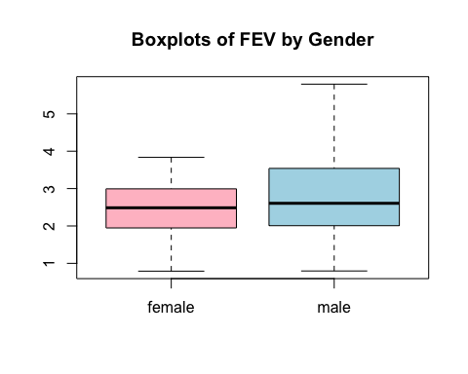
For a page or line break in the document, use three or more astericks (*) or dashes (-).

Figure dimensions are controlled by the fig.height and fig.width parameters (units are inches). You can also add a caption with the fig.cap parameter.
plot(fev ~ height,ylab="FEV", xlab="Height",main="FEV versus Height",data=fevdata)
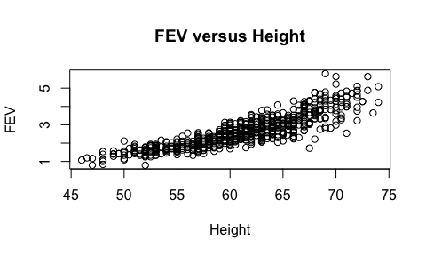
Scatterplot and Regression Line of of FEV on Height
Note that for the following chunk, the R code is suppressed by the “echo=F” paramater. This is useful when you are using R markdown to write a report and only want to see the results. Here is a plot, without the R code appearing in the document:
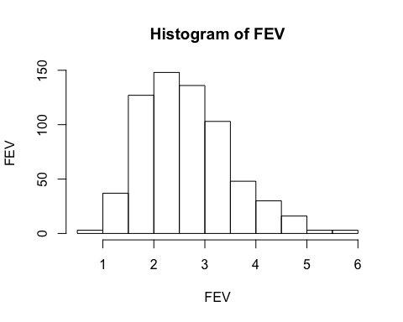
Histogram of FEV

Extension R packages can easily be used with Rmarkdown.
For example, can use the ggplot2 package for data visualization.
library(ggplot2)
Suppose we are interested in investigating the relationship between smoking and FEV. Let’s first create a new smoking indicator variable for smoker, where 1 corresponds to a smoker and 0 corresponds to a non-smoker
fevdata$smoker<-(2-fevdata$smoke)
head(fevdata)
## seqnbr subjid age fev height sex smoke sex2 smoker
## 1 1 301 9 1.708 57.0 2 2 female 0
## 2 2 451 8 1.724 67.5 2 2 female 0
## 3 3 501 7 1.720 54.5 2 2 female 0
## 4 4 642 9 1.558 53.0 1 2 male 0
## 5 5 901 9 1.895 57.0 1 2 male 0
## 6 6 1701 8 2.336 61.0 2 2 female 0
Boxplot of FEV by smoking group
ggplot(fevdata,aes(x=as.factor(smoker),y=fev,fill=as.factor(smoker)))+ geom_boxplot() +xlab("Smoker") +ylab("FEV") +scale_fill_discrete(name="Smoker")
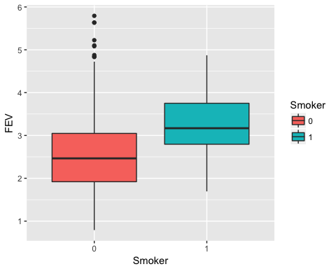 Boxplot of FEV by smoking group across each age group that has both non-smokers and smokers
fevdata2<-subset(fevdata,age>=9)
ggplot(fevdata2,aes(x=as.factor(smoker),y=fev,fill=as.factor(smoker)))+ geom_boxplot() +xlab("Smoker") +ylab("FEV") +scale_fill_discrete(name="Smoker")+facet_wrap(~age)
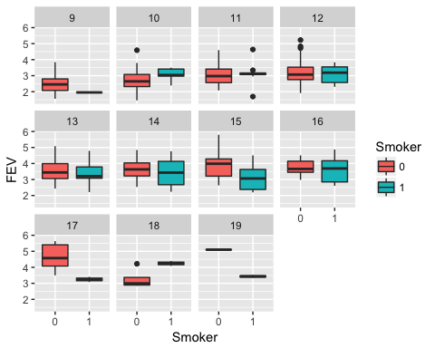
Boxplot of FEV by smoking group across each age and gender group that has both non-smokers and smokers
ggplot(fevdata2,aes(x=as.factor(smoker),y=fev,fill=as.factor(smoker)))+ geom_boxplot() +xlab("Smoker") +ylab("FEV") +scale_fill_discrete(name="Smoker")+facet_wrap(~age+sex2)
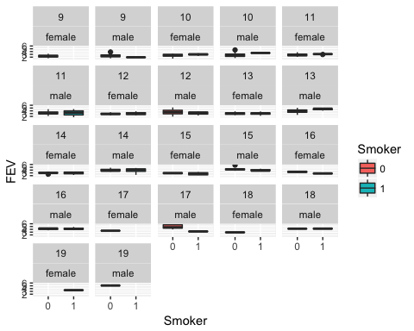
Scatterplot of FEV by age with LOESS smoothing curve for each smoking group
p<-ggplot(fevdata2,aes(x=age,y=fev,colour=as.factor(smoker)))
p+geom_point(size=1.5)+geom_smooth(method="loess",se=FALSE)+xlab("Age (in years)")+ylab("FEV")+scale_colour_discrete(name="Smoker",breaks=c("1","0"),labels=c("Yes", "No"))+ggtitle("Scatterplot of FEV vs. Age")
