Division of Physical Therapy
Department of Rehabilitation Medicine
University of Washington

Physical Therapy Portfolio

As part of an on-going program requirement, you will be developing your personal Physical Therapy Portfolio.

What is the purpose of the Physical Therapy Portfolio?

The purpose the physical therapy portfolio is to provide an evolving record of your development as a physical therapist. It is a purposeful compilation of “evidence” of your professional development as a physical therapist and your thoughtful reflection on the evidence you select to include. In a sense, your portfolio is a dynamic self-assessment that captures your growth in the profession of physical therapy over time. It is intended to be an expression of your developing competence in achieving our transcurricular objectives.

What does the Physical Therapy Portfolio do for me?

In the short-term, the physical therapy portfolio is a:

- Guide in the process of becoming a physical therapist.
- Personal reflection on the process and your progress on becoming a physical therapist.
- Tangible display of “evidence” of personally important work that can be shared with others (e.g., colleagues, mentors, advisors).

In the long-term, your portfolio will be a useful tool to help prospective employers learn more about you, and your goals and abilities in the profession.

What constitutes evidence?

While there are some requirements (subsequently detailed), for the most part what you choose to include as evidence in your physical therapy portfolio will be up to you. You may choose to include certain course assignments as evidence of your developing competence in the transcurricular objectives. For example, in the second quarter of physical therapy seminar you will be developing patient and family education materials. You may choose to include a copy your group’s final product as evidence under the category of Physical Therapist as Educator. You may also include evidence from sources outside of this program that relate to mastery of the transcurricular objectives. For example, you might include documentation of your work as a volunteer for Ski-for-All under the section on Professionalism

How does a Physical Therapy Portfolio differ from a file?

Your physical therapy portfolio is not just a depository of papers in a notebook. What sets your portfolio apart from this is the inclusion of thoughtful reflections, sometimes referred to as captions, on your selected evidence. For most evidence you will include a typed commentary that that expresses why you have included a particular item and your thoughts on where you are along the continuum of achieving the transcurricular objective. While they need not be lengthily, they sometimes may be. Most important is that the reflections/captions are a sincere, deliberate consideration of the evidence and your process and progress toward becoming a physical therapist.

What is the timeline for developing my Physical Therapy Portfolio?

You should begin to develop your portfolio immediately and keep it current. It must include the required sections listed on the following page, but may include others you feel are relevant to your experience. Italics indicate required evidence. You will be required to bring your Physical Therapy Portfolio to your advising meetings throughout the program.

What do I need to begin building my Physical Therapy Portfolio?

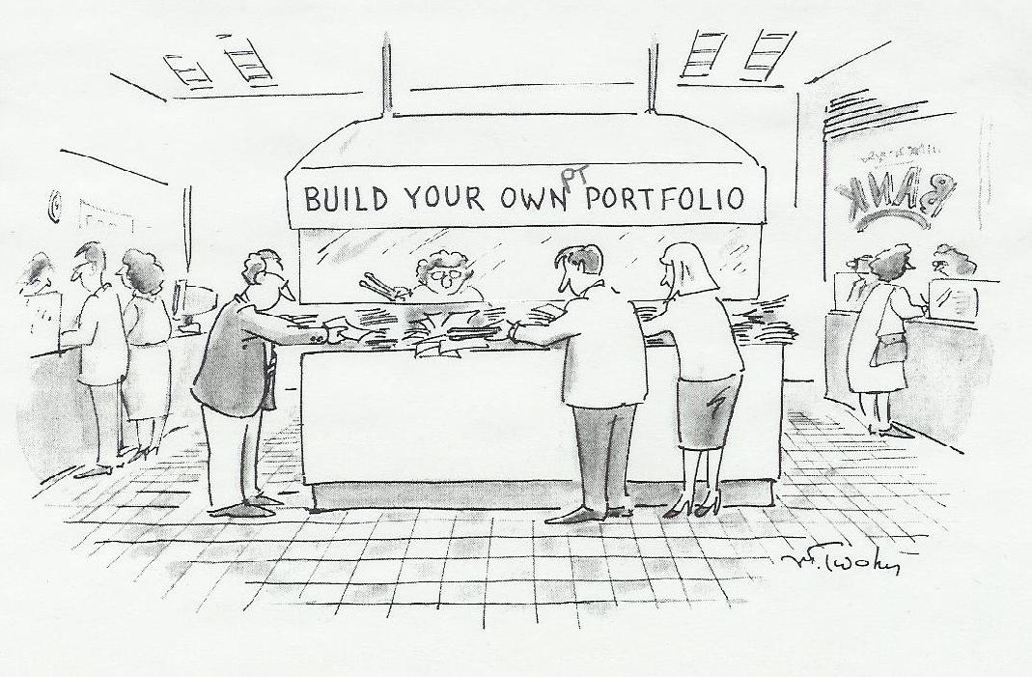

You will need to purchase a rigid, white 2-inch 3-ring view binder that will allow you to insert the cover sheet on the front. You will also need a set of dividers that will allow you to create the sections of your portfolio. Two good options for dividers are Avery Ready Indexing System or Wilson-Jones View Tab transparent Dividers. Both allow you to use your computer to format the text and the outcome is a very professional look. Page pockets may be used, but are not required.

Physical Therapy Portfolio
Table of Contents

- Professionalism
Purpose/personal goal statement/personal philosophy
Professional Development Plan
Activity in professional association
Resume/CV (no caption required)
HIPPA Documentation: User Code
Continuing education participation
Community service – pro bono
Advocacy

- Effective Communication
Documentation
Sample letter of justification

- Diversity: Individual and Cultural Differences

- Life Span Perspective

- Physical Therapist as Educator
Patient and family education materials

- Critical Inquiry and Decision-Making: Evidence-based Practice
Evidence-based paper for Rehab 517

- Safe and Efficient Practice (no captions required for these items)
Certificate of Completion: AIDS Education
Certificate of Completion: CPR for Healthcare Professionals
Certificate of Completion: Universal Precautions
Criminal History Check
Immunization Record

Interprofessional Collaboration

- Other
Summary pages from Clinical Education Evaluation and signature page

Please note that items in italics are required for all portfolios.
Kartin 11/04
Doctor of Physical Therapy Program
Department of Rehabilitation Medicine
University of Washington

TRANSCURRIUCLAR OBJECTIVES

Effective Communication: Throughout all aspects of the curriculum, the student will demonstrate effective expressive and receptive communication, both orally and in writing, with the entire classroom community including, but not limited to: instructors, peers, patients, clients, families, care givers, and other practitioners and community partners.

Diversity: Individual and Cultural Differences: Throughout all aspects of the curriculum, the student will demonstrate cultural competence and be able to exemplify specific implications of cultural differences as they relate to physical therapy practice, research, and education.

Life Span Perspective: The student will be able to articulate the importance of developmental differences across the lifespan that relate specifically to the curriculum content and generically to physical therapy practice, research, and education.

Professionalism: Throughout all aspects of the curriculum, the student will demonstrate professional behavior in all interactions in the context of the broad physical therapy community including, but not limited to: instructors, peers, patients, clients, families, care givers, other practitioners, and community partners.

Critical Inquiry and Decision Making: Evidence-based Practice: Throughout all aspects of the curriculum, the student will demonstrate clinical decision-making skills, including clinical reasoning, clinical judgment, and reflective practice in the application of curriculum content to clinical problems.

Throughout the curriculum the student will demonstrate the ability to critique assigned readings and other published literature.

Physical Therapist as Educator: The student will have effectively demonstrated the role of the physical therapists as educator through classroom and/or in-service presentations and in the development of educational materials that are responsive to the needs and unique characteristics of the learner.

Safe and Efficient Practice: Throughout all aspects of the curriculum, students will have demonstrated safe and efficient clinical practice that minimizes risk to the patient, client, physical therapist, and others.

Interprofessional Collaboration: Throughout all aspects of the curriculum, students will have demonstrated competence as effective team members in a collaborative, interprofessional, environment.

