Researching and Sponsoring Your Own Major Bill

One of the most rewarding aspects of being a legislator is sponsoring a bill that is eventually enacted into law. This is not an easy task for a number of reasons. Legislators will often disagree about priorities, and resources are limited for even those things that legislators do agree deserve attention. Fewer than 1 out of 10 bills introduced in Congress eventually makes it into law.

You can sponsor as many bills as you prefer on any subject. However, this assignment asks you to research and draft an original and significant bill of your choosing. If you don’t know where to begin, consider looking at some actual bills by visiting the Library of Congress’ Thomas website or the bills that different members have sponsored (see the resources below). Then you should look at the sample bill at the bottom of this assignment.

Begin by considering several questions:

- How is a bill structured?
- What strategic considerations should you be thinking about when you draft the actual language of your bill?

Next, decide on a topic. Choose an important policy issue that interests you. Begin by drafting some initial language that conforms to the structure of the Sample bill (title, findings and purposes, etc).

Research your subject. It is entirely appropriate for you to develop your bill based on the work of others, whether policy organizations or legislators. However, your bill should be original in the sense that it reflects your own approach to the problem, as opposed to copying and pasting language developed by others. Originality counts! The Related Resources below provide some helpful starting points for learning more about issues.

Get feedback. Share your proposed idea with respected colleagues and asked for feedback and suggestions. After all, you will need their support later on. Give yourself time to tweak and improve your idea.

Introduce your bill on LegSim. Proofread! You will not be able to edit your bill after you have submitted it. Login to LegSim, click on “Submit Legislation” under My Office, and copy the text of your bill into the template provided.

Now it is time to find out what others think!

***Finally, as a separate assignment, turn your bill in to your instructor along with a paragraph on why you chose the subject and where you found information that helped you to formulate the specifics of your bill.***

Sample Bill Handout (also found in your LegSim session under Instruction)

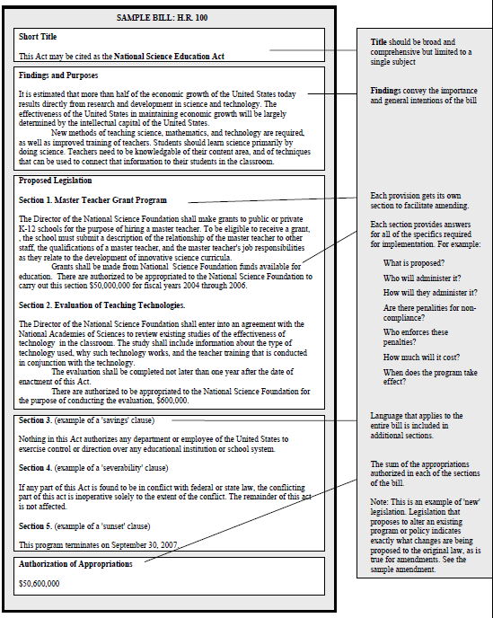
Sample Amendment Handout

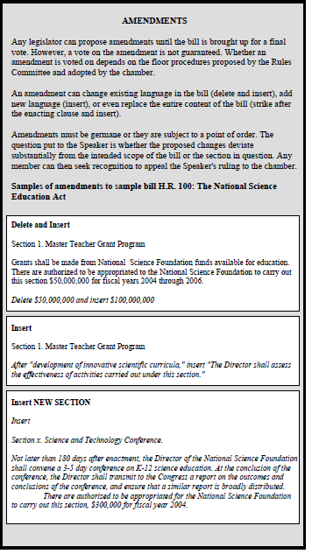

The Green Book: The Green Book is a primer Members of Congress use to quickly gain an appreciation of government policies and programs. This on-line version enables you to search the volume by subject.

Congressional Quarterly Almanac: Available in the reference section of Odegaard and on-line through the UW Library. Another great way to learn about the legislative history of a subject.

THOMAS Website: Thomas allows you to research bill histories, and to find examples of bills and committee reports. The history of any bill introduced from 1973 to the present can be found here. Also includes links to House and Senate websites, etc.

Members’ sponsorship and cosponsorship list (http://thomas.loc.gov/bss/d109/sponlst.html):
Clickable information about each Members’ legislative activity. Illustrates the diversity of sponsorship and co-sponsorship activity.

