Web Design: HTML and Web Publishing

TC310: The Computer in Technical Communication

During today’s class, we will be covering the following:
- HTML Basics – Exploring the basic structure of HTML documents
- HTML Creation – Creating a simple web page using basic HTML commands
- Publishing HTML Pages – Setting up UW web publishing and publishing a page

These activities have the following goals:
- Take the magic out of Dreamweaver (a program that supports web design)
- Prepare you to debug code created by Dreamweaver
- Prepare you to appreciate what Dreamweaver does for you
- Engender questions that will promote broader, deeper, and richer learning

Part 1: Creating a web page
- Description: In this part of the activity, you will take web page content located on the class website, and format is as an html document. A model will be provided in class. At the end of this activity, students will be able to create HTML pages with the following functionality:
- Title
- Headings, Paragraphs, and Emphasized text
- Lists and Tables
- Links to other pages
- Images and Background Images

- Create basic page
  - Create a file in “notepad”
  - Type the following text in the file (handout, 1a):
<title>Usability: An Important TC Topic</title>
  - Add the following tags at the end of your usability.html file
<body>USABILITY</body>
  - Save the file as “usability.html”
  - View your html page:
In a browser, select file/open, select browse, navigate to the local location of your file, and select your file.

- Get a running start - Add all of the text.
  - Copy text from the “06-Html-Practice” Word document on class website
  - Paste this text between the between the begin body tag (<body>) and the end body tag (</body>), replacing the phrase, “USABILITY TEXT GOES HERE”.
  - Save and View – Note that there are few breaks!

- Add formatting
  - Add font formatting and spacing
- Add header tags and paragraph breaks as needed (handout, 1b)
- Add emphasis tags as needed (handout, 1c)
- Save and View.
  - Add lists to the page
- Add tags that transform “Useful web links” into “unordered list” (handout, 2a)
- Add tags that transform “important steps” information into “ordered list” (handout, 2b)
- Save and View.
  - Add a table.
- Following the instructions about creating tables (handout, 5), transform the “names” and “why famous” information into a table.
- Save and View.

- Make links live
  - Following the instructions about adding links (handout, 3), transform the web link information into live web links.
  - Save and View.

- Add Graphic Images
  - Add Graphic Image
- Find the “UseIT.com” screen shot on the class website, and save it to the save local location as your usability.html file.
- Add the image – following the instructions on the handout (4a).
<IMG src="06-useit.bmp" align=right>
- Right align the image - Following the instructions on the handout (4b).
- Save and View.

  - Add a background image
  - Find the “book.jpg” screen shot on the class website, and save it to the save local location as your usability.html file.
  - Modify the <body> tag as follows:
<body bgcolor="white" Text="black" background="book.jpg">
  - Save and View.

Part 2: Publishing your web page

- Thought Question: What files need to be “published”?

- Create “space” for Web Publishing
  - If you already have a “web space”, go to step 3 (and use your information)
  - Activate web publishing on server “students.washington.edu”
    - Follow instructions at http://www.washington.edu/computing/web/publishing/students.html.
    - For additional guidance, please see the screen shots located between page 4 and page 7 of this document (in the version online at the class website).

- Publish the “usability.html” to “students.Washington.edu” using FTP
  - Open FTP Program
    - Located at
Start/Programs/Uwick Applications/SSH Secure FTP/Secure FTP
  - Log on to “server”
    - Click “Quick Connect”
    - Type “dante.u.washington.edu” in “Host Name”
    - Type your UW account in “User Name”
    - Press return
    - Enter your password
    - Press return
  - Upload HTML files to “public_html folder
    - Double click on public_html folder
    - Select “Operation/Upload” from menus
    - Navigate to your local HTML file and
    - Select file/files to upload
    - Click on Upload button
    - Repeat as necessary for all required files.
  - View the published pages
    - Open a browser
Enter URL: http://students/washington.edu/yourID/pageName.html

Activating Web Publishing – What it looks like!

1. Starting Place
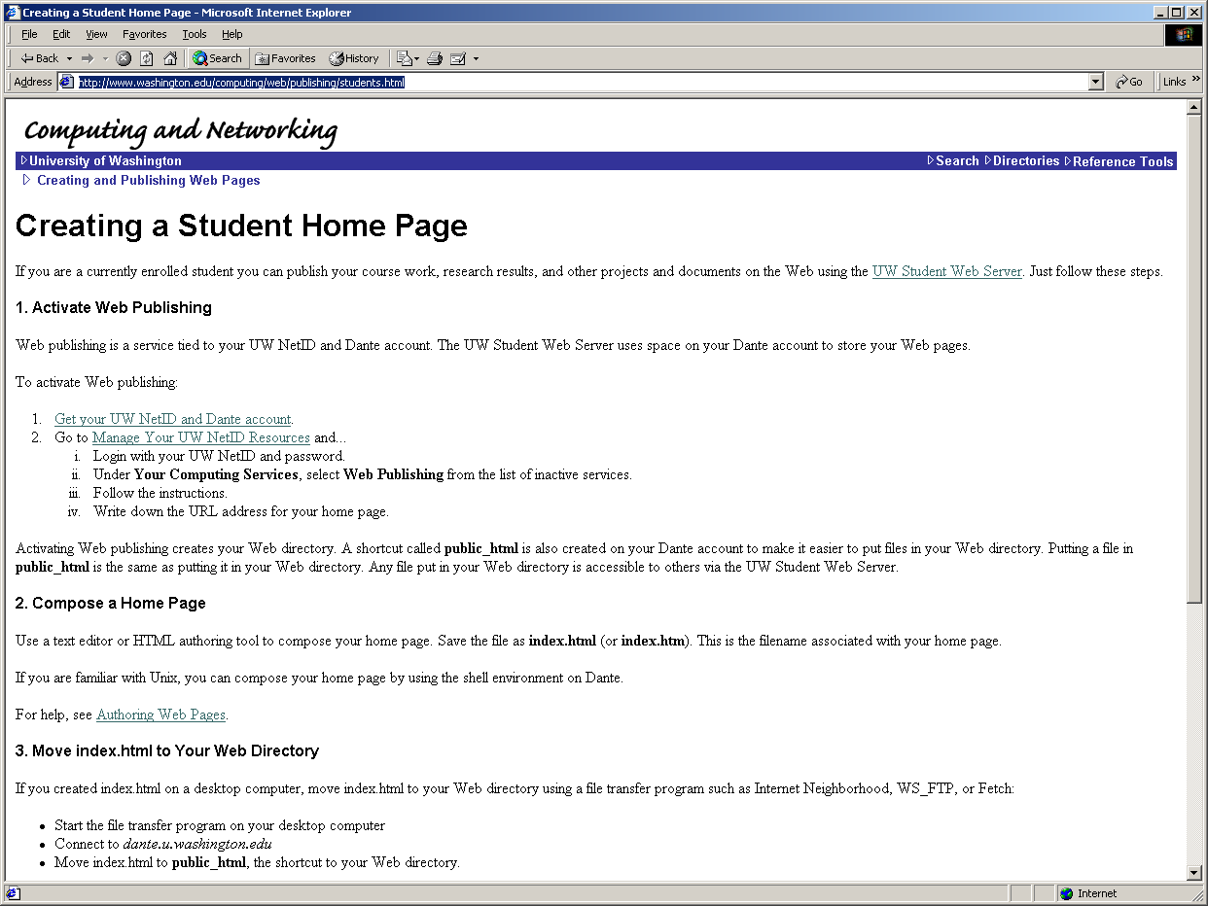

2. Logging In…
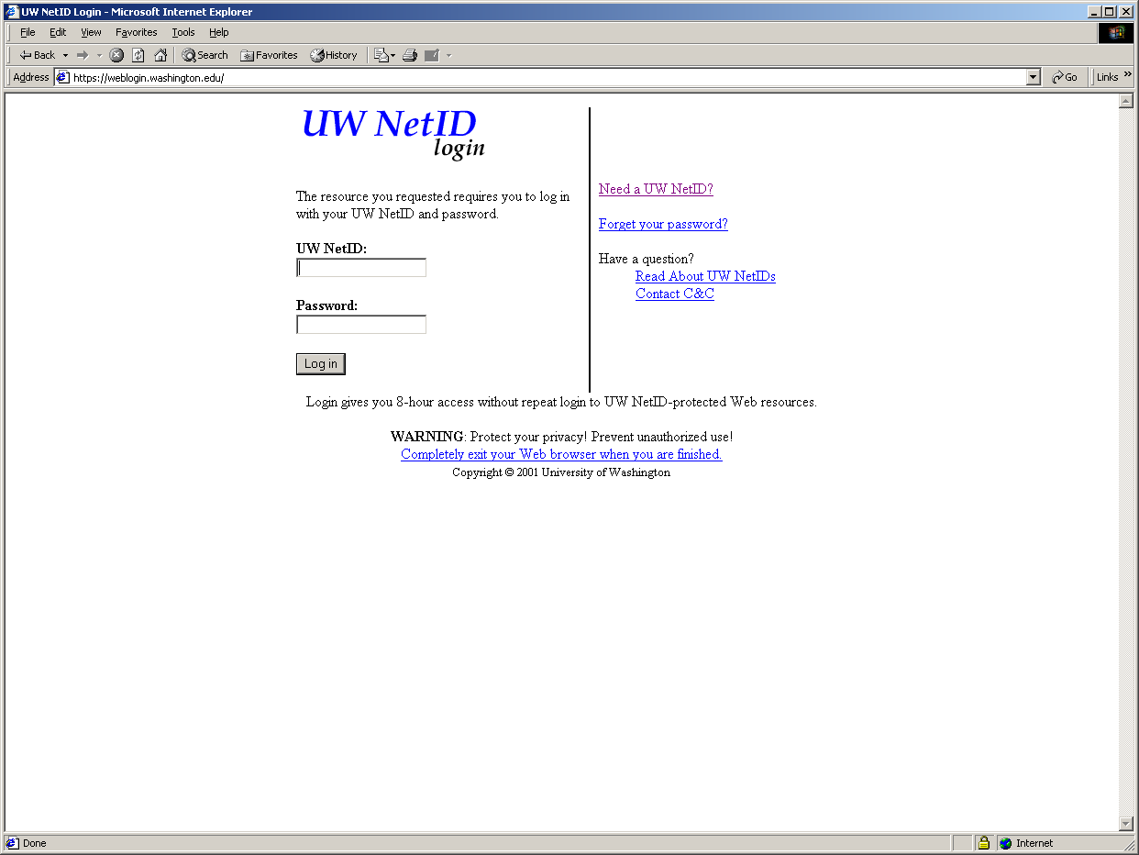
3. The place where you request that “Web Publishing” be activated…
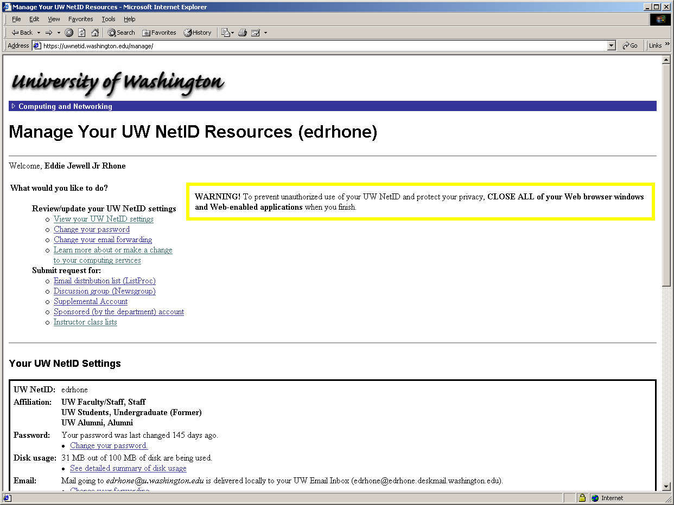
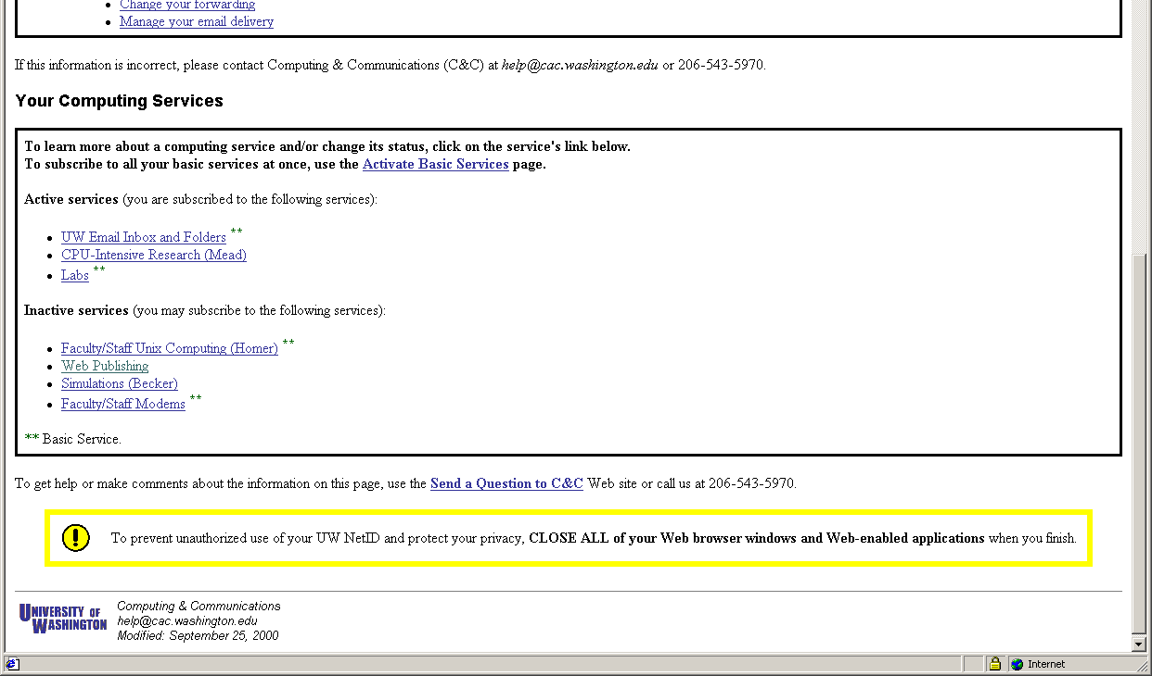
4. Actually making the “Activate Web Publishing” request.
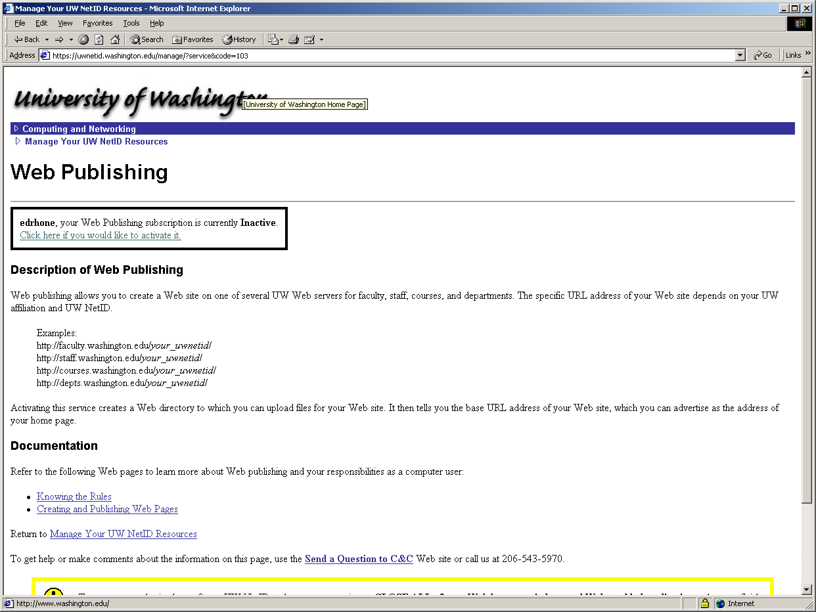

5. Letting you know your “responsibilities” related to web publishing…
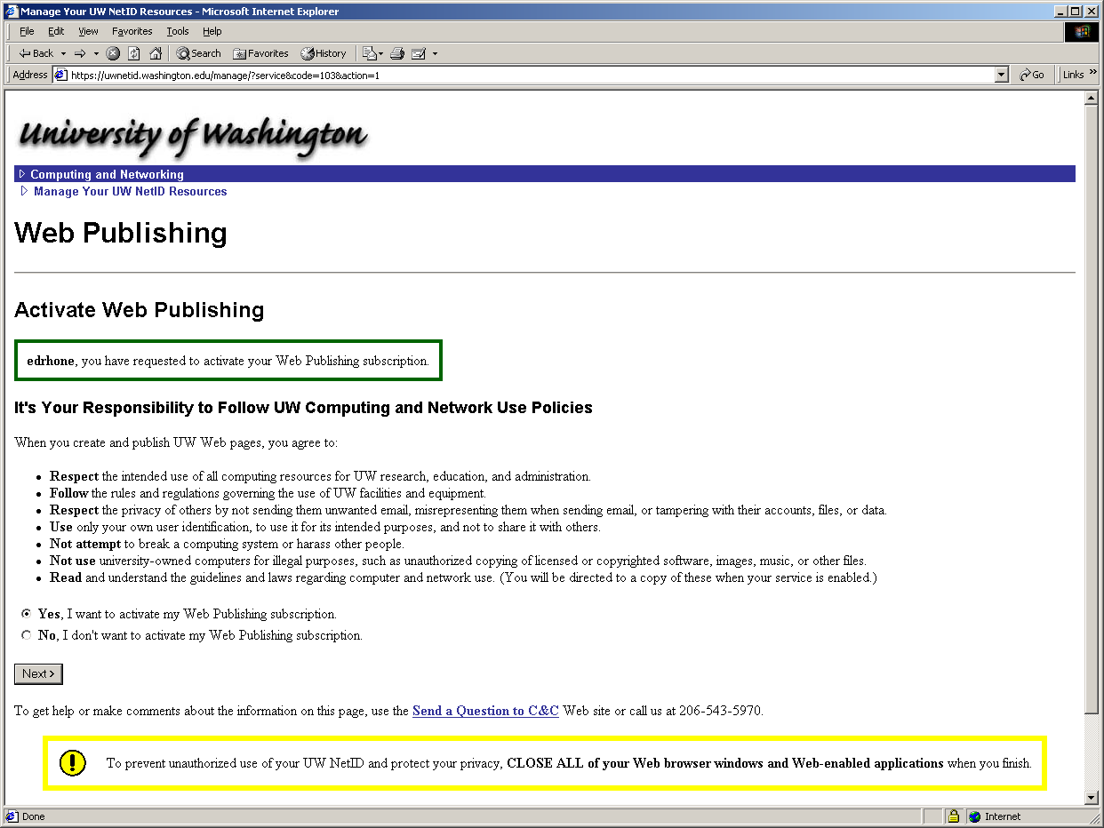
6. The final step – getting your URL…


