TO: TC 310 Students
FROM: Dr. Turns
RE: Materials for Web Design Class
DATE: 15 November 2001

Goals:
The goal today is to complete the introduction to the technology of web site creation and publishing. By the end of today, each student will have created a publicly available multiple page website and will have experienced using Dreamweaver to support the website development process.

As a result of these activities, students at the end of class will
- Be comfortable using Dreamweaver to create and edit a web page
- Be comfortable using FTP to “publish” web pages
- Be aware of how they can use Dreamweaver to manage website “publishing”.
- Be confident that they can create a multiple page website and publish the website.

Background:
There are at least three ways to create and publish a website.
- Minimal Support (Maximum control)
  - Create pages: Create HTML pages with “Basic” editor (e.g., Notepad)
  - Publish Pages: Use FTP to transfer files
- HTML Supported, Manual Publishing
  - Create pages: Create pages using supportive editor (e.g. Dreamweaver)
  - Publish Pages: Use FTP to transfer files
- Maximum Support
  - Create pages: Create pages using supportive editor (e.g., Dreamweaver)
  - Publish Pages: Use supportive environment to manage “publishing” of pages

Tasks for Today:
- Use Dreamweaver to create a web page:
  - Recreate the “Usability.html” page using Dreamweaver
    - Download/Access information for page
      - Copy the text for the page from the class website
      - Download the images for the page from the class website
    - Recreate “usability.html” page (Using Table 1 as a guide)
      - Create a new document in Dreamweaver
      - Format the document using dreamweaver
      - For support in using Dreamweaver, check the tutorials at:
http://www.sitebuilder.ws/dreamweaver/tutorials/index.htm
    - As you are working…
      - Preview: You can preview the page, as it will appear in the browser, by selecting “File/Preview in Browser”
      - Underlying HTML: To see the underlying HTML document, you can open the document using “Notepad”
Table 1. Webpage Formatting Guide
Formatting for Web Page | Tutorial
Format the headings | Making a Simple Webpage with Dreamweaver
Add spaces between paragraphs | Making a Simple Webpage with Dreamweaver
Add links | Making a Simple Webpage with Dreamweaver
Change the colors and fonts of the text | Using Dreamweaver's Built-In Color Schemes
Create the unordered list | How to Create Unordered (Bulleted) Lists in Dreamweaver
Create the ordered list | How to Create Ordered (Numbered) Lists in Dreamweaver
Add the table | Inserting a Table into a Web Document
Insert the figure (and right align the figure) | Insert an Image into a Web Document
Add the background image | Search for it ☺

- Create “space” for Web Publishing
  - If you already have a “web space”, go to step 3 (and use your information)
  - Activate web publishing on server “students.washington.edu”
    - Follow instructions at http://www.washington.edu/computing/web/publishing/students.html.
    - For additional guidance, please see the screen shots located between page 4 and page 7 of this document (in the version online at the class website).

- Publish the “usability.html” to “students.Washington.edu” using FTP
  - Open FTP Program
    - Located at
Start/Programs/Uwick Applications/SSH Secure FTP/Secure FTP
  - Log on to “server”
    - Click “Quick Connect”
    - Type “dante.u.washington.edu” in “Host Name”
    - Type your UW account in “User Name”
    - Press return
    - Enter your password
    - Press return
  - Upload HTML files to “public_html folder
    - Double click on public_html folder
    - Select “Operation/Upload” from menus
    - Navigate to your local HTML file and
    - Select file/files to upload
    - Click on Upload button
    - Repeat as necessary for all required files.
  - View the published pages
    - Open a browser
    - Enter URL: http://students/washington.edu/yourID/pageName.html

- Use Dreamweaver to create the pages that compose an entire “Site”
  - Create a simple “user centered design page”
  - Create a simple “technical communications topics” page, that contains links to the “user centered design” page and the “usability” page.

- Publish the entire Site
  - (Time Permitting) Publish the “site” using Dreamweaver
    - Define the “site” using Dreamweaver:
      - Follow the instructions for the tutorial located at
http://www.sitebuilder.ws/dreamweaver/tutorials/define1.htm to learn to define a site.
      - When you are defining the site, you will be given information in class about how to specify the fields.
    - Now actually publish the “site” using Dreamweaver:
      - Using the functionality provided in the “site” window, “publish” (upload) the files that compose the site.
        - You can upload each individual page OR all files at once
        - When you request that a page be uploaded, you will asked if you wish all related files to be uploaded (e.g., images, etc.). Say “YES”.
.
  - (As fallback plan…) Publish the “site” using FTP
    - You could publish the “site” by uploading (using FTP) each page separately. The purpose of this exercise is to explore another approach to uploading the website files

Activating Web Publishing – What it looks like!

1. Starting Place
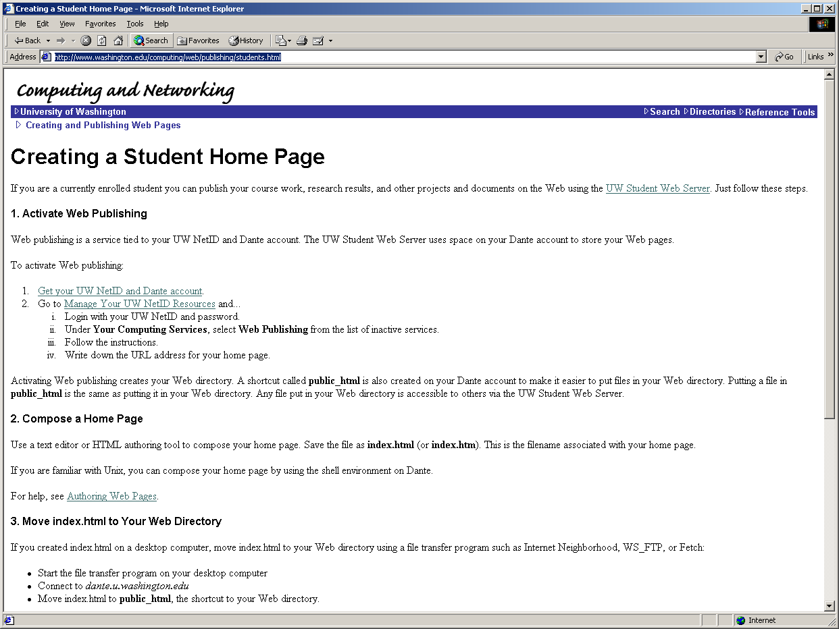

2. Logging In…
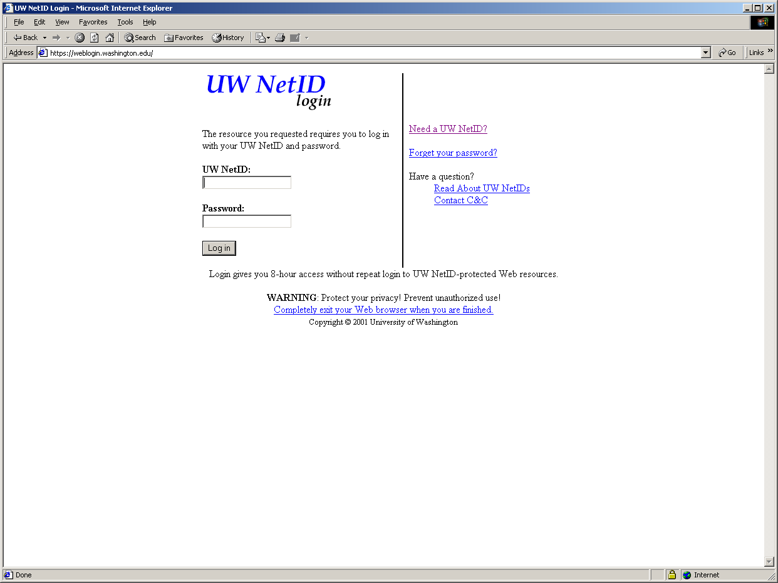
3. The place where you request that “Web Publishing” be activated…
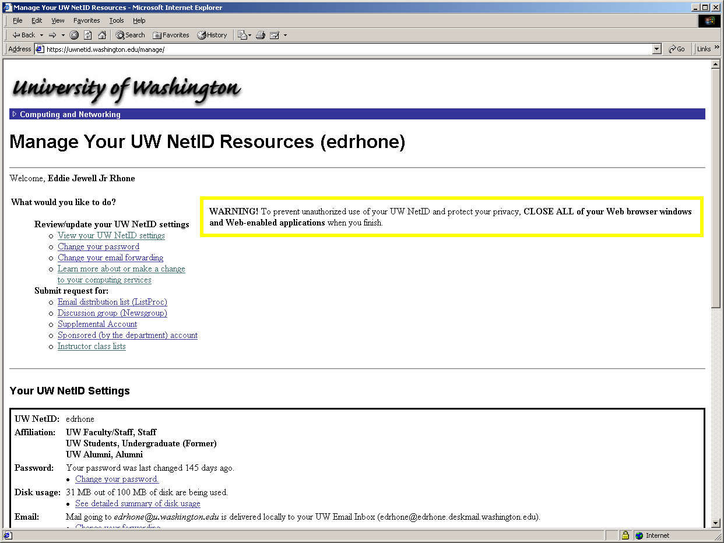
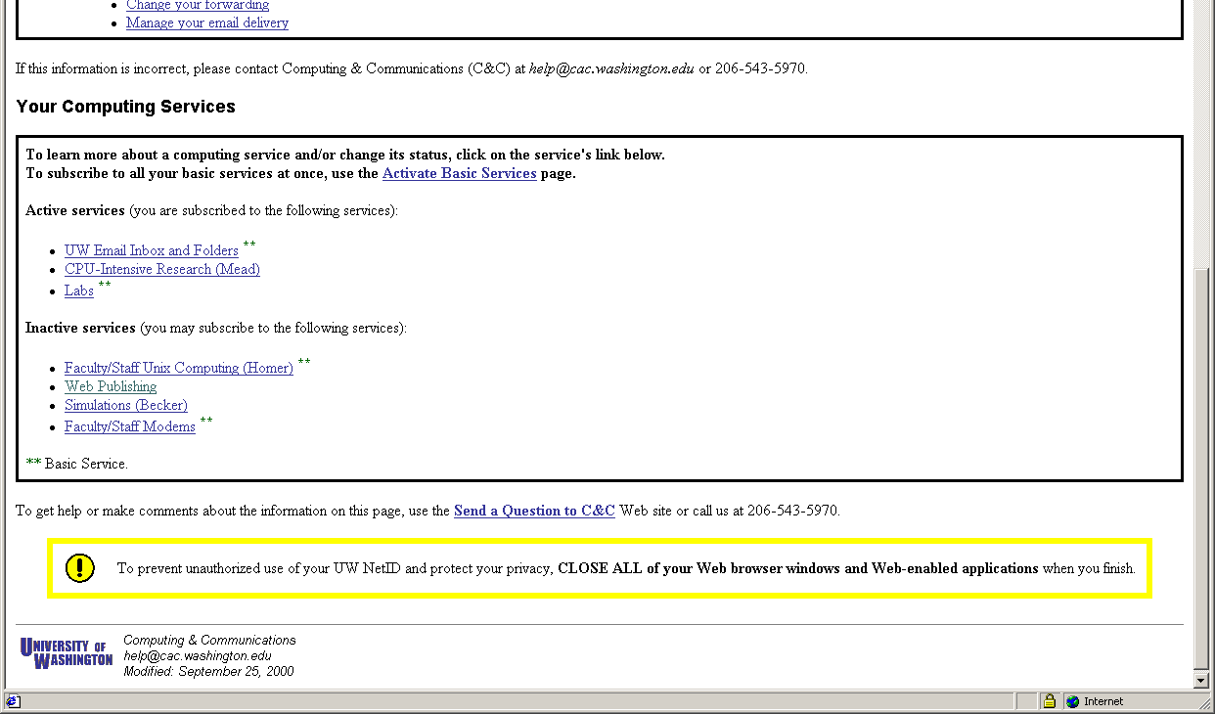
4. Actually making the “Activate Web Publishing” request.
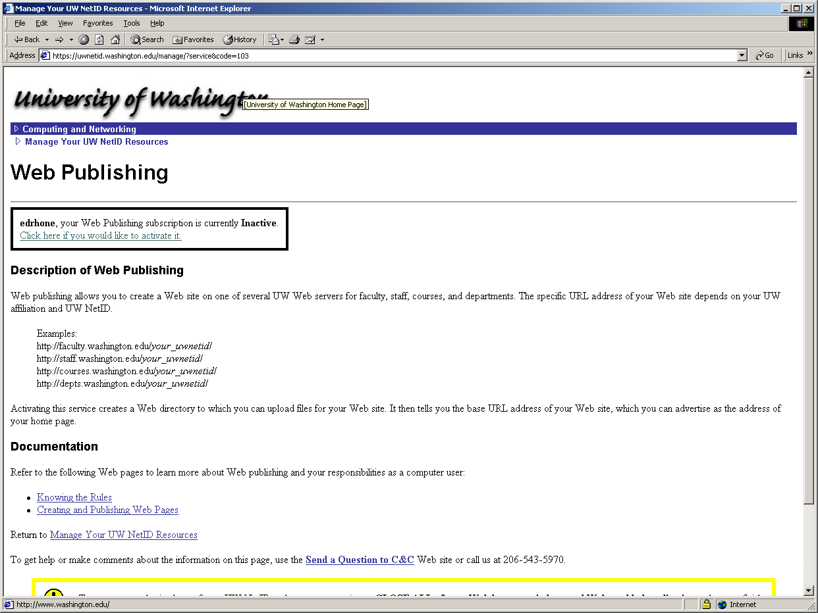

5. Letting you know your “responsibilities” related to web publishing…
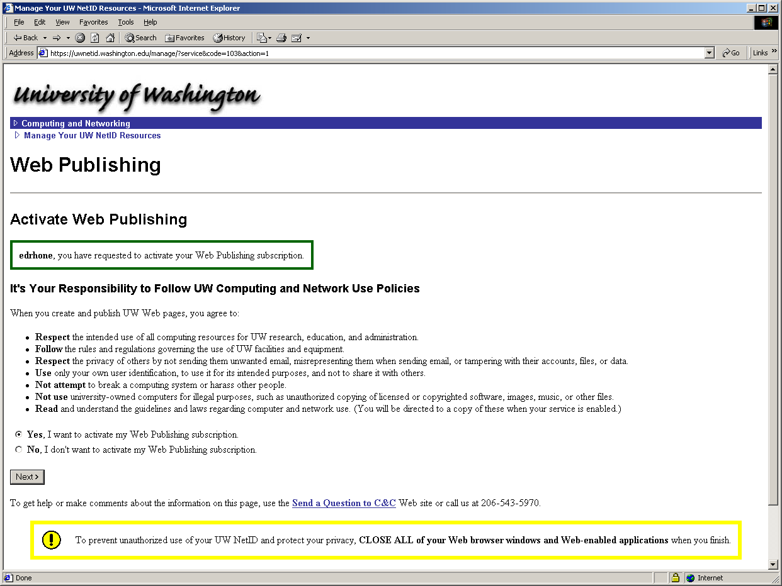
6. The final step – getting your URL…


